Attachment A

Superintendent’s Memo 281-21

October 1, 2021

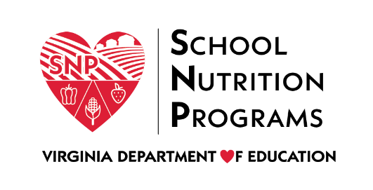

Governor’s Scorecard on Nutrition and Physical Activity

Executive Summary
Document last modified on 09/22/2021
The Governor’s Scorecard on Nutrition and Physical Activity measures initiatives taken beyond requirements to promote a culture of health and wellness through food quality, participation in meal programs, health and physical education, and physical activity. The Scorecard based on the Centers for Disease Control and Prevention’s Whole School, Whole Community, Whole Child model supports and promotes mental and physical wellness to increase opportunities for all students to achieve. Schools are encouraged to use the scorecard as a tool for identifying best practices and measuring progress towards meeting the nutrition and physical activity needs of students.
The Governor’s Scorecard, which originally launched in 2005 as part of Governor Warner's Healthy Virginians Initiative, replaces the U.S. Department of Agriculture's HealthierUS School Challenge and identifies best practices, establishes benchmarks, and provides recognition to schools that exceed minimum requirements related to nutrition and physical activity.
The scorecard includes 40 scored questions and takes approximately 90 minutes to complete. Each question is worth up to four points and points are automatically calculated according the answers selected. Each scored question is followed by prompts to add supporting documentation of the best practices reported. The two major sections of the scorecard include:
- Nutrition Environment (25 questions): school nutrition programs, food quality, equitable access to meals, food insecurity, school gardens, and nutrition education
- Healthy School Environment (15 questions): physical activity promotion and health and physical education

The scorecard and additional information is located on the VDOE Governor's Scorecard webpage.

