Attachment B

Superintendent’s Memo #079-21

March 26, 2021
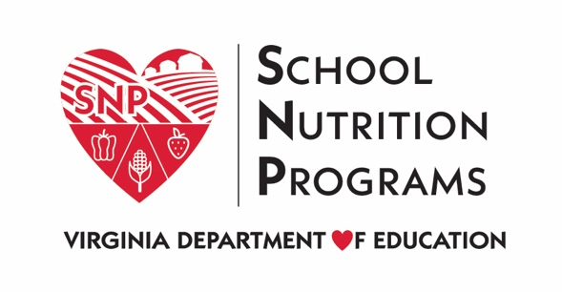

School Year 2020-2021 Waivers - SSO
Waiver Title | Description | Sponsor Actions | Data Requirements
Nationwide Waiver to Allow Summer Food Service Program (SFSP) and Seamless Summer Option (SSO) Operations through September 2021 | This waiver allows states to grant approval for school food authorities (SFAs) to operate the SSO through June 30, 2021.  Effective through September 30, 2021. | Sponsors must request to elect this waiver from the VDOE by completing the 2020-2021 SSO/SFSP Waiver Survey. | - A summary of the use of the waiver by the state agency and local program operators.  - A description of whether and how this waiver resulted in improved services to program participants.
Nationwide Waiver to Allow Area Eligibility for Closed Enrolled Sites in the SFSP and the SSO | This waives the requirements for closed enrolled sties under the SSO to collect income applications to determine that 50 percent of the children are eligible for free and reduced-price meals.  Effective through September 30, 2021. | Sponsors must request to elect this waiver from the VDOE by completing the 2020-2021 SSO/SFSP Waiver Survey. | - A summary of the use of the waiver by the state agency and local program operators.  - A description of whether and how this waiver resulted in improved services to program participants.
Nationwide Waiver of Meal Service Time Restrictions in SFSP and SSO | This waiver eliminates the requirements that three hours elapse between the beginning of one meal and the beginning of another, supper must begin no later than 7:00 p.m. and extend beyond 8:00 p.m., and service for lunch and supper is limited to two hours and breakfast and snack to one hour. This waiver lifts all restrictions on duration of meal service and elapsed time.  Effective through September 30, 2021. | Sponsors must request to elect this waiver from the VDOE by completing the 2020-2021 SSO/SFSP Waiver Survey. | - A summary of the use of the waiver by the state agency and local program operators.  - A description of whether and how this waiver resulted in improved services to program participants.
Nationwide Waiver to Allow Non-congregate Feeding in the SFPS and SSO | This waiver allows meals to be served in a non-congregate setting.  Effective through September 30, 2021. | Sponsors must request to elect this waiver from the VDOE by completing the 2020-2021 SSO/SFSP Waiver Survey. | - A summary of the use of the waiver by the state agency and local program operators.  - A description of whether and how this waiver resulted in improved services to program participants.
Nationwide Waiver to Allow Parents and Guardians to Pick-up Meals for Children | This waiver allows meals to be distributed to parents or guardians to take home to their children. In order to elect this waiver, sponsors must be approved to provide meals in a non-congregate setting.  Effective through September 30, 2021. | Sponsors must request to elect this waiver from the VDOE by completing the 2020-2021 SSO/SFSP Waiver Survey. | - A summary of the use of the waiver by the state agency and local program operators.  - A description of whether and how this waiver resulted in improved services to program participants.
Nationwide Waiver to Extend Area Eligibility Waivers | This waiver allows for the continuation of the suspension of area eligibility requirements for all eligible sponsors operating the SSO. Program requirements require that open sites must be located in an area where at least 50 percent of National School Lunch Program (NSLP) participants are eligible for free and reduced-price meals. This waiver allows the VDOE to continue to approve sites that are below the 50 percent NSLP free and reduced-price meal participant threshold.  Effective through September 30, 2021. | Sponsors must request to elect this waiver from the VDOE by completing the 2020-2021 SSO/SFSP Waiver Survey. | - A summary of the use of the waiver by the state agency and local program operators.  - A description of whether and how this waiver resulted in improved services to program participants.
Nationwide Waiver to Allow Meal Pattern Flexibility in the SFSP and the SSO | This waiver allows state agencies to approve flexibilities in meal pattern requirements in the SSO. This also waives the requirement that schools must offer students a variety (at least two different options) of fluid milk.  Effective through September 30, 2021. | Sponsors must request to elect this waiver from the VDOE by completing the 2020-2021 SSO/SFSP Waiver Survey. | - A summary of the use of the waiver by the state agency and local program operators.  - A description of whether and how this waiver resulted in improved services to program participants.

