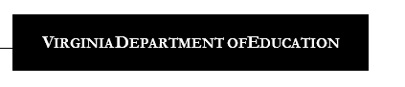
EIRI Assessment Schedule
 | Fall | Mid-Year | Spring
Kindergarten | All students screened | Optional progress  monitoring  window | All students screened
First Grade | All students screened | Optional progress  monitoring  window | All students without a "high  benchmark* score" are  screened
Second Grade | All students screened | Optional progress  monitoring  window | All students without a "high  benchmark* score" are  screened
Third Grade | Students who are new to Virginia  public schools and students who  received summer intervention are  screened | Optional progress  monitoring  window | All students take the SOL  English/ reading test

*The purpose of the high benchmark is to exempt from future PALS screenings those students whose
PALS scores are so high in spring of second grade, that it is unlikely that future PALS screenings will
identify them for additional instruction. Students meeting the high benchmark do not need to take PALS in the future unless the teacher wishes to administer PALS to those students for instructional purposes.

