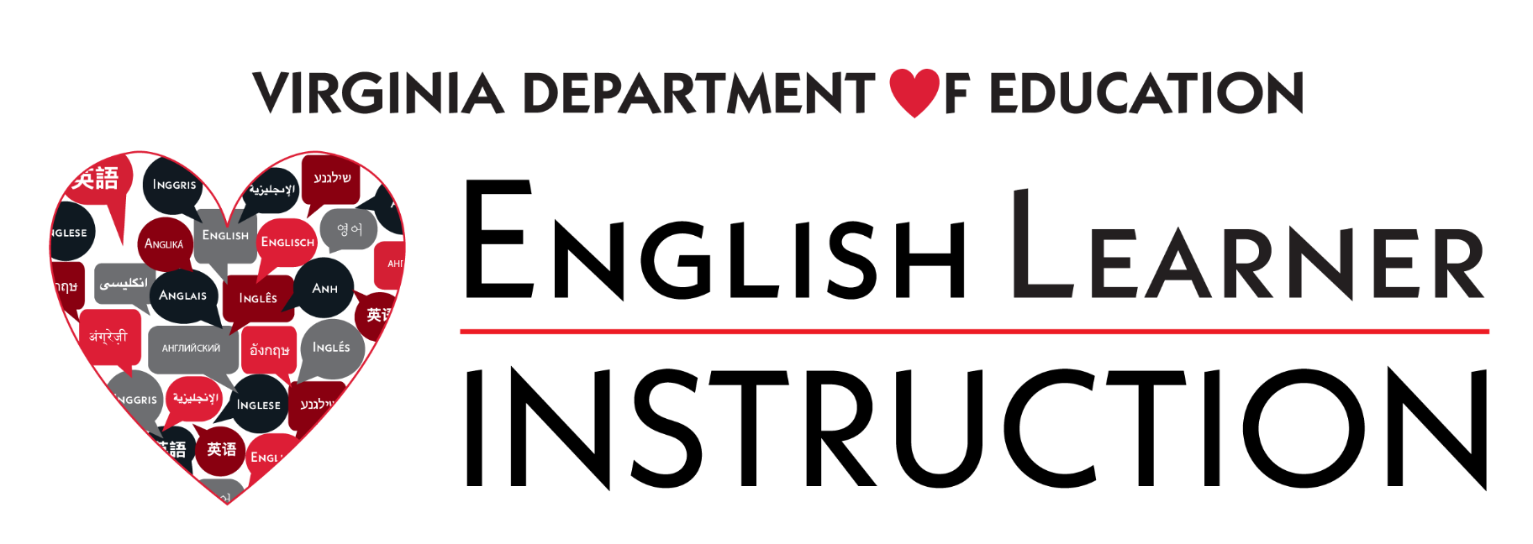

English Language Development (ELD) Standards Framework Implementation Trainings Available
The Virginia Department of Education will offer various professional learning options and resources to support divisions as they work to roll-out the new English Language Development (ELD) Standards Framework. Please see below for the list of trainings and available resources.
Additional opportunities, including webinars specific to content area instruction for English learners (ELs), will be provided throughout the roll-out period and announced via the English Learner Instruction Newsletter.

Supporting Division Implementation of the ELD Standards Framework 2020 Roll-Out
This session for EL program leaders and coordinators who will be supporting the 2020 ELD Standards Roll-Out and Implementation. The focus of this session will be on sharing resources available to support division level implementation and for leaders to share initial ideas about their plans for implementation.
The options below are repeat sessions, so leaders may choose the one that is most convenient.
May 13, 2021 10:30 -11: 30 a.m. or 4 – 5 p.m.
May 19, 2021 10:30 -11: 30 a.m. or 4 – 5 p.m.
May 25, 2021 10:30 -11: 30 a.m. or 4 – 5 p.m.
June 9, 2021 10:30 -11: 30 a.m. or 4 – 5 p.m.
June 17, 2021 10:30 -11: 30 a.m. or 4 – 5 p.m.
July 7, 2021 10:30-11:30 a.m. or 2- 3 p.m.
July 19, 2021 10:30-11:30 a.m. or 2- 3 p.m.
At the conclusion of this series, all who registered will be sent a list of ideas and questions shared in the session and on the post-webinar survey.

Leading for Equity for English Learners
This session is for school and division leaders to explore a sample classroom walkthrough tool and make connections to the main components of the 2020 ELD Standards Framework. The options below are repeat sessions, so leaders may choose the one that is most convenient.
Options available:
April 21, 2021 10-11 a.m. or 4- 5 p.m.
May 12, 2021 10-11 a.m. or 4- 5 p.m.
June 30, 2021 10-11 a.m. or 2- 3 p.m.
July 14, 2021 10-11 a.m. or 2- 3 p.m.
August 3, 2021 10-11 a.m. or 2- 3 p.m.
At the conclusion of this series, all who registered will be sent a list of ideas and questions shared in the session and on the post-webinar survey.

Planning with the WIDA Standards Framework
Training for EL program leaders who will be providing division-level training to support build staff understanding and capacity for implementing the new 2020 Edition of the ELD Standards Framework
These sessions will be delivered by a WIDA Professional Learning Specialist and will have participant maximums. Each division is guaranteed one space. Division Title III Coordinators or Directors identify someone to attend who will be responsible for turn-around training. Additional division staff may be able to attend. Space for sessions is first come-first serve. Registration options and links will be sent via email to those division requested participants. If you are a Title III Coordinator and have not already identified your division’s representative(s), please email jessica.costa@doe.virginia.gov.
Additional sessions will provide time for participants to share ideas for roll-out and implementation training and support. This session will include collaborative work time for drafting training materials and discussing curriculum refresh ideas.
July 12 , 2021 1-3 p.m.

Introduction to Virginia’s new ELD Standards Framework
This session is for any educator working with an EL as an overview of the components and possible applications of the 2020 edition. The options below are repeat sessions, so teachers may choose the one that is most convenient.
Options Available:
April 26, 2021 3:30- 4:30 p.m.
May 10, 2021 3:30- 4:30 p.m.
June 7, 2021 3:30- 4:30 p.m.
July 12, 2021 10:30-11:30 a.m.
August 9, 2021 10:30-11:30 a.m.
At the conclusion of this series, all who registered will be sent a list of ideas and questions shared in the session and on the post-webinar survey.

