Virginia Department of Education Superintendent’s Regions
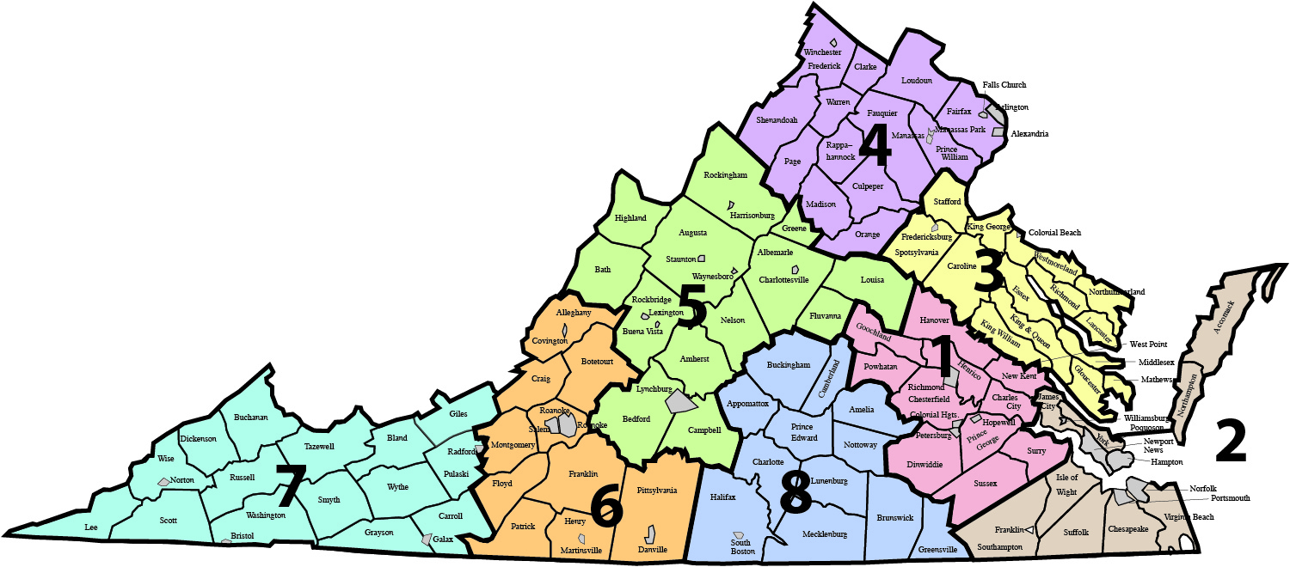

Region 1 – Central Virginia
- Charles City County
- Chesterfield County
- Colonial Heights
- Dinwiddie County
- Goochland County
- Hanover County
- Henrico County
- Hopewell
- New Kent County
- Petersburg
- Powhatan County
- Prince George County
- Richmond
- Surry County
- Sussex County

Region 2 – Tidewater
- Accomack County
- Chesapeake
- Franklin
- Hampton
- Isle of Wight County
- Newport News
- Norfolk
- Northampton County
- Poquoson
- Portsmouth
- Southampton County
- Suffolk
- Virginia Beach
- Williamsburg James City County
- York County

Region 3 – Northern Neck
- Caroline County
- Colonial Beach
- Essex County
- Fredericksburg
- Gloucester County
- King George County
- King William County
- King and Queen County
- Lancaster County
- Mathews County
- Middlesex County
- Northumberland County
- Richmond County
- Spotsylvania County
- Stafford County
- Westmoreland County
- West Point

Region 4 – Northern Virginia
- Alexandria
- Arlington County
- Clarke County
- Culpeper County
- Fairfax County
- Falls Church
- Fauquier County
- Frederick County
- Loudoun County
- Madison County
- Manassas
- Manassas Park
- Orange County
- Page County
- Prince William County
- Rappahannock County
- Shenandoah County
- Warren County
- Winchester
Region 5 – Valley
- Albemarle County
- Amherst County
- Augusta County
- Bath County
- Bedford County
- Buena Vista
- Campbell County
- Charlottesville
- Fluvanna County
- Greene County
- Harrisonburg
- Highland County
- Lexington
- Louisa County
- Lynchburg
- Nelson County
- Rockbridge County
- Rockingham County
- Staunton
- Waynesboro

Region 6 – Western Virginia
- Alleghany County
- Botetourt County
- Covington
- Craig County
- Danville
- Floyd County
- Franklin County
- Henry County
- Martinsville
- Montgomery County
- Patrick County
- Pittsylvania County
- Roanoke
- Roanoke County
- Salem

Region 7 – Southwest
- Bland County
- Bristol
- Buchanan County
- Carroll County
- Dickenson County
- Galax
- Giles County
- Grayson County
- Lee County
- Norton
- Pulaski County
- Radford
- Russell County
- Scott County
- Smyth County
- Tazewell County
- Washington County
- Wise County
- Wythe County

Region 8 – Southside
- Amelia County
- Appomattox County
- Brunswick County
- Buckingham County
- Charlotte County
- Cumberland County
- Greensville County
- Halifax County
- Lunenburg
- Mecklenburg County
- Nottoway County
- Prince Edward County

