# Virginia Department of Education Superintendent’s Regions

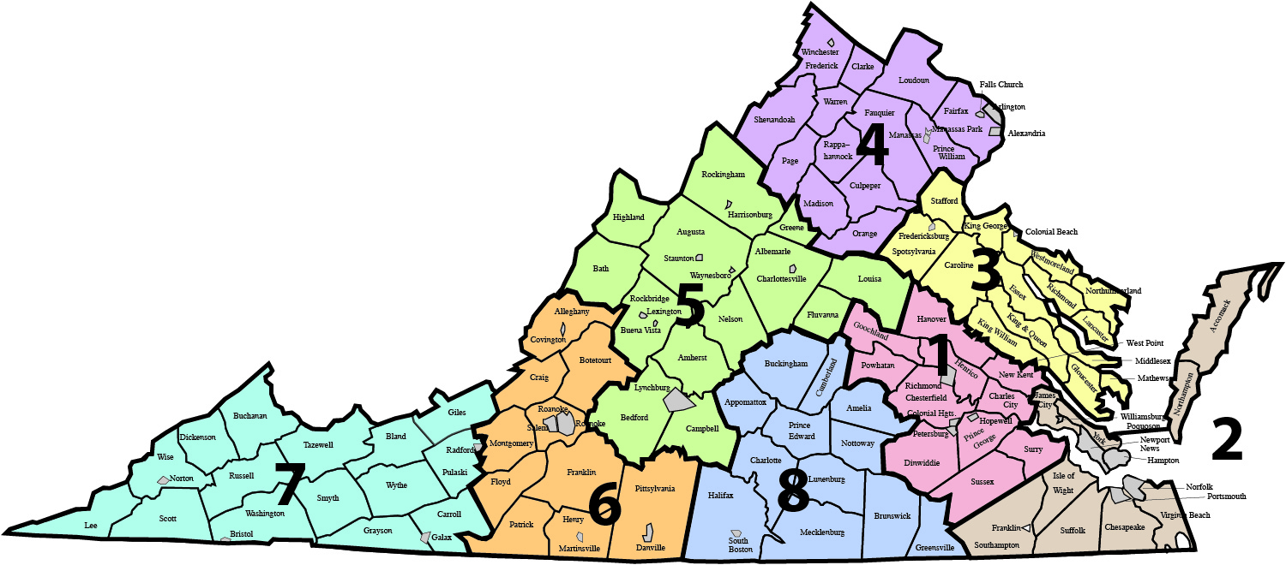

## Region 1 – Central Virginia

* Charles City County
* Chesterfield County
* Colonial Heights
* Dinwiddie County
* Goochland County
* Hanover County
* Henrico County
* Hopewell
* New Kent County
* Petersburg
* Powhatan County
* Prince George County
* Richmond
* Surry County
* Sussex County

## Region 2 – Tidewater

* Accomack County
* Chesapeake
* Franklin
* Hampton
* Isle of Wight County
* Newport News
* Norfolk
* Northampton County
* Poquoson
* Portsmouth
* Southampton County
* Suffolk
* Virginia Beach
* Williamsburg James City County
* York County

## Region 3 – Northern Neck

* Caroline County
* Colonial Beach
* Essex County
* Fredericksburg
* Gloucester County
* King George County
* King William County
* King and Queen County
* Lancaster County
* Mathews County
* Middlesex County
* Northumberland County
* Richmond County
* Spotsylvania County
* Stafford County
* Westmoreland County
* West Point

## Region 4 – Northern Virginia

* Alexandria
* Arlington County
* Clarke County
* Culpeper County
* Fairfax County
* Falls Church
* Fauquier County
* Frederick County
* Loudoun County
* Madison County
* Manassas
* Manassas Park
* Orange County
* Page County
* Prince William County
* Rappahannock County
* Shenandoah County
* Warren County
* Winchester

## **Region 5 – Valley**

* Albemarle County
* Amherst County
* Augusta County
* Bath County
* Bedford County
* Buena Vista
* Campbell County
* Charlottesville
* Fluvanna County
* Greene County
* Harrisonburg
* Highland County
* Lexington
* Louisa County
* Lynchburg
* Nelson County
* Rockbridge County
* Rockingham County
* Staunton
* Waynesboro

## Region 6 – Western Virginia

* Alleghany County
* Botetourt County
* Covington
* Craig County
* Danville
* Floyd County
* Franklin County
* Henry County
* Martinsville
* Montgomery County
* Patrick County
* Pittsylvania County
* Roanoke
* Roanoke County
* Salem

## Region 7 – Southwest

* Bland County
* Bristol
* Buchanan County
* Carroll County
* Dickenson County
* Galax
* Giles County
* Grayson County
* Lee County
* Norton
* Pulaski County
* Radford
* Russell County
* Scott County
* Smyth County
* Tazewell County
* Washington County
* Wise County
* Wythe County

## Region 8 – Southside

* Amelia County
* Appomattox County
* Brunswick County
* Buckingham County
* Charlotte County
* Cumberland County
* Greensville County
* Halifax County
* Lunenburg
* Mecklenburg County
* Nottoway County
* Prince Edward County