Instructions – Completing the Spring VPI Application (Projected 2022-2023)

Instructions include the following sections to assist you in completing this year’s Spring VPI Verification Application in SSWS.
- Spring 2022 VPI Application Submission Requirements (Projected 2022-2023)
  - Summary of Data Collection Elements Needed (VPI 4-year-olds)
  - Competitive Application for Serving VPI 3-Year-Olds
  - VPI Local Plan Questions
- SSWS Screen Shots with Directions
- All applications are due on May 15, 2022

Spring 2022 VPI Application Requirements (Projected 2022-2023)

All eligible divisions must certify electronically participation or nonparticipation in the VPI program for the 2022-2023 school year by May 15, 2021.

Division who did not receive a initial VPI 4-year-old allocation can still apply to request waitlist VPI 4-year-old slots and/or the competitive 3-year-old application

The data and application will be collected through the Virginia Department of Education’s (VDOE) Single Sign-On for Web Systems portal (SSWS). Access to the VPI application in SSWS must be requested through the school division’s SSWS account manager.

Summary of Data Collection Elements Needed
For divisions choosing to participate or request waitlist/3-year-old slots, additional information will be collected through SSWS. Please have the following information available before you begin entering the data into the SSWS application:

Competitive Application for Serving VPI 3-Year-Olds (2022-2023)

The application for the VPI Pilot for 3-Year-Olds is included as a part of the spring VPI Application due on May 15. Following is the content of the application.

All requested slots for 3-year-olds will be considered but are NOT guaranteed. Final decisions about available slots for 3-year-olds will be communicated to divisions by July 1. If requests for state funds to serve at-risk 3-year-olds equal more than appropriated funds amount of state funds, VDOE staff will prioritize applications using the following priority ranking:

- Communities with limited childcare options;
- Programs serving children in private, mixed-delivery settings,
- Communities that demonstrate full support of public and private providers, or
- Communities that have successfully participated in the Pilot for Serving 3-Year-Olds during the last school year.

- Our community (check all that apply):
  - Serves VPI slots for 4-year-olds in community settings or is planning to do so next school year.
  - Participates in the Virginia Early Childhood Foundation’s Mixed Delivery grant or plans to apply for a grant for next school year.
  - Participates in the federal Preschool Development Grant or plans to apply for a grant for next school year.
  - None of the above
- Where will VPI pilot 3-year olds be served (check all that apply):
  - School-based setting
  - Community-based setting
- Describe the availability of childcare options for 3-year-olds in your community and provide general estimates of the number available.
- Describe the broad stakeholder support for the VPI pilot for serving at-risk 3-year-olds. Please include support from Head Start and other early care and education providers in your community.
- How will the school division maximize federal and state funds to preserve existing birth to five slots already being implemented in the community (supplementing not supplanting existing slots)?
- How will the school division collaborate among the local department of social services, programs accepting child subsidy payments, and providers for Head Start, private child care, and early childhood special education and early intervention programs?

Programmatic Information

- VPI Coordinator contact information
- Lead agency contact information
- Will the school division also apply for 3-year-olds
- Projected number of full-day and/or half-day 4-year-old students to be served in 2022-2023
- Projected number of full-day and/or half-day 4-year-old students to be served in a community-provider setting in 2022-2023*
  - If applying for 3-year-olds: projected number of full-day and/or half-day 3s be served in 2022-2023*
  - If applying for 3-year-olds: Projected number of full-day and/or half-day 3s to be served in a community-provider setting in 2022-2023*

*Funds Projected but Not Allocated to Divisions: Community Provider Add-on funds (4s and 3s) and VPI Slots for 3s are dependent on available funds after projected, spring VPI applications are submitted by divisions on May 15. School divisions submitting projected data for Community Provider Add-on Funds (4s and 3s) and slots for VPI 3s will be notified by July 1 by the Office of Early Childhood regarding any approved funds for these initiatives.

- Projected number of VPI classrooms (any classroom with one or more VPI funded students)
- Number of eligible 4-year-olds from the division’s wait list (if projecting to serve 100% of allocated slots or if not allocated any slots) does the division request to serve next school year
- Number of VPI classrooms (any classroom with one or more VPI funded student)
- Number of VPI classrooms projected to operate less than 180 instructional days or 990 hours of instruction in 2021-2022
- Number of schools or centers
- Total number of VPI teachers
- Number of VPI teachers who hold a BA degree or higher and a Virginia teaching license with an NK or PK endorsement
- Number of VPI teachers with BA degree or higher
- Number of VPI teachers with Associate degrees
- Number of VPI teachers with Child Development Associate (CDA) credentials
- Total number of paraprofessionals
- Number of paraprofessionals with BA degrees
- Number of paraprofessionals with Associate degrees
- Number of paraprofessionals with Child Development Associate (CDA) credentials
- Number of paraprofessionals with high school diplomas or GED credentials
- Complete name of the vetted evidenced-based curriculum

VPI Local Plan Questions

- Describe how the program ensures the Virginia’s Birth-to-Five Early Learning and Development Standards will be implemented and how the five areas will be assessed (Approaches to Play & Learning; Social & Emotional Development; Communication, Language, & Literacy; Health & Physical Development; and Cognitive Development).
- Describe the intentional plan for implementing meaningful parental involvement and family engagement strategies throughout the school year.
- Describe how teachers and teaching assistants are provided with ongoing training and professional development to implement the vetted curriculum.
- In alignment with VQB5, provide information on who will serve as certified, local CLASS™ observers. Describe how teachers and teacher assistants will be supported in improving practice as a result of scores from observations completed.
- Describe how the program will facilitate linkages to obtain comprehensive services and resources for children and families (i.e., health physical, hearing and vision screenings, and behavioral and mental health screenings).
- Describe the VPI Steering Committee. List members, organizations, and frequency of meetings. Describe how members are consulted to ensure federal funds are preserved and maximized for serving preschoolers.
- Describe how leaders representing VPI and Early Childhood Special Education programs work together as a team to support inclusive practices of children with special needs in VPI classrooms and endure the 10% inclusion target is met or exceeded.
- Describe the transportation plan that is in place to ensure eligible VPI children have access to a safe method of transportation to and from the home setting and the VPI program site. Transportation should not present a barrier to access for any child.
- Divisions must upload a copy of the Local VPI Income Eligibility Verification Form (includes staff/parent signature and lists documents used for income verification)
- * In the previous school year, your division did not meet the General Assembly Inclusion Target of 10%. Please indicate below, what additional steps are being taken to ensure the inclusion target will be met in the upcoming school year.
* This question will only populate for divisions who did not meet the 10% inclusion target in 2021-2022.
Complete all data entry in SSWS and have the division superintendent certify electronically in SSWS that the data are correct by May 15, 2022.

SSWS Screen Shots with Directions

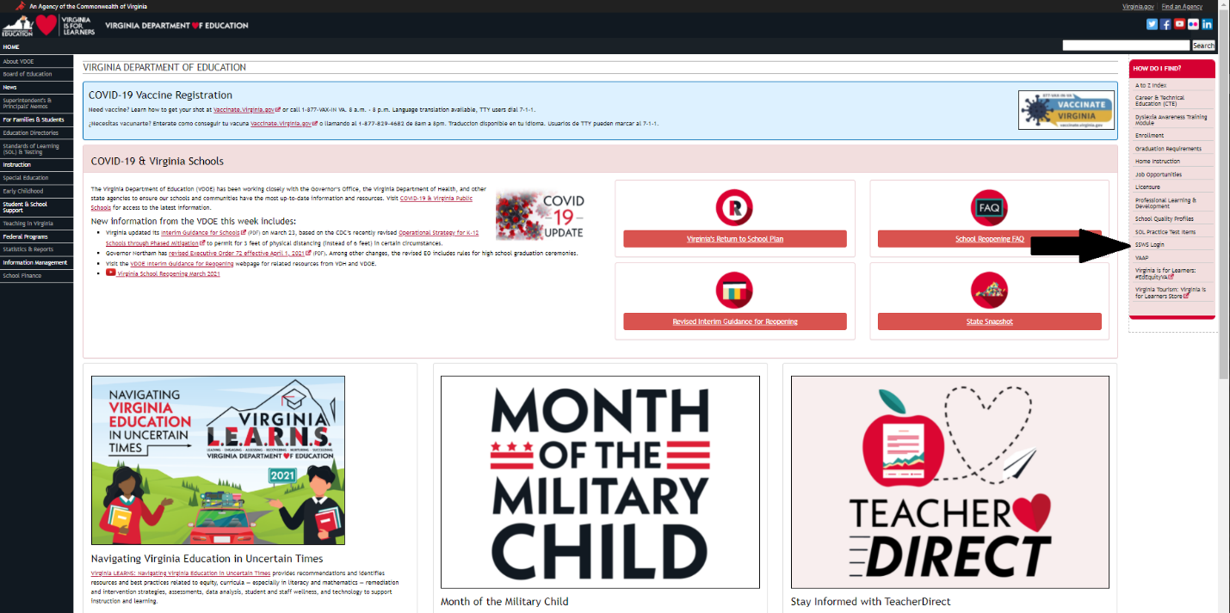

- From the VDOE home page, select SSWS Login
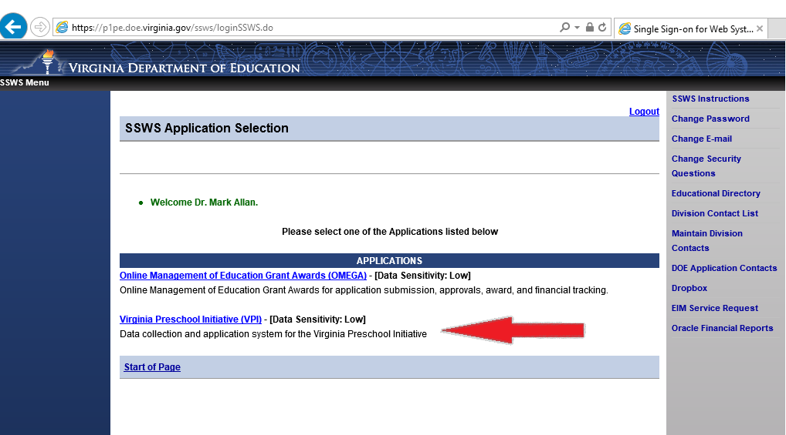

- After logging into SSWS select the Virginia Preschool Initiative
  - If you do not have a log in or do not see VPI on your SSWS screen AFTER you are logged in, you must contact YOUR LOCAL SCHOOL DIVISION SSWS CONTACT. Every school division has at least one person assigned to manage SSWS accounts for the division. Please inquire within your school division for who serves as the SSWS contact.

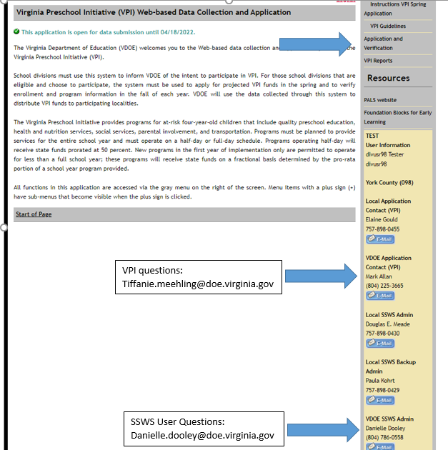

- Once in the VPI Application, select “ Application and Verification”
- If you have questions regarding SSWS and its functions as a data collection system contact Danielle Dooley at danielle.dooley@doe.virginia.gov . If you have questions about VPI and the Spring VPI Application (4s & pilot 3s), contact Tiffanie Meehling at tiffanie.meehling@doe.virginia.gov
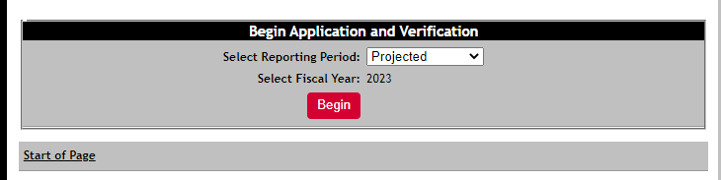

- Select PROJECTED & 2023 in order to complete the Spring VPI Application. This application is a projection of the VPI program in the 2022-2023 school year. Select BEGIN.

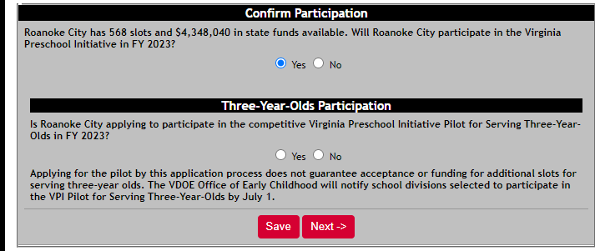

- Top Row: Select YES if your division will fill ANY of the allocated VPI slots for 2021-22. Select NO only if your school division is not eligible to participate in VPI or is eligible but is not participating.
- Second Row: Select YES if your division is requesting to serve VPI 3-Year-Olds. Select No if not. If YES is selected, you will be directed to the application for VPI 3-Year-Olds. If NO is selected, you will not be asked to complete pilot application questions.

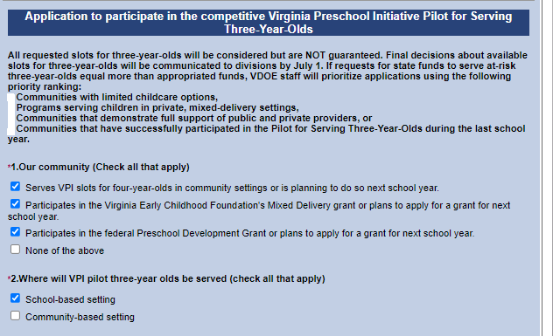

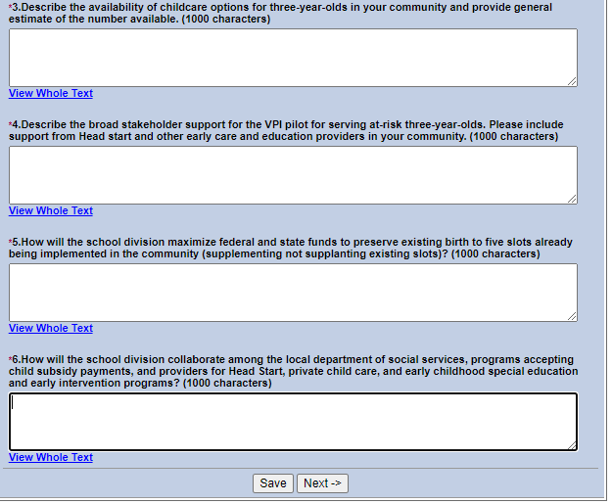

- Divisions applying to serve VPI 3-Year-Olds will see the application displayed. Answer each question. Select Save and Next to continue to the regular VPI Application. Divisions not applying for the Pilot will not see this section.

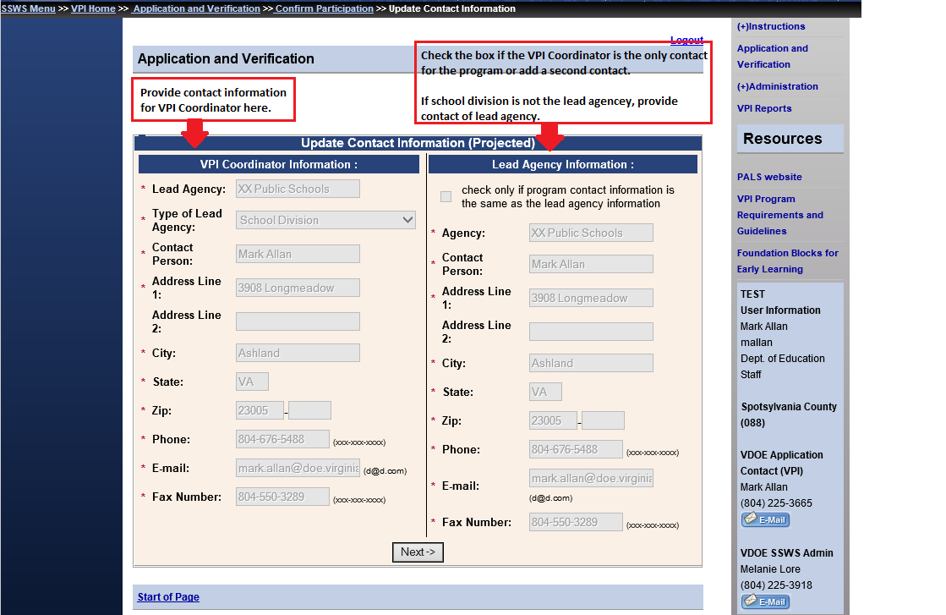

- Provide the name and contact information for the VPI Coordinator on the left (person responsible for day-to-day operation of VPI).
- If another governmental agency serves as the lead, fiscal agency for VPI you must enter contact information for this lead agency on the right.
  - If the school division is the lead, fiscal agency for VPI you may check the box and only have the VPI Coordinator as the contact or you may not check the box and add a second contact person for VPI here.

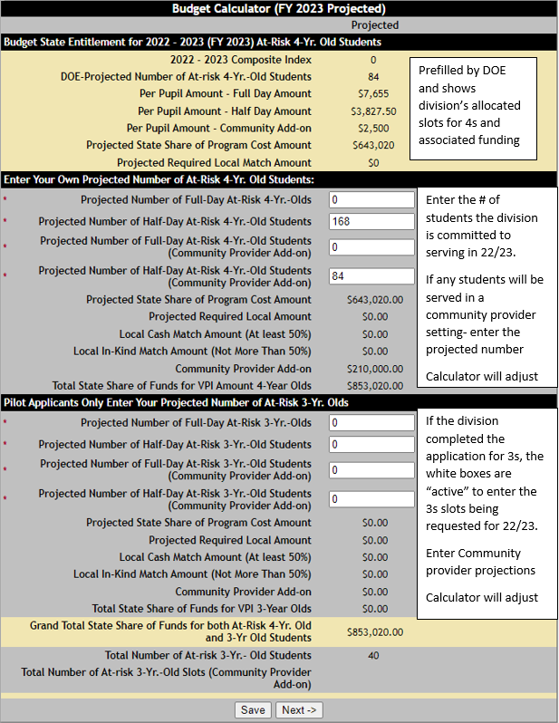

- Top Section: The SSWS budget calculator automatically displays the division’s allocated VPI slots for 4-year-olds in the top section and associated funding information. It includes per pupil amounts for full-day or half-day participation and the amount per pupil served in a community provider setting.
- Middle Section: Each division must enter the projected number of VPI 4-year-olds the division is committed to serving in VPI during 2022-2023. This number CANNOT exceed the number of slots the state has allocated to the division (shown in top of calculator). Enter the # of students, not slots, for full-day or half-day programs. Enter the # of any students, not slots, who will be served in a community provider setting (full-day or half-day settings).
- Bottom Section: This section will be visible by all divisions, but only divisions that selected and completed the application for VPI 3-Year-Olds will be able to enter data into this part of the budget calculator. Divisions applying must enter the number of 3-year-olds the division is committed to serving in VPI during 2022-2023. The division may request any number of slots for 3s that the division is committed to filling but the number of slots requested is NOT guaranteed and will be based on availability of funds.
- Important Note: Divisions requesting community provider add-on slots and slots for 3s are NOT guaranteed funds for these enhancements. Divisions will be notified by July 1, 2022 regarding approval of funding for any community provider add-on funds (4s & 3s) and for slots for 3s.

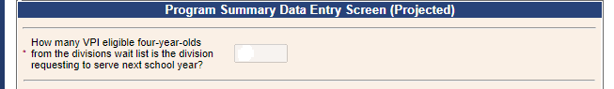

- If your division projects to fill 100% of your division’s allocated VPI slots in 2022-23 or your division was not allocated any slots, you will see this question. Since you project to use all slots, do you also plan to serve additional VPI students who may be on a wait list in the fall? If so, how many additional slots is your division committed to filling and would like to request for 2022-23. These slots are not guaranteed, requesting divisions will be notified of any reallocation by July 1, 2022.

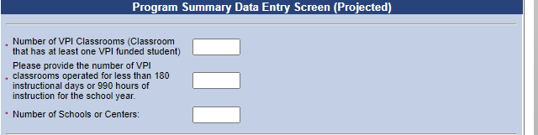

- A classroom with one or more state-funded VPI student is a VPI classrooms. Report total number of VPI classrooms projected for 2022-23. Include VPI classrooms in community provider settings.
- If the division is projecting to open one or more VPI classroom(s) later than other VPI classrooms resulting in less instructional days and hours, report the number of classrooms impacted.
- Report total number of schools or centers hosting VPI classrooms.
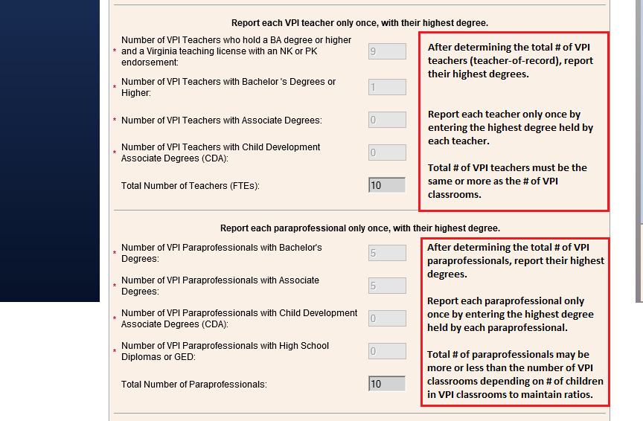
- Report # of teachers by highest degree and number of paraprofessionals by highest degree as described in the directions in the above screen shot. Include any teacher and paraprofessional serving VPI students in a community provider setting.

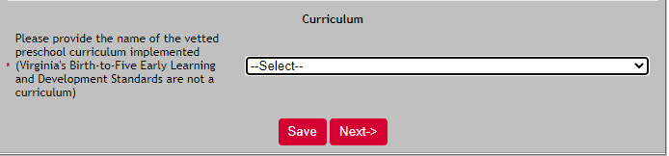

- Report the vetted curriculum for 2022-23.

VPI Local Plan Questions

What is the plan for VPI in 2022-2023? Each spring VPI programs must create a new local plan as a part of the spring application process. In fall 2022, this written plan will appear on the fall Verification Report and can be updated with any changes for the actual school year.

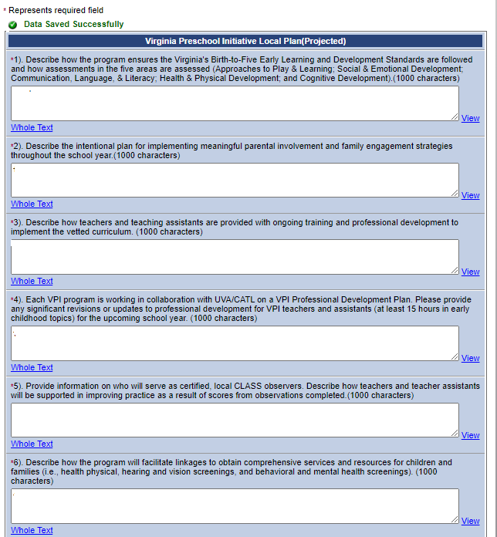

Total # of students must equal total # of VPI students in budget calculator.

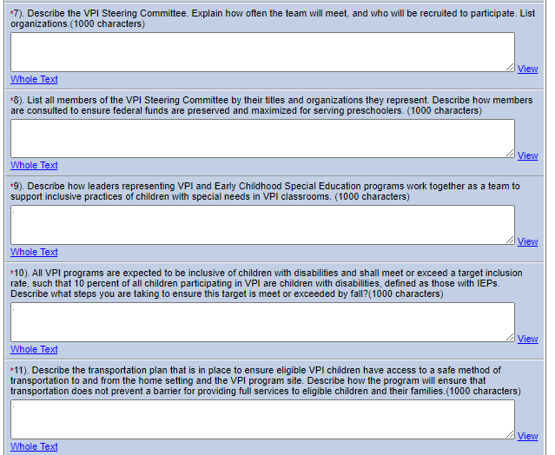

#12 Upload Local VPI Income Eligibility Form (PDF)

- Provide answers for your local VPI Plan for 2022-23.
- Question #12 asks you to upload the program’s Local VPI Income Eligibility Form (PDF only). Upload the current form your program uses to verify the family’s income eligibility (i.e., includes type of income documents submitted, staff signature, parent signature). A sample of what a Local VPI Income Eligibility Form might look like is provided at the end of this document.
- This is the final page. When complete, select SAVE and NEXT. You will be provided with an important summary of the division’s Spring VPI Application to review.

- After reviewing the Spring Application Summary for accuracy, select “Submit for Verification” for the division superintendent to verify and submit to VDOE.
- You will not be able to make changes to the application once it has been submitted to the superintendent.
- The Spring VPI Application will be electronically approved and certified by the division superintendent through the Superintendent’s Data Collection Approvals (SDCA) in SSWS. The SDCA will automatically be available to school division superintendents through SSWS and is designed to be an easy process for division superintendents. For superintendents, SDCA will automatically launch upon SSWS login. However, for their designees, SDCA will function just as any other SSWS application functions with a selection being required from the main system menu.

ALL APPLICATIONS ARE DUE ON MAY 15, 2021

SAMPLE LOCAL VPI INCOME ELIGIBILITY FORM
