Attachment A

SCNP Memo No. 2023-2024-82

May 23, 2024

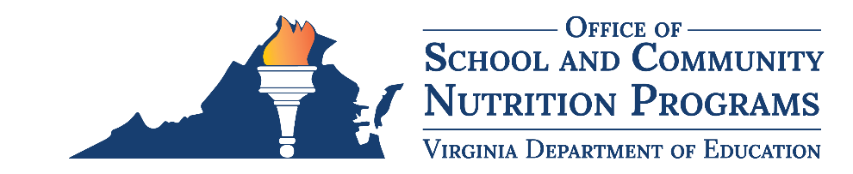

2024 Virginia Food for Virginia Kids Cohort

Scope of Work

Background
The Virginia Department of Education, Office of School and Community Nutrition Programs (VDOE-SCNP) Virginia Food for Virginia Kids (VFVK) initiative builds the commitment and capacity of Virginia school divisions to increase scratch cooking and serve more fresh, seasonal, and student inspired meals. VFVK directly supports school food authorities (SFAs) while weaving in workforce development initiatives to bolster the school nutrition workforce. Each year, the VDOE-SCNP works with eight new SFAs interested in, and committed to, operational change in the areas of scratch cooking, local food procurement, and student inspired meal offerings. This unique, pioneering opportunity includes strategic planning, training, group discussion, and in-person technical assistance. The VDOE-SCNP contracted the Chef Ann Foundation (CAF) to work alongside the VFVK Cohorts.
The VDOE-SCNP will select eight SFAs for the SY 2024–2025 VFVK Cohort that demonstrate they are committed to operational change in the areas of scratch cooking, local procurement, and student inspired meal offerings. Members of the SY 2024–2025 VFVK Cohort agree to complete the items listed within the following scope of work.

Scope of Work
The SFA (Contractor) shall be responsible for providing the following deliverable(s) during SY 2024–2025 through September 2025:
- Actively participate in:
  - one group cohort kick-off call;
  - three quarterly group cohort calls that are structured with pre-determined topics;
  - 10 monthly group calls to discuss successes and challenges;
  - two, two-day visits from VDOE-SCNP and CAF staff to the SFA to observe cafeteria operations and identify areas of opportunity; and
  - at least two individual virtual technical assistance meetings with CAF staff.
- Complete an operational assessment (SCALE) to identify opportunities for growth. The operational assessment includes five key areas: food, finance, facilities, human resources, and marketing. The assessment will take approximately 2–3 hours to complete and will used by CAF to develop an individualized report for the SFA.
- Develop a strategic plan with CAF that aligns with the SFA’s vision for operational change in the areas of scratch cooking, local procurement, and student inspired meal offerings.
- Complete online training provided/offered by CAF and the VDOE-SCNP in the areas of scratch cooking, local food procurement, and student inspired meal offerings.
- Complete additional workshops based on cohort need on areas such as financial management.
- Participate in discussions on school meal topics, such as barriers and opportunities for change. For example, previous VFVK cohort members have participated in gatherings at the University of Virginia.
- Attend one or more in-person leadership gatherings in Virginia for discussions related to improving school meals throughout the Commonwealth.
- Attend one or more conferences geared towards scratch cooking, such as ScratchWorks. Travel expenses will be paid by the VDOE-SCNP.
- Participate in monitoring and evaluation activities as requested by the VDOE-SCNP. As a part of these activities, the SFA agrees to track its local food purchases throughout the course of the program and submit this information to the VDOE-SCNP at the end of the school year.
In partnership with CAF and the VDOE-SCNP, the SFA agrees to set specific, measurable goals to increase its scratch cooking, local procurement, and student inspired meal offerings. The VDOE-SNCP uses the following definitions:
- Scratch cooking includes food preparation using whole ingredients such as raw proteins, fresh produce, and/or intact whole grains.
- Local food procurement includes the purchasing of food items grown and/or raised within a specific geographic radius defined by the SFA.
- Student inspired meals includes participation from the student and overall school community in menu development. The School Nutrition Program engages with the student and school community to ensure meals reflect student interests and preferences.
Once SY 2024–2025 VFVK Cohort activities are completed with the VDOE-SCNP and CAF, the SFA agrees to the following during SY 2025-2026:
- Attend four quarterly virtual group cohort meetings with the VDOE-SCNP to discuss successes and challenges.
- Host a VDOE-SCNP team member for one visit to discuss progress on the strategic plan.
- Track local food purchases throughout the course of the year and submit this information to the VDOE-SCNP at the end of the school year.

Contract Period of Performance
Date of Contract Execution through October 30, 2026. Cohort activities will begin August 2024 and end September 2025. Follow-up activities will occur throughout SY 2025–2026.

Application Process
Applications for the SY 2024–2025 VFVK Cohort should be submitted via the online application form by Friday, June 14, 2024.

