SCNP Memo #2023-2024-88
Attachment A

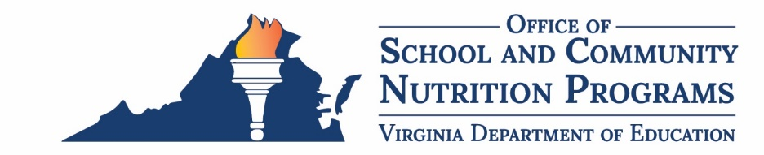

Nonprogram Revenue Tool
The U.S. Department of Agriculture, Food and Nutrition Service (USDA-FNS) developed a tool to help SFAs calculate the amount of revenue from nonprogram foods required to meet their cost. The Nonprogram Revenue Tool is available in the Download Forms section of SNPWeb.

New Simplified Approach
The new simplified approach consists of the following five steps.
- Determine the reference period.
- SFAs must identify costs and revenues specifically for one month of operation.
- The chosen month must reflect typical food service operations. Data from summer school, holidays, breaks, or special circumstances may distort the program and nonprogram foods data, and therefore, cannot be included.
- The VDOE-SCNP advises SFAs to use October or February.
- If the SFA is able to show that the percentage of nonprogram revenue generated is at least as great as the percentage of nonprogram food costs incurred during the selected month, the SFA complies with Federal requirements.
- Identify nonprogram foods.
- The SFA must identify all nonprogram foods that will be included in the tool, such as a la carte, adult meals, catering, and vended meals.
- Costs and revenues for catering, vended meals, or purchasing for other entities that occurred during the reference month are not required but can be included if this helps the assessment for the SFA. If the SFA chooses to add these costs, the revenues generated from these areas must also be included in the nonprogram revenue section.
- SFAs should use their point of sale to run a sales activity or transaction report to identify all nonprogram foods that were sold in the reference month.
- Determine nonprogram food costs.
- The SFA must use the new Nonprogram Food Tracking Tool template found in SNPWeb Download Forms. VDOE-SCNP created the template to help SFAs determine total nonprogram food costs and revenues as well as a recommended selling price. The tool will help SFAs ensure they are charging at least the cost of their a la carte items.
  - Tool Tip - If the tool is started when the SFA prepares for the new school year, it will save time when completing the nonprogram food revenue tool at the end of the year.
  - The SFA will enter their name, the reference period month being used such as October or February, the name of the person completing the tool, and the date the template was completed in the green shaded cells.
  - The peach-colored cells within the tool are to be completed by the SFA.
  - The SFA will enter each nonprogram food item, its raw food cost, actual selling price, and actual number of units sold for the reference month.
  - Once the tracking tool is complete, the total cost of nonprogram foods (column H) and total nonprogram food revenue (column I) should be entered into the Nonprogram Revenue Tool.
- Determine reimbursable meal food costs and total revenue.
- The SFA must determine the cost of reimbursable meal food and total revenue.
- The SFA can use the completed SNPWeb monthly financial report for the reference month or the SFAs revenue and expense reports from the NSFSA to determine these figures.
- Total food cost is a protected cell in the Nonprogram Revenue Tool. If using the SNPWeb monthly financial report, the SFA will take the amount in line 21 Food Products and deduct the cost of nonprogram food entered into the nonprogram revenue tool to determine the cost for reimbursable meal food. If using an expense report from the NSFSA, the cost of nonprogram foods must also be deducted from the total food costs unless the SFA separates program and nonprogram food costs.
- Total Revenue includes all money in the NSFSA. This is found in the SNPWeb monthly financial report under line 14.
- Once all data is entered, the tool is complete.
- Interpret the results.
- Once completed, the tool will calculate the minimum amount of revenue from nonprogram foods required to meet the nonprogram food revenue requirement.
- The SFA must ensure that the nonprogram food revenue that is available supports the production of reimbursable meals and is not subsidized by revenues from program foods.
- The Minimum Revenue Required from the Sale of Nonprogram Foods is the minimum amount of nonprogram food revenue needed for compliance.
- If the minimum revenue required from the sale of nonprogram foods is equal to or less than the total nonprogram food revenue, the SFA is in compliance.
- If the Minimum Revenue Required from the Sale of Nonprogram Foods is greater than the total nonprogram food revenue, the SFA is not in compliance.
- The tool will calculate any additional revenue needed to comply.
- If not in compliance, the SFA will need to either add non-federal funds to the NSFSA or revise its nonprogram food pricing structure to increase the total nonprogram food revenue.
- Documentation showing corrective action to meet requirements must be kept on hand.

The tool, tracking template, any related SFA reports to complete the tool, and documentation of compliance must be kept on hand for three years plus the current year. The tool does not have to be submitted to VDOE-SCNP but may be reviewed during a Federal Program Administrative Review.

Training Webinar
To assist SFAs in completing the Nonprogram Revenue Tool, VDOE-SCNP has created a pre-recorded training webinar located in the VDOE-SCNP Training Hub in Virtual Virginia. The webinar walks through the new food tracking tool template and the five steps to complete the tool using the new simplified approach. SFAs should watch the training prior to filling out the Nonprogram Revenue Tool.

