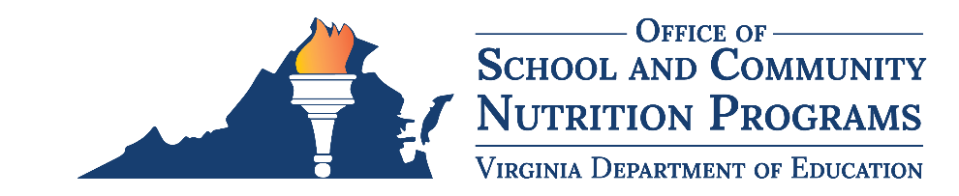

Federal Program Administrative Review School Nutrition Program Summary
Section 207 of the Healthy Hunger Free Kids Act 2010, amended section 22 of the National School Lunch Act (42 U.S.C. 1769c) requires the Virginia Department of Education, Office of School and Community Nutrition Programs (VDOE-SCNP), to report the final results of the administrative review to the public in an accessible, easily understood manner in accordance with guidelines promulgated by the Secretary.
School Food Authority (SFA): Prince George County Public Schools
Date of Administrative Review: January 23-24, 2024
Review Month and Year: November 2023
Date review results were provided to the SFA: February 6, 2024
Date review summary was publicly posted: June 14, 2024
SFA participates in the following Child Nutrition Programs:
☒ School Breakfast Program
☒ National School Lunch Program
☐ Fresh Fruit & Vegetable Program
☐ Afterschool Snack
☐ Seamless Summer Option
SFA operates under the following Special Provisions:
☐ Community Eligibility Provision
☐ Provision 2

Review Findings
Review Area | Details
Program Access and Reimbursement  ☐ Certification and Benefit Issuance  ☒ Verification  ☐ Meal Counting and Claiming | The SFA did not follow mandatory timelines for completing the verification process.
Meal Patterns and Nutritional Quality  ☒ Meal Components and Quantities  ☐ Offer versus Serve  ☐ Dietary Specifications and Nutrient Analysis | The weekly minimum grain requirement was not met.
School Nutrition Environment and Civil Rights  ☐ Food Safety  ☐ Buy American  ☐ Local Wellness Policy  ☐ Smart Snacks and Competitive Foods  ☐ Civil Rights | No findings identified.
This institution is an equal opportunity provider.

