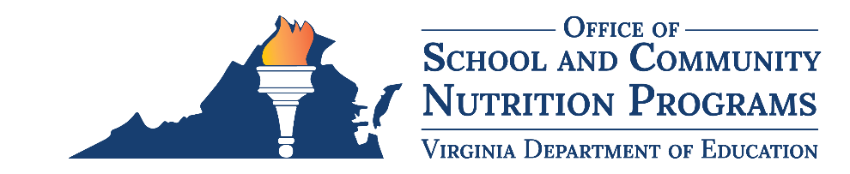

Federal Program Administrative Review School Nutrition Program Summary
Section 207 of the Healthy Hunger Free Kids Act 2010, amended section 22 of the National School Lunch Act (42 U.S.C. 1769c) requires the Virginia Department of Education, Office of School and Community Nutrition Programs (VDOE-SCNP), to report the final results of the administrative review to the public in an accessible, easily understood manner in accordance with guidelines promulgated by the Secretary.
School Food Authority (SFA): Arlington County Public Schools
Date of Administrative Review: November 14, 2023
Review Month and Year: October 2023
Date review results were provided to the SFA: November 16, 2023
Date review summary was publicly posted: June 7, 2024
SFA participates in the following Child Nutrition Programs:
☒ School Breakfast Program
☒ National School Lunch Program
☐ Fresh Fruit & Vegetable Program
☐ Afterschool Snack
☐ Seamless Summer Option
SFA operates under the following Special Provisions:
☒ Community Eligibility Provision
☐ Provision 2

Review Findings
Review Area | Details
Program Access and Reimbursement  ☐ Certification and Benefit Issuance  ☐ Verification  ☐ Meal Counting and Claiming | No findings identified.
Meal Patterns and Nutritional Quality  ☒ Meal Components and Quantities  ☐ Offer versus Serve  ☐ Dietary Specifications and Nutrient Analysis | The minimum daily quantity of vegetables was not met.
School Nutrition Environment and Civil Rights  ☒ Food Safety  ☒ Buy American  ☒ Local Wellness Policy  ☐ Smart Snacks and Competitive Foods  ☒ Civil Rights | Food safety plans were not site-specific, and some aspects were not being followed.  Violations of the Buy American Provision were observed.  The local school wellness policy did not meet all federal requirements.  Civil rights training requirements were not met.
This institution is an equal opportunity provider.

