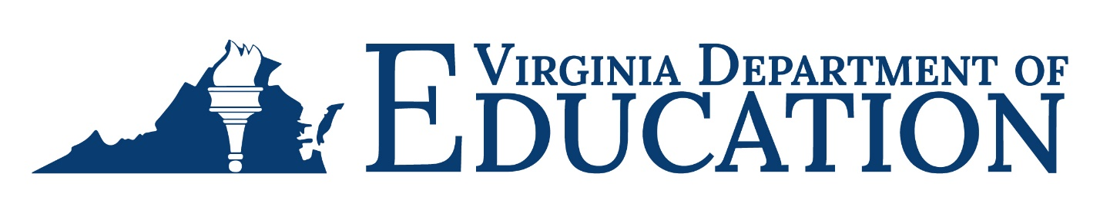

2024-2025 Adult Education Program Due Dates

Month | AEFLA/C&I/  IELCE | GAE | SLCA | Race to GED | PIVA
July
August
September
October | Quarterly Reimbursement,  Business Services,  Program Income, and Match Reports due 10/18/2024 | Quarterly Reimbursement,  Program Income Report due 10/18/2024 | Expenditure  Report or Quarterly Reimbursement due  10/18/2024
November
December
January | Quarterly Reimbursement,  Business Services,  Program Income, and Match Reports due 1/17/2025 | Quarterly Reimbursement,  Program Income Report due 1/17/2025 | Expenditure  Report or Quarterly Reimbursement due  1/17/2025
February |  |  |  | First  Reimbursement due 2/14/2025 | First Reimbursement due 2/14/2025
March
April | Quarterly Reimbursement,  Business Services,  Program Income, and Match Reports due 4/18/2025 | Quarterly Reimbursement,  Program Income Report due 4/18/2025 | Expenditure  Report or Quarterly Reimbursement due  4/18/2025
May |  | Final  Paper-based Reimbursement due 5/23/2025 | Final  Paper-based Reimbursement due 5/23/2025
June |  | Final OMEGA Reimbursement due 5/30/2025 |  | Final Reimbursement due 5/30/2025 | Final Reimbursement due 5/30/2025
July | Business Services,  Final Program Income, and Match Reports due 7/18/2025 | Final Program Income Report due 7/18/2025 | Final Expenditure Report due 7/18/2025
August | Final Reimbursement, One-Stop, and Career & Training Services Reports due 8/15/2025

