SCNP Memo #2023-2024-86
Attachment B
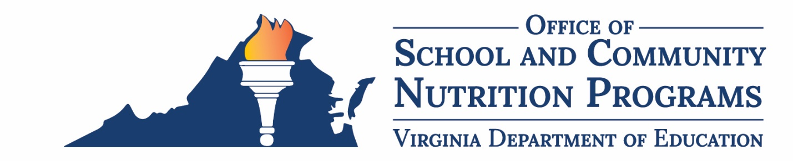

Memorandum of Understanding for Indirect Cost Recovery

This form is a sample template developed by the Virginia Department of Education, Office of School and Community Nutrition Programs.
This Agreement is made and entered into between Click or tap to enter division name School Food Authority (SFA), hereinafter referred to as the SFA, and Click or tap to enter division name hereinafter referred to as the local education agency (LEA). Program regulations at 7 CFR 210.14 and 220.13(i) require a SFA to establish a nonprofit school food service account (NSFSA), in which all reimbursements and other revenues from all food service operations conducted by the SFA, principally for the benefit of school children, are retained and used only for the operation or improvement of the nonprofit school food service. This agreement authorizes the LEA recovery of indirect costs from the U.S. Department of Agriculture (USDA) National School Lunch Program (NSLP), Summer Food Service Program (SFSP) and the Child and Adult Care Food Program (CACFP) operated by the SFA, as applicable, and overseen by the Virginia Department of Education, School and Community Nutrition Programs (VDOE-SCNP).

Effective and Expiration Dates
This Agreement begins on Click or tap to enter MM/DD/YYYY and ends on Click or tap to enter MM/DD/YYYY (Note: the MOU may be for a period of up to two years beginning in school year 2024-2025).
This Agreement (hereinafter referred to as Agreement) executed in duplicate and entered into on Click or tap to enter MM/DD/YYYY between the SFA and the LEA is created to signify the acceptance of indirect cost recovery from the SFA NSFSA by the LEA in accordance with the expectations outlined in this Agreement.

Indirect Cost Rate Applied
The LEA will charge the SFA NSFSA:
[ ] The actual VDOE unrestricted rate for state fiscal year 2025 effective from July 1, 2024 to June 30, 2025 and state fiscal year 2026 effective from July 1, 2025 to June 30, 2026. Each annual rate will be consistent with the LEA unrestricted rates published annually on the VDOE website: https://www.doe.virginia.gov/data-policy-funding/school-finance/budget-grants-management.
[ ] A rate of 0.00% which is less than the maximum LEA unrestricted rate published annually on the VDOE website.
It is understood that indirect cost rates are approved by the VDOE for each state fiscal year; therefore two unrestricted rates may apply for MOUs executed for a two year duration.

Schedule
The LEA will charge the SFA NSFSA indirect costs for the prior period of expenditures:
[ ] Monthly [ ] Quarterly [ ] Semi-annually [ ] Annually by Click or tap to enter MM/DD/YYYY

Both parties hereby agree that:
- The LEA will apply the indirect cost percentage according to the schedule indicated under the previous subsection during the effective period(s) covered under this Agreement.
- As the financial steward of the NSFSA, the SFA is ultimately responsible for reviewing LEA indirect costs recovered and ensuring they are allowable and adhere to federal and VDOE-SCNP requirements including the USDA Indirect Costs Guidance for State Agencies & School food Authorities issued on September 30, 2016.
- Indirect costs charged will comply with the federal cost principles put forth in 2 CFR Part 200- Subpart E of the OMB Uniform Administrative Requirements, Cost Principles, and Audit Requirements for Federal Awards for Non-Federal Entities. Costs must be reasonable, allocable, properly classified as direct or indirect, consistently treated and adequately documented.
- LEA records, including the calculation and billing of indirect costs charged to the NSFSA, will be promptly and readily available to the SFA so that it may verify and validate claims for indirect costs. The records must include a detailed description of the direct cost base to which the identified indirect cost rate has been applied.
- If the SFA determines that the LEA has over-claimed indirect costs from the NSFSA, the SFA is obligated to recover the amount over-claimed from the LEA within 30 days. Reimbursement of indirect costs must be documented with the appropriate accounting entries to the financial records of both the general fund and the NSFSA.
- The LEA must initiate, in advance by written request to the SFA, any adjustment consisting of an increase or decrease to the indirect cost rate applied or a change to the indirect cost methodology. A justification must accompany the request and the adjustment(s) negotiated and approved by both parties and reflected in a modification to this Agreement.
- The indirect cost rate may not be adjusted to address a general fund deficit or capture an excess balance of funds in the NSFSA.
- The NSFSA may not be charged indirect costs that were previously paid from the general fund in the absence of an executed loan agreement indicating that the LEA has been “loaning” the NSFSA funds to cover the indirect costs in one or more prior years.
- The LEA may not apply a change in its indirect cost recovery procedure retroactively for prior years.
- The SFA is responsible for reporting indirect costs charged by the LEA in the annual VDOE-SCNP State Financial Report in the SNPWeb reporting system.
- Regulations at 7 CFR Parts 210.23(c) and 220.7(e)(13) require that records must be retained for 3 years; except that if audit findings have not been resolved, the records shall be retained beyond the 3‐year period as long as is required for resolution of the issues raised by the audit.
- Mediation of disputes over indirect cost recovery may be initiated by either party and directed to the VDOE Department of Budget and Finance.

Signatures
The undersigned hereby agrees to all terms and conditions of this agreement.

Division Name (SFA)
Name and Title of SFA School Nutrition Administrator: Click or tap to enter name and title

Signature
Date: Click or tap to date

Division Name (LEA)
Name and Title of LEA school official: Click or tap to enter name and title

Signature
Date: Click or tap to date

