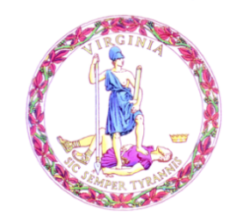

Commonwealth of Virginia

College Partnership Laboratory Schools Standing Committee Agenda

Date of Meeting: June 10, 2024 Time: 1:00 p.m.

Location: Virtual

1:00 p.m. STANDING COMMITTEE CONVENES

MOMENT OF SILENCE

APPROVAL OF THE AGENDA

APPROVAL OF MINUTES

UPDATES FROM MAY VIRGINIA BOARD OF EDUCATION MEETING FROM STATE BOARD VICE PRESIDENT
PUBLIC COMMENT ON AGENDA ITEMS
ACTION/DISCUSSION ITEMS
- First and Final Review of College Partnership Laboratory School Application from Norfolk State University
  - Attachment 1 - Application
  - Attachment 2 - Completeness and Compliance Report
  - Presentation
- First and Final Review of College Partnership Laboratory School Application from Old Dominion University
  - Attachment 1 - Application
  - Attachment 2 - Completeness and Compliance Report
  - Presentation
- Pipeline Update
- Innovation Network Update
- Schedule of Meetings
DISCUSSION OF CURRENT ISSUES
PUBLIC COMMENT ON NON-AGENDA ITEMS

ADJOURNMENT

