2023 Mathematics
Standards of Learning

Algebra 1 Instructional Guide

Copyright © 2024
by the
Virginia Department of Education
P.O. Box 2120
Richmond, Virginia 23218-2120
http://www.doe.virginia.gov

All rights reserved. Reproduction of these materials for instructional purposes in public school classrooms in Virginia is permitted.

Superintendent of Public Instruction
Dr. Lisa Coons

Office of STEM
Dr. Anne Petersen, Director
Dr. Angela Byrd-Wright, Mathematics Coordinator
Dr. Jessica Brown, Elementary Mathematics Specialist
Mrs. Regina Mitchell, Mathematics and Special Education Specialist

NOTICE
The Virginia Department of Education does not unlawfully discriminate on the basis of race, color, sex, national origin, age, or disability in employment or in its educational programs or services.

The contents of this Instructional Guide were informed by the U.S. Department of Education's Institute of Education Sciences (IES), What Works Clearinghouse, as a central, trusted source of scientific evidence for what works in education. Sample questions reflect applicable and aligned content from the Virginia Department of Education's published assessment items, Mathematics Item Maps, and National Association of Educational Progress (NAEP) assessment questions.

Introduction
The Mathematics Instructional Guide, a companion document to the 2023 Mathematics Standards of Learning, amplifies the Standards of Learning by defining the core knowledge and skills in practice, supporting teachers and their instruction, and serving to transition classroom instruction from the 2016 Mathematics Standards of Learning to the newly adopted 2023 Mathematics Standards of Learning. Instructional supports are accessible in #GoOpenVA and support the decisions local school divisions must make concerning local curriculum development and how best to help students meet the goals of the standards. The local curriculum should include a variety of information sources, readings, learning experiences, and forms of assessment selected at the local level to create a rigorous instructional program.

For a complete list of the changes by standard, the 2023 Virginia Mathematics Standards of Learning – Overview of Revisions is available and delineates in greater specificity the changes for each grade level and course.

The Instructional Guide is divided into three sections: Understanding the Standard, Skills in Practice, and Concepts and Connections aligned to the Standard. The purpose of each is explained below.

Understanding the Standard
This section includes mathematics understandings and key concepts that assist teachers in planning standards-focused instruction. The statements may provide definitions, explanations, or examples regarding information sources that support the content. They describe what students should know (core knowledge) as a result of the instruction specific to the course/grade level and include evidence-based practices to approaching the Standard. There are also possible misconceptions and common student errors for each standard to help teachers plan their instruction.

Skills in Practice
This section outlines supporting questions and skills that are specifically linked to the standard. They frame student inquiry, promote critical thinking, and assist in learning transfer. Curriculum writers and teachers should use them to plan instruction to deepen understanding of the broader unit and course objectives. This is not meant to be an exhaustive list of student expectations.

Concepts and Connections
This section outlines concepts that transcend grade levels and thread through the K through 12 mathematics programs as appropriate at each level. Concept connections reflect connections to prior grade-level concepts as content and practices build within the discipline as well as potential connections across disciplines.

Expressions and Operations
Expressions and operations comprise the foundation for algebraic thinking, understanding, and application. Students use expressions and operations to develop and solve equations, inequalities, and functions. These skills unpack building blocks that are necessary for geometrical thinking, understanding, and application. Also, mastery of performing operations on expressions is required for higher level mathematics courses.
Throughout Algebra 1, students will represent verbal quantitative situations algebraically and evaluate these expressions for given replacement values of the variables. Additionally, students will perform operations on and factor polynomial expressions in one variable, derive and apply the laws of exponents, and simplify square roots of whole numbers and cube roots of integers.

A.EO.1 The student will represent verbal quantitative situations algebraically and evaluate these expressions for given replacement values of
the variables.
Students will demonstrate the following Knowledge and Skills:
- Translate between verbal quantitative situations and algebraic expressions, including contextual situations.
- Evaluate algebraic expressions which include absolute value, square roots, and cube roots for given replacement values to include rational numbers, without rationalizing the denominator.

Understanding the Standard
- Mathematical modeling involves creating algebraic representations of quantitative practical situations.
- The numerical value of an expression depends upon the values of the replacement set for the variables.
- Evaluating algebraic expressions and determining the value of numerical expressions can be accomplished using a range of methods, all of which adhere to the order of operations.
- The operations and the magnitude of the numbers in an expression affect the choice of an appropriate computational technique (e.g., mental mathematics, estimation, calculator, paper and pencil).

Skills in Practice
While the five process goals are expected to be embedded in each standard, the Skills in Practice highlight the most prevalent process goals in relation to the content presented.

Mathematical Problem Solving:

- When students attempt to convert between algebraic and verbal expressions or vice versa, they should identify which mathematical operations are represented in the given problem first. Examples with common misconceptions follow –

Write an algebraic expression for each verbal expression.

  - The product of the cube root of 5 and a number

A common error for students is to confuse “cubed” and “cube root” and respond with $5^{3}n$ or $\frac{\sqrt[3]{n}}{5}$. This indicates the student may need more conceptual understanding of the difference between exponents and roots. The teacher should revisit the concept of the relationship between exponents and their corresponding inverse operations.

  - The quotient of a number cubed and five

A student may also confuse the terms “product” and “quotient” and use the wrong operation to represent them. The teacher should provide additional practice and examples with the vocabulary of product and quotient to reinforce the terms.

- When asked to evaluate an expression using replacement values, students must understand the substitution property of equality and mathematical operators. Examples with common misconceptions follow –

  - Evaluate the expression $\sqrt{a^{2}-b^{2}}$ if a = - 8 and b = 6. Show your work/thinking.

A common error a student may make is to square -8 incorrectly resulting in $\sqrt{-64-36},$ indicating a misunderstanding of what it means to square a negative number. Teachers may want to review integer operations and how exponents are applied. It may also help the student to place parentheses around the variable before inserting the replacement set so that they can see what value is being squared. The use of sliders in Desmos may help to demonstrate this concept.
  - What is the value of the expression $x^{2}∙\left|y+5\right|+\sqrt[3]{-}z$, when x = $\frac{1}{3}$, y = -14, and z = 125? Show your work/thinking.

A common error a student may make is to neglect the absolute value signs altogether, writing $\left|-14+5\right|=-9$. This indicates a misunderstanding of what absolute value is and how to apply it to a problem or scenario. Reviewing the meaning of absolute value using a number line may help the student to visualize that $\left|-14+5\right|=9$. The student may see the absolute value signs as parentheses, and it may help to provide highlighters to distinguish between symbols.
  - What is the value of the expression shown when $m=4, n=8,$ and $p=-6$? Show your work/thinking.
$$6\sqrt[3]{n}-p\sqrt{m}+1$$

A common error a student may make is to use the minus in front of the p as the negative for the substitution value. Teachers should review integer operations and use manipulatives to demonstrate the use of the substitution property to show that both signs are necessary. Desmos can be used to check the answer step-by-step to reinforce correct application of the substitution property.
  - Evaluate the expression shown if $x=\frac{1}{2}$ and $y=-1$. Show your work/thinking.
$$\frac{16x+2y}{y-3}$$
A common error a student may make is to incorrectly apply the order of operations by dividing the first terms and the second terms before completing the addition and subtraction. Teachers should demonstrate how the numerator and denominator are grouped together and should be simplified individually before reducing the fraction with division. Desmos can be used to check the answer step-by-step to reinforce correct application of the grouping symbols.

Mathematical Communication:

- When reading algebra, order is important for subtraction. For example, “$5$ less than a number” means $n –5$, not $5 –n$.

- When students attempt to convert between algebraic and verbal expressions or vice versa, the use of a table may be helpful to organize their thoughts. An example with common misconceptions follows -

Write an algebraic expression for each verbal expression.
Verbal Expression | Algebraic Expression
The difference between a number and five
Five less than a number
A number less five
The difference between five and a number

A common error would be for students to mix up the order of subtraction ($x –5$) versus ($5-x$) between the variable and the number depending upon the verbal expression used (“difference between,” “less than,” or “less”). The student may need to develop more conceptual understanding of these subtraction terms. The teacher should provide additional practice with multiple examples, including numerical ones and practical situations that can be simplified to show the relationship between the term and order of the numbers.

Mathematical Connections:

- The word “quotient” is derived from a word meaning “how many times.” When you divide, you are finding how many times one quantity goes into another. “The quotient of a number and $5$” means $\frac{y}{5}$, not $\frac{5}{y}$.

- When students attempt to convert between algebraic and verbal expressions or vice versa, they may struggle to understand how unknown quantities are described in context. An example with common misconceptions follows –
  - A high school is having a can food drive.
- The freshman class collected 54 more cans than the sophomore class.
- The junior class collected three times the number of cans collected by the sophomore class.
- The senior class collected ten cans less than the sophomore class.

Write an algebraic expression in one variable to model the total number of cans collected at the school.
A common error for students is they will struggle to determine which class represents $x$. This may indicate students need help with organizing the information. It may help to have students create a chart to organize information from the problem and list each class separately. This will help them to express the other classes in terms of $x$.

Mathematical Reasoning: When students attempt to translate between algebraic and verbal expressions or vice versa, they may struggle to unpack given information using what they know about mathematical symbols and operators when given similar problems. An example with common misconceptions follows –
Translate each algebraic expression into a verbal expression. Then, compare and contrast the two verbal expressions. What do you notice?
$\sqrt{x}-4$and $\sqrt{x-4}$

A common error would be for students to confuse how to verbally express the square root of a quantity and possibly result in two verbal expressions with minimal differences between them. This indicates the student may need more conceptual understanding of working with quantities both in translating and evaluating. The misconception may be in understanding what it means for terms to be grouped together. The student should continue to model both algebraic and verbal expressions dealing with quantities, with scaffolded assistance as needed.

Concepts and Connections
Concepts
Expressions are mathematical phrases. In language, a phrase on its own may include an action, but it does not make a complete sentence. It is important to understand how to read, write, and apply mathematical expressions correctly. Expressions can be used to quantify values, including real world scenarios, in many ways.

Connections: Prior to Algebra 1, students simplified numerical expressions in one variable (8.PFA.1), and evaluated algebraic expressions for given replacement values of the variables (7.PFA.2). Given these understandings, students will evaluate and translate expressions from verbal to algebraic forms and vice versa in coursework beyond Algebra 1 to include performing operations on and simplifying rational expressions (A2.EO.1), radical expressions (A2.EO.2); and, performing operations on polynomial expressions and factoring polynomial expressions in one and two variables (A2.EO.3).

- Within the grade level/course:
  - A.EO.2 – The student will perform operations on and factor polynomial expressions in one variable.
  - A.EO.3 – The student will derive and apply the laws of exponents.
  - A.EO.4 – The student will simplify and determine equivalent radical expressions involving square roots of whole numbers and cube roots of integers.
- Vertical Progression:
  - 7.PFA.2 – The student will simplify numerical expressions, simplify and generate equivalent algebraic expressions in one variable, and evaluate algebraic expressions for given replacement values of the variables.
  - 8.PFA.1 – The student will represent, simplify, and generate equivalent algebraic expressions in one variable.
  - A2.EO.1 – The student will perform operations on and simplify rational expressions.
  - A2.EO.2 – The student will perform operations on and simplify radical expressions.
  - A2.EO.3 – The student will perform operations on polynomial expressions and factor polynomial expressions in one and two variables.

Textbooks and HQIM for Consideration
- A list of approved textbooks and instructional materials will be posted on the VDOE website.

A.EO.2 The student will perform operations on and factor polynomial expressions in one variable.
Students will demonstrate the following Knowledge and Skills:
- Determine sums and differences of polynomial expressions in one variable, using a variety of strategies, including concrete objects and their related pictorial and symbolic models.
- Determine the product of polynomial expressions in one variable, using a variety of strategies, including concrete objects and their related pictorial and symbolic models, the application of the distributive property, and the use of area models. The factors should be limited to five or fewer terms (e.g., (4x + 2)(3x + 5) represents four terms and (x + 1)(2x² + x + 3) represents five terms).
- Factor completely first- and second-degree polynomials in one variable with integral coefficients. After factoring out the greatest common factor (GCF), leading coefficients should have no more than four factors.
- Determine the quotient of polynomials, using a monomial or binomial divisor, or a completely factored divisor.
- Represent and demonstrate equality of quadratic expressions in different forms (e.g., concrete, verbal, symbolic, and graphical).

Understanding the Standard
- Operations with polynomials can be represented concretely, pictorially, and symbolically.
- Polynomial expressions can be used to define functions and model practical situations.
- Example of multiplying $\left(3x-4\right)\left(x+2\right)$ using the box method:

After combining like terms $6x$ and $-4x$, the final answer would be $3x^{2}+2x-8$.
- Factoring reverses distribution and polynomial multiplication.
- Prime polynomials cannot be factored over the set of integers into two or more factors, each of lesser degree than the original polynomial.
- The factors of a number, $n$, include $1$ and $n$.
- Trinomials may be factored by various methods including factoring by grouping and using models.

- Example of factoring by grouping:
$$2x^{2} + 5x – 3$$
$$2x^{2} + 6x – x – 3$$
$$2x(x + 3) – 1(x + 3)$$
$$(x + 3)(2x – 1)$$
- Example of factoring a quadratic trinomial with models:
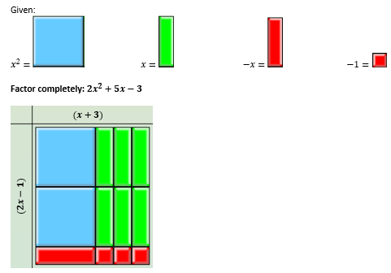
- For the division of polynomials in this standard, instruction on the use of long or synthetic division is not required, but students may benefit from experiences with these methods, which become more useful and prevalent in the study of advanced levels of algebra.

Skills in Practice
While the five process goals are expected to be embedded in each standard, the Skills in Practice highlight the most prevalent process goals in relation to the content presented.

Mathematical Problem Solving: When students attempt to determine the sums and differences of polynomial expressions in one variable, they may not remember to combine like terms. Examples with common misconceptions follow –

- James simplified $(16x+8x^{2}y-7xy^{2}+9y)+(5xy^{2}+10x^{2}y+x-7y)$. His work is shown below. Find and correct his mistake.

$16x+8x^{2}y-7xy^{2}+9y$ +$5xy^{2}+10x^{2}y+x-7y$
$$\left(16x+x\right)+\left(8x^{2}y-7xy^{2}+5xy^{2}+10x^{2}y\right)+\left(9y-7y\right)$$
$$17x+16x^{2}y^{2}+2y$$
A common misconception when adding and subtracting polynomials with multiple variables, is that students will add terms that are not like. This may indicate the student is not able to identify similar terms. The student may need more practice with algebra tiles to build a conceptual understanding between the terms as well as a review of algebraic vocabulary. Students would benefit from extra practice in identifying like terms – such as a card sort. It may also benefit students to use colored pencils or highlighters to distinguish like terms.
- Simplify $(3x^{3}-4x^{2}-4)-(2x^{3}-3x^{2}+3)$.
A common error for students is they may not recognize that the subtraction operation applies to all terms in the second polynomial. This commonly results in the negative sign (subtraction) only being distributed to the first term of the second trinomial. This may indicate the students is confused about distributing a negative sign. The teacher should revisit the integer operation rules and remind students to always watch for this and possibly use a highlighter to help them identify signs. It may help some students to subtract vertically and/or rewrite the subtraction problem as “addition of the opposite.”

Mathematical Reasoning:

- An original expression is always equivalent to each correctly simplified version.

- Students can substitute replacement values into expressions to confirm equivalent expressions.

- The Box Method is a strategy that connects students’ prior learning to algebraic thinking. Previously, students were exposed to the concept of partial products. The Box Method utilizes partial products when multiplying polynomial expressions.

- When attempting to divide polynomial expressions in one variable, students should completely factor both the numerator and denominator before simplifying the problem. Examples with common misconceptions follow –

  - Which polynomial is equivalent to this expression if $n≠-2$?

$$\frac{8-2n-3n^{2}}{n+2}$$

a. $3n-4$ b. $4+3n$ c. $-3n+4$ d. $-4-3n$

Although it is not required, a common error students might make is not rewriting the numerator in standard form prior to factoring it. Choice c is the correct answer to this problem.

- Simplify, if $n≠0$ :
$$\frac{16n^{2}+4n}{4n}$$

A common error students might make is failing to factor the numerator before simplifying the expression. Students may divide the quadratic term by the denominator or the linear term by the denominator in error. The answer is $4n+1$.

- When attempting to square a binomial expression, students should be encouraged to express the expression as a product of two identical binomials prior to multiplying. An example with common misconceptions follows –

- Simplify the expression below. Show your work/thinking.
$${\left(x+2\right)}^{2}$$
A common misconception made by students is to only square each term: $x^{2}+4$. This may indicate they are confused about the meaning of squaring a binomial. The teacher may need to provide a visual of this problem using algebra tiles and have students rewrite the problem as $(x + 2)(x + 2)$. The teacher may need to revisit the concept of raising a base to a power. Explain that raising $3^{2}$ means to multiply the base of three two times, whereas ${(x+2)}^{2}$ means to multiply the base of $\left(x+2\right)$ two times.

Mathematical Representations: When attempting to determine the product of polynomial expressions in one variable, students should be exposed to a variety of strategies. An example with common misconceptions follows –
Multiply the following. Show your work/thinking.
$$\left(4x-2\right)\left(2x-4\right)$$
A common error when multiplying binomials involving subtraction is that students may make errors with the signs. This may indicate that a student needs to revisit multiplication of integers. One strategy is to have students rewrite the problem using “add the opposite” or $(4x + (-2))(2x + (-4))$ so that distribution of terms would be $4x(2x) + 4x(-4) + -2(2x) + -2(-4)$. This may help students keep track of the signs. Teachers may find it helpful for students to use a box method for multiplication so that they can organize terms and signs. An example setting up the box method is provided below –
· | $$2x$$ | $$-4$$
$$4x$$ | $$8x^{2}$$ | $$-16x$$
$$-2$$ | $$-4x$$ | $$8$$

Mathematical Connections:

- When multiplying binomials, algorithms such as FOIL (First, Outer, Inner, Last) can be used to determine resulting products.

- When attempting to determine the product of polynomial expressions in one variable, students should understand how to apply the distributive property of multiplication over addition and subtraction. An example with common misconceptions follows –
What is the product of the expression shown? Write your answer in simplest form. Show your work/thinking.
$$(x+2)(x^{2}+x+3)$$

A common error when multiplying binomials is that students may leave out one or more terms when multiplying. This may indicate that a student needs to revisit the distributive property. Teachers may find it helpful for students to use a box method for multiplication so that they can organize terms and signs or rewriting the problem as two separate monomials by trinomial multiplication problems and then combining terms as the final step.

- Teachers may have students break this problem down into chunks by using the distributive property. First, decompose the binomial $(x+2).$ Then, distribute each $x$ across the trinomial separately. Repeat this process for $+2$. See below:

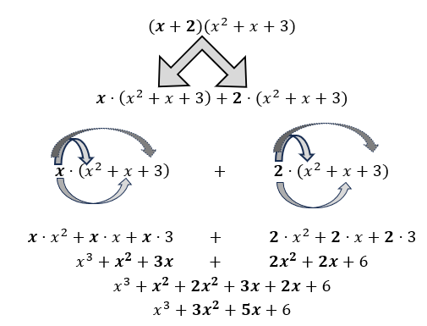
Mathematical Communication: When attempting to divide polynomial expressions in one variable, students should translate verbal expressions that use the term quotient to algebraic expressions which contain a fraction bar in order to identify and separate the numerator and denominator prior to simplifying the problem. An example with common misconceptions follows –

If $x≠\frac{4}{3}$ , find the quotient of $9x^{2}-9x-4$ and $3x-4$.
A misunderstanding may occur if students incorrectly inverted the numerator and denominator. The correct answer is $3x+1$ not $\frac{1}{3x+1}$ .

Concepts and Connections
Concepts
Expressions are used to model real world phenomena. Simplifying polynomial expressions through addition, subtraction, multiplication, division, and factoring, allows us to make sense of quantitative algebraic data in comparable ways that we understand numerical data.

Connections: Students will be able to perform operations on expressions, including factoring due to the understandings of operations, variables, and expressions they learned in previous grades. Prior to Algebra 1, students investigated and simplified numerical expressions (8.PFA.1) in one variable and evaluated algebraic expressions for given replacement values of the variables (7.PFA.2). These skills will be embedded into coursework beyond Algebra 1 to include performing operations on and simplifying rational expressions (A2.EO.1) and radical expressions (A2.EO.2); performing operations on polynomial expressions and factoring polynomial expressions in one and two variables (A2.EO.3); and, performing operations on complex numbers (A2.EO.4).

- Within the grade level/course:
  - A.EO.1 – The student will represent verbal quantitative situations algebraically and evaluate these expressions for given replacement values of the variables.
  - A.EO.3 – The student will derive and apply the laws of exponents.
  - A.EO.4 – The student will simplify and determine equivalent radical expressions involving square roots of whole numbers and cube roots of integers.
- Vertical Progression:
  - 7.PFA.2 – The student will simplify numerical expressions, simplify and generate equivalent algebraic expressions in one variable, and evaluate algebraic expressions for given replacement values of the variables.
  - 8.PFA.1 – The student will represent, simplify, and generate equivalent algebraic expressions in one variable.
  - A2.EO.1 – The student will perform operations on and simplify rational expressions.
  - A2.EO.2 – The student will perform operations on and simplify radical expressions.
  - A2.EO.3 – The student will perform operations on polynomial expressions and factor polynomial expressions in one and two variables.
  - A2.EO.4 – The student will perform operations on complex numbers.

Textbooks and HQIM for Consideration
- A list of approved textbooks and instructional materials will be posted on the VDOE website.

A.EO.3 The student will derive and apply the laws of exponents.
Students will demonstrate the following Knowledge and Skills:
- Derive the laws of exponents through explorations of patterns, to include products, quotients, and powers of bases.
- Simplify multivariable expressions and ratios of monomial expressions in which the exponents are integers, using the laws of exponents.

Understanding the Standard
- Students should have opportunities to engage in exploration activities that will help them to generalize and derive the laws of exponents prior to be given the rules of exponents. The rules of exponents include:
  - Product Rule: When multiplying two exponential expressions with the same base, add the exponents. For example, $a^{m}$ $∙$ $a^{n}$ = $a^{m+n}$
$$a^{2}∙a^{5}=(a∙a)(a∙a∙a∙a∙a)$$
$$a^{2}∙a^{5}=a∙a∙a∙a∙a∙a∙a$$
$$a^{2}∙a^{5}=a^{7}$$

  - Quotient Rule: When dividing two exponential expressions with the same base, subtract the exponents. For example, $\frac{a^{m}}{a^{n}}=a^{m-n}$
$$\frac{a^{5}}{a^{2}}=\frac{a∙a∙a∙a∙a}{a∙a}$$
$$\frac{a^{5}}{a^{2}}=\frac{a∙a∙a}{1}∙\frac{a∙a}{a∙a}$$
$$\frac{a^{5}}{a^{2}}=\frac{a^{3}}{1}∙1=a^{3}$$

  - Power Rule: When raising an exponential expression to a power, multiply the exponents. For example, ${{(a}^{m})}^{n}=a^{m∙n}$
$${{(a}^{2})}^{3}={(a}^{2}){(a}^{2}){(a}^{2})$$
$${{(a}^{2})}^{3}=(a∙a)(a∙a)(a∙a)$$
$${{(a}^{2})}^{3}=a∙a∙a∙a∙a∙a$$
$${{(a}^{2})}^{3}=a^{6}$$

  - Negative Exponent Rule: Any non-zero base raised to a negative exponent is equal to 1 divided by the same base raised to the opposite positive exponent. For example, $a^{-n}=\frac{1}{a^{n}}$
$$\frac{a^{2}}{a^{5}} \frac{a^{2}}{a^{5}}$$

$$\frac{a^{2}}{a^{5}}=\frac{a∙a}{a∙a∙a∙a∙a} \frac{a^{2}}{a^{5}}=a^{2-5}$$

$$\frac{a^{2}}{a^{5}}=\frac{a∙a}{a∙a}∙\frac{1}{a∙a∙a} \frac{a^{2}}{a^{5}}=a^{-3}$$

$$\frac{a^{2}}{a^{5}}=1∙\frac{1}{a^{3}} \frac{a^{2}}{a^{5}}=\frac{1}{a^{3}}$$

  - Zero Rule: Any non-zero base raised to the power of zero is equal to 1. For example, $a^{0}=1$
$$a^{3-3}$$
$$\frac{a∙a∙a}{a∙a∙a} \frac{a^{3}}{a^{3}}=a^{0}$$
$$\frac{a^{3}}{a^{3}}=1 \frac{a^{3}}{a^{3}}=1$$

- The laws of exponents can be applied to perform operations involving numbers written in scientific notation.

Skills in Practice
While the five process goals are expected to be embedded in each standard, the Skills in Practice highlight the most prevalent process goals in relation to the content presented.

Mathematical Problem Solving:

- When applying appropriate use of the combined laws of exponents, such as the power and quotient rules, students should understand that they should apply the power to every term inside the parentheses.

- Additionally, students should consider whether a term should be placed in the numerator or denominator of the fraction.
- Students should be reminded that equivalent expressions are congruent. Determining congruency can be obtained by substituting replacement values for given variables. An example with common misconceptions follows –

Student A was asked to simplify the following expression:
$${\left(\frac{30x^{5}y^{2}}{6xy^{3}}\right)}^{2}$$

Student A obtained the following result:
$$\frac{{30}^{2}x^{8}y^{2}}{6^{2}}$$

Determine if the two expressions are equivalent. Justify your thinking.
A common mistake that occurs in division of exponents is students will incorrectly apply the Quotient of Powers Property. Students may subtract correctly, but then place the result in the wrong place. For example, students may apply the power rule and get –
$$\frac{{30}^{2}x^{10}y^{4}}{6^{2}x^{2}y^{6}}$$

But then simplify and get –
$$\frac{{30}^{2}x^{8}y^{2}}{6^{2}}$$

If this occurs, the teacher may need to model the Quotient of Powers Property using the expanded form so that students see why their answer is incorrect.

Refer to the calculator image below the shows how replacement values can help students confirm equivalent expressions and rule out errors in their work. Replacement values assigned for this problem are $x=5$ and $y=6$.

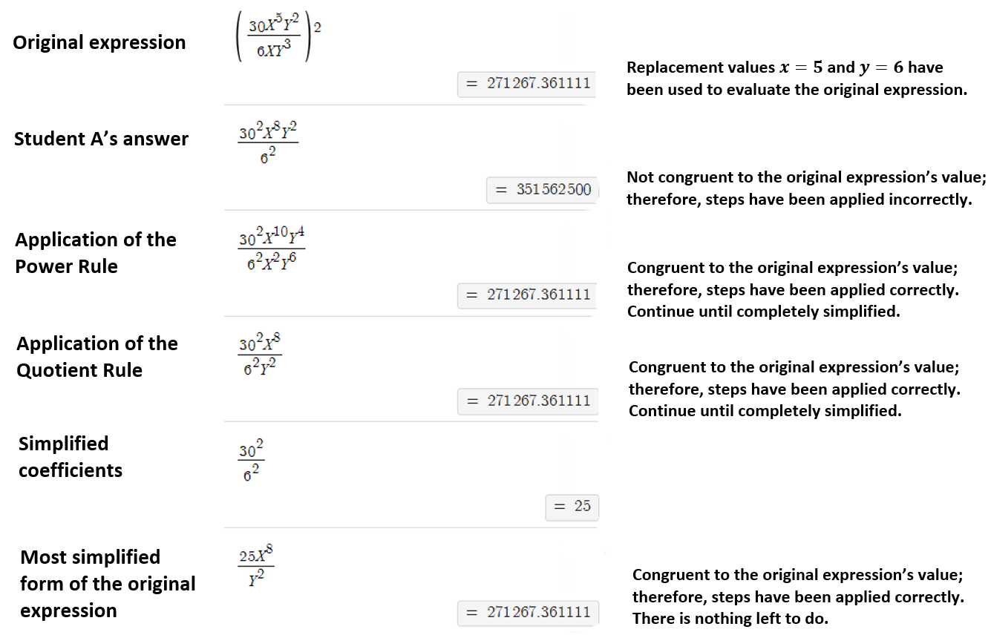

Mathematical Reasoning: When applying appropriate use of the product rule, students should understand that they should add exponents. Examples with common misconceptions follow –
- Simplify: $({{3x}^{2})}^{3} ({{2x}^{4})}^{2}$
The correct answer is ${108x}^{14}$. A common error would be squaring or cubing an exponent instead of multiplying the exponents.
$\left({27x}^{8}\right)\left({4x}^{16}\right)=$ ${108x}^{24}$
- Simplify the following expression. Write your answer using only positive exponents. Show your work/thinking.
$${(2x^{3})}^{2}{(3x)}^{4}$$
A common misconception is that after students apply the power rule, they may multiply the exponents instead of adding them. This indicates that students may not conceptually understand the difference between “raising to a power” and the product rule. The teacher may want to model simpler problems in expanded form to help students develop an understanding of exponents and why the product rule works (e.g., $\left(x^{4}\right)\left(x^{2}\right)=x∙x∙x∙x∙x∙x$).

Mathematical Connections:

- When applying appropriate use of the laws of exponents, students should understand that the order of operations still applies. Thus, exponents still come before multiplication or division and addition or subtraction. An example with common misconceptions follows –

  - Simplify the following expression. Write your answers using only positive exponents. Show your work/thinking.

$$\left({\frac{{(12x}^{-2})}{{6x}^{4}y^{-3}}}^{2}\right)$$
A common misconception that students may have is to simplify the integer coefficient before applying the power rule. This may indicate the student does not understand the order of applying the laws of exponents when raising a power and fraction bars are included. The teacher may want to ensure students understand the fraction bar serves as a grouping symbol and the numerator must be simplified separately from the denominator. It may help to have students highlight or color the fraction bar.

- When applying appropriate use of the quotient rule, students should understand that subtracting negative values should convert to addition. An example with common misconceptions follows –

For what value of p is the given expression equivalent to $x^{48}$ when x $≠0$?

$$\frac{{\left(x^{8} \right)}^{p}}{{\left(x^{4} \right)}^{-4}}$$
A. 2
B. 4
C. 6
D. 8
The correct answer is $4$. A common error is $8$ because students incorrectly use $8p – 16 = 48$ to solve for $p$.

Concepts and Connections
Concepts
Many real-life quantities can be modeled by expressions that contain exponents.

Connections: Students will be able to apply the laws of exponents based on understandings of exponents and powers they learned in previous grades. Prior to Algebra 1, students investigated, recognized, and represented patterns with exponents and recognized and described the relationship between square roots and perfect squares to generate equivalent expressions in one variable (8.PFA.1). These skills will be embedded into coursework beyond Algebra 1 to include performing operations on and simplifying rational expressions (A2.EO.1) and radical expressions (A2.EO.2); performing operations on polynomial expressions and factoring polynomial expressions in one and two variables (A2.EO.3); and, performing operations on complex numbers (A2.EO.4).

- Within the grade level/course:
  - A.EO.1 – The student will represent verbal quantitative situations algebraically and evaluate these expressions for given replacement values of the variables.
  - A.EO.2 – The student will perform operations on and factor polynomial expressions in one variable.
  - A.EO.4 – The student will simplify and determine equivalent radical expressions involving square roots of whole numbers and cube roots of integers.
- Vertical Progression:
  - 8.PFA.1 – The student will represent, simplify, and generate equivalent algebraic expressions in one variable.
  - A2.EO.1 – The student will perform operations on and simplify rational expressions.
  - A2.EO.2 – The student will perform operations on and simplify radical expressions.
  - A2.EO.3 – The student will perform operations on polynomial expressions and factor polynomial expressions in one and two variables.
  - A2.EO.4 – The student will perform operations on complex numbers.

Textbooks and HQIM for Consideration
- A list of approved textbooks and instructional materials will be posted on the VDOE website.

A.EO.4 The student will simplify and determine equivalent radical expressions involving square roots of whole numbers and cube roots of
integers.
Students will demonstrate the following Knowledge and Skills
- Simplify and determine equivalent radical expressions involving the square root of a whole number in simplest form.
- Simplify and determine equivalent radical expressions involving the cube root of an integer.
- Add, subtract, and multiply radicals, limited to numeric square and cube root expressions.
- Generate equivalent numerical expressions and justify their equivalency for radicals using rational exponents, limited to rational exponents of $\frac{1}{2}$ and $\frac{1}{3}$ (e.g., $\sqrt{5}$ = $5^{\frac{1}{2}}$; $\sqrt[3]{8}=8^{\frac{1}{3}}$ = ${\left(2^{3}\right)}^{\frac{1}{3}}$ = 2).

Understanding the Standard
- Radical expressions in Algebra 1 can be expressed with the square root symbol () or the cube root symbol ($\sqrt[3]{}$).
- Radical expressions in Algebra 1 can also be expressed as expressions containing rational exponents $\frac{1}{2}$ and $\frac{1}{3}$.
- A square root of a number, a, is a number, y, such that $y^{2}$ = a.
- A cube root of a number, b, is a number, y, such that $y^{3}$ = b.
- The square root of a perfect square is an integer.
- The cube root of a perfect cube is an integer.
- A square root in simplest form is one in which the radicand has no perfect square factors other than one.
- A cube root in simplest form is one in which the radicand has no perfect cube factors other than one.
- The inverse of squaring a number is determining the square root.
- The inverse of cubing a number is determining the cube root.
- Any non-negative number other than a perfect square has a principal square root that lies between two consecutive whole numbers.
- The cube root of a nonperfect cube lies between two consecutive integers.
- The radicand should be limited to integers.
- Radical expressions should be limited to numerical radicands when adding, subtracting, or multiplying.
- The inverse of a rational (unit fraction) exponent describes the radical.

Skills in Practice
While the five process goals are expected to be embedded in each standard, the Skills in Practice highlight the most prevalent process goals in relation to the content presented.

Mathematical Problem Solving: When simplifying square root expressions, students should be reminded to completely simplify the original problem by identifying all perfect square roots in the radicand. Likewise, perform the same with cube root expressions by identifying all perfect cubes in the radicand. Examples with common misconceptions follow –

- Student A was asked to simplify the expression:
$$\sqrt[3]{1944}$$

Student A obtained the following result:
$$3\sqrt[3]{72}$$

Determine if this answer is correct or incorrect. Justify your thinking.

A common error students may have is not completely simplifying the radicand. This may indicate they are not identifying all the perfect cubes in the radicand. The teacher may encourage the student to use the prime factorization method to identify all perfect cubes. Students should be advised that equivalent expressions will result in the same numerical value; however, this does not mean the expression is in its most simplified form. Students should continue simplifying until all perfect cubes have been removed from the radicand.

- Write the expression in simplest radical form. Show your work/thinking.

$$(\sqrt[3]{12})(\sqrt[3]{36)}$$

A misconception students may have is to simplify the expression as though it is a square root instead of a cube root resulting in $12\sqrt{3}$. This may indicate that the student sees a radical symbol and assumes it is a square root without regard to the index. The teacher may suggest for students to write each radicand as a product of prime factors and look for groups of three of the same factor or perfect cubes.

Mathematical Reasoning: Students will benefit from examples that require them to simplify radicals with numerical radicands. Examples with common misconceptions follow –

- Determine if the given expression is written in simplest radical form. Explain your reasoning.

$$-\sqrt{150}$$

A common error some students may make is to transpose the resulting simplified expression writing $6\sqrt{5}$ instead of $5\sqrt{6}$. This may indicate a student understands how to simplify a radical expression but does not understand which number stays inside the radical. The teacher should make sure students are familiar with what it means to take the square root of a number. Providing visual models of square numbers to show the relationship between squares and square roots may help. Also, the use of Desmos to verify equivalence between the problem and simplified expression may be helpful.

- Simplify the expression. Show your work/thinking.
$$\sqrt[3]{-128}$$

A misconception students may have is to think that the cube root of a negative number cannot be simplified. This may indicate they do not understand the difference between a cube and square root. The teacher may want to model cubing a negative number and connecting it to the inverse operation of cube root or provide visual representation of squares and cubes to help clarify.

- Simplify the expression. Show your work/thinking.
$$\sqrt[3]{432}$$

A common error made by students is to take the square root instead of the cube root. This may indicate they are not paying attention to the index. The teacher may want to have the student highlight or circle the index number. The use of a prime factor tree where students circle groups of three common factors may help students organize their thinking.

Mathematical Connections:

- Radicals should be treated the same way as variables when combining like terms or performing other polynomial operations. An example with common misconceptions follows –

- Simplify the expression. Show your work/thinking.
$$10\sqrt{7}+\sqrt{8}$$

A common misconception students may have is to add the radicands. This may indicate the students do not understand that $\sqrt{a}+\sqrt{b}≠ \sqrt{a+b}$. Teachers may want to revisit grouping like terms of an algebraic expression as well as using Desmos to verify if the expressions are equivalent.

- When expressions are written using rational exponents, students should understand the radical’s index can be located in the denominator of the rational exponent. The base of an expression containing rational exponents reflects the radical expression’s radicand. Such that:

$a^{\frac{power}{index}}$, where a is the base and radicand and the index is located in the denominator of the exponent.

For example –

  - Given: $8^{\frac{1}{2}}$ . Generate an equivalent radical expression.

  - Given: $\sqrt[3]{16}$ . Generate the equivalent numerical expression using rational exponents.

- In Grade 7, students determined the positive square root of a perfect square from $0$ to $400$. This is understood to be the principal square root. This understanding should be connected and extended at Grade 8, where students learn that both the positive and negative roots of whole numbers, except zero, can be determined. The symbol $±$ means both the positive and negative of the number or variable given.

  - Negative numbers can be squared. When a negative number is squared the result is a positive number. This is because a negative number multiplied by a negative number yields a positive result. For example –

    - $\left(-5\right)\left(-5\right)= 25$, therefore, ${\left(-5\right)}^{2} = 25$
    - $(-7)(-7) = 49$, therefore, ${(-7)}^{2} = 49$

  - The concept above is true for all numbers and variables. For example –

    - ${(4)}^{2}$and ${(-4)}^{2}$ both equal $16$.
    - ${(x)}^{2}$ and ${(-x)}^{2}$ both equal$x^{2}$.

  - To synthesize this understanding: ${(3)}^{2}$ and ${(-3)}^{2}$ both equal$9$. Thus, 9 has two square roots, 3 and (-3). This is written as $±\sqrt{9}=\left(±3\right).$ Teachers should use caution with how answers are written. Parentheses are required when listing negative integer values as answers to square root problems. Refer to the following image which emphasizes the correct use of parentheses that supports the order of operations.

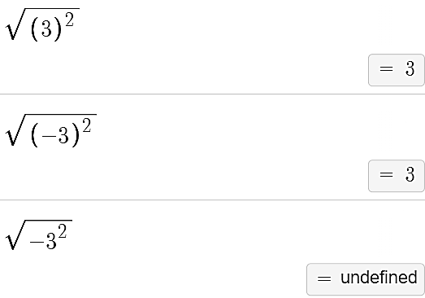

- In Algebra 2, students will learn to solve radical equations. During their exposure to radical equations, students will learn that when isolated, square roots cannot equal negative numbers. This results in an equation that has no solution, which can be reflected by an empty set. For example –

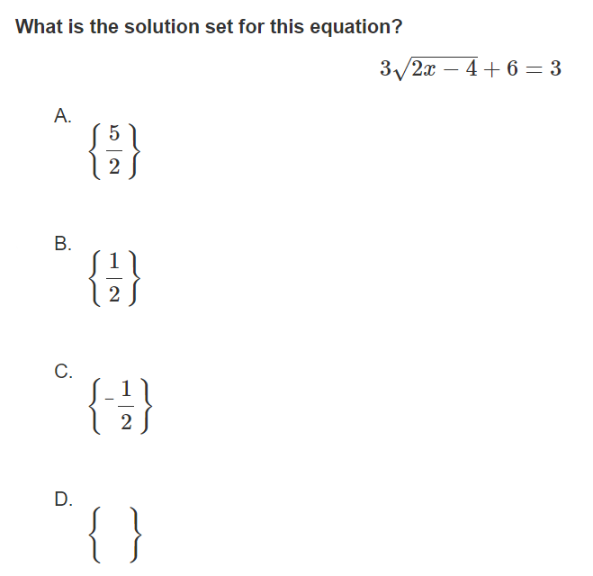
Mathematical Representations:

- Students should understand that radical expressions contain an index and radicand.

$$\sqrt[index]{radicand}$$

- When examining square roots, although the index is not always written, it is understood to be 2.

$$\sqrt{radicand}= \sqrt[2]{radicand}$$

- When examining cube roots, the index is 3.

$$\sqrt[3]{radicand}$$

- Students will benefit from connections to other topics when performing operations on radicals. Radicals should be treated the same way as variables when combining like terms or performing other polynomial operations. An example with common misconceptions follows –

- Find the area of this rectangle with the given length and width.

$$3\sqrt{6}$$
$$4\sqrt{15}$$
A common error students may make is to multiply the coefficients and radicands but neglect to simplify the product of the radicand. This may indicate that students believe simplifying only involves performing the operation of multiplication. Teachers may want to have students apply the commutative property to rewrite the expression as $4∙3\sqrt{15∙6}$ before simplifying.

Concepts and Connections
Concepts
Radicals are important in everyday life. Distance calculations, even GPS and map navigation software, use radicals to compute travel time. Formulas involving circles and even construction measurements utilize concepts of radicals to accurately arrive at essential values.

Connections: Prior to Algebra 1, students investigated, recognized, and described the relationship between square roots and perfect squares in order to generate equivalent algebraic expressions in one variable (8.PFA.1) Given these understandings, simplifying radical expressions will be embedded into coursework beyond Algebra 1 to include radical expressions (A2.EO.2) and performing operations on complex numbers (A2.EO.4).

- Within the grade level/course:
  - A.EO.1 – The student will represent verbal quantitative situations algebraically and evaluate these expressions for given replacement values of the variables.
  - A.EO.2 – The student will perform operations on and factor polynomial expressions in one variable.
- Vertical Progression:
  - 8.PFA.1 – The student will represent, simplify, and generate equivalent algebraic expressions in one variable.
  - A2.EO.2 – The student will perform operations on and simplify radical expressions.
  - A2.EO.4 – The student will perform operations on complex numbers.

Textbooks and HQIM for Consideration
- A list of approved textbooks and instructional materials will be posted on the VDOE website.

Equations and Inequalities
Equations and inequalities are major components of algebra. Equations and inequalities are comprised of expressions and operations. These skills lead to the understanding and analysis of functions. Also, mastery of solving equations and inequalities is essential for developing and creating mathematical models. The knowledge of equations and inequalities is required for all mathematics courses beyond the level of Algebra 1.
Throughout Algebra 1, students will represent, solve, and interpret the solution to quadratic equations, multistep linear equations, and inequalities in one variable. Students will apply skills learned about expressions and operations to literal equations and solve literal equations for a specified variable. Additionally, students will solve and interpret the solution to a system of two linear equations, a linear inequality in two variables, or a system of two linear inequalities in two variables.

A.EI.1 The student will represent, solve, explain, and interpret the solution to multistep linear equations and inequalities in one variable and
literal equations for a specified variable.
Students will demonstrate the following Knowledge and Skills:
- Write a linear equation or inequality in one variable to represent a contextual situation.
- Solve multistep linear equations in one variable, including those in contextual situations, by applying the properties of real numbers and/or properties of equality.
- Solve multistep linear inequalities in one variable algebraically and graph the solution set on a number line, including those in contextual situations, by applying the properties of real numbers and/or properties of inequality.
- Rearrange a formula or literal equation to solve for a specified variable by applying the properties of equality.
- Determine if a linear equation in one variable has one solution, no solution, or an infinite number of solutions.
- Verify possible solution(s) to multistep linear equations and inequalities in one variable algebraically, graphically, and with technology to justify the reasonableness of the answer(s). Explain the solution method and interpret solutions for problems given in context.

Understanding the Standard
- Practical problems may be interpreted, represented, and solved using linear equations and inequalities.
- The process of solving linear equations and inequalities can be modeled in a variety of ways, using concrete, pictorial, and symbolic representations.
- Properties of Real Numbers and Properties of Equality/Inequality are applied to solve equations/inequalities.
- Properties of Real Numbers:
- Associative Property of Addition
- Associative Property of Multiplication
- Commutative Property of Addition
- Commutative Property of Multiplication
- Identity Property of Addition (Additive Identity)
- Identity Property of Multiplication (Multiplicative Identity)
- Inverse Property of Addition (Additive Inverse)
- Inverse Property of Multiplication (Multiplicative Inverse)
- Distributive Property
- Properties of Equality:
- Multiplicative Property of Zero
- Zero Product Property
- Reflexive Property
- Symmetric Property
- Transitive Property of Equality
- Addition Property of Equality
- Subtraction Property of Equality
- Multiplication Property of Equality
- Division Property of Equality
- Substitution
- Properties of Inequality:
- Transitive Property of Inequality
- Addition Property of Inequality
- Subtraction Property of Inequality
- Multiplication Property of Inequality
- Division Property of Inequality
- Substitution
- A solution to an equation/inequality is the value or set of values that can be substituted to make the equation/inequality true.
- Solutions and intervals may be expressed in different formats, including equations and inequalities, set notation, and interval notation. Examples may include:

Equation/ Inequality | Set Notation | Interval Notation
x = 3 | {3} | {3}
x = 3 or x = 5 | {3, 5} | {3, 5}
y ≥ 3 | {y: y ≥ 3} | [3, $∞)$
$$-2<x≤6$$ | {$x:-2<x≤6$} | ($-$2, 6]
Empty (null) set ∅ | { } | { }

- Formulas are a type of literal equation.

Skills in Practice
While the five process goals are expected to be embedded in each standard, the Skills in Practice highlight the most prevalent process goals in relation to the content presented.

Mathematical Problem Solving:
- Students need additional practice justifying steps used to solve an equation using the axioms of equality. An example with common misconceptions follows –

- What property justifies the work between Step 1 and Step 2?

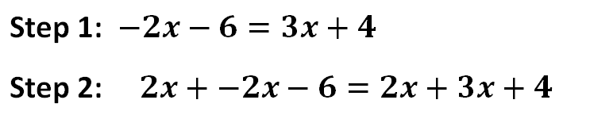
- Commutative property of addition
- Inverse property of addition
- Addition property of equality
- Associative property of addition

The answer is the Addition Property of Equality because between Step 1 and Step 2, “$2x$” is added to both sides of the equation. A common error is to label this as the Inverse Property of Addition, presumably because Step 2 shows $2x + -2x$. However, the Inverse Property of Addition states that a number a plus its opposite equals $0$. That property would be applied in a later step when $2x$ plus $-2x$ is shown to equal zero.

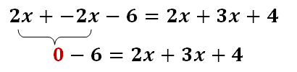

- Students will benefit from examples where the variable is on the right side of the inequality symbol. An example with common misconceptions follows –

  - Solve the inequality and graph the solution set on the number line. Show your work/thinking.

$$15≤3\left(8x-4\right)-9x$$

A common error students may make is shading the number line in the wrong direction because the variable is on the right side of the inequality. Students sometimes erroneously believe that the direction the inequality symbol points is the direction the number line should be shaded. Teachers may help students fix this misconception by providing additional practice with variables on the right side of the inequality. Teachers may want to start with very simple inequalities such as comparing the graphs of $x > 3$ and $3 > x$. Selecting “test” points from the shaded region to substitute into the original inequality to verify the solution is another way students can check their work. Students can also use Desmos to confirm their graphed solution. If there is a difference between their graph and the one Desmos displays, students should be encouraged to find the reason for the discrepancy and explain how to correct the error.

- Students will benefit from examples that require them to test whether values are included in the solution set of the inequality. An example with common misconceptions follows –

  - Which of the following values are in the solution set for the inequality $\frac{2}{3}\left(9-15x\right)<8x$? Show your work/thinking.

$$\left\{ -1, \frac{1}{3}, 1, 2\frac{1}{2} \right\}$$

A common mistake students make on this question is including $\frac{1}{3}$ as an element of the solution set. This could indicate that students think that the value they identify when they solve an inequality (the endpoint of the graphical representation of the solution set) is always a solution for the inequality. Teachers may want to encourage students to graph the inequality on a number line so they can see that the endpoint is an open circle or on Desmos so they can see that the vertical line that passes through the endpoint is dashed.
Mathematical Representations: Students need additional practice solving literal equations. Teachers are encouraged to use strategies such as highlighting the indicated variable or placing shapes around the variable prior to isolating it. Examples with common misconceptions follow –

- The formula for the surface area (S) of a triangular prism is –

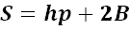

where h is the height of the prism, p is the perimeter of the base, and B is the area of the base. Solve the equation for the given variable:

a. Solve for h:
b. Solve for B:

- Graph the solution for the linear inequality.

$$6x-5y≥10$$

One typical error students make when representing the solution to this given inequality is to shade the area above the line on the coordinate plane. This may indicate that students do not understand that they must reverse the inequality symbol when they divide both sides of the inequality by $-5$. Teachers may want to encourage students to select a test point from the region they shaded and substitute it into the original inequality to verify that they have shaded the correct area. Teachers might also have students use Desmos to explore the graphs of $y > 4$ and $-y > 4$ to develop a deeper understanding of why the inequality symbol is reversed when multiplying or dividing an inequality by a negative value.

Concepts and Connections
Concept:
Linear equations and functions are the foundation of algebraic thinking.

Connections: Prior to Algebra 1, students wrote and solved multistep linear equations and inequalities in one variable and applied these skills to contextual problems (8.PFA.4, 8.PFA.5). Given these understandings, students will solve broader multistep linear equations and apply these skills to solve inequalities. Students will gain mathematical knowledge by examining solutions to equations to contextual situations and gain an understanding of algebra which prepares them for advanced learning opportunities and understanding how to justify their thinking using appropriate algebraic properties which builds their critical thinking skills and use of logic. In coursework beyond Algebra 1, students will represent, solve, and interpret the solution to quadratic equations in one variable over the set of complex numbers and solve quadratic inequalities in one variable (A2.EI.2); solve systems of equations in two variables containing a quadratic expression (A2.EI.3); and, represent, solve, and interpret the solution to a polynomial equation (A2.EI.6).

- Within the grade level/course:
  - A.EI.2 – The student will represent, solve, explain, and interpret the solution to a system of two linear equations, a linear inequality in two variables, or a system of two linear inequalities in two variables.
  - A.EI.3 – The student will represent, solve, and interpret the solution to a quadratic equation in one variable.
- Vertical Progression:
  - 8.PFA.4 – The student will write and solve multistep linear equations in one variable, including problems in context that require the solution of a multistep linear equation in one variable.
  - 8.PFA.5 – The student will create and solve multistep linear inequalities in one variable, including problems in context that require the solution of a multistep linear inequality in one variable.
  - A2.EI.2 – The student will represent, solve, and interpret the solution to quadratic equations in one variable over the set of complex numbers and solve quadratic inequalities in one variable.
  - A2.EI.3 – The student will solve a system of equations in two variables containing a quadratic expression.
  - A2.EI.6 – The student will represent, solve, and interpret the solution to a polynomial equation.

Textbooks and HQIM for Consideration
- A list of approved textbooks and instructional materials will be posted on the VDOE website.

A.EI.2 The student will represent, solve, explain, and interpret the solution to a system of two linear equations, a linear inequality in two
variables, or a system of two linear inequalities in two variables.
Students will demonstrate the following Knowledge and Skills:
- Create a system of two linear equations in two variables to represent a contextual situation.
- Apply the properties of real numbers and/or properties of equality to solve a system of two linear equations in two variables, algebraically and graphically.
- Determine whether a system of two linear equations has one solution, no solution, or an infinite number of solutions.
- Create a linear inequality in two variables to represent a contextual situation.
- Represent the solution of a linear inequality in two variables graphically on a coordinate plane.
- Create a system of two linear inequalities in two variables to represent a contextual situation.
- Represent the solution set of a system of two linear inequalities in two variables, graphically on a coordinate plane.
- Verify possible solution(s) to a system of two linear equations, a linear inequality in two variables, or a system of two linear inequalities algebraically, graphically, and with technology to justify the reasonableness of the answer(s). Explain the solution method and interpret solutions for problems given in context.

Understanding the Standard
- Systems of two linear equations or inequalities can be used to model two practical conditions that must be satisfied simultaneously.
- A system of linear equations with exactly one solution is characterized by the graphs of two lines whose intersection is a single point, and the coordinates of this point satisfy both equations. The solution is represented as an ordered pair such as (3, 4).
- A system of two linear equations with no solution is characterized by the graphs of two parallel lines that do not intersect.
- A system of two linear equations having an infinite number of solutions is characterized by two lines that coincide (the lines appear to be the graph of one line) and the coordinates of all points on the line satisfy both equations. These lines will have the same slope and y-intercept.
- The graph of the solutions of a linear inequality is a half-plane bounded by the graph of its related linear equation. Points on the boundary are included unless the inequality contains only < or > (no equality condition).
- The graph of the solutions of a system of linear inequalities is the intersection of the graphs of the corresponding half-planes. Any point in the intersecting planes is a valid mathematical solution.
- There may be mathematically valid answers that do not satisfy contextual problems.
- Properties of Real Numbers, Properties of Equality, and Properties of Inequality are used to solve equations/inequalities. See Understanding the Standard for SOL A.EI.1 for a list of properties.

Skills in Practice
While the five process goals are expected to be embedded in each standard, the Skills in Practice highlight the most prevalent process goals in relation to the content presented.

Mathematical Problem Solving: Students will benefit from practice identifying variables to represent quantities in a real-world contextual situation. An example with common misconceptions follows –

- Cassie is planning a birthday party for her little brother and wants to rent a snow cone machine. She will also need to buy the flavored syrup, ice, and paper cones. She has at most $50 to spend.
  - The rental of the snow cone machine costs $25 for the day.
  - The flavored syrup, ice, and the paper cones will cost $0.70 per serving.
What is the greatest number of snow cones Cassie can serve? Show your work/thinking.

A common mistake that students may make is to say that Cassie can serve 71 snow cones, forgetting to include the initial cost for renting the machine. This might indicate that the student has not completely understood the problem and ignored the fixed cost. Teachers may want to encourage students to consider different problem-solving strategies, such as drawing a visual representation of the problem. Visualizing a problem can help students to better understand the context of the problem.

Mathematical Reasoning: Students will benefit from practice using the substitution property when verifying solutions to systems of equations. Also, students should have additional practice substituting values into both equations in a system. Examples with common misconceptions follow –

- Is the point $\left(3,-\frac{1}{3}\right)$ a solution to the system $\left\{\begin{aligned}2x-3y=7 \\ x+6y=11\end{aligned}\right.$? Explain how you know.

A common error students make is substituting the point into only one equation and not both. In this case, the point lies on the first line but not the second. Students may incorrectly say it is a solution to the system. This may indicate that students do not understand that a solution to a system must be a point that lies on both lines. Teachers may want to encourage students to check their work by graphing on Desmos which will allow students to see that the point lies on only one line and not both.
- Graph the solution to this system of inequalities: $\left\{ \begin{aligned}2x+4y≤12 \\ 5x-2y<6\end{aligned}\right.$
A common error a student may make is to incorrectly graph the second equation by shading below the line. This may indicate that the student does not understand that the inequality symbol is reversed when solving for $y$ requires dividing by a negative. Teachers may want to encourage students to select a test point from the region they shaded and substitute it into both inequalities to verify that they have shaded the correct area. Allowing students to use Desmos to check their graphs will also help reinforce the need to reverse the inequality.
Mathematical Connections: Students need additional practice with writing a system of equations that represents a real-life contextual situation. An example with common misconceptions follows –

- Pam bought 20 pieces of fruit for her class.
  - Each piece of fruit was either an apple or an orange.
  - She spent $1.25 on each apple.
  - She spent $0.95 on each orange.
  - Pam spent a total of $22.60.
Write a system of equations that can be used to find the number of apples Pam bought. Make sure to define your variables.

A common mistake students may make on this problem is setting up the system of equations incorrectly. Students may set up one side of each equation correctly ($x + y$ and $1.25x + 0.95y$), but place the wrong total with each equation. This may indicate that students are following a procedure rather than reading for understanding (e.g., students read the problem, identify the totals, and write two equations). Teachers may consider encouraging students to use a problem-solving strategy such as the three-reads protocol or the teacher may want to model a think-aloud strategy to help students learn how to read a situation and understand the context of the problem. Included in the problem-solving strategy or think-aloud modeling is labeling units for all variables and values (e.g., $x$ apples + $y$ oranges = 20 pieces of fruit, not $22.60).

Mathematical Representations:

- Students will benefit from multiple examples of two lines having the same slope and different $y$-intercepts. Also, students will benefit from examples of two lines having the same slope and $y$-intercept but written in different forms. Students should practice writing equations that match these examples. An example with common misconceptions follows –

  - Given the equation: $3x+y=4$, write an equation of a line that would create a system of equations with the given line that has infinitely many solutions. How did you decide on your equation?

One common misconception students make is thinking any two lines with the same slope have infinitely many solutions. This may indicate that students do not recognize the difference between parallel and coinciding lines. Teachers may encourage students to graph their system using Desmos to help them visualize that two lines must have both the same slope and the same $y$-intercept in order to have infinitely many solutions. Teachers may also encourage students to solve the equation for $y$ to help identify the slope and $y$-intercept.

- Students will benefit from additional practice writing equations that model real-life contextual situations. An example with common misconceptions follows –

  - Suzi’s brother has ten more than twice as many sports cards as Suzi does. Together, they have 70 sports cards. How many sports cards does Suzi have? Show your work/thinking.

A common mistake students make when writing the equation for this situation is to leave out the variable expression that represents Suzi’s cards (i.e., they write the equation $2x + 10 = 70,$ rather than $x + 2x + 10 = 70$). This may indicate that students do not have a complete understanding of the problem. Teachers may want to encourage students to draw a visual representation of the problem. Two examples are shown.

Example 1:
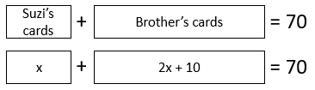
Example 2:
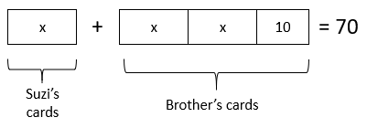

- Students will benefit from multiple opportunities to explore graphs of inequalities. Specifically, they should recognize solutions to inequalities can fall on solid lines. Conversely, solutions of inequalities do not lie on dotted or dashed lines. An example with common misconceptions follows –
Avery has correctly started the graph of the system of inequalities $\left\{\begin{aligned}y≥4x+3 \\ y<-x-2\end{aligned}\right.$. Which region would Avery need to shade to complete the graph of this system? How do you know?

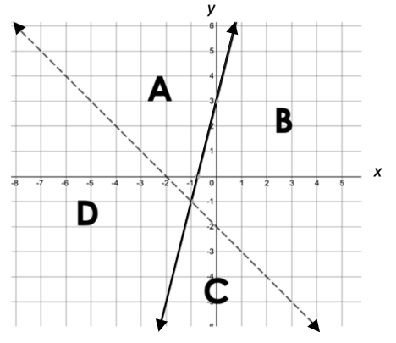

A common error a student may make is to select region B. This may indicate that the student has confused which inequality goes with a dashed line and which goes with a solid line. Teachers may want to continue to make connections between inequalities with two variables and inequalities with one variable, connecting dashed lines to open circles and solid lines to closed circles. Allowing students to use Desmos to check their graphs will also help reinforce the meaning of dashed and solid lines.

Concepts and Connections
Concepts
Systems of equations and inequalities model real-life contextual situations. The solution of a linear system is the ordered pair that is a solution to all equations in the system. Systems of inequalities are used when a problem requires a range of solutions, and there is more than one constraint on those solutions.

Connections: Prior to Algebra 1, students created and solved multistep systems of inequalities in one variable (8.PFA.5), and wrote and solved multistep linear equations in one variable, and applied these skills to contextual problems (8.PFA.4). Given these understandings, students will apply these skills to solve systems of linear equations and inequalities. Students will gain mathematical knowledge by examining solutions to systems of equations and inequalities within contextual situations, and will develop an understanding of algebra that prepares them for similar topics learned beyond Algebra 1 to include representing, solving, and interpreting the solution to quadratic equations in one variable over the set of complex numbers and solve quadratic inequalities in one variable (A2.EI.2); solving a system of equations in two variables containing a quadratic expression (A2.EI.3); and, representing, solving, and interpreting the solution to a polynomial equation (A2.EI.6).

- Within the grade level/course:
  - A.EI.1 – The student will represent, solve, explain, and interpret the solution to multistep linear equations and inequalities in one variable and literal equations for a specified variable.
- Vertical Progression:
  - 8.PFA.4 – The student will write and solve multistep linear equations in one variable, including problems in context that require the solution of a multistep linear equation in one variable.
  - 8.PFA.5 – The student will create and solve multistep linear inequalities in one variable, including problems in context that require the solution of a multistep linear inequality in one variable.
  - A2.EI.2 – The student will represent, solve, and interpret the solution to quadratic equations in one variable over the set of complex numbers and solve quadratic inequalities in one variable.
  - A2.EI.3 – The student will solve a system of equations in two variables containing a quadratic expression.
  - A2.EI.6 – The student will represent, solve, and interpret the solution to a polynomial equation.

Textbooks and HQIM for Consideration
- A list of approved textbooks and instructional materials will be posted on the VDOE website.

A.EI.3 The student will represent, solve, and interpret the solution to a quadratic equation in one variable.
Students will demonstrate the following Knowledge and Skills:
- Solve a quadratic equation in one variable over the set of real numbers with rational or irrational solutions, including those that can be used to solve contextual problems.
- Determine and justify if a quadratic equation in one variable has no real solutions, one real solution, or two real solutions.
- Verify possible solution(s) to a quadratic equation in one variable algebraically, graphically, and with technology to justify the reasonableness of answer(s). Explain the solution method and interpret solutions for problems given in context.

Understanding the Standard
- A solution to an equation is the value or set of values that can be substituted to make the equation true.
- Practical problems may be interpreted, represented, and solved using quadratic equations.
- The process of solving quadratic equations can be modeled in a variety of ways using concrete, pictorial, and symbolic representations.
- Quadratic equations in one variable may be solved algebraically by factoring and applying properties of equality or by using the quadratic formula over the set of real numbers (Algebra 1) or the set of complex numbers (Algebra 2).
- The number of real solutions of a quadratic equation can be found by graphing the quadratic function and finding the number of x-intercepts.
- The number of real solutions of a quadratic equation $y=ax^{2}+bx+c$ can be found algebraically using the discriminant, $b^{2}-4ac$.
  - If $b^{2}-4ac>0$, there are 2 real solutions.
  - If $b^{2}-4ac=0$, there is 1 real solution.
  - If $b^{2}-4ac<0$, there are 0 real solutions.
- The real solutions of a quadratic equation can be found by graphing the quadratic function and finding the x-intercepts or zeros.
- The real solutions of a quadratic equation $0=ax^{2}+bx+c$ can be found algebraically using the quadratic formula, $\frac{-b±\sqrt{b^{2}-4ac}}{2a}$.
- The real, rational solutions of a quadratic equation can also be found algebraically through factoring.

Skills in Practice
While the five process goals are expected to be embedded in each standard, the Skills in Practice highlight the most prevalent process goals in relation to the content presented.

Mathematical Reasoning: Students should be exposed to quadratic equations written multiple ways. When solving quadratic equations algebraically using the quadratic formula, it is a best practice to set the quadratic equation equal to zero prior to identifying a, b, and c. Also, students should be encouraged to use integer values for a, b, and c. Examples with common misconceptions follow –
- What are the solutions to the equation shown? Show your work/thinking.

$$2x^{2}-3x=4$$

A common mistake students make is to substitute values into the quadratic formula without having set the equation equal to zero first (e.g., $c = 4$, rather than $c = -4$). This may indicate that students have not connected the solutions to the zeros of an equation. Reinforcing this vocabulary could help students realize that in order to find the zeros (solutions), the equation must be set equal to zero first. It might be helpful for a teacher to have students use Desmos to visually represent the function and make connections between the graph and the solutions to the quadratic.
- What values of $x$ are solutions to the equation? Show your work/thinking.

$$\frac{1}{2}x^{2}-\frac{1}{4}x-2=0$$

Students may make errors substituting rational values for a, b, and c when using the quadratic formula. This may indicate that students lack proficiency with operations with rational numbers. A strategy teachers can use is to encourage students to write an equivalent equation by multiplying all of the terms of the equation by a scalar value that will produce integer coefficients before using the quadratic formula. Care must be taken to multiply each term of the equation by the selected scalar in order to create an equivalent equation. Verifying solutions with a graphing utility could also help students identify when a mistake has been made and allow them the opportunity to review their work to find the error.

Mathematical Connections: Students will benefit from additional experiences and practice with conceptual understanding surrounding perfect squares and square roots. An example with common misconceptions follows –
- Emile and Andrea solved the given quadratic equation in different ways and got different answers. Determine which student made an error. Explain the mistake and how to correct it.

Emile: Andrea:
$8x^{2}=72$ $8x^{2}=72$
$x^{2}=9$ $8x^{2}-72=0$
$\sqrt{x^{2}}=\sqrt{9}$ $8\left(x^{2}-9\right)=0$
$x=3$ $8\left(x-3\right)\left(x+3\right)=0$
$x=3$or$x=-3$
A common error students may make is to only provide the positive square root as the solution (e.g., $x = 3,$ rather than $x = 3$or$x = -3$), thus identifying Emile’s answer as correct. This could indicate that students do not have a well-developed understanding of positive numbers having two square roots. Teachers may want to ask follow-up questions such as, “Is three the only number that when squared results in 9?” and “What is the sign of the product of two negative numbers?” To correct the mistake, Emile’s last two steps should have been:

$$\sqrt{x^{2}}=±\sqrt{9}$$
$$x=±3$$

Concepts and Connections
Concepts
Quadratic equations are seen throughout Algebra 1 and beyond. Students can use accessible algebraic and arithmetical manipulation to show the relationships between input/output values, different algebraic representations, and graphical representations.

Connections: Prior to Algebra 1, students created and solved multistep linear equations in one variable and applied these skills to contextual problems (8.PFA.4). Given these understandings, students will apply these skills to solve quadratic equations. They will make connections to radicals and exponents throughout their learning opportunities with quadratics. Experiences with interpreting solutions to quadratic equations will prepare students for a comprehensive journey into quadratic functions and modeling beyond Algebra 1 to include representing, solving, and interpreting the solution to quadratic equations in one variable over the set of complex numbers and solving quadratics in one variable (A2.EI.2); solving a system of equations in two variables containing a quadratic expression (A2.EI.3); and, representing, solving, and interpreting the solution to an equation containing rational algebraic expressions (A2.EI.4), radical expressions (A2.EI.5), and polynomial equations (A2.EI.6).

- Within the grade level/course:
  - A.EI.1 – The student will represent, solve, explain, and interpret the solution to multistep linear equations and inequalities in one variable and literal equations for a specified variable.
- Vertical Progression:
  - 8.PFA.4 – The student will write and solve multistep linear equations in one variable, including problems in context that require the solution of a multistep linear equation in one variable.
  - A2.EI.2 – The student will represent, solve, and interpret the solution to quadratic equations in one variable over the set of complex numbers and solve quadratic inequalities in one variable.
  - A2.EI.3 – The student will solve a system of equations in two variables containing a quadratic expression.
  - A2.EI.4 – The student will represent, solve, and interpret the solution to an equation containing rational algebraic expressions.
  - A2.EI.5 – The student will represent, solve, and interpret the solution to an equation containing a radical expression.
  - A2.EI.6 – The student will represent, solve, and interpret the solution to a polynomial equation.

Textbooks and HQIM for Consideration
- A list of approved textbooks and instructional materials will be posted on the VDOE website.

Functions
Functions represent a main tenant of algebra. A thorough understanding of functions can be derived from skills obtained from exploring operations, expressions, and equations. The knowledge of functions allows students to transition equations from algebraic to graphical representations using coordinate methods. Function operations and transformations are connected to skills obtained from the exploration of expressions and equations. Mastery of functions will be required for successful completion of mathematics courses beyond the level of Algebra 1.
Throughout Algebra 1, students will investigate, analyze, and compare linear functions algebraically and graphically. Additionally, students will investigate, analyze, and compare characteristics of quadratic and exponential functions.
A.F.1 The student will investigate, analyze, and compare linear functions algebraically and graphically, and model linear relationships.
Students will demonstrate the following Knowledge and Skills:
- Determine and identify the domain, range, zeros, slope, and intercepts of a linear function, presented algebraically or graphically, including the interpretation of these characteristics in contextual situations.
- Investigate and explain how transformations to the parent function y = x affect the rate of change (slope) and the y-intercept of a linear function.
- Write equivalent algebraic forms of linear functions, including slope-intercept form, standard form, and point-slope form, and analyze and interpret the information revealed by each form.
- Write the equation of a linear function to model a linear relationship between two quantities, including those that can represent contextual situations. Writing the equation of a linear function will include the following situations:
  - given the graph of a line;
  - given two points on the line whose coordinates are integers;
  - given the slope and a point on the line whose coordinates are integers;
  - vertical lines as x = a; and
  - horizontal lines as y = c.
- Write the equation of a line parallel or perpendicular to a given line through a given point.
- Graph a linear function in two variables, with and without the use of technology, including those that can represent contextual situations.
- For any value, x, in the domain of f, determine f(x), and determine x given any value f(x) in the range of f, given an algebraic or graphical representation of a linear function.
- Compare and contrast the characteristics of linear functions represented algebraically, graphically, in tables, and in contextual situations.

Understanding the Standard
- The domain of a function is the set of all possible values of the independent variable and may be restricted by the practical situation modeled by a function.
- The range of a function is the set of all possible values of the dependent variable.
- The slope of a line represents a constant rate of change in the dependent variable when the independent variable changes by a constant amount.
- Slope can be described as a rate of change and will be positive, negative, zero, or undefined.
- The x-intercept is the point at which the graph of a relation or function intersects with the x-axis. It can be expressed as a value or a coordinate.
- The y-intercept is the point at which the graph of a relation or function intersects with the y-axis. It can be expressed as a value or a coordinate.
- Functions describe the relationship between two variables where each input is paired with a unique output.
- Function families consist of a parent function and all transformations of the parent function. The parent function for linear functions is $f\left(x\right)=x$.
- Transformations are limited to horizontal and vertical translations, reflections over the x-axis, and vertical dilations.
- For all functions, including linear functions, the transformation f(x) + k translates the graph vertically by k units.
- For all functions, including linear functions, the transformation kf(x) dilates the graph vertically by a factor of k. When $k<0$, the graph reflects vertically.
- When graphing a parent function with multiple transformations, order of operations determines which transformation should be applied first.
- Changes in slope may be described by dilations, reflections, or both.
- Changes in the y-intercept may be described by translations.
- A line can be represented by its graph or by an equation. The equation of a line defines the relationship between two variables.
- Linear equations can be written in three forms: slope-intercept form, standard form, or point-slope form.
  - Slope-intercept form, $y=mx+b$, expresses a line using the slope, $m$, and the $y$-intercept, $b$.
  - Standard form, $Ax+By=C$, expresses a line using only integers, $A$, $B$, and $C$, for constants and coefficients.
  - Point-slope form, $\left(y-y_{1}\right)=m(x-x_{1})$, expresses a line using the slope, $m$, and any point on the line, $\left(x_{1},y_{1}\right)$.
- Lines in standard form can be graphed by solving for the $x$ and $y$-intercepts.
- Standard form is particularly useful for solving systems of equations algebraically.
- The point-slope form can have multiple equivalent expressions as $\left(x_{1},y_{1}\right)$ can be any point on the line.
- The slopes of parallel lines are equal or congruent.
- The slopes of perpendicular lines are negative reciprocals (e.g., $\frac{2}{5}$ and $-\frac{5}{2}$).
- The product of the slope of two perpendicular lines is $-$1 unless one of the lines has an undefined slope.
- Linear equations can be graphed using a point that lies on the line and the slope of the line, x- and y-intercepts, two points that lie on the line, and/or transformations of the parent function.
- The graph of a line represents the set of points that satisfies the equation of a line.
- Each point on the graph of a linear equation in two variables is a solution of the equation.
- The x-coordinate of the point where the graphs of the linear equations y = f(x) and y = g(x) intersect is the solution of the equation f(x) = g(x).
- For each x in the domain of f, x is a member of the input of the function f, f(x) is a member of the output of f, and the ordered pair x, f(x)) is a member of f.

Skills in Practice
While the five process goals are expected to be embedded in each standard, the Skills in Practice highlight the most prevalent process goals in relation to the content presented.

Mathematical Problem Solving: Students will benefit from practice writing equations of linear functions in slope-intercept and standard forms. Examples with common misconceptions follow –
- A line passes through the point $(-4, 3)$ and has a slope of $\frac{1}{2}$. Write the equation of the line in –
    - Slope-intercept form
A common error a student might make is to incorrectly substitute the $x$- and $y$-values into the slope-intercept equation. This may indicate students need practice with plotting ordered pairs and identifying the $x$- and $y$-coordinates. Teachers may want to have students check their final equation by graphing both the point and the line in Desmos to ensure the line passes through the given point.
    - Standard form
A common error is for students to make an algebraic error as they convert the equation from point-slope or slope-intercept form to standard form. Teachers may want to ensure that students understand that the different forms of the equation are equivalent, and their graphs are the same. To help students identify any algebraic mistakes, teachers may have students graph their different forms of the equation in Desmos to verify that they are equivalent, and that they all pass through the given point with the given slope.
- Given the graph of the function $g(x)$ below, what is the approximate value of $g(3)$?

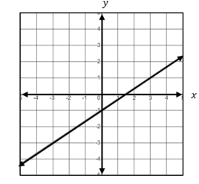

A common error a student may make is to say $g\left(3\right)=1.5$. This may indicate that a student interprets finding the value of a function as finding the zero of the function when given a graph. Since $g(3)$ means to find the value of the function when $x = 3,$ a strategy that might be helpful for students is to draw a vertical line representing $x = 3,$ and determine the $y$-coordinate of the point where the vertical line intersects the graph of the function provided.
Mathematical Reasoning:

- In addition to using the slope formula in isolation, students will benefit from the understanding that slope represents the change in $y$-values divided by the change in $x$-values. Slope is the ratio of the change in $y$ to the change in $x$. Slope is graphically represented by rise divided by run. An example with common misconceptions follows –

- A line passes through the points $(2, a)$ and $\left(4a, 5\right),$ and has a slope of $\frac{1}{2}$. Find the value of $a$.

A common error could occur when using the slope formula to set up an equation, writing the change in $x$-values over the change in $y$-values equals $\frac{1}{2},$ and calculating to find $a$ to equal $1$. This may indicate that students are procedurally using the slope formula and may benefit from a review of slope triangles to calculate slope. A strategy might be to have the students plot the points created by substituting the value of $a$ in each coordinate to ensure that a line with the desired slope is obtained. Students who struggle with the use of variables may benefit from being provided similar problems, where only one of the coordinates has a missing variable.

- Teachers may consider explaining that the slope-intercept form may be most useful when the $y$-intercept is an integer that is relatively close to $0$. Additionally, the point-slope form may be more versatile than slope-intercept as it can be graphed easily even when the intercepts are not integers.

Mathematical Connections:

- Students will benefit from experiences that require them to write the equation of a line that is perpendicular to another line. An example with common misconceptions follows –

- Line t passes through the points $(3, -7)$ and $(-3, -3)$. Write an equation of a line (in any form) that is perpendicular to line t and passes through the point $(3, 2)$. Show your work/thinking.

A common error that students may make is to take the reciprocal of the slope of line m, but not negate the reciprocal. This may indicate that students think that the phrase “negative reciprocal” means the answer is negative or they may just forget that they need to change the sign. Teachers may want to explore perpendicular lines using Desmos in order to help students visualize and then compare two lines whose slopes are the opposite reciprocals of one another. Care should be taken in Desmos to make sure that the ZOOM SQUARE option has been selected using the wrench to ensure that lines that are perpendicular look perpendicular.

- Students should be reminded that when writing ordered pairs that represent intercepts, the $x$-value is the first coordinate for the $x$-intercept, and $y = 0$; such as$(x, 0)$. Also, the $y$-value is the second coordinate for the $y$-intercept, and $x = 0$; such as$(0, y)$. An example with common misconceptions follows –

  - Write the $x$- and $y$-intercept of the function $f\left(x\right)=3x-4,$ each as an ordered pair.

A common error a student may make is to write the $x$-intercept as $(0, \frac{4}{3} )$ or the $y-$intercept as $(-4, 0).$ This may indicate a misunderstanding of representing $x$- and $y$-intercepts as ordered pairs. A strategy that might be helpful for students is to verify the intercepts using a graphing utility such as Desmos. In addition, a student might find helpful to use the table feature in Desmos to verify intercepts.

Mathematical Representations:

- Students will benefit from practice identifying attributes of horizontal and vertical lines. An example with common misconceptions follows –

  - The graph below shows the line $x = 3$. Describe the slope of the line.
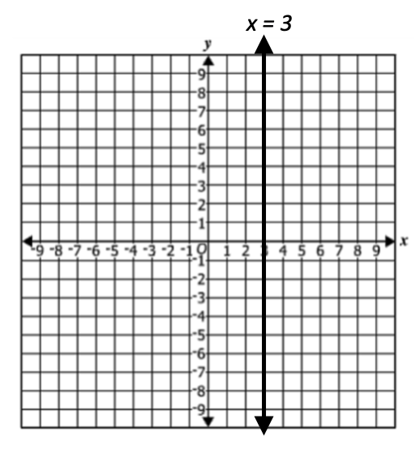

A common error that students might make is to say the slope of a vertical line is $0$. This might indicate that the student does not have a strong understanding of the difference between lines with a slope of zero and an undefined slope. Teachers may want to reinforce the idea that division by zero is undefined. Teachers might have students explore the slope of vertical and horizontal lines by plotting any two points on the line and using rise over run or a slope formula to explore the difference between a numerator of $0$ and a denominator of $0$.

- When comparing changes to slopes and $y$-intercepts after transformations to functions have occurred, students should be encouraged to identify the slopes and $y$-intercepts of the original and transformed functions prior to summarizing any change that occurred. For example –

  - The graph of the parent function $f(x) = x$is transformed to the new function $g(x) = 3x + 4$.

  - Describe the change in the slope of $g(x)$ compared to $f(x)$.
  - Describe the change in the $y$-intercept of $g(x)$ compared to $f(x)$.

A common error might be to say that the slope is “$3$ more than,” and the $y$-intercept is “$4$ times.” This may indicate that the student is confusing the appropriate language for the transformations. Teachers may want to be sure to connect the change in the slope with mathematical language including “dilation,” “reflection,” “steep,” “less steep,” and “times.” Mathematical language for changes in the $y$-intercept should include “translate,” “shift up,” “shift down,” “more than,” and “less than.”

- Students are encouraged to identify ordered pairs of points in order to determine the domain and range of relations and functions. Also, students should understand that $x$-values represent domain and $y$-values represent range.

Concepts and Connections:
Concepts
Linear functions can be applied to real-life contextual situations. Linear functions are used to model everyday experiences.

Connections: Prior to Algebra 1, students were exposed to fundamental principles of functions by examining properties of relations and functions. Students determined whether a relation was a function and were required to identify a function’s domain and range (8.PFA.2). Given these understandings, students will investigate, analyze, and compare linear functions algebraically and graphically. Also, students will apply these skills to model linear relationships. This knowledge will be applied in coursework beyond Algebra 1 to include investigating, analyzing, and comparing square root, square root, cube root, rational, exponential, and logarithmic function families, algebraically and graphically, using transformations (A2.F.1); and, investigating and analyzing characteristics of square root, cube root, rational, polynomial, exponential, logarithmic, and piecewise-defined functions algebraically and graphically (A2.F.2).

- Within the grade level/course:
  - A.F.2 – The student will investigate, analyze, and compare characteristics of functions, including quadratic and exponential functions, and model quadratic and exponential relationships.
- Vertical Progression:
  - 8.PFA.2 – The student will determine whether a given relation is a function and determine the domain and range of a function.
  - A2.F.1 – The student will investigate, analyze, and compare square root, cube root, rational, exponential, and logarithmic function families, algebraically and graphically, using transformations.
  - A2.F.2 – The student will investigate and analyze characteristics of square root, cube root, rational, polynomial, exponential, logarithmic, and piecewise-defined functions algebraically and graphically.

Textbooks and HQIM for Consideration
- A list of approved textbooks and instructional materials will be posted on the VDOE website.

A.F.2 The student will investigate, analyze, and compare characteristics of functions, including quadratic, and exponential functions, and
model quadratic and exponential relationships.
Students will demonstrate the following Knowledge and Skills:
- Determine whether a relation, represented by a set of ordered pairs, a table, a mapping, or a graph is a function; for relations that are functions, determine the domain and range.
- Given an equation or graph, determine key characteristics of a quadratic function including x-intercepts (zeros), y-intercept, vertex (maximum or minimum), and domain and range (including when restricted by context); interpret key characteristics as related to contextual situations, where applicable.
- Graph a quadratic function, f(x), in two variables using a variety of strategies, including transformations f(x) + k and kf(x), where k is limited to rational values.
- Make connections between the algebraic (standard and factored forms) and graphical representation of a quadratic function.
- Given an equation or graph of an exponential function in the form y = ab^{x} (where b is limited to a natural number), interpret key characteristics, including y-intercepts and domain and range; interpret key characteristics as related to contextual situations, where applicable.
- Graph an exponential function, f(x), in two variables using a variety of strategies, including transformations f(x) + k and kf(x), where k is limited to rational values.
- For any value, x, in the domain of f, determine f(x) of a quadratic or exponential function. Determine x given any value f(x) in the range of f of a quadratic function. Explain the meaning of x and f(x) in context.
- Compare and contrast the key characteristics of linear functions (f(x) = x), quadratic functions (f(x) = x²), and exponential functions (f(x) = b^{x}) using tables and graphs.

Understanding the Standard
- A relation is a function if and only if each element in the domain is paired with a unique element of the range.
- Functions describe the relationship between two variables where each input is paired to a unique output.
- The domain of a function is the set of all possible values of the independent variable.
- The range of a function is the set of all possible values of the dependent variable.
- Solutions and intervals may be expressed in different formats, including equations and inequalities, set notation, and interval notation. Examples may include:

Equation/ Inequality | Set Notation | Interval Notation
x = 3 | {3} | {3}
x = 3 or x = 5 | {3, 5} | {3, 5}
y ≥ 3 | {y: y ≥ 3} | [3,$∞)$
$$-2<x≤6$$ | {$x:-2<x≤6$} | ($-$2, 6]
Empty (null) set ∅ | { } | { }

- For each x in the domain of f, x is a member of the input of the function f, f(x) is a member of the output of f, and the ordered pair (x, f(x)) is a member of f.
- A value, x, in the domain of f is an x-intercept or a zero of a function f if and only if f(x) = 0.
- Given a quadratic function f(x), the following statements are equivalent for any real number, k, such that f(k) = 0:
  - k is a zero of the function f(x), located at (k, 0);
  - (x – k) is a factor of f(x);
  - k is a solution or root of the equation f(x) = 0; and
  - the point (k, 0) is an x-intercept for the graph of y = f(x).
- The x-intercept is the point at which the graph of a relation or function intersects with the x-axis. It can be expressed as a value or a coordinate.
- The y-intercept is the point at which the graph of a relation or function intersects with the y-axis. It can be expressed as a value or a coordinate.
- The y-intercept of a quadratic function is the constant term when a function is written in standard form.
- The vertex of a quadratic function can be found graphically as well as algebraically.
- Given the quadratic function $f\left(x\right)=ax^{2}+bx+c$, the $x$-coordinate of the vertex can be found by solving $\frac{-b}{2a}$. The $y$-coordinate can be found by substituting the produced $x$-coordinate back into the function.
- The domain of a function may be restricted by the practical situation modeled by a function.
- Function families consist of a parent function and all transformations of the parent function.
  - The parent function for quadratics is $f\left(x\right)=x^{2}$.
  - The parent function for exponential functions is $f\left(x\right)=b^{x}$ where $b$ is a natural number.
- Transformations are limited to horizontal and vertical translations, reflections over the x-axis, and vertical dilations.
- For all functions, including quadratic and exponential functions, the transformation f(x) + k translates the graph vertically by k units.
- For all functions, including quadratic and exponential functions, the transformation kf(x) dilates the graph vertically by a factor of k. When $k<0$, the graph reflects vertically.

Skills in Practice
While the five process goals are expected to be embedded in each standard, the Skills in Practice highlight the most prevalent process goals in relation to the content presented.

Mathematical Problem Solving:

- Students should understand that a zero is an $x$-intercept of the graph of a polynomial function. Thus, algebraic methods used to identify a zero should incorporate substituting $0$ for the dependent variable in order to identify the independent variables which cause the dependent variable to equal $0$. This can be understood by first explaining that the function is defined by independent and dependent variables. Given $h(t)$, this is read “$h$ is a function of $t,$” where $h$ depends upon $t$. The independent variable is $t$, and the dependent variable is $h$. An example with common misconceptions follows –

- Chris threw a ball into the air vertically. The height of the ball above the ground can be modeled by the equation $h\left(t\right)=-16t^{2}+30t+4$, where $h$ is the height in feet and $t$ is the time in seconds. When will the ball hit the ground? Show your work/thinking.

Students may make the mistake of substituting zero for t instead of for $h(t)$. This may indicate a lack of understanding of the definitions of the variables in the equation. Teachers may encourage students to use a three-reads protocol to ensure they understand the situation, equation, and variable definitions. Teachers may also engage students in experiments in which students collect data that can be modeled with parabolic equations. Using Desmos to create these models will allow students to visualize the path of the object and may lead to greater understanding of what the variables and critical points on the graph represent in the context of the problem (e.g., maximum/minimum, $x$-intercepts, $y$-intercept).
- Students will benefit from opportunities which require them to apply the substitution property when evaluating functions. An example with common misconceptions follows –

- Let $h\left(x\right)=-2x^{2}+kx+5$. If $h\left(1\right)=-5$, what is the value of $h(-4)$?
A common error a student may make is to only complete the first step of this multi-step problem by substituting $1$ for $x$ and $-5$ for $y$ and stating the value of $k$ as the answer ($k = -8$, therefore $h(-4) = -8$). This may indicate that a student has a misunderstanding of solving equations and finding function values that involve a multi-step process. A strategy that might be very helpful for students is to explain that finding the value of $h(-4)$ requires finding the value of $k$ first, and then using that value as the coefficient of $x$ in the quadratic function in order to determine the output value of $h(-4)$.
Mathematical Reasoning: Students will benefit from practice writing domain and range using inequality notation. Also, students should understand that a parabola’s vertex and direction of concavity are critical values when determining the range of a quadratic function. An example with common misconceptions follows –

- Write the range of the function $f\left(x\right)=-{\left(x+4\right)}^{2}-3$ in set notation below.

The range of $f(x)$ is $\{y|y___________\}$.

A common error a student may make is to say the range is less than or equal to $-4$, the $x$-coordinate of the vertex. This indicates the student has a misconception in associating domain and range with the independent and dependent variables, respectively. A strategy that could be used is to have the student practice with discrete points in identifying the domain and range and then continue practice with continuous graphs.

Mathematical Connections: Students should be exposed to properties of polynomial functions. Factors are opposite solutions. Solutions to quadratic equations can be reflected by the $x$-intercepts or zeros of the quadratic function. Also, the sign of a polynomial function’s leading term determines the function’s end behavior. Quadratic equations and functions can be written in a variety of methods. The most common forms of a quadratic equation or function are vertex, standard, and factored forms. Examples with common misconceptions follow –
- If a second-degree polynomial function with a leading coefficient of 1 has zeros of $x=3$ and $x=-2$, what is the factored form of this function?

A common error a student may make is to write the factored form as $f\left(x\right)=(x+3)(x-2)$. This indicates a misunderstanding of the connection between $x$-intercepts and factors. A strategy that could be used is to review the connection between factors and solutions. This could be done algebraically or graphically.

- What are the root(s) of the function $f\left(x\right)={2x}^{2}-x-6$?

A common error is for a student to only list the positive zero of $2$ instead of both the positive and negative zero. This indicates a misconception regarding the concept that there can be more than one zero and zeros can be positive or negative values. A strategy that could be used is to graph the function using Desmos or graph paper and show how at both zeros the function is equal to zero.

Mathematical Representations:
- Students should understand that quadratic and linear functions can have the same $x$-intercept. Quadratic functions can have zero, one, or two $x$-intercepts. An example with common misconceptions follows –

- Select all of the following functions that have an $x$-intercept of $3$.
$$f\left(x\right)=x^{2}-2x+3$$
$g\left(x\right)=2x-6$
$h\left(x\right)=x^{2}-9$
$p\left(x\right)=-\frac{1}{2}x+3$
$q\left(x\right)=-3x^{2}+10x-3$

A common error a student may make is to select the functions with a $y$-intercept of $3$, such as $f(x)$ and $p(x)$. This may indicate that a student has difficulty differentiating between an $x$-intercept and $y$-intercept using an algebraic approach. A strategy that might be useful is to have a student represent the functions visually and determine which functions have an $x$-intercept of $3,$ and then make the connection algebraically. Desmos is a powerful tool that can be used to show connections between algebraic forms, graphs, and intercepts.
- Students should have multiple exposures identifying $x$- and $y$-intercepts, given a graph of a quadratic function. An example with common misconceptions follows –

- Identify the $y$-intercept of the function shown on the graph.
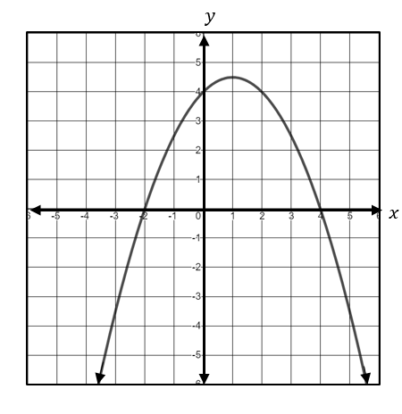
A common error a student may make is to circle both the $x$- and $y$-intercepts or to circle only the $x$-intercepts. This may indicate that a student has difficulty distinguishing between $x$- and $y$-intercepts and a misunderstanding between intercepts and solutions of a function. A strategy that might be helpful for students is to represent the $x$- and $y$-intercepts as a set of ordered pairs or in a table to show the similarities and differences between the coordinates.
- Students should understand that data can be modeled with an exponential curve of the form $y = ab^{x}$. Refer to the following activity:

Have the students fold a rectangular sheet of notebook paper in half, noticing that the fold divides the paper into two rectangles. Then have them fold the paper in half again and open the paper to observe the four rectangles formed by the folds. Have them refold their paper and then fold it in half a third time. Have them use a table similar to the one below to record the number of rectangles formed by each number of folds. Direct them to continue folding until they cannot make another fold. They should use the following table to record their findings.

Number of Folds | Number of Rectangles
0 | 1
1 | 2
2 | 4
3
4
5

Verify that this data represents an exponential function.

Concepts and Connections
Concepts
Quadratic and exponential functions are used to model everyday experiences.

Connections: Prior to Algebra 1, students were exposed to exponents and primary skills regarding functions. Students determined whether a relation was a function and were required to identify a function’s domain and range (8.PFA.2). Given these understandings, students will be equipped with the necessary background required to investigate, analyze, and compare characteristics of quadratic and exponential functions. This knowledge will be applied in coursework beyond Algebra 1 to include investigating, analyzing, and comparing square root, square root, cube root, rational, exponential, and logarithmic function families, algebraically and graphically, using transformations (A2.F.1); and, investigating and analyzing characteristics of square root, cube root, rational, polynomial, exponential, logarithmic, and piecewise-defined functions algebraically and graphically (A2.F.2).

- Within the grade level/course:
  - A.F.1 – The student will investigate, analyze, and compare linear functions algebraically and graphically, and model linear relationships.
- Vertical Progression:
  - 8.PFA.2 – The student will determine whether a given relation is a function and determine the domain and range of a function.
  - A2.F.1 – The student will investigate, analyze, and compare square root, cube root, rational, exponential, and logarithmic function families, algebraically and graphically, using transformations.
  - A2.F.2 – The student will investigate and analyze characteristics of square root, cube root, rational, polynomial, exponential, logarithmic, and piecewise-defined functions algebraically and graphically.

Textbooks and HQIM for Consideration
- A list of approved textbooks and instructional materials will be posted on the VDOE website.

Statistics
Statistics is a branch of mathematics that allows people to qualify and quantify data. Students use statistics to formulate questions and communicate results of data that has been collected and analyzed. These skills are used in almost every area of life, including sports, banking, medicine, agriculture, government, and education to name a few.
Throughout Algebra 1, students will apply the data cycle with a focus on representing bivariate data in scatterplots, tables, and ordered pairs. Additionally, students will use data to determine appropriate linear and quadratic best-fit curves that model the data.

A.ST.1 The student will apply the data cycle (formulate questions; collect or acquire data; organize and represent data; and analyze data and
communicate results) with a focus on representing bivariate data in scatterplots and determining the curve of best fit using linear and
quadratic functions.
Students will demonstrate the following Knowledge and Skills:
- Formulate investigative questions that require the collection or acquisition of bivariate data.
- Determine what variables could be used to explain a given contextual problem or situation or answer investigative questions.
- Determine an appropriate method to collect a representative sample, which could include a simple random sample, to answer an investigative question.
- Given a table of ordered pairs or a scatterplot representing no more than 30 data points, use available technology to determine whether a linear or quadratic function would represent the relationship, and if so, determine the equation of the curve of best fit.
- Use linear and quadratic regression methods available through technology to write a linear or quadratic function that represents the data where appropriate and describe the strengths and weaknesses of the model.
- Use a linear model to predict outcomes and evaluate the strength and validity of these predictions, including through the use of technology.
- Investigate and explain the meaning of the rate of change (slope) and y-intercept (constant term) of a linear model in context.
- Analyze relationships between two quantitative variables revealed in a scatterplot.
- Make conclusions based on the analysis of a set of bivariate data and communicate the results.

Understanding the Standard
- Students should explore the entire data cycle with a question and set of data that has been collected or acquired. Student reflection should occur throughout the data cycle. The data cycle includes the following steps: formulating questions to be explored with data, collecting or acquiring data, organizing and representing data, and analyzing and communicating results.
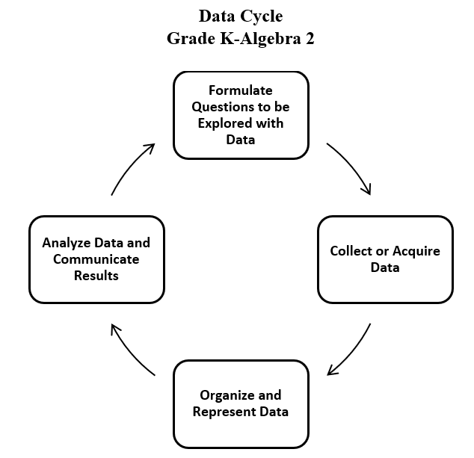
- Statistical questions should not be worded in a way that leads an individual to a particular answer.
- Many problems can be solved by using a mathematical model as an interpretation of a practical situation. The solution must then refer to the original practical situation.
- Randomization is a process that often results in a representative sample.
- A simple random sample is one type of random sampling method that gives every member of the population an equal chance of being selected (e.g., pulling names out of a hat).
- Non-random sampling methods such as convenience sampling may result in a sample that is not representative of the population.
- Collecting data involves conducting an experiment, surveying or polling individuals, making observations or measurements, etc. Acquiring data involves gathering data that already exists.
- Data and scatterplots may indicate patterns that can be modeled with an algebraic equation.
- Determining the curve of best fit for a relationship among a set of data points is a tool for the algebraic analysis of data. In Algebra 1, curves of best fit are limited to linear or quadratic functions.
- By examining patterns in data (shape), given different representations like a table or scatterplot, specific bivariate relationships can be determined.
- Bivariate data is data that is collected from two different variables and compared against each other.
- Knowledge of transformational graphing using parent functions can be used to verify a mathematical model from a scatterplot that approximates the data.
- Categorical variables can be added to a scatterplot using color or different symbols.
- Graphing utilities can be used to collect, organize, represent, and generate an equation of a curve of best fit for a set of data.
- Data that fit linear y = mx + b and quadratic y = ax² + bx + c functions arise from practical situations.
- The curve of best fit for the relationship among a set of data points can be used to make predictions where appropriate.
- Rounding that occurs during intermediate steps of problem solving may reduce the accuracy of the final answer.
- Interpolation is a method of estimating values within a set of data points based on the known values of the surrounding points. In other words, it involves using the data points that are available to make an educated guess about the value of a data point that is not explicitly given.
- Extrapolation is the process of estimating values outside the range of known data by extending a curve or trend line beyond the observed data points. In other words, it involves making predictions about values that are outside the range of the available data based on the assumption that the same trend will continue beyond the observed data.
- The validity of predictions decreases as the degree of extrapolation increases.
- Evaluation of the reasonableness of a mathematical model of a practical situation involves asking questions including:
  - “Is there another linear or quadratic curve that better fits the data?”
  - “Does the curve of best fit make sense?”
  - “Could the curve of best fit be used to make reasonable predictions?”

Skills in Practice
While the five process goals are expected to be embedded in each standard, the Skills in Practice highlight the most prevalent process goals in relation to the content presented.

Mathematical Communication: There are many good questions students can ask about univariate data and bivariate data. With univariate data,
information is gathered around a single characteristic (examples: scores on assessments, time spent looking at social media, hours spent on an activity). Numerical data represented by two variables (examples: time and distance, age and height) are bivariate data.
- Students should ask questions in which they are considering the relationship between two characteristics or variables; they are looking for trends in this relationship or looking to make a prediction based on the relationship.

- Students should have opportunities to explore the shape of the data in a scatterplot. Is it linear or is it nonlinear? Does it have a quadratic relationship?
- Students should explore the concept of curve of best fit. How does the shape of the scatterplot determine what type of curve should be applied?

- The labels are key to communication: What title and labels are necessary to clearly communicate? Should I draw a line of best fit to model the data?

- Examples of questions students may consider when building good samples include:
  - What is the context of the data to be collected?
  - Who is the audience?
  - What is an appropriate amount of data?

Mathematical Reasoning: As students analyze data and reflect upon their results, they should determine if there is a pattern to the data displayed (correlation or no correlation). Further, students should consider the shape of the data and determine if a specific linear or quadratic model fits the data. Students must return to the question to see if their data answers the question and if not, begin the cycle again. While doing so, students must determine how bias or sample size impacts the data and the representation.

- Scatterplots are used to model the relationship between two variables. Considerations for scatterplots include –
  - Is my goal to determine the potential relationship between these two variables?
  - Do I want to see individual data points?
  - Is my goal to make predictions about these variables?
  - Does a line (or curve) of best fit help me make predictions about this data?
  - Is there a correlation between the variables? If so, what type of correlation?

- As students explore the data displays, they should be looking for patterns that are evident in the shape of the data. Students should ask if the display appears linear or nonlinear. If the display appears nonlinear, is there a quadratic relationship?

- Using Desmos, tables with headers of x₁ and y₁ can be used to create scatterplots. The syntax of y₁~ ax₁ + b and y₁~ ax₁² + b + c can be used to develop a curve of best fit.

- It is not necessary to focus on r or r² values when describing the strengths and weaknesses of the model; general discussions about the shape and “closeness” of the points to the line is sufficient.

Mathematical Representations: As students organize and represent data using scatterplots, students should be given opportunities to identify a correlation or relationship between two variables. A line or curve of best fit can be drawn to show a trend in the data and to help make predictions based on the data. The relationship between the variables could be positive, negative, or have no correlation. The relationship could be linear, nonlinear, or quadratic.

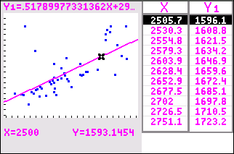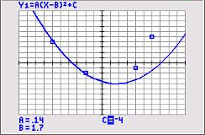
- Students should communicate the relationship (if it exists) but not assume causality. Where applicable, students should use data to make predictions.

- Students should be clear about what the representation allows them to conclude and what it does not (e.g., what are the limitations of the data display?)

- When working with regressions and curves of best-fit, students will benefit from examples that model real-life contextual situations. For example –
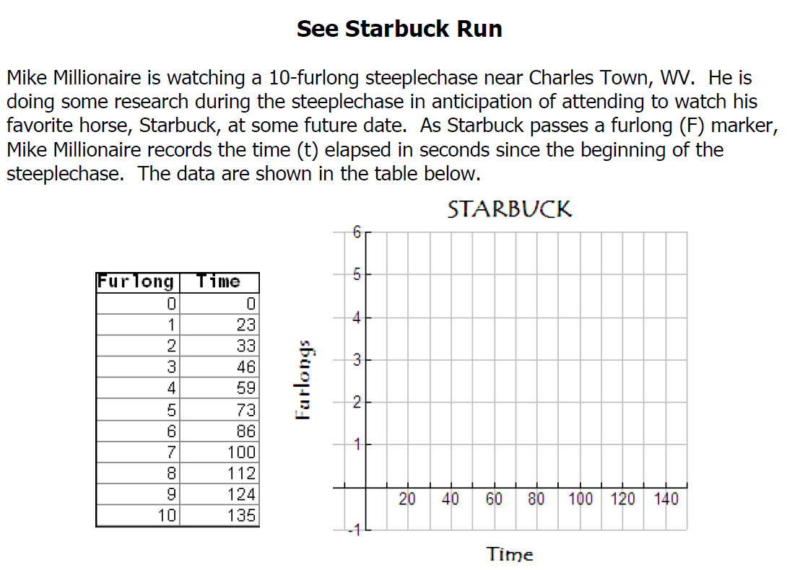
  - Create a scatter plot using the data and coordinate plane above. What are the independent and dependent variables?
  - What is the equation that best fits this data?
  - How fast is Starbuck running from the exact moment he passes the 4th furlong marker to the moment he passes the 5th furlong marker?
  - How fast is Starbuck running from the moment he passes the 6th furlong marker to the moment he passes the 7th furlong marker?
  - How fast is Starbuck running during the last furlong?
  - How long does it take for Starbuck to finish the event?

Errors may arise by incorrectly entering the data into a graphing utility or spreadsheet or by selecting an incorrect regression model.

Mathematical Connections: When working with regressions and curves of best-fit, students will benefit from additional practice converting from ordered pairs to tabular and graphical forms of representing data. For example –

- Using the quadratic curve of best fit, write an equation that represents the set of data.

$$\{\left(-8.3, 79.9\right), \left(-7.6, 56.3\right), \left(-6.23, 40.3\right), \left(2.87, 19.2\right), \left(4.91, 50.23\right), \left(6.95, 96.8\right)\}$$

Errors may arise by incorrectly converting the ordered pairs to a table when using a graphing utility or spreadsheet or by selecting an incorrect regression model.

Concepts and Connections
Concepts
Real-life contextual situations can be modeled by data. Data allows us to make decisions.

Connections: Prior to Algebra 1, students began collecting, acquiring, organizing, representing, and analyzing data. Additionally, students formulated questions about data and communicated their results via scatterplots (8.PS.3). These skills established a foundation for students to apply the data cycle. Given these understandings, students will incorporate these skills to concepts of linear and quadratic regressions, curves of best fit, and the analysis of bivariate data. This knowledge will be applied in coursework beyond Algebra 1 to include investigating and analyzing characteristics of square root, cube root, rational, polynomial, exponential, logarithmic, and piecewise-defined functions algebraically and graphically (A2.F.2). Further, students will apply the data cycle with a focus on univariate quantitative data represented by a smooth curve, including a normal curve (A2.ST.1); and, represent bivariate data in scatterplots and determining the curve of best fit using linear, quadratic, exponential, or a combination of these functions (A2.ST.2).

- Within the grade level/course:
  - A.F.1 – The student will investigate, analyze, and compare linear functions algebraically and graphically, and model linear relationships.
  - A.F.2 – The student will investigate, analyze, and compare characteristics of functions, including quadratic and exponential functions, and model quadratic and exponential relationships.
- Vertical Progression:
  - 8.PS.3 – The student will apply the data cycle (formulate questions; collect or acquire data; organize and represent data; and analyze data and communicate results) with a focus on scatterplots.
  - A2.F.2 – The student will investigate and analyze characteristics of square root, cube root, rational, polynomial, exponential, logarithmic, and piecewise-defined functions algebraically and graphically.
  - A2.ST.1 – The student will apply the data cycle (formulate questions; collect or acquire data; organize and represent data; and analyze data and communicate results) with a focus on univariate quantitative data represented by a smooth curve, including a normal curve.
  - A2.ST.2 – The student will apply the data cycle (formulate questions; collect or acquire data; organize and represent data; and analyze data and communicate results) with a focus on representing bivariate data in scatterplots and determining the curve of best fit using linear, quadratic, exponential, or a combination of these functions.

Textbooks and HQIM for Consideration
- A list of approved textbooks and instructional materials will be posted on the VDOE website.

