2023 Mathematics
Standards of Learning

Grade 7 Instructional Guide

Copyright © 2024
by the
Virginia Department of Education
P.O. Box 2120
Richmond, Virginia 23218-2120
http://www.doe.virginia.gov

All rights reserved. Reproduction of these materials for instructional purposes in public school classrooms in Virginia is permitted.

Superintendent of Public Instruction
Dr. Lisa Coons

Office of STEM
Dr. Anne Petersen, Director
Dr. Angela Byrd-Wright, Mathematics Coordinator
Dr. Jessica Brown, Elementary Mathematics Specialist
Mrs. Regina Mitchell, Mathematics and Special Education Specialist

NOTICE
The Virginia Department of Education does not unlawfully discriminate on the basis of race, color, sex, national origin, age, or disability in employment or in its educational programs or services.

The contents of this Instructional Guide were informed by the U.S. Department of Education's Institute of Education Sciences (IES), What Works Clearinghouse, as a central, trusted source of scientific evidence for what works in education. Sample questions reflect applicable and aligned content from the Virginia Department of Education's published assessment items, Mathematics Item Maps, and National Association of Educational Progress (NAEP) assessment questions.

Introduction
The Mathematics Instructional Guide, a companion document to the 2023 Mathematics Standards of Learning, amplifies the Standards of Learning by defining the core knowledge and skills in practice, supporting teachers and their instruction, and serving to transition classroom instruction from the 2016 Mathematics Standards of Learning to the newly adopted 2023 Mathematics Standards of Learning. Instructional supports are accessible in #GoOpenVA and support the decisions local school divisions must make concerning local curriculum development and how best to help students meet the goals of the standards. The local curriculum should include a variety of information sources, readings, learning experiences, and forms of assessment selected at the local level to create a rigorous instructional program.

For a complete list of the changes by standard, the 2023 Virginia Mathematics Standards of Learning – Overview of Revisions is available and delineates in greater specificity the changes for each grade level and course.

The Instructional Guide is divided into three sections: Understanding the Standard, Skills in Practice, and Concepts and Connections aligned to the Standard. The purpose of each is explained below.

Understanding the Standard
This section includes mathematics understandings and key concepts that assist teachers in planning standards-focused instruction. The statements may provide definitions, explanations, or examples regarding information sources that support the content. They describe what students should know (core knowledge) as a result of the instruction specific to the course/grade level and include evidence-based practices to approaching the Standard. There are also possible misconceptions and common student errors for each standard to help teachers plan their instruction.

Skills in Practice
This section outlines supporting questions and skills that are specifically linked to the standard. They frame student inquiry, promote critical thinking, and assist in learning transfer. Curriculum writers and teachers should use them to plan instruction to deepen understanding of the broader unit and course objectives. This is not meant to be an exhaustive list of student expectations.

Concepts and Connections
This section outlines concepts that transcend grade levels and thread through the K through 12 mathematics program as appropriate at each level. Concept connections reflect connections to prior grade-level concepts as content and practices build within the discipline as well as potential connections across disciplines.

Number and Number Sense
In K-12 mathematics, numbers and number sense form the foundation building blocks for mathematics understanding. Students develop a foundational understanding of numbers, their properties, and the relationships between them as they learn to compare and order numbers, understand place value, and perform numerical operations. Number sense includes an understanding of patterns and the relationships between numbers and being able to apply this knowledge to real world problems. Throughout K-12, students build on their number sense to develop a deeper understanding of mathematical concepts and reasoning.

In Grade 7, students use multiple representations of numbers and relationships among numbers that provide meaning and structure to allow for sense-making. At this grade level, students describe the concepts of exponents for powers of ten and compare and order number greater than zero written in scientific notation; compare and order rational numbers; and, recognize and describe the relationships between square roots and perfect squares.

7.NS.1 The student will investigate and describe the concept of exponents for powers of ten and compare and order numbers greater than
zero written in scientific notation.
Students will demonstrate the following Knowledge and Skills:
- Investigate and describe powers of 10 with negative exponents by examining patterns.
- Represent a power of 10 with a negative exponent in fraction and decimal form.
- Convert between numbers greater than 0 written in scientific notation and decimals.*
- Compare and order no more than four numbers greater than 0 written in scientific notation. Ordering may be in ascending or descending order.*
* On the state assessment, items measuring this knowledge and skill are assessed without the use of a calculator.

Understanding the Standard
- Negative exponents for powers of 10 are used to represent numbers between 0 and 1.
(e.g., ${10}^{-3}$ = $\frac{1}{1000}$ = 0.001).
- Exponents for powers of 10 can be investigated through patterns such as:
  - ${10}^{2}$ = 100
  - ${10}^{1}$ = 10
  - ${10}^{0}$ = 1
  - ${10}^{-1}$=$\frac{1}{{10}^{1}}=\frac{1}{10}$ = 0.1
  - ${10}^{-2}$ =$\frac{1}{{10}^{2}}=\frac{1}{100}$ = 0.01
- Scientific notation should be used whenever the situation calls for the use of very large or very small numbers.
- A number written in scientific notation is the product of two factors - a decimal greater than or equal to 1 but less than 10, and a power of 10 (e.g., 3.1 ⋅ 10⁵= 310,000 and 2.85 × ${10}^{-4}$ = 0.000285).
- Numbers written in scientific notation can be interpreted to determine magnitude. For example, a student notices that their calculations reveal two values, $5.67×{10}^{11}$ and $1.14×{10}^{20}$. The student interprets both numbers as large values with $1.14×{10}^{20}$ being much larger than $5.67×{10}^{11}.$

Skills in Practice
While the five process goals are expected to be embedded in each standard, the Skills in Practice highlight the most prevalent process goals in relation to the content presented.

Mathematical Connections:

- When students are converting between numbers greater than 0 written in scientific notation and decimal form, they must make the connection that a number written in scientific notation is the product of two factors – a decimal greater than or equal to 1 but less than 10, and a power of 10. A common misconception students may have is thinking the exponent in scientific notation indicates the number of zeros in standard notation.

- Another common error students may make is moving the decimal point in the wrong direction or writing the opposite of the exponent. It may be helpful to guide students to rewrite the power of ten as a whole number or decimal number and then use multiplication to determine the equivalent standard notation. Students may also benefit from looking at patterns of powers of ten multiplied by the same factor. For example, 3.21 x 10⁰ = 3.21; 3.21 x 10¹ = 32.1; and 3.21 x 10² = 321, etc.

- When students are ordering and comparing numbers written in scientific notation, students must develop an understanding of the relationship between scientific notation and standard form. For example, when ordering the following numbers in ascending order a common error students may have is using the decimal numbers to order the numbers instead of looking at the exponents first –

$$4.16×{10}^{-2}, 2.13×{10}^{3}, 3.02×{10}^{-1}, 2.62×{10}^{3}$$

  - A possible strategy to assist students in connecting this relationship is to have students compare the exponents first and determine the correct order needed. Students would benefit from more practice converting numbers in scientific notation into standard notation; using the standard notation to compare; writing them back in scientific notation; and then noticing patterns in the exponents once they are in order.
  - Teachers may want to provide students with grid paper or a place value chart to ensure that students align the numbers by the appropriate place value to compare them.

- The following questions will help students to create connections:
  - What information do you know when the exponent is positive for a power of ten?
  - What information do you know when the exponent is negative for a power of ten?
  - How do you represent a negative power of ten as a fraction and as a decimal?
  - When numbers are written in scientific notation, why is the exponent important?

Mathematical Representations:

- Students must examine patterns when investigating and describing powers of 10 with negative exponents. Consider the chart below.

Power of 10 | Value
10² | 100
10¹ | 10
10⁰ | 1
10^{–1} | 0.1
10^{–2} | 0.01

If asked to determine the values of 10⁶ and 10^{–6}, some students may provide such answers as 60 (multiplying the base by the exponent) or 60,466,176 (multiplying the exponent of 6 ten times). If asked to determine the value of 10^{–5}, a student may respond by writing $\frac{1}{{10}^{-5}}$ .This indicates that a student may not have a clear understanding of using reciprocals of bases when associated with a negative power. For the decimal representation, common errors that students may make is to write either 0.000001 or 0.00005. Responses other than 0.00001 represent misconceptions connecting the meaning of a negative power of 10 to either its fraction or decimal form. Students will benefit from examining patterns of powers of 10 using an expanded chart or table.

- When given 10^{–3}, students should transfer their understanding patterns of powers of 10 with negative exponents and the associated vocabulary of exponential form and expanded form to determine the fraction $(\frac{1}{{10}^{3}}=\frac{1}{1000})$ and the decimal representation. A common misconception is that students may provide answers such as 10 • -3, (multiplying the base and the exponent); -10 • -10 • -10 (delineating the base as a negative 10 three times); or vice versa -3 • -3 • -3 • -3 • -3 • -3 • -3 • -3 • -3 • -3 (delineating the exponent of -3 ten times). This misconception underscores students’ not understanding that negative exponents for powers of 10 are used to represent numbers between 0 and 1. When encountering negative powers of ten, it might be helpful for students to write the reciprocal of 10 the same number of times as the power (expanded form).

Concepts and Connections
Concepts
There are multiple representations of numbers and relationships among numbers that provide meaning and structure and allow for sense-making.

Connections: In Grade 7, students will use multiple strategies to compare and order rational numbers (7.NS.2). Prior to Grade 7, students used multiple strategies to express equivalency, compare, and order rational numbers (e.g., fractions, mixed numbers, decimals, and percents) (6.NS.1) and used multiple strategies to represent, compare, and order integers (6.NS.2). Using these foundational understandings, students will investigate and describe the concept of exponents for powers of ten and compare and order numbers greater than zero written in scientific notation (7.NS.1). In the subsequent grade level, Grade 8 students will use multiple strategies (e.g., benchmarks, number line, equivalency) to compare and order no more than five real numbers expressed as integers, fractions (proper or improper), decimals, mixed numbers, percents, numbers written in scientific notation, radicals, and π (8.NS.1c).

- Within the grade level/course:
  - 7.NS.2 – The student will reason and use multiple strategies to compare and order rational numbers.
- Vertical Progression:
  - 6.NS.1 – The student will reason and use multiple strategies to express equivalency, compare, and order numbers written as fractions, mixed numbers, decimals, and percents.
  - 6.NS.2 – The student will reason and use multiple strategies to represent, compare, and order integers.
  - 8.NS.1c – Use multiple strategies (e.g., benchmarks, number line, equivalency) to compare and order no more than five real numbers expressed as integers, fractions (proper or improper), decimals, mixed numbers, percents, numbers written in scientific notation, radicals, and π. Radicals may include both positive and negative square roots of values from 0 to 400. Ordering may be in ascending or descending order. Justify solutions orally, in writing or with a model.

Textbooks and HQIM for Consideration
- A list of approved textbooks and instructional materials will be posted on the VDOE website.

7.NS.2 The student will reason and use multiple strategies to compare and order rational numbers.
Students will demonstrate the following Knowledge and Skills:
- Use multiple strategies (e.g., benchmarks, number line, equivalency) to compare (using symbols <, >, =) and order (a set of no more than four) rational numbers expressed as integers, fractions (proper or improper), mixed numbers, decimals, and percents. Fractions and mixed numbers may be positive or negative. Decimals may be positive or negative and are limited to the thousandths place. Ordering may be in ascending or descending order. Justify solutions orally, in writing or with a model.*
* On the state assessment, items measuring this knowledge and skill are assessed without the use of a calculator.

Understanding the Standard
- The set of rational numbers includes the set of all numbers that can be expressed as fractions in the form $\frac{a}{b}$where a and b are integers and b does not equal zero. The decimal form of a rational number can be expressed as a terminating or repeating decimal. A few examples of rational numbers are: $\sqrt{25}$, -14, 2.3, 82, 75%, $0.\overline{7}$.
- Rational numbers may be expressed as positive and negative fractions or mixed numbers, positive and negative decimals, integers, and percents.
- The set of integers includes the set of whole numbers and their opposites {…-2, -1, 0, 1, 2, …}.
- Zero has no opposite and is neither positive nor negative.
- The opposite of a positive number is negative, and the opposite of a negative number is positive.
- Negative numbers lie to the left of zero and positive numbers lie to the right of zero on a number line.
- Smaller numbers always lie to the left of larger numbers on the number line.
- Proper fractions, improper fractions, and mixed numbers are terms often used to describe fractions. A proper fraction is a fraction whose numerator is less than the denominator. An improper fraction is a fraction whose numerator is equal to or greater than the denominator. An improper fraction may be expressed as a mixed number. A mixed number is written with two parts: a whole number and a proper fraction (e.g., $3\frac{3}{5}$).
- Percent means “per 100” or how many “out of 100”; percent is another name for hundredths.
- A percent is a ratio in which the denominator is 100. A number followed by a percent symbol (%) is equivalent to that number with a denominator of 100 (e.g., $\frac{3}{5}$ = $\frac{60}{100}$ = 0.60 = 60%).
- Equivalent relationships among fractions, decimals, and percents may be determined by using concrete materials and pictorial representations (e.g., fraction bars, base ten blocks, fraction circles, colored counters, cubes, decimal squares, shaded figures, shaded grids, number lines, calculators).
- Methods for comparing and ordering rational numbers include using benchmarks, models, or number lines, and converting to one representation.

Skills in Practice
While the five process goals are expected to be embedded in each standard, the Skills in Practice highlight the most prevalent process goals in relation to the content presented.

Mathematical Reasoning: Students must justify their solutions through writing, speaking, symbols, and models. Suppose a student was asked to determine whether the given statement is true or false and provide justification of the following –

$$1.\overline{4}>\frac{7}{5}$$

The student responds, “This statement is false because 1.4 is equal to $\frac{7}{5}$ . This is because the improper fraction converted to a decimal is equal to 1.4. I solved this by dividing 7 by 5 and it is equal to 1.4.” A common error the student made here is assuming this statement is false because they ignored the repeating symbol and thought the two values were equal. This misconception may indicate that a student has not yet developed an understanding of comparing decimal numbers expressed as terminating or repeating decimals.

Mathematical Representations:

- Students must have an understanding that percent means a part of 100. Students may benefit from modeling decimals and percents using a 10 by 10 grid.

- Students must use multiple strategies to include benchmarks, number lines, and application of algorithms to recognize equivalence and when comparing and ordering rational numbers. For example, if students were asked to order the given numbers in ascending order –

$$-1.25, -\frac{3}{10}, -1\frac{2}{5}, -0.03$$

A common misconception that students may have is thinking that $-1\frac{2}{5}$ has the greatest value because it has the largest absolute value and/or the student is treating the numbers as if they are all positive. This may indicate a need to revisit representing, ordering, and comparing integers (6.NS.2).

- Another strategy is to use a place value chart to ensure that students align the numbers by the appropriate place value to compare them and order them properly. With grid paper, this can be done by stacking each value in different rows and aligning the decimal points on one vertical line.

Mathematical Communication: Students must be given opportunities to communicate their understanding of this standard through writing, speaking, symbols, and models. Care must be taken to demonstrate these various forms of communication so that students may replicate various models through mathematically accurate computation and derivation of appropriate solutions. For example, have students explain to each other how to order and compare rational numbers. Students must use the appropriate vocabulary (ascending or descending order) when ordering and comparing rational numbers.

Concepts and Connections
Concepts
There are multiple representations of numbers and relationships among numbers that provide meaning and structure and allow for sense-making.

Connections: In Grade 7, students will investigate and describe the concept of exponents for powers of ten and compare and order numbers greater than zero written in scientific notation (7.NS.1). Prior to Grade 7, students have used multiple strategies to express equivalency, compare, and order rational numbers (e.g., fractions, mixed numbers, decimals, and percents) (6.NS.1) and have used multiple strategies to represent, compare, and order integers (6.NS.2). Using these foundational understandings, students will reason and use multiple strategies to compare and order rational numbers (7.NS.2). In the subsequent grade level, Grade 8 students will use multiple strategies (e.g., benchmarks, number line, equivalency) to compare and order no more than five real numbers expressed as integers, fractions (proper or improper), decimals, mixed numbers, percents, numbers written in scientific notation, radicals, and π (8.NS.1c).

- Within the grade level/course:
  - 7.NS.1 – The student will investigate and describe the concept of exponents for powers of ten and compare and order numbers greater than zero written in scientific notation.
- Vertical Progression:
  - 6.NS.1 – The student will reason and use multiple strategies to express equivalency, compare, and order numbers written as fractions, mixed numbers, decimals, and percents.
  - 6.NS.2 – The student will reason and use multiple strategies to represent, compare, and order integers.
  - 8.NS.1c – Use multiple strategies (e.g., benchmarks, number line, equivalency) to compare and order no more than five real numbers expressed as integers, fractions (proper or improper), decimals, mixed numbers, percents, numbers written in scientific notation, radicals, and π. Radicals may include both positive and negative square roots of values from 0 to 400. Ordering may be in ascending or descending order. Justify solutions orally, in writing or with a model.

Textbooks and HQIM for Consideration
- A list of approved textbooks and instructional materials will be posted on the VDOE website.

7.NS.3 The student will recognize and describe the relationship between square roots and perfect squares.
Students will demonstrate the following Knowledge and Skills:
- Determine the positive square root of a perfect square from 0 to 400.*
- Describe the relationship between square roots and perfect squares.*
* On the state assessment, items measuring this knowledge and skill are assessed without the use of a calculator.

Understanding the Standard
- A perfect square is a whole number whose square root is an integer (e.g., 36 = 6 ∙ 6 = 6²).
- Zero (a whole number) is a perfect square.
- A square root of a number is a number which, when multiplied by itself, produces the given number (e.g., $\sqrt{121}$ is 11 since 11 ∙ 11 = 121).
- The symbol √ may be used to represent a non-negative (principal) square root.
- The square root of a number can be represented geometrically as the length of a side of a square. The connection between square roots and perfect squares can be made by investigating side lengths and areas of geometric squares using arrays, grid paper, square tiles, etc.
- Squaring a number and taking a square root of a number are inverse operations.

Skills in Practice
While the five process goals are expected to be embedded in each standard, the Skills in Practice highlight the most prevalent process goals in relation to the content presented.

Mathematical Representations:

- Students develop their understanding of the relationship between square roots and perfect squares by using concrete manipulatives, pictorial representations, and the standard algorithm. For example –
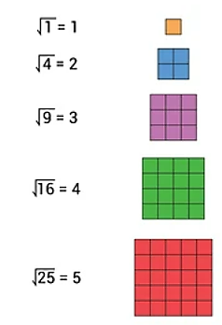

- Allow students to derive meaning through the construction of squares using concrete manipulatives and pictorial representations to observe the relationship between square roots and perfect squares. By extension, students can determine whether a perfect square exists using concrete manipulatives or grid paper with examples such as 62, 81, 99, 100, or 144 (where these numbers would represent areas of the possible squares).. Students can explore the structure of the tiles and discover similarities and differences between numbers such as 62 and 81.

- Have students create using tiles or draw representations of perfect squares on grid paper to represent their corresponding square root through 400. Questions (or statements) to elicit understanding of these representations may include –
  - How can you create a definition for a perfect square, using tiles?
  - Explain the difference between finding the square root and squaring a number.
  - Explain to a friend how to find the square root of a number.
  - Explain whether every number has a square root that is a whole number.

Mathematical Connections: A square root of a number is a number which, when multiplied by itself, produces the given number.

- To develop students’ understanding of this concept, provide them with values such as 0, 50, 125, 200, and 361 and ask them to determine whether the values are perfect squares; and provide a justification with their response. A common misconception students may have from the given values is assuming that even numbers are perfect squares because they can be divided by 2 to get a whole number. The values of 50 and 200, when divided by two, provide students with whole numbers.

- Students may make the error of adding a number to itself to get the perfect square value instead of multiplying it by itself. Teachers should emphasize a square root is a repeated factor of the perfect square, not a repeated addend. For example, 289 is a perfect square
since $\sqrt{289}$ = $\sqrt{17 ∙17}$ or ${17}^{2}$ = 17 ∙ 17 = 289. This shows the student the repeated factor of 17. Graph paper or an area model can be used to illustrate perfect squares, giving students a concrete and pictorial representation of these concepts. Creating opportunities such as these allow for students to recognize that squaring a number and taking a square root of a number are inverse operations.

Concepts and Connections
Concepts
There are multiple representations of numbers and relationships among numbers that provide meaning and structure and allow for sense-making.

Connections: In Grade 7, students will use their knowledge of exponents to investigate and describe powers of 10 by examining patterns (7.NS.1a). Prior to Grade 7, students recognized and represented patterns with whole number exponents and perfect squares (6.NS.3). Using this foundational understanding, students will recognize and describe the relationship between square roots and perfect squares (7.NS.3). In the subsequent grade level, Grade 8 students will Estimate and identify the two consecutive natural numbers between which the positive square root of a given number lies and justify which natural number is the better approximation (8.NS.1a); and, use rational approximations (to the nearest hundredth) of irrational numbers to compare, order, and locate values on a number line (8.NS.1b).

- Within the grade level/course:
  - 7.NS.1a – Investigate and describe powers of 10 with negative exponents by examining patterns.
- Vertical Progression:
  - 6.NS.3 – The student will recognize and represent patterns with whole number exponents and perfect squares.
  - 8.NS.1a – Estimate and identify the two consecutive natural numbers between which the positive square root of a given number lies and justify which natural number is the better approximation. Numbers are limited to natural numbers from 1 to 400.
  - 8.NS.1b – Use rational approximations (to the nearest hundredth) of irrational numbers to compare, order, and locate values on a number line. Radicals may include both positive and negative square roots of values from 0 to 400 yielding an irrational number.

Textbooks and HQIM for Consideration
- A list of approved textbooks and instructional materials will be posted on the VDOE website.

Computation and Estimation

In K-12 mathematics, computation and estimation are integral to developing mathematical proficiency. Computation refers to the process of performing numerical operations, such as addition, subtraction, multiplication, and division. It involves applying strategies and algorithms to solve arithmetic problems accurately and efficiently. Estimation is the process of obtaining a reasonable or close approximation of a result without performing an exact calculation. Estimation is particularly useful when an exact answer is not required, especially in real-world situations, and when assessing the reasonableness of an answer. Computation and estimation are used to support problem solving, critical thinking, and mathematical reasoning by providing students with a range of approaches to solve mathematics problems quickly and accurately.

In Grade 7, students use estimation and the operations of addition, subtraction, multiplication, and division to model, represent, and solve different types of problems with rational numbers. At this grade level, students solve multistep contextual problems with rational numbers and problems involving proportional relationships.

It is critical at this grade level that while students build their conceptual understanding through concrete and pictorial representations, that students also apply standard algorithms when performing operations as specified within the parameters of each standard of this strand. At this grade level, students become more efficient with problem solving strategies. Fluent use of standard algorithms not only depends on automatic retrieval (automaticity learned during the elementary grades), but also reinforces them. Automaticity further grounds students’ entry points and the structures needed to solve contextual problems and execute mathematical procedures with rational numbers.

7.CE.1 The student will estimate, solve, and justify solutions to multistep contextual problems involving operations with rational numbers.
Students will demonstrate the following Knowledge and Skills:
- Estimate, solve, and justify solutions to contextual problems involving addition, subtraction, multiplication, and division with rational numbers expressed as integers, fractions (proper or improper), mixed numbers, and decimals. Fractions may be positive or negative. Decimals may be positive or negative and are limited to the thousandths place.

Understanding the Standard
- The set of rational numbers includes the set of all numbers that can be expressed as fractions in the form $\frac{a}{b}$where a and b are integers and b does not equal zero. The decimal form of a rational number can be expressed as a terminating or repeating decimal. A few examples of rational numbers are: $\sqrt{25}$, −14, 2.3, 82, 75%, $0.\overline{7}$.
- The set of integers includes the set of whole numbers and their opposites {…-2, -1, 0, 1, 2, …}.
- Zero has no opposite and is neither positive nor negative.
- The opposite of a positive number is negative, and the opposite of a negative number is positive.
- Negative numbers lie to the left of zero and positive numbers lie to the right of zero on a number line.
- Smaller numbers always lie to the left of larger numbers on the number line.
- Proper fractions, improper fractions, and mixed numbers are terms often used to describe fractions. A proper fraction is a fraction whose numerator is less than the denominator. An improper fraction is a fraction whose numerator is equal to or greater than the denominator. An improper fraction may be expressed as a mixed number. A mixed number is written with two parts: a whole number and a proper fraction (e.g., $3\frac{3}{5}$).
- Solving problems in contextual situations enhances proficiency with estimation strategies. Contextual problems involving rational numbers in Grade 7 provide students with opportunities to use problem solving to apply computation skills involving positive and negative rational numbers expressed as integers, fractions, and decimals.

Skills in Practice
While the five process goals are expected to be embedded in each standard, the Skills in Practice highlight the most prevalent process goals in relation to the content presented.

Mathematical Problem Solving: Problem-solving requires both an ability to correctly define a problem and finding a solution to it. Model effective practices that demonstrate for students how to arrive at their solutions through estimation, exactness, and justification. To unpack contextual problems, guide students through the problem-solving process by taking care to annotate essential vocabulary (not “key words”) related to applied operations.

For example –
- Understand the problem by reading and then re-reading the problem; visualize the problem or draw a picture; underline or highlight the important information and essential vocabulary within the problem.
- Create a plan by deciding what to do and how to solve the problem using the applicable operation(s).
- Carry out the plan by showing all work to represent thinking (e.g., using symbols, words, concrete manipulatives, pictorial representations).
- Check the solution by determining if the solution answers the question asked in the contextual problem. During this phase of problem solving, it is essential that students are exposed to strategies that allow them to determine the reasonableness of their responses and solutions; and to support multiple mathematically sound and accurate ways of arriving at a solution.
- Graphic organizers such as the four-square model (Polya method) can help students to organize their thinking as they solve contextual problems –

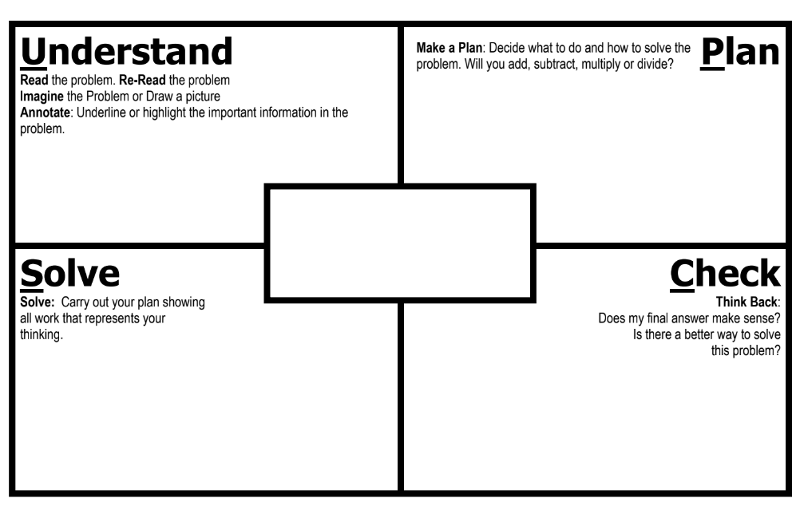

- As students solve contextual problems, ask questions such as –
  - Are there multiple ways to solve a single problem?
  - How do you know that you have provided a reasonable answer?
  - What role does estimation play in solving contextual problems?

Mathematical Communication: Recall multiple problem types learned at the elementary grades and apply to contextual problems as students advance in their understanding of more complex contextual problems and structures. Teach students a solution method for solving each problem type. Introduce a solution method using a worked-out example. Talk through the problem-solving process and connect the relevant problem information to the worked-out example. Say out loud the decisions that were made to solve the problem at each step. Then demonstrate how to apply the solution method by solving a similar problem with students using that method. Discuss each decision made and ask students guiding questions to engage them as problems are solved.

Mathematical Reasoning: Solving problems in contextual situations enhances proficiency with estimation strategies. Reasoning skills are essential for solving problems effectively and strategically. Reasoning involves analyzing information, identifying assumptions, evaluating evidence, and drawing logical conclusions. When solving problems in context, students may have difficulty understanding which operation(s) to use and may use the wrong operation(s) when solving. Students may not realize that all numbers in a contextual problem are not always needed. To help students derive meaning of which operation to apply, ask students how thinking about the meaning of addition can help when solving word problems. Give students a chance to explain individually and share their thoughts with each other. Repeat this process for subtraction, multiplication, and division. Have students explain the action of the word to move away from a reliance on “key words.” For example –
- Addition:
  - Finding the total quantity of separate quantities
  - Combining two or more quantities
- Subtraction:
  - Finding how much more or how much less
  - Finding how much further
  - Finding the difference between two quantities
  - Determining a quantity when taking one amount from another
- Multiplication:
  - Finding the quantity needed for x number of people or x number of something
  - Having equal groups and finding the total of all groups
  - Finding a part (fraction) of a whole number
  - Taking a part of a part (fraction of a fraction)
- Division:
  - Dividing an item (or quantity) into equal sized pieces
  - Dividing a quantity into equal groups
  - Using an equal amount of something over time
  - Determining how many fractional groups can be made from a quantity

Mathematical Connections: Students must connect fluency of facts, concepts, procedures, and mathematical language through mathematical reasoning to effectively solve contextual problems. Fluency with rational numbers at this grade level will help with improving logical reasoning skills, which will then lend themselves to solving contextual problems. In the following example, first, students must use their previous understanding of computation with rational numbers (e.g., decimals, percents, and fractions) to arrive at an exact solution. Next, students must apply their understanding of mathematical language to determine which operation(s) to use, and with this information, design a plan to solve the solution. Lastly, students must determine the reasonableness of their solution by providing their reasoning. Common misconceptions are given below when either fluency of facts, concepts, procedures, or misinterpretation of mathematical language can derail students’ provision of a correct response –
Micheal has $425.50 before he goes shopping. He spends 20% of it on groceries and then $\frac{2}{5}$ of the remaining amount on supplies for an art project. How much money does Michael have left over?
A common error students may make is determining how much money Joe has spent instead of how much he has left over. This may indicate students could benefit from more practice in determining what the question is asking and developing the steps needed to answer that question. Another common mistake students may make is to add 20% and $\frac{2}{5} or 40\%$ and then multiply the amount of money by 60% to determine what was spent. This demonstrates that students may not understand the correct sequence of calculations necessary to solve the problem. Creating a visual model will help students see the sequence of events and to justify the reasonableness of their solutions.

Concepts and Connections
Concepts
Estimation and the operations of addition, subtraction, multiplication, and division, allow us to model, represent, and solve different types of problems with rational numbers.

Connections: In Grade 7, students will solve problems involving proportional relationships (7.CE.2). Prior to Grade 7, students estimated, demonstrated, solved, and justified solutions to problems using operations with fractions and mixed numbers, including those in context (6.CE.1). Using these foundational understandings, students will solve contextual, multistep problems involving operations with rational numbers by estimation, solving, and justifying their solutions (7.CE.1). In the subsequent grade level, Grade 8 students will estimate and apply proportional reasoning and computational procedures to solve contextual problems (8.CE.1).

- Within the grade level/course:
  - 7.CE.2 – The student will solve problems, including those in context, involving proportional relationships.
- Vertical Progression:
  - 6.CE.1 – The student will estimate, demonstrate, solve, and justify solutions to problems using operations with fractions and mixed numbers, including those in context.
  - 8.CE.1 – The student will estimate and apply proportional reasoning and computational procedures to solve contextual problems.

Textbooks and HQIM for Consideration
- A list of approved textbooks and instructional materials will be posted on the VDOE website.

7.CE.2 The student will solve problems, including those in context, involving proportional relationships.
Students will demonstrate the following Knowledge and Skills:
- Given a proportional relationship between two quantities, create and use a ratio table to determine missing values.
- Write and solve a proportion that represents a proportional relationship between two quantities to find a missing value, including problems in context.
- Apply proportional reasoning to solve problems in context, including converting units of measurement, when given the conversion factor.
- Estimate and determine the percentage of a given whole number, including but not limited to the use of benchmark percentages.

Understanding the Standard
- A proportion is a statement of equality between two ratios. A proportion can be written as $\frac{a}{b}$ = $\frac{c}{d}$, a:b = c:d, or a is to b as c is to d.
- Equivalent ratios are created by multiplying each value in a ratio by the same constant value. For example, the ratio of 3:2 would be equivalent to the ratio 6:4 because each of the values in 3:2 can be multiplied by 2 to get 6:4.
- A ratio table is a table of values representing a proportional relationship that includes pairs of values that represent equivalent rates or ratios.
- In a proportional relationship, two quantities increase multiplicatively. One quantity is a constant multiple of the other.
- A proportion can be solved by determining the product of the means and the product of the extremes. For example, in the proportion a:b = c:d, a and d are the extremes and b and c are the means. If values are substituted for a, b, c, and d such as 5:12 = 10:24, then the product of extremes (5 ∙ 24) is equal to the product of the means (12 ∙ 10).
- A proportion can be solved by determining equivalent ratios. A proportion is an equation which states that two ratios are equal. When solving a proportion, the ratios may first be written as fractions.
  - Example: A recipe for oatmeal cookies calls for 2 cups of flour for every 3 cups of oatmeal. How much flour is needed for a larger batch of cookies that uses 9 cups of oatmeal? To solve this problem, the ratio of flour to oatmeal could be written as a fraction in the proportion used to determine the amount of flour needed when 9 cups of oatmeal is used. To use a proportion to solve for the unknown cups of flour needed, solve the proportion: $\frac{2}{3}= \frac{x}{9}$
To use a table of equivalent ratios to find the unknown amount, create the table. To complete the table, create an equivalent ratio to 2:3. Just as 4:6 is equivalent to 2:3, then 6 cups of flour to 9 cups of oatmeal would create an equivalent ratio.
flour (cups) | 2 | 4 | ?
oatmeal (cups) | 3 | 6 | 9
- Proportions are used in everyday contexts, such as speed, recipe conversions, scale drawings, map reading, reducing, and enlarging, comparison shopping, and monetary conversions.
- Proportions can be used to convert length, weight (mass), and volume (capacity) within and between measurement systems. For example, if 1 inch is equal to approximately 2.54 centimeters (cm), how many inches are in 16 cm?
$\frac{1 inch}{2.54 cm}$ = $\frac{x inch}{16 cm}$
$$2.54x=1∙16$$
$$2.54x=16$$
$$x=\frac{16}{2.54}$$
$x=$6.299 or about 6.3 inches
- Examples of conversions may include, but are not limited to:
  - Length: between feet and miles; miles and kilometers;
  - Weight: between ounces and pounds; pounds and kilograms; and
  - Volume: between cups and fluid ounces; gallons and liters.
- When converting measurement units in contextual situations, the precision of the conversion factor used will be determined by the accuracy required within the context of the problem. For example, when converting from miles to kilometers, a conversion factor of 1 mile ≈ 1.6 km or 1 mile ≈ 1.609 km may be used, depending upon the accuracy needed.
- Estimation may be used prior to calculating conversions to evaluate the reasonableness of a solution.
- A percent is a ratio in which the denominator is 100.
- Benchmark percentages may include 5%, 10%, 20%, 25%, 50%, and any multiples of 5%.
- Benchmark percentages and their equivalent fractions can be used as a point of reference. Double number lines can be used to easily interchange benchmark percentages and fractions. Values of benchmark percentages can be added, subtracted, or multiplied to calculate the value of other percentages.
- Common benchmark percentages can be used to determine tips.
  - Example: A customer decides to leave a 15% tip for a server. The customer could calculate 10% of the bill, and then calculate half of that, which is equal to 5%. Then the customer could add the two resulting values to obtain 15% of the bill.
- Proportions can be used to represent percent problems as follows: $\frac{percent}{100}$= $\frac{part}{whole}$

Skills in Practice
While the five process goals are expected to be embedded in each standard, the Skills in Practice highlight the most prevalent process goals in relation to the content presented.

Mathematical Problem Solving: When determining missing values in proportional relationships, including those in context, students may confuse the whole and the part when trying to write the proportion or incorrectly reverse the numerator and denominator in the ratios used to solve proportions. Encourage students to label the units, reminding them that the most important aspect of solving proportions is setting them up correctly. In the example below, care must be used in determining what unit of measure will be placed in the denominator of the first ratio. Once that is done, the second ratio in the proportion must be set up with like units of measure in the numerator and denominator. Students should be encouraged to set up ratio tables and use grid paper to create pictorial representations to help them develop the proportional relationships and assist them in correctly setting up proportions. For example –

Give each student a set of four red and six yellow color tiles or paper squares.

Ask students to state the ratio of red tiles to all the tiles in the set $(\frac{4}{10})$ and the ratio of yellow tiles to the whole set $(\frac{6}{10})$. Ask: “If the ratio stays the same, how many red tiles would be in a set of 100 tiles?” Remind students that the numerator of the ratio represents the part of the set and the denominator represents the whole set. When setting up a proportion, the second ratio must have the same type of numerator and the same type of denominator. For this problem, $\frac{4}{10}= \frac{n}{100}$. Using cross-multiplication, 10n = 400, so n = 40. Distribute a sheet of grid paper to each student, and help students use it to see this relationship by outlining 10 squares and shading four out of the 10 to represent the original ratio, as shown below.

Then, have students outline 100 squares and shade four out of each set of 10, as shown above.

Encourage students to continue to use grid pictures to helps them visualize various ratios or create a ratio table to further explore the relationship of red and yellow tiles.
Red tiles | 4
Yellow tiles | 6

Mathematical Reasoning:

- When applying proportional reasoning to solve problems in context, the following questions may elicit students’ understanding –
  - What does it mean for ratios to be proportional?
  - Can a proportion be solved in more than one way?
  - Does it matter where the missing term is located?
  - Can you think of an experience you have had and create a ratio table that relates to it?

- Superficial cues present in the context of a problem do not provide sufficient evidence of proportional relationships between quantities. When students are solving problems, they must base their decision to use proportional reasoning on the nature of the quantities in a particular situation. However, students may rely on the following superficial cues to determine proportionality:
  - The problem gives three numbers, and one other number is missing; or
  - The problem involves vocabulary such as per, rate, or speed.

Mathematical Connections:

- A common misconception students may have is thinking that a proportional relationship is additive, instead of multiplicative. Practice finding equivalent ratios and finding missing values in a ratio table is a strategy used to help students understand this connection.

- Proportionality involves grasping the meaning of a ratio as a multiplicative comparison and as a composed unit and making connections among ratios, fractions, and quotients.

*Reference 7.CE.1 Skills in Practice for guidance related to Mathematical Problem-Solving, Mathematical Communication, Mathematical Reasoning, and Mathematical Connections when solving contextual problems.

Concepts and Connections
Concepts
Estimation and the operations of addition, subtraction, multiplication, and division, allow us to model, represent, and solve different types of problems with rational numbers.

Connections: In Grade 7, students will estimate, solve, and justify solutions to multistep contextual problems involving operations with rational numbers (7.CE.1) and justify relationships of similarity using proportional reasoning (7.MG.2). Graphical representation of proportionality is extended at this grade level as students will investigate and analyze proportional relationships between two quantities using verbal descriptions, tables, equations in y = mx form, including problems in context (7.PFA.1). Prior to Grade 7, students used ratios to represent relationships between quantities, including those in context (6.PFA.1) and identified and represented proportional relationships between two quantities, including those in context (with unit rates limited to positive values) (6.PFA.2). Using these foundational understandings, students will solve problems, including those in context, involving proportional relationships (7.CE.2). In the subsequent grade level, Grade 8 students will estimate and apply proportional reasoning and computational procedures to solve contextual problems (8.CE.1).

- Within the grade level/course:
  - 7.CE.1 – The student will estimate, solve, and justify solutions to multistep contextual problems involving operations with rational numbers.
  - 7.MG.2 - The student will solve problems and justify relationships of similarity using proportional reasoning.
  - 7.PFA.1 – The student will investigate and analyze proportional relationships between two quantities using verbal descriptions, tables, equations in y = mx form, and graphs, including problems in context.
- Vertical Progression:
  - 6.PFA.1 – The student will use ratios to represent relationships between quantities, including those in context.
  - 6.PFA.2 – The student will identify and represent proportional relationships between two quantities, including those in context (unit rates are limited to positive values).
  - 8.CE.1 – The student will estimate and apply proportional reasoning and computational procedures to solve contextual problems.

Textbooks and HQIM for Consideration
- A list of approved textbooks and instructional materials will be posted on the VDOE website.

Measurement and Geometry
In K-12 mathematics, measurement and geometry allow students to gain understanding of the attributes of shapes as well as develop an understanding of standard units of measurement. Measurement and geometry are imperative as students develop a spatial understanding of the world around them. The standards in the measurement and geometry strand aim to develop students’ special reasoning, visualization, and ability to apply geometric and measurement concepts in real-world situations.

In Grade 7, students analyze and describe geometric objects, the relationships and structures among them, or the space that they occupy to classify, measure, or count one or more attributes. At this grade level, students solve problems involving volume and surface area of rectangular prisms and right cylinders, as well as justify relationships of similarity using proportional reasoning. Students will also compare and contrast quadrilaterals based on their properties and determine unknown side lengths and angle measures. Graphically, students apply dilations of polygons in the coordinate plane.

7.MG.1 The student will investigate and determine the volume formula for right cylinders and the surface area formulas for rectangular
prisms and right cylinders and apply the formulas in context.
Students will demonstrate the following Knowledge and Skills:
- Develop the formulas for determining the volume of right cylinders and solve problems, including those in contextual situations, using concrete objects, diagrams, and formulas.
- Develop the formulas for determining the surface area of rectangular prisms and right cylinders and solve problems, including those in contextual situations, using concrete objects, two-dimensional diagrams, nets, and formulas.
- Determine if a problem in context, involving a rectangular prism or right cylinder, represents the application of volume or surface area.
- Describe how the volume of a rectangular prism is affected when one measured attribute is multiplied by a factor of $\frac{1}{4}$, $\frac{1}{3}$, $\frac{1}{2}$, 2, 3, or 4, including those in contextual situations.
- Describe how the surface area of a rectangular prism is affected when one measured attribute is multiplied by a factor of $\frac{1}{2}$ or 2, including those in contextual situations.

Understanding the Standard
- A polyhedron is a solid figure whose faces are all polygons.
- A rectangular prism is a polyhedron in which all six faces are rectangles. A rectangular prism has eight vertices and 12 edges.
- A cylinder is a solid figure formed by two congruent parallel faces called bases joined by a curved surface. At this grade level, cylinders are limited to right circular cylinders, where the axis joining the two centers of the bases is perpendicular to the bases.
- A face is any flat surface of a solid figure.
- The surface area of a prism is the sum of the areas of all six faces and is measured in square units.
- The volume of a three-dimensional figure is a measure of capacity and is measured in cubic units.
- Nets are two-dimensional representations of a three-dimensional figure that can be folded into a model of the three-dimensional figure.
- A rectangular prism can be represented on a flat surface as a net that contains six rectangles — two that have areas of the measures of the length and width of the base, two others that have areas of the measures of the length and height, and two others that have areas of the measures of the width and height. The surface area of a rectangular prism is the sum of the areas of all six faces (SA = 2lw + 2lh + 2wh).
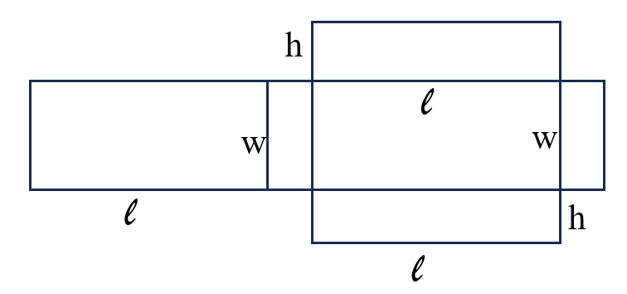
- It is helpful for students to use nets to explore the development of the formula for surface area. Students may find the sum of the faces of a rectangular prism and develop this expanded formula for surface area as:

SA = (lw)+(lw)+(lh)+(lh)+(wh)+(wh) = 2lw + 2lh + 2wh.

- A cylinder can be represented on a flat surface as a net that contains two circles (the bases of the cylinder) and one rectangular region (the curved surface of the cylinder) whose length is the circumference of the circular base and whose width is the height of the cylinder. The surface area of the cylinder is the sum of the area of the two circles and the rectangle representing the curved surface.
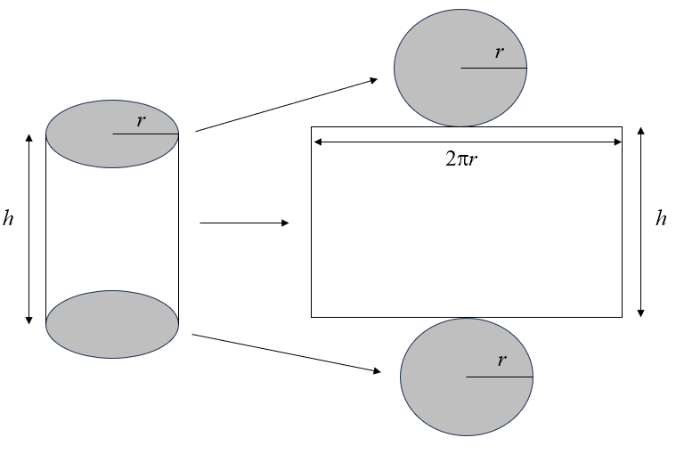
- When using the net of a cylinder and its labeled dimensions (radius and height) when developing a formula, students may find the sum of the two circular bases as ${πr}^{2}+ {πr}^{2}$. They may need to manipulate the net to form the 3-dimensional cylinder to discover that the width of the rectangular portion of the net is the circumference of the circle (2πr) and the length is the height of the cylinder. Their developed formula may look like this:

Surface Area (SA) = ${πr}^{2}+ {πr}^{2}$ + 2πrh.

- The volume of a rectangular prism is computed by multiplying the area of the base, B, (length times width) by the height of the prism (V = Bh = lwh).
- The volume of a cylinder is computed by multiplying the area of the base, B, (${πr}^{2}$) by the height of the cylinder (V = ${πr}^{2}h$ = Bh).
- When developing the formula for volume of rectangular prisms, using centimeter cubes is helpful to facilitate the understanding that the volume can be found by finding the area of the base and multiplying it by its number of layers (height). This idea can then be applied to cylinders for students to discover that the volume is found by multiplying the area of the circular base by the height of the cylinder.
- The calculation of determining surface area and volume may vary depending upon the approximation for pi (π) that is used. Common approximations for π include 3.14 or $\frac{22}{7}$.
- When the measurement of one attribute of a rectangular prism is changed through multiplication or division the volume increases by the same factor by which the attribute increased.
- Example: If a prism has a volume of 2 • 3 • 4, the volume is 24 cubic units. However, if one of the attributes is doubled, the volume doubles. That is, 2 • 3 • 8, the volume is 48 cubic units, or 24 cubic units doubled. This is an application of proportional reasoning.

Skills in Practice
While the five process goals are expected to be embedded in each standard, the Skills in Practice highlight the most prevalent process goals in relation to the content presented.

Mathematical Problem Solving:

- Stress that there are four steps to solving contextual problems related to volume and surface area: determining which application should be used (when not explicitly stated to find the volume or the surface area), writing the formula, substituting the values, and solving including proper units.

- The Middle School Mathematics Formula Sheet should be used in tandem with this standard to help students use the appropriate formula when solving stand-alone problems or problems in context.

- Questions to further elicit students’ understanding of this standard are –
  - How do you determine the surface area and volume of a cylinder?
  - How do you determine the surface area and volume of a rectangular prism?
  - How are volume and surface area related? How are they different?
  - What is volume? Why is volume measured in cubic units?
  - What is surface area? Why is surface area measured in square units?

Mathematical Reasoning: Students must understand that when solving contextual problems, they must look for essential vocabulary to determine whether the problem is requiring applications of volume or surface area. Contexts such as filling a tank (volume) or wrapping a present (surface area) are not always explicitly written in the phrasing like “find the volume or surface area of x figure.” Therefore, students should have exposure to problems that are in context as these represent real-world applications of surface area and volume. For example –

- Display two solids made from linking cubes. One might be a rectangular prism while the other might be an irregular solid. Ask the students to sketch and compare these two solid figures. Ask: “Which has the greater surface area? Which has the greater volume? How can you tell?” Allow students to manipulate the two solids. Have them write down strategies for determining surface area and volume as well as for comparing the surface areas and volumes of the two solids.

  - Have students share their various strategies for determining surface area and volume. Ask them to decide which figure has the greater surface area and which has the greater volume. Reinforce that square units describe surface area and cubic units describe volume.

  - Display a 2 x 3 x 4 rectangular prism made from linking cubes. Ask students to sketch this solid and explain in writing how to measure its surface area and volume. Also, ask them to explain in writing how measuring surface area and volume are similar and how they are different.

- Real-world examples include –

  - Pretend that you are painting a cylinder-shaped water tank. Explain how the formula would change if you do not need to paint the bottom of the tank.

  - Provide real-life items and ask the students to determine the volume and surface area (e.g., soft drink can, potato chip can, oatmeal container, cereal box, shoe box). Students can use a ruler to determine the measurements.

Mathematical Connections:

- Nets should be used to create connections between the two-dimensional representation of a three-dimensional figure for students to develop formulas for determining the volume of right cylinders; and determining the surface area of rectangular prisms and right cylinders. The use of nets will allow students the opportunity to unpack problems when given in context while providing teachers the ability to work through misconceptions that students may have with this concept. For example –

The net below could be used to form a rectangular prism. Using the net, determine the surface area of the figure.
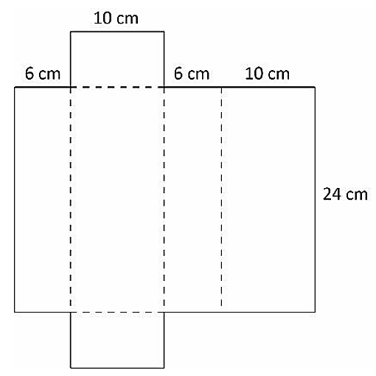
A common error a student may make is incorrectly identifying the length, width, and height of the figure. They may use one of the numbers more than once, resulting in an incorrect answer. This may indicate a need to emphasize vocabulary associated with rectangular prisms and the formula for surface area. When determining the surface area of a rectangular prism, it might be helpful for the student to label which values they will use as the length, width, and height. Teachers are encouraged to provide students with concrete nets of three-dimensional figures before transitioning to the pictorial representation to support students with misconceptions and errors about the dimensions of such figures.

- Use of concrete nets or pictorial representations of nets help students understand that a cylinder can be represented on a flat surface as a net that contains two circles (the bases of the cylinder) and one rectangular region (the curved surface of the cylinder) whose length is the circumference of the circular base and whose width is the height of the cylinder. Create nets on graph paper and ask students to measure and determine the volume and surface area of the given shapes. The surface area of the cylinder is the sum of the area of the two circles and the rectangle representing the curved surface.

- When developing the formula for volume of rectangular prisms, using centimeter cubes is helpful to facilitate the understanding that the volume can be found by finding the area of the base and multiplying it by its number of layers (height). This idea can then be applied to cylinders for students to discover that the volume is found by multiplying the area of the circular base by the height of the cylinder.

Mathematical Representations: Using linking cubes (tactile), grid paper (pictorial), and technology platforms (virtual manipulation) can help students understand the relationship between the initial volume or surface area and what occurs when a measurement of one attribute of a rectangular prism is changed through multiplication or division. A contextual example is given with common misconceptions below–

A movie theater sells two sizes of popcorn, large and small, in bags shaped like rectangular prisms. The large bag has a height of 9 inches, a length of 6 inches, and a width of 4 inches. The small bag has the same width and length as the large bag, but one-third of the volume. What is the height of the small bag?

- A common error students may make is multiplying the height of the larger bag by three, resulting in an incorrect answer of 27 inches. This may indicate a need to review vocabulary such as double, triple, quadruple, or multiplication by a factor of $\frac{1}{4}$ , $\frac{1}{3}$ , or $\frac{1}{2}$ . Care should be taken to provide additional practice with practical applications involving this vocabulary and these factors.

- A common error students may make is calculating the volume of the small bag, rather than finding the height. This error may indicate a need to emphasize vocabulary associated with rectangular prisms and the components of the formula. Students should be encouraged to reference the Middle School Mathematics Formula Sheet.

Concepts and Connections
Concepts
Analyzing and describing geometric objects, the relationships and structures among them, or the space that they occupy can be used to classify, quantify, measure, or count one or more attributes.

Connections: In Grade 7, students will solve problems and justify relationships of similarity using proportional reasoning (7.MG.2); make connections, compare, and contrast polygons based on their properties (7.MG.3); and apply dilations of polygons in the coordinate plane (7.MG.4). Prior to Grade 7, students identified the characteristics of circles and solve problems, including those in context, involving circumference and area (6.MG.1) and area and perimeter of triangles and parallelograms (6.MG.2). Using these foundational understandings, students will investigate and determine the volume formula for right cylinders and the surface area formulas for rectangular prisms and right cylinders and apply the formulas in context (7.MG.1). In the subsequent grade level, Grade 8 students will investigate and determine the surface area of square-based pyramids and the volume of cones and square-based pyramids (8.MG.2).

- Within the grade level/course:
  - 7.MG.2 – The student will solve problems and justify relationships of similarity using proportional reasoning.
  - 7.MG.3 – The student will compare and contrast quadrilaterals based on their properties and determine unknown side lengths and angle measures of quadrilaterals.
  - 7.MG.4 – The student will apply dilations of polygons in the coordinate plane.
- Vertical Progression:
  - 6.MG.1 – The student will identify the characteristics of circles and solve problems, including those in context, involving circumference and area.
  - 6.MG.2 – The student will reason mathematically to solve problems, including those in context, that involve the area and perimeter of triangles and parallelograms.
  - 8.MG.2 The student will investigate and determine the surface area of square-based pyramids and the volume of cones and square-based pyramids.

Textbooks and HQIM for Consideration
- A list of approved textbooks and instructional materials will be posted on the VDOE website.

7.MG.2 The student will solve problems and justify relationships of similarity using proportional reasoning.
Students will demonstrate the following Knowledge and Skills:
- Identify corresponding congruent angles of similar quadrilaterals and triangles, through the use of geometric markings.
- Identify corresponding sides of similar quadrilaterals and triangles.
- Given two similar quadrilaterals or triangles, write similarity statements using symbols.
- Write proportions to express the relationships between the lengths of corresponding sides of similar quadrilaterals and triangles.
- Recognize and justify if two quadrilaterals or triangles are similar using the ratios of corresponding side lengths.
- Solve a proportion to determine a missing side length of similar quadrilaterals or triangles.
- Given angle measures in a quadrilateral or triangle, determine unknown angle measures in a similar quadrilateral or triangle.
- Apply proportional reasoning to solve problems in context including scale drawings. Scale factors shall have denominators no greater than 12 and decimals no less than tenths.

Understanding the Standard
- Congruent polygons have the same size and shape. In congruent polygons, corresponding angles and sides are congruent.
- Congruent polygons are similar polygons for which the ratio of the corresponding sides is 1:1. However, similar polygons are not necessarily congruent.
- The symbol ≅ is used to represent congruence. For example, ∠A ≅ ∠B is read as “Angle A is congruent to Angle B.”
- Similar polygons have corresponding sides that are proportional and corresponding interior angles that are congruent.
- Similarity has contextual applications in a variety of areas, including art, architecture, and the sciences.
- Similarity does not depend on the position or orientation of the figures.
- The symbol ~ is used to represent similarity. For example, ∆ABC ~ ∆DEF is read as “Triangle ABC is similar to triangle DEF.”
- Similarity statements can be used to determine corresponding parts of similar figures.
Example: Given: ∆ABC ~ ∆DEF
∠A corresponds to ∠D
$\overline{AB}$ corresponds to $\overline{DE}$
- A proportion representing corresponding sides of similar figures can be created.
  - Example: Given two similar quadrilaterals with corresponding angles labeled, write a proportion involving corresponding sides.
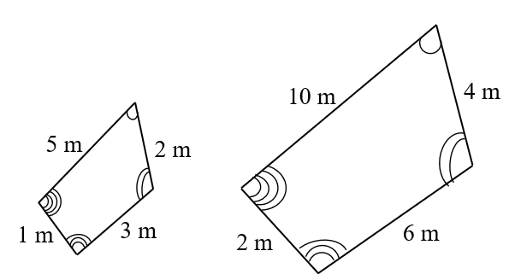
  - Some ways to express the proportional relationships between these two figures are $\frac{5}{10}=\frac{2}{4}$ or $\frac{5}{10}=\frac{3}{6}$ or $\frac{1}{2}=\frac{2}{4}$.
- The traditional notation for marking congruent angles is to use a curve on each angle. Congruent angles are denoted with the same number of curved lines. For example, if ∠A is congruent to ∠C, then both angles will be marked with the same number of curved lines.
- Congruent sides are denoted with the same number of hatch (or hash) marks on each congruent side. For example, a side on a polygon with two hatch marks is congruent to the side with two hatch marks on a congruent polygon or within the same polygon.
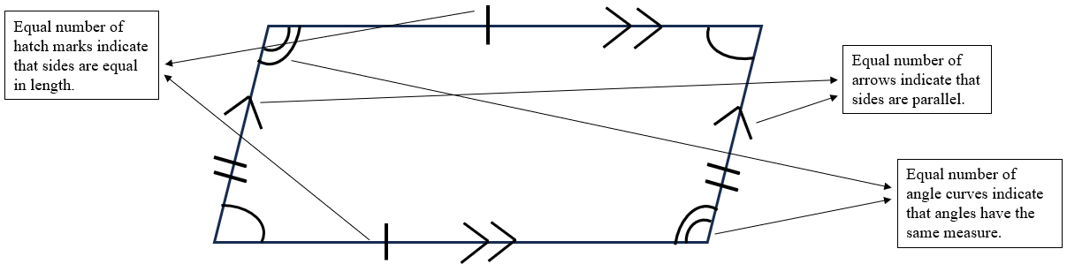

Skills in Practice
While the five process goals are expected to be embedded in each standard, the Skills in Practice highlight the most prevalent process goals in relation to the content presented.

Mathematical Connections:

- Students must understand that two figures are congruent if and only if they can map one onto the other using rigid transformations. Since rigid transformations preserve both distance and angle measure, all corresponding sides and angles are congruent.

- Students must understand that similar figures have the same shape, corresponding angles are congruent, and the ratios of the lengths of their corresponding sides are equal. For example, consider the two trapezoids below. The angles are corresponding and congruent, and so are the sides. The sides also have ratios of the same lengths. Because of this, it can be said that ABCD ∼ EFGH. However, it is important for students to make the connection that the order of the letters matters. While ABCD may be similar to EFGH, it is not similar to EHGF.
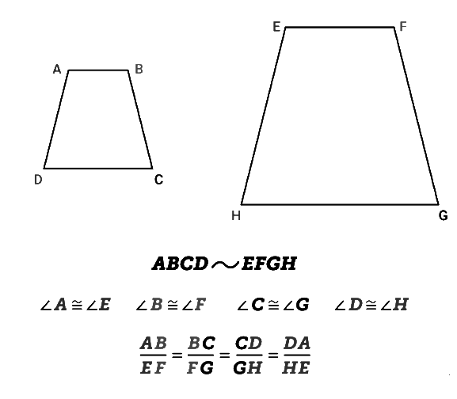
- The same holds true when determining unknown angle measures in a quadrilateral or triangle in a similar quadrilateral or triangle – students must understand that order matters and not be distracted by figure orientation. For example –

Quadrilateral HOME is similar to quadrilateral TRAP. What is the measure of angle M?
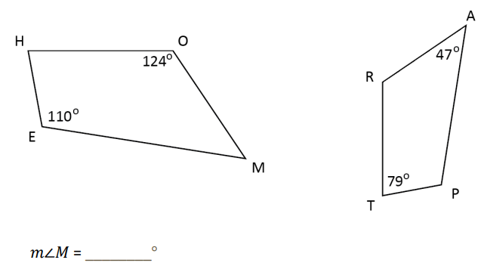
A common error a student may make is incorrectly identifying the measure of ∠𝑀 as 79 degrees. This may indicate that a student does not understand how to use a statement of similarity to identify corresponding parts and angle measures. It might be helpful for students to number or color-code the corresponding angles before calculating angle measures. Care should be taken to review properties of quadrilaterals as well as developing the understanding that similar polygons have corresponding sides that are proportional and corresponding angles that are congruent.

- To ensure that students understand the difference between congruence and similarity, engage them in the following questions (or statements) –
  - What makes two figures similar?
  - How do polygons that are similar compare with polygons that are congruent?
  - Explain whether a figure can be similar with only one corresponding angle congruent.
  - True or false – “Corresponding angles and sides in the same relative position are similar.” Provide an explanation and a picture to prove your response.

- Allow students to create similar and congruent figures on geoboards and note how the figures are either similar or congruent using corresponding parts and proportions.

Mathematical Representations:

- When using pictorial representations of similar figures, it is helpful to color-code corresponding sides and corresponding angles. When doing so, ensure that students apply the appropriate markings and represent similarity or congruence using the correct symbols to show relationships (~ or $≅$) or parts of figures (e.g., segments or angle notations).

- Use a color-coded figure and shadow it with a similar figure of another color to assist in finding corresponding sides and angles.

- A common misconception students may have is to incorrectly think that figures are not congruent or similar because they have been rotated or are not shown in the same orientation. To correct this misconception, have students to sort figures into pairs and discover the relationship between figures that are similar or congruent and justify their reasoning. For example, after reviewing the sets of triangles, ask students to pair up the triangles that are related in some way, explaining that for each triangle, there is another that is like it in one way or another. Have students write down the triangle pairs they matched and an explanation of why they paired the triangles the way they did.
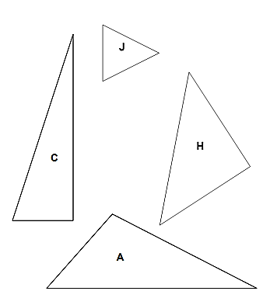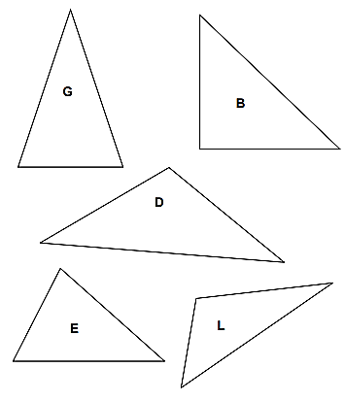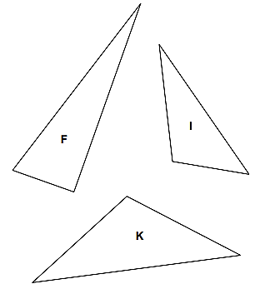

Concepts and Connections
Concepts
Analyzing and describing geometric objects, the relationships and structures among them, or the space that they occupy can be used to classify, quantify, measure, or count one or more attributes.

Connections: In Grade 7, students will solve problems, including those in context, involving proportional relationships (7.CE.2). Students at this grade level will also make connections, compare and contrast polygons based on their properties (7.MG.3) and apply dilations of polygons in the coordinate plane (7.MG.4). Graphical representation of proportionality is extended at this grade level where students investigate and analyze proportional relationships between two quantities using verbal descriptions, tables, equations in y = mx form, including problems in context (7.PFA.1). Prior to Grade 7, students used ratios to represent relationships between quantities, including those in context (6.PFA.1) and identified and represented proportional relationships between two quantities, including those in context (with unit rates limited to positive values) (6.PFA.2). Further, students determined congruence of segments, angles, and polygons (6.MG.4). Using these foundational understandings, students will solve problems and justify relationships of similarity using proportional reasoning (7.MG.2). In the subsequent grade level, Grade 8 students will estimate and apply proportional reasoning and computational procedures to solve contextual problems (8.CE.1).

- Within the grade level/course:
  - 7.CE.2 – The student will solve problems, including those in context, involving proportional relationships.
  - 7.MG.3 – The student will compare and contrast quadrilaterals based on their properties and determine unknown side lengths and angle measures of quadrilaterals.
  - 7.MG.4 – The student will apply dilations of polygons in the coordinate plane.
  - 7.PFA.1 – The student will investigate and analyze proportional relationships between two quantities using verbal descriptions, tables, equations in y = mx form, and graphs, including problems in context.
- Vertical Progression:
  - 6.MG.4 – The student will determine congruence of segments, angles, and polygons.
  - 6.PFA.1 – The student will use ratios to represent relationships between quantities, including those in context.
  - 6.PFA.2 – The student will identify and represent proportional relationships between two quantities, including those in context (unit rates are limited to positive values).
  - 8.CE.1 – The student will estimate and apply proportional reasoning and computational procedures to solve contextual problems.

Textbooks and HQIM for Consideration
- A list of approved textbooks and instructional materials will be posted on the VDOE website.

7.MG.3 The student will compare and contrast quadrilaterals based on their properties and determine unknown side lengths and angle
measures of quadrilaterals.
Students will demonstrate the following Knowledge and Skills:
- Compare and contrast properties of the following quadrilaterals: parallelogram, rectangle, square, rhombus, and trapezoid:
  - parallel/perpendicular sides and diagonals;
  - congruence of angle measures, side, and diagonal lengths; and
  - lines of symmetry.
- Sort and classify quadrilaterals as parallelograms, rectangles, trapezoids, rhombi, and/or squares based on their properties:
  - parallel/perpendicular sides and diagonals;
  - congruence of angle measures, side, and diagonal lengths; and
  - lines of symmetry.
- Given a diagram, determine an unknown angle measure in a quadrilateral, using properties of quadrilaterals.
- Given a diagram, determine an unknown side length in a quadrilateral using properties of quadrilaterals.

Understanding the Standard
- A polygon is a closed plane figure composed of at least three line segments that do not cross.
- A quadrilateral is a polygon with four sides.
- Properties of quadrilaterals include the number of parallel sides, angle measures, number of congruent sides, lines of symmetry, and the relationship between the diagonals.
- A diagonal is a segment in a polygon that connects two vertices but is not a side.
- To bisect means to divide into two equal parts. A midpoint is the point where a line segment is divided into two congruent segments.
- A line of symmetry divides a figure into two congruent parts, each of which is the mirror image of the other. Lines of symmetry are not limited to horizontal and vertical lines.
- Parallel lines lie in the same plane and never intersect. Parallel lines are always the same distance apart and do not share any points. Therefore, parallel lines have the same slope.
- Perpendicular lines intersect at right angles.
- Adjacent sides are any two sides of a figure that share a common vertex.
- A parallelogram is a quadrilateral with both pairs of opposite sides parallel. Properties of a parallelogram include the following:
  - opposite sides are parallel and congruent;
  - opposite angles are congruent; and
  - diagonals bisect each other and one diagonal divides the figure into two congruent triangles.
- Parallelograms, with the exception of rectangles and rhombi, have no lines of symmetry. A rectangle and a rhombus have two lines of symmetry, with the exception of a square which has four lines of symmetry.
- A rectangle is a quadrilateral with four right angles. Properties of a rectangle include the following:
  - opposite sides are parallel and congruent;
  - all four angles are congruent and each angle measures 90°; and
  - diagonals are congruent and bisect each other.
- A rhombus is a quadrilateral with four congruent sides. Properties of a rhombus include the following:
  - all sides are congruent;
  - opposite sides are parallel;
  - opposite angles are congruent; and
  - diagonals bisect each other at right angles.
- A square is a quadrilateral that is a regular polygon with four congruent sides and four right angles. A square is a special type of a rectangle and a rhombus. Properties of a square include the following:
  - opposite sides are congruent and parallel;
  - all four angles are congruent and each angle measures 90°; and
  - diagonals are congruent and bisect each other at right angles.
- A square has four lines of symmetry. The diagonals of a square coincide with two of the lines of symmetry that can be drawn, as shown in the image below.
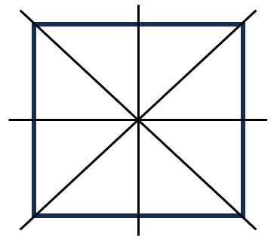
- A trapezoid is a quadrilateral with exactly one pair of parallel sides. The parallel sides of a trapezoid are called bases. The nonparallel sides of a trapezoid are called legs.
- An isosceles trapezoid has legs of equal length and congruent base angles. An isosceles trapezoid has one line of symmetry, as shown in the image below.
- A chart, graphic organizer, or Venn diagram can be used to organize quadrilaterals according to properties such as sides and/or angles.
- Quadrilaterals can be classified by the number of parallel sides: parallelograms, rectangles, rhombi, and squares each have two pairs of parallel sides; trapezoids have one pair of parallel sides; other quadrilaterals have no parallel sides.
- Quadrilaterals can be classified by the measures of the angles: rectangles and squares have four 90° angles; trapezoids may have zero or two 90° angles.
- Quadrilaterals can be classified by the number of congruent sides: rhombi and squares have four congruent sides; parallelograms and rectangles have two pairs of congruent sides; isosceles trapezoids have one pair of congruent sides.
- Any figure that has the properties of more than one subset of quadrilaterals can belong to more than one subset (e.g., a square can belong to the subset of squares, the subset of rhombi, the subset of rectangles, and the subset of parallelograms).
- The sum of the measures of the interior angles of a quadrilateral is 360°. Properties of quadrilaterals can be used to find unknown angle measures in a quadrilateral.

Skills in Practice
While the five process goals are expected to be embedded in each standard, the Skills in Practice highlight the most prevalent process goals in relation to the content presented.

Mathematical Connections:

- A chart, graphic organizer, or Venn diagram can be used to organize quadrilaterals according to properties such as sides and/or angles. Students may confuse the names of the different types of quadrilaterals. Students may not understand that a square is also a rectangle and a rhombus. Students may assume that all rectangles are squares or that all rhombi are squares. Therefore, when using graphic organizers like those provided below, incorporate activities like “Always, Sometimes, Never,” to help students not only recognize the properties of individual quadrilaterals, but also compare and contrast them.

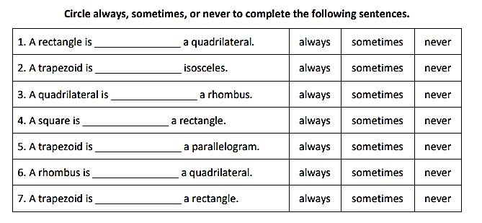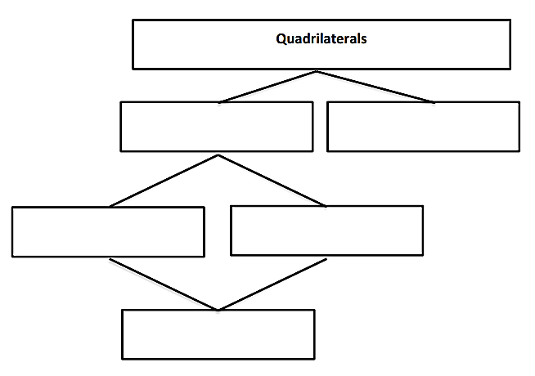

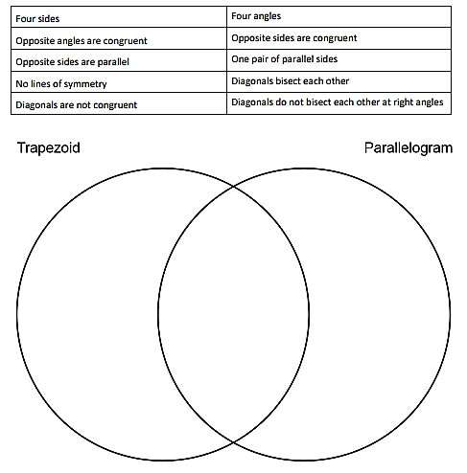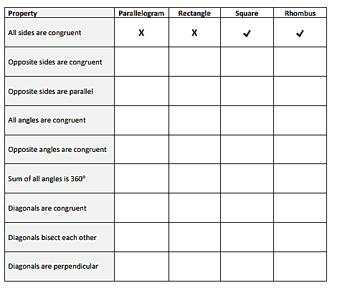
- To ensure that students understand the various properties, engage them in the following questions or notes to differentiate quadrilaterals –
  - Describe the three ways in which you can classify quadrilaterals by their attributes. Give examples.
  - Explain why all squares are rectangles but not all rectangles are squares.
  - Explain why all squares are rhombi, but not all rhombi are squares.
  - Explain the relationships among a rectangle, a rhombus, and a square.
  - Given an attribute, ask students to locate all of the quadrilaterals that have that attribute.
  - Given a shape, ask students to provide all names that apply to the shape.

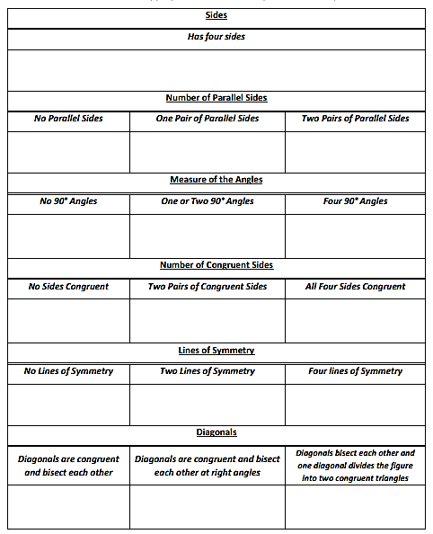

Concepts and Connections
Concepts
Analyzing and describing geometric objects, the relationships and structures among them, or the space that they occupy can be used to classify, quantify, measure, or count one or more attributes.

Connections: In Grade 7, students will solve problems and justify relationships of similarity using proportional reasoning (7.MG.2). Prior to Grade 7, in the elementary grades (particularly at grade 4), students classified and described quadrilaterals using specific properties and attributes (4.MG.5). Using these foundational understandings, students will compare and contrast quadrilaterals based on their properties and determine unknown side lengths and angle measures of quadrilaterals (7MG.3). These concepts are extended to Geometry where students will prove and justify theorems and properties of quadrilaterals, and verify and use properties of quadrilaterals to solve problems, including the relationships between the sides, angles, and diagonals (G.PC.1).

- Within the grade level/course:
  - 7.MG.2 – The student will solve problems and justify relationships of similarity using proportional reasoning.
- Vertical Progression:
  - 4.MG.5 – The student will classify and describe quadrilaterals (parallelograms, rectangles, squares, rhombi, and/or trapezoids) using specific properties and attributes.
  - G.PC.1 – The student will prove and justify theorems and properties of quadrilaterals, and verify and use properties of quadrilaterals to solve problems, including the relationships between the sides, angles, and diagonals.

Textbooks and HQIM for Consideration
- A list of approved textbooks and instructional materials will be posted on the VDOE website.

7.MG.4 The student will apply dilations of polygons in the coordinate plane.
Students will demonstrate the following Knowledge and Skills:
- Given a preimage in the coordinate plane, identify the coordinates of the image of a polygon that has been dilated. Scale factors are limited to $\frac{1}{4}$, $\frac{1}{2}$, 2, 3, or 4. The center of the dilation will be the origin.
- Sketch the image of a dilation of a polygon limited to a scale factor of $\frac{1}{4}$, $\frac{1}{2}$, 2, 3, or 4. The center of the dilation will be the origin.
- Identify and describe dilations in context including, but not limited to, scale drawings and graphic design.

Understanding the Standard
- A transformation of a figure, called the preimage, changes the size, shape, and/or position of the figure to a new figure, called the image.
- A transformation of preimage point A can be denoted as the image A’ (read as “A prime”).
- A dilation is a transformation in which an image is formed by enlarging or reducing the preimage proportionally by a scale factor from the center of dilation (limited to the origin in Grade 7).
- A dilation of a figure and the original figure are similar. The center of dilation may or may not be on the preimage. This concept can be connected to the study of similar figures and scale drawings.
- Contextual applications of dilations may include, but are not limited to, the following:
  - A model airplane is the production model of the airplane.
  - Photographs are resized by enlarging or reducing the image.
- Blueprints of a building are a scale drawing of the actual building.

Skills in Practice
While the five process goals are expected to be embedded in each standard, the Skills in Practice highlight the most prevalent process goals in relation to the content presented.

Mathematical Connections:

- To elicit students’ understanding, ask the following questions and provide opportunities for students to explore what occurs with a polygon when it is dilated with a scale factor greater than 1 and less than 1. For example –
  - What is the difference between a scale factor less than 1 and greater than 1?
  - How do you know, and what happens to the image?

- To further this understanding, examples have been provided below along with misconceptions students may have when dilating polygons in the coordinate plane. Use examples of this type to engage in student discourse and compare and contrast what occurs with the polygons from preimage to image –

  - Triangle ABC is shown on the grid. Identify the coordinates of the image of triangle ABC after a dilation about the origin by a scale factor of 2.
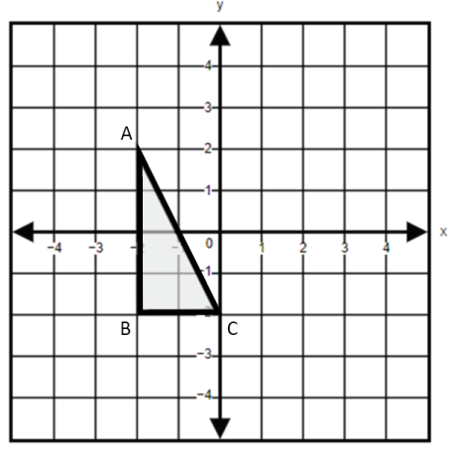

A common error a student may make is adding two to each coordinate. This may indicate a need to emphasize vocabulary associated with dilations and that a scale factor represents multiplying by a constant. When dilating a figure in the coordinate plane, it may be helpful for teachers to encourage a deeper understanding of the value of the scale factor and its effect on the figure. A scale factor greater than 1 will increase the size of the original figure whereas a scale factor less than 1 will produce a resulting figure that is smaller than the original. Teachers are encouraged to demonstrate dilations using technology.

- Graph quadrilateral PQRS. The vertices are located at (-2, 4), (2, 4), (-2, -4), and (2, -4). Graph the image of quadrilateral PQRS after a dilation about the origin by a scale factor of $\frac{1}{4}$.

A common error a student may make is multiplying each coordinate by 4. This may indicate that the student does not understand the vocabulary of scale factor. Teachers are encouraged to develop a conceptual understanding of scale factor by using real-world examples, such as model cars, scale drawings, etc.

Mathematical Representations: Students may confuse the x- and y-coordinates when recording the ordered pair for the new point. Students may confuse the terms image and preimage. Students may have difficulty multiplying by a fractional scale factor. An activity such as the one described below may be beneficial to students having difficulty representing dilations in the coordinate plane –
- Have students graph the given coordinates A, B, C, and D and connect the dots. Ask, “What shape did you draw?” (rectangle). Have them determine how long sides AB and AD are in grid units and record these lengths in the chart. Ask students to fill in the second row of coordinates by multiplying both coordinates of each point in the first row by 2. Have students predict what they think this new shape will look like.

- Then, have them plot the new coordinates and label the new coordinates A′, B′, C′, and D′ (the prime sign is used to indicate that a point belongs to an image). Ask them to describe the new shape (it is the same shape but larger). Ask students to describe exactly how much larger it is (twice as large) by comparing the length of the new side A′B′ to the original side AB and comparing the length of the new side A′D′ to the original side AD. Explain that they have just performed a dilation, using a scale factor of 2. This means that the figure gets twice as large.

- Next, ask students how they think they will perform a dilation of the original figure, using a scale factor of 3 (multiply both coordinates of each point by 3). Have them perform the dilation in the same manner, labeling the points A″, B″, C″, and D″ (read as A double prime, B double prime, and so on).

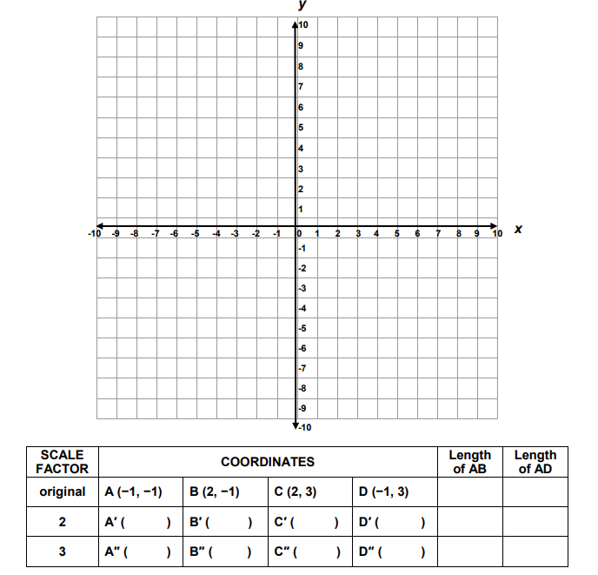
- Lastly, ask students reflection questions such as –
  - What happens to the size of the figure after dilating it, using a scale factor of 2?
  - What happens to the size of the figure after dilating it, using a scale factor of 3?
  - Does a dilation cause the shape to change?

Concepts and Connections
Concepts
Analyzing and describing geometric objects, the relationships and structures among them, or the space that they occupy can be used to classify, quantify, measure, or count one or more attributes.

Connections: In Grade 7, students will solve problems, including those in context, involving proportional relationships (7.CE.2). Students at this grade level will also make connections, compare, and contrast polygons based on their properties (7.MG.3). Prior to Grade 7, students described the characteristics of the coordinate plane and graphed ordered pairs (6.MG.3), and determined congruence of segments, angles, and polygons (6.MG.4). Using these foundational understandings, students will apply dilations of polygons in the coordinate plane (7.MG.4). In the subsequent grade level, Grade 8 students will apply translations and reflections to polygons in the coordinate plane (8.MG.3).

- Within the grade level/course:
  - 7.CE.2 – The student will solve problems, including those in context, involving proportional relationships.
  - 7.MG.3 – The student will compare and contrast quadrilaterals based on their properties and determine unknown side lengths and angle measures of quadrilaterals.
- Vertical Progression:
  - 6.MG.3 – The student will describe the characteristics of the coordinate plane and graph ordered pairs.
  - 6.MG.4 – The student will determine congruence of segments, angles, and polygons.
  - 8.MG.3 – The student will apply translations and reflections to polygons in the coordinate plane.

Textbooks and HQIM for Consideration
- A list of approved textbooks and instructional materials will be posted on the VDOE website.

Probability and Statistics

In K-12 mathematics, probability and statistics introduce students to the concepts of uncertainty and data analysis. Probability involves understanding the likelihood of events occurring, often using concepts such as experiments, outcomes, and the use of fractions and percentages. The formal study or probability begins in Grade 4. Statistics focuses on collecting, organizing, and interpreting data and includes a basic understanding of graphs and charts. Probability and statistics help students analyze and make sense of real-world data and are fundamental for developing critical thinking skills and making informed decisions using data.

In Grade 7, students will understand that the world can be investigated through posing questions and collecting, representing, analyzing, and interpreting data to describe and predict events and real-world phenomena. At this grade level, students use statistical investigation to determine experimental and theoretical probability and apply the data cycle (formulate questions; collect or acquire data; organize and represent data; and analyze data and communicate results) with a focus on histograms.

7.PS.1 The student will use statistical investigation to determine the probability of an event and investigate and describe the difference
between the experimental and theoretical probability.
Students will demonstrate the following Knowledge and Skills:
- Determine the theoretical probability of an event.
- Given the results of a statistical investigation, determine the experimental probability of an event.
- Describe changes in the experimental probability as the number of trials increases.
- Investigate and describe the difference between the probability of an event found through experiment or simulation versus the theoretical probability of that same event.

Understanding the Standard
- In general, if all outcomes of an event are equally likely, the probability of an event occurring is equal to the ratio of desired outcomes to the total number of possible outcomes in the sample space.
- The probability of an event occurring can be represented as a ratio or equivalent fraction, decimal, or percent.
- The probability of an event occurring is a ratio between 0 and 1.
- A probability of 0 means the event will never occur (i.e., it is impossible).
- A probability of 1 means the event will always occur (i.e., it is certain).
- The theoretical probability of an event is the expected probability and can be determined with a ratio. If all outcomes of an event are equally likely, then:
theoretical probability of an event = $\frac{number of possible favorable outcomes}{total number of possible outcomes}$
- The experimental probability of an event is determined by carrying out a simulation or an experiment.
- The experimental probability of an event = $\frac{number of times desired outcomes occur}{number of trials in the experiment}$
- In experimental probability, as the number of trials increases, the experimental probability gets closer to the theoretical probability (Law of Large Numbers).
- Investigating the difference between the experimental probability and theoretical probability of the same event can be connected to comparing and ordering rational numbers.

Skills in Practice
While the five process goals are expected to be embedded in each standard, the Skills in Practice highlight the most prevalent process goals in relation to the content presented.

Mathematical Reasoning:

- To be successful with this standard, students must know the difference between theoretical and experimental probability. Students should understand that theoretical probability calculates the likeliness of an event happening based on reasoning and mathematics. It forms a hypothesis but does not actually test the hypothesis like experimental probability. Experimental probability is based on the results of several trials or experiments (statistical investigations). Theoretical probability is calculated by taking the number of favorable outcomes over the total number of outcomes. Experimental probability is calculated by taking the actual outcomes over the total number of trials.

- Students should have the opportunity to engage in games of chance to explore theoretical and experimental probability. For example –

  - Show students a coin and ask what the possible outcomes are when a coin is flipped (i.e., heads, tails). Ask students to determine the chance of flipping heads. Write their responses on the board, and discuss the different representations (i.e., $\frac{1}{2}$, 0.50, 50%). Have students explain their responses. This should include a discussion of the formula they used for finding probability.

  - Ask students whether they think the theoretical probability for heads will hold true if a coin is flipped 10 times. Demonstrate this and record the results. Ask students what the probability of flipping heads was. Discuss whether this was the same or different from the theoretical probability they already established. Explain that the probability they got after flipping the coin 10 times is called experimental probability, which results from calculating probability using the results of an experiment. Discuss how this differs from theoretical probability.

  - Continue the statistical investigation for 10 more rounds (trials) and recalculate the probabilities using a total of 20. As the rounds continue, have students engage in discourse to describe what changes they observe in the experimental probability as the number of trials increases. Discuss that, as the number of trials increases, the experimental probability gets closer to the theoretical probability.

Mathematical Connections: A common error students may make is calculating the experimental probability using the total number of possible outcomes instead of the number of trials in the experiment. Ask students to create a list of events that are likely to occur and another list of events that are not likely to occur. Use the lists to illustrate that the probability of an event occurring is a ratio between 0 and 1. Discuss events that are not likely to occur or have a probability close to 0. Discuss events that are likely to occur or have a probability close to 1.

Concepts and Connections
Concepts
The world can be investigated through posing questions and collecting, representing, analyzing, and interpreting data to describe and predict events and real-world phenomena.

Connections: In Grade 7, students will apply the data cycle (formulate questions; collect or acquire data; organize and represent data; and, analyze data and communicate results) (7.PS.2). In the elementary grades (particularly at grade 5), students determined the probability of an outcome by constructing a model of a sample space and using the Fundamental (Basic) Counting Principle (5.PS.3). Using these foundational understandings, students will use statistical investigation to determine the probability of an event and investigate and describe the difference between the experimental and theoretical probability (7.PS.1). In the subsequent grade level, Grade 8 students will use statistical investigation to determine the probability of independent and dependent events, including those in context (8.PS.1).

- Within the grade level/course:
  - 7.PS.2 – The student will apply the data cycle (formulate questions; collect or acquire data; organize and represent data; and analyze data and communicate results) with a focus on histograms.
- Vertical Progression:
  - 5.PS.3 – The student will determine the probability of an outcome by constructing a model of a sample space and using the Fundamental (Basic) Counting Principle.
  - 8.PS.1 – The student will use statistical investigation to determine the probability of independent and dependent events, including those in context.

Textbooks and HQIM for Consideration
- A list of approved textbooks and instructional materials will be posted on the VDOE website.

7.PS.2 The student will apply the data cycle (formulate questions; collect or acquire data; organize and represent data; and analyze data and
communicate results) with a focus on histograms.
Students will demonstrate the following Knowledge and Skills:
- Formulate questions that require the collection or acquisition of data with a focus on histograms.
- Determine the data needed to answer a formulated question and collect the data (or acquire existing data) using various methods (e.g., observations, measurement, surveys, experiments).
- Determine how sample size and randomness will ensure that the data collected is a sample that is representative of a larger population.
- Organize and represent numerical data using histograms with and without the use of technology.
- Investigate and explain how using different intervals could impact the representation of the data in a histogram.
- Compare data represented in histograms with the same data represented in other graphs, including but not limited to line plots (dot plots), circle graphs, and stem-and-leaf plots, and justify which graphical representation best represents the data.
- Analyze data represented in histograms by making observations and drawing conclusions. Determine how histograms reveal patterns in data that cannot be easily seen by looking at the corresponding given data set.

Understanding the Standard
- Students should explore the entire data cycle with a question and set of data that has been collected or acquired. Student reflection should occur throughout the data cycle. The data cycle includes the following steps: formulating questions to be explored with data, collecting or acquiring data, organizing and representing data, and analyzing and communicating results.
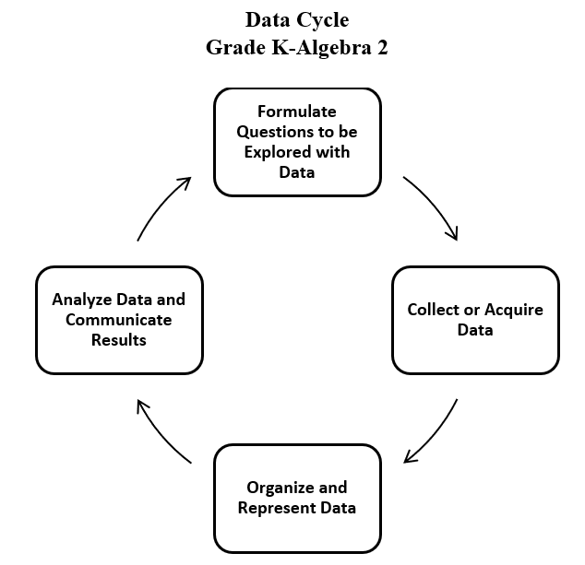
- To collect data for any problem situation, an experiment can be designed, a survey can be conducted, or other data-gathering strategies can be used. The data can be organized, displayed, analyzed, and interpreted to solve the problem.
- The teacher can provide data sets in addition to students engaging with their own data collection or acquisition.
- A population is the entire set of individuals or items from which data is drawn for a statistical study.
- A sample is a data set obtained from a subset that represents an entire population. This data set can be used to make reasonable assumptions about the whole population.
- Sampling is the process of selecting a suitable sample, or a representative part of a population, for the purpose of determining characteristics of the whole population.
- An example of a population would be the entire student body at a school, whereas a sample might be selecting a subset of students from each grade level. A sample may or may not be representative of the population as a whole. Questions to consider when determining whether an identified sample is representative of the population include:
  - What is the target population of the formulated question?
  - Who or what is the subject or context of the question?
- A random sample is one in which each member of the population has an equal chance of being selected. Random samples can be used to ensure that the sample is representative of the population and to avoid bias.
- Sample size refers to the number of participants or observations included in a study. Statistical data may be more accurate, and outliers may be more easily identified with larger sample sizes.
- Examples of questions to consider in building good samples:
  - What is the context of the data to be collected?
  - Who is the audience?
  - What amount of data should be collected?
- A histogram is a graph that provides a visual interpretation of numerical data by indicating the number of data points that lie within a range of values, called a class or a bin. The frequency of the data that falls in each class or bin is depicted by the use of a bar. Every element of the data set is not preserved when representing data in a histogram.
- A histogram is a form of bar graph in which the categories are consecutive and equal intervals. The length or height of each bar is determined by the number of data elements (frequency) falling into a particular interval. See the example below.
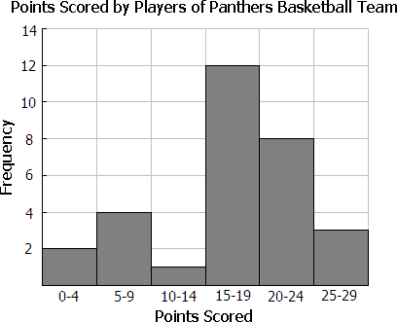
- Histograms do not directly display measures of center.
- Histograms do not display individual data points. Instead, histograms provide an easy-to-read summary for large data sets where displaying individual data points would become cumbersome.
- The data in a histogram is organized so that ranges of data values can be compared easily; that is, it can be determined which ranges occurred more or less often than others, the range that occurs most often, and where the data is concentrated. Histograms show where the ranges of data are centered or if there are gaps in data.
- Numerical data that can be characterized using consecutive intervals are best displayed in a histogram.
- Statistical questions or data sets that would not be well represented in a histogram include:
  - questions related to qualitative (categorical) data that would be better represented with circle graphs, bar graphs, etc.; and
  - questions related to quantitative (numerical) data that would be better represented with stem-and-leaf plots, line plots, etc. where visualizing individual data points would be important.
- A frequency distribution shows how often an item, a number, or range of numbers occurs. It can be used to construct a histogram.
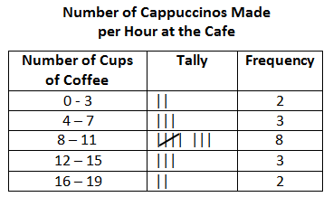
- To construct a histogram:
  - Organize collected data into a table. Create one column for data range categories (bins), divided into equal intervals that will include all of the data (for example, 0 - 10, 11 - 20, 21 - 30), and another column for frequency.
    - Bins should be all the same size.
    - Bins should include all of the data.
    - Boundaries for bins should reflect the data values being represented.
    - Determine the number of bins based upon the data.
    - If possible, the number of bins created should be a factor the number of data values (e.g., a histogram representing 20 data values might have 4 or 5 bins).
  - Create a graph. Mark the data range intervals on the x-axis (horizontal axis) with no space between the categories. Mark frequency on the y-axis (vertical axis), also in equal intervals. All histograms should include a title and labels that describe the data.
  - Plot the data. For each data range category (bin), draw a horizontal line at the appropriate frequency or marker. Then, create a vertical bar for that category reaching up to the marked frequency. Do this for each data range category (bin).
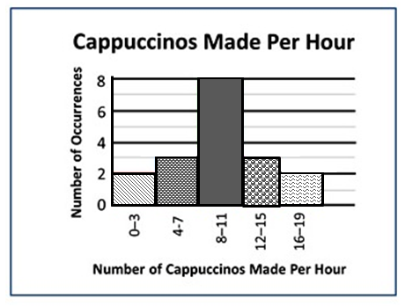
- Histograms may be drawn so that the bars are horizontal. To do this, interchange the x- and y-axis. Mark the data range intervals (bins) on the y-axis and the frequency on the x-axis. Draw the bars horizontally.
- Manipulating intervals in a histogram could result in misleading conclusions regarding the data set. For example, extremely large or small intervals (bins) can make it difficult to see the shape of the data.
- Comparisons, predictions, and inferences are made by examining characteristics of a data set displayed in a variety of graphical representations to draw conclusions. Data analysis helps describe data, recognize patterns or trends, and make predictions.
- There are two types of data: categorical and numerical. Categorical data can be sorted into groups or categories while numerical data are values or observations that can be measured. For example, types of fish caught would be categorical data while weights of fish caught would be numerical data. An awareness of the differences between categorical data and numerical data is important, however, students are not expected to know the terms for each type of data.
- In previous grades, students had experience with pictographs, bar graphs, line graphs, line plots, stem-and-leaf plots, and circle graphs. In Grade 7, students are not expected to construct these graphs.
  - A pictograph is used to show categorical data. Pictographs are used to show frequency and compare categories.
  - A bar graph is used for categorical data and is used to show comparisons between categories.
  - A line graph is used to show how numerical data changes over time.
  - A line plot provides an ordered display of all values in a data set and shows the frequency of data on a number line. Line plots are used to show the spread of the data, to include clusters (groups of data points) and gaps (large spaces between data points), and quickly identify the range, mode, and any extreme data values.
  - A stem-and-leaf plot is used for discrete numerical data and is used to show frequency of data distribution. A stem-and-leaf plot displays the entire data set and provides a picture of the distribution of data.
  - A circle graph is used for categorical and discrete numerical data. Circle graphs are used to show a relationship of the parts to a whole. Every element of the data set is not preserved when representing data in a circle graph.
- Different types of graphs can be used to display categorical and numerical data. The way data is displayed is often dependent on what someone is trying to communicate.
- Comparing different types of representations (charts and graphs) provides an opportunity to learn how different graphs can show different things about the same data. Discussions around what information different graphs representing the same data provides is beneficial for determining which graphical representation best represents the data.
- The information displayed in different graphs may be examined to determine how data are or are not related, differences between characteristics (comparisons), trends that suggest what new data might be like (predictions), and/or questions such as “What could happen if…” (inferences).

Skills in Practice
While the five process goals are expected to be embedded in each standard, the Skills in Practice highlight the most prevalent process goals in relation to the content presented.

Mathematical Communication: There are many good questions students can ask about histograms –

- Histograms are used for large sets of numerical data and are used to show an easy-to-read summary where data ranges can be compared.
  - Is the sample representative of the population I am making conclusions about?
  - Am I interested in the overall features of the data, including where the data is concentrated and where there may be gaps?
  - Am I interested in comparing ranges of data values?​
  - Do I need details of individual data points? (If so, a histogram is not the appropriate representation.)
- Data displays are intended to simplify. It is challenging to digest the raw data. However, most data displays will lose details.
  - Does a histogram address your question?

- The labels are key to communication.
  - What title and labels are necessary to clearly communicate?
  - What should be the boundaries of the intervals based on the data?
  - What intervals will show the appropriate features of the data? What should be the frequency scale based on the data?

Mathematical Reasoning: Students should consider which graph best represents the data: circle graph, bar graph, histogram, pictograph, line plot, line graph, or stem-and-leaf plot? When analyzing data, students should compare the ranges of the data; determine data concentration or gaps; determine how interval size impacts the representation; and return to their formulated question(s) to see if the data answers it.

Mathematical Representations:

- At this grade, it would be appropriate to provide a cursory overview of the difference between a sample and a population and how sampling is a process used to determine characteristics of the whole population.

- Students often confuse a bar graph for a histogram. Bar graphs represent categorical data and there are spaces between the bars to separate the categories. In a bar graph, the data in the first column of the table is usually displayed on the x-axis, and the data from the second column is usually displayed on the y-axis. Students need to review that a histogram presents an analysis of a set of numerical data by showing the frequency with which pieces of data fall within given intervals, or bins.

- Students have a difficult time making the bins at equal intervals. Therefore, students must understand the requirements for histogram data – data is numerical; data can be characterized using consecutive intervals; and visualizing individual data points is not necessary.

- Students should be led to discussions of numerical data. Students should ask questions in which they are considering looking at an overall summary of a large data set instead of individual data points. Samples must be considered as questions are formulated. Some questions that will direct students toward good samples include –
  - What is the context of the data to be collected?
  - Who is the audience?
  - What is an appropriate amount of data?

Concepts and Connections
Concepts
The world can be investigated through posing questions and collecting, representing, analyzing, and interpreting data to describe and predict events and real-world phenomena.

Connections: In Grade 7, students will use statistical investigation to determine the probability of an event and investigate and describe the difference between the experimental and theoretical probability (7.PS.1). Prior to Grade 7, students applied the data cycle with a focus on circle graphs (6.PS.1). Using these foundational understandings, students will apply the data cycle (formulate questions; collect or acquire data; organize and represent data; and analyze data and communicate results) with a focus on histograms. In the subsequent grade level, Grade 8 students will apply the data cycle with a focus on scatterplots (8.PS.3).

- Within the grade level/course:
  - 7.PS.2 – The student will use statistical investigation to determine the probability of an event and investigate and describe the difference between the experimental and theoretical probability.
- Vertical Progression:
  - 6.PS.1 – The student will apply the data cycle (formulate questions; collect or acquire data; organize and represent data; and analyze data and communicate results) with a focus on circle graphs.
  - 8.PS.3 – The student will apply the data cycle (formulate questions; collect or acquire data; organize and represent data; and analyze data and communicate results) with a focus on scatterplots.

Textbooks and HQIM for Consideration
- A list of approved textbooks and instructional materials will be posted on the VDOE website.

Patterns, Functions, and Algebra
In K-12 mathematics, the patterns, functions, and algebra strand focuses on the recognition, description, and analysis of patterns, functions, and algebraic concepts. Students develop an understanding of mathematical relationships and represent these using symbols, tables, graphs, and rules. In later grades, students use models as they solve equations and inequalities and develop an understanding of functions. This strand is designed to develop students’ algebraic thinking and problem-solving skills, laying the foundation for more advanced mathematical concepts.

In Grade 7, students will understand that proportional relationships can be described, and generalizations can be made using patterns, relations, and functions. Algebraic equations and inequalities can be used to represent and solve real world problems. At this grade level, students analyze proportional relationships between two quantities using verbal descriptions, tables, equations in y = mx form, and graphs. Students simplify and generate equivalent numerical and algebraic expressions, and evaluate algebraic expressions given replacement values. Students create and some solve two-linear equations and inequalities in one variable.

7.PFA.1 The student will investigate and analyze proportional relationships between two quantities using verbal descriptions, tables,
equations in y = mx form, and graphs, including problems in context.
Students will demonstrate the following Knowledge and Skills:
- Determine the slope, m, as the rate of change in a proportional relationship between two quantities given a table of values, graph, or contextual situation and write an equation in the form y = mx to represent the direct variation relationship. Slope may include positive or negative values (slope will be limited to positive values in a contextual situation).
- Identify and describe a line with a slope that is positive, negative, or zero (0), given a graph.
- Graph a line representing a proportional relationship, between two quantities given an ordered pair on the line and the slope, m, as rate of change. Slope may include positive or negative values.
- Graph a line representing a proportional relationship between two quantities given the equation of the line in the form y = mx, where m represents the slope as rate of change. Slope may include positive or negative values.
- Make connections between and among representations of a proportional relationship between two quantities using problems in context, tables, equations, and graphs. Slope may include positive or negative values (slope will be limited to positive values in a contextual situation).

Understanding the Standard
- A rate is a ratio that compares two quantities measured in different units. A unit rate is a rate with a denominator of 1. Examples of rates include miles/hour and revolutions/minute.
- When two quantities, x and y, vary in such a way that one of them is a constant multiple of the other, the two quantities are “proportional.” A model for this situation is y = mx, where m is the slope or rate of change. Slope may also represent the unit rate of a proportional relationship between two quantities, also referred to as the constant of proportionality or the constant ratio of y to x. This can also be referred to as direct variation.
- A direct variation is a proportional relationship between two quantities. The statement “y is directly proportional to x” can be represented by the equation y = mx. The graph of a direct variation can be represented by a line passing through the origin (0, 0).
- The slope of a proportional relationship can be determined by finding the unit rate.
  - Example: The ordered pairs (4, 2) and (6, 3) make up points that could be included on the graph of a proportional relationship. Determine the slope, or rate of change, of a line passing through these points. Write an equation of the line representing this proportional relationship.

x | y
4 | 2
6 | 3

  - The slope, or rate of change, would be $\frac{1}{2}$ or 0.5 since the y-coordinate of each ordered pair is the result of multiplying $\frac{1}{2}$ times the x-coordinate. This would also be the unit rate of this proportional relationship. The ratio of y to x is the same for each ordered pair. That is, $\frac{y}{x }$ = $\frac{2}{4}$ = $\frac{3}{6}$ = $\frac{1}{2 }$ = 0.5.
  - The equation of a line representing this proportional relationship of y to x is y = $\frac{1}{2 }$x or y = 0.5x.
- A linear function is an equation in two variables whose graph is a straight line, a type of continuous function.
- A linear function represents a situation with a constant rate. For example, when driving at a steady rate of 35 mph, the distance increases as the time increases, but the rate of speed remains the same.
- Slope (m) represents the rate of change in a linear function or the “steepness” of the line.
- The slope of a line is a rate of change, a ratio describing the vertical change to the horizontal change of the line.
slope = $\frac{change in y}{change in x}$= $\frac{vertical change}{horizontal change}$

- A line is increasing if it rises from left to right. The slope is positive (i.e., m > 0).
- A line is decreasing if it falls from left to right. The slope is negative (i.e., m < 0).
- A horizontal line has zero slope (i.e., m = 0).
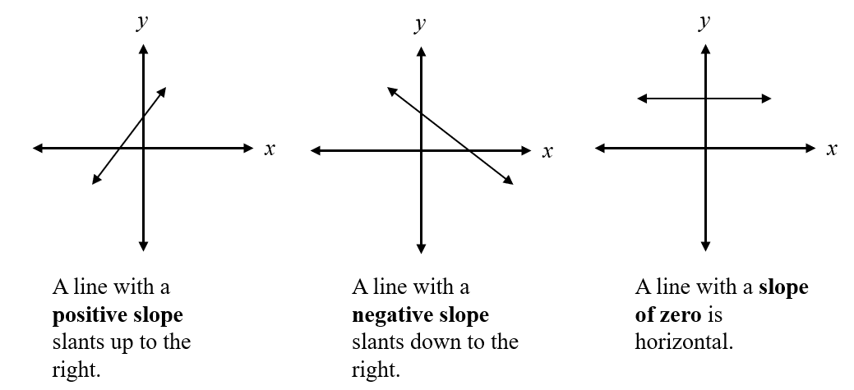
- The graph of the line representing a proportional relationship will include the origin (0, 0).
- A proportional relationship between two quantities can be modeled given a contextual situation. Representations may include verbal descriptions, tables, equations, or graphs. An informal discussion about independent and dependent variables when modeling contextual situations may be beneficial. (Formal instruction about dependent and independent variables occurs in Grade 8.)
  - Example (using a table of values): Cecil walks 2 meters every second (verbal description). If x represents the number of seconds and y represents the number of meters he walks, this proportional relationship can be represented using a table of values:
x (seconds) | 1 | 2 | 3 | 4
y (meters) | 2 | 4 | 6 | 8
    - This proportional relationship could be represented using the equation y = 2x, since he walks 2 meters for each second of time. That is, $\frac{y}{x }$ = $\frac{2}{1}$ = $\frac{4}{2}$ = $\frac{6}{3 }$ = $\frac{8}{4 }$ = $2$, the unit rate (constant of proportionality) is 2 or $\frac{2}{1}$. The same constant ratio of y to x exists for every ordered pair. This proportional relationship could be represented by the following graph:
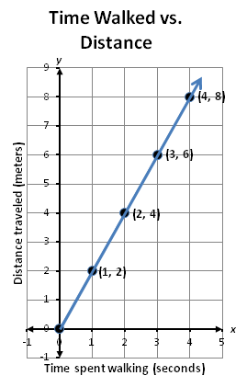
    - A graph of a proportional relationship can be created by graphing ordered pairs generated in a table of values (as shown above) or by observing the rate of change or slope of the relationship and using slope triangles to graph ordered pairs that satisfy the relationship given.
      - Example (using slope triangles): Cecil walks 2 meters every second. If x represents the number of seconds and y represents the number of meters he walks, this proportional relationship can be represented graphically using slope triangles.
    - The rate of change from (1, 2) to (2, 4) is 2 units up (the change in y) and 1 unit to the right (the change in x), $\frac{2}{1}$ or 2. Thus, the slope of this line is 2. Slope triangles can be used to generate points on a graph that satisfy this relationship.
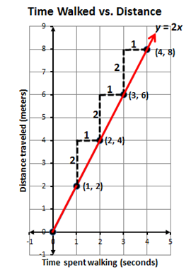
- In a proportional relationship, the relationship can be defined as y = mx, where m is known as the constant of proportionality and the ratio $\frac{y}{x}$ will always produce the same result. In a contextual situation, the terms x and y may take on meanings such as hours worked (x) and wages earned (y) or time passed (x) and distance traveled (y). Contextual situations may limit the slope or constant of proportionality to positive values.
- Graphing a line given an equation can be addressed using different methods. One method involves determining a table of ordered pairs by substituting into the equation values for one variable and solving for the other variable, plotting the ordered pairs in the coordinate plane, and connecting the points to form a straight line. Another method involves using slope triangles to determine points on the line.

Skills in Practice
While the five process goals are expected to be embedded in each standard, the Skills in Practice highlight the most prevalent process goals in relation to the content presented.

Mathematical Problem Solving:

- In a proportional relationship, the relationship can be defined as y = mx, where m is known as the constant of proportionality and the ratio $\frac{y}{x}$ will always produce the same result. In a contextual situation, the terms x and y may take on meanings such as hours worked (x) and wages earned (y) or time passed (x) and distance traveled (y). Contextual situations may limit the slope or constant of proportionality to positive values.

- One important way of describing functions is by identifying the rate at which the variables change together. Students use this understanding in later grade levels when grouping functions into families with similar patterns of change. These functions and the situations that they model, share certain general characteristics.

Mathematical Connections: There are several essential understandings when investigating and analyzing proportional relationships between two quantities, including the multiplicative versus additive proportionality. Essential understandings include –

- Functions provide a tool for describing how variables change together. Using a function in this way is called modeling and the function is the model.

- Some representations of a function may be more useful than others, depending on how they are used.

- Linear functions have constant rates of change. Example(s) with common misconceptions follow –

Larry and Jerri each wrote an equation to represent the linear function graphed below.
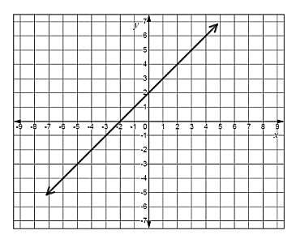
Larry’s answer is y = 2x and Jerri’s answer is y = x + 2. Which student is correct? Explain your answer.

A common error a student may make is to interpret the y-intercept as the value that represents the slope of the line and answer that Larry is correct. This type of error may indicate a student cannot differentiate between an additive and a proportional relationship. A student may benefit from choosing an ordered pair on the graph of the line shown and substituting that ordered pair into the equation to determine if it satisfies the condition. For example, a student could choose to substitute the ordered pair (3, 5) and the ordered pair (-4, -2) into each equation to determine if they both produce a true statement. In addition, a student may benefit from additional practice writing equations for additive and proportional relationships.

Mathematical Representations: Graphing a line given an equation can be addressed using different methods. One method involves determining a table of ordered pairs by substituting into the equation values for one variable and solving for the other variable, plotting the ordered pairs in the coordinate plane, and connecting the points to form a straight line. Another method involves using slope triangles to determine points on the line. Because functions can be represented using algebraic symbols, situations, graphs, tables, and verbal descriptions, these representations and the links among them are useful when analyzing patterns of change. Students may be presented with multiple representations and asked to match them with an equation, as per the example below –
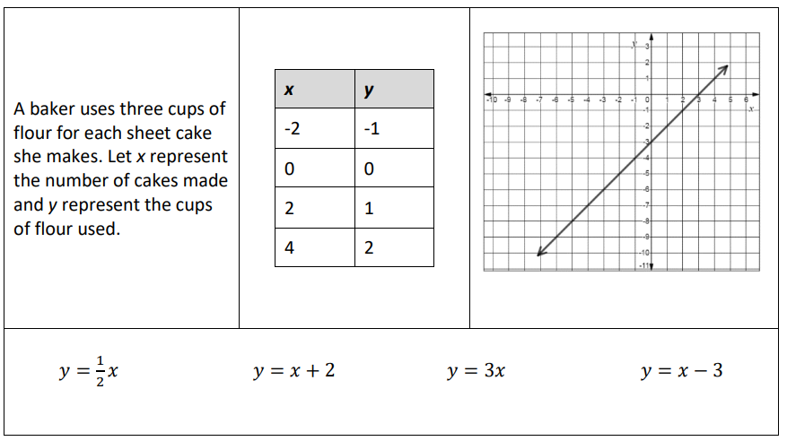

A student may incorrectly match the graph with the equation y = 3x, thinking the x-intercept of three represents the slope of the line. A student may incorrectly match the table with the equation y = x + 2 using the ordered pairs (0, 0) and (4, 2) and substituting for the wrong variable. These errors may indicate confusion distinguishing between additive relationships and proportional relationships when presented with multiple representations of linear functions.

Concepts and Connections
Concepts
Proportional relationships can be described, and generalizations can be made using patterns, relations, and functions. Algebraic equations and inequalities can be used to represent and solve real world problems.

Connections: In Grade 7, students will estimate, solve, and justify solutions to multistep contextual problems involving operations with rational numbers (7.CE.1) and justify relationships of similarity using proportional reasoning (7.MG.2). Further, students will solve problems, including those in context, involving proportional relationships (7.CE.2) and write and solve two-step linear equations in one variable, including problems in context, that require the solution of a two-step linear equation in one variable (7.PFA.3). Prior to Grade 7, students used ratios to represent relationships between quantities, including those in context (6.PFA.1) and identified and represented proportional relationships between two quantities, including those in context (with unit rates limited to positive values) (6.PFA.2). Using these foundational understandings, graphical representation of proportionality is extended at this grade level where students will investigate and analyze proportional relationships between two quantities using verbal descriptions, tables, equations in y = mx form, including problems in context (7.PFA.1). In the subsequent grade level, Grade 8 students will estimate and apply proportional reasoning and computational procedures to solve contextual problems (8.CE.1); and, will represent and solve problems and those in context by using linear functions and analyzing their key characteristics (8.PFA.3).
- Within the grade level/course:
  - 7.CE.1 – The student will estimate, solve, and justify solutions to multistep contextual problems involving operations with rational numbers.
  - 7.CE.2 – The student will solve problems, including those in context, involving proportional relationships.
  - 7.MG.2 – The student will solve problems and justify relationships of similarity using proportional reasoning.
  - 7.PFA.3 –The student will write and solve two-step linear equations in one variable, including problems in context, that require the solution of a two-step linear equation in one variable.
- Vertical Progression:
  - 6.PFA.1 – The student will use ratios to represent relationships between quantities, including those in context.
  - 6.PFA.2 – The student will identify and represent proportional relationships between two quantities, including those in context (unit rates are limited to positive values).
  - 8.CE.1 – The student will estimate and apply proportional reasoning and computational procedures to solve contextual problems.
  - 8.PFA.3 – The student will represent and solve problems, including those in context, by using linear functions and analyzing their key characteristics (the value of the y-intercept (b) and the coordinates of the ordered pairs in graphs will be limited to integers).

Textbooks and HQIM for Consideration
- A list of approved textbooks and instructional materials will be posted on the VDOE website.

7.PFA.2 The student will simplify numerical expressions, simplify and generate equivalent algebraic expressions in one variable, and evaluate
algebraic expressions for given replacement values of the variables.
Students will demonstrate the following Knowledge and Skills:
- Use the order of operations and apply the properties of real numbers to simplify numerical expressions. Exponents are limited to 1, 2, 3, or 4 and bases are limited to positive integers. Expressions should not include braces { } but may include brackets [ ] and absolute value bars | |. Square roots are limited to perfect squares.*
- Represent equivalent algebraic expressions in one variable using concrete manipulatives and pictorial representations (e.g., colored chips, algebra tiles).
- Simplify and generate equivalent algebraic expressions in one variable by applying the order of operations and properties of real numbers. Expressions may require combining like terms to simplify. Expressions will include only linear and numeric terms. Coefficients and numeric terms may be positive or negative rational numbers.*
- Use the order of operations and apply the properties of real numbers to evaluate algebraic expressions for given replacement values of the variables. Exponents are limited to 1, 2, 3, or 4 and bases are limited to positive integers. Expressions should not include braces { } but may include brackets [ ] and absolute value bars | |. Square roots are limited to perfect squares. Limit the number of replacements to no more than three per expression. Replacement values may be positive or negative rational numbers.
* On the state assessment, items measuring this knowledge and skill are assessed without the use of a calculator.

Understanding the Standard
- An expression is a representation of a quantity. It may contain numbers, variables, and/or operation symbols. It does not have an “equal sign” (e.g. $\frac{3}{4}$, $5x$, 140 – 38.2, -18 ∙ 21, $(5+2x)∙4$). An expression cannot be solved.
- A numerical expression contains only numbers, the operations symbols, and grouping symbols.
- Expressions are simplified by using the order of operations.
- The order of operations is a convention that defines the computation order to follow in simplifying an expression. It ensures that there is only one correct value.
- The order of operations is as follows:
  - First, complete all operations within grouping symbols. If there are grouping symbols within other grouping symbols, do the innermost operations first. Note: Parentheses ( ), brackets [ ], absolute value bars | |, and the division bar should be treated as grouping symbols.
  - Second, evaluate all terms with exponents.
  - Third, multiply and/or divide in order from left to right.
  - Fourth, add and/or subtract in order from left to right.
- An algebraic expression is a variable expression that contains at least one variable (e.g., x – 3).
- Equivalent algebraic expressions can be modeled with concrete and pictorial representations. Modeling algebraic expressions should reflect the Concrete-Representational-Abstract (CRA) model.
- Simplifying an algebraic expression means to write the expression as a more compact and equivalent expression. This usually involves combining like terms.
- Like terms are terms that have the same variables and exponents. The coefficients do not need to be equivalent (e.g., 12x and -5x; 45 and -6 and $\frac{2}{3}$; 9y and -51y and $\frac{4}{9}y$). Like terms in Grade 7 are limited to variables with an exponent of 1.
- Like terms may be added or subtracted using properties of real numbers. For example,
4x + 2 – 2x
4x – 2x + 2
2x +2
4x + 2 – 2x and 2x +2 are equivalent expressions.
- To evaluate an algebraic expression, substitute a given replacement value for a variable and apply the order of operations.
  - For example, if a = 3 and b = -2 then 5a + b can be evaluated as 5(3) + (-2). When simplified using the order of operations, this equals 15 + (-2) = 13.
- Evaluating expressions occurs in many mathematical contexts including, but not limited to:
  - replacing the value of a variable to verify a solution to an equation;
  - replacing the value of a variable to confirm whether or not a value is part of the solution set to an inequality;
  - replacing values in formulas to determine surface area and volume.
- Expressions are simplified using the order of operations and applying the properties of real numbers. The following properties can be used, where appropriate, to further develop flexibility and fluency in problem solving (limitations may exist for the values of a, b, or c in this standard).
  - Commutative property of addition: $a+b=b+a$.
  - Commutative property of multiplication: $a∙b=b∙a$.
  - Associative property of addition: $\left(a+b\right)+c=a+(b+c)$.
  - Associative property of multiplication: $\left(a∙b\right)∙c=a∙(b∙c)$.
  - Subtraction and division are neither commutative nor associative.
  - Distributive property (over addition/subtraction): $a∙\left(b+c\right)=a∙b+a∙c and a∙\left(b-c\right)=a∙b-a∙c$.
  - The additive identity is zero (0) because any number added to zero is the number.
  - Identity property of addition (additive identity property): $a+0=a and 0+a=a$.
  - The multiplicative identity is one (1) because any number multiplied by one is the number.
  - Identity property of multiplication (multiplicative identity property): $a∙1=a and 1∙a=a$.
  - There are no identity elements for subtraction and division.
  - Inverses are numbers that combine with other numbers and result in identity elements (e.g., 5 + (–5) = 0; $\frac{1}{5}$ · 5 = 1).
    - Inverse property of addition (additive inverse property): $a+\left(-a\right)=$ 0 and $\left(-a\right)+a=0$.
    - Inverse property of multiplication (multiplicative inverse property): $a∙\frac{1}{a}=1 and \frac{1}{a}∙a=1$.
    - Zero has no multiplicative inverse.
  - Multiplicative property of zero: $a∙0=0 and 0∙a=0$.
  - Substitution property: If $a=b$, then b can be substituted for a in any expression, equation, or inequality.
- Division by zero is not a possible mathematical operation. It is undefined. In the example below, there is no single defined number possibility for dividing by 0, since zero multiplied by any number is zero:
- 12 ÷ 0 = r → r · 0 = 12

Skills in Practice
While the five process goals are expected to be embedded in each standard, the Skills in Practice highlight the most prevalent process goals in relation to the content presented.

Mathematical Problem Solving:

- Expressions are foundational for algebra as they serve as building blocks for work with equations and functions. Expressions serve as powerful tools for exploring, reasoning about, and representing situations.

- Two or more expressions may be equivalent, even when their symbolic forms differ.

- A relatively small number of symbolic transformations can be applied to expressions to yield equivalent expressions.

- Expressions are simplified using the order of operations and applying the properties of real numbers. Common errors or misconceptions include –
  - Applying the Distributive Property to simplify expressions: Students sometimes multiply the first term in the grouping symbols and not others.
  - Applying the properties to simplify algebraic expressions (Additive Identity and Additive Inverse): Students may get the additive identity and additive inverse properties confused because they both use addition.
  - Applying the properties to simplify algebraic expressions (Multiplicative Identity and Multiplicative Inverse): Students may get the multiplicative identity and multiplicative inverse properties confused because they both use multiplication.
  - Applying the properties to simplify algebraic expressions (Multiplicative Property of Zero and Additive Identity): Students may confuse the multiplicative property of zero and additive identity properties confused because they both have a zero in the expression.
Mathematical Representations: Variables are tools for expressing mathematical ideas clearly and concisely. They have many different meanings, depending on context and purpose. Using variables permits representing and writing expressions whose values are not known or vary under different circumstances. The use of variables is important in studying relationships between varying quantities as well as evaluating expressions using the order of operations.

- For example, when using concrete models and transferring to pictorial representations –

Draw a model for the expression 2x + 3: A common error is that some students may incorrectly represent two x as two positive square tiles and one x-tile along with three positive square tiles. Another common mistake is that some students may model two x as two positive square tiles along with three positive square tiles. In either scenario, a student may need more experiences modeling single term expressions or numbers before modeling expressions with multiple terms.

Draw a model for the expression x – 5: A student may incorrectly model the expression using only positive tiles, ignoring the negative five. The student may need more experiences modeling positive and negative values. In both of the examples, a student may need opportunities to identify the terms in the expression and model each one separately.

- For example, when evaluating expressions and applying the order of operations –

If p = 2, determine the value of the expression |4p − 10| + 3p: A student may incorrectly take the absolute value of 4p and -10 separately and then subtract the results. This may indicate that a student believes that the absolute value of each term of the expression should occur before the difference of 4p – 10. A student may need to review grouping symbols and have additional opportunities to practice simplifying operations within absolute value bars. Another common misconception is a student may simplify 4p – 10 + 3p before finding the absolute value of 4p – 10, resulting in a value of four. A student may benefit from translating the symbolic form to a verbal expression, such as finding the absolute value of 4p − 10, then adding three times p. A student may benefit from reviewing grouping symbols and applying the order of operations to expressions contained in the grouping symbols.

Concepts and Connections
Concepts
Proportional relationships can be described, and generalizations can be made using patterns, relations, and functions. Algebraic Equations and Inequalities can be used to represent and solve real world problems.

Connections: In Grade 7, students will write and solve two-step linear equations in one variable, including problems in context, that require the solution of a two-step linear equation in one variable (7.PFA.3) or a two-step linear inequality in one variable (7.PFA.4). Prior to Grade 7, students wrote and solved one-step linear equations in one variable, including contextual problems that required the solution of a one-step linear equation in one variable (6.PFA.3), and represented a contextual situation using a linear inequality in one variable with symbols and graphs on a number line (6.PFA.4). Using these foundational understandings, students will simplify numerical expressions, simplify and generate equivalent algebraic expressions in one variable, and evaluate algebraic expressions for given replacement values of the variables (7.PFA.2). In the subsequent grade level, Grade 8 students will represent, simplify, and generate equivalent algebraic expressions in one variable (8.PFA.1).

- Within the grade level/course:
  - 7.PFA.3 – The student will write and solve two-step linear equations in one variable, including problems in context, that require the solution of a two-step linear equation in one variable.
  - 7.PFA.4 – The student will write and solve one- and two-step linear inequalities in one variable, including problems in context, that require the solution of a one- and two-step linear inequality in one variable.
- Vertical Progression:
  - 6.PFA.3 – The student will write and solve one-step linear equations in one variable, including contextual problems that require the solution of a one-step linear equation in one variable.
  - 6.PFA.4 – The student will represent a contextual situation using a linear inequality in one variable with symbols and graphs on a number line.
  - 8.PFA.1 – The student will represent, simplify, and generate equivalent algebraic expressions in one variable.

Textbooks and HQIM for Consideration
- A list of approved textbooks and instructional materials will be posted on the VDOE website.

7.PFA.3 The student will write and solve two-step linear equations in one variable, including problems in context, that require the solution of
a two-step linear equation in one variable.
Students will demonstrate the following Knowledge and Skills:
- Represent and solve two-step linear equations in one variable using a variety of concrete materials and pictorial representations.
- Apply properties of real numbers and properties of equality to solve two-step linear equations in one variable. Coefficients and numeric terms will be rational.
- Confirm algebraic solutions to linear equations in one variable.
- Write a two-step linear equation in one variable to represent a verbal situation, including those in context.
- Create a verbal situation in context given a two-step linear equation in one variable.
- Solve problems in context that require the solution of a two-step linear equation.

Understanding the Standard
- An equation is a mathematical sentence that states that two expressions are equal.
- The solution to an equation is the value(s) that makes it a true statement. Many equations have one solution and can be represented as a point on a number line. Not all linear equations have one solution; however, equations that have no solution or an infinite number of solutions are beyond the scope of Grade 7 and are addressed in Algebra 1.
- A variety of concrete materials such as colored chips, algebra tiles, or weights on a balance scale may be used to model solving equations in one variable.
- The inverse operation for addition is subtraction, and the inverse operation for multiplication is division.
- A two-step linear equation may include, but not be limited to, equations such as the following:
  - 2x + $\frac{1}{2}$ = -5
  - -25 = 7.2x + 1
  - $\frac{x-7}{-3}$ = 4
  - $\frac{3}{4}$x – 2 = 10
  - $3x+5x=4$
- An algebraic expression is a variable expression that contains at least one variable (e.g., 2x – 3).
- An algebraic equation is a mathematical statement that says that two expressions are equal (e.g., 2x – 8 = 7).
- Word choice and language are very important when representing verbal situations in context using mathematical operations, equality, and variables. When presented with an equation or context, choice of language should reflect the situation being modeled.
- Identifying the mathematical operation(s) to represent the action(s) and the variable to represent the unknown quantity will help to write equations to represent the contextual situation.
- When creating equations and verbal situations in context, the coefficient may be limited to a positive value.
- Properties of real numbers and properties of equality can be applied when solving equations and justifying solutions. The following properties should be used, where appropriate, to further develop flexibility and fluency in problem solving (limitations may exist for the values of a, b, or c in this standard):
  - Commutative property of addition: $a+b=b+a$
  - Commutative property of multiplication: $a∙b=b∙a$
  - Subtraction and division are not commutative.
  - The additive identity is zero (0) because any number added to zero is the number.
  - Identity property of addition (additive identity property): $a+0=a and 0+a=a$
  - The multiplicative identity is one (1) because any number multiplied by one is the number.
  - Identity property of multiplication (multiplicative identity property): $a∙1=a$ $and 1∙a=a$
  - There are no identity elements for subtraction and division.
  - Inverses are numbers that combine with other numbers and result in identity elements (e.g., 5 + (–5) = 0; $\frac{1}{5}$ · 5 = 1).
    - Inverse property of addition (additive inverse property): $a+\left(-a\right)=0 and \left(-a\right)+a=0$
    - Inverse property of multiplication (multiplicative inverse property): $a∙\frac{1}{a}=1 and \frac{1}{a}∙a=1$
    - Zero has no multiplicative inverse.
  - Multiplicative property of zero: $a∙0=0 and 0∙a=0$
  - Substitution property: If $a=b$, then b can be substituted for a in any expression, equation, or inequality.
  - Addition property of equality: If $a=b$, then $a+c=b+c$
  - Subtraction property of equality: If $a=b,$ then $a-c=b-c$
  - Multiplication property of equality: If $a=b,$ then $a∙c=b∙c$
  - Division property of equality: If $a=b and c≠0,$ then $\frac{a}{c}=\frac{b}{c}$
- Division by zero is not a possible mathematical operation. It is undefined. In the example below, there is no single defined number possibility for dividing by 0, since zero multiplied by any number is zero:
- 12 ÷ 0 = r → r · 0 = 12

Skills in Practice
While the five process goals are expected to be embedded in each standard, the Skills in Practice highlight the most prevalent process goals in relation to the content presented.

Mathematical Problem Solving:

- General algorithms exist for solving many kinds of equations. These algorithms are broadly applicable for solving a wide range of similar equations.

- Some problems or situations – circumstances that students explore concretely and immediately (for example by working with algebra tiles) and circumstances in stated problems – should be based on situations from everyday life.

- Linear equations can be solved by symbolic, graphical, or numerical methods. Students may have trouble moving from solving using the concrete materials to solving numerically. It is important to link the two methods together before releasing students to solve solely using algebraic methods.

- Students must review and apply the properties of real numbers and properties of equality to solve equations. Students should be familiar with the properties of real numbers and properties of equality. Common errors or misconceptions include –
  - Additive inverse and identity: Students may get the additive identity and additive inverse properties confused because they both use addition.
  - Multiplicative inverse and identity: Students may get the multiplicative identity and multiplicative inverse properties confused because they both use multiplication.
  - Multiplicative property of zero: Students may confuse the multiplicative property of zero and additive identity properties confused because they both have a zero in the expression.

Mathematical Representations: Variables are tools for expressing mathematical ideas clearly and concisely. They have many different meanings, depending on context and purpose. Using variables permits representing and writing expressions whose values are not known or vary under different circumstances. This use of variables is important in studying relationships between varying quantities as well as evaluating expressions using the order of operations.

- For example, when using concrete models and transferring to pictorial representations –

The balance scale represents an equation. Write an equation for this model and solve for x.
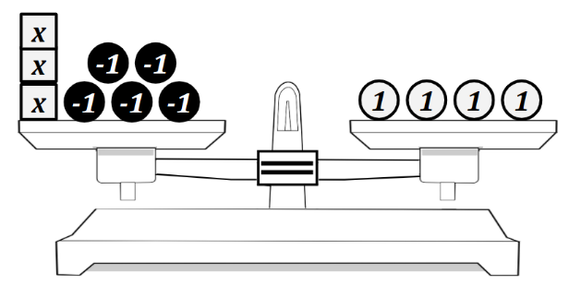
A common error a student may make is to incorrectly write an expression rather than an equation resulting in 3x – 5 + 4. This error indicates that the student is not making the connection between pictorial and symbolic representations of equations. Another common error a student may make is to translate the model as 3𝑥 + 5 = 4. This indicates a misunderstanding of negative numbers and how they are represented. A student may benefit from exposure to different visual representations of equations including pictorial representations, balance scales, and algebra tiles. Colored tiles, balance scales, and algebra tiles are all great choices.

- For example, when manipulating equations with rational coefficients or fractional operations –
$\frac{1}{3}$x + 5 = 14
After subtracting 5 from both sides, a student may incorrectly divide both sides by 3 instead of multiplying by 3. A student may benefit from additional practice with solving one-step equations involving fractional coefficients. Additional practice dividing fractions may help students recognize that a fraction multiplied by its reciprocal will result in a product of one.
$\frac{x+7}{3}$= 4
A student may incorrectly subtract seven from both sides of the equation first, resulting in a solution of x = -9. This error indicates a misconception that $\frac{x+7}{3}$= 4 is the same as $\frac{x}{3}$ +7 = 4. The student may need additional instruction and practice with solving equations that include an expression involving addition or subtraction divided by a constant (implied parentheses).

- For example, when writing a two-step linear equation in one variable to represent a verbal situation, including those in context, and then solving the equation –
The monthly fees to swim at the community pool are:
- $8 cleaning fee once a month
- $2 fee per visit to the pool

- If Hector paid a total of $34 in pool fees for the month, write an equation that could be used to determine how many times Hector visited the pool.: A student may make the mistake of writing 8x + 2 = 34. This error indicates that the student is struggling to conceptualize the scenario and transfer that into an algebraic equation. A student may need additional practice with writing equations from practical scenarios.

- How many times did Hector visit the pool this month? A student may incorrectly answer that Hector visited the pool 4 times. This error may indicate that the student struggles to conceptualize practical problems and transfer to a mathematical context. A student may need additional practice with writing equations from practical scenarios.

Concepts and Connections
Concepts
Proportional relationships can be described, and generalizations can be made using patterns, relations, and functions. Algebraic Equations and Inequalities can be used to represent and solve real world problems.

Connections: In Grade 7, students will simplify numerical expressions, simplify and generate equivalent algebraic expressions in one variable, and evaluate algebraic expressions for given replacement values of the variables (7.PFA.2) and solve two-step linear inequalities in one variable (7.PFA.4). Prior to Grade 7, students wrote and solved one-step linear equations in one variable, including contextual problems that required the solution of a one-step linear equation in one variable (6.PFA.3), and represented a contextual situation using a linear inequality in one variable with symbols and graphs on a number line (6.PFA.4). Using these foundational understandings, students will write and solve two-step linear equations in one variable, including problems in context, that require the solution of a two-step linear equation in one variable (7.PFA.3). In the subsequent grade level, Grade 8 students will represent, simplify, and generate equivalent algebraic expressions in one variable (8.PFA.1); and, write and solve multistep linear equations in one variable, including those in context (8.PFA.4).

- Within the grade level/course:
  - 7.PFA.2 – The student will simplify numerical expressions, simplify and generate equivalent algebraic expressions in one variable, and evaluate algebraic expressions for given replacement values of the variables.
  - 7.PFA.4 – The student will write and solve one- and two-step linear inequalities in one variable, including problems in context, that require the solution of a one- and two-step linear inequality in one variable.
- Vertical Progression:
  - 6.PFA.3 – The student will write and solve one-step linear equations in one variable, including contextual problems that require the solution of a one-step linear equation in one variable.
  - 6.PFA.4 – The student will represent a contextual situation using a linear inequality in one variable with symbols and graphs on a number line.
  - 8.PFA.1 – The student will represent, simplify, and generate equivalent algebraic expressions in one variable.
  - 8.PFA.4 – The student will write and solve multistep linear equations in one variable, including problems in context that require the solution of a multistep linear equation in one variable.

Textbooks and HQIM for Consideration
- A list of approved textbooks and instructional materials will be posted on the VDOE website.

7.PFA.4 The student will write and solve one- and two-step linear inequalities in one variable, including problems in context, that require the
solution of a one- and two-step linear inequality in one variable.
Students will demonstrate the following Knowledge and Skills:
- Apply properties of real numbers and the addition, subtraction, multiplication, and division properties of inequality to solve one- and two-step inequalities in one variable. Coefficients and numeric terms will be rational.
- Investigate and explain how the solution set of a linear inequality is affected by multiplying or dividing both sides of the inequality statement by a rational number less than zero.
- Represent solutions to one- or two-step linear inequalities in one variable algebraically and graphically using a number line.
- Write one- or two-step linear inequalities in one variable to represent a verbal situation, including those in context.
- Create a verbal situation in context given a one or two-step linear inequality in one variable.
- Solve problems in context that require the solution of a one- or two-step inequality.
- Identify a numerical value(s) that is part of the solution set of as given one- or two-step linear inequality in one variable.
- Describe the differences and similarities between solving linear inequalities in one variable and linear equations in one variable.

Understanding the Standard
- In an inequality, there can be more than one value for the variable that makes the inequality true. There can be many solutions. (e.g., Given the inequality x + 4 > −3, the solution is x > −7. This means that x can be any number greater than −7. A few solutions might be −6.5, −3, 0, 4, 25, etc.)
- Solutions to inequalities can be represented using a number line.
- When both expressions of an inequality are multiplied or divided by a negative number, the inequality symbol should be reversed (e.g., –3x < 15 is equivalent to x > –5).
- Word choice and language are very important when representing verbal situations in context using mathematical operations, inequality symbols, and variables. When presented with an inequality or context, choice of language should reflect the situation being modeled. Identifying the mathematical operation(s) to represent the action(s), and the variable to represent the unknown quantity will help to write inequalities that represent contextual situations.
- When creating inequalities and verbal situations in context, the coefficient may be limited to a positive value.
- Properties of real numbers and properties of inequality can be used to solve inequalities, justify solutions, and express simplification. The following properties can be used, where appropriate, to further develop flexibility and fluency in problem solving (limitations may exist for the values of a, b, or c in this standard).
  - Commutative property of addition: $a+b=b+a$
  - Commutative property of multiplication: $a∙b=b∙a$
  - Subtraction and division are not commutative.
  - The additive identity is zero (0) because any number added to zero is the number.
  - Identity property of addition (additive identity property): $a+0=a and 0+a=a$
  - The multiplicative identity is one (1) because any number multiplied by one is the number.
  - Identity property of multiplication (multiplicative identity property): $a∙1=a$ $and 1∙a=a$
  - There are no identity elements for subtraction and division.
  - Inverses are numbers that combine with other numbers and result in identity elements (e.g., 5 + (–5) = 0; $\frac{1}{5}$ · 5 = 1)
    - Inverse property of addition (additive inverse property): $a+\left(-a\right)=0$ $and \left(-a\right)+a=0$
    - Inverse property of multiplication (multiplicative inverse property): $a∙\frac{1}{a}=1 and \frac{1}{a}∙a=1$
    - Zero has no multiplicative inverse.
  - Multiplicative property of zero: $a∙0=0 and 0∙a=0$
  - Substitution property: If $a=b$, then b can be substituted for a in any expression, equation, or inequality.
  - Addition property of inequality: If $a<b,$ then$a+c<b+c$; if $a>b,$ then $a+c>b+c$
  - Subtraction property of inequality: If $a<b,$ then$a-c<b-c$; if $a>b,$ then $a-c>b-c$
  - Multiplication property of inequality: If $a<b and c>0,$ then $a∙c<b∙c$; if $a>b and c>0,$ then $a∙c>b∙c$
  - Multiplication property of inequality (multiplication by a negative number): If $a<b and c<0,$ then $a∙c>b∙c$; if $a>b and c<0,$ then $a∙c<b∙c$
  - Division property of inequality: If $a<b and c>0,$ then $\frac{a}{c}<\frac{b}{c}$; if $a>b and c>0,$ then $\frac{a}{c}>\frac{b}{c}$
  - Division property of inequality (division by a negative number): If $a<b$and $c<0,$ then $\frac{a}{c}>\frac{b}{c}$; if $a>b and c<0,$ then $\frac{a}{c}<\frac{b}{c}$
- Division by zero is not a possible mathematical operation. It is undefined. In the example below, there is no single defined number possibility for dividing by 0, since zero multiplied by any number is zero:
12 ÷ 0 = r → r · 0 = 12

Skills in Practice
While the five process goals are expected to be embedded in each standard, the Skills in Practice highlight the most prevalent process goals in relation to the content presented.

Mathematical Problem Solving:

- Students must understand that an equation states that two expressions are equal, while an inequality relates two different values.

- An inequality is another way to describe a relationship between two expressions; instead of showing that the values of two expressions are equal, inequalities indicate that the value of one expression is greater than (or greater than or equal to) the value of the other expression.

- When solving an inequality, multiplying or dividing both expressions by a negative number reverses the sign (<, >, <, >) that indicates the relationship between the two expressions. As a strategy, review how to solve one and two-step inequalities. Discuss how the steps for solving inequalities are the same as they are for solving equations, with the exception of one situation: when multiplying or dividing both sides of the inequality with a negative. Review this concept with the following questions and discussion:
  - 4 < 8. Is this true? YES
  - Add 2 to both sides (now 6 < 10). Is it still true? YES
  - Subtract 2 from both sides (now 2 < 6). Is it still true? YES
  - Subtract 9 from both sides (now –5 < –1). Is it still true? YES
  - Multiply by 3 on both sides. (now 12 < 24). Is it still true? YES
  - Multiply by ½ on both sides (now 2 < 4). Is it still true? YES
  - Divide by 4 on both sides (now 1 < 2). Is it still true? YES
  - Multiply by –5 on both sides. (now –20 < –40). Is it still true? NO
  - Divide by –2 on both sides, (now –2 < –4). Is it still true? NO
  - Based on our discussion, can you create a rule about multiplying and dividing by negatives?

- Students must review and apply the properties of real numbers and properties of inequality to solve inequalities. Students should be familiar with the properties of real numbers and properties of equality. Common errors or misconceptions include –
  - Additive inverse and identity: Students may get the additive identity and additive inverse properties confused because they both use addition.
  - Multiplicative inverse and identity: Students may get the multiplicative identity and multiplicative inverse properties confused because they both use multiplication.
  - Multiplicative property of zero: Students may confuse the multiplicative property of zero and additive identity properties confused because they both have a zero in the expression.

Mathematical Representations: Students have difficulty understanding, writing, and graphing the inequality both ways (e.g., m > 6, 6 < m). Students have trouble making sense of such terms as “at least” and “at most.” Students use “tricks” to help them figure out which direction to shade the number line without conceptually understanding the meaning of the inequality.

- For example, when graphing an inequality and determining whether a value is a part of the solution set –
Ask students what you need to do when graphing inequalities. They should remember that you need to shade toward the side of the possible solutions and add an arrow. Review how to solve this inequality: 2x + (-6) < 12. The solution is x < 9 and the final graph should look like this:
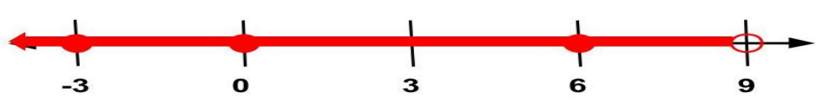
Students should then check to see whether their answers are correct by using the substitution property. If they say that 5 is a possible solution, rewrite the inequality 2x + (-6) < 12 and substitute 5 for x. Rewrite it as 2(5) + (-6) < 12, solve it, and see whether the statement is true. In this case, 4 is less than 12, so 4 is a correct solution. Accept a variety of responses from the students and try each of them in the same manner.

- For example, when creating a verbal situation in context given a one or two-step linear inequality in one variable and solving inequalities in context –
Martina needs to buy a new pair of shoes and some socks. The shoes cost $42, and each pack of socks costs $1.50. Martina has $53 to buy shoes and socks. If Martina buys one pair of shoes, what is the greatest number of packs of socks she can buy? Write and solve an inequality representing this situation.
A common error is for a student to say that Martina can buy seven and one third socks. Another common mistake is to round the final answer up, resulting in an answer of eight. Both errors indicate that the student does not understand what the answer means relating to the context of the problem. Another common error would be incorrectly subtracting $42 and $1.50 from $53 before setting up the inequality resulting in x < 9.5. This error indicates the student does not understand how to translate verbal expressions as inequalities. The student may benefit from additional practice translating verbal expressions.

Concepts and Connections
Concepts
Proportional relationships can be described, and generalizations can be made using patterns, relations, and functions. Algebraic Equations and Inequalities can be used to represent and solve real world problems.

Connections: In Grade 7, students will simplify numerical expressions, simplify and generate equivalent algebraic expressions in one variable, and evaluate algebraic expressions for given replacement values of the variables (7.PFA.2); and solve two-step linear equations in one variable (7.PFA.3). Prior to Grade 7, students wrote and solved one-step linear equations in one variable, including contextual problems that required the solution of a one-step linear equation in one variable (6.PFA.3), and represented a contextual situation using a linear inequality in one variable with symbols and graphs on a number line (6.PFA.4). Using these foundational understandings, students will write and solve one- and two-step linear inequalities in one variable, including problems in context, that require the solution of a one- and two-step linear inequality in one variable (7.PFA.4). In the subsequent grade level, Grade 8 students will represent, simplify, and generate equivalent algebraic expressions in one variable (8.PFA.1) as well as solve multistep linear equations (8.PFA.4) and inequalities (8.PFA.5) in one variable.

- Within the grade level/course:
  - 7.PFA.2 – The student will simplify numerical expressions, simplify and generate equivalent algebraic expressions in one variable, and evaluate algebraic expressions for given replacement values of the variables.
  - 7.PFA.3 – The student will write and solve two-step linear equations in one variable, including problems in context, that require the solution of a two-step linear equation in one variable.
- Vertical Progression:
  - 6.PFA.3 – The student will write and solve one-step linear equations in one variable, including contextual problems that require the solution of a one-step linear equation in one variable.
  - 6.PFA.4 – The student will represent a contextual situation using a linear inequality in one variable with symbols and graphs on a number line.
  - 8.PFA.1 – The student will represent, simplify, and generate equivalent algebraic expressions in one variable.
  - 8.PFA.4 – The student will write and solve multistep linear equations in one variable, including problems in context that require the solution of a multistep linear equation in one variable.
  - 8.PFA.5 – The student will create and solve multistep linear inequalities in one variable, including problems in context that require the solution of a multistep linear inequality in one variable.

Textbooks and HQIM for Consideration
- A list of approved textbooks and instructional materials will be posted on the VDOE website.

