2023 Mathematics
Standards of Learning

Algebra 2 Instructional Guide

Copyright © 2024
by the
Virginia Department of Education
P.O. Box 2120
Richmond, Virginia 23218-2120
http://www.doe.virginia.gov

All rights reserved. Reproduction of these materials for instructional purposes in public school classrooms in Virginia is permitted.

Superintendent of Public Instruction
Dr. Lisa Coons

Office of STEM
Dr. Anne Petersen, Director
Dr. Angela Byrd-Wright, Mathematics Coordinator
Dr. Jessica Brown, Elementary Mathematics Specialist
Mrs. Regina Mitchell, Mathematics and Special Education Specialist

NOTICE
The Virginia Department of Education does not unlawfully discriminate on the basis of race, color, sex, national origin, age, or disability in employment or in its educational programs or services.

The contents of this Instructional Guide were informed by the U.S. Department of Education's Institute of Education Sciences (IES), What Works Clearinghouse, as a central, trusted source of scientific evidence for what works in education. Sample questions reflect applicable and aligned content from the Virginia Department of Education's published assessment items, Mathematics Item Maps, and National Association of Educational Progress (NAEP) assessment questions.

Introduction
The Mathematics Instructional Guide, a companion document to the 2023 Mathematics Standards of Learning, amplifies the Standards of Learning by defining the core knowledge and skills in practice, supporting teachers and their instruction, and serving to transition classroom instruction from the 2016 Mathematics Standards of Learning to the newly adopted 2023 Mathematics Standards of Learning. Instructional supports are accessible in #GoOpenVA and support the decisions local school divisions must make concerning local curriculum development and how best to help students meet the goals of the standards. The local curriculum should include a variety of information sources, readings, learning experiences, and forms of assessment selected at the local level to create a rigorous instructional program.

For a complete list of the changes by standard, the 2023 Virginia Mathematics Standards of Learning – Overview of Revisions is available and delineates in greater specificity the changes for each grade level and course.

The Instructional Guide is divided into three sections: Understanding the Standard, Skills in Practice, and Concepts and Connections aligned to the Standard. The purpose of each is explained below.

Understanding the Standard
This section includes mathematics understandings and key concepts that assist teachers in planning standards-focused instruction. The statements may provide definitions, explanations, or examples regarding information sources that support the content. They describe what students should know (core knowledge) as a result of the instruction specific to the course/grade level and include evidence-based practices to approaching the Standard. There are also possible misconceptions and common student errors for each standard to help teachers plan their instruction.

Skills in Practice
This section outlines supporting questions and skills that are specifically linked to the standard. They frame student inquiry, promote critical thinking, and assist in learning transfer. Curriculum writers and teachers should use them to plan instruction to deepen understanding of the broader unit and course objectives. This is not meant to be an exhaustive list of student expectations.

Concepts and Connections

This section outlines concepts that transcend grade levels and thread through the K through 12 mathematics programs as appropriate at each level. Concept connections reflect connections to prior grade-level concepts as content and practices build within the discipline as well as potential connections across disciplines.

Expressions and Operations
Expressions and operations comprise the foundation for algebraic thinking, understanding, and application. Students use expressions and operations to develop and solve equations, inequalities, and functions. These skills unpack building blocks that are necessary for advanced mathematical thinking, understanding, and application. Also, mastery of performing operations on expressions is required for higher level mathematics courses.
Throughout Algebra 2, students will perform operations on rational and radical expressions. Additionally, students will factor polynomial expressions, and perform operations on complex numbers.

A2.EO.1 The student will perform operations on and simplify rational expressions.
Students will demonstrate the following Knowledge and Skills:
- Add, subtract, multiply, or divide rational algebraic expressions, simplifying the result.
- Justify and determine equivalent rational algebraic expressions with monomial and binomial factors. Algebraic expressions should be limited to linear and quadratic expressions.
- Recognize a complex algebraic fraction and simplify it as a product or quotient of simple algebraic fractions.
- Represent and demonstrate equivalence of rational expressions written in different forms.

Understanding the Standard
- A rational algebraic expression is the ratio of two polynomial expressions.
- Computational skills applicable to numerical fractions also apply to rational algebraic expressions.
- In this standard, denominators are assumed to be non-zero; however, students would benefit from learning experiences that make connections between values of the variable that would lead to having a zero in the denominator of a rational expression and domain restrictions of the corresponding rational function.
- A complex algebraic fraction is a rational algebraic expression where one or both of the numerator or denominator is also a rational algebraic expression.
- A complex algebraic fraction can be rewritten in an equivalent form as the quotient or product of simple algebraic fractions and then simplified to create a third equivalent form.
- Rewriting a rational expression in different but equivalent forms allows some aspects of the expression to be more apparent. For example, it may be easier to visualize the simplified form of a rational expression, but this may not reveal possible domain restrictions.

Skills in Practice
While the five process goals are expected to be embedded in each standard, the Skills in Practice highlight the most prevalent process goals in relation to the content presented.

Mathematical Connections: Students will benefit from ample exposure and opportunities with factoring quadratic trinomials prior to performing operations on and simplifying rational expressions. Examples with common misconceptions follow –

- Assuming no denominator equals zero, completely simplify each expression.

- $\frac{x^{2}+8x+15}{2x^{2}+5x-3}÷\frac{-9x-45}{1-2x}$
- $\frac{4x^{2}+15x+9}{8x^{2}+10x+3}· \frac{2x+1}{x^{2}+4x}$
Students tend to make errors in factoring or forget to factor prior to simplifying rational expressions. In order to simplify many rational expressions, students need to be proficient at factoring polynomials. When solving the first example, there is a need to factor out a negative one in order to simplify. This is a skill in which students should be proficient. The answers to the two examples are provided below.

- $\frac{1}{9}$
- $\frac{x+3}{x(x+4)}$
Mathematical Reasoning: Students will benefit from examples that require addition or subtraction with rational expressions. An example with common misconceptions follows –

- Assuming no denominator equals zero, completely simplify the expression.

$$\frac{5x^{2}-245}{2x^{2}-11x-21}-\frac{4x+35}{2x+3}$$

The most common student errors are to add or subtract the numerators, and add or subtract the denominators when the rational expressions do not contain like denominators. For this example, students can simplify the rational expression on the left so that it has a denominator of “$2x+3$.” This will make it easier to simplify because they will see the common factor in the denominator. The solution is $\frac{x}{2x+3}$ .

Concepts and Connections
Concepts
Rational expressions can be used to describe and define real-life contextual situations.

Connections: Prior to Algebra 2, students investigated, factored, and simplified algebraic expressions in one variable (A.EO.2). Students evaluated algebraic expressions for given replacement values of the variables (A.EO.1), derived and applied the laws of exponents (A.EO.3), and simplified and determined equivalent radical expressions involving square roots of whole numbers and cube roots of integers (A.EO.4). Given these understandings, students will perform operations on and simplify rational expressions (A2.EO.1) and this knowledge will be embedded into coursework beyond Algebra 2.

- Within the grade level/course:
  - A2.EO.2 – The student will perform operations on and simplify radical expressions.
  - A2.EO.3 – The student will perform operations on polynomial expressions and factor polynomial expressions in one and two variables.
  - A2.EO.4 – The student will perform operations on complex numbers.
- Vertical Progression:
  - A.EO.1 – The student will represent verbal quantitative situations algebraically and evaluate these expressions for given replacement values of the variables.
  - A.EO.2 – The student will perform operations on and factor polynomial expressions in one variable.
  - A.EO.3 – The student will derive and apply the laws of exponents.
  - A.EO.4 – The student will simplify and determine equivalent radical expressions involving square roots of whole numbers and cube roots of integers.

Textbooks and HQIM for Consideration
- A list of approved textbooks and instructional materials will be posted on the VDOE website.

A2.EO.2 The student will perform operations on and simplify radical expressions.
Students will demonstrate the following Knowledge and Skills:
- Simplify and determine equivalent radical expressions that include numeric and algebraic radicands.
- Add, subtract, multiply, and divide radical expressions that include numeric and algebraic radicands, simplifying the result. Simplification may include rationalizing the denominator.
- Convert between radical expressions and expressions containing rational exponents.

Understanding the Standard
- When simplifying radicals that have even indices (such as a square root), examine the radicand. If the radicand contains an algebraic expression with a negative coefficient, then use the imaginary unit, $i$ to simplify the radical completely.
- In Algebra 2, students may benefit from conversations about how techniques used to simplify square root and cube root expressions can be applied to simplify radical expressions with higher indices.
- Only radicals with a common radicand and index can be added or subtracted, which may require writing the radical in an equivalent form using a lower base and different index.
- Multiplying and dividing radical expressions containing different indices may require writing the expression in an equivalent form using rational exponents.
- Radical expressions can be written in an equivalent form using rational exponents.
- In Algebra 2, any variables in a radical expression will be assumed to be non-negative, but students may benefit from conversations about when absolute value notation would be necessary in simplifying a radical expression.

Skills in Practice
While the five process goals are expected to be embedded in each standard, the Skills in Practice highlight the most prevalent process goals in relation to the content presented.

Mathematical Problem Solving: Students need exposure to radical expressions that contain indices greater than two or three. An example with common misconceptions follows –

- Simplify the expression completely. Show your work/thinking.

$$\sqrt[4]{256a^{8}b^{30}}$$

A common error some students may make is to find the square root of the expression instead of the fourth root. This may indicate that some students do not understand what the index represents in a radical expression. Teachers may want to encourage students to circle the index, then make a factor tree and circle the same number of groups of factors that is equivalent to the value of the index.

Mathematical Representations: Students will benefit from multiple opportunities rewriting expressions containing rational exponents in radical form and vice versa. Additionally, students may need practice recognizing when expressions containing rational exponents are in the most simplified form. An example with common misconceptions follows –

- Rewrite the expression $6^{\frac{1}{5}}x^{\frac{9}{5}}y^{\frac{4}{5}}$ in simplest radical form. Show your work/thinking.

A common error some students may make is to rewrite the expression as a 5th root without simplifying. This may indicate that some students do not understand that terms with common bases in the expression in the radicand must first be simplified, and the radicand is in simplest radical form when the exponent of a base is less than the value of the index. Students may benefit from writing the expression in expanded form as $\sqrt[5]{6∙x∙x∙x∙x∙x∙x∙x∙x∙x∙y∙y∙y∙y}$. This may help students identify that a group of five $x$ terms can be simplified as $x$ because $\sqrt[5]{x^{5}}=x.$

A point of clarification is to explain that the numerator of the rational exponent should not be greater than the denominator of the rational exponent. This translates to radical expression notation as well. The power of the radicand should not be greater than the index of the radical. In either case, the expression is not written in its most simplified form.

Concepts and Connections
Concepts
Radicals are important in everyday life. Distance calculations, even GPS and map navigation software, use radicals to compute travel time.

Connections: Prior to Algebra 2, students represented verbal quantitative situations algebraically and evaluate these expressions for given replacement values of the variables (A.EO.1); performed operations on and factored polynomial expressions in one variable (A.EO.2); derived and applied the laws of exponents (A.EO.3); and, simplified and determined equivalent radical expressions involving square roots of whole numbers and cube roots of integers (A.EO.4). Given these understandings, students will continue to simplify radical expressions (A.EO.2) and this knowledge will be embedded into coursework beyond Algebra 2.

- Within the grade level/course:
  - A2.EO.1 – The student will perform operations on and simplify rational expressions.
  - A2.EO.3 – The student will perform operations on polynomial expressions and factor polynomial expressions in one and two variables.
  - A2.EO.4 – The student will perform operations on complex numbers.
- Vertical Progression:
  - A.EO.1 – The student will represent verbal quantitative situations algebraically and evaluate these expressions for given replacement values of the variables.
  - A.EO.2 – The student will perform operations on and factor polynomial expressions in one variable.
  - A.EO.3 – The student will derive and apply the laws of exponents.
  - A.EO.4 – The student will simplify and determine equivalent radical expressions involving square roots of whole numbers and cube roots of integers.

Textbooks and HQIM for Consideration
- A list of approved textbooks and instructional materials will be posted on the VDOE website.

A2.EO.3 The student will perform operations on polynomial expressions and factor polynomial expressions in one and two variables.
Students will demonstrate the following Knowledge and Skills:
- Determine sums, differences, and products of polynomials in one and two variables.
- Factor polynomials completely in one and two variables with no more than four terms over the set of integers.
- Determine the quotient of polynomials in one and two variables, using monomial, binomial, and factorable trinomial divisors.
- Represent and demonstrate equality of polynomial expressions written in different forms and verify polynomial identities including the difference of squares, sum and difference of cubes, and perfect square trinomials.

Understanding the Standard
- Combining like terms is a method which should be employed when adding or subtracting polynomial expressions.
- Applying laws of exponents is required when multiplying or dividing polynomial expressions.
- Factoring polynomials completely assists with dividing and simplifying polynomial expressions.
- The complete factorization of polynomials occurs when each factor cannot be written as the product of polynomials of lower degree.
- Polynomials may be factored in various ways, including but not limited to, grouping or recognizing general patterns such as difference of squares, sum and difference of cubes, and perfect square trinomials.
- Techniques for factoring quadratic expressions can be extended to factoring some higher degree binomials and trinomials. For example, $x^{4}+2x^{2}-8$ can be expressed in an equivalent form as $\left(x^{2}+4\right)\left(x^{2}-2\right)$.
- For division of polynomials in this standard, students may benefit from experiences with multiple methods, to include, but are not limited to long or synthetic division.
- Polynomial expressions can be used to define functions and these functions can be represented graphically.
- Rewriting a polynomial expression in different but equivalent forms allows some aspects of the expression to be more apparent. For example, a quadratic expression written in vertex form allows the vertex to be found by visual inspection of the expression. The quadratic written in standard form allows for the $y$-intercept to be found by visual inspection.

Skills in Practice
While the five process goals are expected to be embedded in each standard, the Skills in Practice highlight the most prevalent process goals in relation to the content presented.

Mathematical Reasoning: When attempting to divide polynomial expressions in one variable, students should completely factor both the numerator and denominator before simplifying the problem. Examples with common misconceptions follow –
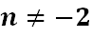
- Which polynomial is equivalent to this expression if ?
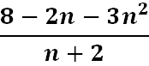

Although it is not required, a common error students might make is not rewriting the numerator in standard form prior to factoring it. Choice c is the correct answer to this problem.

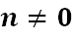
- Simplify, if :
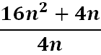

A common error students might make is failing to factor the numerator before simplifying the expression. Students may divide the quadratic term by the denominator or the linear term by the denominator in error. The solution is $4n+1$.

Mathematical Representations: When attempting to determine the product of polynomial expressions in one variable, students should be exposed to a variety of strategies. An example with common misconceptions follows –
- Multiply the following. Show your work/thinking.
$$\left(4x-2\right)\left(2x-4\right)$$
A common error when multiplying binomials involving subtraction is that students may make errors with the signs. This may indicate that a student needs to revisit multiplication of integers. One strategy is to have students rewrite the problem using “add the opposite” or $(4x + (-2))(2x + (-4))$ so that distribution of terms would be $4x(2x) + 4x(-4) + -2(2x) + -2(-4)$. This may help students keep track of the signs. Teachers may find it helpful for students to use a box method for multiplication so that they can organize terms and signs.

· | $$2x$$ | $$-4$$
$$4x$$ | $$8x^{2}$$ | $$-16x$$
$$-2$$ | $$-4x$$ | $$8$$

Example setting up the box method:

Concepts and Connections
Concepts
Expressions can be used to describe and define real-life contextual situations. Simplifying polynomial expressions through sums, differences, products, quotients, and factoring, allows us to make sense of algebraic data in comparable ways that we understand numerical data.

Connections: Prior to Algebra 2, students represented verbal quantitative situations algebraically and evaluated these expressions for given replacement values of the variables (A.EO.1); performed operations on and factored polynomial expressions in one variable (A.EO.2); applied the laws of exponents (A.EO.3); and, simplified and determined equivalent radical expressions involving square roots of whole numbers and cube roots of integers (A.EO.4). Given these understandings, students will perform operations on polynomial expressions and factor polynomial expressions in one and two variables (A.EO.3) and
these skills will be embedded into coursework beyond Algebra 2.

- Within the grade level/course:
  - A2.EO.1 – The student will perform operations on and simplify rational expressions.
  - A2.EO.2 – The student will perform operations on and simplify radical expressions.
  - A2.EO.4 – The student will perform operations on complex numbers.
- Vertical Progression:
  - A.EO.1 – The student will represent verbal quantitative situations algebraically and evaluate these expressions for given replacement values of the variables.
  - A.EO.2 – The student will perform operations on and factor polynomial expressions in one variable.
  - A.EO.3 – The student will derive and apply the laws of exponents.
  - A.EO.4 – The student will simplify and determine equivalent radical expressions involving square roots of whole numbers and cube roots of integers.

Textbooks and HQIM for Consideration
- A list of approved textbooks and instructional materials will be posted on the VDOE website.

A2.EO.4 The student will perform operations on complex numbers.
Students will demonstrate the following Knowledge and Skills:
- Explain the meaning of i.
- Identify equivalent radical expressions containing negative rational numbers and expressions in a + bi form.
- Apply properties to add, subtract, and multiply complex numbers.

Understanding the Standard
- $i$ is the imaginary unit that satisfies the equation $i^{2}=-1$, where $i= \sqrt{-1}.$
- $i$ can be described using a cyclical approach:
  - $i= \sqrt{-1}$
  - $i^{2}=-1$
  - $i^{3}=-i$
  - $i^{4}=1$
  - $i^{5}= \sqrt{-1}$
- All complex numbers can be written in the form $a+bi$, where $a$ and $b$ are real numbers.
  - $a$ is considered to be the real part of the complex number
  - $bi$ is considered to be the imaginary part of the complex number
- Real numbers and pure imaginary numbers are subsets of the complex number system. For example:
  - $5=5+0i$
  - $±\sqrt{-9}=0±3i$
- The conjugate of the complex number $a+bi$ is $a-bi$.
- A complex number multiplied by its conjugate is a non-negative real number.
- Algebraic properties apply to complex numbers as well as real numbers.

Skills in Practice
While the five process goals are expected to be embedded in each standard, the Skills in Practice highlight the most prevalent process goals in relation to the content presented.

Mathematical Problem Solving: Students should be able to identify the properties used while simplifying an expression. Students will benefit from exposure to examples where more than one property needs to be identified. An example follows –

Identify the property used between each step:

Step 1 | $$6i+4+2(i+3)$$ | Given
Step 2 | $$6i+4+2i+6$$
Step 3 | $$6i+2i+4+6$$
Step 4 | $$8i+4+6$$
Step 5 | $$8i+10$$

Mathematical Communication: Students should be able to recognize and communicate properties when applied to complex numbers. They should also recognize and communicate the properties as they are used to solve equations or simplify expressions. Examples follow –

- Identify the property represented in each example.

- 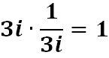
- If $3i +2i = 5i$, and $5i = 11i – 6i$, then $3i+2i=11i-6i$.
- Students need additional practice identifying the field properties that are valid for complex numbers. The answers are listed below.

- Inverse property with respect to multiplication.
- Transitive property of equality.

Concepts and Connections
Concepts
Complex numbers include imaginary units that cannot be defined in a real number system.

Connections: Prior to Algebra 2, students represented verbal quantitative situations algebraically and evaluated these expressions for given replacement values of the variables (A.EO.1); performed operations on and factored polynomial expressions in one variable (A.EO.2); applied the laws of exponents (A.EO.3); and, simplified and determined equivalent radical expressions involving square roots of whole numbers and cube roots of integers (A.EO.4). Students investigated and simplified mathematical problems solely from the perspective of the real number system. Given these understandings, students will perform operations on complex numbers (A2.EO.4) and these skills will be embedded into coursework beyond Algebra 2.

- Within the grade level/course:
  - A2.EO.1 – The student will perform operations on and simplify rational expressions.
  - A2.EO.2 – The student will perform operations on and simplify radical expressions.
  - A2.EO.3 – The student will perform operations on polynomial expressions and factor polynomial expressions in one and two variables.
- Vertical Progression:
  - A.EO.1 – The student will represent verbal quantitative situations algebraically and evaluate these expressions for given replacement values of the variables.
  - A.EO.2 – The student will perform operations on and factor polynomial expressions in one variable.
  - A.EO.3 – The student will derive and apply the laws of exponents.
  - A.EO.4 – The student will simplify and determine equivalent radical expressions involving square roots of whole numbers and cube roots of integers.

Textbooks and HQIM for Consideration
- A list of approved textbooks and instructional materials will be posted on the VDOE website.

Equations and Inequalities
Equations and inequalities are major components of algebra. Equations and inequalities are comprised of expressions and operations. These skills lead to the understanding and analysis of functions. Also, mastery of solving equations and inequalities is essential for developing and creating mathematical models. The knowledge of equations and inequalities is required for all mathematics courses, beyond Algebra 2.
Throughout Algebra 2, students will represent, solve, and interpret the solution to absolute value, quadratic, rational, and radical equations, and absolute value inequalities in one variable. Students will apply skills learned about systems of two linear equations to solve systems containing a quadratic expression. Additionally, students will solve and interpret the solution to a polynomial equation.

A2.EI.1 The student will represent, solve, and interpret the solution to absolute value equations and inequalities in one variable.
Students will demonstrate the following Knowledge and Skills:
- Create an absolute value equation in one variable to model a contextual situation.
- Solve an absolute value equation in one variable algebraically and verify the solution graphically.
- Create an absolute value inequality in one variable to model a contextual situation.
- Solve an absolute value inequality in one variable and represent the solution set using set notation, interval notation, and using a number line.
- Verify possible solution(s) to absolute value equations and inequalities in one variable algebraically, graphically, and with technology to justify the reasonableness of answer(s). Explain the solution method and interpret solutions for problems given in context.

Understanding the Standard
- The definition of absolute value (for any real numbers a and b, where b > 0, if |a|= b, then a = b or a = − b) is used in solving absolute value equations and inequalities.
- The absolute value of any number is the distance from that number to zero on a number line.
- Absolute value inequalities in one variable can be solved algebraically using a compound statement.
- Compound statements representing solutions of an inequality in one variable can be represented graphically on a number line.
- Practical problems can be interpreted, represented, and solved using equations and inequalities.
- Solutions and intervals may be expressed in different formats, including set notation, using equations and inequalities, or interval notation.
- Interval notation is used when describing a range of values. Thus, interval notation could be used to define solutions to inequalities.
- Examples may include:
Equation/ Inequality | Set Notation | Interval Notation
x = 3 | {3} | {3}
x = 3 or x = 5 | {3, 5} | {3, 5}
y ≥ 3 | {y: y ≥ 3} | [3, $∞)$
$$-2<x≤6$$ | {$x:-2<x≤6$} | ($-$2, 6]
Empty (null) set ∅ | { } | { }

- The process of solving equations or inequalities can lead to extraneous solutions.
- An extraneous solution is a solution of the simplified form of an equation/inequality that does not satisfy the original equation/inequality. Use substitution to verify solutions.

Skills in Practice
While the five process goals are expected to be embedded in each standard, the Skills in Practice highlight the most prevalent process goals in relation to the content presented.

Mathematical Problem Solving: Student need additional practice verifying the reasonableness of their answers by checking for extraneous solutions. An example with common misconceptions follows –

- Write the solution set for the inequality $|4x+10|≤6x$. Show your work/thinking.

A common error students may make is to not check for extraneous solutions. This may indicate that some students do understand how to interpret the solution of $\{x|x≥5\}$ and $\left\{x | x≥-1\right\},$ and that $\{x|x≥5\}$ are the only values of $x$ that satisfy the given inequality. This may indicate that the students did not check to verify if both inequality statements $x≥5$and $x≥-1$ satisfy the given inequality. Teachers may want to encourage students to select values from their solution set and values outside the solution set to substitute into the original inequality to determine their validity. For example, not all values of $x$ within $\{x|x≥-1\}$ satisfy the original inequality.

Mathematical Communication: Students may benefit from additional opportunities solving absolute value equations that contain an absolute value expression set equal to an algebraic expression. An example with common misconceptions follows –

- Student A was asked to solve the equation $|5x-2|=3x+5.$ Their work is shown below.

$$|5x-2|=3x+5$$

$$5x-2=3x+5$$  $$2x-2 = 5$$  $$2x =7$$  $$x=\frac{7}{2}$$ | $$5x-2=-3x+5$$  $$8x-2=5$$  $$8x=7$$  $$x=\frac{7}{8}$$

Describe and correct the errors made.

A common error some students make is to neglect to properly distribute the negative for the second equation resulting in $5x-2=-3x+5,$ instead of $5x-2=-3x-5$. This may indicate that the student does not understand applying the distribution property $a(b + c) = ab + ac$. Teachers may want to have students write the right side of the equation using parentheses resulting in $5x-2=-(3x+5)$ to help ensure students distribute the negative to both terms. Teachers may also find it helpful to use Desmos to show students the graphical representation of their solutions by separating the functions $y = |5x-2|$ and $y=3x+5$. Students will be able to use the points of intersections to verify their solutions as modeled below.

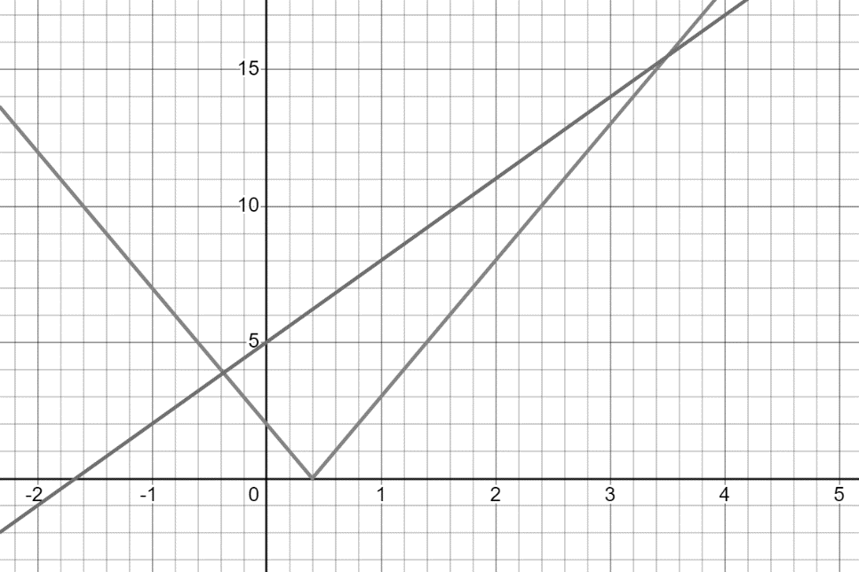

Concepts and Connections
Concepts
Absolute value equations and inequalities can be used to model real-life contextual situations.

Connections: Prior to Algebra 2, students represented, solved, explained, and interpreted the solution to multistep linear equations and inequalities in one variable and literal equations for a specified variable (A.EI.1); represented, solved, explained, and interpreted the solution to a system of two linear equations, a linear inequality in two variables, or a system of two linear inequalities in two variables (A.EI.2); and, represented, solved, and interpreted the solution to a quadratic equation in one variable (A.EI.3). Given these understandings, students will represent, solve, and interpret the solution to absolute value equations and inequalities in one variable (A2.EI.1) and these skills will be embedded into coursework beyond Algebra 2.

- Within the grade level/course:
  - A2.EI.2 – The student will represent, solve, and interpret the solution to quadratic equations in one variable over the set of complex numbers and solve quadratic inequalities in one variable.
  - A2.EI.3 – The student will solve a system of equations in two variables containing a quadratic expression.
  - A2.EI.4 – The student will represent, solve, and interpret the solution to an equation containing rational algebraic expressions.
  - A2.EI.5 – The student will represent, solve, and interpret the solution to an equation containing a radical expression.
  - A2.EI.6 – The student will represent, solve, and interpret the solution to a polynomial equation.
- Vertical Progression:
  - A.EI.1 – The student will represent, solve, explain, and interpret the solution to multistep linear equations and inequalities in one variable and literal equations for a specified variable.
  - A.EI.2 – The student will represent, solve, explain, and interpret the solution to a system of two linear equations, a linear inequality in two variables, or a system of two linear inequalities in two variables.
  - A.EI.3 – The student will represent, solve, and interpret the solution to a quadratic equation in one variable.

Textbooks and HQIM for Consideration
- A list of approved textbooks and instructional materials will be posted on the VDOE website.

A2.EI.2 The student will represent, solve, and interpret the solution to quadratic equations in one variable over the set of complex numbers
and solve quadratic inequalities in one variable.
Students will demonstrate the following Knowledge and Skills:
- Create a quadratic equation or inequality in one variable to model a contextual situation.
- Solve a quadratic equation in one variable over the set of complex numbers algebraically.
- Determine the solution to a quadratic inequality in one variable over the set of real numbers algebraically.
- Verify possible solution(s) to quadratic equations or inequalities in one variable algebraically, graphically, and with technology to justify the reasonableness of answer(s). Explain the solution method and interpret solutions for problems given in context.

Understanding the Standard
- Quadratic equations and inequalities can be used to represent, interpret, and solve contextual problems.
- Quadratic equations can be solved in a variety of ways, including graphing, factoring, the quadratic formula, and completing the square.
- The quadratic formula and completing the square can be used to solve any quadratic equation over the set of complex numbers.
- The quadratic formula shows that the solutions to the equation $ax^{2}+bx+c=0$are $x=\frac{-b±\sqrt{b^{2}-4ac}}{2a}$.
- The discriminant of the equation $ax^{2}+bx+c=0$ is defined as $b^{2}-4ac$.
- The value of the discriminant of a quadratic equation can be used to describe the number and type of solutions to the equation:
  - If $b^{2}-4ac>0,$ then the equation has two real solutions. Further, if the discriminant is a rational number, then the original equation could be solved by factoring.
  - If $b^{2}-4ac=0$, then the equation has one real solution with a multiplicity of 2. Further, the original equation is a perfect square trinomial.
  - If $b^{2}-4ac<0$, then the equation has two complex, non-real, solutions.
- The quadratic formula can be derived by applying the completion of squares to any quadratic equation in standard form.
- Solutions of quadratic equations are real or a sum or difference of a real and imaginary component.
- Complex solutions occur in conjugate pairs.
- Quadratic equations with exactly one real root can be referred to as having one distinct root with a multiplicity of two. This is called a double zero. For instance, the quadratic equation, $x^{2}-4x+4$, has two identical factors, giving one real root with a multiplicity of two. In this case, the equation is a perfect square trinomial.
- Solutions and intervals may be expressed in different formats, including set notation, using equations and inequalities, or interval notation.
- Interval notation is used when describing a range of values. Thus, interval notation could be used to define solutions to inequalities.
- Examples may include:
Equation/Inequality | Set Notation | Interval Notation
$x$ = 3 | {3}
$x$ = 3 or $x$ = 5 | {3, 5}
$x= -2-5i$or $x= -2+5i$ | $\{-2-5i, -2+5i\}$ or $\{-2±5i\}$
$$0≤x<3$$ | {x|$0≤x<3$} | [0, 3)
y ≥ 3 | {y: y ≥ 3} | [3, ∞)
Empty (null) set ∅ | { }

- Sign charts can be used to solve quadratic inequalities.
Example: $x^{2}+3x+2≥0$
$(x+2)(x+1)≥0$
- Equality holds when $x=-2$ and $x=-1$
Perform sign analysis:
Interval | $$x<-2$$ | $$-2<x<-1$$ | $$x>-1$$
Test Value | $$-3$$ | $$-1.5$$ | $$0$$
Sign Analysis | $$\left(-\right)\left(-\right)=+$$ | $$\left(+\right)\left(-\right)=-$$ | $$\left(+\right)\left(+\right)=+$$

Solution: $x≤-2$ and $x≥-1$

Skills in Practice
While the five process goals are expected to be embedded in each standard, the Skills in Practice highlight the most prevalent process goals in relation to the content presented.

Mathematical Reasoning: Students should be exposed to quadratic equations written multiple ways. When solving quadratic equations algebraically using the quadratic formula, it is a best practice to set the quadratic equation equal to zero prior to identifying a, b, and c. Also, students should be encouraged to use integer values for a, b, and c. Examples with common misconceptions follow –
- What are the solutions to the equation shown? Show your work/thinking.

$$2x^{2}-3x=4$$

A common mistake students make is to substitute values into the quadratic formula without having set the equation equal to zero first (e.g., $c = 4,$ rather than $c = -4$). This may indicate that students have not connected the solutions to the zeros of an equation. Reinforcing this vocabulary could help students realize that in order to find the zeros (solutions), the equation must be set equal to zero first.

- What values of $x$ are solutions to the equation? Show your work/thinking.

$$\frac{1}{2}x^{2}-\frac{1}{4}x-2=0$$

Students may make errors substituting rational values for a, b, and c when using the quadratic formula. This may indicate that students lack proficiency with operations with rational numbers. A strategy teachers can use is to encourage students to write an equivalent equation by multiplying all of the terms of the equation by a scalar value that will produce integer coefficients before using the quadratic formula. Care must be taken to multiply each term of the equation by the selected scalar in order to create an equivalent equation. Verifying solutions with a graphing utility could also help students identify when a mistake has been made and allow them the opportunity to review their work to find the error.

Mathematical Connections: Students may have trouble solving a quadratic equation when the quadratic equation is not written in standard form, and the solutions have imaginary roots. An example with common misconceptions follows –

- What is the solution set for the equation shown?

$$4x^{2}+4x=-17$$

The solution is $\left\{-\frac{1}{2}±2i\right\}$ or $\left\{-\frac{1}{2}-2i, -\frac{1}{2}+2i\right\}$. Note the two different formats for listing the solution set. Students should be familiar with multiple representations of solutions.

Concepts and Connections
Concepts
Quadratic equations can be used to model real-life contextual situations.

Connections: Prior to Algebra 2, students represented, solved, explained, and interpreted the solution to multistep linear equations and inequalities in one variable and literal equations for a specified variable (A.EI.1); and, represented, solved, and interpreted the solution to a quadratic equation in one variable (A.EI.3). Given these understandings, students will represent, solve, and interpret the solution to quadratic equations in one variable over the set of complex numbers and solve quadratic inequalities in one variable (A2.EI.2) and these skills will be embedded into coursework beyond Algebra 2.

- Within the grade level/course:
  - A2.EI.1 – The student will represent, solve, and interpret the solution to absolute value equations and inequalities in one variable.
  - A2.EI.3 – The student will solve a system of equations in two variables containing a quadratic expression.
  - A2.EI.4 – The student will represent, solve, and interpret the solution to an equation containing rational algebraic expressions.
  - A2.EI.5 – The student will represent, solve, and interpret the solution to an equation containing a radical expression.
  - A2.EI.6 – The student will represent, solve, and interpret the solution to a polynomial equation.
- Vertical Progression:
  - A.EI.1 – The student will represent, solve, explain, and interpret the solution to multistep linear equations and inequalities in one variable and literal equations for a specified variable.
  - A.EI.3 – The student will represent, solve, and interpret the solution to a quadratic equation in one variable.

Textbooks and HQIM for Consideration
- A list of approved textbooks and instructional materials will be posted on the VDOE website.

A2.EI.3 The student will solve a system of equations in two variables containing a quadratic expression.
Students will demonstrate the following Knowledge and Skills:
- Create a linear-quadratic or quadratic-quadratic system of equations to model a contextual situation.
- Determine the number of solutions to a linear-quadratic and quadratic-quadratic system of equations in two variables.
- Solve a linear-quadratic and quadratic-quadratic system of equations algebraically and graphically, including situations in context.
- Verify possible solution(s) to linear-quadratic or quadratic-quadratic system of equations algebraically, graphically, and with technology to justify the reasonableness of answer(s). Explain the solution method and interpret solutions for problems given in context.

Understanding the Standard
- Systems of equations can be used to represent, interpret, and solve contextual problems.
- The coordinates of points of intersection in any system of equations are solutions to the system.
- Quadratic equations included in this standard will only include those that can be represented as parabolas of the form $y=ax^{2}+bx+c$ where $a≠0$.
- Solutions of a system of equations are numerical values that satisfy every equation in the system.
- A linear-quadratic system of equations may have zero, one, or two solutions.
- A quadratic-quadratic system of equations may have zero, one, two, or an infinite number of solutions.
- Solving an equation or system of equations graphically with technology may lead to approximate solutions. The context of the problem should be considered when determining whether to report an exact or approximate solution.

Skills in Practice
While the five process goals are expected to be embedded in each standard, the Skills in Practice highlight the most prevalent process goals in relation to the content presented.

Mathematical Connections: Students may require additional practice finding the solutions of a system of equations containing a quadratic expression when the equations are given symbolically. An example with common misconceptions follows –

- What is the value of the $y$-coordinate of the solution to this system of equations?

$$\left\{\begin{aligned}y=x^{2}-3x+5 \\ y-1=x \end{aligned}\right.$$

Students may have difficulty when the question is in fill-in-the-blank format, and they are asked to provide the $x$- or $y$-coordinate of the solution. The answer to this example is $y=3$.

Mathematical Representations: Students will benefit from additional practice plotting the solution to a system of equations graphed on the coordinate plane. An example with common misconceptions follows –

- Plot the apparent solutions to the system of equations shown.
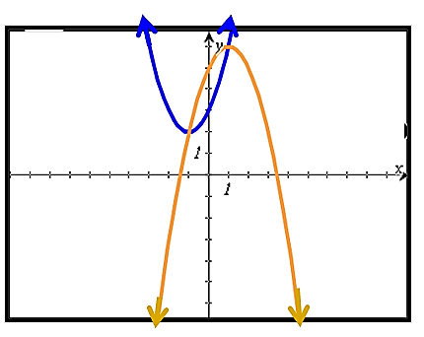

Students have trouble when asked to identify the solution to a quadratic-quadratic system of equations represented on a coordinate plane, given the system graphed on the coordinate plane, and asked to plot the solutions. Students tend to include additional points that are not solutions, such as the $y$-intercepts of the quadratics. The correct answers are $(-1, 2)$ and $(1, 6)$.

Concepts and Connections
Concepts
Systems of quadratic equations can be used to model real-life contextual situations.

Connections: Prior to Algebra 2, students represented, solved, explained, and interpreted the solution to multistep linear equations and inequalities in one variable and literal equations for a specified variable (A.EI.1); represented, solved, explained, and interpreted the solution to a system of two linear equations, a linear inequality in two variables, or a system of two linear inequalities in two variables (A.EI.2); and, represented, solved, and interpreted the solution to a quadratic equation in one variable (A.EI.3). Given these understandings, students will solve a system of equations in two variables containing a quadratic expression (A2.EI.3) and these skills will be embedded into coursework beyond Algebra 2.

- Within the grade level/course:
  - A2.EI.1 – The student will represent, solve, and interpret the solution to absolute value equations and inequalities in one variable.
  - A2.EI.2 – The student will represent, solve, and interpret the solution to quadratic equations in one variable over the set of complex numbers and solve quadratic inequalities in one variable.
  - A2.EI.4 – The student will represent, solve, and interpret the solution to an equation containing rational algebraic expressions.
  - A2.EI.5 – The student will represent, solve, and interpret the solution to an equation containing a radical expression.
  - A2.EI.6 – The student will represent, solve, and interpret the solution to a polynomial equation.
- Vertical Progression:
  - A.EI.1 – The student will represent, solve, explain, and interpret the solution to multistep linear equations and inequalities in one variable and literal equations for a specified variable.
  - A.EI.2 – The student will represent, solve, explain, and interpret the solution to a system of two linear equations, a linear inequality in two variables, or a system of two linear inequalities in two variables.
  - A.EI.3 – The student will represent, solve, and interpret the solution to a quadratic equation in one variable.

Textbooks and HQIM for Consideration
- A list of approved textbooks and instructional materials will be posted on the VDOE website.

A2.EI.4 The student will represent, solve, and interpret the solution to an equation containing rational algebraic expressions.
Students will demonstrate the following Knowledge and Skills:
- Create an equation containing a rational expression to model a contextual situation.
- Solve rational equations with real solutions containing factorable algebraic expressions algebraically and graphically. Algebraic expressions should be limited to linear and quadratic expressions.
- Verify possible solution(s) to rational equations algebraically, graphically, and with technology to justify the reasonableness of answer(s). Explain the solution method and interpret solutions for problems given in context.
- Justify why a possible solution to an equation containing a rational expression might be extraneous.

Understanding the Standard
- Equations that contain rational expressions can be used to represent, interpret, and solve contextual problems.
- Equations that contain rational expressions can be solved in a variety of ways.
- The process of solving equations that contain rational expressions can lead to extraneous solutions.
- An extraneous solution is a solution of the simplified form of an equation that does not satisfy the original equation. Use substitution to verify solutions.
- The process used to solve an equation with a rational expression may lead to solving an equivalent equation containing a polynomial expression. In Algebra 2, these experiences should be limited to equivalent linear or quadratic equations.
- Solving an equation graphically with technology may lead to approximate solutions. The context of the problem should be considered when determining whether to report an exact or approximate solution.

Skills in Practice
While the five process goals are expected to be embedded in each standard, the Skills in Practice highlight the most prevalent process goals in relation to the content presented.

Mathematical Communication: Students may benefit from additional opportunities solving rational equations and communicating their results. An example with common misconceptions follows –

- Student A was asked to solve the equation $\frac{-x+4}{2-x}$ $+ 4x=$ $\frac{2x+1}{2x+3}$. Their work is shown below.

$\frac{-x+4}{2-x}$ $+ 4x=$ $\frac{2x+1}{2x+3}$
$$\frac{4}{2}+4x=\frac{1}{3}$$
$$2+4x=\frac{1}{3}$$
$$4x=\frac{1}{3}-2$$
$$4x=-\frac{5}{3}$$
$$x=-\frac{5}{12}$$
Describe and correct the errors made.

A common error some students may make is to cancel terms rather than common factors. This may indicate that a student does not understand that terms may only be canceled when written as a monomial expression, and binomial expressions may not be canceled unless it is a common factor. Teachers may have students solve simpler rational problems involving monomial expressions and binomial expressions to ensure they understand when and how to properly cancel factors. For example, provide students with problems similar to $\frac{6x^{2}y}{3x(x+2)}, \frac{2x+4}{(x+2)}$ , $\frac{x-3}{x^{2}-9}$ , and $\frac{x}{x^{2}+2x}$ to ensure that students understand when monomial and binomial factors can be canceled.

Mathematical Connections: Students may benefit from additional practice adding rational expressions prior to solving rational equations. An example with common misconceptions follows –

- Solve the equation $\frac{2x}{3x^{2}}+\frac{7x}{4} =5$. Show your work/thinking.

A common error some students may make is to combine the denominators of two fractions without first finding a common denominator, writing $\frac{9x}{3x^{2}+4}=5$. This may indicate that some students do not understand that the fractions must be rewritten as equivalent fractions using common denominators before combining and writing as one fraction. Students may also not understand how to find the least common multiple of different denominators. Teachers may want to provide additional practice combining rational numbers that do not have common denominators, for example, $\frac{1}{4x}+\frac{9}{x-1}$.

Concepts and Connections
Concepts
Rational equations can be used to model real-life contextual situations.

Connections: Prior to Algebra 2, students represented, solved, explained, and interpreted the solution to multistep linear equations and inequalities in one variable and literal equations for a specified variable (A.EI.1); and, represented, solved, and interpreted the solution to a quadratic equation in one variable (A.EI.3). Given these understandings, students will represent, solve, and interpret the solution to an equation containing rational algebraic expressions (A2.EI.4) and these skills will be embedded into coursework beyond Algebra 2.

- Within the grade level/course:
  - A2.EI.1 – The student will represent, solve, and interpret the solution to absolute value equations and inequalities in one variable.
  - A2.EI.2 – The student will represent, solve, and interpret the solution to quadratic equations in one variable over the set of complex numbers and solve quadratic inequalities in one variable.
  - A2.EI.3 – The student will solve a system of equations in two variables containing a quadratic expression.
  - A2.EI.5 – The student will represent, solve, and interpret the solution to an equation containing a radical expression.
  - A2.EI.6 – The student will represent, solve, and interpret the solution to a polynomial equation.
- Vertical Progression:
  - A.EI.1 – The student will represent, solve, explain, and interpret the solution to multistep linear equations and inequalities in one variable and literal equations for a specified variable.
  - A.EI.3 – The student will represent, solve, and interpret the solution to a quadratic equation in one variable.

Textbooks and HQIM for Consideration
- A list of approved textbooks and instructional materials will be posted on the VDOE website.
A2.EI.5 The student will represent, solve, and interpret the solution to an equation containing a radical expression.
Students will demonstrate the following Knowledge and Skills:
- Solve an equation containing no more than one radical expression algebraically and graphically.
- Verify possible solution(s) to radical equations algebraically, graphically, and with technology, to justify the reasonableness of answer(s). Explain the solution method and interpret solutions for problems given in context.
- Justify why a possible solution to an equation with a square root might be extraneous.

Understanding the Standard
- Equations that contain a radical expression can be used to represent, interpret, and solve contextual problems.
- Equations that contain a radical expression can be solved in a variety of ways.
- Radical expressions may be converted to expressions using rational exponents.
- The process of solving equations that contain a radical expression can lead to extraneous solutions.
- An extraneous solution is a solution of the simplified form of an equation that does not satisfy the original equation. Use substitution to verify solutions.
- In Algebra 2, solving equations involving radical expressions is limited to those with square root expressions, but students may benefit from conversations about how techniques used to solve equations containing square roots apply to solving equations containing radical expressions with higher indices.
- The process used to solve an equation containing the square root of an algebraic expression and a linear expression may involve solving an equivalent quadratic equation.
- Solving an equation graphically with technology may lead to approximate solutions. The context of the problem should be considered when determining whether to report an exact or approximate solution.

Skills in Practice
While the five process goals are expected to be embedded in each standard, the Skills in Practice highlight the most prevalent process goals in relation to the content presented.

Mathematical Problem Solving: When solving radical equations, students should be exposed to opportunities that require them to explore with graphs of radical equations. An example with common misconceptions follows –

How many distinct real solutions does this equation have?
$$x^{2}+1=\sqrt{3x^{2}+1}$$

The correct answer is 3. A common error is that students graph the equation as written in implicit form and only see two solutions. When verifying solutions on a calculator, students should be aware of limitations that may occur with graphing utilities.

Mathematical Representations: When solving radical equations, students should have experiences where the solutions are obtained given graphical representations. An example with common misconceptions follows –

- Which graph could be used to verify the solution of $x+\sqrt{x}=6$?
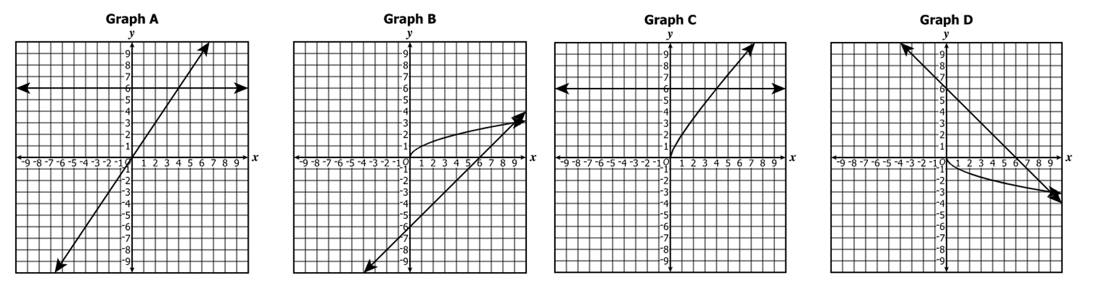

The correct answer is Graph C. A common error is that students often select Graph A because they only graph equations $y = x$ and $y = 6$.

Concepts and Connections
Concepts
Radical equations can be used to model real-life contextual situations.

Connections: Prior to Algebra 2, students represented, solved, explained, and interpreted the solution to multistep linear equations and inequalities in one variable and literal equations for a specified variable (A.EI.1); represented, solved, explained, and interpreted the solution to a system of two linear equations, a linear inequality in two variables, or a system of two linear inequalities in two variables (A.EI.2); and, represented, solved, and interpreted the solution to a quadratic equation in one variable (A.EI.3). Given these understandings, students will represent, solve, and interpret the solution to an equation containing a radical expression (A2.EI.5) and these skills will be embedded into coursework beyond Algebra 2.

- Within the grade level/course:
  - A2.EI.1 – The student will represent, solve, and interpret the solution to absolute value equations and inequalities in one variable.
  - A2.EI.2 – The student will represent, solve, and interpret the solution to quadratic equations in one variable over the set of complex numbers and solve quadratic inequalities in one variable.
  - A2.EI.3 – The student will solve a system of equations in two variables containing a quadratic expression.
  - A2.EI.4 – The student will represent, solve, and interpret the solution to an equation containing rational algebraic expressions.
  - A2.EI.6 – The student will represent, solve, and interpret the solution to a polynomial equation.
- Vertical Progression:
  - A.EI.1 – The student will represent, solve, explain, and interpret the solution to multistep linear equations and inequalities in one variable and literal equations for a specified variable.
  - A.EI.2 – The student will represent, solve, explain, and interpret the solution to a system of two linear equations, a linear inequality in two variables, or a system of two linear inequalities in two variables.
  - A.EI.3 – The student will represent, solve, and interpret the solution to a quadratic equation in one variable.

Textbooks and HQIM for Consideration
- A list of approved textbooks and instructional materials will be posted on the VDOE website.

A2.EI.6 The student will represent, solve, and interpret the solution to a polynomial equation.
Students will demonstrate the following Knowledge and Skills:
- Determine a factored form of a polynomial equation, of degree three or higher, given its zeros or the x-intercepts of the graph of its related function.
- Determine the number and type of solutions (real or imaginary) of a polynomial equation of degree three or higher.
- Solve a polynomial equation over the set of complex numbers.
- Verify possible solution(s) to polynomial equations of degree three or higher algebraically, graphically, and with technology to justify the reasonableness of answer(s). Explain the solution method and interpret solutions in context.

Understanding the Standard
- Polynomial equations can be used to represent, interpret, and solve contextual problems.
- Polynomial equations can be solved in a variety of ways.
- The degree of a polynomial equation is the largest power or exponent of a variable in the equation.
- The Fundamental Theorem of Algebra states that, including complex and repeated solutions, an $n^{th}$ degree polynomial equation has exactly $n$ roots (solutions).
- Solutions of polynomial equations may be real or imaginary.
- Imaginary solutions occur in conjugate pairs.
- Polynomial equations may have fewer distinct roots than the degree of the polynomial. In these situations, a root may have “multiplicity.” For instance, the polynomial equation $y=x^{3}-6x^{2}+9x$ has two identical factors, $(x-3)$, and one other factor, $x$. This polynomial equation has two distinct, real roots, one with a multiplicity of 2.
- Solving an equation graphically with technology may lead to approximate solutions. The context of the problem should be considered when determining whether to report an exact or approximate solution.
- Polynomial equations can be solved using graphing, factoring, or the quadratic formula, or some combination of these.
- In Algebra 2, students may benefit from experiences with multiple methods, to include, but are not limited to long or synthetic division to solve polynomial equations.

Skills in Practice
While the five process goals are expected to be embedded in each standard, the Skills in Practice highlight the most prevalent process goals in relation to the content presented.

Mathematical Problem Solving: Students may benefit from additional exposure with determining the factored form of a polynomial equation given the zeros of its related function. An example with common misconceptions follows –

- Use the equation provided below to answer the following questions.

$${0=x}^{3}+x^{2}+4x+4$$

- Determine the degree of the equation.
- What type of polynomial equation is shown?
- Is the polynomial equation written in standard form? If not, write it in standard form.
- Verify whether the factored form of the equation is: $0=(x^{2}+4)(x+1)$.
- Use the factored form of the equation to identify its corresponding roots (real and imaginary).
- Convert the given equation to function form. Then, graph the corresponding function.
- Does the graph support your findings?

When presented with an equation, students should list what they notice. Then, students should graph the related function and make notes of what they see represented by the graph. Once students approach the problem using these strategies, they should attempt to answer the questions listed above.

- Determine the degree of the equation. The degree is the highest exponent in the equation. This is a 3rd degree polynomial equation.

- What type of polynomial equation is shown? This is a cubic polynomial equation because the degree is 3.

- Is the polynomial equation written in standard form? If not, write it in standard form. Yes. The polynomial equation is written in standard form because there are no unlike terms present, and the terms are written in descending order from left to right, based on the highest degree.

- Verify whether the factored form of the equation is: $0=(x^{2}+4)(x+1)$. Yes. This is the factored form of the given polynomial equation. This can be confirmed by factoring the given polynomial equation by grouping. Also, you can use the algorithm FOIL (First, Outer, Inner, Last) to verify that the factored form results in the given standard form after multiplying the two binomial terms. Another way to verify the two equations are congruent is to isolate the polynomial expressions in both equations and substitute $x$ with a replacement value to determine if they result in the same value. Lastly, both equations can be graphed. If they overlap, then the graphs are equivalent.
- Use the factored form of the equation to identify its corresponding roots (real and imaginary). Given the factored form of the equation is $0=\left(x^{2}+4\right)\left(x+1\right)$, write both factors equal zero.

$0=(x+1)$ or $0=(x^{2}+4)$

$$0=\left(x+1\right)$$  $$0=x+1$$  $$-1 -1$$  $$-1 = x$$ | $$0=(x^{2}+4)$$  $$0=x^{2}+4$$  $$-4 -4$$  $$-4=x^{2}$$  $$±\sqrt{-4}=x$$  $$±\sqrt{4}\sqrt{-1}=x$$  $$±i\sqrt{4}=x$$  $$±2i=x$$  $x=2i$ or $x=-2i$

In summary, there are 3 solutions. One is real and two are imaginary. They are $x= -1;x=2i; x= -2i$. These solutions can also be written in other ways: $\{-1, -2i, 2i\}$ or $\{±2i, -1\}$.

- Convert the given equation to function form. Then, graph the corresponding function. The equation written in function format is ${y=x}^{3}+x^{2}+4x+4$.
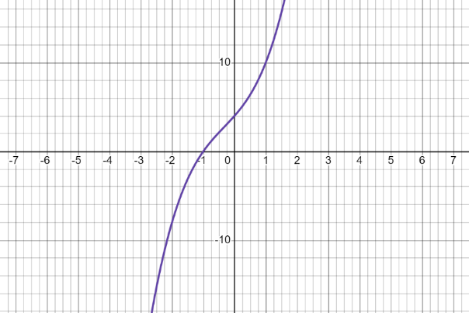

- Does the graph support your findings? Yes. (Verbiage will vary.)

Mathematical Representations: Students may benefit from additional exposure with determining the number and types of solutions (real or imaginary) of a polynomial equation of degree three or higher. An example with common misconceptions follows –

- Use the graphed form of a polynomial equation shown below to respond to this example.

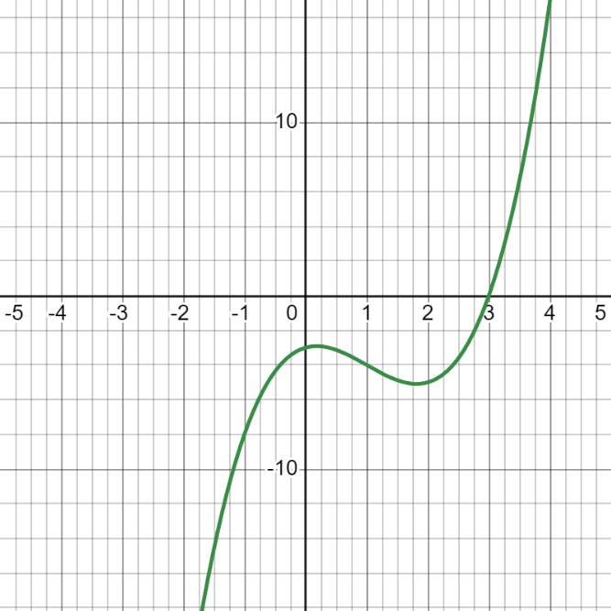
Based on the given graph, determine the following information:

- Degree of the polynomial equation
- Type of polynomial equation
- Number of real solutions
- Identify all real solutions
- Use any real solutions that exist to determine a factor of the equation.
- Number of imaginary solutions

When presented with the graphed form of a polynomial equation, students should begin to list all attributes shown. This graph has opposite end behavior. From the left, the graph is approaching negative infinity or pointed down. From the right, the graph is approaching positive infinity or pointed up. Based on this information, the function or corresponding polynomial equation must have an odd degree. There appear to be two humps or turning points. There’s one $x$-intercept and one $y$-intercept. The $x$-intercept is $(3, 0)$. Thus, the zero is $\{3\}.$ The $y$-intercept is negative and appears to lie between $-2$ and $-4$.

Students should be encouraged to use their findings to answer the questions outlined in the given example –

- Degree of the polynomial equation – The best answer is 3rd degree because the degree is equal to the number of turning points plus one, $2 + 1 = 3.$

- Type of polynomial equation – The best answer is cubic because the degree is $3$.

- Number of real solutions – The best answer is one. There is one $x$-intercept.

- Identify all real solutions – The best answer can be written multiple ways. $x = 3; (3, 0);$or $\{3\}$

- Use any real solutions that exist to determine a factor of the equation. – The best answer is $(x – 3)$ is a factor because factors are opposite solutions.

- Number of imaginary solutions – The best answer is two because the number of real plus imaginary solutions must equal the degree. Also, imaginary solutions are presented as pairs because they are conjugates.

Concepts and Connections
Concepts
Polynomial equations can be used to model real-life contextual situations.

Connections: Prior to Algebra 2, students represented, solved, explained, and interpreted the solution to multistep linear equations and inequalities in one variable and literal equations for a specified variable (A.EI.1); represented, solved, explained, and interpreted the solution to a system of two linear equations, a linear inequality in two variables, or a system of two linear inequalities in two variables (A.EI.2); and, represented, solved, and interpreted the solution to a quadratic equation in one variable (A.EI.3). Given these understandings, students will represent, solve, and interpret the solution to a polynomial equation (A2.EI.6) and these skills will be embedded into coursework beyond Algebra 2.

- Within the grade level/course:
  - A2.EI.1 – The student will represent, solve, and interpret the solution to absolute value equations and inequalities in one variable.
  - A2.EI.2 – The student will represent, solve, and interpret the solution to quadratic equations in one variable over the set of complex numbers and solve quadratic inequalities in one variable.
  - A2.EI.3 – The student will solve a system of equations in two variables containing a quadratic expression.
  - A2.EI.4 – The student will represent, solve, and interpret the solution to an equation containing rational algebraic expressions.
  - A2.EI.5 – The student will represent, solve, and interpret the solution to an equation containing a radical expression.
- Vertical Progression:
  - A.EI.1 – The student will represent, solve, explain, and interpret the solution to multistep linear equations and inequalities in one variable and literal equations for a specified variable.
  - A.EI.2 – The student will represent, solve, explain, and interpret the solution to a system of two linear equations, a linear inequality in two variables, or a system of two linear inequalities in two variables.
  - A.EI.3 – The student will represent, solve, and interpret the solution to a quadratic equation in one variable.

Textbooks and HQIM for Consideration
- A list of approved textbooks and instructional materials will be posted on the VDOE website.

Functions
Functions represent a main tenant of algebra. A thorough understanding of functions can be derived from skills obtained from exploring operations, expressions, and equations. The knowledge of functions allows students to transition equations from algebraic to graphical representations using coordinate methods. Function operations and transformations are connected to skills obtained from the exploration of expressions and equations. Mastery of functions will be required for successful completion of advanced mathematics courses, beyond Algebra 2.
Throughout Algebra 2, students will investigate, analyze, and compare square root, cube, root, rational, exponential, and logarithmic function families, algebraically and graphically, using transformations. Additionally, students will investigate, analyze, and compare characteristics of square root, cube root, rational, polynomial, exponential, logarithmic, and piecewise-defined functions algebraically and graphically.
A2.F.1 The student will investigate, analyze, and compare square root, cube root, rational, exponential, and logarithmic function families,
algebraically and graphically, using transformations.
Students will demonstrate the following Knowledge and Skills:
- Distinguish between the graphs of parent functions for square root, cube root, rational, exponential, and logarithmic function families.
- Write the equation of a square root, cube root, rational, exponential, and logarithmic function, given a graph, using transformations of the parent function, including
f(x) + k; f(kx); f(x + k); and kf(x), where k is limited to rational values. Transformations of exponential and logarithmic functions, given a graph, should be limited to a single transformation.
- Graph a square root, cube root, rational, exponential, and logarithmic function, given the equation, using transformations of the parent function including f(x) + k; f(kx); f(x + k); and kf(x), where k is limited to rational values. Use technology to verify transformations of the functions.
- Determine when two variables are directly proportional, inversely proportional, or neither, given a table of values. Write an equation and create a graph to represent a direct or inverse variation, including situations in context.
- Compare and contrast the graphs, tables, and equations of square root, cube root, rational, exponential, and logarithmic functions.

Understanding the Standard
- Connections between multiple representations (graphs, tables, and equations) of a function can be made.
- The transformation of a function, called a pre-image, changes the size, shape, and/or position of the function to a new function, called the image.
- The graphs/equations for a family of functions can be determined using a transformational approach.
- The graph of a parent function is an anchor graph from which other graphs are derived using transformations.
- Function families consist of a parent function and all transformations of the parent function.
- Transformations of functions act in a similar way as transformations on plane figures which students studied in Geometry and middle school mathematics.
- Transformations of graphs include:
- Translations (horizontal and/or vertical shifting of a graph) which is represented by the function notation f(x) + k and f(x + k);
- Reflections over the y-axis which is represented by the function notation $f(-x)$;
- Reflections over the x-axis which is represented by the function notation $-f(x)$; and
- Dilations (vertical stretching and compressing of graphs) which is represented by the function notation f(kx) and kf(x).
- A direct variation is a linear relationship that represents a proportional relationship between two quantities. If y is directly proportional to x, then y = kx, where k is the constant of proportionality.
- The constant of proportionality (k) in a direct variation is represented by the ratio of the dependent variable to the independent variable. This is also referred to as the constant of variation.
- A direct variation represents a linear relationship, where the constant of proportionality $(k)$ is the slope of the line and the y-intercept is zero.
- A direct variation can be represented graphically by a line passing through the origin.
- An inverse variation represents an inversely proportional relationship between two quantities and is represented by a rational function. If $y$ is inversely proportional to $x$, then y = $\frac{k}{x}$.
- The constant of proportionality ($k$) in an inverse variation is represented by the product of the dependent variable and the independent variable. This is also referred to as the constant of variation.
- The value of the constant of proportionality is typically positive when applied in contextual situations.
- Contextual situations involving direct and inverse variation occur in Chemistry.

Skills in Practice
While the five process goals are expected to be embedded in each standard, the Skills in Practice highlight the most prevalent process goals in relation to the content presented.

Mathematical Reasoning: Students will benefit from additional opportunities grouping functions that belong to the same family given a variety of function types written in algebraic form. An example with common misconceptions follows –

- The graph of f(x) is shown. Select each function that belongs to this same family.
$$g\left(x\right)=2x^{3}+5$$
$$h\left(x\right)=x^{1/3}-4$$
$$k\left(x\right)=x^{3}+x^{2}-x+3$$
$$m\left(x\right)=\sqrt[3]{x+7}$$
$$p\left(x\right)=\sqrt{x-2}$$
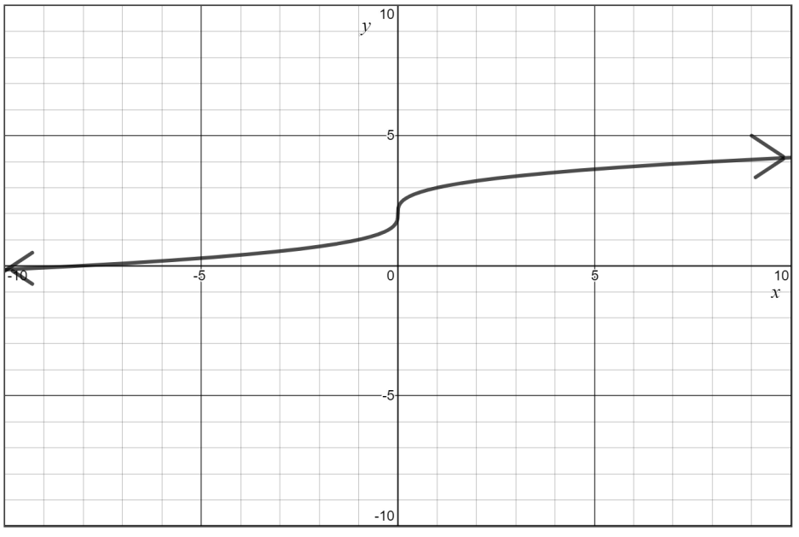

A common misconception is for students to confuse cubic and cube root functions. A student may select functions $g(x)$ and $k(x).$ This could indicate the student did not consider the differing rates at which these functions increase. A potential strategy would be for students to identify points on the graph and then make a table of values for several of these functions.

Mathematical Representations: When identifying families of functions, students should be exposed to graphs of parent functions. An example with common misconceptions follows –

- Which graph appears to belong to the family of rational functions?

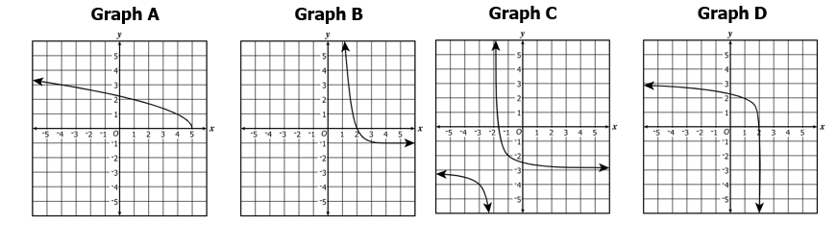
The correct answer is Graph C. Students may select any other choice if they do not know what parent functions look like for exponential, logarithmic, or radical functions.

Concepts and Connections
Concepts
Exponential, logarithmic, square root, cube root, and rational functions are used to model daily contextual experiences.

Connections: Prior to Algebra 2, students were exposed to exponents and primary skills regarding functions. Students determined whether a relation was a function and were required to identify a function’s domain and range (8.PFA.2). Throughout Algebra 1, students studied properties of linear (A.F.1), quadratic (A.F.2), and exponential (A.F.2) functions. Given these understandings, students will investigate, analyze, and compare square root, cube root, rational, exponential, and logarithmic function families, algebraically and graphically, using transformations (A2.F.1) and this knowledge will embedded into coursework beyond Algebra 2.

- Within the grade level/course:
  - A2.F.2 – The student will investigate and analyze characteristics of square root, cube root, rational, polynomial, exponential, logarithmic, and piecewise-defined functions algebraically and graphically.
- Vertical Progression:
  - 8.PFA.2 – The student will determine whether a given relation is a function and determine the domain and range of a function.
  - A.F.1 – The student will investigate, analyze, and compare linear functions algebraically and graphically, and model linear relationships.
  - A.F.2 – The student will investigate, analyze, and compare characteristics of functions, including quadratic and exponential functions, and model quadratic and exponential relationships.

Textbooks and HQIM for Consideration
- A list of approved textbooks and instructional materials will be posted on the VDOE website.

A2.F.2 The student will investigate and analyze characteristics of square root, cube root, rational, polynomial, exponential, logarithmic, and
piecewise-defined functions algebraically and graphically.
Students will demonstrate the following Knowledge and Skills:
- Determine and identify the domain, range, zeros, and intercepts of a function presented algebraically or graphically, including graphs with discontinuities.
- Compare and contrast the characteristics of square root, cube root, rational, polynomial, exponential, logarithmic, and piecewise-defined functions.
- Determine the intervals on which the graph of a function is increasing, decreasing, or constant.
- Determine the location and value of absolute (global) maxima and absolute (global) minima of a function.
- Determine the location and value of relative (local) maxima or relative (local) minima of a function.
- For any value, x, in the domain of f, determine f(x) using a graph or equation. Explain the meaning of x and f(x) in context, where applicable.
- Describe the end behavior of a function.
- Determine the equations of any vertical and horizontal asymptotes of a function using a graph or equation (rational, exponential, and logarithmic).
- Determine the inverse of a function algebraically and graphically, given the equation of a linear or quadratic function (linear, quadratic, and square root). Justify and explain why two functions are inverses of each other.
- Graph the inverse of a function as a reflection over the line y = x.
- Determine the composition of two functions algebraically and graphically.

Understanding the Standard
- Functions may be used to represent contextual situations.
- Functions describe the relationship between two variables where each input is paired to a unique output.
- The domain of a function is the set of all possible values of the independent variable.
- The range of a function is the set of all possible values of the dependent variable.
- Given f is a function: for each x in the domain of f, x is a member of the input of the function f, f(x) is a member of the output of f, and the ordered pair (x, f(x)) is a member of f. In other words, f(x) represents values of the range and x represents values of the domain.
- The domain of a function may be restricted algebraically, graphically, or by the contextual situation represented by a function.
- Given a polynomial function f(x), the following statements are equivalent for any real number, k, such that f(k) = 0:
  - k is a zero of the polynomial function f(x) located at (k, 0);
  - k is a solution or root of the polynomial equation f(x) = 0;
  - the point (k, 0) is an x-intercept for the graph of f(x) = 0; and
  - (x – k) is a factor of f(x).
- A function is said to be continuous on an interval if its graph has no jumps or holes in that interval.
- Discontinuous domains and ranges include those with removable (holes) and nonremovable (asymptotes) discontinuities.
- A function can be described on an interval as increasing, decreasing, or constant over a specified interval or over the entire domain of the function.
- A function, f(x), is increasing over an interval if the values of f(x) consistently increase over the interval as the x values increase.
- A function, f(x), is decreasing over an interval if the values of f(x) consistently decrease over the interval as the x values increase.
- A function, f(x), is constant over an interval if the values of f(x) remain constant over the interval as the x values increase.
- Solutions and intervals may be expressed in different formats, including set notation, using equations and inequalities, or interval notation.
- Interval notation is used when describing a range of values.
- Examples may include:
Equation/ Inequality | Set Notation | Interval Notation
x = 3 | {3}
x = 3 or x = 5 | {3, 5}
$$0≤x<3$$ | {x|$0≤x<3$} | [0, 3)
y ≥ 3 | {y: y ≥ 3} | [3, $∞)$
Empty (null) set ∅ | { }

- A function, f, has an absolute maximum located at x = a if f(a) is the largest value of f over its domain.
- A function, f, has an absolute minimum located at x = a if f(a) is the smallest value of f over its domain.
- Relative maximum points occur where the function changes from increasing to decreasing.
- A function, f, has a relative maximum located at x = a over some open interval of the domain if f(a) is the largest value of f on the interval.
- Relative minimum points occur where the function changes from decreasing to increasing.
- A function, f, has a relative minimum located at x = a over some open interval of the domain if f(a) is the smallest value of f on the interval.
- A value x in the domain of f is an x-intercept or a zero of a function f if and only if f(x) = 0.
- End behavior describes the values of a function as x approaches positive or negative infinity.
- If (a, b) is an element of a function, then (b, a) is an element of the inverse of the function.
- The reflection of a function over the line $y=x$ represents the inverse of the reflected function.
- A function is invertible if its inverse is also a function. For an inverse of a function to be a function, the domain of the function may need to be restricted.
- Functions can be combined using composition of functions.
- Two functions, f(x) and g(x), are inverses of each other if f(g(x)) = g(f(x)) = x.
- For contextual situations, exponential functions can be used to represent compound interest, population growth, and radioactive decay.
- Restrictions on the domain may need to be added to the function to appropriately represent the contextual situation.

Skills in Practice
While the five process goals are expected to be embedded in each standard, the Skills in Practice highlight the most prevalent process goals in relation to the content presented.

Mathematical Reasoning: Students will benefit from additional practice finding vertical and horizontal asymptotes. An example with common misconceptions follows –

- Determine the vertical and horizontal asymptotes for this function.

$$y=\frac{2}{x^{2}-9}+1$$

The correct answer is:
- Vertical Asymptote(s): $x = 3; x = -3$
- Horizontal Asymptote(s): $y = 1$

Common errors include confusing the horizontal asymptote with the vertical asymptote and not factoring the denominator prior to identifying the asymptotes.

Mathematical Connections: When examining functions, students need practice locating intervals where the local minimum/maximum exist. An example with common misconceptions follows –

- Given: $g\left(x\right)=x^{3}-x^{2}-6x+3$

On which interval is the local minimum of $g\left(x\right)$?

- (-3, -2)
- (-2, -1)
- (-1, 1)
- (1, 2)

The correct answer is (1, 2). A common error is that students often choose (-1, 1) because the function is decreasing over the interval.

Concepts and Connections
Concepts
Polynomial, exponential, logarithmic, piecewise-defined, radical, and rational functions are used to model everyday experiences.

Connections: Prior to Algebra 2, students determine whether a given relation is a function and determine the domain and range of a function (8.PFA.2); investigated, analyzed, and compared linear functions algebraically and graphically, and modeled linear relationships (A.F.1); and, investigated, analyzed, and compared characteristics of functions, including quadratic and exponential functions, and modeled quadratic and exponential relationships (A.F.2). Given these understandings, students will investigate and analyze characteristics of square root, cube root, rational, polynomial, exponential, logarithmic, and piecewise-defined functions algebraically and graphically (A2.F.2) and this knowledge will be embedded into coursework beyond Algebra 2.

- Within the grade level/course:
  - A2.F.1 – The student will investigate, analyze, and compare square root, cube root, rational, exponential, and logarithmic function families, algebraically and graphically, using transformations.
- Vertical Progression:
  - 8.PFA.2 – The student will determine whether a given relation is a function and determine the domain and range of a function.
  - A.F.1 – The student will investigate, analyze, and compare linear functions algebraically and graphically, and model linear relationships.
  - A.F.2 – The student will investigate, analyze, and compare characteristics of functions, including quadratic and exponential functions, and model quadratic and exponential relationships.

Textbooks and HQIM for Consideration
- A list of approved textbooks and instructional materials will be posted on the VDOE website.

Statistics
Statistics is a branch of mathematics that allows people to qualify and quantify data. Students use statistics to formulate questions and communicate results of data that has been collected and analyzed. These skills are used in almost every area of life, including sports, banking, medicine, agriculture, government, and education to name a few.
Throughout Algebra 2, students will apply the data cycle with a focus on representing bivariate data in scatterplots, tables, and ordered pairs. Students will also be exposed to univariate quantitative data represented by a normal curve. Additionally, students will use data to determine appropriate linear, quadratic, and exponential best-fit curves that model the data. Further, students will compute and distinguish between permutations and combinations.

A2.ST.1 The student will apply the data cycle (formulate questions; collect or acquire data; organize and represent data; and analyze data
and communicate results) with a focus on univariate quantitative data represented by a smooth curve, including a normal curve.
Students will demonstrate the following Knowledge and Skills:
- Formulate investigative questions that require the collection or acquisition of a large set of univariate quantitative data or summary statistics of a large set of univariate quantitative data and investigate questions using a data cycle.
- Collect or acquire univariate data through research, or using surveys, observations, scientific experiments, polls, or questionnaires.
- Examine the shape of a data set (skewed versus symmetric) that can be represented by a histogram, and sketch a smooth curve to model the distribution.
- Identify the properties of a normal distribution.
- Describe and interpret a data distribution represented by a smooth curve by analyzing measures of center, measures of spread, and shape of the curve.
- Calculate and interpret the z-score for a value in a data set.
- Compare two data points from two different distributions using z-scores.
- Determine the solution to problems involving the relationship of the mean, standard deviation, and z-score of a data set represented by a smooth or normal curve.
- Apply the Empirical Rule to answer investigative questions.
- Compare multiple data distributions using measures of center, measures of spread, and shape of the distributions.

Understanding the Standard
- There are data sets that cannot be represented by a smooth or normal curve.
- A very large data set provides a representation that can closely approximate the population.
- Summary statistics include measures of center (mean, median, mode) and dispersion or spread (variance and standard deviation). These statistics can be used to approximate the shape of the distribution.
- Descriptive statistics include measures of center (mean, median, mode) and dispersion or spread (variance and standard deviation).
- Variance (σ ²) and standard deviation (σ) measure the spread of data about the mean in a data set.
- Standard deviation is expressed in the original units of measurement of the data.
- The greater the value of the standard deviation, the further the data tends to be dispersed from the mean.
- In order to develop an understanding of standard deviation as a measure of dispersion (spread), students should have experience analyzing the formulas for and the relationship between variance and standard deviation.
- A normal distribution curve is the family of symmetrical, bell-shaped curves defined by the mean and the standard deviation of a data set. The arithmetic mean (μ) is located on the line of symmetry of the curve and is approximately equivalent to the median and mode of the data set.
- The normal curve is a probability distribution and the total area under the curve is 1.
- For a normal distribution, approximately 68 percent of the data fall within one standard deviation of the mean, approximately 95 percent of the data fall within two standard deviations of the mean, and approximately 99.7 percent of the data fall within three standard deviations of the mean. This is often referred to as the Empirical Rule or the 68 – 95 – 99.7 rule.
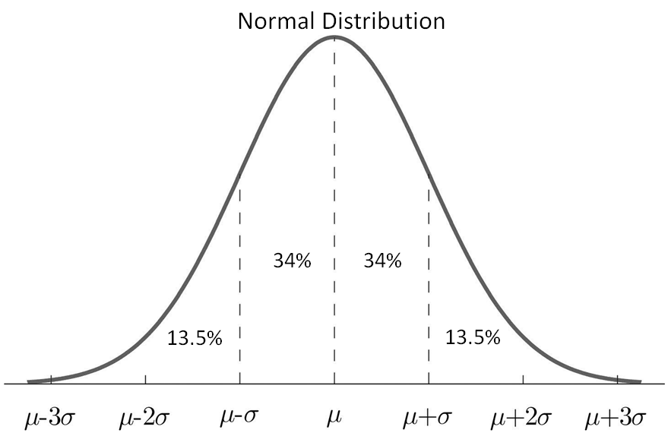
2.35%
2.35%
NOTE: This chart illustrates percentages that correspond to subdivisions in one standard deviation increments. Percentages for other subdivisions require the table of Standard Normal Probabilities or a graphing utility.
- The mean and standard deviation of a normal distribution affect the location and shape of the curve. The vertical line of symmetry of the normal distribution falls at the mean. The greater the standard deviation, the wider (“flatter” or “less peaked”) the distribution of the data.
- A z-score derived from a particular data value tells how many standard deviations that data value falls above or below the mean of the data set. It is positive if the data value lies above the mean and negative if the data value lies below the mean.
- A standard normal distribution is the set of all z-scores. The mean of the data in a standard normal distribution is 0 and the standard deviation is 1. This allows for the comparison of unlike normal data.
- Graphing utilities can be used to represent a normally distributed data set and explore relationships between the data set and its descriptive statistics.

Skills in Practice
While the five process goals are expected to be embedded in each standard, the Skills in Practice highlight the most prevalent process goals in relation to the content presented.

Mathematical Problem Solving: Students may benefit from exposure to contextual problems that require the application of a normal distribution. For example –

The weights of chocolate bars at a candy factory are normally distributed with a mean of 2.2 ounces and a standard deviation of 0.08 ounce. Identify each statement that must be true.

84% of the candy bars weigh more than 2.28 ounces
The median weight is 2.2 ounces.
50% of the candy bars weigh at most 2.2 ounces
The modal weight is 2.28 ounces.

The following two statements are true:
- The median weight is 2.2. ounces.
- 50% of the candy bars weigh at most 2.2 ounces.

Mathematical Communication: There are many good questions students can ask about univariate data and bivariate data. With univariate data, information is gathered around a single characteristic (examples: scores on assessments, time spent looking at social media, hours spent on an activity). In Algebra 2, this data should be limited to continuous data so that the data can be appropriately modeled, as opposed to approximated by, a smooth curve.

- What type of data can be collected for this question?
- Does the data I would collect make sense as either a histogram that can be modeled with a smooth curve (A2.ST.1) or a scatterplot (A2.ST.2)?
- Does that data allow for larger trend analysis?
- Does the available data reflect a representative sample of the population?
- Students should ask questions in which they are considering the overall pattern or trend of a single variable or of the relationship between two variables.

- Examples of questions students may consider for histograms to smooth curves are –
  - Is my goal to determine the Is my goal to determine the overall distribution of this variable?
  - Is my goal to determine the spread of this variable?
  - Is my goal to make comparisons between values of the variable?
  - Do I think the values of the variable may be normally distributed?

- The data sources must be considered as questions are formulated. Some questions that will direct students toward appropriate data sets include:
  - What is the context of the data to be collected?
  - What data is readily available?
  - What is my population of interest?
  - Who is the audience?

Mathematical Reasoning:

- As students analyze data and reflect upon their results, they should determine if there is a pattern to the data displayed. Further, students should consider the shape of the data and the curve(s) that could be used to model the data. Students must return to the question to see if their data answers the question and if not, begin the cycle again. While doing so, students must determine how bias or sample size impacts the data and the representation.

- Bias should be considered when analyzing data and reflecting upon results. Students should consider how valid the data set was; the intention of the data collection and proving a specific point; data cleaning; and, patterns to any of the data that needed to be cleaned.

Mathematical Representations:

- As students organize and represent data using histograms to smooth curves, students should be clear about the what the representation allows them to conclude and what it does not (e.g., what are the limitations of the data display?). Histograms to smooth curves help to show the overall shape, center, and spread of the data; and, show the distribution in a way that does not rely on the size of the bins. These data displays allow for a comparison between an individual value and the population.

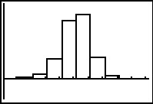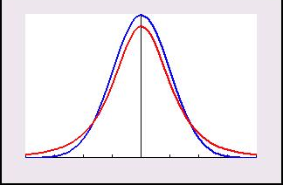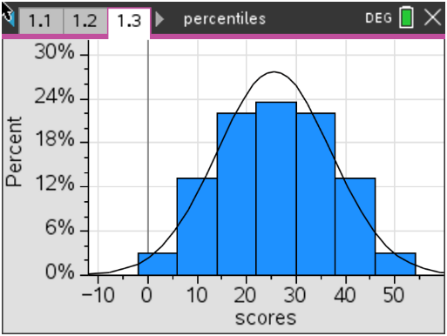

- Students may benefit from additional practice using properties of the normal distribution curve to find the probability of an event, the percent of data that falls within a specified interval, and the number of expected values that fall within a specified interval. An example with common misconceptions follows –

A population of adult males had their heights measured. Their heights were normally distributed. Given the following percentages of the heights, rounded to the nearest whole number, determine the percent that accounts for data residing between two standard deviations of the mean?

Students should be familiar with using the empirical rule to determine the approximate percentage of data that falls within one, two, and three standard deviations of the mean. Students should also know that the total area under the curve is one. The correct answer to this example is 95%.

Concepts and Connections
Concepts
Real-life contextual situations can be modeled by data. Normally distributed data can be investigated through generally accepted patterns, including the empirical rule.

Connections: Prior to Algebra 2, students began using statistical investigation to determine the probability of independent and dependent events, including those in context (8.PS.1). Given these understandings, students will apply the data cycle (formulate questions; collect or acquire data; organize and represent data; and analyze data and communicate results) with a focus on univariate quantitative data represented by a smooth curve, including a normal curve (A2.ST.1). This knowledge will be embedded into content beyond Algebra 2.

- Within the grade level/course:
  - A2.ST.3 The student will compute and distinguish between permutations and combinations.
- Vertical Progression:
  - 8.PS.1 – The student will use statistical investigation to determine the probability of independent and dependent events, including those in context.

Textbooks and HQIM for Consideration
- A list of approved textbooks and instructional materials will be posted on the VDOE website.

A2.ST.2 The student will apply the data cycle (formulate questions; collect or acquire data; organize and represent data; and analyze data
and communicate results) with a focus on representing bivariate data in scatterplots and determining the curve of best fit using
linear, quadratic, exponential, or a combination of these functions.
Students will demonstrate the following Knowledge and Skills:
- Formulate investigative questions that require the collection or acquisition of bivariate data and investigate questions using a data cycle.
- Collect or acquire bivariate data through research, or using surveys, observations, scientific experiments, polls, or questionnaires.
- Represent bivariate data with a scatterplot using technology.
- Determine whether the relationship between two quantitative variables is best approximated by a linear, quadratic, exponential, or a combination of these functions.
- Determine the equation(s) of the function(s) that best models the relationship between two variables using technology. Curves of best fit may include a combination of linear, quadratic, or exponential (piecewise-defined) functions.
- Use the correlation coefficient to designate the goodness of fit of a linear function using technology.
- Make predictions, decisions, and critical judgments using data, scatterplots, or the equation(s) of the mathematical model.
- Evaluate the reasonableness of a mathematical model of a contextual situation.

Understanding the Standard
- Data and scatterplots may indicate patterns that can be represented with an algebraic equation.
- Categorical variables can be added to a scatterplot using color or different symbols.
- Technology such as spreadsheets and graphing utilities can be used to collect, organize, represent, and generate a mathematical model for a set of data.
- Knowledge of transformational graphing using parent functions can be used to verify a mathematical model from a scatterplot that approximates the data.
- Data that fit linear ($y=ax+b$), quadratic ($y={ax}^{2}+bx+c$), and exponential ($y={ab}^{x}$) represent arise from contextual situations.
- Correlation coefficient measures the strength of a linear correlation of variables. Correlation coefficients can range from -1 to 1, where -1 is a perfectly linear negative correlation, 0 suggests little to no correlation, and 1 is a perfectly linear positive correlation.
- The mathematical model of the relationship among a set of data points can be used to make predictions, decisions, and critical judgements where appropriate.
- The curve of best fit for the relationship among a set of data points can be used to make predictions where appropriate.
- Rounding that occurs during intermediate steps of problem solving may reduce the accuracy of the final answer.
- Evaluation of the reasonableness of a mathematical model of a contextual situation involves asking questions including:
  - “Is there another curve (quadratic or exponential) that better fits the data?”
  - “Does the curve of best fit make sense?”
  - “Could the curve of best fit be used to make reasonable predictions?”
  - “Is some subset of the data better represented by a different function?”
  - “For what values of the domain is the model appropriate?”

Skills in Practice
While the five process goals are expected to be embedded in each standard, the Skills in Practice highlight the most prevalent process goals in relation to the content presented.

Mathematical Communication: There are many good questions students can ask about univariate data and bivariate data. With univariate data,
information is gathered around a single characteristic (examples: scores on assessments, time spent looking at social media, hours spent on an activity). Numerical data represented by two variables (examples: time and distance, age and height) are bivariate data.
- Students should ask questions in which they are considering the relationship between two characteristics or variables; they are looking for trends in this relationship or looking to make a prediction based on the relationship.

- Students should have opportunities to explore the shape of the data in a scatterplot. Is it linear or is it nonlinear? Does it have a quadratic relationship? Does it have an exponential relationship?

- Students should explore the concept of curve of best fit. How does the shape of the scatterplot determine what type of curve should be applied?

- The labels are key to communication: What title and labels are necessary to clearly communicate? Should I draw a line of best fit to model the data?

- Examples of questions students may consider when building good samples include:
  - What is the context of the data to be collected?
  - Who is the audience?
  - What is an appropriate amount of data?

Mathematical Reasoning: As students analyze data and reflect upon their results, they should determine if there is a pattern to the data displayed. The relationship could be linear, quadratic, exponential, or a combination of these. Further, students should consider the shape of the data and determine if a specific linear, quadratic, or exponential model fits the data. Students must return to the question to see if their data answers the question and if not, begin the cycle again. While doing so, students must determine how bias or sample size impacts the data and the representation.

- Scatterplots show the relationship between two variables. Considerations for scatterplots include –
  - Is my goal to determine the potential relationship between these variables?
  - Is my goal to make predictions about these variables?
  - Am I interested in the relationship between these two variables?
  - Do I want to see individual data points?
  - Is there a curve, or a combination of curves, that best explain the relationship?
  - Does a line (or curve) of best fit help me make predictions about this data?
  - Is there a correlation between the variables? If so, what type of correlation?

- As students explore the data displays, they should be looking for patterns that are evident in the shape of the data. Students should ask if the display appears linear or nonlinear. If the display appears nonlinear, is there a quadratic relationship? Exponential relationship?

- In Algebra 2, students recognize that for many data sets, the relationship between two variables does not follow the same consistent pattern for all values in the domain. For example, a person’s height does not increase at the same relationship with their age over the course of their lifetime.

- Students may need additional practice identifying the equation for the curve of best fit and making predictions using the curve of best fit. An example follows –

A data set is displayed in this table. Using the exponential curve of best, what is the value of $y$, rounded to the nearest hundredth, when $x = 5$?

$$x$$ | -3 | -2 | -1 | 0
$$y$$ | 3.375 | 2.25 | 1.5 | 1

The correct answer to this problem is $y=0.13$.

Mathematical Representations: As students organize and represent data using scatterplots, students should be given opportunities to identify a correlation or relationship between variables. A line or curve of best fit can be drawn to show a trend in the data and to help make predictions based on the data. The relationship between the variables could be positive, negative, or have no correlation. The relationship could be linear, nonlinear, quadratic, or exponential.
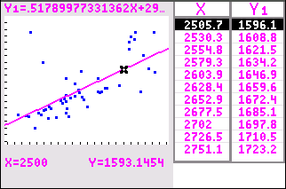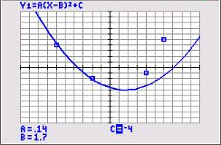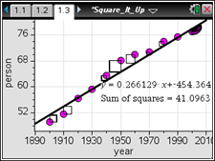

- Students should communicate the relationship (if it exists) but not assume causality. Where applicable, students should use data to make predictions.

- Students should be clear about what the representation allows them to conclude and what it does not (e.g., what are the limitations of the data display?)

Mathematical Connections: Students may benefit from additional practice finding the exponential curve of best fit for a set of data and making predictions using this curve. An example with common misconceptions follows –

- The table provides the value of an account over time that earned annual compound interest. There was an initial deposit of $1,500 into the account, and no other deposits were made.
Value of Account Over Time
Time in years, $x$ | 0 | 5 | 10 | 15 | 20 | 25 | 30
Value in dollars, $y$ | 1,500.00 | 1,914.42 | 2,443.34 | 3,118.39 | 3,979.95 | 5,079.53 | 6,482.91

Assuming the account continues to grow in the same way, use the exponential curve of best fit to find the value of the account at the end of 40 years, rounded to the nearest dollar.

When the data points are graphed, students might do well on choosing the equation of the curve of best fit or predicting a value; however, students may struggle with this skill when they are required to determine the curve of best fit and/or make a prediction when the data is represented in a table or in a set. The correct answer to this example is $10,560.

Concepts and Connections
Concepts
Real-life contextual situations can be modeled by data. Data allows us to make decisions.

Connections: Prior to Algebra 2, students investigated, analyzed, and compared linear functions algebraically and graphically, and modeled linear relationships (A.F.1); and, investigated, analyzed, and compared characteristics of functions, including quadratic and exponential functions, and model quadratic and exponential relationships (A.F.2). Additionally, students applied the data cycle (formulate questions; collect or acquire data; organize and represent data; and analyze data and communicate results) with a focus on representing bivariate data in scatterplots and determining the curve of best fit using linear and quadratic functions (A.ST.1). Given these understandings, students will incorporate these skills to concepts of analyzing bivariate data and using curves of best fit, including linear, quadratic, exponential, or a combination of these functions (A2.ST.2). This knowledge will be embedded into coursework beyond Algebra 2.

- Within the grade level/course:
  - A2.F.2 – The student will investigate and analyze characteristics of square root, cube root, rational, polynomial, exponential, logarithmic, and piecewise-defined functions algebraically and graphically.
- Vertical Progression:
  - A.F.1 – The student will investigate, analyze, and compare linear functions algebraically and graphically, and model linear relationships.
  - A.F.2 – The student will investigate, analyze, and compare characteristics of functions, including quadratic and exponential functions, and model quadratic and exponential relationships.
  - A.ST.1 – The student will apply the data cycle (formulate questions; collect or acquire data; organize and represent data; and analyze data and communicate results) with a focus on representing bivariate data in scatterplots and determining the curve of best fit using linear and quadratic functions.

Textbooks and HQIM for Consideration
- A list of approved textbooks and instructional materials will be posted on the VDOE website.

A2.ST.3 The student will compute and distinguish between permutations and combinations.
Students will demonstrate the following Knowledge and Skills:
- Compare and contrast permutations and combinations to count the number of ways that events can occur.
- Calculate the number of permutations of n objects taken r at a time.
- Calculate the number of combinations of n objects taken r at a time.
- Use permutations and combinations as counting techniques to solve contextual problems.
- Calculate and verify permutations and combinations using technology.

Understanding the Standard
- The Fundamental Counting Principle states that if one decision can be made n ways and another can be made m ways, then the two decisions can be made nm ways.
- A permutation is the number of possible ways to arrange a group of objects without repetition and when order matters (e.g., the outcome 1, 2, 3 is different from the outcome 3, 2, 1 when order matters; therefore, both arrangements would be included in the possible outcomes).
- A combination is the number of possible ways to select or arrange objects when there is no repetition and order does not matter (e.g., the outcome 1, 2, 3 is the same as the outcome 3, 2, 1 when order does not matter; therefore, both arrangements would not be included in the possible outcomes).

Skills in Practice
While the five process goals are expected to be embedded in each standard, the Skills in Practice highlight the most prevalent process goals in relation to the content presented.

Mathematical Communication: Students may benefit from additional practice identifying scenarios that represent a permutation versus a combination. Additionally, students will benefit from practice that requires them to identify outcomes using different terminology. An example with common misconceptions follows –

- Westfield High School is having a contest and needs a team with 5 students from Mr. Chapman’s class. There are 20 students in Mr. Chapman’s class.

- Does this situation represent a permutation or a combination? Explain your reasoning.
- How many different teams can be formed?
A common misconception some students may have is difficulty distinguishing the difference between a permutation and a combination. This may indicate that some students may see the word “different” and assume the scenario represents a permutation. When providing instruction about combinations, make sure students know that every object selected from the whole group has equal value/importance (e.g., same job, same title). One strategy that may benefit students is to provide a visual representation of combination and permutations. Have three students volunteer to stand in a row in front of the classroom. Ask questions like -- How many groups of students are standing in front of the class? If the students rearrange themselves in a different order, does this change the number of groups of students standing in front of the class?

Mathematical Reasoning: Students may benefit from additional practice identifying when to use a permutation or combination calculation. Two examples follow –

- Decide whether each of these can be answered using a permutation or a combination, and then determine the answer.
  - Twenty horses competed in a race. In how many ways could the horses have finished in first place through third place?
  - A 10-person student council will be selected from 18 students at a school. How many possibilities are there for this student council?
Students must select the appropriate formula (permutation or combination), identify the total number of objects, understand the number of ways being presented, and perform the calculation correctly in order to derive the correct answer. The correct answers are 6,280 and 43,758 respectively.

Concepts and Connections
Concepts
Real-life contextual situations can be modeled by data. The world can be investigated through posing questions and collecting, representing, analyzing, and interpreting data to describe and predict events and real-world phenomena.

Connections: Prior to Algebra 2, students began using statistical investigation to determine the probability of independent events (8.PS.1). These skills established a foundation for students to apply statistical procedures to contextual situations. Given these understandings, students will incorporate these skills to concepts of computations and permutations (A2.ST.3) and this knowledge will be embedded into coursework beyond Algebra 2.

- Within the grade level/course:
  - A2.ST.1 – The student will apply the data cycle (formulate questions; collect or acquire data; organize and represent data; and analyze data and communicate results) with a focus on univariate quantitative data represented by a smooth curve, including a normal curve.
- Vertical Progression:
  - 8.PS.1 – The student will use statistical investigation to determine the probability of independent and dependent events, including those in context.

Textbooks and HQIM for Consideration
- A list of approved textbooks and instructional materials will be posted on the VDOE website.

