2023 Mathematics
Standards of Learning

Geometry Instructional Guide

Copyright © 2024
by the
Virginia Department of Education
P.O. Box 2120
Richmond, Virginia 23218-2120
http://www.doe.virginia.gov

All rights reserved. Reproduction of these materials for instructional purposes in public school classrooms in Virginia is permitted.

Superintendent of Public Instruction
Dr. Lisa Coons

Office of STEM
Dr. Anne Petersen, Director
Dr. Angela Byrd-Wright, Mathematics Coordinator
Dr. Jessica Brown, Elementary Mathematics Specialist
Mrs. Regina Mitchell, Mathematics and Special Education Specialist

NOTICE
The Virginia Department of Education does not unlawfully discriminate on the basis of race, color, sex, national origin, age, or disability in employment or in its educational programs or services.

The contents of this Instructional Guide were informed by the U.S. Department of Education's Institute of Education Sciences (IES), What Works Clearinghouse, as a central, trusted source of scientific evidence for what works in education. Sample questions reflect applicable and aligned content from the Virginia Department of Education's published assessment items, Mathematics Item Maps, and National Association of Educational Progress (NAEP) assessment questions.

Introduction
The Mathematics Instructional Guide, a companion document to the 2023 Mathematics Standards of Learning, amplifies the Standards of Learning by defining the core knowledge and skills in practice, supporting teachers and their instruction, and serving to transition classroom instruction from the 2016 Mathematics Standards of Learning to the newly adopted 2023 Mathematics Standards of Learning. Instructional supports are accessible in #GoOpenVA and support the decisions local school divisions must make concerning local curriculum development and how best to help students meet the goals of the standards. The local curriculum should include a variety of information sources, readings, learning experiences, and forms of assessment selected at the local level to create a rigorous instructional program.

For a complete list of the changes by standard, the 2023 Virginia Mathematics Standards of Learning – Overview of Revisions is available and delineates in greater specificity the changes for each grade level and course.

The Instructional Guide is divided into three sections: Understanding the Standard, Skills in Practice, and Concepts and Connections aligned to the Standard. The purpose of each is explained below.

Understanding the Standard
This section includes mathematics understandings and key concepts that assist teachers in planning standards-focused instruction. The statements may provide definitions, explanations, or examples regarding information sources that support the content. They describe what students should know (core knowledge) as a result of the instruction specific to the course/grade level and include evidence-based practices to approaching the Standard. There are also possible misconceptions and common student errors for each standard to help teachers plan their instruction.

Skills in Practice
This section outlines supporting questions and skills that are specifically linked to the standard. They frame student inquiry, promote critical thinking, and assist in learning transfer. Curriculum writers and teachers should use them to plan instruction to deepen understanding of the broader unit and course objectives. This is not meant to be an exhaustive list of student expectations.

Concepts and Connections

This section outlines concepts that transcend grade levels and thread through the K through 12 mathematics programs as appropriate at each level. Concept connections reflect connections to prior grade-level concepts as content and practices build within the discipline as well as potential connections across disciplines.

Reasoning, Lines, and Transformations
Reasoning is the foundation for problem solving, higher-order thinking, understanding, and application. Students use reasoning skills in every branch of mathematics in addition to other courses. These skills unpack building blocks that are necessary for advanced mathematical thinking, understanding, and application. Also, mastery of contextual application of lines and transformations prepare students for engineering, calculus, and physical sciences.
Throughout Geometry, students will translate, construct, and judge the validity of a logical argument and use and interpret Venn diagrams. Additionally, students will analyze the relationships of parallel lines cut by a transversal, solve problems including contextual problems, involving symmetry and transformation.

G.RLT.1 The student will translate logic statements, identify conditional statements, and use and interpret Venn diagrams.
Students will demonstrate the following Knowledge and Skills:
- Translate propositional statements and compound statements into symbolic form, including negations ($\sim p,$ read “not p”), conjunctions (p $∧q$, read “p and q”), disjunctions (p$∨q$, read “p or q”), conditionals (p $→$ q, read “if p then q”), and biconditionals (p$↔$ q, read “p if and only if q”), including statements representing geometric relationships.
- Identify and determine the validity of the converse, inverse, and contrapositive of a conditional statement, and recognize the connection between a biconditional statement and a true conditional statement with a true converse, including statements representing geometric relationships.
- Use Venn diagrams to represent set relationships, including union, intersection, subset, and negation.
- Interpret Venn diagrams, including those representing contextual situations.

Understanding the Standard
- Symbolic notation is used to represent logical arguments, including the use of →, ↔, ~, $∴$, $∧$, and $∨$.
- The symbol $∴$ is read as “therefore.”
- When a conditional (p→q) and its converse (q→p) are true, the statements can be written as a biconditional:
  - p iff q
  - p if and only if q
  - p↔q
- The Pythagorean Theorem and its converse can be used as an example. If a triangle is a right triangle, then the sum of the squares of the legs is equal to the square of the hypotenuse ($a^{2}+b^{2}=c^{2})$. If the sum of the squares of the legs is equal to the square of the hypotenuse ($a^{2}+b^{2}=c^{2}$), then the triangle is a right triangle. Therefore, a triangle is a right triangle if and only if the sum of the squares of the legs is equal to the square of the hypotenuse ($a^{2}+b^{2}=c^{2}$).
- Logical arguments consist of a set of premises or hypotheses and a conclusion.
- Truth and validity are not synonymous. Valid logical arguments may be false. Validity requires only logical consistency between the statements, but it does not imply true statements.
- For example, the following argument is valid, but not true. If you are a happy person, then you like animals. If you like animals, then you like dogs. Therefore, if you are a happy person, then you like dogs.
- Formal proofs utilize symbols of formal logic to determine the validity of a logical argument.
- Inductive reasoning, deductive reasoning, and proofs are critical in establishing general claims.
- Inductive reasoning is the method of drawing conclusions from a limited set of observations.
- Deductive reasoning is the method that uses logic to draw conclusions based on definitions, postulates, and theorems. Valid forms of deductive reasoning include the law of syllogism, the law of contrapositive, the law of detachment, and the identification of a counterexample.
- Proof is a justification that is logically valid and based on initial assumptions, definitions, postulates, theorems, and/or properties.
- The law of detachment states that if p→q is true and p is true, then q is true. For example, if two angles are vertical, then they are congruent. ∠A and ∠B are vertical, therefore ∠A ≅ ∠B.
- The law of syllogism states that if p→q is true and q→r is true, then p→r is true. For example, if two angles are vertical, then they are congruent. If two angles are congruent, then they have the same measure. Thus, if two angles are vertical, then they have the same measure.
- The law of contrapositive states that if p→q is true and ~q is true, then ~p is true. For example, if two angles are vertical, then they are congruent. ∠A ≇ ∠B, therefore ∠A and ∠B are not vertical.
- A counterexample is used to show an argument is false. For example, the argument “All rectangles are squares,” is proven false with the following counterexample since quadrilateral ABDC is a rectangle but not a square.
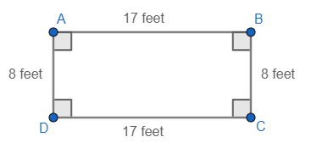
- A counterexample of a statement confirms the hypothesis but negates the conclusion.
- Exploration of the representation of conditional statements using Venn diagrams may assist in deepening student understanding.
- Venn diagrams can be interpreted within contextual situations.
- Venn diagrams can be used to support the understanding of special quadrilateral relationships or problems involving probability. For example –
  - Surveys can provide opportunities for discussion of experimental probability. For example, the Venn diagram below shows the results of a survey of students to determine who likes comedy movies © and/or horror movies (H). Eight students like comedy movies, but not horror movies; five students like horror movies, but not comedy movies; and two students like both comedy movies and horror movies.
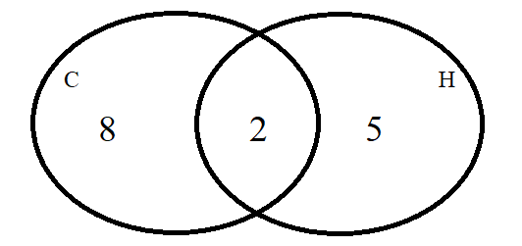

Skills in Practice
While the five process goals are expected to be embedded in each standard, the Skills in Practice highlight the most prevalent process goals in relation to the content presented.

Mathematical Representations: Students will benefit from additional practice using and interpreting logic symbols $∴$, $⋀$ and $⋁$. Example(s) with common misconceptions follow –

Let m represent: Angle A is obtuse.
Let n represent: Angle B is obtuse.

Which is a symbolic representation of the following argument?
Angle A is obtuse if and only if Angle B is obtuse.
Angle A is obtuse or Angle B is obtuse.
Therefore, Angle A is obtuse and Angle B is obtuse.

A. m → n
m ∧ n
∴ m ∨ n
B. m → n
m ∨ n
∴ m ∧ n
C. m ↔ n
m ∧ n
∴ m ∨ n
D. m ↔ n
m ∨ n
∴ m ∧ n

Misconceptions occur when students do not fully understand logic symbols. They tend to make mistakes when converting between symbolic form and written statements. The correct answer to this problem is D.

Mathematical Reasoning: Students need additional practice judging the validity of a logical argument and using valid forms of deductive reasoning, including the law of syllogism, the law of contrapositive, the law of detachment, and counterexamples. Example(s) with common misconceptions follow –

Let p = “a dog eats bread”
Let q = “the dog gains weight”

p → q, “If a dog eats bread, then the dog gains weight” is a true statement.

John’s dog eats bread. What can be concluded?

Misconceptions occur when students are not well versed in rules of logic. Using the law of detachment, the answer is: John’s dog gains weight.

Concepts and Connections
Concepts
Logic and reasoning provide the foundation of how we use explanations and justifications. Proofs are developed throughout higher-order thinking using logical statements.

Connections: Prior to Geometry, critical thinking skills and reasoning strategies have been embedded into mathematics courses. During Algebra 1, students represented verbal quantitative situations algebraically and evaluate these expressions for given replacement values of the variables (A.EO.1). Given these understandings, students will translate logic statements, identify conditional statements, and use and interpret Venn diagrams (G.RLT.1). Students will apply logic and reasoning skills to prove, justify, or confirm answers using postulates, theorems, definitions, and other appropriate justification statements. Students will continue to apply logic and reasoning skills in coursework beyond Geometry.

- Within the grade level/course:
  - Throughout each Geometry SOL, students will apply logic and reasoning skills to prove, justify, or confirm answers using postulates, theorems, definitions, and other appropriate justification statements.
- Vertical Progression:
  - Critical thinking skills have been embedded in each Mathematics SOL prior to Geometry. Beyond Geometry, students will continue to apply logic and reasoning skills.
  - A.EO.1 The student will represent verbal quantitative situations algebraically and evaluate these expressions for given replacement values of the variables.

Textbooks and HQIM for Consideration
- A list of approved textbooks and instructional materials will be posted on the VDOE website.

G.RLT.2 The student will analyze, prove, and justify the relationships of parallel lines cut by a transversal.
Students will demonstrate the following Knowledge and Skills:
- Prove and justify angle pair relationships formed by two parallel lines and a transversal, including:
  - corresponding angles;
  - alternate interior angles;
  - alternate exterior angles;
  - same-side (consecutive) interior angles; and,
  - same-side (consecutive) exterior angles.
- Prove two or more lines are parallel given angle measurements expressed numerically or algebraically.
- Solve problems by using the relationships between pairs of angles formed by the intersection of two parallel lines and a transversal.

Understanding the Standard
- Parallel lines intersected by a transversal form angle with specific relationships.
- If two parallel lines are intersected by a transversal, then:
  - corresponding angles are congruent;
  - alternate interior angles are congruent;
  - alternate exterior angles are congruent;
  - same-side (consecutive) interior angles are supplementary; and,
  - same-side (consecutive) exterior angles are supplementary.
- Transformations of vertical and linear angle pairs can be used to explore relationships of alternate interior, alternate exterior, corresponding, and same-side interior angles.
- To prove two or more lines parallel, one of the angle pairs listed above must be shown to be true. The angles must be on the same transversal that intersects both or all of the lines.
- The parallel line construction uses the Converse of the Corresponding Angles Theorem which states, “If two lines ($\overset{⃡}{EF}$ and $\overset{⃡}{GJ}$) and a transversal ($\overset{⃡}{EG}$) form corresponding angles ($∠HEI$ and $∠KGL$) that are congruent, then the lines ($\overset{⃡}{EF}$ and $\overset{⃡}{GJ}$) are parallel.

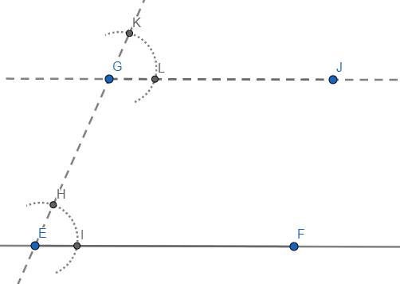

Skills in Practice
While the five process goals are expected to be embedded in each standard, the Skills in Practice highlight the most prevalent process goals in relation to the content presented.

Mathematical Problem Solving: Students may benefit from additional practice identifying which parts of a figure can be used to determine whether lines are parallel when more than one statement may be true. Example(s) with common misconceptions follow –
- Lines a and b intersect lines c and d.
a
b
c
d
1
2
3
4
5
6

- Which statement could be used to prove a║b and c║d?
- ∠1 and ∠2 are supplementary and ∠5 ≅ ∠6
- ∠1 ≅ ∠3 and ∠3 ≅ ∠5
- ∠3 and ∠5 are supplementary, and ∠5 and ∠6 are supplementary
- ∠3 ≅ ∠4 and ∠2 ≅ ∠6

Misconceptions occur when students do not select appropriate pairs of angles from all lines that must be proved to be parallel. In this case, students are asked to prove two sets of lines are parallel. They must select pairs of angles from $a$ and $b$ and $c$ and $d$ with appropriate justifications. The correct answer to this problem is: ∠3 and ∠5 are supplementary, and ∠5 and ∠6 are supplementary.

Mathematical Reasoning: Students need additional practice determining parallelism in complex figures. Given information about a figure, determine parallel lines or congruent angles. The example shown is a complex figure with more than one transversal (common misconceptions follow) –

- Given: a ll c – respond to the following questions.

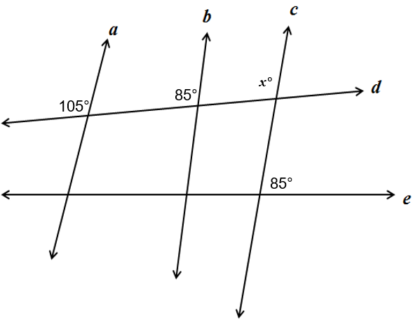
- What is the value of x ?
x = 105; corresponding angles are congruent.
- Is b ll c ? Why or why not?
No, because there are no congruent corresponding, alternate interior, or alternate exterior angles.
- Is d ll e ? Why or why not?
No, because there are no congruent corresponding, alternate interior, or alternate exterior angles.
Potential misconceptions may occur when students attempt to use visual judgement to determine whether lines are parallel. Students should be reminded to rely on postulates and theorems learned to make judgements regarding parallelism.

Concepts and Connections
Concepts
Lines transcend mathematical content areas. Lines and angles are embedded in every area of mathematics.

Connections: Prior to Geometry, students used relationships among pairs of vertical, adjacent, complementary, and supplementary angles to determine the measure of unknown angles (8.MG.1). Also, students investigated lines and slope in Algebra 1 (A.F.1). Throughout Geometry, students will use logical statements (G.RLT.1) to prove and justify congruent (G.TR.2) and similar (G.TR.3) triangles and solve problems involving quadrilaterals (G.PC.1). Given these understandings, students will prove, analyze, and justify relationships of parallel lines cut by a transversal (G.RLT.2) in coursework beyond Geometry.

- Within the grade level/course:
  - G.RLT.1 – The student will translate logic statements, identify conditional statements, and use and interpret Venn diagrams.
  - G.TR.2 – The student will, given information in the form of a figure or statement, prove and justify two triangles are congruent using direct and indirect proofs, and solve problems involving measured attributes of congruent triangles.
  - G.TR.3 – The student will, given information in the form of a figure or statement, prove and justify two triangles are similar using direct and indirect proofs, and solve problems, including those in context, involving measured attributes of similar triangles.
  - G.PC.1 – The student will prove and justify theorems and properties of quadrilaterals and verify and use properties of quadrilaterals to solve problems, including the relationships between the sides, angles, and diagonals.
- Vertical Progression:
  - 8.MG.1 – The student will use the relationships among pairs of angles that are vertical angles, adjacent angles, supplementary angles, and complementary angles to determine the measure of unknown angles.
  - A.F.1 – The student will investigate, analyze, and compare linear functions algebraically and graphically, and model linear relationships.

Textbooks and HQIM for Consideration
- A list of approved textbooks and instructional materials will be posted on the VDOE website.

G.RLT.3 The student will solve problems, including contextual problems, involving symmetry and transformation.
Students will demonstrate the following Knowledge and Skills:
- Locate, count, and draw lines of symmetry given a figure, including figures in context.
- Determine whether a figure has point symmetry, line symmetry, both, or neither, including figures in context.
- Given an image or preimage, identify the transformation or combination of transformations that has/have occurred. Transformations include:
  - translations;
  - reflections over any horizontal or vertical line or the lines y = x or y = -x;
  - clockwise or counterclockwise rotations of 90°, 180°, 270°, or 360° on a coordinate grid where the center of rotation is limited to the origin; and
  - dilations, from a fixed point on a coordinate grid.

Understanding the Standard
- Symmetry and transformations can be explored with coordinate methods.
- Transformations and combinations of transformations can be used to define and describe the movement of objects in a plane or coordinate system.
- A transformation of a figure, called a preimage, changes the size, shape, and/or position of the figure to a new figure called the image.
- A rigid transformation (or isometry) is a transformation that does not change the size or shape of a geometric figure. Is a special kind of transformation that does not change the size or shape of a figure.
- The image of an object or function graph after a rigid transformation is congruent to the preimage of the object.
- Congruent figures can be shown through a series of rigid transformations.
- A translation is a rigid transformation in which an image is formed by moving every point on the preimage the same distance in the same direction.
- The rules for translation can be described using coordinates and/or verbal descriptions.
- Coordinate rules for translation:

Translation | (x, y)→(x + a, y + b)
Reflection across the x-axis | (x, y)→(x, −y)
Reflection across the y-axis | (x, y)→(−x, y)
Reflection across the line y=x | (x, y)→(y, x)
Reflection across the line y=-x | (x, y)→(−y, −x)
Rotation 90° (counterclockwise) about the origin | (x, y)→(−y, x)
Rotation 180° about the origin | (x, y)→(−x, −y)
Rotation 270° (counterclockwise) about the origin | (x, y)→(y, −x)
Dilation with respect to the origin and scale factor of k | (x, y)→(kx, ky)

- A reflection is a rigid transformation in which an image is formed by reflecting the preimage over a line called the line of reflection. All corresponding points in the image are equidistant from the line of reflection.
- The midpoint between any set of reflected points lies on the line of reflection.
- The line of reflection can be determined by finding the midpoint (or balance point) between any set of two reflected points.
- A rotation is a rigid transformation in which an image is formed by rotating the preimage about a point called the center of rotation. The center of rotation may or may not be on the preimage.
- A dilation is a transformation in which an image is formed by enlarging or reducing the preimage proportionally by a scale factor from the center of dilation. The center of dilation may or may not be on the preimage. The image is similar to the preimage.
- A set of points has line symmetry if and only if there is a line, l, such that the reflection through l of each point in the set is also a point in the set.
- Point symmetry exists when a figure is built around a single point called the center of the figure. For every point in the figure, there is another point found directly opposite it on the other side of the center, at the same distance from the center. A figure with point symmetry will appear the same after a 180° rotation. In point symmetry, the center point is the midpoint of every segment formed by joining a point to its image.
- The perpendicular bisector construction creates the perpendicular bisector as the line of reflection of the provided line segment.

Skills in Practice
While the five process goals are expected to be embedded in each standard, the Skills in Practice highlight the most prevalent process goals in relation to the content presented.

Mathematical Problem Solving: Students need additional practice identifying the result of a combination of two transformations; and completing a combination of two transformations to determine the new coordinates of a given figure. Example(s) with common misconceptions follow –

Which sequence of two transformations maps △ABC to △A′B′C′? (The vertices of the triangles have integral coordinates.)

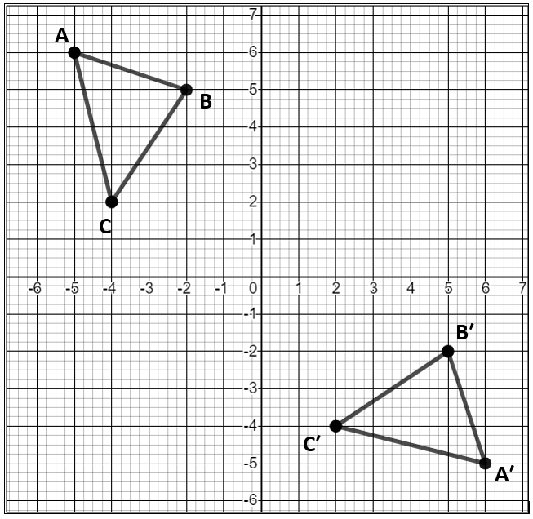

  - A rotation 90° counterclockwise about the origin, then a reflection over the line $y=-x$
  - A rotation 90° clockwise about the origin, then a reflection over the x-axis
  - A translation 7 units to the right, then a reflection over the x-axis
  - A reflection over the y-axis, then a translation 8 units down

Common errors include confusing the x-axis with the y-axis; confusing clockwise and counterclockwise; confusing horizontal with vertical; and incorrectly locating the line $y=x$or $y=-x.$ The answer is: a rotation 90° clockwise about the origin, then a reflection over the x-axis.

Mathematical Connections: Students will benefit from additional practice finding the coordinates of vertices after a figure has been transformed. Example(s) with common misconceptions follow –

Given: Triangle ABC with vertices located at A(1, 1), B(2, -3), and C(-1, -4).

Triangle ABC will be reflected over the line $y = x$. What will be the integral coordinates of point C’ after this transformation?

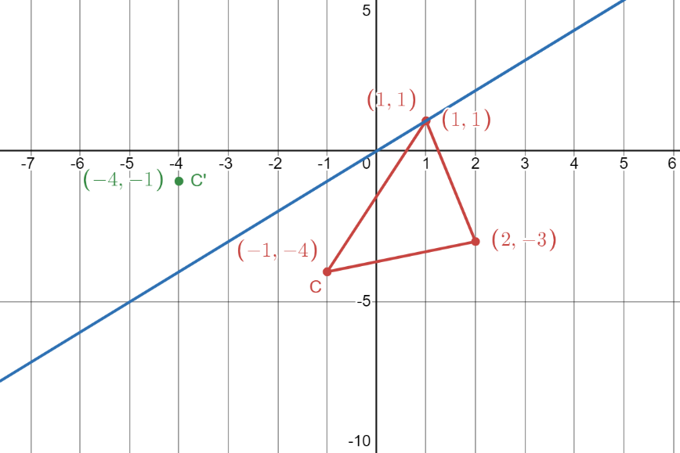

Misconceptions occur when students do not plot the points first to see a visual representation of triangle ABC. Although this step is not required, it is helpful to solve problems if a picture is available. In this case, students must also understand what reflecting over or across the line $y = x$ means. What happens to the points during this transformation? The correct answer to this problem is C’(-4, -1).

Concepts and Connections
Concepts
Analyzing and describing geometric objects, the relationships and structures among them, or the space that they occupy can be used to classify, quantify, measure, or count one or more attributes.

Connections: In Geometry, students will given information in the form of a figure or statement, prove and justify two triangles are congruent using direct and indirect proofs, and solve problems involving measured attributes of congruent triangles (G.TR.2) and similar triangles (G.TR.3). Further, students will prove and justify theorems and properties of quadrilaterals and verify and use properties of quadrilaterals to solve problems, including the relationships between the sides, angles, and diagonals (G.PC.1). During Algebra 1, students examined slopes of parallel and perpendicular lines (A.F.1). Prior to Geometry, students applied translations and reflections to polygons in the coordinate plane (8.MG.3). Given these understandings, students will continue to solve problems including contextual problems involving symmetry and transformations (G.RLT.3) in coursework beyond Geometry.

- Within the grade level/course:
  - G.TR.2 – The student will, given information in the form of a figure or statement, prove and justify two triangles are congruent using direct and indirect proofs, and solve problems involving measured attributes of congruent triangles.
  - G.TR.3 – The student will, given information in the form of a figure or statement, prove and justify two triangles are similar using direct and indirect proofs, and solve problems, including those in context, involving measured attributes of similar triangles.
  - G.PC.1 – The student will prove and justify theorems and properties of quadrilaterals and verify and use properties of quadrilaterals to solve problems, including the relationships between the sides, angles, and diagonals.
- Vertical Progression:
  - 8.MG.3 – The student will apply translations and reflections to polygons in the coordinate plane.
  - A.F.1 – The student will investigate, analyze, and compare linear functions algebraically and graphically, and model linear relationships.

Textbooks and HQIM for Consideration
- A list of approved textbooks and instructional materials will be posted on the VDOE website.

Triangles
Triangles comprise the foundation for trigonometric thinking, understanding, and application. Students explore triangle properties and formulas to develop a deeper understanding how to approach contextual situations. These skills unpack building blocks that are necessary for advanced mathematical thinking, understanding, and application. Also, mastery of applications involving triangles is required for higher level mathematics courses.
Throughout Geometry, students will determine the relationships between the measures of angles and lengths of sides in triangles, including contextual problems. Additionally, students will prove two triangles are congruent and solve contextual problems involving measured attributes of congruent triangles. Given a triangle, students will use geometric constructions to create a congruent triangle. Students will prove triangles are similar and solve contextual problems involving measured attributes of similar triangles. Also, students will solve problems, including contextual problems, involving trigonometry in right triangles and applications of the Pythagorean Theorem.

G.TR.1 The student will determine the relationships between the measures of angles and lengths of sides in triangles, including problems in
context.
Students will demonstrate the following Knowledge and Skills:
- Given the lengths of three segments, determine whether a triangle could be formed.
- Given the lengths of two sides of a triangle, determine the range in which the length of the third side must lie.
- Order the sides of a triangle by their lengths when given information about the measures of the angles.
- Order the angles of a triangle by their measures when given information about the lengths of the sides.
- Solve for interior and exterior angles of a triangle, when given two angles.

Understanding the Standard
- For a triangle to exist, the length of each side must be within a range that is determined by the lengths of the other two sides.
- The longest side of a triangle is opposite the largest angle of the triangle and the shortest side is opposite the smallest angle.
- In a triangle, the lengths of two sides and the included angle determine the length of the side opposite the angle.
- Because isosceles triangles have two congruent sides, they also have two congruent angles.
- Triangle Angles Sum Theorem: the sum of the measures of the interior angles of a triangle is 180°.
- Exterior Angle Theorem: an exterior angle of a triangle is equal to the sum of the two opposite interior angles.

Skills in Practice
While the five process goals are expected to be embedded in each standard, the Skills in Practice highlight the most prevalent process goals in relation to the content presented.

Mathematical Problem Solving:

- Students must understand the Triangle Inequality Theorem in order to accurately determine the range of sides measures that can form a triangle. Refer to the diagram below.
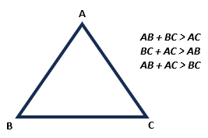
- Students will benefit from additional practice finding all possible lengths for a third side of a triangle when given lengths of two sides of the triangle. Example(s) with common misconceptions follow –

Given: Triangle ABC with AB = 42 and BC = 20

Which of the following are possible lengths for AC?
12 20 22 32 42 50 62 70

Misconceptions occur when students do not understand the Triangle Inequality Theorem. Using the image provided above, students should understand that AC can be found by using substitution. $AC > 42 – 20$ and $42 + 20 > AC$. Thus, $22 < AC < 62$. A quick way to find these values is to have students add and subtract the given two sides of the triangle. Have them write down those numbers. Tell students that the missing side falls between the sum and difference. AC cannot equal 22 or 62. This can be written as $AC ≠22$ and $AC ≠62$. The correct answer to this problem is {32, 42, 50}.
Mathematical Representations: Students will benefit from problems that are presented in a contextual format, when ordering and determining missing lengths and sides of triangles. Example(s) with common misconceptions follow –

Shenandoah National Park has many hiking trails. In the south district location of the Shenandoah National Park, there are three hiking trails that are in close proximity of each other – Big Run Loop, Browns Gap Loop, and Jones River Falls Loop. These hiking trails create a triangle as shown. Given the angle measures of the triangle formed, determine the longest trail and the shortest trail. Place your response in the blanks provided below. The figure is not drawn to scale.
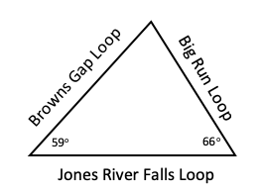

Longest trail: ________ Shortest trail: ________
A common misconception that students may have is thinking that not enough information is given to determine the longest and shortest trail. This may indicate that students do not recognize that the Triangle Sum Theorem must be applied to find the missing angle measure first before determining the longest and shortest sides of the triangle. Teachers are encouraged to emphasize with students to calculate the sum of the given angles; and, then subtract the sum from 180º as the sum of the angles of any triangle is equivalent to 180º. Once the missing angle measure is known, teachers should model for students how to order the side opposite each angle from least to greatest.

Concepts and Connections
Concepts
Analyzing and describing geometric objects, the relationships and structures among them, or the space that they occupy can be used to classify, quantify, measure, or count one or more attributes.

Connections: Prior to Geometry, students solved problems and justified relationships of similarity using proportional reasoning (7.MG.2), studied the relationships among pairs of vertical ,adjacent, supplementary, and complementary angles (8.MG.1), and applied the Pythagorean Theorem to solve problems involving right triangles (8.MG.4, G.TR.4). Throughout Geometry, students will prove and justify triangle congruence (G.TR.2) and similarity (G.TR.3). Given these understandings, students will continue to determine the relationships between the measures of angles and lengths of sides in triangles, including problems in context (G.TR.1) in coursework beyond Geometry.

- Within the grade level/course:
  - G.TR.2 – The student will, given information in the form of a figure or statement, prove and justify two triangles are congruent using direct and indirect proofs, and solve problems involving measured attributes of congruent triangles.
  - G.TR.3 – The student will, given information in the form of a figure or statement, prove and justify two triangles are similar using direct and indirect proofs, and solve problems, including those in context, involving measured attributes of similar triangles.
  - G.TR.4 – The student will model and solve problems, including those in context, involving trigonometry in right triangles and applications of the Pythagorean Theorem.
- Vertical Progression:
  - 7.MG.2 – The student will solve problems and justify relationships of similarity using proportional reasoning.
  - 8.MG.1 – The student will use the relationships among pairs of angles that are vertical angles, adjacent angles, supplementary angles, and complementary angles to determine the measure of unknown angles.
  - 8.MG.4 – The student will apply the Pythagorean Theorem to solve problems involving right triangles, including those in context.

Textbooks and HQIM for Consideration
- A list of approved textbooks and instructional materials will be posted on the VDOE website.

G.TR.2 The student will, given information in the form of a figure or statement, prove and justify two triangles are congruent using direct and
indirect proofs, and solve problems involving measured attributes of congruent triangles.
Students will demonstrate the following Knowledge and Skills:
- Use definitions, postulates, and theorems (including Side-Side-Side (SSS); Side-Angle-Side (SAS); Angle-Side-Angle (ASA); Angle-Angle-Side (AAS); and Hypotenuse-Leg (HL)) to prove and justify two triangles are congruent.
- Use algebraic methods to prove that two triangles are congruent.
- Use coordinate methods, such as the slope formula and the distance formula, to prove two triangles are congruent.
- Given a triangle, use congruent segment, congruent angle, and/or perpendicular line constructions to create a congruent triangle (SSS, SAS, ASA, AAS, and HL).

Understanding the Standard
- Tools for understanding the standard: physical protractor, ruler, compass, straight edge, paper folding as well as digital tools in mathematical and drafting platforms (dynamic software).
- Deductive or inductive reasoning is used in mathematical proofs.
- Congruence does not depend on the position of the triangles.
- Congruent figures are also similar, but similar figures are not necessarily congruent. This relationship can be depicted through a Venn diagram.
- The phrase, “Corresponding parts of congruent triangles are congruent,” is abbreviated CPCTC.
- Two triangles can be proven congruent using the following criterion:
- Side-Angle-Side (SAS);
- Side-Side-Side (SSS);
- Angle-Angle-Side (AAS);
- Angle-Side-Angle (ASA); and,
- Hypotenuse-Leg (HL).
- Triangle congruency can be explored using geometric constructions such as an angle congruent to a given angle or a line segment congruent to a given line segment.
- The construction for an angle congruent to a given angle can be justified using congruent triangles. In the example below, using the congruent segment construction, $\overline{BF}≅\overline{DH}$ and $\overline{FG}≅\overline{HI}$. Because of the intersecting arcs, $∠BFG≅∠DHI$. Thus, $∆BFG≅∆DHI$ by SAS.
- The construction for the bisector of a given angle can be justified using congruent triangles. In the example construction below, the construction of a perpendicular bisector creates a set of congruent triangles, $∆ACD≅BCD$ by SSS. Using CPCTC, $∠ACE≅∠BCE$. Also, because $∆ACB$ is isosceles with $\overline{AC}≅\overline{BC}$, $∆CAE≅∆CBE$. Thus, $∆ACE≅∆BCE$ by ASA. Because $∠CEA≅∠CEB$, by CPCTC, and they form a linear pair, they must be right angles. This, combined with $\overline{AE}≅\overline{BE}$ by CPCTC, proves that $\overline{CD}$ is the perpendicular bisector of $\overline{AB}$.

- The construction of the perpendicular to a given line from a point not on the line can be justified by proving $∆CDG≅∆CEG$. The proof is very similar to the proof for the construction of the perpendicular bisector.

- The construction of the perpendicular to a given line from a point on the line can be justified using isosceles and congruent triangles by SSS.

Skills in Practice
While the five process goals are expected to be embedded in each standard, the Skills in Practice highlight the most prevalent process goals in relation to the content presented.

Mathematical Communication: Students will benefit from additional practice completing the steps and reasons in two-column deductive proofs and paragraph proofs that prove triangles congruent. Example(s) with common misconceptions follow –
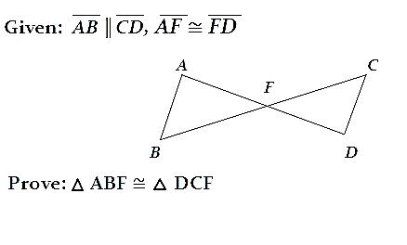
Misconceptions occur when students do not redraw the figure using two separate triangles situated in the same direction as the given congruence statement. Using the image provided above, students should identify everything they know about the triangles before moving to completing their two-column proof for this problem. First, students should use markings to indicate what is given in the problem. Teachers are encouraged to use multiple colors throughout this process.

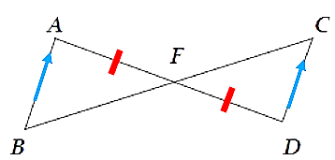
First start with what’s “Given”:
- AB is parallel to CD is denoted by blue arrows placed in the same direction.
- AF is congruent to DF is denoted by red segment markings on each line segment.

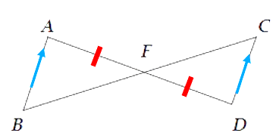
Next, fill in what you know:
- Angles BFA and CFA are vertical. Vertical angles are congruent. This is denoted by green angle markings.
- Since AB and DC are parallel, BC is a transversal of the given parallel lines. Thus, angles B and C are congruent because they are alternate interior angles. This is denoted by purple double angle markings.

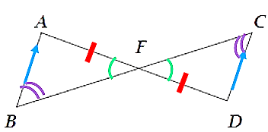
Lastly, use one of the congruence postulates to write your summary:
- Angles C and B are congruent because they are alternate interior angles. (see above)
- Angle F is congruent to itself due to the reflexive property.
- Sides FD and FA are congruent. This was given.
- Thus, using AAS, triangles ABF and DCF are congruent.

You can transfer this to a two-column proof starting with what was given and working your way through the problem. This problem has multiple ways to prove congruence. Have students explain and share the approach they took. The steps provided are just one strategy that can be used.

Mathematical Reasoning: Students will benefit from additional practice completing the steps and reasons in two-column deductive proofs and paragraph proofs that prove triangles congruent. Example(s) with a possible solution follows –

Given: In the figure, line segments AC and BD bisect each other at point E.
Prove: $∆$ AED ≅ $∆$CEB

Statements | Reasons
- AC and BD bisect each other at point E.  - $AE=EC$ and $DE=EB$ | 1. Given  2. Definition of bisector
3. and | 3. Definition of congruence
4. ∠AED ≅ ∠CEB | 4. Vertical angles are congruent.
5. $∆$ AED ≅ $∆$CEB | 5. SAS (Side-Angle-Side) Theorem

Concepts and Connections
Concepts
Analyzing and describing geometric objects, the relationships and structures among them, or the space that they occupy can be used to classify, quantify, measure, or count one or more attributes.

Connections: Prior to Geometry, students explored the coordinate plane and graphed ordered pairs (6.MG.3), determined congruence of segments, angles, and polygons (6.MG.4), solved problems and justified relationships of similarity using proportional reasoning (7.MG.2), and applied the Pythagorean Theorem to solve problems involving right triangles (8.MG.4, G.TR.4). During Algebra 1, students examined slopes of parallel and perpendicular lines (A.F.1). Throughout Geometry, students will use logical statements to justify, prove (G.RLT.1), and determine relationships of angles and sides in triangles (G.TR.1), prove and justify triangle similarity (G.TR.3). Given these understandings, students will continue to prove and justify triangle congruence beyond Geometry.

- Within the grade level/course:
  - G.RLT.1 – The student will translate logic statements, identify conditional statements, and use and interpret Venn diagrams.
  - G.TR.1 – The student will determine the relationships between the measures of angles and lengths of sides in triangles, including problems in context.
  - G.TR.3 – The student will, given information in the form of a figure or statement, prove and justify two triangles are similar using direct and indirect proofs, and solve problems, including those in context, involving measured attributes of similar triangles.
  - G.TR.4 – The student will model and solve problems, including those in context, involving trigonometry in right triangles and applications of the Pythagorean Theorem.
- Vertical Progression:
  - 6.MG.3 – The student will describe the characteristics of the coordinate plane and graph ordered pairs.
  - 6.MG.4 – The student will determine congruence of segments, angles, and polygons.
  - 7.MG.2 – The student will solve problems and justify relationships of similarity using proportional reasoning.
  - 8.MG.4 – The student will apply the Pythagorean Theorem to solve problems involving right triangles, including those in context.
  - A.F.1 – The student will investigate, analyze, and compare linear functions algebraically and graphically, and model linear relationships.

Textbooks and HQIM for Consideration
- A list of approved textbooks and instructional materials will be posted on the VDOE website.

G.TR.3 The student will, given information in the form of a figure or statement, prove and justify two triangles are similar using direct and
indirect proofs, and solve problems, including those in context, involving measured attributes of similar triangles.
Students will demonstrate the following Knowledge and Skills:
- Use definitions, postulates, and theorems (including Side-Angle-Side (SAS); Side-Side-Side (SSS); and Angle-Angle (AA)) to prove and justify that triangles are similar.
- Use algebraic methods to prove that triangles are similar.
- Use coordinate methods, such as the slope formula and the distance formula, to prove two triangles are similar.
- Describe a sequence of transformations that can be used to verify similarity of triangles located in the same plane.
- Solve problems, including those in context involving attributes of similar triangles.

Understanding the Standard
- Tools for understanding the standard: physical protractor, ruler, compass, straight edge, paper folding as well as digital tools in mathematical and drafting platforms (dynamic software).
- Deductive or inductive reasoning is used in mathematical proofs.
- Similarity does not depend on the position of the triangles.
- Similar triangles are created using dilations.
- A dilation is a transformation in which an image is formed by enlarging or reducing the preimage proportionally by a scale factor from the center of dilation. The center of dilation may or may not be on the preimage. The image of a dilation is similar to the preimage.
- Congruent figures are also similar, but similar figures are not necessarily congruent. Thus, congruence is a special case of similarity.
- Corresponding sides of similar triangles are proportional.
- Corresponding angles of similar triangles are congruent.
- Proportional reasoning is important when comparing attribute measures in similar figures.
- The altitude in a right triangle creates three similar right triangles.

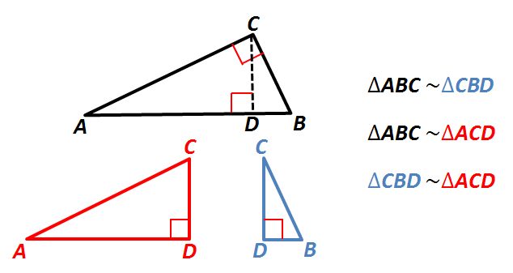
- Similar triangles are connected to trig triangles. The similarity between triangles with the same angles is why the trig functions are consistent across all right triangles with the same angle.

Skills in Practice
While the five process goals are expected to be embedded in each standard, the Skills in Practice highlight the most prevalent process goals in relation to the content presented.

Mathematical Problem Solving: Students will benefit from additional practice proving triangles similar by using properties, postulates, or theorems. Example(s) with common misconceptions follow –

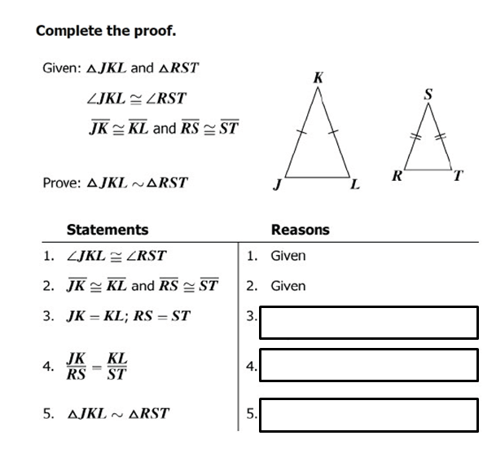
Misconceptions exist when students forget to apply the correct justification in the appropriate row given a two-column proof. The answers are:
  - Definition of congruence
  - Division property of equality
  - SAS Similarity

Mathematical Reasoning: Students need additional practice proving triangles similar when specific measurements are not given. Example(s) follow –

Refer to the image that follows. Given: $∆$ MNO and $∆$ VTS

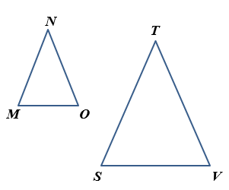

Select two relationships that together would prove $∆$ MNO and $∆$ VTS by the Side-Angle-Side (SAS) Similarity Theorem.

  - ∠N ≅ ∠T
  - ∠M ≅ ∠S
  - ∠M ≅ ∠V

The answers are:
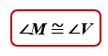 and 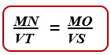

Concepts and Connections
Concepts
Analyzing and describing geometric objects, the relationships and structures among them, or the space that they occupy can be used to classify, quantify, measure, or count one or more attributes.

Connections: Prior to Geometry, students explored the coordinate plane and graphed ordered pairs (6.MG.3), solved problems and justified relationships of similarity using proportional reasoning (7.MG.2), and applied the Pythagorean Theorem to solve problems involving right triangles (8.MG.4, G.TR.4). During Algebra 1, students examined slopes of parallel and perpendicular lines (A.F.1). Throughout Geometry, students will determine relationships of angles and sides in triangles (G.TR.1), prove and justify triangle congruence (G.TR.2). Given these understandings, students will continue to prove and justify triangle similarity in coursework beyond Geometry.

- Within the grade level/course:
  - G.RLT.1 – The student will translate logic statements, identify conditional statements, and use and interpret Venn diagrams.
  - G.TR.1 – The student will determine the relationships between the measures of angles and lengths of sides in triangles, including problems in context.
  - G.TR.2 – The student will, given information in the form of a figure or statement, prove and justify two triangles are congruent using direct and indirect proofs, and solve problems involving measured attributes of congruent triangles.
  - G.TR.4 – The student will model and solve problems, including those in context, involving trigonometry in right triangles and applications of the Pythagorean Theorem.
- Vertical Progression:
  - 6.MG.3 – The student will describe the characteristics of the coordinate plane and graph ordered pairs.
  - 7.MG.2 – The student will solve problems and justify relationships of similarity using proportional reasoning.
  - 8.MG.4 – The student will apply the Pythagorean Theorem to solve problems involving right triangles, including those in context.
  - A.F.1 – The student will investigate, analyze, and compare linear functions algebraically and graphically, and model linear relationships.

Textbooks and HQIM for Consideration
- A list of approved textbooks and instructional materials will be posted on the VDOE website.

G.TR.4 The student will model and solve problems, including those in context, involving trigonometry in right triangles and applications of the Pythagorean Theorem.
Students will demonstrate the following Knowledge and Skills:
- Determine whether a triangle formed with three given lengths is a right triangle.
- Find and verify trigonometric ratios using right triangles.
- Model and solve problems, including those in context, involving right triangle trigonometry (sine, cosine, and tangent ratios).
- Solve problems using the properties of special right triangles.
- Solve for missing lengths in geometric figures, using properties of 45°-45°-90° triangles, where rationalizing denominators may be necessary.
- Solve for missing lengths in geometric figures, using properties of 30°-60°-90° triangles, where rationalizing denominators may be necessary.
- Solve problems, including those in context, involving right triangles using the Pythagorean Theorem and its converse, including recognizing Pythagorean Triples.

Understanding the Standard
- Tools for understanding the standard: physical protractor, ruler, compass, straight edge, paper folding as well as digital tools in mathematical and drafting platforms (dynamic software).
- The converse of the Pythagorean Theorem can be used to determine if a triangle is a right triangle. If $c^{2}=a^{2}+b^{2}$, then the triangle is right.
- If a triangle is not a right triangle, the Pythagorean Inequality Theorem can be used to determine the type of triangle based on angles.
    - If $c^{2}<a^{2}+b^{2}$, then the triangle is acute.
    - If $c^{2}>a^{2}+b^{2}$, then the triangle is obtuse.
- Similar triangles can be used to develop the concept of Pythagorean triples and trigonometric ratios.
- The sine of an acute angle in a right triangle is equal to the cosine of its complement.
- Missing side lengths or angle measurements in a right triangle can be solved by using sine, cosine, and tangent ratios.
- 45°-45°-90° and 30°-60°-90° triangles are special right triangles because their side lengths can be specified as exact values using radicals rather than decimal approximations.
- Pythagorean triples are whole number side length measures of right triangles. Examples include (3, 4, 5) and (5, 12, 13).
- Additional sets of Pythagorean triples can be found by applying properties for similar triangles and proportional sides. For example, doubling the sides of a triangle with sides of (3, 4, 5) creates another Pythagorean triple of (6, 8, 10).
- Pythagorean theorem can be used to develop the distance formula. When the two endpoints are graphed, a right triangle can be drawn with the hypotenuse being the diagonal distance between the points. The distance horizontally and vertically can be substituted for 𝑎 and 𝑏 in the Pythagorean theorem.
- The distance formula can be used to determine the length of a line segment when given the coordinates of the endpoints.
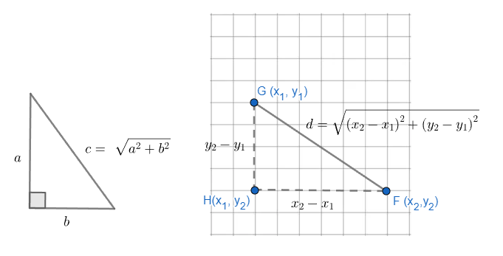

Skills in Practice
While the five process goals are expected to be embedded in each standard, the Skills in Practice highlight the most prevalent process goals in relation to the content presented.

Mathematical Connections:
- Students need additional practice applying properties of special right triangles to composite figures to determine unknown side lengths, particularly when radicals are used to represent the given information and/or the final answer. Example(s) with common misconceptions follow –

Given: Circle C with diameter $\overline{DE}$, A and B on circle C, and isosceles △ABC
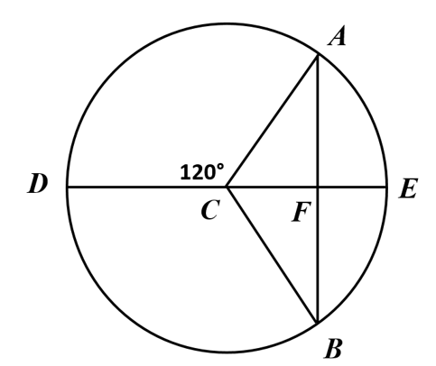
If DE = 20 inches, what is AF ?
- 10 inches
- 5 inches
- 5$\sqrt{3}$ inches
- 10$\sqrt{3}$ inches

- Students need additional practice applying the Pythagorean Theorem to triangles whose side lengths are represented by algebraic expressions. Example(s) with common misconceptions follow –

A triangle has side lengths $25, 15x$and$20x$. The longest side is 25. What value for $x$ proves that this triangle is a right triangle?

Common errors include not squaring all side lengths; and/or not squaring the variable. Additional common errors include using the wrong side of the triangle as the hypotenuse; and failing to square the variable when it is used in the Pythagorean Theorem. The answer is: $x = 1$.

Mathematical Representations: Students will benefit from additional practice using trigonometry to solve practical problems. Example(s) follow –

A ladder leans against a wall. The bottom of the ladder is 10 feet from the base of the wall, and the top of the ladder makes an angle of 25° with the wall. Find the length, $x$, of the ladder.

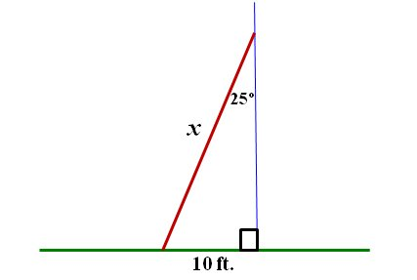

The answer is $x=23.7$ft.

Concepts and Connections
Concepts
Analyzing and describing geometric objects, the relationships and structures among them, or the space that they occupy can be used to classify, quantify, measure, or count one or more attributes.

Connections: Prior to Geometry, students applied the Pythagorean Theorem to solve problems involving right triangles, including those in context (8.MG.4). Throughout Geometry, students will determine relationships of angles and sides in triangles (G.TR.1), prove and justify triangle congruence (G.TR.2) and similarity (G.TR.3). Given these understandings, students will continue to model and solve contextual problems involving trigonometry in right triangles and applications of the Pythagorean Theorem in coursework beyond Geometry.

- Within the grade level/course:
  - G.TR.1 – The student will determine the relationships between the measures of angles and lengths of sides in triangles, including problems in context.
  - G.TR.2 – The student will, given information in the form of a figure or statement, prove and justify two triangles are congruent using direct and indirect proofs, and solve problems involving measured attributes of congruent triangles.
  - G.TR.3 – The student will, given information in the form of a figure or statement, prove and justify two triangles are similar using direct and indirect proofs, and solve problems, including those in context, involving measured attributes of similar triangles.
- Vertical Progression:
  - 8.MG.4 – The student will apply the Pythagorean Theorem to solve problems involving right triangles, including those in context.

Textbooks and HQIM for Consideration
- A list of approved textbooks and instructional materials will be posted on the VDOE website.

Polygons and Circles
Polygons and circles are major components of geometrical thinking. Building upon the knowledge of triangles, polygons are expounded upon to foster critical thinking, understanding, and application of two- and three- dimensional figures. Students use applications of polygons and circles to develop their sense for contextual applications. These skills unpack building blocks that are necessary for advanced mathematical thinking, understanding, and application. Also, mastery of knowledge and skills relating to polygons and circles is required for higher level mathematics courses.
Throughout Geometry, students will prove and justify theorems and properties of quadrilaterals, and verify and use properties of quadrilaterals, including the relationships between the sides, angles, and diagonals, to solve problems, including those in context. Additionally, students will verify relationships and solve problems, including contextual problems, involving the number of sides and angles of convex polygons. Students will solve problems, including those in context, by applying properties of circles. Also, students will solve problems in the coordinate plane, including those in context, involving equations of circles.

G.PC.1 The student will prove and justify theorems and properties of quadrilaterals and verify and use properties of quadrilaterals to solve problems, including the relationships between the sides, angles, and diagonals.
Students will demonstrate the following Knowledge and Skills:
- Solve problems, using the properties specific to parallelograms, rectangles, rhombi, squares, isosceles trapezoids, and trapezoids.
- Prove and justify that quadrilaterals have specific properties, using coordinate and algebraic methods, such as the slope formula, the distance formula, and the midpoint formula.
- Prove and justify theorems and properties of quadrilaterals using deductive reasoning.
- Use congruent segment, congruent angle, angle bisector, perpendicular line, and/or parallel line constructions to verify properties of quadrilaterals.

Understanding the Standard
- The properties of quadrilaterals can be verified experimentally using rulers, protractors, coordinate methods, and other measurement tools.
- A parallelogram is a quadrilateral with both pairs of opposite sides parallel. Additional properties of a parallelogram include:
- opposite sides are congruent;
- opposite angles are congruent;
- consecutive angles are supplementary; and,
- diagonals bisect each other.
- A rectangle is a quadrilateral with four right angles. In addition to all the parallelogram properties, the properties of rectangles also include:
- diagonals are congruent.
- A rhombus is a quadrilateral with four congruent sides. In addition to all the parallelogram properties, the properties of rhombi also include:
- all sides are congruent;
- diagonals are perpendicular;
- diagonals bisect opposite angles; and,
- diagonals divide the rhombus into four congruent right triangles.
- A square is a quadrilateral that is a regular polygon with four congruent sides and four right angles. In addition to all of the parallelogram, rhombus, and rectangle properties, the properties of squares also include:
- diagonals divide the square into four congruent 45°-45°-90° triangles.
- In order to prove that a quadrilateral is a square, it must be shown that the quadrilateral has at least one rhombus property as well as at least one rectangle property.
- A trapezoid is a quadrilateral with exactly one pair of parallel sides. The parallel sides of a trapezoid are called bases. The nonparallel sides of a trapezoid are called legs.
- An isosceles trapezoid is a quadrilateral with one set of opposite sides parallel and the other set of opposite sides congruent. In addition to all of the trapezoid properties, the properties of an isosceles trapezoid also include:
- base angles are congruent; and,
- diagonals are congruent.
- Properties of quadrilaterals can be used to identify the quadrilateral and to determine the measures of sides and angles.
- Given coordinate representations of quadrilaterals, the distance, slope, and midpoint formulas may be used to prove and justify that quadrilaterals have specific properties.
- The angle relationships formed when parallel lines are intersected by a transversal can be used to prove the properties of quadrilaterals.
- Deductive reasoning can be used to prove and justify theorems of quadrilaterals. Examples include:
  - All rectangles have congruent diagonals. Quadrilateral ABCD is a rectangle. Quadrilateral ABCD has diagonals that are congruent.
  - If a quadrilateral is a rhombus, then its opposite sides are parallel. If a quadrilateral has opposite sides parallel, then it is a parallelogram. Conclusion: If a quadrilateral is a rhombus, then it is a parallelogram.
- Congruent triangles can be used to prove properties of quadrilaterals.
- The construction of the perpendicular bisector of a line segment can be justified using the perpendicular diagonals of a rhombus.
- The construction of the perpendicular to a given line from a point on, or not on, the line can be justified using the perpendicular diagonals of a rhombus.
- The construction of a bisector of a given angle can be justified using that the diagonals of a rhombus bisect the angles.
- Verify properties of quadrilaterals with compass constructions:
Property | Construction
Both pairs of opposite sides are parallel | Parallel line
Both pairs of opposite sides are congruent | Congruent segments
Both pairs of opposite angles are congruent | Congruent angles
Diagonals bisect each other | Congruent segments
One pair of opposite sides are congruent and parallel | Congruent segments and parallel lines
Diagonals are congruent | Congruent segments
All sides are congruent | Congruent segments
Diagonals are perpendicular bisectors of each other | Perpendicular line and congruent segments
Diagonals bisect opposite angles | Angle bisector
Nonparallel sides are congruent | Congruent segments
Base angles are congruent | Congruent angles

Skills in Practice
While the five process goals are expected to be embedded in each standard, the Skills in Practice highlight the most prevalent process goals in relation to the content presented.

Mathematical Problem Solving: Students need additional practice with contextual problems involving quadrilaterals. Example(s) with common misconceptions follow –

Sasha built a window for her dollhouse in the shape of a quadrilateral. She knows the opposite sides of the window are parallel, but she wants to be sure it is in the shape of a rectangle. Which of these can she use?

- The consecutive angles of the window are supplementary.
- The opposite sides of the window are congruent.
- The diagonals of the window bisect each other.
- The diagonals of the window are congruent.

Misconceptions arise when students do not draw a picture that corresponds to the problem. The answer is: the diagonals of the window are congruent.

Mathematical Reasoning:
- Rectangle MNOP is shown below with $m∠MON=62°$. Find $m∠OMN and m∠PRO$. Explain your reasoning.

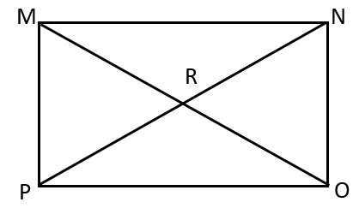
$m∠OMN=$ _________
$m∠PRO=$ _________
A common error a student may make is to find $m∠OMN=62°$. This may indicate the student views $∠MON$ and $∠OMN$ as opposite angles and concludes that they are congruent. Another common error a student may make would be to find $m∠RPO$ instead of $m∠PRO$. A student may struggle with identifying the correct angle when the angle is named by three letters instead of named by one letter or indicated by a number. To address these errors, teachers could encourage students to trace their angles to better visualize which angles are being represented in the problem. Students may also benefit from a discussion of why the four smaller triangles inside the rectangle are isosceles triangles.

Concepts and Connections
Concepts
Analyzing and describing geometric objects, the relationships and structures among them, or the space that they occupy can be used to classify, quantify, measure, or count one or more attributes.

Connections: Prior to Geometry, students were exposed to rectangles, squares, trapezoids, and parallelograms (8.MG.5). Also, students categorized quadrilaterals based on parallel and perpendicular sides (7.MG.3). Previously, students received practice examining distance within the coordinate plane (6.MG.3). During Algebra 1, students examined slopes of parallel and perpendicular lines (A.F.1). Throughout Geometry, students will use logic statements to prove and justify (G.RLT.1) parallel lines cut by a transversal (G.RLT.2) and solve problems involving convex polygons (G.PC.2). Given these understandings, students will prove, justify, verify, and use theorems and properties relating to quadrilaterals to solve problems, including the relationship between the sides, angles, and diagonals in coursework beyond Geometry.

- Within the grade level/course:
  - G.RLT.1 – The student will translate logic statements, identify conditional statements, and use and interpret Venn diagrams.
  - G.RLT.2 – The student will analyze, prove, and justify the relationships of parallel lines cut by a transversal.
  - G.PC.2 – The student will verify relationships and solve problems involving the number of sides and measures of angles of convex polygons.
- Vertical Progression:
  - 6.MG.3 – The student will describe the characteristics of the coordinate plane and graph ordered pairs.
  - 7.MG.3 – The student will compare and contrast quadrilaterals based on their properties and determine unknown side lengths and angle measures of quadrilaterals.
  - 8.MG.5 – The student will solve area and perimeter problems involving composite plane figures, including those in context.
  - A.F.1 – The student will investigate, analyze, and compare linear functions algebraically and graphically, and model linear relationships.

Textbooks and HQIM for Consideration
- A list of approved textbooks and instructional materials will be posted on the VDOE website.

G.PC.2 The student will verify relationships and solve problems involving the number of sides and measures of angles of convex polygons.
Students will demonstrate the following Knowledge and Skills:
- Solve problems involving the number of sides of a regular polygon given the measures of the interior and exterior angles of the polygon.
- Justify the relationship between the sum of the measures of the interior and exterior angles of a convex polygon and solve problems involving the sum of the measures of the angles.
- Justify the relationship between the measure of each interior and exterior angle of a regular polygon and solve problems involving the measures of the angles.

Understanding the Standard
- In convex polygons, each interior angle has a measure less than 180°.
- In concave polygons, one or more interior angles have a measure greater than 180°.
- A regular polygon is a convex polygon that is both equiangular (all angles congruent) and equilateral (all sides congruent).
- The sum of the measures of the interior angles of a convex polygon may be found by dividing the interior of the polygon into nonoverlapping triangles and multiplying the number of triangles created by 180$°$.
- An exterior angle is formed by extending a side of a polygon.
- The exterior angle and the corresponding interior angle form a linear pair.
- The sum of exterior angles in any convex polygon is 360$°$.
- As the number of sides increases in a regular polygon, the measure of each interior angle increases and the measure of each exterior angle decreases.
- Given a number of sides, the following chart can be used to organize the polygon formulas.
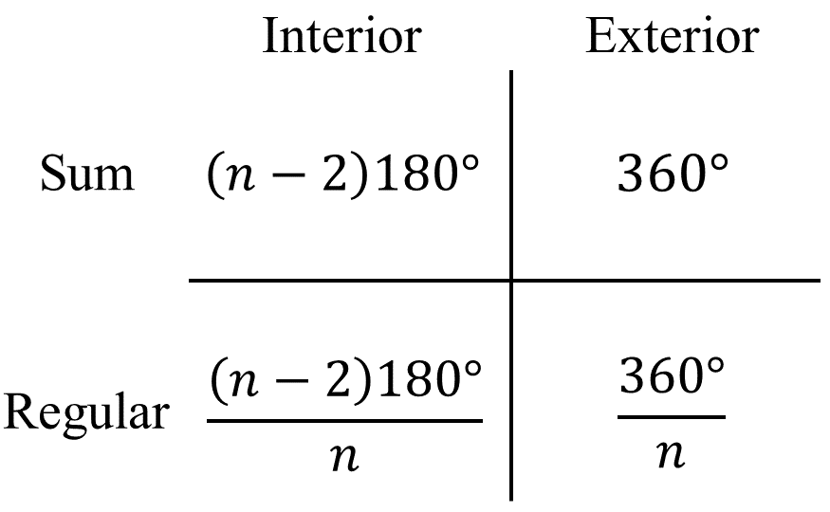

Skills in Practice
While the five process goals are expected to be embedded in each standard, the Skills in Practice highlight the most prevalent process goals in relation to the content presented.

Mathematical Problem Solving: Students will benefit from examples finding the measure of angles of convex polygons. Example(s) with common misconceptions follow –

- A convex polygon is shown. What is the value of $x$?

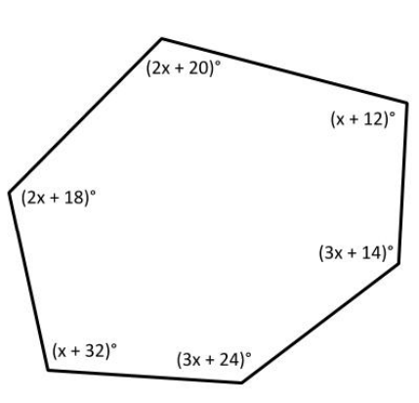

A common error a student may make is to write an equation where the sum of the measures of the interior angles is set equal to 360°. This may indicate that a student has confused the sum of the exterior angles with the sum of the interior angles of a convex hexagon. Students may benefit from analyzing the interior angle sum as a pattern that increases by 180 with each added side.

Mathematical Communication: Students will benefit from multiple representations used to solve problems involving convex polygons. Example(s) with common misconceptions follow –

- Kelvin would like to find the sum of the interior angles in a pentagon. Kelvin thinks that if he can divide the pentagon into triangles, he can find the total interior angle sum.

  - How many non-overlapping triangles can be formed by drawing all possible diagonals from one vertex of a pentagon? Use the diagram to draw them.

A common misconception that some students have is assuming that the number of triangles will be equivalent to the number of sides. This misconception indicates that students will likely misuse or incorrectly remember the formula for the sum of the interior angles as $180°n$ instead of $180°(n – 2)$. Students may benefit from determining the number of triangles as part of a pattern that increases by 1 with every side length that is added.

  - Use what you know about the angle measures in each triangle to find the sum of the interior angles of a pentagon.

A common error is that even after determining the number of triangles correctly, a student may still apply the interior angle sum theorem incorrectly by using either $180°n$ or $360°(n – 2).$ This error indicates that the student does not understand and connect to the conceptual basis of the interior angle sum theorem. One strategy would be to have students work through a small subset of polygons, draw in the non-overlapping triangles from one vertex and use the triangle angle sum in order to generalize how to find the sum of the interior angles of a convex polygon.

Concepts and Connections
Concepts
Analyzing and describing geometric objects, the relationships and structures among them, or the space that they occupy can be used to classify, quantify, measure, or count one or more attributes.

Connections: Prior to Geometry, students categorized quadrilaterals based on parallel and perpendicular sides (7.MG.3). Previously, students received practice determining an angle’s measure with regards to supplementary and complementary relationships (8.MG.1). Throughout Geometry, students will solve problems involving quadrilaterals (G.PC.1). Given these understandings, students will verify relationships and solve problems in coursework beyond Geometry.

- Within the grade level/course:
  - G.PC.1 – The student will prove and justify theorems and properties of quadrilaterals and verify and use properties of quadrilaterals to solve problems, including the relationships between the sides, angles, and diagonals.
- Vertical Progression:
  - 7.MG.3 – The student will compare and contrast quadrilaterals based on their properties and determine unknown side lengths and angle measures of quadrilaterals.
  - 8.MG.1 – The student will use the relationships among pairs of angles that are vertical angles, adjacent angles, supplementary angles, and complementary angles to determine the measure of unknown angles.

Textbooks and HQIM for Consideration
- A list of approved textbooks and instructional materials will be posted on the VDOE website.

G.PC.3 The student will solve problems, including those in context, by applying properties of circles.
Students will demonstrate the following Knowledge and Skills:
- Determine the proportional relationship between the arc length or area of a sector and other parts of a circle.
- Solve for arc measures and angles in a circle formed by central angles.
- Solve for arc measures and angles in a circle involving inscribed angles.
- Calculate the length of an arc of a circle.
- Calculate the area of a sector of a circle.
- Apply arc length or sector area to solve for an unknown measurement of the circle including the radius, diameter, arc measure, central angle, arc length, or sector area.

Understanding the Standard
- A central angle is an angle whose vertex is the center of the circle.
- An inscribed angle is an angle whose vertex is a point on the circle and whose sides contain chords of the circle.
- The measure of a central angle is equal to the measure of its intercepted arc.
- The measure of an inscribed angle is half the measure of its intercepted arc.
- Portions of circles can be thought of in three ways:
  - Arc Measure: Measured in degrees or radians and expresses the portion of the circle out of the whole. It is not affected by the size of the circle.
  - Arc Length: Measured in linear units (e.g., inches, meters) and expresses the length of a particular arch. It is affected by the size of the circle.
  - Sector Area: Measured in square units (e.g., $in.^{2}$, $m^{2}$) and expresses how much area is contained within the sector. It is affected by the size of the circle.
- The ratio of the central angle to 360° is proportional to the ratio of the arc length to the circumference of the circle.
- The ratio of the central angle to 360° is proportional to the ratio of the area of the sector to the area of the circle.

Skills in Practice
While the five process goals are expected to be embedded in each standard, the Skills in Practice highlight the most prevalent process goals in relation to the content presented.

Mathematical Problem Solving: Students will benefit from using problem solving strategies to unpack and solve problems given in context regarding circles. Example(s) with common misconceptions follow –

- Bob divides his circular garden into 10 congruent sectors to plant different types of flowers. The circumference of Bob’s garden is 50.5 feet.
What is the area of one sector of Bob’s garden?

Errors often occur when students fail to implement an action plan to solve contextual problems including circles. Steps students should take are listed below:
- Draw a figure.
- Find the diameter or radius.
- Find the area.
- Fine the area of one sector.

The answer is approximately 20.3 sq. ft.

Mathematical Reasoning: Students will benefit from additional practice using a measure of one part of the circle to find measures of other parts of the circle. Example(s) with common misconceptions follow –

In Circle O, the length of $\hat{BC}$ is 25.4 cm.
Find the length of $\hat{BAC}$ to the nearest tenth of a centimeter.

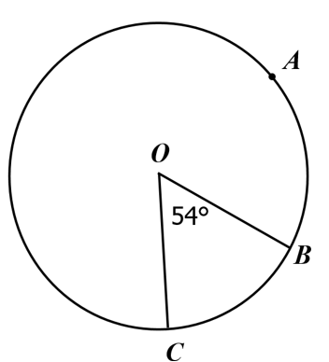

Common misconceptions exist when students do not appear to recognize that the ratio of the central angle to the whole circle is equal to the ratio of the arc length to the circumference. The answer is: the length of arc BAC, to the nearest tenth of a centimeter, is 143.9 cm.

Concepts and Connections
Concepts
Analyzing and describing geometric objects, the relationships and structures among them, or the space that they occupy can be used to classify, quantify, measure, or count one or more attributes.

Connections: Prior to Geometry, students explored attributes of circles, investigated relationships among a circle’s attributes, developed an approximation for pi and the formula for the circumference of a circle, and solved contextual problems relating to circles (6.MG.1). Also, students investigated perimeter and area problems related to composite figures that included circles (8.MG.5). Throughout Geometry, students will solve problems involving circles (G.PC.4). Given these understandings, students will solve contextual problems by applying properties of circles beyond Geometry.

- Within the grade level/course:
  - G.PC.4 – The student will solve problems in the coordinate plane involving equations of circles.
- Vertical Progression:
  - 6.MG.1 – The student will identify the characteristics of circles and solve problems, including those in context, involving circumference and area.
  - 8.MG.5 – The student will solve area and perimeter problems involving composite plane figures, including those in context.

Textbooks and HQIM for Consideration
- A list of approved textbooks and instructional materials will be posted on the VDOE website.

G.PC.4 The student will solve problems in the coordinate plane involving equations of circles.
Students will demonstrate the following Knowledge and Skills:
- Derive the equation of a circle given the center and radius using the Pythagorean Theorem.
- Solve problems in the coordinate plane involving equations of circles:
  - given a graph or the equation of a circle in standard form, identify the coordinates of the center of the circle;
  - given the coordinates of the endpoints of a diameter of a circle, determine the coordinates of the center of the circle.
  - given a graph or the equation of a circle in standard form, identify the length of the radius or diameter of the circle.
  - given the coordinates of the endpoints of the diameter of a circle, determine the length of the radius or diameter of the circle.
  - given the coordinates of the center and the coordinates of a point on the circle, determine the length of the radius or diameter of the circle; and
  - given the coordinates of the center and length of the radius of a circle, identify the coordinates of a point(s) on the circle.
- Determine the equation of a circle given:
  - a graph of a circle with a center with coordinates that are integers;
  - coordinates of the center and a point on the circle;
  - coordinates of the center and the length of the radius or diameter; and,
  - coordinates of the endpoints of a diameter.

Understanding the Standard
- A circle is a locus of points equidistant from a given point, the center.
- The distance between any point on the circle and the center is the length of the radius.
- The equation of a circle with a given center and radius can be derived using the Pythagorean Theorem as follows: Every point (x, y) on a circle is the same distance from the center of the circle (h, k). This distance is defined as the radius (r). To determine the distance (radius) between (x, y) and (h, k), a right triangle is created with the hypotenuse as the radius (r) and the legs defined as (x – h) and (y – k). Substituting these variables into the Pythagorean Theorem results in the following equation: (x – h)² + (y – k)² = r².
- Standard form for the equation of a circle is (x – h)² + (y – k)² = r², where the coordinates of the center of the circle are (h, k) and r is the length of the radius.
- Given the graph of a circle in the coordinate plane, identify the circle’s center and radius/diameter required to determine the equation for the circle. The midpoint of the diameter is the center of the circle.
- The midpoint formula can be used to find the center of the circle when given two endpoints.
- The distance formula can be used to determine the length of a radius given an endpoint and a midpoint.
- The equation of a circle gives the coordinates of every point, (x, y), on the circle.

Skills in Practice
While the five process goals are expected to be embedded in each standard, the Skills in Practice highlight the most prevalent process goals in relation to the content presented.

Mathematical Problem Solving: Students need additional practice using the equation of a circle to identify the radius, diameter, center, and/or a point on the circle. Example(s) with common misconceptions follow –

- The coordinates of the center of a circle are (-2, 6). This circle has a diameter of 10 units.

- What is the equation of the circle?
- Give the integral coordinates of two points that lie on the circle.

Misconceptions about this type of problem originate at the entry point. Students must understand that the center of the circle is not a point that lies on the circle. Also, given the diameter of the circle, the radius can be found. Plot the center on a coordinate plane. Use the radius and the center to write the equation of the circle in standard form. Also, use the radius and the coordinates of the center of the circle to find four integral points that lie on the circle. Add the radius to one of the center’s coordinates to identify another point that lies on the circle. Once you have those two new ordered pairs, plot them. Then repeat the process using subtraction to find two additional points. Answers to this problem are shown below. Graphical representations are provided.

- ${\left(x+2\right)}^{2}+{\left(y-6\right)}^{2}=25$
- Possible points: (-2, 1), (-2, 11), (-7, 6), (3, 6)

Graph the center and four points found by moving horizontally and vertically on the coordinate plane in r units of distance.

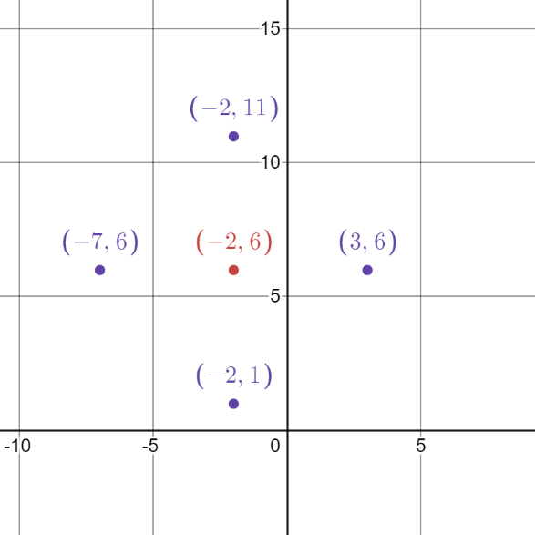

Graph the circle’s equation to confirm that the four points lie on the circle.

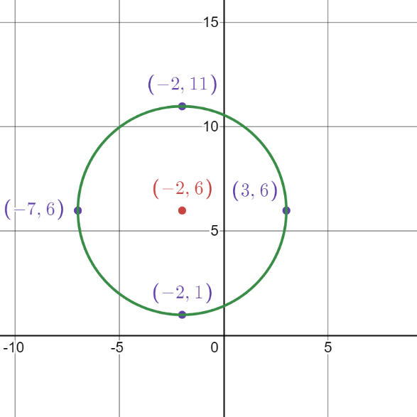
Mathematical Reasoning: Students will benefit from practice identifying the center, radius, and diameter of a circle, given the equation written in standard form. Example(s) with common misconceptions follow –

The equation of a circle is $(x - 3)² + (y + 4)² = 16$.
- What are the coordinates of the center of the circle?
- What is the radius of the circle?
- What is the diameter of the circle?
- Give the integral coordinates of two points that lie on the circle.
Errors might occur when students forget to apply the negative sign when addition is reflected in the equation. Also, students may forget to take the square root of the constant to find the radius. Answers to this problem are shown below:

- (3, -4)
- 4
- 8
- Possible points: (-1,-4) (7,-4) (3,-8) (3,0)

Concepts and Connections
Concepts
Analyzing and describing geometric objects, the relationships and structures among them, or the space that they occupy can be used to classify, quantify, measure, or count one or more attributes.

Connections: Prior to Geometry, students explored attributes of circles, investigated relationships among a circle’s radius and diameter and solved contextual problems relating to circles (6.MG.1). Also, students investigated the Pythagorean Theorem and right triangles (8.MG.5). Throughout Geometry, students will solve problems involving trigonometry in right triangles (G.TR.4) and apply properties of circles (G.PC.3). Given these understandings, students will solve problems in the coordinate plane involving equations of circles in coursework beyond Geometry.
- Within the grade level/course:
  - G.TR.4 – The student will model and solve problems, including those in context, involving trigonometry in right triangles and applications of the Pythagorean Theorem.
  - G.PC.3 – The student will solve problems, including those in context, by applying properties of circles.
- Vertical Progression:
  - 6.MG.1 – The student will identify the characteristics of circles and solve problems, including those in context, involving circumference and area.
  - 8.MG.4 – The student will apply the Pythagorean Theorem to solve problems involving right triangles, including those in context.

Textbooks and HQIM for Consideration
- A list of approved textbooks and instructional materials will be posted on the VDOE website.

Two- and Three-Dimensional Figures
Two- and three-dimensional figures comprise the foundation for study, understanding, and application of geometry. Students use models and graphs to develop necessary skills used to solve contextual problems regarding two- and three-dimensional figures. These skills unpack building blocks that are required for advanced mathematical thinking, understanding, and application throughout physical science courses, engineering, and calculus.
Throughout Geometry, students will create models and solve problems, including those in context, involving surface area and volume of three-dimensional objects. Additionally, students will determine the effects of changing one or more dimensions of a three-dimensional figure, including recognizing when two- and three-dimensional figures are similar.

G.DF.1 The student will create models and solve problems, including those in context, involving surface area and volume of rectangular and
triangular prisms, cylinders, cones, pyramids, and spheres.
Students will demonstrate the following Knowledge and Skills:
- Identify the shape of a two-dimensional cross-section of a three-dimensional figure.
- Create models and solve problems, including those in context, involving surface area of three-dimensional figures, as well as composite three-dimensional figures.
- Solve multistep problems, including those in context, involving volume of three-dimensional figures, as well as composite three-dimensional figures.
- Determine unknown measurements of three-dimensional figures using information such as length of a side, area of a face, or volume.

Understanding the Standard
- A cylinder is a solid figure formed by two congruent parallel faces called bases joined by a curved surface. In this course, cylinders are limited to right circular cylinders.
- A prism is a polyhedron that has a congruent pair of parallel bases and faces that are parallelograms. In this course, prisms are limited to right prisms.
- A pyramid is a polyhedron with a base that is a polygon and three or more faces that are triangles with a common vertex.
- A cone is a solid figure formed by a face called a base that is joined to a vertex (apex) by a curved surface. In this course, cones are limited to right circular cones.
- Slicing a three-dimensional figure using a geometric plane results in an intersection that is a two-dimensional figure. Slicing vertically, horizontally, or diagonally can result in cross-sections that include circles, triangles, rectangles, squares, ellipses, and trapezoids.
- Subdivision of polygons may assist in determining the area of regular polygons.
- The formula for the area of regular polygon is $A=\frac{1}{2}ap$, where:
- $a$ represents apothem which is the perpendicular distance from any side to the center of the regular polygon; and,
- $p$represents the length of the polygon’s perimeter.
- Generalize the surface area formula of prisms and cylinders to $SA=LA+2B$.
- Generalize the surface area formula of cones and pyramids to $SA=LA+B$.
- The surface area of a prism or pyramid is the sum of the areas of all its faces.
- The surface area of a cylinder, cone, or hemisphere is the sum of the areas of the curved surface and base(s).
- The surface area of a sphere is the area of the curved surface.
- Surface area of spheres, cones, and cylinders should be considered in terms of p or as a decimal approximation.
- Calculators may be used to determine decimal approximations for results.
- The lateral area (LA) of a cylinder or a cone is the area of the curved surface of the cylinder or cone, not including the base(s).
- The lateral area (LA) of a prism or a pyramid is the sum of the areas of all faces, not including the base(s).
- Generalize the volume formula of prisms and cylinders to $V=Bh$.
- Generalize the volume formula of cones and pyramids to $V=\frac{1}{3}Bh$.
- Volume and surface area of spheres, cones and cylinders should be considered in terms of p or as a decimal approximation.
- Composite figures consist of two or more three-dimensional figures. The surface area of a composite figure may not be equal to the sum of the surface areas of the individual figures.
- Composite figures consist of two or more three-dimensional figures. The volume of a composite figure equals the sum or difference of the volumes of the individual figures.

Skills in Practice
While the five process goals are expected to be embedded in each standard, the Skills in Practice highlight the most prevalent process goals in relation to the content presented.

Mathematical Problem Solving: Students need additional practice finding surface area and/or volume of three-dimensional figures when some values are not directly provided on the figure and/or when the answer is expressed in terms of pi ($π$). Example(s) with common misconceptions follow –

- A square pyramid has a height of 15 cm and a base edge of 16 cm.
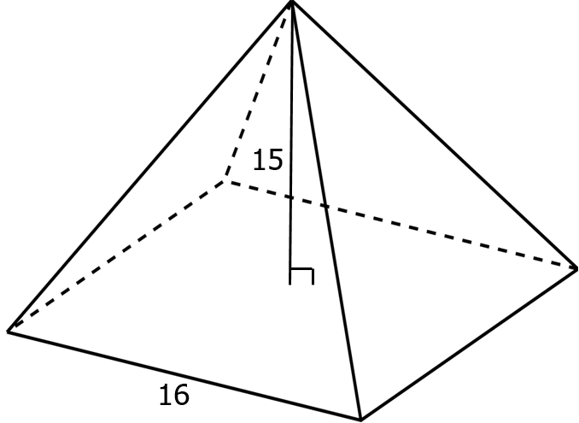

What is the area of one face of this pyramid?

Common errors occur when students confuse the height with the slant height, or they do not know how to use the Pythagorean Theorem to find the slant height. Also, students may become confused about when to use a radius or diameter. The answer is: 136 cm².

Mathematical Reasoning: Students need additional practice determining surface area and volume of three-dimensional composite figures. Example(s) with common misconceptions follow –

A statue consists of a square pyramid and a rectangular prism with congruent bases. Specific measurements of the statue are shown in this figure.
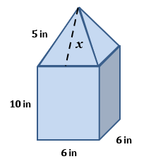

What is the total surface area of the statue represented by this composite figure? [Figure is not drawn to scale.]

Students must understand that the Pythagorean Theorem can be used to identify the slant height. The answer is 324 square inches. Refer to the image that follows.

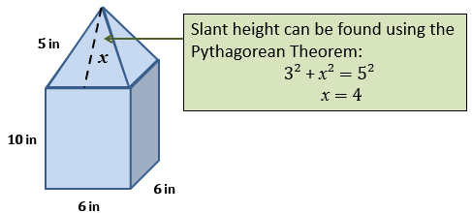

Concepts and Connections
Concepts
Analyzing and describing geometric objects, the relationships and structures among them, or the space that they occupy can be used to classify, quantify, measure, or count one or more attributes.

Connections: Prior to Geometry, students investigated surface area and volume (8.MG.2). Also, students applied area formulas to composite figures (8.MG.5). During Algebra 1, students used area models to factor polynomials. Additionally, students used area formulas in contextual situations when performing operations on polynomial expressions (A.EO.2). Throughout Geometry, students will justify relationships of parallel lines cut by a transversal (G.RLT.2), solve problems involving circles (G.PC.3), and determine changes in dimensions of three-dimensional figures (G.DF.2). Given these understandings, students will create models and solve problems involving surface area and volume (G.DF.1) in coursework beyond Geometry.

- Within the grade level/course:
  - G.RLT.2 – The student will analyze, prove, and justify the relationships of parallel lines cut by a transversal.
  - G.PC.3 – The student will solve problems, including those in context, by applying properties of circles.
  - G.DF.2 – The student will determine the effect of changing one or more dimensions of a three-dimensional geometric figure and describe the relationship between the original and changed figure.
- Vertical Progression:
  - 8.MG.2 – The student will investigate and determine the surface area of square-based pyramids and the volume of cones and square-based pyramids.
  - 8.MG.5 – The student will solve area and perimeter problems involving composite plane figures, including those in context.
  - A.EO.2 – The student will perform operations on and factor polynomial expressions in one variable.

Textbooks and HQIM for Consideration
- A list of approved textbooks and instructional materials will be posted on the VDOE website.

G.DF.2 The student will determine the effect of changing one or more dimensions of a three-dimensional geometric figure and describe the
relationship between the original and changed figure.
Students will demonstrate the following Knowledge and Skills:
- Describe how changes in one or more dimensions of a figure affect other derived measures (perimeter, area, total surface area, and volume) of the figure.
- Describe how changes in surface area and/or volume of a figure affect the measures of one or more dimensions of the figure.
- Solve problems, including those in context, involving changing the dimensions or derived measures of a three-dimensional figure.
- Compare ratios between side lengths, perimeters, areas, and volumes of similar figures.
- Recognize when two- and three-dimensional figures are similar and solve problems, including those in context, involving attributes of similar geometric figures.

Understanding the Standard
- A change in one dimension of a figure results in a predictable change in area. The resulting figure may or may not be similar to the original figure.
- A change in one dimension of a figure results in a predictable change in volume. The resulting figure may or may not be similar to the original figure.
- A change in one dimension of a figure results in a predictable change in perimeter. The resulting figure may or may not be similar to the original figure.
- A change in surface area and/or volume results in a predictable change in one or more dimensions of the figure. The resulting figure may or may not be similar to the original figure.
- A constant ratio, the scale factor, exists between corresponding dimensions of similar figures.
- If the ratio between dimensions of similar figures is a:b then:
  - the ratio of their areas is $a^{2}: b^{2}.$
  - the ratio of their volumes is $a^{3}: b^{3}$.
- Proportional reasoning is important when comparing attribute measures in similar figures.

Skills in Practice
While the five process goals are expected to be embedded in each standard, the Skills in Practice highlight the most prevalent process goals in relation to the content presented.

Mathematical Problem Solving: Students need additional practice determining the relationship between changes that affect one dimension (linear), changes that affect two dimensions (area), and changes that affect three dimensions (volume), particularly when figures are not provided. Example(s) with common misconceptions follow –
A rectangular prism has a volume of 36 cm³. If all dimensions of the original rectangular prism are tripled, what is the volume of the new rectangular prism?

Misconceptions occur when students forget to cube the changes in dimensions when all three are impacted. Oftentimes, they will triple the value in error. The answer to this problem is 972 cubic cm.

Mathematical Connections: Students need additional practice determining the relationship between changes that affect one dimension (linear), changes that affect two dimensions (area), and changes that affect three dimensions (volume), particularly when figures are not provided. Teachers can incorporate geometric objects into the learning experience to include various sized cans and nets. Example(s) follow –

A large soda can has a surface area of 96 square inches. If all dimensions of this cylindrical figure are multiplied by $\frac{1}{2}$ to create a new soda can, what will be the surface area of the new cylindrical figure?

The answer is 24 sq. in.

Concepts and Connections
Concepts
Analyzing and describing geometric objects, the relationships and structures among them, or the space that they occupy can be used to classify, quantify, measure, or count one or more attributes.

Connections: Prior to Geometry, students solved problems using proportional reasoning to understand similarity (7.MG.2) and investigated surface area and volume (8.MG.2). Also, students applied area formulas to composite figures (8.MG.5). Previously, students learned about patterns with exponents (6.NS.3) and how to apply square and cube roots (A.EO.4). Throughout Geometry, students will justify two triangles are similar (G.TR.3), solve problems involving circles (G.PC.3), and perform computations involving surface area and volume (G.DF.1). Given these understandings, students will determine the effect of changing one or more dimensions of a three-dimensional geometric figure and describe the relationship between the original and changed figure (G.DF.2) in coursework beyond Geometry.

- Within the grade level/course:
  - G.TR.3 – The student will, given information in the form of a figure or statement, prove and justify two triangles are similar using direct and indirect proofs, and solve problems, including those in context, involving measured attributes of similar triangles.
  - G.PC.3 – The student will solve problems, including those in context, by applying properties of circles.
  - G.DF.1 – The student will create models and solve problems, including those in context, involving surface area and volume of rectangular and triangular prisms, cylinders, cones, pyramids, and spheres.
- Vertical Progression:
  - 6.NS.3 – The student will recognize and represent patterns with whole number exponents and perfect squares.
  - 7.MG.2 – The student will solve problems and justify relationships of similarity using proportional reasoning.
  - 8.MG.2 – The student will investigate and determine the surface area of square-based pyramids and the volume of cones and square-based pyramids.
  - 8.MG.5 – The student will solve area and perimeter problems involving composite plane figures, including those in context.
  - A.EO.4 – The student will simplify and determine equivalent radical expressions involving square roots of whole numbers and cube roots of integers.

Textbooks and HQIM for Consideration
- A list of approved textbooks and instructional materials will be posted on the VDOE website.

