2023 Mathematics
Standards of Learning

Kindergarten Instructional Guide
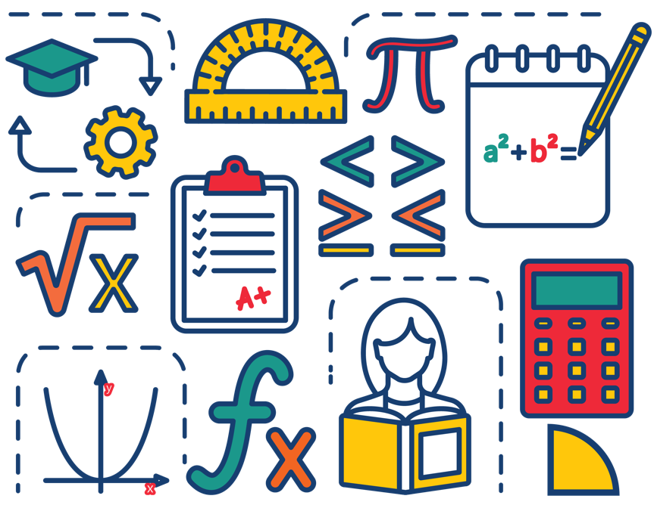

Copyright © 2024
by the
Virginia Department of Education
P.O. Box 2120
Richmond, Virginia 23218-2120
http://www.doe.virginia.gov

All rights reserved. Reproduction of these materials for instructional purposes in public school classrooms in Virginia is permitted.

Superintendent of Public Instruction
Dr. Lisa Coons

Office of STEM
Dr. Anne Petersen, Director
Dr. Angela Byrd-Wright, Mathematics Coordinator
Dr. Jessica Brown, Elementary Mathematics Specialist
Mrs. Regina Mitchell, Mathematics and Special Education Specialist

NOTICE
The Virginia Department of Education does not unlawfully discriminate on the basis of race, color, sex, national origin, age, or disability in employment or in its educational programs or services.

The contents of this Instructional Guide were informed by the U.S. Department of Education's Institute of Education Sciences (IES), What Works Clearinghouse, as a central, trusted source of scientific evidence for what works in education. Sample questions reflect applicable and aligned content from the Virginia Department of Education's published assessment items, Mathematics Item Maps, and National Association of Educational Progress (NAEP) assessment questions.

Introduction
The Mathematics Instructional Guide, a companion document to the 2023 Mathematics Standards of Learning, amplifies the Standards of Learning by defining the core knowledge and skills in practice, supporting teachers and their instruction, and serving to transition classroom instruction from the 2016 Mathematics Standards of Learning to the newly adopted 2023 Mathematics Standards of Learning. Instructional supports are accessible in #GoOpenVA and support the decisions local school divisions must make concerning local curriculum development and how best to help students meet the goals of the standards. The local curriculum should include a variety of information sources, readings, learning experiences, and forms of assessment selected at the local level to create a rigorous instructional program.

For a complete list of the changes by standard, the 2023 Virginia Mathematics Standards of Learning – Overview of Revisions is available and delineates in greater specificity the changes for each grade level and course.

The Instructional Guide is divided into three sections: Understanding the Standard, Skills in Practice, and Concepts and Connections aligned to the Standard. The purpose of each is explained below.

Understanding the Standard
This section includes mathematics understandings and key concepts that assist teachers in planning standards-focused instruction. The statements may provide definitions, explanations, or examples regarding information sources that support the content. They describe what students should know (core knowledge) as a result of the instruction specific to the course/grade level and include evidence-based practices to approaching the Standard. There are also possible misconceptions and common student errors for each standard to help teachers plan their instruction.

Skills in Practice
This section outlines supporting questions and skills that are specifically linked to the standard. They frame student inquiry, promote critical thinking, and assist in learning transfer. Curriculum writers and teachers should use them to plan instruction to deepen understanding of the broader unit and course objectives. This is not meant to be an exhaustive list of student expectations.

Concepts and Connections
This section outlines concepts that transcend grade levels and thread through the K through 12 mathematics program as appropriate at each level. Concept connections reflect connections to prior grade-level concepts as content and practices build within the discipline as well as potential connections across disciplines.

Number and Number Sense
In K-12 mathematics, numbers and number sense form the foundation building blocks for mathematics understanding. Students develop a foundational understanding of numbers, their properties, and the relationships between them as they learn to compare and order numbers, understand place value, and perform numerical operations. Number sense includes an understanding of patterns and the relationships between numbers and being able to apply this knowledge to real world problems. Throughout K-12, students build on their number sense to develop a deeper understanding of mathematical concepts and reasoning.

In Kindergarten, students develop a sense of quantity, allowing them to see relationships between numbers, think flexibly about numbers, and notice patterns that can emerge with numbers to quantify, measure, and make decisions in life. In this grade level, students use flexible counting strategies to determine and describe quantities up to 100; and identify, represent, and compare quantities up to 30.

K.NS.1 The student will utilize flexible counting strategies to determine and describe quantities up to 100.
Students will demonstrate the following Knowledge and Skills:
a) Use one-to-one correspondence to determine how many are in a given set containing 30 or fewer concrete objects (e.g., cubes, pennies, balls), and describe the last number named as the total number of objects counted.
b) Recognize and explain that the number of objects remains the same regardless of the arrangement or the order in which the objects are counted.
c) Represent forward counting by ones using a variety of tools, including five-frames, ten-frames, and number paths (a prelude to number lines).
d) Count forward orally by ones from 0 to 100.
e) Count forward orally by ones, within 100, starting at any given number.
f) Count backward orally by ones when given any number between 1 and 20.
g) State the number after, without counting, when given any number between 0 and 30.
h) State the number before, without counting, when given any number between 1 and 20.
i) Use objects, drawings, words, or numbers to compose and decompose numbers 11-19 into a ten and some ones.
j) Group a collection of up to 100 objects (e.g., counters, pennies, cubes) into sets of ten and count by tens to determine the total (e.g., there are 3 groups of ten and 6 leftovers, 36 total objects).

Understanding the Standard
- Counting is a complex skill that involves three developmental levels:
  - rote sequence;
  - one-to-one correspondence; and
  - the cardinality of numbers.
- Counting involves two separate skills: verbalizing the list (rote sequence counting) of standard number words in order (e.g., “zero, one, two, three, …”) and connecting this sequence with the objects in the set being counted, using one-to-one correspondence.
- Connecting rote counting to the counting of collections is necessary for students to understand the meaning of a number. Association of number words with collections of objects is achieved by moving, touching, or pointing to objects as the number words are spoken. Objects may be presented in random order or arranged for easy counting.
- When counting objects:
  - number names are said in standard order;
  - one item is counted for each number word (one-to-one correspondence);
  - the number of objects is the same regardless of their arrangement or the order in which they were counted (conservation of number);
  - the last number verbalized names the total amount of objects counted (cardinality);
  - each successive number name refers to a quantity that is one larger (hierarchical inclusion).
- When a set is empty, it has zero objects or elements. Zero is both a number and a digit.
- Counting forward and backward leads to the development of counting on and counting back. Counting forward by rote lays the foundation for addition. Counting backward by rote lays the foundation for subtraction. Identifying the number after and/or the number before any given number demonstrates an understanding of number relationships as opposed to a memorized sequence of numbers.
- Counting forward by rote, supported by visuals such as the hundred chart or number path, advances children’s development of sequencing.
- A number path is a counting model where each number is represented within a rectangle and can be counted. This is an example of a number path:
1 | 2 | 3 | 4 | 5 | 6 | 7 | 8 | 9 | 10
- A number line is a length model where each number represents its length (distance) from zero. When young children use a number line as a counting tool, they often confuse what should be counted (the numbers or the spaces between the numbers). A number path is more appropriate for students at this age.
- Counting skills are essential components of the development of number sense; however, they are only one of the indicators of the understanding of numbers.
- Describing numbers 11 to 19 as a ten and some ones will help students think of ten ones as a unit of ten. This also lays a foundation for place value.

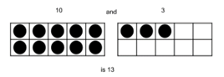
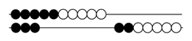

- Manipulatives that can be grouped into sets of tens and ones such as counters on ten-frames, beans in cups, buttons on paper plates, connecting cubes, etc., help students organize, understand, and count groups of tens and ones.

Skills in Practice
While the five process goals are expected to be embedded in each standard, the Skills in Practice highlight the most prevalent process goals in relation to the content presented.

Mathematical Connections: As students are counting sets of objects, they may miscount by counting an object more than once or skipping an object altogether. This indicates that the student is lacking one-to-one correspondence (the ability to accurately count one item for each number). Students need regular experiences counting real objects. A set of objects presented in an unorganized formation may be more difficult to count than a set of objects presented in an organization formation (see image below). Students should be encouraged to organize a set of objects by physically moving objects when counting them or to touch each object as they count.

Mathematical Communication: As students are developing their counting skills, it is important to listen to them do so orally. For example, when counting a set of 15 objects, a student could skip an object and count another object twice, thus providing a correct total. Listening to students count allows the teacher to understand students’ counting strategies. Additionally, when counting to 100 students may have difficulty with 11, 12, and the teen numbers. They may also struggle when crossing a decade (e.g., going from 29 to 30 or 59 to 60). Students will need additional practice, tailored to their specific needs.

Concepts and Connections
Concepts
Flexibility with composing and decomposing base 10 numbers and understanding the structure to build relationships among numbers allows us to quantify, measure, and make decisions in life.
Connections: In kindergarten, students develop an understanding of forward (up to 100) and backward (from 20) counting patterns (K.NS.1). They develop proficiency with using one-to-one correspondence when counting sets of objects. This connects with the content of identifying, representing, and comparing quantities up to 30 (K.NS.2). In the subsequent grade, Grade 1 students will use flexible counting strategies to determine and describe quantities up to 120 (1.NS.1).

- Within the grade level/course:
  - K.NS.2 – The student will identify, represent, and compare quantities up to 30.
- Vertical Progression:
  - 1.NS.1 – The student will utilize flexible counting strategies to determine and describe quantities up to 120.

Across Content Areas [Theme – Numbers, Number Sense, and Patterns]: Number sense includes an understanding of patterns and the relationships between numbers and being able to apply this knowledge to real-world problems. Throughout K-12, students build on their number sense to develop a deeper understanding of mathematical concepts and reasoning. Teachers may consider using the standards below as students develop their number sense. Describing, extending, creating, and transferring repeating and increasing patterns is a skill that spans multiple disciplines. Patterns are also evident in the science and computer science standards as students explore phenomena in science and develop programs in computer science. Teachers may consider using the standards below as students develop number sense when engaged in instructional activities that focus on patterns.
- Science:
  - K.8 – The student will demonstrate how shadows change as the direction of the light source changes.
  - K.9a-c – The student will investigate and understand that there are patterns in nature. Key patterns include daily weather, seasonal changes, and day and night.
  - K.10a – The student will describe things human-made things and things in nature that change over time.
  - K.10b,c – The student will describe living and nonliving things that change over time; identify some changes that people experience over time; and use observations to describe the change of an object or living thing over time.
  - K.10d – The student will classify examples as fast changes or slow changes.
- Computer Science: Updates will be made after the 2024 Virginia Computer Science Standards of Learning are approved by the Board of Education.

Textbooks and HQIM for Consideration
- A list of approved textbooks and instructional materials will be posted on the VDOE website.

K.NS.2 The student will identify, represent, and compare quantities up to 30.
Students will demonstrate the following Knowledge and Skills:
a) Read, write, and identify the numerals 0 through 30.
b) Construct a set of objects that corresponds to a given numeral within 30, including an empty set.
c) Determine and write the numeral that corresponds to the total number of objects in a given set of 30 or fewer concrete objects or pictorial models.
d) Given a set of up to 30 objects, construct another set which has more, fewer, or the same number of objects using concrete or pictorial models.
e) Given a numeral up to 30, construct a set which has more, fewer, or the same number of objects using concrete or pictorial models.
f) Compare two sets containing up to 30 concrete objects or pictorial models, using the terms more, fewer, or the same as (equal to).
g) Compare numbers up to 30, to the benchmarks of 5 and to the benchmark of 10 using various models (e.g., five frames, ten frames, number paths [a prelude to number lines], beaded racks, hands) using the terms greater than, less than, or the same as (equal to).

Understanding the Standard
- Kinesthetic involvement (e.g., tracing the numerals or using tactile materials such as sand, sandpaper, carpeting, or finger paint) facilitates the writing of numerals.
- Symbolic reversals in numeral writing are common at this level and should not be mistaken for lack of understanding.
- Comparing sets is an extension of conservation of number (e.g., 5 is 5 whether it is 5 marbles or 5 basketballs even though 5 basketballs take up more space). When comparing objects, the set can be arranged differently while still containing the same number (e.g., 5 marbles in a cup is the same as 5 marbles on the floor).
- Quickly recognizing and naming the number of objects in a small group without counting is called subitizing. The size of the group a student can subitize is dependent upon the arrangement. At this age, students should subitize irregular or unfamiliar arrangements up to 5. When there is a familiar or structured pattern (e.g., dots on number cubes, counters on a ten frame) students may be able to subitize larger numbers.
- Sets of objects can be compared by matching, lining up the objects, visually estimating magnitude, recognizing quantities without counting (subitizing), or counting the number of objects in each set.
- Using the terms more and fewer together build an understanding of their relationship. For example, when asking which group has more, follow with asking which group has fewer.
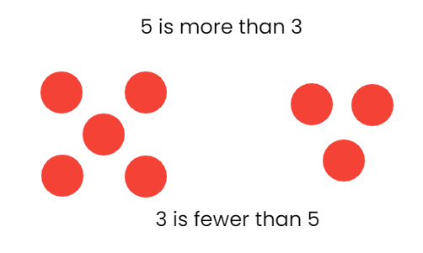
- Benchmarks of 5 and 10 are useful when comparing numbers. Various models (e.g., five frames, ten frames, and number paths) can be helpful when students are comparing numbers using the benchmarks of 5 and 10.

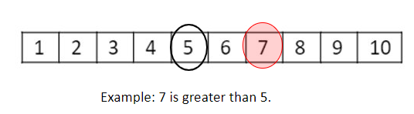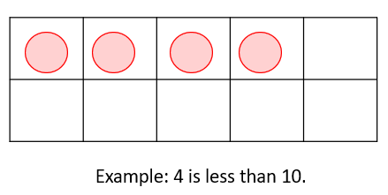

Skills in Practice
While the five process goals are expected to be embedded in each standard, the Skills in Practice highlight the most prevalent process goals in relation to the content presented.

Mathematical Representations: As students are learning to read, write, and identify numerals up to 30, students may misread a number or confuse numbers (e.g., identifying the number 9 as 6). Additionally, students often have difficulty recognizing and reading the numbers 11-19. Students will need additional practice with counting and matching the correct number with the set of objects counted.

Mathematical Communication: Some students have difficulty with the vocabulary term “fewer” because they have had less exposure to this word. Providing opportunities for students to use this term when describing quantities and comparing sets will be beneficial.

Concepts and Connections
Concepts
Flexibility with composing and decomposing base 10 numbers and understanding the structure to build relationships among numbers allows us to quantify, measure, and make decisions in life.
Connections: In kindergarten, students become proficient with reading, writing, and identifying numerals up to 30, comparing two sets of objects (up to 30), and determining which set has more or fewer (K.NS.2). This connect so the content of using flexible counting strategies to determine and describe quantities up to 100 (K.NS.1). In the subsequent grade, Grade 1 students will represent, compare, and order quantities up to 120 (1.NS.2).

- Within the grade level/course:
  - K.NS.1 – The student will utilize flexible counting strategies to determine and describe quantities up to 100.
- Vertical Progression:
  - 1.NS.2 – The student will represent, compare, and order quantities up to 120.

Across Content Areas: Reference K.NS.1.

Textbooks and HQIM for Consideration
- A list of approved textbooks and instructional materials will be posted on the VDOE website.

Computation and Estimation
In K-12 mathematics, computation and estimation are integral to developing mathematical proficiency. Computation refers to the process of performing numerical operations, such as addition, subtraction, multiplication, and division. It involves applying strategies and algorithms to solve arithmetic problems accurately and efficiently. Estimation is the process of obtaining a reasonable or close approximation of a result without performing an exact calculation. Estimation is particularly useful when an exact answer is not required, especially in real-world situations, and when assessing the reasonableness of an answer. Computation and estimation are used to support problem solving, critical thinking, and mathematical reasoning by providing students with a range of approaches to effectively solve mathematical tasks.

In Kindergarten, the operations of addition and subtraction are used to represent and solve many different types of problems. At this grade level, students will compose and decompose numbers up to 10; will describe part-part-whole relationships for numbers up to 5; and model and solve single-step contextual problems using addition and subtraction with whole numbers within 10.

K.CE.1 The student will model and solve single-step contextual problems using addition and subtraction with whole numbers within 10.

Students will demonstrate the following Knowledge and Skills:
a) Use objects, drawings, words, or numbers to compose and decompose numbers less than or equal to 5 in multiple ways.
b) Recognize and describe with fluency part-part-whole relationships for numbers up to 5 in a variety of configurations.
c) Model and identify the number that makes 5 when added to a given number less than or equal to 5.
d) Use objects, drawings, words, or numbers to compose and decompose numbers less than or equal to 10 in multiple ways.
e) Model and identify the number that makes 10 when added to a given number less than or equal to 10.
f) Model and solve single-step contextual problems (join, separate, and part-part-whole) using 10 or fewer concrete objects.

Understanding the Standard
- Problem-solving is enhanced by:
  - visualizing the action in the problem;
  - modeling the problem using manipulatives, representations, and/or number sentences; and
  - justifying reasoning and varied approaches through collaborative discussions.
- Extensive research has been undertaken over the last several decades regarding different problem types. Many of these studies have been published in professional mathematics education publications using different labels and terminology to describe the varied problem types.
- The problem types most appropriate in kindergarten are included in the chart below:
Kindergarten: Common Addition and Subtraction Problem Types
Join  (Result Unknown) | Sue had 4 pennies. Josh gave her 2 more. How many pennies does Sue have altogether?
Separate  (Result Unknown) | Sue had 8 pennies. She gave 5 pennies to Josh. How many pennies does Sue have now?
Part-Part-Whole  (Whole Unknown) | Josh has 4 red balloons and 3 blue balloons. How many balloons does he have?
Part-Part-Whole  (Both Parts Unknown) | Josh has 5 balloons. Some of them are red and some of them are blue. How many balloons can be blue and how many can be red?
- The language “equals,” “is” or “is the same as” are appropriate when describing the results of contextual problems.
- Operation symbols (+, -, =) are formally introduced in Grade 1.
- Computational fluency is the ability to think flexibly to choose appropriate strategies to solve problems accurately and efficiently. Flexibility requires knowledge of more than one approach to solving a particular kind of problem.
- Accuracy is the ability to determine a correct answer using knowledge of number facts and other important number relationships.
- Efficiency is the ability to carry out a strategy easily when solving a problem without getting bogged down in too many steps or losing track of the logic of the strategy being used.
- Composing and decomposing numbers flexibly forms a basis for understanding properties of the operations and later formal algebraic concepts and procedures.
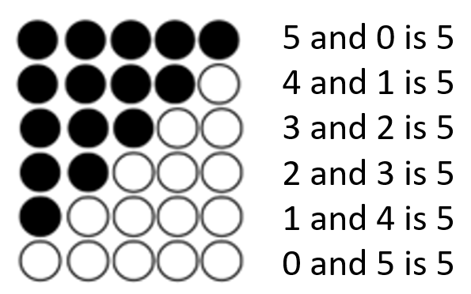
- Quickly recognizing and naming the number of objects in a small group without counting is called subitizing. The size of the group a student can subitize is dependent upon the arrangement. At this age, students should subitize irregular or unfamiliar arrangements up to 5. When there is a familiar or structured pattern (e.g., dots on number cubes, counters on a ten frame) students may be able to subitize larger numbers.
- Numbers can be composed and decomposed using part-whole relationships (e.g., 4 can be decomposed as 3 and 1, 2 and 2, or 4 and 0).
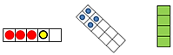
- Dot patterns should be presented in both regular and irregular arrangements. This will help students to understand that numbers are made up of parts and will later assist them in combining parts as well as counting on.
- Benchmarks of 5 and 10 are essential in building place value knowledge through the understanding of decomposition of the numbers of 5 and 10.
- Parts of 5 and 10 should be represented in a variety of ways, such as five frames, ten frames, strings of beads, arrangements of tiles or toothpicks, dot cards, or beaded number frames.

Skills in Practice
While the five process goals are expected to be embedded in each standard, the Skills in Practice highlight the most prevalent process goals in relation to the content presented.

Mathematical Problem Solving: When solving contextual problems, students should have opportunities to act out the problem, which will allow them to visualize the action that is occurring in the problem. The use of concrete manipulatives will help students to act out problems.

Mathematical Communication: When solving contextual problems, students should be encouraged to verbalize what is happening in the problem, which will help them develop their understanding of early operations.

Mathematical Representations: Students may have difficulty organizing objects when acting out a contextual problem. The use of concrete manipulatives on a five-frame, ten-frame, part-part-whole model, or number bond can provide an organizational tool to support students (see examples below).
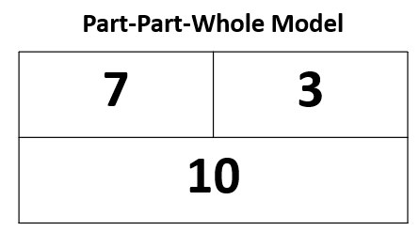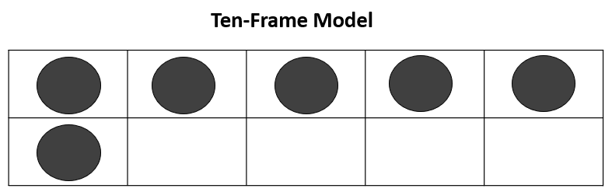

Concepts and Connections
Concepts
The operations of addition and subtraction are used to represent and solve many different types of problems.
Connections: In kindergarten, students begin to model and solve single-step contextual problems using addition and subtraction, become fluent with part-part-whole relationships for numbers up to 5, and begin to compose and decompose numbers up to 10 (K.CE.1). This content connects with the number sense standards, as students use flexible counting strategies up to 100 (K.NS.1), and identify, represent, and compare quantities up to 30 (K.NS.2). In the subsequent grade, Grade 1 students will recall with automaticity addition and subtraction facts within 10 and will solve single-step problems, including those in context, with whole numbers within 20 (1.CE.1).

- Within the grade level/course:
  - K.NS.1 – The student will utilize flexible counting strategies to determine and describe quantities up to 100.
  - K.NS.2 – The student will identify, represent, and compare quantities up to 30.
- Vertical Progression:
  - 1.CE.1 – The student will recall with automaticity addition and subtraction facts within 10 and represent, solve, and justify solutions to single-step problems, including those in context, using addition and subtraction with whole numbers within 20.

Textbooks and HQIM for Consideration
- A list of approved textbooks and instructional materials will be posted on the VDOE website.

Measurement and Geometry
In K-12 mathematics, measurement and geometry allow students to gain understanding of the attributes of shapes as well as develop an understanding of standard units of measurement. Measurement and geometry are imperative as students develop a spatial understanding of the world around them. The standards in the measurement and geometry strand aim to develop students’ special reasoning, visualization, and ability to apply geometric and measurement concepts in real-world situations.

In Kindergarten, students analyze and describe geometric objects, and the relationships and structures among them to classify, quantify, measure, or count one or more attributes. At this grade level, students reason mathematically by making direct comparisons between two objects or events using the attributes of length, height, weight, volume, and time; identify, describe, name, compare, and construct plane figures (circles, triangles, squares, and rectangles); and describe the units of time represented in a calendar.

K.MG.1 The student will reason mathematically by making direct comparisons between two objects or events using the attributes of length, height, weight, volume, and time.

Students will demonstrate the following Knowledge and Skills:
a) Use direct comparisons to compare, describe, and justify the:
i) lengths of two objects using the terms longer or shorter;
ii) heights of two objects using the terms taller or shorter;
iii) weights of two objects using the terms heavier or lighter;
iv) volumes of two containers using the terms more or less; and
v) amount of time spent on two events using the terms longer or shorter.

Understanding the Standard
- Hands-on experiences are needed to gain the ability to compare the attributes of objects.
- The attribute being measured (e.g., length, height, weight, volume) must be identified before the items are compared.
- Length is the distance between two points.
- Height is the distance from the bottom or base of something to the top.
- Weight is a measure of the heaviness of an object.
- Volume is the measure of the capacity of a container and how much it holds.
- Time is the measure of an event from its beginning to its end.
- Conservation of measurement is the understanding that the attributes of an object do not change when the object is manipulated (e.g., a piece of string that is coiled maintains its length as it is straightened; the volume of water does not change when poured from a pitcher into a fish tank).

Skills in Practice
While the five process goals are expected to be embedded in each standard, the Skills in Practice highlight the most prevalent process goals in relation to the content presented.

Mathematical Communication: Some students may understand the vocabulary words long, short, tall, short, heavy, light but may struggle to use them appropriately when making comparisons. These students would benefit from additional opportunities to use these terms when making direct comparisons with items in the classroom and at home.

Mathematical Reasoning: Time is an abstract concept for young children. As such, some students may have difficulty when telling which event will take more time. Providing opportunities throughout the school day to compare the length of time an event takes will be beneficial as students are able to consider the length of time. Some ideas might include asking students: “Will it take more time to do one jumping jack or ten jumping jacks? Which takes less time – walking across the room or walking to the front office?”

Concepts and Connections
Concepts
Analyzing and describing geometric objects in our world, the relationships and structures among them, or the space that they occupy can be used to classify, quantify, measure, or count one or more of their attributes.
Connections: In kindergarten, students begin to explore measurement by determining direct comparisons between objects (K.MG.1). This could be connected to number sense content such as having a tower of six cubes compared to a tower of 15 cubes and determining which tower is taller or shorter (or longer or shorter) (K.NS.2). Direct comparisons can also be used as students are engaging in data collection (K.PS.1) and using a picture graph to determine which categories have more or less or the same. In subsequent grades, students will begin to formalize their understanding of measurement as they measure with nonstandard units (1.MG.1) and standard units (2.MG.1).

- Within the grade level/course:
  - K.NS.2d – Given a set of up to 30 objects, construct another set which has more, fewer, or the same number of objects using concrete or pictorial models.
  - K.NS.2f – Compare two sets containing up to 30 concrete objects or pictorial models, using the terms more, fewer, or the same as (equal to).
  - K.PS.1 – The student will apply the data cycle (pose questions; collect or acquire data; organize and represent data; and analyze data and communicate results) with a focus on object graphs and picture graphs.
- Vertical Progression:
  - 1.MG.1 – The student will reason mathematically using nonstandard units to measure and compare objects by length, weight, and volume.

Across Content Areas [Theme – Modeling]: Modeling in mathematics is crucial as it enables the representation of real-world situations, and allows for making predictions, testing hypotheses, and solving complex problems using mathematical tools and concepts. The term modeling is used in science, mathematics, and computer science but it looks different in the three disciplines which may confuse students. Modeling may be a way to represent numbers, phenomena, natural events, the visualization of data, or behavior. Students use modeling throughout the mathematics standards. Teachers may consider integrating the science and computer science standards indicated below.

- Science:
  - K.1e – The student will demonstrate an understanding of scientific and engineering practices by developing and using models (distinguishing between a model and an actual object).
- Computer Science: Updates will be made after the 2024 Virginia Computer Science Standards of Learning are approved by the Board of Education.

Textbooks and HQIM for Consideration
- A list of approved textbooks and instructional materials will be posted on the VDOE website.

K.MG.2 The student will identify, describe, name, compare, and construct plane figures (circles, triangles, squares, and rectangles).
Students will demonstrate the following Knowledge and Skills:
a) Identify and name concrete and pictorial representations of circles, triangles, squares, and rectangles regardless of their orientation in space.
b) Describe triangles, squares, and rectangles to include the number of sides and number of vertices.
c) Describe a circle using terms such as round and curved.
d) Distinguish between examples and nonexamples of identified plane figures (circles, triangles, squares, and rectangles).
e) Compare and contrast two plane figures using characteristics to describe similarities and differences.
f) Construct plane figures (circles, triangles, squares, and rectangles) using a variety of materials (e.g., straws, sticks, pipe cleaners).

Understanding the Standard
- A plane figure is any closed, two-dimensional shape.
- A vertex is the point at which two or more lines, line segments, or rays meet to form an angle. The term vertices is the plural form of vertex.
- A polygon is a closed plane figure composed of at least three line segments that do not cross. Students at this level do not need to use the term polygon.
- A triangle is a polygon with three sides and three vertices. Experiences with different types of triangles allow students to analyze the characteristics of triangles (e.g., equilateral, isosceles, scalene, right, acute, obtuse); however, at this level, they are not expected to name the various types.
- A quadrilateral is a polygon with four sides and four vertices. Students at this level do not need to use the term quadrilateral.
- A rectangle is a quadrilateral with four right angles.
- A square is a quadrilateral with four congruent (equal length) sides and four right angles. At this level, students might describe a square as a special rectangle with four sides of equal length. Students at this level do not need to use the term congruent.
- A circle is not a polygon because it does not have straight sides.
- An important part of the geometry strand in kindergarten through Grade 2 is the naming and describing of figures. Students move from using their own vocabulary to incorporating conventional terminology as the teacher uses geometric terms.
- Triangles, rectangles, and squares should be presented in a variety of spatial orientations so that students are less likely to develop the common misconception that triangles, rectangles, and squares must have one side parallel to the bottom of the page on which they are printed.
- A common misconception that students develop is referring to a rotated square as a diamond. Ongoing clarification should be provided (i.e., a square is a square regardless of its location in space; there is no plane figure called a diamond).

- Early experiences with comparing, sorting, composing, and subdividing figures or manipulatives (e.g., pattern blocks, attribute blocks) assist students in analyzing the characteristics of plane geometric figures.

Skills in Practice
While the five process goals are expected to be embedded in each standard, the Skills in Practice highlight the most prevalent process goals in relation to the content presented.

Mathematical Reasoning: Students may have difficulty when determining nonexamples of some shapes, particularly squares and rectangles. These students would benefit from additional activities that focus on selecting a shape, describing its characteristics, and comparing it to other shapes with different characteristics. Playing games such as “Guess My Shape” can engage students in describing a shape and reasoning whether it is an example or nonexample of plane figures.

Mathematical Representations: Students may be accustomed to seeing shapes in the same configuration (e.g., an equilateral triangle with one side parallel to the bottom of the paper) and may have difficulty seeing shapes that are in different sizes or positions. Engaging activities such as “Going on a Shape Hunt” or “I Spy” may provide opportunities for students to identify shapes in different representations or orientations.

Concepts and Connections
Concepts
Analyzing and describing geometric objects in our world, the relationships and structures among them, or the space that they occupy can be used to classify, quantify, measure, or count one or more of their attributes.
Connections: Kindergarten students often come to school with prior experiences in identifying shapes. They will begin to formalize their understanding as they identify, describe, name, compare, and construct plane figures (K.MG.2). Students may use plane figures when identifying, describing, extending, and creating simple repeating patterns (K.PFA.1). In future grades, students will continue to formalize their understanding of the characteristics of plane figures as they describe, sort, draw, and name plane figures, and compose larger plane figures (1.MG.2).

- Within the grade level/course:
  - K.PFA.1 – The student will identify, describe, extend, and create simple repeating patterns using various representations.
- Vertical Progression:
  - 1.MG.2 – The student will describe, sort, draw, and name plane figures (circles, triangles, squares, and rectangles) and compose larger plane figures by combining simple plane figures.

Across Content Areas: Reference K.MG.1.

Textbooks and HQIM for Consideration
- A list of approved textbooks and instructional materials will be posted on the VDOE website.

K.MG.3 The student will describe the units of time represented in a calendar.
Students will demonstrate the following Knowledge and Skills:
a) Identify a calendar as a tool used to measure time.
b) Name the days of the week and state that there are seven days in one week.
c) Determine the day before and after a given day (e.g., yesterday, today, tomorrow).
d) Name the twelve months of the year and state that there are twelve months in one year.
e) Distinguish between days of the week and months of the year.

Understanding the Standard
- The calendar is a tool used to represent units of time (e.g., days, weeks, months, years). Using a calendar develops the concept of a day as a 24-hour period rather than a period of time from sunrise to sunset.
- Practical situations are appropriate to develop a sense of the interval of time between events (e.g., club or team meetings occur every week on Monday; there is one week between meetings).

Skills in Practice
While the five process goals are expected to be embedded in each standard, the Skills in Practice highlight the most prevalent process goals in relation to the content presented.

Mathematical Communication: Students may struggle to name the seven days of the week or the 12 months of the year. For example, they may have difficulty with the sequencing and say them out of order or leave out some days (or months) altogether. Daily opportunities to refer to the classroom calendar, including the use of songs and poems, can reinforce the sequence of the days of the week and the months of the year.

Mathematical Connections: Students may have difficulty making connections with calendars. For example, they may confuse the days of the week with the months of the year. Similarly, students who struggle with identifying what day it is, may also have difficulty identifying the day before and the day after. Additional calendar activities, including songs or poems, may benefit students who struggle to make connections within the calendar.

Concepts and Connections
Concepts
Analyzing and describing geometric objects in our world, the relationships and structures among them, or the space that they occupy can be used to classify, quantify, measure, or count one or more of their attributes.
Connections: In kindergarten, students will begin to formalize their understanding of the calendar by naming the days of the weeks and the months of the year, and determining the day before/after a given day (K.MG.3). The repetitious nature of the calendar lends to connections with repeating patterns (K.PFA.1). In first grade, students will continue developing their understanding of the calendar by identifying specific days/dates on a calendar, using ordinal numbers to describe days/dates, and determining the day/date before or after a given day/date (1.MG.3).

- Within the grade level/course:
  - K.PFA.1 – The student will identify, describe, extend, and create simple repeating patterns using various representations.
- Vertical Progression:
  - 1.MG.3g – Identify specific day/dates on a calendar (e.g., What date is Saturday? How many Fridays are in October?).
  - 1.MG.3h – Use ordinal numbers first through tenth to describe the relative position of specific days/dates (e.g., What is the first Monday in October? What day of the week is May 6th?).
  - 1.MG.3i – Determine the day/date before and after a given day/date (e.g., Today is the 8th, so yesterday was the ?), and a date that is specific number of days/weeks in the past or future (e.g., Tim’s birthday is in 10 days, what will be the date of his birthday?).

Across Content Areas: Reference K.MG.1.

Textbooks and HQIM for Consideration
- A list of approved textbooks and instructional materials will be posted on the VDOE website.

Probability and Statistics
In K-12 mathematics, probability and statistics introduce students to the concepts of uncertainty and data analysis. Probability involves understanding the likelihood of events occurring, often using concepts such as experiments, outcomes, and the use of fractions and percentages. The formal study or probability begins in Grade 4. Statistics focuses on collecting, organizing, and interpreting data and includes a basic understanding of graphs and charts. Probability and statistics help students analyze and make sense of real-world data and are fundamental for developing critical thinking skills and making informed decisions using data.

In Kindergarten, students begin to understand that the world can be investigated through posing questions and collecting, representing, analyzing, and interpreting data to describe and predict events and real-world phenomena. At this grade level, students will apply the data cycle (pose questions; collect or acquire data; organize and represent data; and analyze data and communicate results) with a focus on object graphs and picture graphs.

K.PS.1 The student will apply the data cycle (pose questions; collect or acquire data; organize and represent data; and analyze data and
communicate results) with a focus on object graphs and picture graphs.
Students will demonstrate the following Knowledge and Skills:
a) Sort and classify concrete objects into appropriate subsets (categories) based on one attribute (e.g., size, shape, color, thickness).
b) Describe and label attributes (e.g., size, color, shape) of a set of objects (e.g., coins, counters, buttons) that has been sorted.
c) Pose questions, given a predetermined context, that require the collection of data (limited to 25 or fewer data points for no more than four categories).
d) Determine the data needed to answer a posed question, and collect the data using various methods (e.g., counting objects, drawing pictures).
e) Organize and represent a data set (vertically or horizontally) by sorting concrete objects into organized groups to form a simple object graph.
f) Organize and represent a data set (vertically or horizontally) using pictures to form a simple picture graph.
g) Analyze data represented in object graphs and picture graphs and communicate results:
i) ask and answer questions about the data represented in object graphs and picture graphs (e.g., how many in each category, which categories have the greatest, least, or the same amount of data); and
ii) draw conclusions about the data and make predictions based on the data.

Understanding the Standard
- Students should explore the entire data cycle with a question and set of data that has been collected or acquired. Student reflection should occur throughout the data cycle. The data cycle includes the following steps: formulating questions to be explored with data, collecting or acquiring data, organizing and representing data, and analyzing and communicating results.
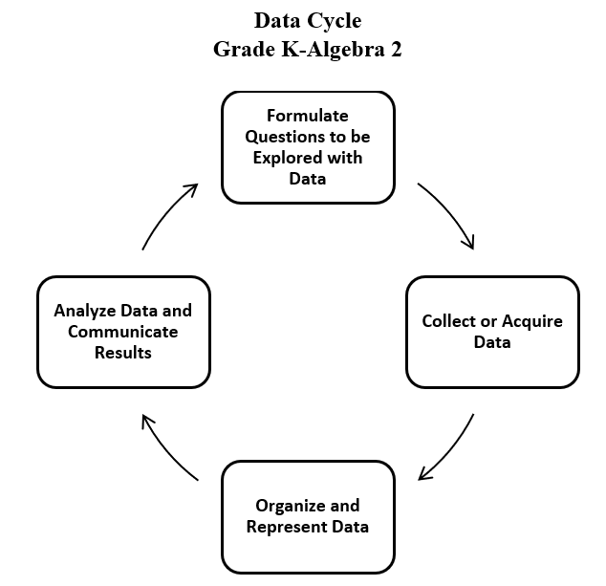
- Exploration of the entire data cycle with a question and set of data that has been collected or acquired should occur throughout the school year. Reflection should occur throughout the data cycle.
- To sort is to compare a set of objects in order to find similarities and differences, so that they may be arranged into organized groups.
- To classify is to arrange or organize a set of objects according to a category or attribute (a quality or characteristic).
- At the kindergarten level, using one attribute such as color, size, shape, or thickness is used to sort and classify.
- Items to be sorted may include:
  - Coins (pennies, nickels, dimes, quarters) - Although formal instruction on coin values and equivalencies will begin in Grade 1, kindergarten students are expected to sort and name coins.
  - Shapes - Attribute blocks and pattern blocks are among the manipulatives that are particularly appropriate for sorting and comparing size and shape; and
  - Real-world objects
- General similarities and differences among objects are easily observed by children entering kindergarten, who can focus on any single attribute. The teacher’s task is to move students toward a more sophisticated understanding of classification in which two or more attributes connect or differentiate sets, such as those found in nature (e.g., leaves having both different colors and different figures). The teacher can provide data sets to students in addition to students engaging in their own data collection.
- Data are pieces of information collected about people or things. The primary purpose of collecting data is to answer questions. The primary purpose of interpreting data is to inform decisions (e.g., which type of clothing to pack for a vacation based on a weather graph or which type of lunch to serve based upon class favorites).
- Methods for organizing data could include five frames or ten frames, tallying, or various methods of grouping concrete materials. Tallying is a method of gathering information. At the kindergarten level, students may use circles or X’s to tally the number of responses, where each symbol represents one occurrence. Tally marks, which are clustered into groups of five, with four vertical marks representing the first four occurrences and the fifth mark crossing the first four on a diagonal to represent the fifth occurrence, are recommended to be used in Grade 1 as students focus on counting by 5s.
- At this level, data gathered and displayed by students should be limited to 25 or fewer data points for no more than four categories.
- In the process of collecting data, students make decisions about what is relevant to their investigation (e.g., when collecting data on their classmates’ favorite pets, making the decision to limit the categories to common pets).
- When students begin to collect data, they recognize the need to categorize, which helps develop the understanding of “things that go together.” Categorical data are used when constructing object graphs, picture graphs, pictographs, and bar graphs.
- Different types of representations emphasize different things about the same data. Object graphs and picture graphs are the focus in kindergarten.
- Object graphs are graphs that use concrete materials to represent the categorical data that are collected (e.g., cubes stacked by the month, with one cube representing the birthday month of each student). An object graph includes a title and labeled categories. Each concrete object should represent one data point. Object graphs can be used to make comparisons between categories.
- Picture graphs are graphs that use pictures to represent and compare information. A picture graph includes a title and labeled categories. At this level, each picture should represent one data point. Picture graphs can be used to make comparisons between categories.
- Students represent data to convey results of their investigations, using concrete objects, pictures, and numbers to provide a “picture” of the organized data.
- Opportunities to interpret graphs, created with the assistance of the teacher, that contain data points where the entire class is represented (e.g., tables that show who brought their lunch and who will buy their lunch for any given day; a picture graph showing how students traveled to school – bus, car, walk) are needed and should continue throughout the school year. Teachers may generate clip art or icons for students to use for picture graphs.
- When making predictions and drawing conclusions about the data, teachers should pose questions such as, “What might happen? What will happen? What will not happen?”
- When data are presented in an organized manner, students can interpret and discuss the results and implications of their investigation (e.g., identifying parts of the data that have special characteristics, including categories with the greatest, the least, or the same number of responses).
- The data cycle can be used to make connections between mathematics and other disciplines including English, social studies, and science.
  - Sample Connections to English Standards of Learning
    - Who is your favorite author?
    - What is your favorite story that was read in class?
  - Sample Connections to History and Social Science Standards of Learning
    - Which is your favorite work of art in our school?
    - Who is your favorite community helper?
    - Which toy would be your favorite to buy?
    - What is your favorite type of transportation?
  - Sample Connections to Science Standards of Learning
    - What is your favorite sense?
    - Sort and classify water as a liquid or solid.
    - Sort and classify objects as living or non-living.
    - Graph daily weather conditions.

Skills in Practice
While the five process goals are expected to be embedded in each standard, the Skills in Practice highlight the most prevalent process goals in relation to the content presented.

Mathematical Problem Solving: As kindergarten students begin to engage in the data cycle, they will likely struggle to pose questions that require the collection of data. Teacher support will be necessary to help students distinguish between questions that require data to answer and questions that do not require data to answer. For example, “Do we have art class today?” is a question that does not require data to answer; the answer is simply yes or no. Questions that require the collection of data could include anything that involves surveying other students, measuring, or counting and quantifying amounts (see examples below).
- Question that requires surveying: What is your favorite activity to do during recess?
- Question that requires measuring: How much rain did we get each day this month?
- Question that requires counting and quantifying: How was the weather this month (sunny, rainy, cloudy)?

Mathematical Communication: When sorting a set of objects that includes differing characteristics (various shapes, sizes, colors, etc.), students may have difficulty when trying to identify similarities or differences among objects. These students would benefit from working with smaller sets that include only one differing characteristic (e.g., all objects are the same size and shape, and only vary by color). If students struggle to identify the similarities and differences of objects, they will benefit from opportunities to choose an object and describe its characteristics. Engaging activities such as “Guess My Shape” or “I Spy” can be used as opportunities for students to identify a shape or object based on its characteristics.

Concepts and Connections
Concepts
Investigating the world through posing questions, collecting data, organizing and representing data, and analyzing data and communicating results can be used to describe and predict events and real-world phenomena.
Connections: Kindergarten students are excited and curious about the world around them. They will learn to pose questions (with teacher support) that require the collection of data, and to represent that data using object and picture graphs (K.PS.1). Answering questions about data connects with modeling and solving single-step contextual problems (K.CE.1f). Students will also sort sets of objects based on a single attribute such as color, shape, or size. In first grade, students will continue to deepen their understanding of the data cycle and will sort objects in categories based on one or two attributes (1.PS.1).

- Within the grade level/course:
  - K.CE.1f – Model and solve single-step contextual problems (join, separate, and part-part-whole) using 10 or fewer concrete objects.
- Vertical Progression:
  - 1.PS.1 – The student will apply the data cycle (pose questions; collect or acquire data; organize and represent data; and analyze data and communicate results) with a focus on object graphs, picture graphs, and tables.

Across Content Areas [Theme – Using Data]: The data cycle is used in mathematics when collecting, organizing, analyzing, and interpreting data. The data cycle in mathematics closely aligns with the Scientific and Engineering Practices in science. Teachers should consider applying the data cycle as they ask questions about the natural world in science. Students also may use tools such as computing devices to collect and visualize the data generated by experimentation. Teachers may consider applying the data cycle when students engage with the science and computer science standards indicated below.

- Science:
  - K.2a-c – The student will determine if a design solution works as intended to change the speed or direction of an object with a push or pull.
  - K.2c – The student will plan and conduct an investigation to compare the effects of different strengths or directions of pushes and pulls on the motion of an object.
  - K.3a-d – The student will compare objects based on a single physical property, including colors, shapes and forms, textures and feel, and relative sizes and weights.
  - K.6a – The student will classify objects as living or nonliving.
  - K.9a – The student will chart and graph daily weather conditions throughout the year to determine seasonal patterns.
- Computer Science: Updates will be made after the 2024 Virginia Computer Science Standards of Learning are approved by the Board of Education.

Across Content Areas [Theme – Graphing]: Graphing is crucial in mathematics, science, and computer science as it helps students visualize patterns and relationships and supports students as they work to understand data. It also helps with the identification of trends so that predictions can be made. Students use data to model real-world scenarios and are fundamental to the development and understanding of algorithms and data structures. Graphing enhances the comprehension of data and promotes critical thinking and problem solving across the disciplines.

- Science: Depending on the data collected in an investigation, students may use graphs to visualize the data.
  - K.1c – The student will organize and represent data, and read and interpret data in object graphs, picture graphs, and tables.
  - K.9a – The student will chart and graph daily weather conditions throughout the year to determine seasonal patterns.
- Computer Science: Updates will be made after the 2024 Virginia Computer Science Standards of Learning are approved by the Board of Education.

Textbooks and HQIM for Consideration
- A list of approved textbooks and instructional materials will be posted on the VDOE website.

Patterns, Functions, and Algebra
In K-12 mathematics, the patterns, functions, and algebra strand focuses on the recognition, description, and analysis of patterns, functions, and algebraic concepts. Students develop an understanding of mathematical relationships and represent these using symbols, tables, graphs, and rules. In later grades, students use models as they solve equations and inequalities and develop an understanding of functions. This strand is designed to develop students’ algebraic thinking and problem-solving skills, laying the foundation for more advanced mathematical concepts.

In Kindergarten, students begin to notice that relationships can be described and generalizations can be made using patterns and relations. At this grade level, students will identify, describe, extend, and create simple repeating patterns using various representations.

K.PFA.1 The student will identify, describe, extend, and create simple repeating patterns using various representations.
Students will demonstrate the following Knowledge and Skills:
a) Identify and describe the core found in repeating patterns.
b) Extend a repeating pattern by adding at least two complete repetitions of the core to the pattern.
c) Create and describe a repeating pattern using objects, colors, sounds, movements, or pictures.

Understanding the Standard
- Patterning is a fundamental cornerstone of mathematics, particularly algebra. The process of generalization leads to the foundation of algebraic reasoning.
- Opportunities to describe, extend, and create repeating patterns are essential to the primary school experience and lay the foundation for algebraic thinking.
- Concrete objects for patterning can include connecting cubes, color tiles, pattern blocks, counters, buttons, etc.
- Concrete materials and pictorial representations (e.g., picture cards) allow students to explore the idea of patterning and make revisions when needed. Extending a pattern on paper limits a student’s ability to repeat the pattern beyond the length of the paper.
- Patterning includes:
  - creating a given pattern, using objects, sounds, movements, and pictures;
  - describing a pattern includes identifying the core of the pattern and labeling the pattern;
  - recording a pattern with pictures or symbols;
  - analyzing patterns in practical situations (e.g., calendar, seasons, days of the week).
- The part of the pattern that repeats is called the core.
- At this level, extending patterns when given a complete repetition of a core (e.g., ABCABCABC) as well as when the final repetition of the core is incomplete (e.g., ABCABCAB... or Red, Blue, Green, Red, Blue, Green, Red, Blue…) is appropriate.
- Examples of repeating patterns include:
  - ABABABAB;
  - ABCABC;
  - ABBAABBA;
  - AABBAABBAABB; and
  - AABAAB.
- Students may begin to discover patterns and relationships within numbers (e.g., part-whole combinations, on the hundreds chart, number path).

Skills in Practice
While the five process goals are expected to be embedded in each standard, the Skills in Practice highlight the most prevalent process goals in relation to the content presented.

Mathematical Communication: Students may struggle to remember what the “core” means and may need to be reminded that the core is the part of the sequence that repeats. If students are unable to identify the core, they will need additional experiences identifying patterns and describing what stays the same in a repeating pattern. See the example below that includes a circle around the four-element core (smiley face, heart, heart, lightning bolt).
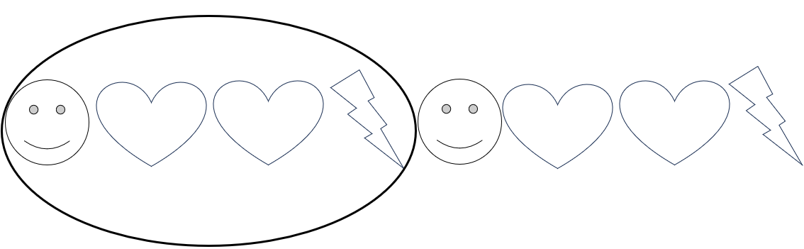

Mathematical Representations: Students may have difficulty creating their own repeating pattern and may place a few shapes that do not build a pattern. These students would benefit from additional experiences to build repeating patterns, starting with simple patterns (e.g., red-blue-red-blue; AABAAB). Students would also benefit from opportunities to notice repeating patterns in their classroom or home and to participate in discussions that focus on what stays the same and what changes in a pattern.

Concepts and Connections
Concepts
Relationships are described and generalizations are made using patterns, relations, and functions.

Connections: Patterns are everywhere in the world around us. In kindergarten, students begin to formalize their understanding of repeating patterns by identifying, describing, extending, and creating simple repeating patterns (K.PFA.1). Students will begin to see patterns in other areas of mathematics including number sense (e.g., counting forwards and backwards - K.NS.1) and geometry (identifying shapes - K.MG.2). In the subsequent grade, Grade 1 students will deepen their understanding of patterns as they identify, describe, extend, create, and transfer repeating and increasing patterns (1.PFA.1).

- Within the grade level/course:
  - K.NS.1 – The student will utilize flexible counting strategies to determine and describe quantities up to 100.
  - K.MG.2 – The student will identify, describe, name, compare, and construct plane figures (circles, triangles, squares, and rectangles).
- Vertical Progression:
  - 1.PFA.1 – The student will identify, describe, extend, create, and transfer repeating patterns and increasing patterns using various representations.

Across Content Areas [Theme – Numbers, Number Sense, and Patterns]: Number sense includes an understanding of patterns and the relationships between numbers and being able to apply this knowledge to real-world problems. Throughout K-12, students build on their number sense to develop a deeper understanding of mathematical concepts and reasoning. Teachers may consider using the standards below as students develop their number sense. Describing, extending, creating, and transferring repeating and increasing patterns is a skill that spans multiple disciplines. Patterns are also evident in the science and computer science standards as students explore phenomena in science and develop programs in computer science. Teachers may consider using the standards below as students develop number sense when engaged in instructional activities that focus on patterns.
- Science:
  - K.8 – The student will demonstrate how shadows change as the direction of the light source changes.
  - K.9a-c – The student will investigate and understand that there are patterns in nature. Key patterns include daily weather, seasonal changes, and day and night.
  - K.10a – The student will describe things human-made things and things in nature that change over time.
  - K.10b,c – The student will describe living and nonliving things that change over time; identify some changes that people experience over time; and use observations to describe the change of an object or living thing over time.
  - K.10d – The student will classify examples as fast changes or slow changes.
- Computer Science: Updates will be made after the 2024 Virginia Computer Science Standards of Learning are approved by the Board of Education.

Textbooks and HQIM for Consideration
- A list of approved textbooks and instructional materials will be posted on the VDOE website.

