Attachment A

SCNP Memo No. 2023-2024-76

April 25, 2024

2024 Summer Manager Workshops Registration Instructions
- Click the Online Registration Form link.
- Read the instructions in their entirety. Type in your email address. Ensure that the address is entered correctly. Click Next.
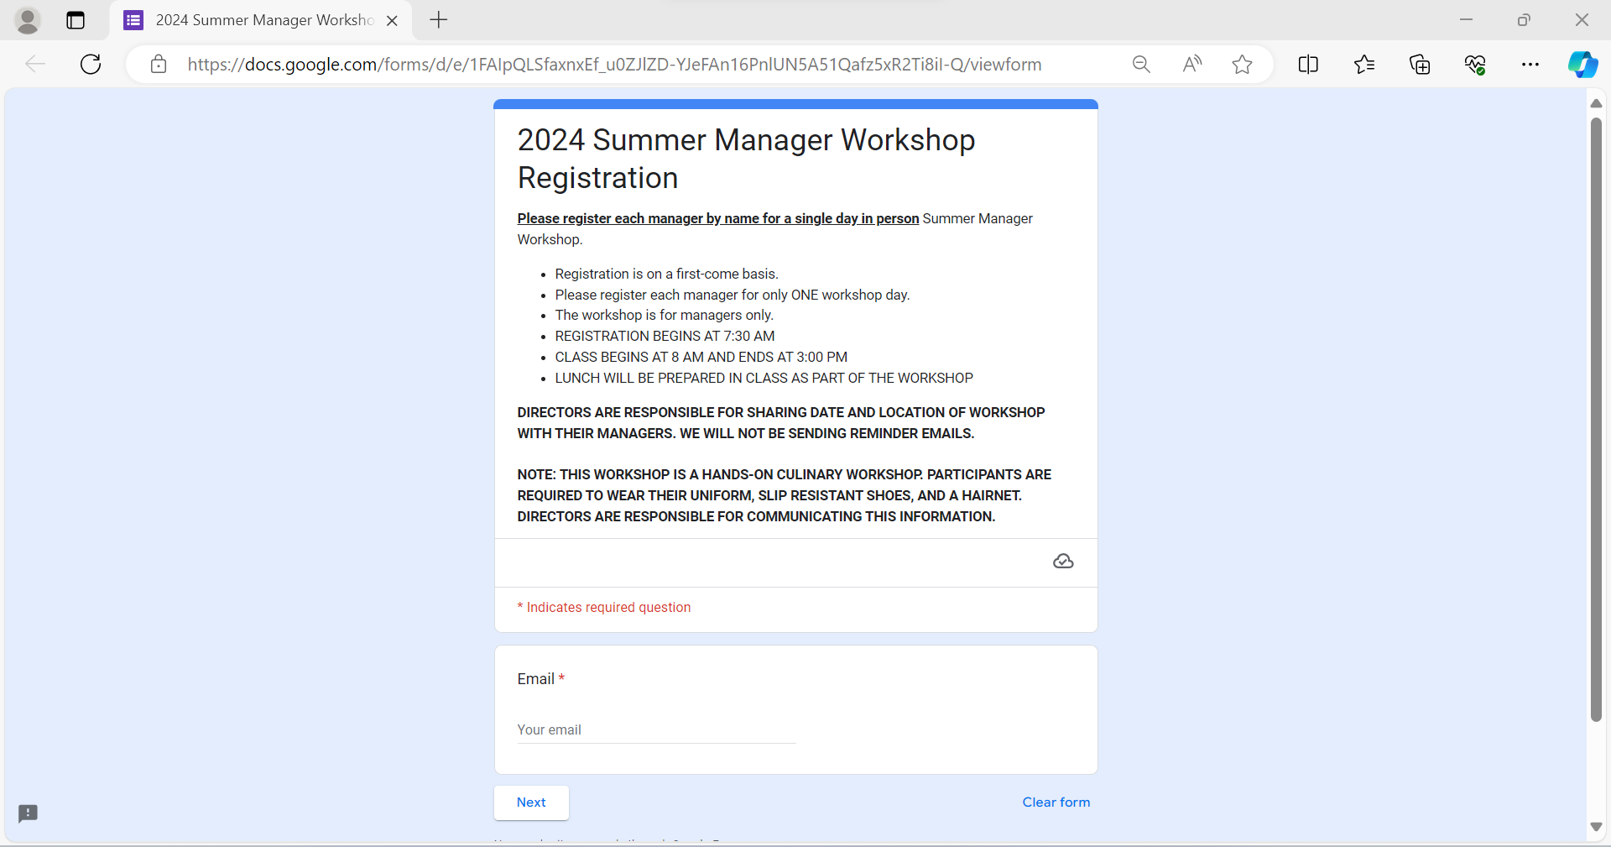
- Complete the required information and scroll down. Click Next.
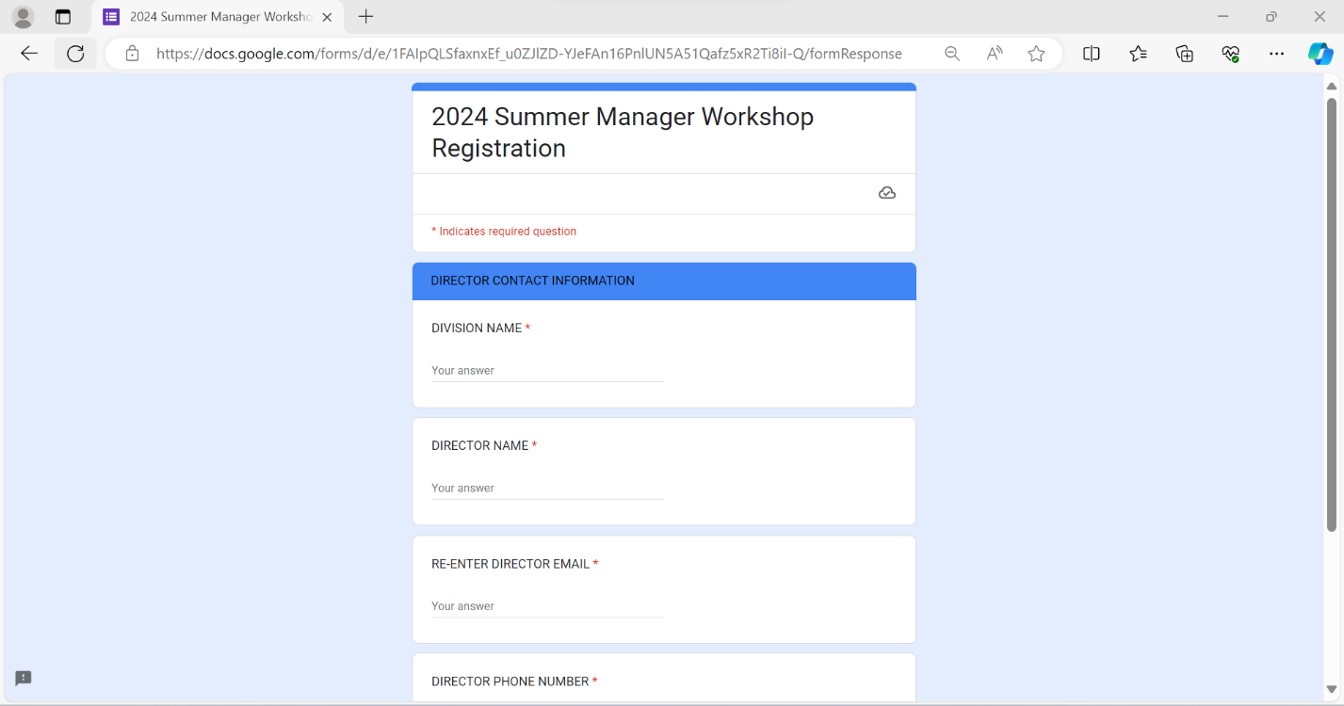

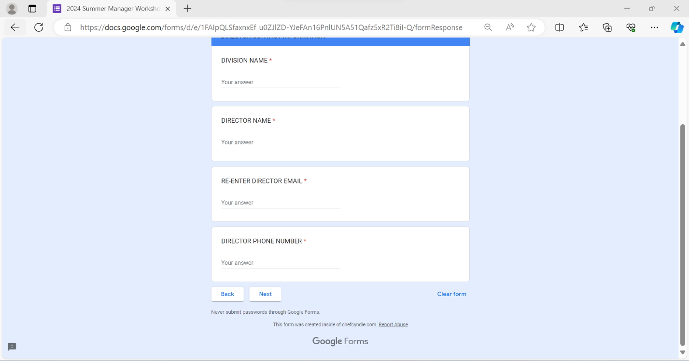
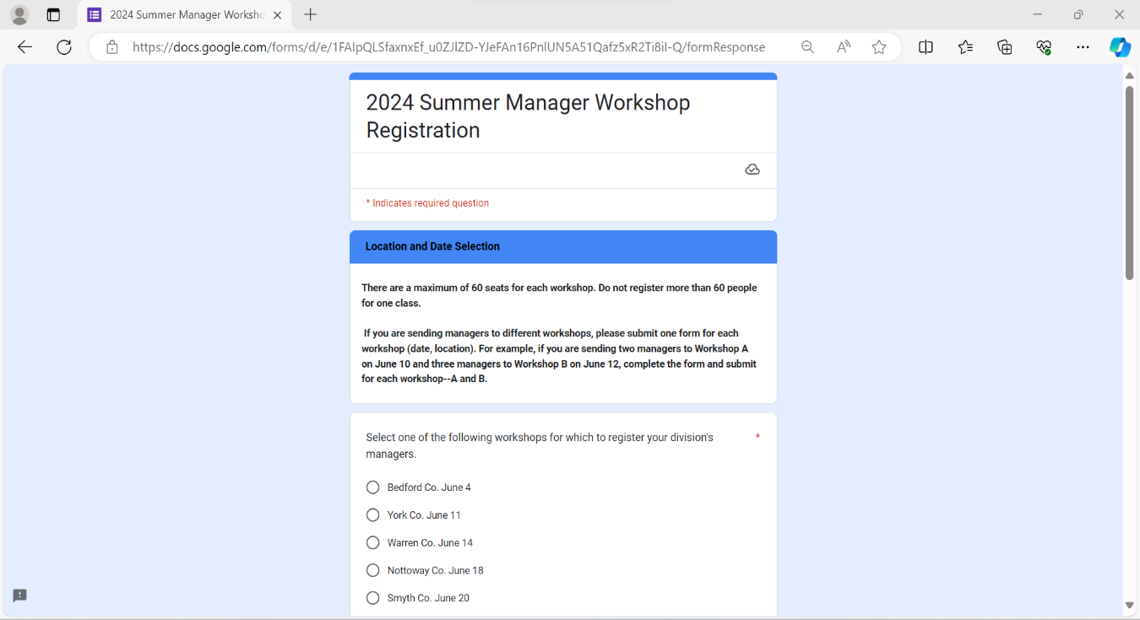
- Read the instructions in their entirety. Select your desired workshop, click Next.
- Please note that if you have some cafeteria managers who are interested in attending a different workshop, you will need to complete this form again for that workshop.
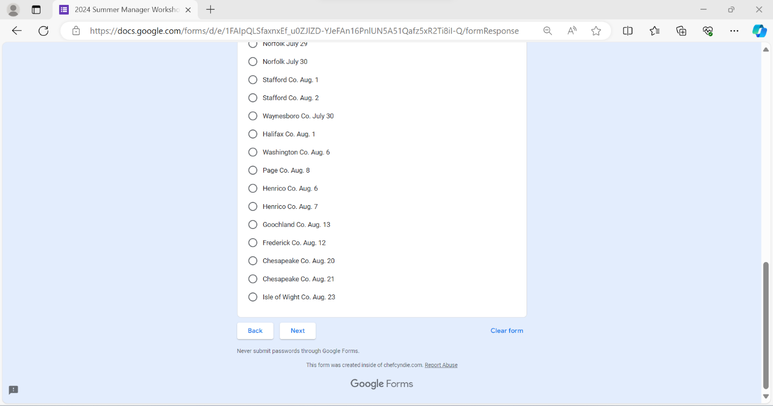

- Save the date and address of the workshop you selected. Complete the first prompt with the number of cafeteria managers attending. Then, enter each cafeteria manager’s first and last name individually. Click Next, pressing the Enter key after each name. Note that there are a maximum of 60 seats for each workshop. Please do not register more than 60 cafeteria managers for one workshop. Once you have entered all the names of cafeteria managers interested in attending this workshop date and location, scroll down and click Next.

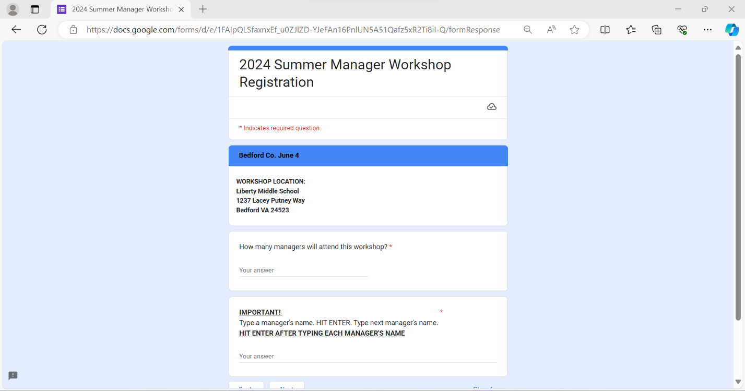

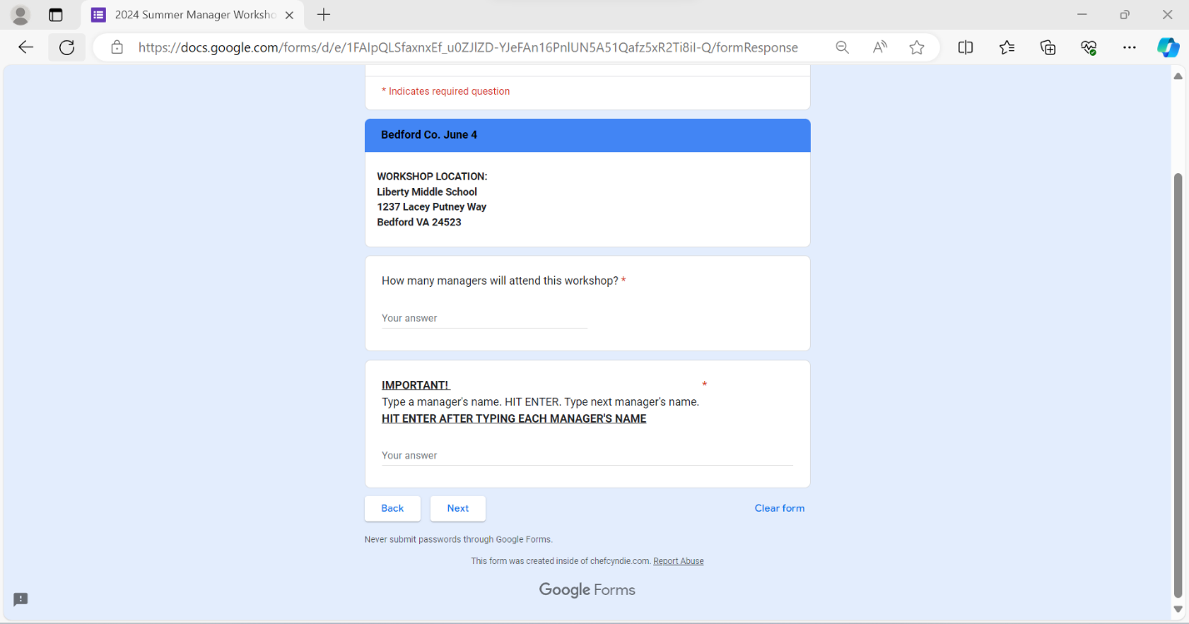

- Read and click to acknowledge your registration. Click Next. Please remember to share this information with your cafeteria managers. If you have some cafeteria managers who will be attending different workshops, a new form will need to be completed for each workshop. Each cafeteria manager should only be registered for one workshop.

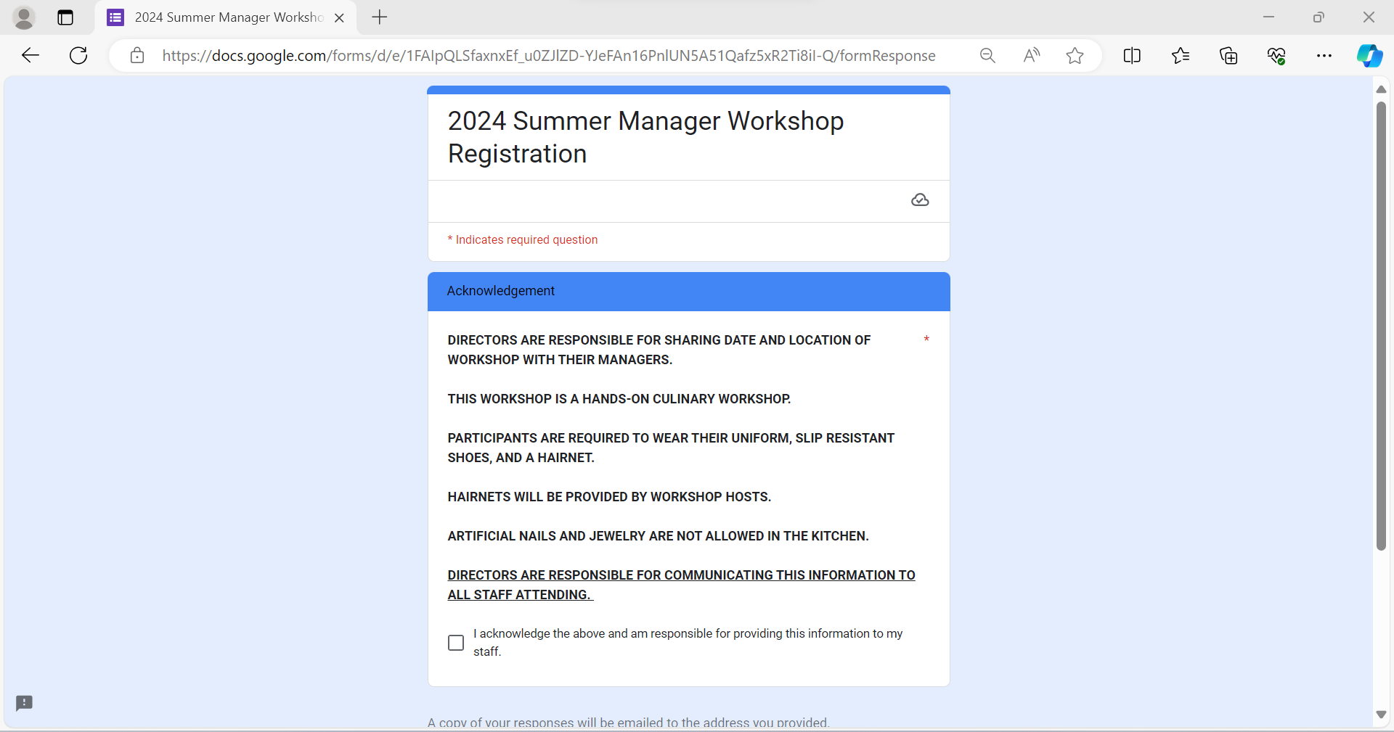

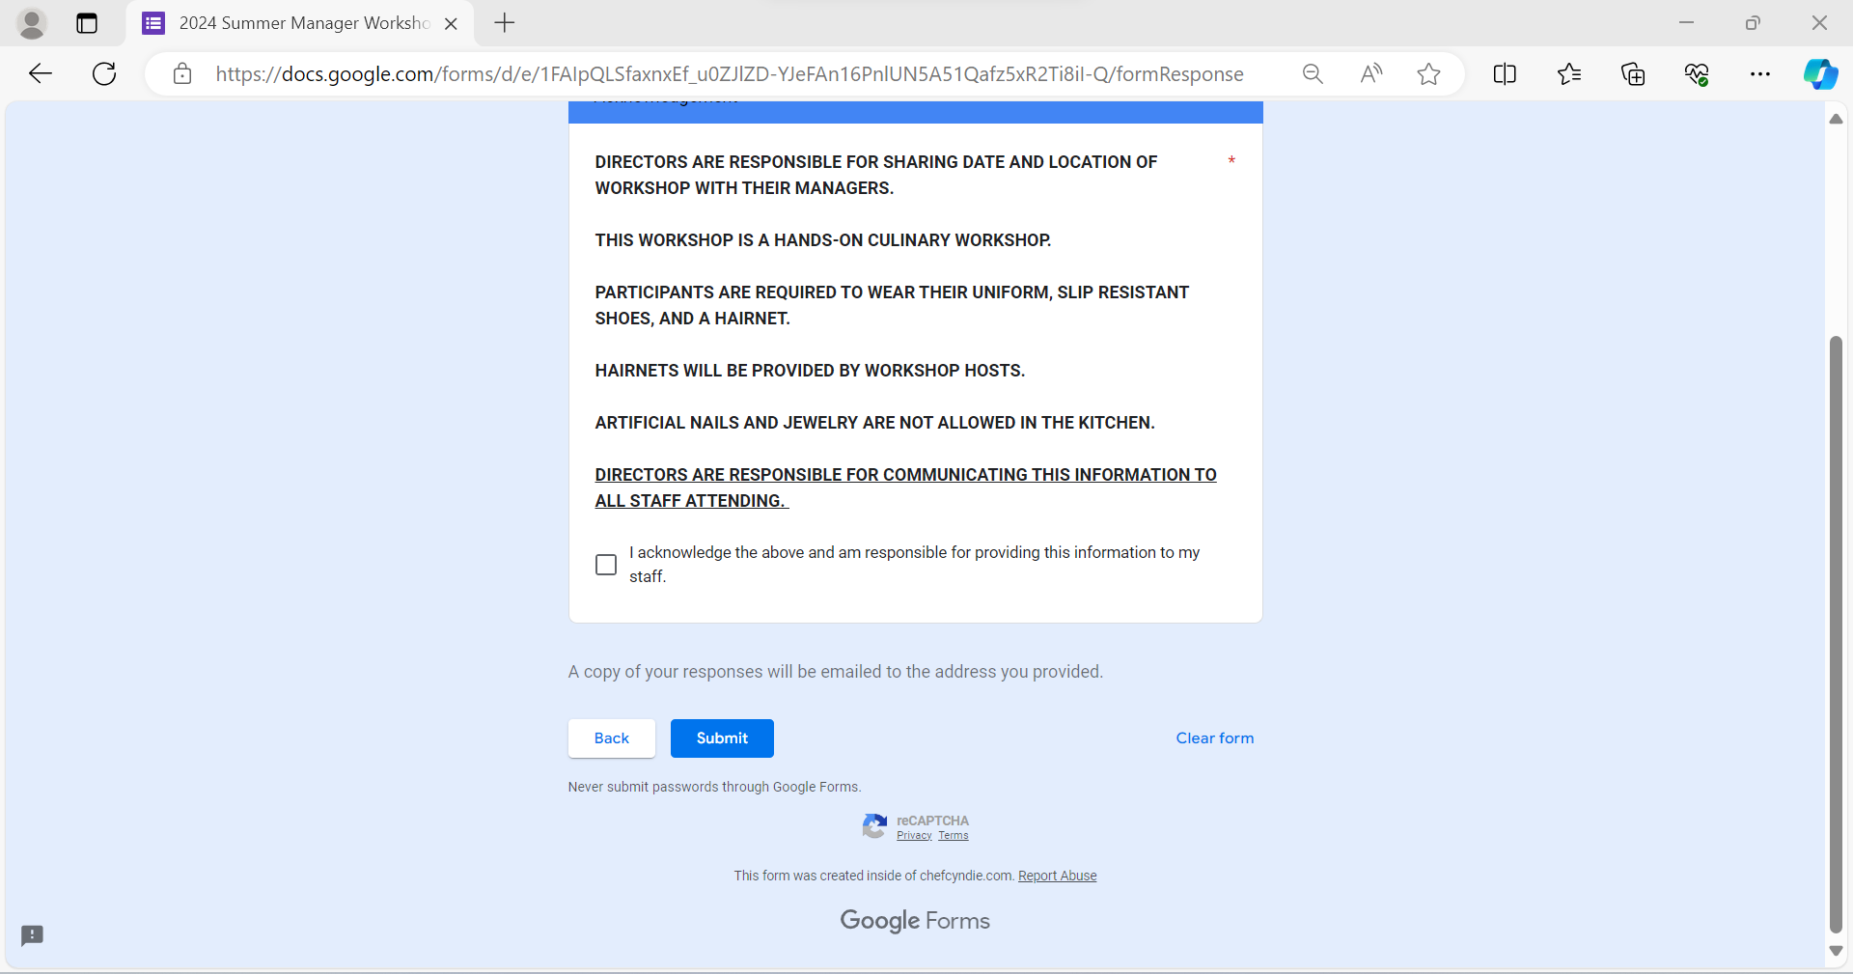

Should you have any questions, please email INFO@chefcyndie.com.

