Attachment A
SCNP Memo No. 2023-2024-75
May 2, 2024

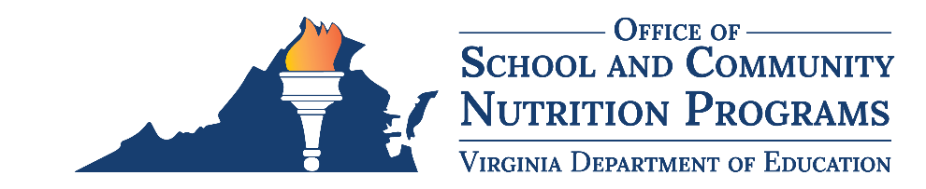

Virginia Farm to School Network

Regional Co-Lead Scope of Work

Background
The Virginia Department of Education, Office of School and Community Nutrition Programs (VDOE-SCNP) maintains the Virginia Farm to School Network in partnership with Virginia Cooperative Extension (VCE), to elevate the health and wellbeing of Virginia’s students by increasing access to local food and food literacy opportunities. The Network creates and strengthens markets for food grown and/or raised in Virginia within schools, preschools, and summer feeding programs. Farm to school activities include local food procurement within school and community nutrition programs, school gardens, and nutrition and/or agriculture education. The Virginia Farm to School Network consists of eight Regional Networks based on the VDOE Superintendent's Regions.

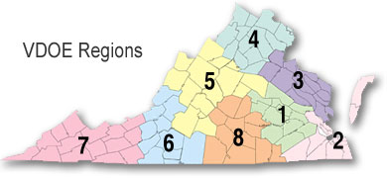
There will be two Regional Co-Leads per region. One Co-Lead will be a school nutrition professional from public school food authority, and one will be a representative of VCE. These two Co-Leads will collaborate on planning and facilitating regional activities and serve as the main points of contact for their Regional Network. Each Regional Network has region-specific goals and objectives, derived from the Virginia Farm to School Strategic Plan (2021-2026). Meetings and events will vary based on the Region and may include activities such as farm tours, hosting guest speakers, or stakeholder updates for networking.

Scope of Work
The school nutrition Regional Co-Lead, in collaboration with their partner Regional Co-Lead from VCE, will be expected to fulfill the following responsibilities on an annual basis:
- Serve as point of contact for the Regional Network and promote activities among regional farm to school stakeholders.
- Schedule, plan, attend, and facilitate four (4) Farm to School Regional Network meetings.
  - Annual meeting requirements:
    - At least one (1) meeting per region should be an in-person gathering designed for networking, learning, and collaboration.
    - The other three (3) meetings can occur virtually. The VDOE-SCNP will provide the virtual meeting links.
  - Regional Co-Leads are encouraged to determine meeting dates in advance. The Regional Co-Lead will send upcoming meeting details to the VDOE-SCNP Farm to School Specialist in the quarterly reports.
  - The Regional Co-Lead will send the meeting agenda, using the template provided by the VDOE-SCNP, to the VDOE-SCNP Farm to School Specialist within one (1) week prior to the event date.
  - Promote Regional Network meetings. A minimum of one promotional activity per meeting is required (total of four per year). These could include emails, social media posts, etc.
- Attend two (2) annual virtual gatherings with all Regional Co-Leads for peer-to-peer learning and discussion. These will be scheduled by the VDOE-SCNP.
- Attend two (2) virtual meetings with state-level Virginia Farm to School Leadership Team members. These meetings will be scheduled by the VDOE-SCNP.
- Collaborate with the VDOE-SCNP and/or VCE on Virginia farm to school initiatives as time allows, such as serving on the Virginia Farm to School Conference Planning Team or providing guidance and support in the development of Virginia farm to school resources.
- Represent the region and Network at statewide convenings such as the Virginia Farm to School Conference.
- Submit four (4) quarterly reports to the VDOE-SCNP Farm to School Specialist, due on March 10, June 10, August 10, and December 10. Reports must contain:
  - List of upcoming meetings and corresponding details, including date, time, location, topics of discussion, and any other important agenda items.
  - Summary of past events, including meeting minutes, list of attendees, and how the meetings were promoted.
  - Summary of the progress toward the items listed within this Scope of Work.
  - Contact details for any new Network members.
- Submit one (1) final summary, if applicable, to the VDOE-SCNP Farm to School Specialist, due on September 15, 2026. A final summary is only necessary/required if there are relevant updates that occurred after the final quarterly report submission on August 10, 2026, and should align with the formatting of the quarterly reports.
- Participate in an annual check-in with the VDOE-SCNP Farm to School Specialist to review deliverables and provide an opportunity for Regional Co-Leads to discuss progress, challenges, and how to make improvements for the next year.

Deliverables
- Four (4) quarterly reports.
- One (1) final summary, if applicable.
- Four (4) meeting agendas.
- Attendance at four (4) Farm to School Regional Network meetings.
- Attendance at two (2) annual virtual gatherings with all Regional Co-Leads.
- Attendance at two (2) virtual Virginia Farm to School Leadership Team meetings.
- Attendance at biannual VDOE-SCNP Virginia Farm to School Conference.
- Attendance at annual check-in with VDOE-SCNP Farm to School Specialist.

Timeline
Regional Co-Leads will hold this position until September 30, 2026.

Stipend
Regional Co-Leads will receive an annual stipend of $2,500 to support the time, effort, and travel involved in carrying out this work.

Application Process
To apply to be a Regional Co-Lead, please complete online application form by Friday, May 24, 2024. The VDOE-SCNP will announce selected candidates by early summer 2024.

