SCNP Memo No. 2023-2024-66

Attachment A

March 28, 2024

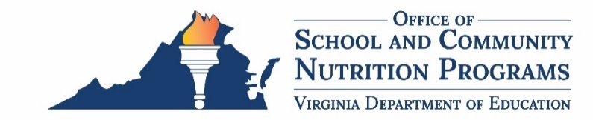

2024 Spring Regional Meeting Agenda
Date: Tuesday, April 23, 2024
Time: 9:00 a.m–3:50 p.m.
Location: Zoom
Time | Topic | Presenters
9:00–9:05 a.m. | Welcome and Housekeeping  (5 minutes) | Sandy Curwood,  Callie Nickles
9:05–9:15 a.m. | Warm Up/Engagement Exercise and Staff Intros (10 minutes) | Callie Nickles,  Kelly Shomo
9:15–9:45 a.m. | Calibrating in School and Community Nutrition Programs (30 minutes) | Sandy Curwood
9:45–10:00 a.m. | Break
10:00–11:00 a.m. | Legislative and Regulation Updates (30-60 minutes) | Courtney Jones, Andrea Nannery
11:00–11:15 a.m. | CEP (15 minutes) | Lynne Fellin
11:15 a.m.–12:15 p.m. | Procurement (45-60 minutes) | Tom Patrick
12:15–1:00 p.m. | Lunch (45 minutes)
1:00–1:10 p.m. | Trivia/Engagement Exercise  (10 minutes) | Callie Nickles,  Kelly Shomo
1:10–1:40 p.m. | Summer Meals/Summer EBT  (30 minutes) | Jon Tirk,  Lynne Fellin
1:40–2:25 p.m. | Summer Meal Counter Training  (45 minutes) | Jon Tirk,  Sivagami Solayappan
2:25–2:45 p.m. | Resources Overview (20 minutes) | Callie Nickles
2:45–3:05 p.m. | Advisory Council Updates  (20 minutes) | SNP/CNP Advisory Council Members
3:05–3:50 p.m. | Hot Topics (30-45 minutes) | Kelly Shomo, Content Area Experts
*Note: This agenda is subject to change.

