Follow the steps below to download the Title I, Part A application:
1. Click the link on the webpage.
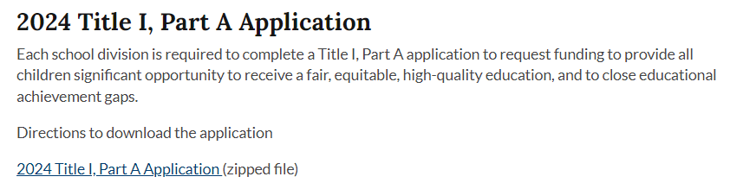

2. The application folder will save into your Downloads folder.
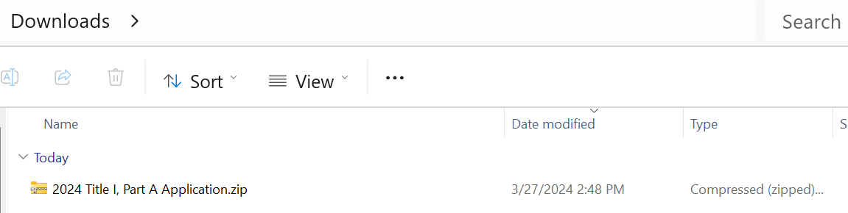

3. Go to the Downloads folder and right-click on the Title I, Part A folder and select "Extract All."
4. A dialog box will open. You can browse and decide where to save the file.
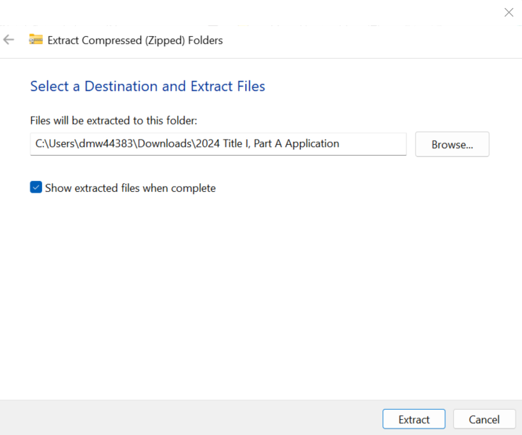
5. Click Extract and open the Title I, Part A folder.
