2023 Mathematics Standards of Learning
Understanding the Standards – Mathematical Analysis
Students enrolled in Mathematical Analysis are assumed to have mastered Algebra 1, Geometry, and Algebra 2 concepts. Mathematical Analysis develops students’ understanding of algebraic and transcendental functions, parametric and polar equations, sequences and series, and vectors. The content of this course serves as appropriate preparation for a calculus course.

Technology tools will be used to assist in teaching and learning. Graphing technologies facilitate visualizing, analyzing, and understanding algebraic and statistical behaviors and provide a powerful tool for solving and verifying solutions.

Characteristics of Functions
MA.CF.1 The student will identify and analyze the properties of polynomial, rational, piecewise-defined, absolute value, radical, and step functions and sketch the graphs of the functions.
Students will demonstrate the following Knowledge and Skills:
- Use mathematical reasoning to identify polynomial, rational, piecewise-defined, absolute value, radical, and step functions, given an equation or graph.
- Given multiple representations of a polynomial, rational, piecewise-defined, absolute value, radical, and step function, analyze:
  - domain and range;
  - roots (including complex roots);
  - intercepts;
  - symmetry (including even and odd functions);
  - asymptotes (horizontal, vertical, and oblique/slant);
  - points of discontinuity;
  - intervals for which the function is increasing, decreasing or constant;
  - end behavior; and
  - relative and/or absolute maximum and minimum points.
- Sketch the graph of a polynomial, rational, piecewise-defined, absolute value, radical, and step function.

MA.CF.1 The student will identify and analyze the properties of polynomial, rational, piecewise-defined, absolute value, radical, and step functions and sketch the graphs of the functions.

Additional Content Background and Instructional Guidance:
- A graph is one of several representations of a function. The analysis of a function includes characterizing various properties.
- A variety of notations may be used to represent functions and the characteristics of functions, including set notation and interval notation.
- Concepts and skills related to end behavior, domain, range, zeros, and intercepts should be reintroduced and applied to polynomial, rational, piecewise-defined, absolute value, radical, and step functions.
- Function continuity and discontinuity should be discussed when examining increasing, decreasing, or constant intervals; points; and horizontal, slant (oblique), or vertical asymptotes.
- The Fundamental Theorem of Algebra explains many aspects of polynomial functions to include degree, roots, and their corresponding factors.
- Determining the equation of the slant asymptote of a function involves dividing polynomial functions. The use of factoring, long division of polynomial functions, synthetic division of polynomial functions, and the rational root theorem may be utilized.
- Sketching a graph involves an understanding of the parent function and transformations. Sketching a graph differs from creating a more precise graph of a function, as it typically does not involve plotting points.
- Critical points (turning points) of a function are places where the rate of change is altered.
- A graphing utility should be used to verify characteristics of functions.

MA.CF.2 The student will determine the limit of a function if it exists.
Students will demonstrate the following Knowledge and Skills:
- Verify estimates about the limit of a function using graphing technology.
- Determine the limit of a function algebraically and verify with graphing technology.
- Determine the limit of a function numerically and verify with graphing technology.
- Use proper limit notation, including when describing the end behavior of a function.
- As the variable approaches a finite number,
  - determine the limit of a function numerically by direct substitution;
  - determine the limit of a function using algebraic manipulation;
  - estimate the limit of a function using a table; and
  - determine the limit of a function from a given graph.
- As the variable approaches positive or negative infinity, analyze the limit of a function to describe the end behavior.

MA.CF.2 The student will determine the limit of a function if it exists.

Additional Content Background and Instructional Guidance:
- The limit of a function is the value approached by f(x) as x approaches a given value or infinity.
- The limit of a function at a point may exist even though the function may not be defined at that point.
- The limit of a function, f, exists at a point c if and only if $\lim_{x→c^{+}}{f\left(x\right)=\lim_{x→c^{-}}{f\left(x\right)}}$.
  - The notation $\lim_{x→c^{+}}{f\left(x\right)}$ reads: The limit of $f(x)$, as x approaches c from the right.
  - The notation $\lim_{x→c^{-}}{f\left(x\right)}$ reads: The limit of $f(x)$, as x approaches c from the left.
- Using limit notation: The limit of $f(x)$ is L as$x$ approaches c is written as $\lim_{x→c}{f(x)}=L$.
  - Limit notation as$x$ approaches positive infinity or negative infinity, without reference to a specific function, which is denoted by f, is $\lim_{x→±∞}{f(x)}=L$.
  - An alternate notation is: $f(x)→L$ as $x→c$.
- The limit of a function may fail to exist when the function is either a piecewise-defined function, a function with oscillating behavior, or a function with unbounded behavior.
- A graphing utility can be used to verify limit estimates.

MA.CF.3 The student will analyze and describe the continuity of functions.
Students will demonstrate the following Knowledge and Skills:
- Describe continuity of a function.
- Use mathematical notation to communicate and describe the continuity of functions including polynomial, rational, piecewise, absolute value, radical, and step function, using graphical and algebraic methods.
- Prove continuity at a point, using the definition.
- Classify types of discontinuity based on which condition of continuity is violated.

MA.CF.3 The student will analyze and describe the continuity of functions.

Additional Content Background and Instructional Guidance:
- Connections to the continuity of functions should be made to a function’s domain and intervals in which it increases, decreases, or remains constant.
- Continuous and discontinuous functions can be identified by their equations or graphs.
- Functions can be considered continuous across all real numbers or across an interval (range of values).
  - Commonly referenced functions which are continuous across the set of all real numbers include:
    - Polynomial
    - Exponential
    - Absolute Value
    - *Cube root
  - Common functions that are continuous across their domain include:
    - Rational
    - Piecewise
    - *Square root
  - *Regarding radical functions:
    - $f\left(x\right)= \sqrt[n]{x}$ is continuous for all real numbers if n is odd.
    - $f\left(x\right)= \sqrt[n]{x}$ is continuous for numbers that satisfy its domain if n is even.
- Discontinuity can be described as point (removable), jump, or infinite (nonremovable).
- The definition of continuity at a point is:
A function, f, is continuous at a point c if and only if
  - $f(c)$ exists
  - $\lim_{x→c}{f(x)}$exists
  - $f\left(c\right)= \lim_{x→c}{f(x)}$
- A graphing utility can be used to examine continuity of functions.

Functional Relationships
MA.FR.1 The student will analyze compositions of functions to determine and verify inverses of functions.
Students will demonstrate the following Knowledge and Skills:
- Construct the composition of functions algebraically and graphically.
- Determine the domain and range of composite functions algebraically and graphically.
- Develop the inverse of a function algebraically and graphically.
- Compare the domain and range of the inverse of a function with the original function, both algebraically and graphically.
- Use mathematical reasoning to generalize and communicate the criteria for an inverse function to exist.

MA.FR.1 The student will analyze compositions of functions to determine and verify inverses of functions.

Additional Content Background and Instructional Guidance:
- In composition of functions,$f(g(x))$, a function $g(x)$ serves as an input for a function, $f(x)$.
- The composition of functions $f(x)$ and $g\left(x\right)$can be determined using the graphs of $f(x)$ and $g\left(x\right).$
- When determining the inverse of a function algebraically:
  - Rewrite the equation in terms of $x$ and $y$.
  - Interchange $x$ and $y$.
  - Solve for $y$ by using inverse operations.
  - Rewrite the equation in terms of $f^{-1}\left(x\right)$ and $x$.
    - $f\left(x\right)=2x+1$
    - $y=2x+1$
    - $x=2y+1$
    - $x-1=2y$
    - $\frac{x-1}{2}=y$
    - $f^{-1}\left(x\right)=\frac{x-1}{2}$
- A graph of a function and its inverse are symmetric about the line y = x.
- The composition of a function and its inverse should equal $x$:
$$\left(f∘f^{-1}\right)\left(x\right)=\left(f^{-1}∘f\right)\left(x\right)=x$$
- Tables or a graphing utility can be used to evaluate compositions of functions and determine the function’s inverse.

MA.FR.2 The student will analyze the characteristics of exponential and logarithmic functions, and sketch the graphs of the functions.
Students will demonstrate the following Knowledge and Skills:
- Generalize characteristics of exponential and logarithmic functions from an equation or a graph.
- Define e and estimate its value.
- Convert between equations written in logarithmic and exponential form.
- Use laws of exponents and properties of logarithms to solve equations and simplify expressions.
- Represent contextual problems, using exponential and logarithmic functions, to include common and natural logarithms.
- Sketch the graph of exponential and logarithmic functions and identify asymptotes, end behavior, intercepts, domain, and range.

MA.FR.2 The student will analyze the characteristics of exponential and logarithmic functions, and sketch the graphs of the functions.

Additional Content Background and Instructional Guidance:
- Exponential and logarithmic functions are inverse functions.
- Any positive number can serve as the base for an exponential function.
- Exponential functions can be easily identified by $x$ or the independent variable used to describe the function represented as the power or exponent in the function equation.
- Exponential functions have horizontal asymptotes.
- Logarithmic functions have vertical asymptotes.
- Converting between exponential and logarithmic forms of functions may assist with determining a function’s inverse or analyzing its characteristics.
  - Given ${f\left(x\right)=log}_{6}{x}$.
  - If $\log_{6}{x}=y$, then the conversion is $6^{y}=x$.
  - Interchange $x$ and $y$ to determine the function’s inverse.
  - $y=6^{x}$
  - $∴f^{-1}\left(x\right)=6^{x}$
- The irrational number, e, is also a commonly used base and may be referred to as the base of a natural logarithm.
  - $\log_{e}{x}= \ln{x}$
  - $e^{\ln{x}}=x$
- The irrational number $e$ is approximately equal to 2.718.
- $y=e^{x}$and $y=\ln{x}$ are inverse functions.
- Some examples of appropriate models or contextual problems for exponential and logarithmic functions are population growth, compound interest, depreciation or appreciation, Richter scale, and radioactive decay.

MA.FR.3 The student will analyze sequences and finite series, and model and solve problems in context using sequences and series.
Students will demonstrate the following Knowledge and Skills:
- Use and interpret the notation: ∑, n, n^{th}, and a_{n}.
- Derive the formulas associated with arithmetic and geometric sequences and series.
- Determine the nth term, a_{n}, for an arithmetic or geometric sequence.
- Determine the sum, S_{n}, if it exists, of an arithmetic or geometric series.
- Model and solve problems in context, using sequences and series.
- Distinguish between a convergent and divergent series.
- Describe convergent series in relation to the concept of a limit.

MA.FR.3 The student will analyze sequences and finite series, and model and solve problems in context using sequences and series.

Additional Content Background and Instructional Guidance:
- A finite series is the summation of a sequence.
- Arithmetic sequences have a common difference between any two consecutive terms.
- In an arithmetic sequence, the difference between any two successive numbers is the same.
- Geometric sequences have a common ratio between any two consecutive terms.
- The ∑ symbol is pronounced “sigma” and means summation. Below ∑ indicates the first term. Above ∑ indicates the last term.
- $n$ represents the number of terms in a sequence.
- The n^{th} term of a sequence is a formula used to identify any term in a sequence.
- Each number in a sequence is an, with n representing the position in the sequence.
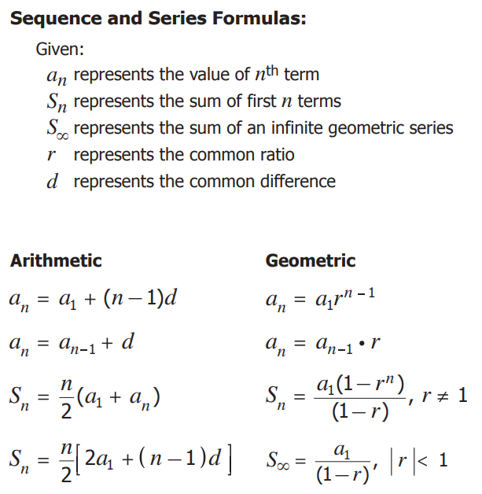

Analytic Geometry
MA.AG.1 The student will identify and analyze the properties of conic sections and sketch a graph given an equation.
Students will demonstrate the following Knowledge and Skills:
- Given a translation or rotation matrix, determine an equation for the transformed function or conic section.
- Convert between standard and general forms of conic equations by completing the square.
- Graph conic sections from equations written in general or standard form using transformations.
- Identify characteristics of conic sections including center, vertices, axes, symmetry, foci, directrix, eccentricity, and asymptotes.
- Represent applications of conic sections.

MA.AG.1 The student will identify and analyze the properties of conic sections and sketch a graph given an equation.

Additional Content Background and Instructional Guidance:
- A conic section is a figure formed by the intersection of a plane with a right circular cone. Conic sections include the parabola, circle, ellipse, and hyperbola.
- Conics can be defined using distance.
  - A circle is the set of all points that are a fixed distance from a point.
  - A parabola is the set of all points that are equidistant from both a line and a point.
  - An ellipse is the set of all points in the plane, the sum of whose distances from two fixed points (the foci) is a constant.
  - A hyperbola is the set of all points in the plane, the difference of whose distances from two fixed points (the foci) is a constant.
- If a cone is cut by a plane parallel to its axis, the intersection is a hyperbola, the only conic section made of two branches.
- The branches of a hyperbola approach two straight lines (asymptotes) that intersect at its center.
- All conic sections have two axes of symmetry except a parabola which only has one.
- Central conics refer to conic sections whose centers or parabolas’ vertices are located at the origin.
- Some examples of appropriate applications that can be modeled with conics include parabolic headlamps and satellite dishes, cables of a suspension bridge, whispering gallery, and lenses.
- A graphing utility should be used to explore and develop conceptual understanding of conic models.

MA.AG.2 The student will use parametric equations to model and solve problems in context.
Students will demonstrate the following Knowledge and Skills:
- Graph and analyze parametric equations and use the graph to determine solutions.
- Use parametric equations to model contextual problems, including motion over time.

MA.AG.2 The student will use parametric equations to model and solve problems in context.

Additional Content Background and Instructional Guidance:
- Parametric equations are used to express two dependent variables, x and y, in terms of an independent variable (parameter), t.
- When interpreting parametric equations, consider the variables. Variables $x$ and $y$ are not directly related to each other, but both variables are related to a third variable, $t$.
- Some curves cannot be represented as a function, f(x). Parametric graphing enables the representation of these curves in terms of functions.
- Parametric equations can be defined by:
  - $x=f\left(t\right)$; $y=g(t)$
  - Values of t can be plotted as a point $(x, y) = (f(t),g(t))$.
  - Consider the example below:
    - $x=t+5$; $y=t^{2}$
    - Create a table of values using three columns, where t is the independent variable and x and y are dependent upon t.
$$x=$$
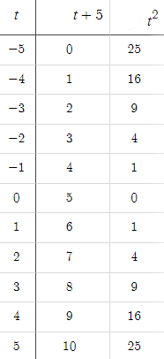
$$y=$$
    - Use the values derived for $x=f(t)$ and $y=g(t)$ to graph $(f(t),g(t))$.
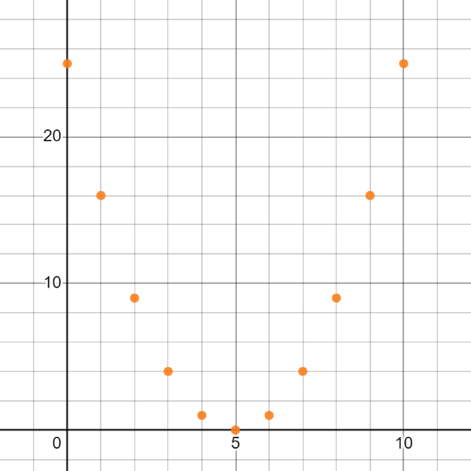
$$t= 4$$
$$t= 5$$
$$t= -3$$
$$t= 3$$
$$t= 2$$
$$t= 1$$
$$t= 0$$
$$t= -1$$
$$t= -2$$
$$t= -4$$
$$t= -5$$
    - When there are no limits on the parameter, the graph will continue in both directions.
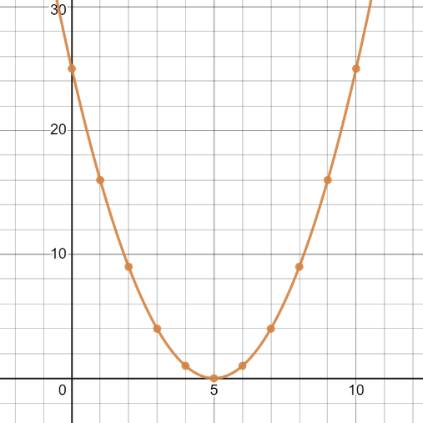
  - Consider the same example with limits on the parameter:
    - $x=t+5$; $y=t^{2}$; $-1≤t≤4$
    - Using the same steps previously outlined, only include the values of t that fall in within the given limits.
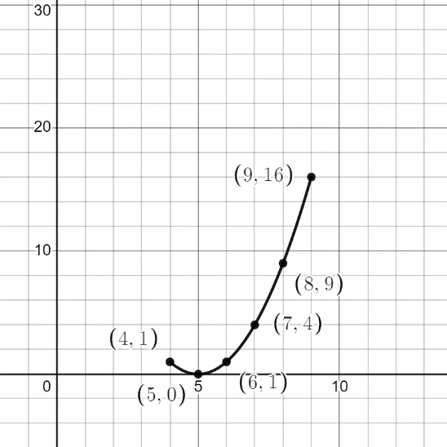
$$t= 4$$
$$t= -1$$
- It is important to note that rectangular equations refer to two-variable equations that typically consists of $x$ and $y$.
- A graphing utility should be used to analyze parametric equations.

MA.AG.3 The student will perform operations with vectors in the coordinate plane.
Students will demonstrate the following Knowledge and Skills:
- Use vector notation.
- Perform the operations of addition, subtraction, and scalar multiplication, graphically and algebraically on vectors.
- Find the dot (inner) product of two vectors and use it to determine the angle between two vectors.
- Determine if two vectors are orthogonal.
- Express complex numbers in vector notation.
- Verify properties of the dot product.
- Determine the components of a vector.
- Determine the norm (magnitude) of a vector.
- Find a unit vector in the same direction of a given vector.
- Apply vectors to problems in context.

MA.AG.3 The student will perform operations with vectors in the coordinate plane.

Additional Content Background and Instructional Guidance:
- A vector is a line segment that has a starting and ending point.
- Every vector has an equal vector that has its initial point at the origin.
- A vector has direction (amplitude) and length (magnitude).
- The magnitude and amplitude of a vector with the origin as the initial point are completely determined by the coordinates of its terminal point.
- Every nonzero vector has a corresponding unit vector, which has the same direction as the vector but a magnitude of 1.
- The dot product of two vectors is the product of the magnitude of the two vectors and the cosine of the angle between them. For example –
  - Two vectors $\vec{m}$and$\vec{n}$ are shown below:
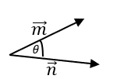

  - The dot product of $\vec{m}$and$\vec{n}$ is defined as $\vec{m}·\vec{n}=\left|\vec{m}\right|\left|\vec{n}\right|\cos{θ}$.
- Two vectors are orthogonal if they are perpendicular to each other.
- Orthogonal vectors have a dot product equal to zero.
- The angle between two orthogonal vectors is $θ=\frac{π}{2}$.
- Vector direction has two components i and j, which can be positive or negative.
  - i corresponds to the direction of the x-axis.
  - j corresponds to the direction of the y-axis.
- Vector notation is denoted by the following:
  - $\vec{v}=ai+bj$
  - $\vec{v}= \left({a \atop b}\right)$

$$bj$$
$$ai+bj$$

$$ai$$

- The magnitude of a vector is denoted by $\left\|\vec{v}\right\|or \left|\vec{v}\right|.$
- $\left\|\vec{v}\right\|=\sqrt{a^{2}+b^{2}}$

MA.AG.4 The student will investigate and identify the characteristics of the graphs of polar equations.
Students will demonstrate the following Knowledge and Skills:
- Classify polar equations (rose, cardioid, limaçon, lemniscate, spiral, and circle), given the graph or the equation.
- Determine the effects of changes in the parameters of polar equations on the graph, using graphing technology.
- Convert between polar and rectangular forms of coordinates.
- Convert between complex numbers written in rectangular form and polar form.
- Convert equations between polar and rectangular forms.
- Determine and verify the intersection of the graphs of two polar equations, using graphing technology.

MA.AG.4 The student will investigate and identify the characteristics of the graphs of polar equations.

Additional Content Background and Instructional Guidance:
- By definition, points in the polar coordinate system are in the form $\left(r,θ\right)$ and there are an infinite number of polar coordinates for every unique cartesian coordinate $\left(x,y\right)$.
- The real number system is represented geometrically on the number line, and the complex number system is represented geometrically on the plane where $a + bi$ corresponds to the point $(a, b)$ in the plane.
- When converting between rectangular and polar coordinate forms, use substitution to replace x with $r\cos{θ}$ and y with $r\sin{θ}$.
  - x $=r\cos{θ}$
  - y $=r\sin{θ}$
- A polar equation in the form $r = a sin(n)$ is called a rose curve.
- Polar limaçon equations have the form $r = a ± b sin\left(\right)or r = a ± b cos\left(\right).$
- There are four common types of limaçons. Each have a relationship to the ratio $\frac{a}{b}$.
  - One contains an inner loop: $\frac{a}{b}<1$
  - One is the cardioid (heart-shaped): $\frac{a}{b}=1$
  - One is dimpled: $1<\frac{a}{b}<2$
  - One in convex and looks like a circle: $\frac{a}{b}≥2$
- Lemniscate polar equations are written in the form $r^{2}=a^{2}\sin{(2θ)}$ or $r^{2}=a^{2}\cos{(2θ)}$.
- When graphed, lemniscate polar equations resemble a figure-8.
- When a and b are equal to $±1$, the equation, $\sqrt{{(x a) }^{2}+ y^{2}} \sqrt{{(x+ a) }^{2}+ y^{2}} b^{2},$ resembles a lemniscate curve.
- Spiral polar equations are presented in the form $r=a+bθ$, where r represents the distance from the origin.
- Circular polar equations have the form $r=±k$.

MA.AG.5 The student will use matrices to organize data and will add and subtract matrices, multiply matrices, multiply matrices by a scalar, and use matrices to solve systems of equations.
Students will demonstrate the following Knowledge and Skills:
- Multiply matrices by a scalar.
- Add, subtract, and multiply matrices.
- Represent problems with a system of no more than three linear equations.
- Express a system of linear equations as a matrix equation.
- Solve a system of equations using matrices.
- Determine the inverse of a two-by-two or three-by-three matrix using paper and pencil.
- Verify two matrices are inverses using matrix multiplication.
- Verify the commutative and associative properties for matrix addition and multiplication.

MA.AG.5 The student will use matrices to organize data and will add and subtract matrices, multiply matrices, multiply matrices by a scalar, and use matrices to solve systems of equations.

Additional Content Background and Instructional Guidance:
- When multiplying a matrix by a scalar, multiply each element in the matrix by the scalar.
- The dimension of a matrix is denoted by the number of rows and columns it contains. A matrix having m rows and n columns is said to be a $m×n$ matrix.
- Matrices must have the same dimensions to be added to or subtracted from one another.
- When multiplying two matrices:
  - The number of columns in the first matrix must be congruent to the number of rows in the second matrix.
  - The dimension of the product matrix will result in the number of rows in the first matrix and the number of columns in the second matrix.
  - Refer to the example that follows,

A B
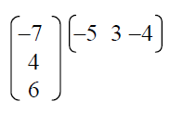
    - Given matrix $A$ has three rows and one column, its dimensions are $3×1$. This is written as $A_{3×1}$.
    - Given matrix $B$ has one row and three columns, its dimensions are $1×3$. This is written as $B_{1×3}$.
    - The product of $A$ and $B$ exists because the number of columns in $A$ (1) matches the number of rows in $B$ (1).
    - The product matrix will result in 3 columns and 3 rows. Let $C$ represent the product matrix.
    - $∴C_{3×3}$
- The identity matrix is denoted by ($I$).
- Matrices can model a variety of linear systems.
  - Solutions of a linear system are values that satisfy every equation in the system.
  - Matrices are a convenient shorthand for solving systems of equations.
  - Inverse matrices are used to solve systems of equations, given a matrix equation.
- For a matrix $A$, find the inverse matrix $A^{-1}$ (if it exists) such that ${A·A}^{-1}=A^{-1}·A=I$.
  - Matrix addition is commutative.
  - The commutative property with respect to multiplication does not hold for all matrices.
  - The product of a matrix and its inverse results in the corresponding identity matrix.
- Matrix equations contain three different matrices.
  - One matrix represents the coefficients of the variables defined in an equation.
  - One matrix reflects the variables defined in an equation.
  - One matrix contains the constant in the equation.
- When using matrices to solve systems of equations, the product of the coefficient matrix and the variable matrix are set equal to a third matrix. The third matrix reflects the constants in the equations. For example –
$$Constants$$
$$Variables$$
$$Coefficients$$
