2023 Mathematics Standards of Learning
Understanding the Standards - Trigonometry

The standards below outline the content for a one-semester course in Trigonometry. Trigonometry includes the study of trigonometric definitions, applications, graphing, and solving trigonometric equations and inequalities. Emphasis should also be placed on using connections between right triangle ratios, trigonometric functions, and circular functions. In addition, the application of trigonometric concepts should be included throughout the course of study. Oral and written communication concerning the language of mathematics, logic of procedure, and interpretation of results should also permeate the course.

Technology tools will be used to assist in teaching and learning. Graphing technologies facilitate visualizing, analyzing, and understanding algebraic and statistical behaviors and provide a powerful tool for solving and verifying solutions.

Triangle Trigonometry
T.TT.1 The student will determine the sine, cosine, tangent, cotangent, secant, and cosecant of the acute angles in a right triangle and use these ratios to solve for missing sides and angle measures, including application in contextual problems.
Students will demonstrate the following Knowledge and Skills:
- Define and represent the six triangular trigonometric ratios (sine, cosine, tangent, cosecant, secant, and cotangent) of an angle in a right triangle.
- Describe the relationships between side lengths in special right triangles (30°-60°-90° and 45°-45°-90°).
- Use the trigonometric functions, the Pythagorean Theorem, the Law of Sines, and the Law of Cosines to solve contextual problems.
- Represent and solve contextual problems involving right triangles, including problems involving angles of elevation and depression.

T.TT.1 The student will determine the sine, cosine, tangent, cotangent, secant, and cosecant of the acute angles in a right triangle and use these ratios to solve for missing sides and angle measures, including application in contextual problems.

Additional Content Background and Instructional Guidance:
- Trigonometry is based on the six trigonometric functions. The six trigonometric functions of angle $θ$ are sine (sin), cosine (cos), tangent (tan), cotangent (cot), secant (sec), and cosecant (csc).
- Cosecant is the reciprocal of sine; secant is the reciprocal of cosine; cotangent is the reciprocal of tangent.
- To define these functions, start with an angle $θ$ in standard position, and choose any point P having coordinates (x, y) on the terminal side of angle $θ$. The point P must not be the vertex of the angle. A perpendicular from P to the x-axis at point Q determines a right triangle, having vertices at O, P, and Q. Find the distance r from P(x, y) to the origin (0, 0), by using the distance formula.

Let (x, y) be a point other than the origin on the terminal side of angle $θ$ in standard position. The distance from the point to the origin is $r,$which is defined by $r=\sqrt{{(x-0)}^{2}+{(y-0)}^{2}}$ = $\sqrt{x^{2}+y^{2}}$, where r > 0. The variable, r, represents the hypotenuse of the right triangle.
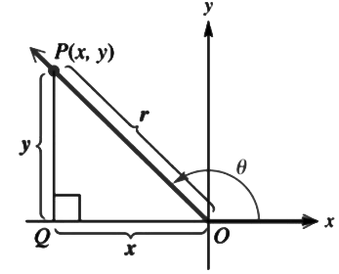
The six trigonometric functions of $θ$ are defined as follows:

sin $θ$ = $\frac{y}{r}$ | cos $θ$ = $\frac{x}{r}$ | tan $θ$ = $\frac{y}{x}$ , where x$≠0$
csc $θ$ = $\frac{r}{y}$ , where $y≠0$ | sec $θ$ = $\frac{r}{x},$ where x$≠0$ | cot $θ$ = $\frac{x}{y}$, where $y≠0$

- Inverse sine, inverse cosine, and inverse tangent are inverse trigonometric functions and can be used to find angle measures in right triangles. Note that inverse sine can be written as both $\sin^{-1}\left(x\right)$and arcsin(x); inverse cosine can be written as both $\cos^{-1}\left(x\right)$and arccos(x); and inverse tangent can be written as $\tan^{-1}\left(x\right)$and arctan (x).
- Sine and the complement of sine (cosine); tangent and the complement of tangent (cotangent); and secant and the complement of secant (cosecant) are cofunctions. As such, $\sin\left(x\right)=\cos\left(90° - x\right),\tan\left(x\right)=\cot\left(90° - x\right), and sec(x)=\csc\left(90° - x\right).$
- 45°-45°-90° and 30°-60°-90° triangles are special right triangles because their side lengths can be specified as exact values using radicals rather than decimal approximations.
- A 30°-60°-90° triangle is a triangle where the angles are always 30°, 60°, and 90°. As one angle is 90°; therefore, this triangle is always a right triangle. The sum of two acute angles is equal to the right angle, and these angles will be in the ratio 1:2 or 2:1.
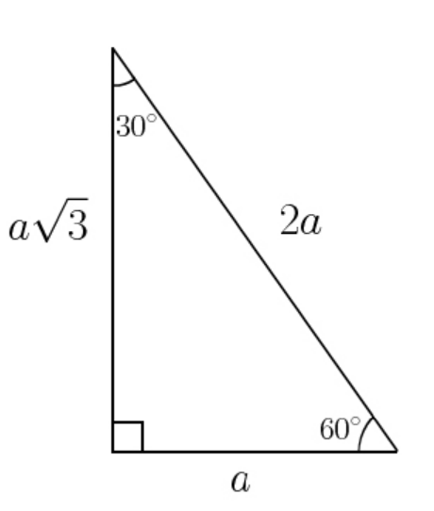
- A 45°-45°-90° triangle is a triangle where the angles are always 45°, 45°, and 90°. The three sides of the triangle in the ratio are 1:1:$2\sqrt{2}.$
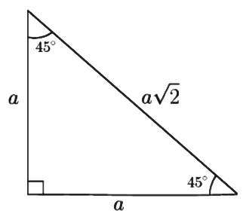
- The hypotenuse of a right triangle is the side opposite the right angle. The hypotenuse of a right triangle is always the longest side of the right triangle. The legs of a right triangle form the right angle.
- In a right triangle, the square of the length of the hypotenuse equals the sum of the squares of the legs. This relationship is known as the Pythagorean Theorem: a² + b² = c².
- The Pythagorean Theorem is used to determine the measure of any one of the three sides of a right triangle when the measures of the other two sides are known.
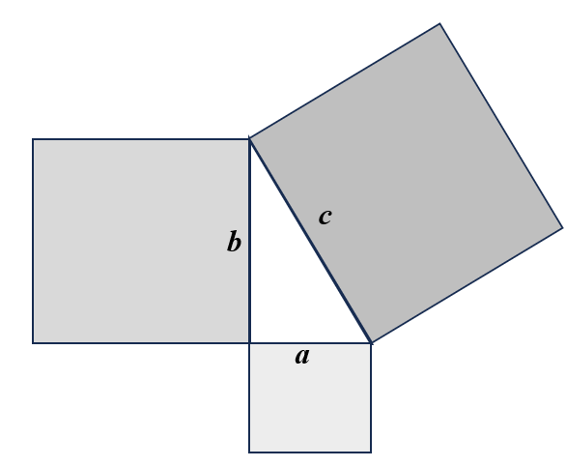
- The converse of the Pythagorean Theorem states that if the square of the length of the hypotenuse equals the sum of the squares of the legs in a triangle, then the triangle is a right triangle. This can be used to determine whether a triangle is a right triangle given the measures of its three sides.
- The Law of Sines relates the sines of the angle of a triangle to the side lengths. The Law of Cosines relates to the length of a side of any triangle to the measure of the opposite angle and the other two side lengths.
- Trigonometric functions, the Pythagorean Theorem, the Law of Sines, and the Law of Cosines, can be applied to many contextual situations, including but not limited to, architecture, construction, sailing, space flight, and angles of elevation and depression.

T.TT.2 The student will find the area of any triangle and solve for the lengths of the sides and measures of the angles in a non-right triangle using the Law of Sines and the Law of Cosines.
Students will demonstrate the following Knowledge and Skills:
- Apply the Law of Sines, and the Law of Cosines, as appropriate, to find missing sides and angles in non-right triangles.
- Recognize the ambiguous case when applying the Law of Sines and the potential for two triangle solutions in some situations.
- Solve problems that integrate the use of the Law of Sines and the Law of Cosines and the triangle area formula (Area = $\frac{1}{2}$absinC, where a and b are triangle sides and C is the included angle) to find the area of any triangle, including those in contextual problems.

T.TT.2 The student will find the area of any triangle and solve for the lengths of the sides and measures of the angles in a non-right triangle using the Law of Sines and the Law of Cosines.

Additional Content Background and Instructional Guidance:
- The Law of Sines can be used to find a missing length in any triangle, not just a right triangle. To apply the Law of Sines, the measures of either two angles and any side, or two sides and an angle opposite one of them is needed. In any triangle, the ratio of the sine of each angle to its opposite side is constant. If given, $∆ABC$:
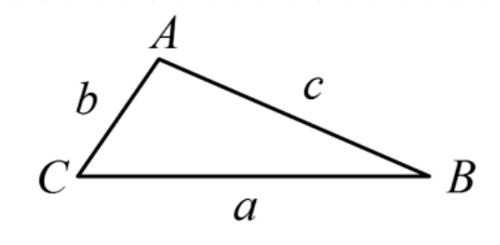
$\frac{\sin{A}}{a}$ = $\frac{\sin{B}}{b}$ = $\frac{\sin{C}}{c}$

- The Law of Cosines relates to the length of a side of any triangle to the measure of the opposite angle and the other two side lengths. If given, $∆ABC$:
$$a^{2}= b^{2}+ c^{2}-2bc\cos{A}$$ | $$b^{2}= a^{2}+ c^{2}-2ac\cos{B}$$ | $$c^{2}= a^{2}+ b^{2}-2ab\cos{C}$$

- The Law of Sines, the Law of Cosines, and the triangle area formula $Area = \frac{1}{2} absinC$can be derived using knowledge of trigonometric ratios and the triangle area formula $Area = \frac{1}{2}bh$.
- When using the Law of Sines to solve for an angle measure in a triangle, technology tools may produce an acute angle solution, even when the angle is or may be obtuse due to the ambiguous case.

Circular Trigonometry
T.CT.1 The student will determine the degree and radian measure of angles; sketch angles in standard position on a coordinate plane; and determine the sine, cosine, tangent, cosecant, secant, and cotangent of an angle, given a point on the terminal side of an angle in standard position or the value of a trigonometric function of the angle.
Students will demonstrate the following Knowledge and Skills:
- Define a radian as a unit of angle measure and determine the relationship between the radian measure of an angle and the length of the intercepted arc in a circle.
- Determine the degree and radian measure of angles to include both negative and positive rotations in the coordinate plane.
- Find both positive and negative coterminal angles for a given angle.
- Identify the quadrant or axis in/on which the terminal side of an angle lies.
- Draw a reference right triangle when given a point on the terminal side of an angle in standard position.
- Draw a reference right triangle when given the value of a trigonometric function of an angle (sine, cosine, tangent, cosecant, secant, and cotangent).
- Determine the value of any trigonometric function (sine, cosine, tangent, cosecant, secant, and cotangent) when given a point on the terminal side of an angle in standard position.
- Given one trigonometric function value, determine the other five trigonometric function values.
- Calculate the length of an arc of a circle in radians.
- Calculate the area of a sector of a circle.

T.CT.1 The student will determine the degree and radian measure of angles; sketch angles in standard position on a coordinate plane; and determine the sine, cosine, tangent, cosecant, secant, and cotangent of an angle, given a point on the terminal side of an angle in standard position or the value of a trigonometric function of the angle.

Additional Content Background and Instructional Guidance:
- Degrees and radians are units of angle measure.
- A radian is the measure of the central angle that is determined by an arc whose length is the same as the radius of the circle.
- To visualize the magnitude of 1 radian, it can be shown that 1 radian is equal to $\frac{180°}{π}$, which is approximately 57.296°.
- Negative angles of rotation are in the clockwise direction, and positive angles of rotation are in the counterclockwise direction.
- The terminal side of an angle in standard position could lie in a quadrant (I, II, III, or IV) or on an axis. The quadrantal angles, in degrees, are: 0°, $±$90°, $±$180°, $±$270°, $±$360°, and their coterminal angles.
- Representation and use of reference triangles facilitate finding the trigonometric function values when the terminal side of an angle lies in one of the quadrants.
- Reference triangles are drawn relative to the x-axis. That is, the reference angle is the acute angle magnitude between the x-axis and the terminal side of the angle of rotation.
- An intuitive way to derive the length of the arc of a circle could include:
  - Circumference (arc length) of a circle is C$=2πr$for $θ=2π$.
  - Arc length of a semicircle is $S=πr$ for $θ=π.$
  - Arc length of a quarter of a circle is $S=\frac{π}{2}θ$ for $θ=\frac{π}{2}$ .
  - $S=θr$
- An intuitive way to derive the area of sectors of a circle could include:
  - Area of a circle is A = $πr^{2}$ for $θ=2π$.
  - Area of a semicircle is A$=\frac{π}{2}r^{2}$ for $θ=π$.
  - Area of a quarter of a circle is A$=\frac{π}{4}r^{2}$ for $θ=\frac{π}{2}$.
  - $A =\frac{ϴ}{2}r^{2}$

T.CT.2 The student will develop and apply the properties of the unit circle in degrees and radians.
Students will demonstrate the following Knowledge and Skills:
- Convert between radian and degree measure of special angles of the unit circle without the use of technology.
- Define the six circular trigonometric functions of an angle in standard position on the unit circle.
- Apply knowledge of right triangle trigonometry, special right triangles, and the properties of the unit circle to determine trigonometric functions values of special angles (0°, 30°, 45°, 60°, and 90°) and their related angles in degree and radians without the use of technology.

T.CT.2 The student will develop and apply the properties of the unit circle in degrees and radians.

Additional Content Background and Instructional Guidance:
- The unit circle has a radius of 1 unit and its center at the origin (0, 0) of the coordinate plane. Points on the unit circle are related to periodic functions.
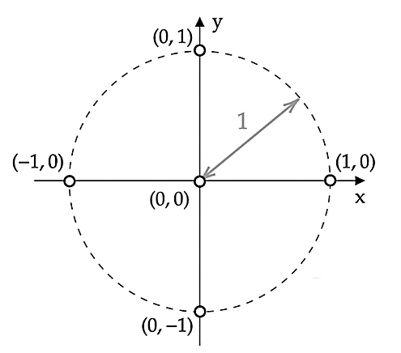
- Unit circle properties allow for the computation of the trigonometric values of special angles without the aid of a graphing utility.
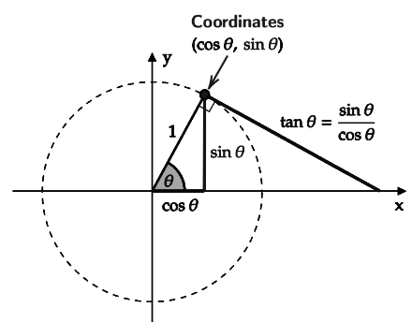
- If $θ$ is an angle plotted in standard position and P(x, y) is the point on the terminal side of $θ$ which lies on the unit circle, then –
  - The cosine of $θ$, denoted and defined by cos $θ$ = x.
  - The sine of $θ,$ denoted and defined by sin $θ$ = y.
  - The secant of $θ,$ denoted and defined by sec $θ$ = $\frac{1}{x}$ , (x $≠$ 0).
  - The cosecant of $θ,$ denoted and defined by csc $θ$ = $\frac{1}{y}$ , (y $≠$ 0).
  - The tangent of $θ,$ denoted and defined by tan $θ$ = $\frac{y}{x}$ , (x $≠$ 0).
  - The cotangent of $θ,$ denoted and defined by cot $θ$ = $\frac{x}{y}$ , (y $≠$ 0).
- Developing a unit circle using special angles and their corresponding ordered pairs can help to reinforce understanding.
- Simultaneously referencing both degree and radian measures of special angles in the unit circle reinforces understanding. The unit circle below can be used to find the exact values of cos $θ$ and sin $θ$ for special angles regardless of if degrees or radians are used. The degrees range from 0° to 360° and the radians from 1 to 2$π$. Because P(x, y) or P(cos $θ$, sin $θ$), specific values can be found using the unit circle.
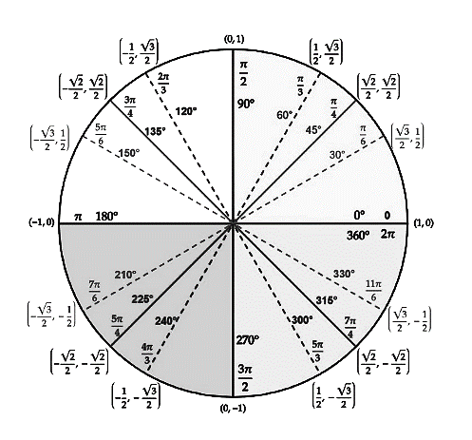

Graphs of Trigonometric Functions
T.GT.1 The student will graph and analyze trigonometric functions and apply trigonometric functions to represent periodic phenomena.
Students will demonstrate the following Knowledge and Skills:
- Sketch the graph of the six parent trigonometric functions (sine, cosine, tangent, cosecant, secant, and cotangent) for at least a two-period interval.
- Determine the domain and range, amplitude, period, and asymptote locations for a trigonometric function, given a graph or an equation.
- Describe the effects of changing the parameters (A, B, C, or D in the standard form of a trigonometric equation) on the graph of the function using graphing technology.
- Sketch the graph of a transformed sine, cosine, and tangent function written in standard form by using transformations for at least a two-period interval, including both positive and negative values for the domain.
- Apply trigonometric functions and their graphs to represent periodic phenomena.

T.GT.1 The student will graph and analyze trigonometric functions and apply trigonometric functions to represent periodic phenomena.

Additional Content Background and Instructional Guidance:
- The graphs of the six parent trigonometric functions (sine, cosine, tangent, cosecant, secant, and cotangent), can be drawn if the following are known:
  - The amplitude is the absolute value of any number multiplied with it on the trigonometric function; how tall or short the curve is.
  - The period goes from any point (one peak) to the next matching point.
  - How far the function is shifted from the usual position horizontally is called a phase shift (maximum and minimum turning points).

- While drawing a graph of the sine function, convert the given function to the general form as a sin(bx – c) + d to find the different parameters such as amplitude, phase shift, vertical shift, and period. Where,

|a| = Amplitude | $\frac{2π}{|b|}$ = Period | $\frac{c}{b}$ = Phase Shift | d = Vertical Shift
Similarly, for the cosine function, the formula a cos(bx – c) + d can be used. Thus, the graphs of all six trigonometric functions are shown below:
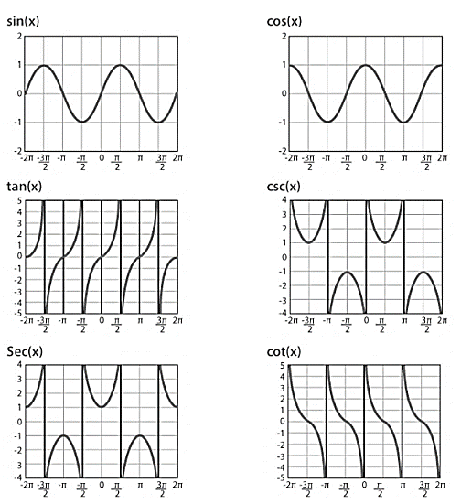
- The midline of a trigonometric function is the horizontal line representing the average of the maximum and minimum values for a sine or cosine function and is useful in visualizing vertical shifts and amplitude changes in transformed functions.
- The amplitude, period, phase shift, and vertical shift are important characteristics of trigonometric functions and can facilitate solving problems using sine and cosine functions as models of periodic behavior.
- The domain and range of a trigonometric function can guide in how to scale the axes for the graph of a trigonometric function.
- Changes to the amplitude, period, and midline of the basic sine and cosine graphs are called transformations. Changing the midline shifts the graph vertically, changing the amplitude stretches or compresses the graph vertically, and changing the period stretches or compresses the graph horizontally.
- The transformations of shifting and stretching can be applied to the tangent. The graph of y = tan(x) does not have an amplitude, but a vertical stretch can be seen by comparing the function values at the guide points.
- Standard form of the trigonometric functions may be written in multiple ways. For example, $y=A sin\left(Bx ±C\right)±D or y=A sin[B(x ±C]±D$.
- Trigonometry can be applied in many fields and disciplines to understand periodic phenomena, such as wave motion or the motion of a Ferris wheel.
- Technology can be used to explore and visualize the effects of transformations and represent contextual data.

T.GT.2 The student will graph the six inverse trigonometric functions.
Students will demonstrate the following Knowledge and Skills:
- Determine the domain and range of the inverse trigonometric functions.
- Use the restrictions on the domain of an inverse trigonometric function to determine a value of the inverse trigonometric function.
- Graph inverse trigonometric functions.

T.GT.2 The student will graph the six inverse trigonometric functions.

Additional Content Background and Instructional Guidance:
- Since trigonometric functions are periodic and not one-to-one, their inverses are not functions, but domain allow for generating inverse trigonometric functions that we use to solve problems.
- The inverses are named alternatively as $arcsine$ or $\sin^{-1}(x$), $arccosine$ or $\cos^{-1}(x)$, and $arctangent$ or $\tan^{-1}(x)$.
- The table below provides all six inverse trigonometric functions with their domains and ranges:

Inverse Function | Domain | Range
 |  | Interval | Quadrants of the  Unit Circle
$$y= \sin^{-1}x$$ | [–1, 1] | $$\left[-\frac{π}{2}, \frac{π}{2}\right]$$ | I and IV
$$y= \cos^{-1}x$$ | [–1, 1] | [0, $π$] | I and II
$$y= \tan^{-1}x$$ | (–∞, ∞) | $$\left(-\frac{π}{2}, \frac{π}{2}\right)$$ | I and IV
$$y= \cot^{-1}x$$ | (–∞, ∞) | (0, $π)$ | I and II
$$y= \sec^{-1}x$$ | (–∞, –1] $∪$ [1, ∞) | [0, $π$], $y≠\frac{π}{2}$ | I and II
$$y= \csc^{-1}x$$ | (–∞, –1] $∪$ [1, ∞) | $$\left[-\frac{π}{2}, \frac{π}{2}\right], y≠0$$ | I and IV

- Reflecting graphs over the line $y=x$ generates the graph of the inverse relation.
- Reflecting graphs of functions over the line $y=x$ corresponds to switching the domain and range to generate the inverse relation (which may or may not be a function).

Identities and Equations
T.IE.1 The student will evaluate expressions involving the six trigonometric functions and the inverse sine, cosine, and tangent functions.
Students will demonstrate the following Knowledge and Skills:
- Determine the values of trigonometric functions, with and without graphing technology.
- Determine angle measures by using the inverse trigonometric functions, with and without a graphing technology.
- Evaluate composite functions that involve trigonometric functions and inverse trigonometric functions.

T.IE.1 The student will evaluate expressions involving the six trigonometric functions and the inverse sine, cosine, and tangent functions.

Additional Content Background and Instructional Guidance:
- Knowledge of restricted domains, periodicity, and the values of trigonometric functions are useful for determining values of inverse trigonometric functions.
- Inverse trigonometric functions can be used to determine angle measures whose trigonometric function values are known.
- Calculations of inverse trigonometric function values can be related to the triangular definitions of the trigonometric functions.
- Trigonometric functions are not invertible, because they are periodic. Therefore, domain restrictions on trigonometric functions are necessary to determine the inverse trigonometric function.
- Use of right triangles can help in understanding inverse trigonometric expressions. and facilitate an understanding of ways to evaluate trigonometric expressions.

T.IE.2 The student will use basic trigonometric identity substitutions to simplify and verify trigonometric identities.
Students will demonstrate the following Knowledge and Skills:
- Use trigonometric identities to make algebraic substitutions to simplify and verify trigonometric identities. The basic trigonometric identities include:
  - reciprocal identities;
  - Pythagorean identities;
  - sum and difference identities;
  - double-angle identities; and,
  - half-angle identities.
- Apply the sum, difference, and half-angle identities to evaluate trigonometric function values of angles that are not integer multiples of the special angles to solve problems, including contextual situations.

T.IE.2 The student will use basic trigonometric identity substitutions to simplify and verify trigonometric identities.

Additional Content Background and Instructional Guidance:
- Trigonometric identity substitutions can be used to simplify and verify trigonometric expressions or identities.
- The interrelationships among the six basic trigonometric functions allow trigonometric expressions in various equivalent forms to be written.
- Trigonometric identities are true only for the values for which the functions are defined. These values are called the domain of validity. For example, if given cos $θ$ = $\frac{1}{\sec{θ }}$ , the domain of cos $θ$ is all real numbers. The domain of $\frac{1}{\sec{θ }}$ excludes all zeros of sec $θ$ (of which there are none) and all values of $θ$ for which sec $θ$ is undefined (odd multiples of $\frac{π}{2}$).
Therefore, the domain of validity is the set of real numbers except for the odd multiples of $\frac{π}{2}$.
- Reciprocal identities are the reciprocals of the six trigonometric functions. Reciprocal identities are not the same as inverse trigonometric functions. Every trigonometric function is a reciprocal of another trigonometric function. For example, cosecant is the reciprocal identity of the sine function.

csc $θ$ = $\frac{1}{\sin{θ}}$ | sec $θ$ = $\frac{1}{\cos{θ}}$ | cot $θ$ = $\frac{1}{\tan{θ}}$
sin $θ$ = $\frac{1}{\csc{θ}}$ | cos $θ$ = $\frac{1}{\sec{θ }}$ | tan $θ$ = $\frac{1}{cot θ }$

- Pythagorean identities are derived from the Pythagorean Theorem and the unit circle.

$\cos^{2}θ$ + $\sin^{2}θ$ = 1 | ${1+tan}^{2}θ$ = $\sec^{2}θ$ | ${1+cot}^{2}θ$ = $\csc^{2}θ$

- Sum and Difference Identities (Formulas):
cos(α + β) = cos α cos β – sin α sin β | sin(α + β) = sin α cos β + cos α sin β
cos(α – β) = cos α cos β + sin α sin β | sin(α – β) = sin α cos β + cos α sin β

- Double Angle Identities (Formulas):

$$sin2θ=2sinθcosθ$$ | $$cos2θ=\cos^{2}θ- \sin^{2}θ$$  $={2cos}^{2}θ- 1$  $$=1-{2sin}^{2}θ$$ | $$tan2θ=\frac{2tanθ}{1-{2tan}^{2}θ}$$

- Half Angle Identities (Formulas):
$\sin^{2}θ= \frac{1 - cos2θ}{2}$ $sin\frac{θ}{2}= ±\sqrt{\frac{1 - cosθ }{2}}$

$\cos^{2}θ= \frac{1 + cos2θ}{2}$ cos$\frac{θ}{2}= ±\sqrt{\frac{1 + cosθ }{2}}$

tan$\frac{θ}{2}= ±\sqrt{\frac{1 - cosθ }{1 + cosθ}}$

T.IE.3 The student will solve trigonometric equations and inequalities.
Students will demonstrate the following Knowledge and Skills:
- Solve trigonometric equations with and without restricted domains algebraically and graphically.
- Solve trigonometric inequalities algebraically and graphically.
- Verify and justify algebraic solutions to trigonometric equations and inequalities, using graphing technology.

T.IE.3 The student will solve trigonometric equations and inequalities.

Additional Content Background and Instructional Guidance:
- Solutions to trigonometric equations may depend on the domain of the related trigonometric function.
- Periodicity can help solve trigonometric equations when no domain restrictions are given. For example, solutions to sin(x) = cos(x) can be written as $x =\frac{π}{4}+nπ,$ where $n$ is an integer.
- A graphing utility can be used to verify the solution of a trigonometric equation.
- Trigonometric identities can help solve trigonometric equations.
- Solving trigonometric inequalities provides additional opportunities for modeling contextual situations and solving problems.

