Virginia’s Comprehensive School Support Plan

Virginia’s comprehensive school support plan (CSSP) integrates findings from Virginia’s needs assessment to help guide schools as they prioritize work, predict and neutralize barriers, and catalyze transformative practices that will improve student outcomes. There are four sections to the comprehensive school support plan, aligned to the Virginia Support Framework:
- Academic Supports
- Staffing Supports
- Professional Learning Supports
- School Climate Supports
High-quality plans support school leaders as they work to allocate human and fiscal resources, establish short-and long-term goals, monitor processes, and scale successes. Specifically, a high-quality plan is:
- Grounded in the continuous improvement process and high expectations for all students;
- Developed and revised through engagement with stakeholders-- including families; and,
- Based on evidence-and research-based strategies aligned to the needs and context of the school.
Effective plans are based on the most important changes needed in the school and demonstrate alignment to federal, state, division, and school priorities by relating goals, measures, strategies, and resources to division plans, federal and state laws and guidance, including Virginia’s Support Framework.
How to use the Virginia Comprehensive School Support Plan:
- Review the Virginia Support Framework domains and the results of the Virginia Support Framework Needs Assessment.
- Become familiar with the explanation and example of the Comprehensive School Support Plan template which includes a description and example for each item.
- Complete the profile information, providing information on designations, School Quality Indicators, Levels, and/or federal identification. An overview of the internal and external stakeholder, including families, that have been engaged in the school improvement process should also be documented.
- Use the results from the needs assessment to develop the plan for each domain and indicator, including barriers from a root-cause analysis establishing SMART goals, the alignment to evidence and research-based strategies, the development and implementation of the plan, and the artifacts to be regularly collected and analyzed for progress monitoring.

Domain of Support | Description
Academic | Providing high-quality instructional materials, routines, and prioritized placement are critical to the successful operation of the school division, and focuses on alignment, engagement, rigor, and organizing staff based on need.
Staffing | Recruiting, allocating, and retaining teachers and principals to address schools and areas with the greatest needs, to include building capacity from those within and the retention of high-quality staff are integral to school division success.
Professional Learning | Managing a school building effectively by providing logistical support to maximize learning through clear calendars and master schedules; and targeting professional learning centered on the instructional cycle with a focus on student outcomes.
School Climate | Engaging with families and providing instructional materials, learning opportunities, and supports to improve attendance creates a welcoming culture. Connecting each student with an adult creates a safe and orderly environment.
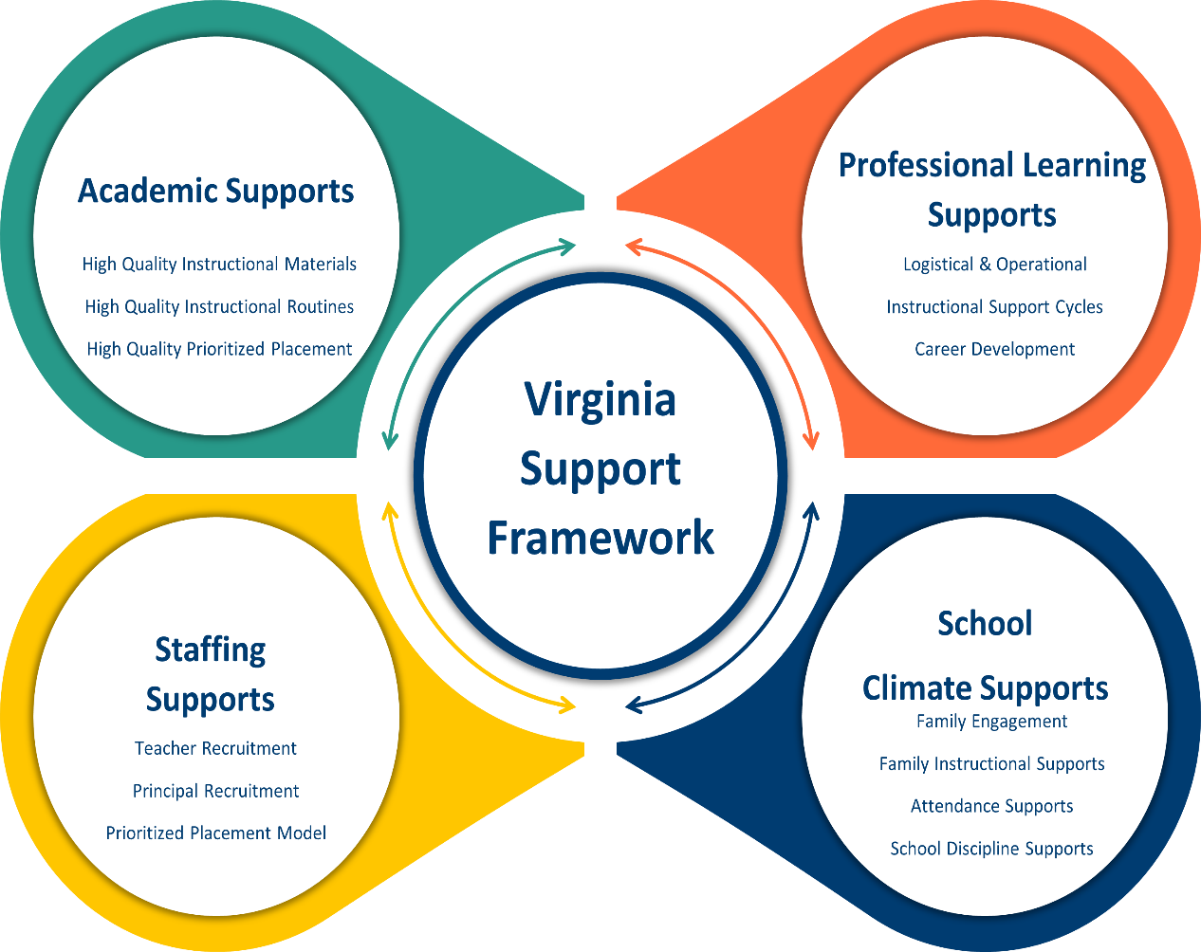

Profile Information
Division: | School:
Principal: | Designations (if applicable):
Stakeholder/Family Engagement
Describe how the school will routinely involve internal and external stakeholders in the school improvement process to include conducting the needs assessment; selecting evidence-and research-based strategies; and developing, implementing, monitoring, and evaluating the plan.
Domain I: Academic Supports |  |  | Content Area: Choose an Item
Barrier(s):
SMART Goal Statement:
(Evidence-based) Strategy Name:  Tier of Evidence: Choose an item. |  | Description:
Student Measure #1: |  | Student Measure #2:
Staff Measure #1: |  | Staff Measure #2:
Action Plan
Action Steps  (Describe the step and include who will implement and how often it will be implemented) | Start of Action Step | End of Action Step | Position Responsible for Monitoring | Budget (local, state, federal funds)
Local Educational Agency (LEA) Support: Describe how the LEA will support in implementing, monitoring, and evaluating this strategy.
Evidence: Based on the action steps, define what measurable evidence would indicate progress towards the long-term goal.
Analysis: Address impact and next steps.
Evidence of Progress (update monthly) |  | Analysis of Progress (update monthly)
Domain of Support
Domain II: Staffing Supports
Barrier(s):
SMART Goal Statement:
(Evidence-based) Strategy Name:  Tier of Evidence: Choose an item. |  | Description:
Student Measure #1: |  | Student Measure #2:
Staff Measure #1: |  | Staff Measure #2:
Action Plan
Action Steps  (Describe the step and include who will implement and how often it will be implemented) | Start of Action Step | End of Action Step | Position Responsible for Monitoring | Budget (local, state, federal funds)
Local Educational Agency (LEA) Support: Describe how the LEA will support in implementing, monitoring, and evaluating this strategy.
Evidence: Based on the action steps, define what measurable evidence would indicate progress towards the long-term goal.
Analysis: Address impact and next steps.
Evidence of Progress (update monthly) |  | Analysis of Progress (update monthly)

Domain of Support
Domain III: Professional Learning Supports
Barrier(s):
SMART Goal Statement:
(Evidence-based) Strategy Name:  Tier of Evidence: Choose an item. |  | Description:
Student Measure #1: |  | Student Measure #2:
Staff Measure #1: |  | Staff Measure #2:
Action Plan
Action Steps  (Describe the step and include who will implement and how often it will be implemented) | Start of Action Step | End of Action Step | Position Responsible for Monitoring | Budget (local, state, federal funds)
Local Educational Agency (LEA) Support: Describe how the LEA will support in implementing, monitoring, and evaluating this strategy.
Evidence: Based on the action steps, define what measurable evidence would indicate progress towards the long-term goal.
Analysis: Address impact and next steps.
Evidence of Progress (update monthly) | Analysis of Progress (update monthly)

Domain IV: School Climate Supports
Barrier(s):
SMART Goal Statement:
(Evidence-based) Strategy Name:  Tier of Evidence: Choose an item. |  | Description:
Student Measure #1: |  | Student Measure #2:
Staff Measure #1: |  | Staff Measure #2:
Action Plan
Action Steps  (Describe the step and include who will implement and how often it will be implemented) | Start of Action Step | End of Action Step | Position Responsible for Monitoring | Budget (local, state, federal funds)
Local Educational Agency (LEA) Support: Describe how the LEA will support in implementing, monitoring, and evaluating this strategy.
Click or tap here to enter text.
Evidence: Based on the action steps, define what measurable evidence would indicate progress towards the long-term goal.
Analysis: Address impact and next steps.
Evidence of Progress (update monthly) | Analysis of Progress (update monthly)

In accordance with the Standards of Quality (SOQ) and Standards of Accreditation (SOA), all schools are to prepare a comprehensive, unified, long-range plan in conjunction with the division long-range comprehensive plan, and make it available to the public (SOQ, § 22.1-253.13:6.; SOA 8VAC20-131-390; 8VAC20-131-400). Under the Every Student Succeeds Act (ESSA), schools identified for comprehensive, targeted, and additional targeted support and improvement are required to develop plans based on a set criteria with state educational agency (SEA), local educational agency (LEA), and school approval (ESSA §1111(d)(1)(B); §1111(d)(2)(B)-(C))

