Attachment A

SNP Memo #2023-2024-59

March 7, 2024

SNPWeb Community Eligibility Provision Site Eligibility Report Checklist 2024
The report for all schools/sites in the school food authority (SFA) is due in SNPWeb by Monday, April 15, 2024, at 5:00 p.m.
Listen to the e-learning module for the April 1 Identified Student Percentage (ISP) report on the Virginia Department of Education, Office of School and Community Nutrition Programs (VDOE-SCNP) Rise.com e-learning portal.
Information needed to complete the report:
For the number of identified students (free only by direct certification (DC) and categorical eligibility) reported on April 1, two sets of documentation are required. The number of identified students report AND a back-up report with individual student details to support the number of identified students reported on April 1, in SNPWeb.
  - Work with your software vendor to create an electronic sortable report (such as an Excel spreadsheet) as backup for the number of free DC and categorically eligible identified students reported as of April 1, 2024, from your local eligibility software.
    - The report of identified students must be in sortable Excel format by school and include the following details for each identified student:
      - student’s first and last names
      - LEA student ID number;
      - school name or number of the school the student attended for lunch on April 1;
      - student’s free eligibility without application type (DC SNAP, DC TANF, DC Medicaid Free, homeless, migrant, runaway, foster care, certain eligible Head Start); and
      - student’s eligibility status date.
    - Do not include any students determined free eligible by an application, with income or case number, and students determined reduced-price eligible by any means, including Medicaid DC reduced-price, in the identified students report.
  - Important: SFAs are required to maintain documentation to support the identified student percentage reported in SNPWeb as of April 1, 2024. Detailed documentation of the identified students and the total membership must be maintained and will be used for the CEP application.
    - Identified student documentation includes both the total number of identified students by school and the back-up identified student detail for each school in an electronic sortable file (such as an Excel spreadsheet) listing all DC/categorically eligible free students (including the 5 data points listed above) that is the same as the number of identified students reported in the SNPWeb CEP Site Eligibility Report.
      - Acceptable documentation does not include a paper or PDF report, or a report with only the number of DC/categorically eligible free students as of April 1.
For the school membership (enrollment) for school nutrition programs:
  - Use the school/site Principal’s Monthly Report by school as of April 1, 2024, to determine the school membership (enrollment).
    - The terms membership and enrollment are used interchangeably by the USDA. For this report, include only students who would have access to at least one meal at the school, which is typically reported in Virginia records as membership.
    - The Principal’s Monthly Report membership number is usually the number that reflects currently active students. The smaller of enrollment vs. membership usually reflects the students with access to meals at school.
  - If there are students who attend an National School Lunch Program school and receive reimbursable meals at that school but are not reported in the membership data for the school in the Principal’s Monthly Report, such as certain Head Start students, Virginia Pre-school Initiative (VPI), and alternative education students, obtain the membership documentation for those students and ADD that membership to the Principal’s Monthly Report to determine the total NSLP membership for the school.
  - Maintain reports on file in the SFA as documentation of the enrollment reported.
Determine the total number of identified students and the total enrollment/membership.
Log into SSWS and the SNPWeb software.
From the main screen, select the Applications tab. Scroll down the item list to Community Eligibility Provision (CEP) and select it.
View the CEP Site List screen. Under Action, select Add for the 2023–2024 school year.
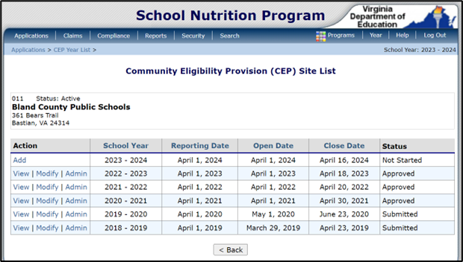
View the complete list of schools/sites for the SFA. Schools/sites are in site number order using the official name from the VDOE database.
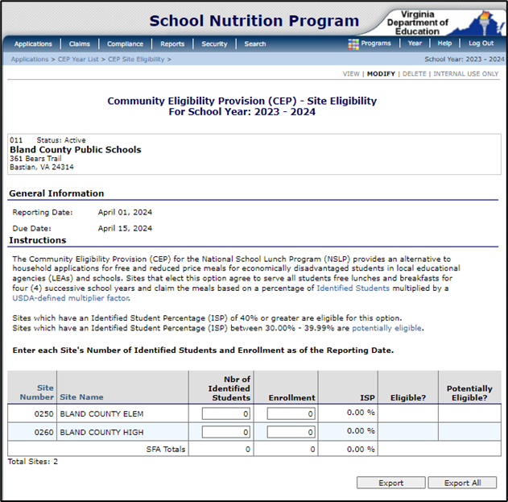

There are two fields open for data entry: Number of Identified Students and Enrollment. Enter the number of identified students (Free by DC or categorically eligible free from explanation above) and the total SNP enrollment for each school/site. SNPWeb will calculate the ISP and Eligible/Potentially Eligible columns.
Review the data. Click the red Save button at the bottom to trigger the SNPWeb edits.
If error messages appear at the top of the screen, review and edit data. Select Save when finished.
To return to the report after saving, select Modify from the CEP Site List screen.
When data is complete, with no error messages, select Save to submit. If there are no errors, the Save Confirmation screen will appear. Select Finish to confirm and submit the report.
The report is complete and submitted when the status to the right displays Submitted.
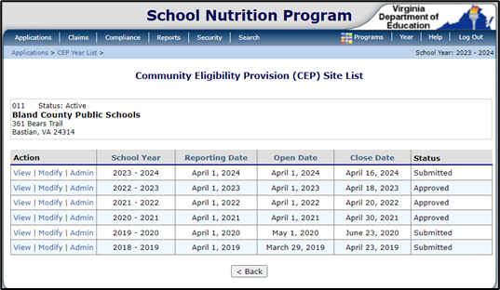
VDOE-SCNP staff will review the report and contact the SFA if edits are needed. When the report has been approved, as part of the CEP application validation process, if applicable, the status to the right will be updated to Approved.

