2023 Mathematics Standards of Learning
Understanding the Standards – Grade 8
The Understanding the Standards document includes the mathematics understandings and key concepts that assist teachers in planning standards-focused instruction of the eighth grade 2023 Mathematics Standards of Learning. The Understanding the Standards includes definitions, explanations, and examples regarding each mathematics standard and describes what students should know (core knowledge) as a result of the instruction specific to the course/grade level.

Number and Number Sense
8.NS.1 The student will compare and order real numbers and determine the relationships between real numbers.
Students will demonstrate the following Knowledge and Skills:
- Estimate and identify the two consecutive natural numbers between which the positive square root of a given number lies and justify which natural number is the better approximation. Numbers are limited to natural numbers from 1 to 400.
- Use rational approximations (to the nearest hundredth) of irrational numbers to compare, order, and locate values on a number line. Radicals may include both positive and negative square roots of values from 0 to 400 yielding an irrational number.
- Use multiple strategies (e.g., benchmarks, number line, equivalency) to compare and order no more than five real numbers expressed as integers, fractions (proper or improper), decimals, mixed numbers, percents, numbers written in scientific notation, radicals, and π. Radicals may include both positive and negative square roots of values from 0 to 400. Ordering may be in ascending or descending order. Justify solutions orally, in writing or with a model.
8.NS.1 The student will compare and order real numbers and determine the relationships between real numbers.
Additional Content Background and Instructional Guidance:
- A perfect square is a whole number whose square root is an integer.
- The square root of a given number is any number which, when multiplied by itself, equals the given number.
- Both the positive and negative roots of whole numbers, except zero, can be determined. The square root of zero is zero. The value is neither positive nor negative. Zero (a whole number) is a perfect square.
- The positive and negative square root of any whole number other than a perfect square lies between two consecutive integers (e.g., $\sqrt{57}$ lies between 7 and 8 since $7^{2}$ = 49 and $8^{2}$ = 64; $-\sqrt{11}$ lies between $-4$ and $-3$ since ${(-4)}^{2}$= 16 and ${(-3)}^{2}$ = 9, and 11 lies between 9 and 16).
- The symbol may be used to represent a positive (principal) root and - may be used to represent a negative root.
- The square root of a whole number that is not a perfect square is an irrational number (e.g., $\sqrt{2 }$is an irrational number). An irrational number cannot be expressed exactly as a fraction $\frac{a}{b}$ where $b≠0$.
- Square root symbols may be used to represent solutions to equations of the form x² = p. Examples may include:
  - If x² = 36, then x is $\sqrt{36}$ = 6 or $-\sqrt{36}$ = $-6$.
  - If x² = 5, then x is $\sqrt{5}$ or −$\sqrt{5}$.
- Grid paper and estimation can be used to determine what is needed to build a perfect square. The square root of a positive number can be defined as the side length of a square with an area equal to the given number. If it is not a perfect square, the area provides a means for estimation.
- Real numbers can be represented as integers, fractions (proper or improper), decimals, percents, numbers written in scientific notation, radicals, and π. Methods for comparing and ordering include using benchmarks, models, number lines, and conversion to one representation.
- Proper fractions, improper fractions, and mixed numbers are terms often used to describe fractions. A proper fraction is a fraction whose numerator is less than the denominator. An improper fraction is a fraction whose numerator is equal to or greater than the denominator (equal to or greater than the integer 1). An improper fraction may be expressed as a mixed number. A mixed number is written with two parts: a whole number and a proper fraction (e.g., 3$\frac{5}{8}$). Fractions can have a positive or negative value.
- The density property states that between any two real numbers lies another real number. For example, between 3 and 5, the number 4 can be found; between 4.0 and 4.2, the number 4.16 can be found; between 4.16 and 4.17, the number 4.165 can be found; between 4.165 and 4.166, the number 4.1655 can be found, etc. Thus, there is always another number between any two numbers. Students are not expected to know the term density property, but the concept allows for a deeper understanding of the set of real numbers.

8.NS.2 The student will investigate and describe the relationship between the subsets of the real number system.
Students will demonstrate the following Knowledge and Skills:
- Describe and illustrate the relationships among the subsets of the real number system by using representations (e.g., graphic organizers, number lines). Subsets include rational numbers, irrational numbers, integers, whole numbers, and natural numbers.
- Classify and explain why a given number is a member of a particular subset or subsets of the real number system.
- Describe each subset of the set of real numbers and include examples and non-examples.
8.NS.2 The student will investigate and describe the relationship between the subsets of the real number system.
Additional Content Background and Instructional Guidance:
- The subsets of real numbers include natural numbers (counting numbers), whole numbers, integers, rational and irrational numbers.
- Some numbers can belong to more than one subset of the real numbers (e.g., 4 is a natural number, a whole number, an integer, and a rational number). The attributes of one subset can be contained in whole or in part in another subset. The relationships between the subsets of the real number system can be illustrated using graphic organizers (e.g., Venn diagrams) and number lines.
- The set of natural numbers is the set of counting numbers {1, 2, 3, 4...}.
- The set of whole numbers includes the set of all the natural numbers and zero {0, 1, 2, 3…}.
- The set of integers includes the set of whole numbers and their opposites {…-2, -1, 0, 1, 2…}. Zero has no opposite and is neither positive nor negative.
- The set of rational numbers includes the set of all numbers that can be expressed as fractions in the form $\frac{a}{b}$ where a and b are integers and b does not equal zero. The decimal form of a rational number can be expressed as a terminating or repeating decimal. A few examples of rational numbers are 25, -2.3, 75%, 4.59, and $0.\overline{3}$.
- The set of irrational numbers is the set of all nonrepeating, nonterminating decimals. An irrational number cannot be written in fraction form (e.g., π, 1.232332333…).
- The real number system is comprised of all rational and irrational numbers. The subsets of the real number system can be seen in the image below.
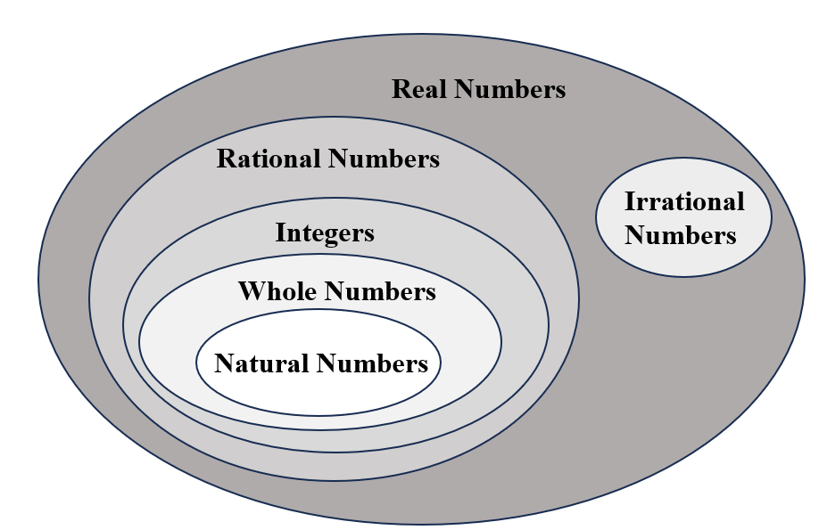

Computation and Estimation
8.CE.1 The student will estimate and apply proportional reasoning and computational procedures to solve contextual problems.
Students will demonstrate the following Knowledge and Skills:
- Estimate and solve contextual problems that require the computation of one discount or markup and the resulting sale price.
- Estimate and solve contextual problems that require the computation of the sales tax, tip and resulting total.
- Estimate and solve contextual problems that require the computation of the percent increase or decrease.
8.CE.1 The student will estimate and apply proportional reasoning and computational procedures to solve contextual problems.
Additional Content Background and Instructional Guidance:
- Proportional reasoning can be used to solve contextual problems that include percents where scaling up and down is efficient.
- A percent is a ratio with a denominator of 100.
- Contextual problems may include, but are not limited to, those related to economics, sports, science, social science, transportation, and health. Some examples include problems involving fees, the discount or markup price on a product, temperature, sales tax, tip, and installment buying.
- Percent increase and percent decrease are both percents of change measuring the percent a quantity increases or decreases.

Measurement and Geometry
8.MG.1 The student will use the relationships among pairs of angles that are vertical angles, adjacent angles, supplementary angles, and complementary angles to determine the measure of unknown angles.
Students will demonstrate the following Knowledge and Skills:
- Identify and describe the relationship between pairs of angles that are vertical, adjacent, supplementary, and complementary.
- Use the relationships among supplementary, complementary, vertical, and adjacent angles to solve problems, including those in context, involving the measure of unknown angles.
8.MG.1 The student will use the relationships among pairs of angles that are vertical angles, adjacent angles, supplementary angles, and complementary angles to determine the measure of unknown angles.
Additional Content Background and Instructional Guidance:
- Vertical angles are a pair of nonadjacent angles formed by two intersecting lines. Vertical angles are congruent and share a common vertex. In the image below, Angles 1 and 2 are vertical angles. Angles 3 and 4 are also vertical angles.
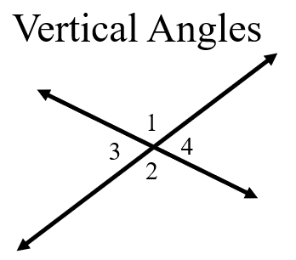
- Complementary angles are any two angles such that the sum of their measures is 90°. In the image below, Angles 1 and 2 are complementary angles.
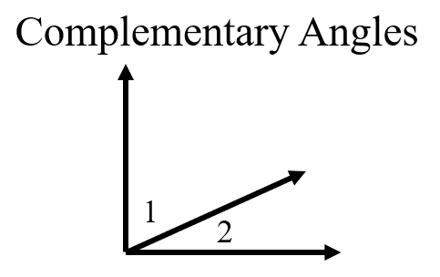
- Supplementary angles are any two angles such that the sum of their measures is 180°. In the image below, Angles 1 and 2 are supplementary angles.
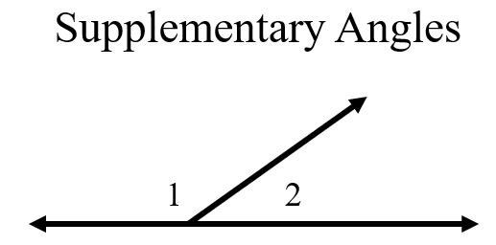
- Complementary and supplementary angles may or may not be adjacent.
- Adjacent angles are any two non-overlapping angles that share a common ray and a common vertex.
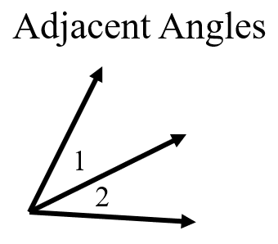
- The content in this standard provides a natural connection to 8.PFA.4. During instruction, students would benefit from opportunities to solve problems about the relationships of angles where unknown angles measures are given as expressions (e.g., a pair of vertical angles whose measures are $(6x+38)$ and $(7x+26)$.

8.MG.2 The student will investigate and determine the surface area of square-based pyramids and the volume of cones and square-based pyramids.
Students will demonstrate the following Knowledge and Skills:
- Determine the surface area of square-based pyramids by using concrete objects, nets, diagrams, and formulas.
- Determine the volume of cones and square-based pyramids, using concrete objects, diagrams, and formulas.
- Examine and explain the relationship between the volume of cones and cylinders, and the volume of rectangular prisms and square based pyramids.
- Solve problems in context involving volume of cones and square-based pyramids and the surface area of square-based pyramids.
8.MG.2 The student will investigate and determine the surface area of square-based pyramids and the volume of cones and square-based pyramids.
Additional Content Background and Instructional Guidance:
- A polyhedron is a solid figure whose faces are all polygons.
- A net is a two-dimensional representation of a three-dimensional figure that can be folded into a model of the three-dimensional figure.
- Surface area of a solid figure is the sum of the areas of the surfaces of the figure.
- Volume is the amount a container holds.
- A rectangular prism is a polyhedron that has a congruent pair of parallel rectangular bases and four faces that are rectangles. A rectangular prism has eight vertices and twelve edges. In Grade 8, prisms are limited to right prisms with bases that are rectangles.
- The volume of prisms can be found by determining the area of the base and multiplying that by the height (e.g., V = $Bh$).
- A cone is a solid figure formed by a face called a base that is joined to a vertex (apex) by a curved surface. In Grade 8, cones are limited to right circular cones.
- The volume of a cone is found by using $V=\frac{1}{3}πr^{2}h$ where h is the height and πr² is the area of the base.
- A square-based pyramid is a polyhedron with a square base and four faces that are congruent triangles with a common vertex (apex) above the base. In Grade 8, pyramids are limited to right regular pyramids with a square base.
- The volume of a pyramid is found by using the formula V = $\frac{1}{3}Bh$, where B is the area of the base and h is the height.
- The surface area of a pyramid is the sum of the areas of the triangular faces and the area of the base, found by using the formula $SA=\frac{1}{2}lp+B$, where l is the slant height, p is the perimeter of the base and B is the area of the base.
- The formulas for determining the volume of cones and cylinders are related. For cones, the volume is $\frac{1}{3}$ of the volume of the cylinder with the same size base and height. The volume of a cone is found by using $V=\frac{1}{3}πr^{2}h$. The volume of a cylinder is the area of the base of the cylinder multiplied by the height, found by using the formula, V = πr²h, where h is the height and πr² is the area of the base.
- The formulas for determining the volume of pyramids and rectangular prisms are related. For pyramids, the volume is $\frac{1}{3}$ of the volume of the rectangular prism with the same size base and height. The volume of a square pyramid is found by using $V=\frac{1}{3}Bh$. The volume of a rectangular prism can be found using the formula, V = Bh, where B is the area of the base, and h is the height.
- The relationship between the volume of a cone and cylinder and the volume of a pyramid and rectangular prism with equivalent base areas and heights is a ratio of 1 to 3. This relationship can be explored with concrete materials.

8.MG.3 The student will apply translations and reflections to polygons in the coordinate plane.
Students will demonstrate the following Knowledge and Skills:
- Given a preimage in the coordinate plane, identify the coordinates of the image of a polygon that has been translated vertically, horizontally, or a combination of both.
- Given a preimage in the coordinate plane, identify the coordinates of the image of a polygon that has been reflected over the x- or y-axis.
- Given a preimage in the coordinate plane, identify the coordinates of the image of a polygon that has been translated and reflected over the x- or y-axis or reflected over the x- or y-axis and then translated.
- Sketch the image of a polygon that has been translated vertically, horizontally, or a combination of both.
- Sketch the image of a polygon that has been reflected over the x- or y-axis.
- Sketch the image of a polygon that has been translated and reflected over the x- or y-axis, or reflected over the x- or y-axis and then translated.
- Identify and describe transformations in context (e.g., tiling, fabric, wallpaper designs, art).
8.MG.3 The student will apply translations and reflections to polygons in the coordinate plane.
Additional Content Background and Instructional Guidance:
- A transformation of a figure, called the preimage, changes the size, shape, and/or position of the figure to a new figure, called the image.
- A transformation of preimage point A can be denoted as the image A’ (read as “A prime”).
- A reflection is a transformation in which an image is formed by reflecting the preimage over a line called the line of reflection. Each point on the image is the same distance from the line of reflection as the corresponding point in the preimage.
- Reflections change the orientation of the image.
- A translation is a transformation in which an image is formed by moving every point on the preimage the same distance in the same direction. Linear equations of the form $y=mx+0$will be translated to $y=mx+b$ in SOL 8.PFA.3a,b.
- Translations and reflections maintain congruence between the preimage and image but change location on the coordinate plane.
- Students in Grade 7 had experiences with dilations. A dilation is a transformation in which an image is formed by enlarging or reducing the preimage proportionally by a scale factor from the center of dilation (limited to the origin in Grade 7). A dilation of a figure and the original figure are similar. The center of dilation may or may not be on the preimage.
- The result of first translating and then reflecting over the x- or y-axis may not result in the same transformation of reflecting over the x- or y-axis and then translating.
- Contextual applications of transformations may include, but are not limited to, the following:
- A reflection of a boat in water shows an image of the boat flipped upside down with the water line being the line of reflection.
- A translation of a figure on a wallpaper pattern shows the same figure slid the same distance in the same direction.
- A dilation of a model airplane is the production model of the airplane.
8.MG.4 The student will apply the Pythagorean Theorem to solve problems involving right triangles, including those in context.
Students will demonstrate the following Knowledge and Skills:
- Verify the Pythagorean Theorem using diagrams, concrete materials, and measurement.
- Determine whether a triangle is a right triangle given the measures of its three sides.
- Identify the parts of a right triangle (the hypotenuse and the legs) given figures in various orientations.
- Determine the measure of a side of a right triangle, given the measures of the other two sides.
- Apply the Pythagorean Theorem, and its converse, to solve problems involving right triangles in context.
8.MG.4 The student will apply the Pythagorean Theorem to solve problems involving right triangles, including those in context.
Additional Content Background and Instructional Guidance:
- The Pythagorean Theorem is essential for solving problems involving right triangles.
- The hypotenuse of a right triangle is the side opposite the right angle.
- The hypotenuse of a right triangle is always the longest side of the right triangle.
- The legs of a right triangle form the right angle.
- In a right triangle, the square of the length of the hypotenuse equals the sum of the squares of the legs. This relationship is known as the Pythagorean Theorem: a² + b² = c².
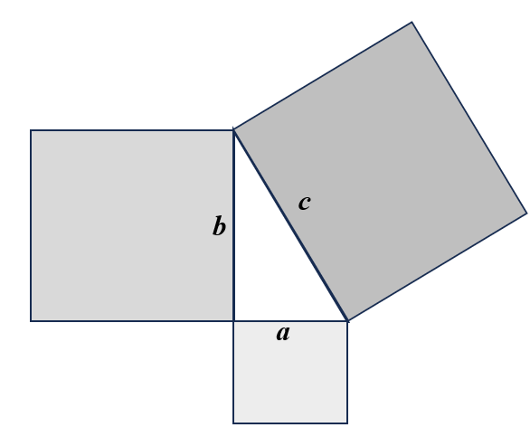
- The Pythagorean Theorem is used to determine the measure of any one of the three sides of a right triangle when the measures of the other two sides are known.
- The converse of the Pythagorean Theorem states that if the square of the length of the hypotenuse equals the sum of the squares of the legs in a triangle, then the triangle is a right triangle. This can be used to determine whether a triangle is a right triangle given the measures of its three sides.
- The triangle inequality theorem states that the sum of any two sides of a triangle is greater than or equal to the third side. This theorem can be explored to check for reasonableness of solutions.
- Whole number triples that are the measures of the sides of right triangles, such as (3, 4, 5) and (5, 12, 13), are commonly known as Pythagorean triples. Additional sets of Pythagorean triples can be found by applying properties for similar triangles and proportional sides. For example, doubling the sides of a triangle with sides of (3, 4, 5) creates a Pythagorean triple of (6, 8, 10).
- The Pythagorean theorem can be applied to many contextual situations, including but not limited to, architecture, construction, sailing, and space flight.
8.MG.5 The student will solve area and perimeter problems involving composite plane figures, including those in context.
Students will demonstrate the following Knowledge and Skills:
- Subdivide a plane figure into triangles, rectangles, squares, trapezoids, parallelograms, circles, and semicircles. Determine the area of subdivisions and combine to determine the area of the composite plane figure.
- Subdivide a plane figure into triangles, rectangles, squares, trapezoids, parallelograms, and semicircles. Use the attributes of the subdivisions to determine the perimeter of the composite plane figure.
- Apply perimeter, circumference, and area formulas to solve contextual problems involving composite plane figures.
8.MG.5 The student will solve area and perimeter problems involving composite plane figures, including those in context.
Additional Content Background and Instructional Guidance:
- A plane figure is any two-dimensional shape that can be drawn in a plane.
- A composite figure is any figure that can be subdivided into two or more shapes.
- The perimeter is the path or distance around any plane figure. The perimeter of a circle is called the circumference.
- The area is the surface included within a plane figure.
- The area of a composite figure can be found by subdividing the figure into triangles, rectangles, squares, trapezoids, parallelograms, circles, and semicircles; calculating their areas; and adding the areas together to get the total area of the composite figure.
- The area of a triangle is computed by multiplying the measure of its base by the measure of its height and dividing the product by 2 or multiplying by $\frac{1}{2}\left(A=\frac{bh}{2} or A=\frac{1}{2}bh\right)$.
- The area of a rectangle is computed by multiplying the lengths of two adjacent sides ($A=bh$).
- The area of a square is computed by multiplying the length of a side by itself ($A=s⋅s$ or $A=s^{2}$).
- The area of a trapezoid is computed by taking the average of the measures of the two bases and multiplying this average by the height ($A=\frac{1}{2}h\left(b_{1}+b_{2}\right)$). A trapezoid can be considered a composite figure composed of triangle(s) and a rectangle.
- The area of a parallelogram is computed by multiplying the measure of its base by the measure of its height ($A = bh$). A parallelogram can be considered a composite figure composed of two triangles and a rectangle or two triangles.
- The area of a circle is computed by multiplying pi times the radius squared ($A=πr^{2}$).
- The circumference of a circle is found by multiplying pi by the diameter or multiplying pi by 2 times the radius ($C=πd$or $C=2πr$).
- The area of a semicircle is half the area of a circle with the same diameter or radius.

Probability and Statistics
8.PS.1 The student will use statistical investigation to determine the probability of independent and dependent events, including those in context.
Students will demonstrate the following Knowledge and Skills:
- Determine whether two events are independent or dependent and explain how replacement impacts the probability.
- Compare and contrast the probability of independent and dependent events.
- Determine the probability of two independent events.
- Determine the probability of two dependent events.
8.PS.1 The student will use statistical investigation to determine the probability of independent and dependent events, including those in context.
Additional Content Background and Instructional Guidance:
- The probability of two events occurring can be represented as a ratio or the equivalent fraction, decimal, or percent.
- The probability of an event occurring is a ratio between 0 and 1. A probability of zero means the event will never occur (i.e., it is impossible). A probability of one means the event will always occur (i.e., it is certain).
- Two events are either dependent or independent.
- If the outcome of one event does not influence the occurrence of the other event, they are called independent. If two events are independent, then the probability of the second event does not change regardless of whether the first occurs. For example:
  - The first roll of a number cube does not influence the second roll of the number cube
  - Spinning a spinner and rolling a number cube
  - Flipping a coin and selecting a card
- If two events occur with replacement, the outcome of one event does not influence the occurrence of the other event. Thus, the two events are independent because the probability of the second event does not change regardless of whether the first occurs. Some examples include:
  - Choosing a card from a deck, replacing the card, and selecting again
  - Choosing a marble from a bag, replacing the marble, and selecting again
- The probability of two independent events is found by multiplying the probability of the first event by the probability of the second event or using the following formula:$P\left(A and B\right)= P\left(A\right)∙P\left(B\right)$. For example:
  - When simultaneously rolling a six-sided number cube and flipping a coin, what is the probability of rolling a 3 on the cube and getting a heads on the coin?
$$P\left(3 and heads\right)=\frac{1}{6}⋅\frac{1}{2}=\frac{1}{12}$$
  - There is a bag with 8 blue marbles, 7 green marbles, and 5 red marbles. What is the probability of selecting a blue marble, replacing it, then selecting a green marble?
$$P\left(blue and green\right)=P\left(blue\right)⋅P\left(green after blue is replaced\right)$$
$$P\left(blue and green\right)=\frac{8}{20}⋅\frac{7}{20}=\frac{56}{400}=\frac{7}{50}$$
- If the outcome of one event has an impact on the outcome of the other event, the events are called dependent. If events are dependent, then the second event is considered only after the first event has already occurred. For example:
  - If two events occur without replacement, the outcome of the first event has an impact on the outcome of the second event. Thus, the probability of the second event changes as a result of the first event occurring. Some examples include:
    - Choosing a blue card from a set of nine different colored cards that has a total of four blue cards and not replacing the blue card back in the set before selecting a second card. The chance of selecting a blue card the second time is diminished because there are now only three blue cards remaining in the set.
    - Choosing two marbles from a bag but not replacing the first after selecting it.
- The probability of two dependent events is found by multiplying the probability of the first event by the probability of the second event after the first event has occurred or using the following formula: $P\left(A and B\right)=P\left(A\right)⋅P\left(B after A\right)$. For example:
  - There is a bag containing a blue ball, a red ball, and a yellow ball. What is the probability of picking a blue ball out of the bag on the first pick, and then, without replacing the blue ball in the bag, picking a red ball on the second pick?
$P\left(blue and red\right)=P\left(blue\right)⋅P\left(red after blue\right)$ $=$ $\frac{1}{3}∙\frac{1}{2}=\frac{1}{6}$
  - You are holding all of the jacks, queens, and kings in a deck of cards. What is the probability of choosing a queen on the first pick, and then, without replacing the queen in the pile, choosing a king on the second pick?
$P\left(queen and king\right)=P\left(queen\right)⋅P\left(king after queen\right)$ $=$ $\frac{4}{12}∙\frac{4}{11}=\frac{16}{132}= \frac{4}{33}$

8.PS.2 The student will apply the data cycle (formulate questions; collect or acquire data; organize and represent data; and analyze data and communicate results) with a focus on boxplots.
Students will demonstrate the following Knowledge and Skills:
- Formulate questions that require the collection or acquisition of data with a focus on boxplots.
- Determine the data needed to answer a formulated question and collect the data (or acquire existing data) using various methods (e.g., observations, measurement, surveys, experiments).
- Determine how statistical bias might affect whether the data collected from the sample is representative of the larger population.
- Organize and represent a numeric data set of no more than 20 items, using boxplots, with and without the use of technology.
- Identify and describe the lower extreme (minimum), upper extreme (maximum), median, upper quartile, lower quartile, range, and interquartile range given a data set, represented by a boxplot.
- Describe how the presence of an extreme data point (outlier) affects the shape and spread of the data distribution of a boxplot.
- Analyze data represented in a boxplot by making observations and drawing conclusions.
- Compare and analyze two data sets represented in boxplots.
- Given a contextual situation, justify which graphical representation (e.g., pictographs, bar graphs, line graphs, line plots/dot plots, stem-and-leaf plots, circle graphs, histograms, and boxplots) best represents the data.
- Identify components of graphical displays that can be misleading.
8.PS.2 The student will apply the data cycle (formulate questions; collect or acquire data; organize and represent data; and analyze data and communicate results) with a focus on boxplots.
Additional Content Background and Instructional Guidance:
- Students should explore the entire data cycle with a question and set of data that has been collected or acquired. Student reflection should occur throughout the data cycle. The data cycle includes the following steps: formulating questions to be explored with data, collecting or acquiring data, organizing and representing data, and analyzing and communicating results.
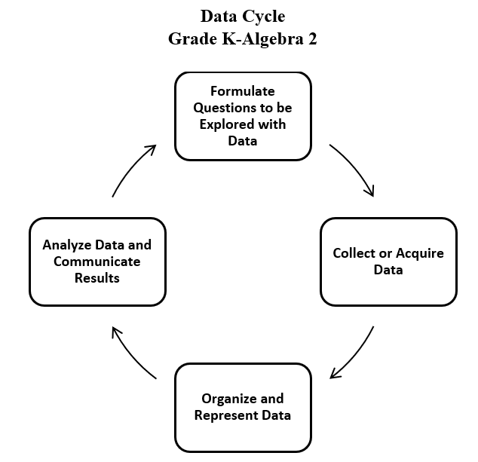
- To collect data for any problem situation, an experiment can be designed, a survey can be conducted, or other data-gathering strategies can be used. The data can be organized, displayed, analyzed, and interpreted to solve the problem.
- The teacher can provide data sets in addition to students engaging in their own data collection or acquisition.
- A population is the entire set of individuals or items from which data is drawn for a statistical study.
- A sample is a data set that you obtain from a subset that represents an entire population. This data set can be used to make reasonable assumptions about the whole population.
- Sampling is the process of selecting a suitable sample, or a representative part of a population, for the purpose of determining characteristics of the whole population.
- An example of a population would be the entire student body at a school, whereas a sample might be only one grade level in the entire student body at a school. A sample may or may not be representative of the population as a whole. Questions to consider when determining whether an identified sample is representative of the population include:
  - What is the target population of the formulated question?
  - Who or what is the subject or context of the question?
- A random sample is one in which each member of the population has an equal chance of being selected. Random samples can be used to ensure that the sample is representative of the population and to avoid bias.
- Sample size refers to the number of participants or observations included in a study. Statistical data may be more accurate, and outliers may be more easily identified with larger sample sizes.
- Examples of questions to consider in building good samples:
  - What is the context of the data to be collected?
  - Who is the audience?
  - What amount of data should be collected?
- Bias may limit the degree to which accurate conclusions can be drawn. Errors in collecting and organizing the data may also contribute to bias.
- Bias may influence data analysis and may result in misleading generalizations and only support one opinion or view.
- Sampling bias may occur when members of a population are systematically more likely to be chosen over other members of the same population. In other words, sampling bias does not ensure proper randomization.
- Numerical univariate data refers to information gathered around a single characteristic. Examples include scores on assessments, distance to school, time spent looking at social media, hours spent practicing a hobby, etc.
- A boxplot (box-and-whisker plot) is a convenient and informative way to represent single-variable (univariate) data.
- A boxplot uses a rectangle to represent the middle half of a set of data and lines (whiskers) at both ends to represent the remainder of the data. The median is marked by a vertical line inside the rectangle.
- The five critical points in a boxplot, commonly referred to as the five-number summary, are lower extreme (minimum), lower quartile, median, upper quartile, and upper extreme (maximum). Each of these points represents the bounds for the four quartiles. In the example below, the lower extreme is 15, the lower quartile is 19, the median is 21.5, the upper quartile is 25, and the upper extreme is 29.
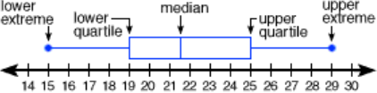
- A quartile is a value, a position on the number line, that separates the data into four sections. These values provide information about what approximate percent of the data falls below that value. The lower quartile is the median of the data points to the left of the median and is referred to as the 25th percentile; the median is referred to as the 50th percentile; and the upper quartile is the median of the data points to the right of the median and is referred to as the 75th percentile.
- To determine the values of the five critical points in a boxplot, first the data should be written in ranked order. Then, the five points can be found as follows:
  - Lower extreme: the smallest data point (minimum);
  - Lower quartile: the middle value of the data points to the left of the median (Note: if there are an odd number of data values, the median should not be considered when calculating the lower quartile);
  - Median: if there are an odd number of data points, the median is the middle value; if there are an even number of data points, the median is the arithmetic average of the two middle values;
  - Upper quartile: the middle value of the data points to the right of the median (Note: if there are an odd number of data values, the median should not be considered when calculating the upper quartile); and,
  - Upper extreme: the largest data point (maximum).
- Example: Calculate the median, lower quartile, and upper quartile for the following data set.
3 5 6 7 8 9 11 13 13
Median: 8; Lower Quartile: 5.5; Upper Quartile: 12
- The range is the difference between the upper extreme and the lower extreme.
- The interquartile range (IQR) is the difference between the upper quartile and the lower quartile. Using the example data set above, the range is 10 or 13 – 3. The interquartile range is 6.5 or 12 – 5.5.
- Boxplots are effective at giving an overall impression of the shape, center, and spread of the data. They do not show a distribution in as much detail as a stem-and-leaf plot or a histogram.
- A boxplot allows for quick analysis of a set of data by identifying key statistical measures (median and range) and major concentrations of data.
- Technology, such as graphing utilities and spreadsheets, can be used to construct box plots.
- In the pulse rate example, shown below, many students incorrectly interpret that longer sections contain more data and shorter ones contain less. It is important to remember that roughly the same amount of data is in each section. The numbers in the left whisker (lowest of the data) are spread less widely than those in the right whisker.
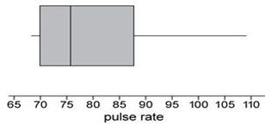
- Boxplots are useful when evaluating and describing spread of data, representing data by percentages, and comparing information about two numerical data sets. The example below compares the test scores for a college class offered at two different times.
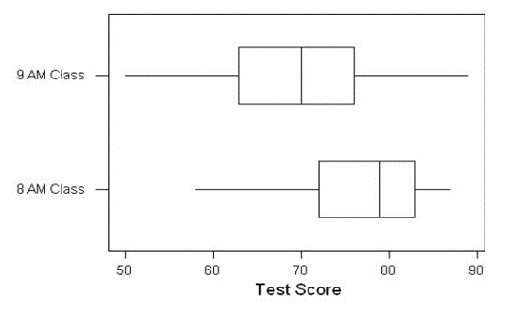
- Using these boxplots, possible interpretations could include, but are not limited to:
  - The 8 am class had a greater median test score than the 9 am class.
  - The highest scoring student was in the 9 am class.
  - The probability of selecting a student who passed the test is greater in the 8 am class than the 9 am class.
  - If a passing score is 70%, then 75% of the students in the 8 am class passed the test.
  - More students failed in the 9 am class if the passing score is 70%.
- An outlier can be identified by sorting the data in ascending order. A data value that is an abnormal distance relative to the other values in the data set is an outlier. It represents a value that "lies outside" (is much smaller or larger than) most of the other values in a set of data. Outliers have a greater effect on the mean and range of a data set but have lesser effect on the median or mode. A boxplot that has a long whisker indicates there is an outlier in the data set.
- In previous grades, students had experience with pictographs, bar graphs, line graphs, line plots, stem-and-leaf plots, circle graphs, and histograms. In Grade 8, students are not expected to construct these graphs.
  - A pictograph is used to show categorical data. Pictographs are used to show frequency and compare categories.
  - A bar graph is used for categorical data and is used to show comparisons between categories.
  - A line graph is used to show how numerical data changes over time.
  - A line plot provides an ordered display of all values in a data set and shows the frequency of data on a number line. Line plots are used to show the spread of the data, to include clusters (groups of data points) and gaps (large spaces between data points), and quickly identify the range, mode, and any extreme data values.
  - A stem-and-leaf plot is used for discrete numerical data and is used to show frequency of data distribution. A stem-and-leaf plot displays the entire data set and provides a picture of the distribution of data.
  - A circle graph is used for categorical and discrete numerical data. Circle graphs are used to show a relationship of the parts to a whole. Every element of the data set is not preserved when representing data in a circle graph.
  - A histogram is a form of bar graph in which the categories are consecutive and equal intervals. The length or height of each bar is determined by the number of data elements (frequency) falling into a particular interval.
- Different types of graphs can be used to display categorical and numerical data. The way data is displayed is often dependent on what someone is trying to communicate.
- Components of graphical displays of data that can be misleading include, but are not limited to:
  - manipulating the scale (e.g., not starting the scale at zero);
  - manipulating intervals that could exaggerate the distance between data points;
  - omitting important information in titles and labels;
  - omitting certain data points, including outliers; and,
  - choosing a graphical display that does not best represent the data.

8.PS.3 The student will apply the data cycle (formulate questions; collect or acquire data; organize and represent data; and analyze data and communicate results) with a focus on scatterplots.
Students will demonstrate the following Knowledge and Skills:
- Formulate questions that require the collection or acquisition of data with a focus on scatterplots.
- Determine the data needed to answer a formulated question and collect the data (or acquire existing data) of no more than 20 items using various methods (e.g., observations, measurement, surveys, experiments).
- Organize and represent numeric bivariate data using scatterplots with and without the use of technology.
- Make observations about a set of data points in a scatterplot as having a positive linear relationship, a negative linear relationship, or no relationship.
- Analyze and justify the relationship of the quantitative bivariate data represented in scatterplots.
- Sketch the line of best fit for data represented in a scatterplot.
8.PS.3 The student will apply the data cycle (formulate questions; collect or acquire data; organize and represent data; and analyze data and communicate results) with a focus on scatterplots.
Additional Content Background and Instructional Guidance:
- Students should explore the entire data cycle with a question and set of data that has been collected or acquired. Student reflection should occur throughout the data cycle. The data cycle includes the following steps: formulating questions to be explored with data, collecting or acquiring data, organizing and representing data, and analyzing and communicating results.
- To collect data for any problem situation, an experiment can be designed, a survey can be conducted, or other data-gathering strategies can be used. The data can be organized, displayed, analyzed, and interpreted to solve the problem.
- The teacher can provide data sets in addition to students engaging in their own data collection or acquisition.
- A scatterplot illustrates the relationship between two sets of numerical data represented by two variables (bivariate data). A scatterplot consists of points on the coordinate plane. The coordinates of a point represent the measures of the two attributes of the point.
- In a scatterplot, each point may represent an independent and dependent variable. The independent variable is graphed on the horizontal axis and the dependent is graphed on the vertical axis.
- Scatterplots can be used to predict linear trends and estimate a line of best fit.
- A line of best fit helps in making interpretations and predictions about the situation modeled in the data set. Lines and curves of best fit are explored more in Algebra 1 and used to make interpretations and predictions.
- A scatterplot can suggest various kinds of linear relationships between variables. Linear relationships may be positive (rising) or negative (falling). If the pattern of points slopes from lower left to upper right, it indicates a positive linear relationship between the variables being studied. If the pattern of points slopes from upper left to lower right, it indicates a negative linear relationship.
- No relationship: The position of the data values when graphed suggests that there is no definite positive or negative pattern established.
- Positive relationship: The position of the data values when graphed suggest that as one of the variables increases it has the same effect on the second variable. As variable 1 increases, variable 2 increases to indicate a positive linear relationship.
- Negative relationship: The position of the data values when graphed suggest that as one variable increases it has an opposite effect on the second variable. As variable 1 increases, variable 2 decreases to indicate a negative linear relationship.
- The following scatterplots illustrate how patterns in data values may indicate linear relationships.
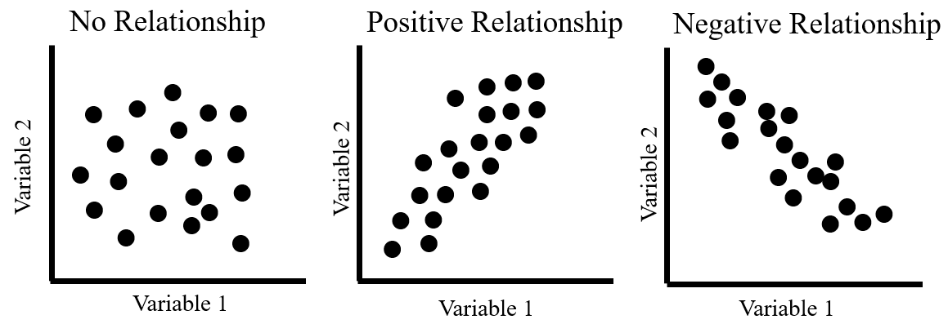
- A linear relationship between variables does not necessarily imply causation. For example, as the temperature at the beach increases, the sales at an ice cream store increase. If data were collected for these two variables, a positive linear relationship would exist, however, there is no causal relationship between the variables (e.g., the temperature outside does not cause ice cream sales to increase, but there is a relationship between the two).
- The relationship between variables is not always linear and may be modeled by other types of functions that are studied in high school and college level mathematics.

Patterns, Functions, and Algebra
8.PFA.1 The student will represent, simplify, and generate equivalent algebraic expressions in one variable.
Students will demonstrate the following Knowledge and Skills:
- Represent algebraic expressions using concrete manipulatives or pictorial representations (e.g., colored chips, algebra tiles), including expressions that apply the distributive property.
- Simplify and generate equivalent algebraic expressions in one variable by applying the order of operations and properties of real numbers. Expressions may need to be expanded (using the distributive property) or require combining like terms to simplify. Expressions will include only linear and numeric terms. Coefficients and numeric terms may be rational.
8.PFA.1 The student will represent, simplify, and generate equivalent algebraic expressions in one variable.
Additional Content Background and Instructional Guidance:
- The distributive property can be demonstrated by multiplying the sum of two or more addends by a number. The same result can be obtained by multiplying each addend individually by a number and then adding the products.
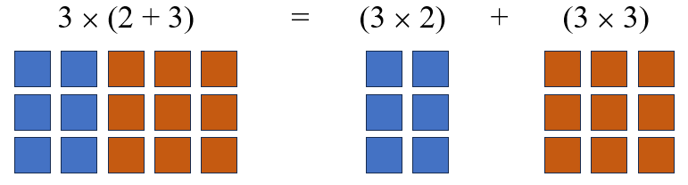
- The distributive property is a useful tool for mental math. For example: $7⋅13=7\left(10+3\right)=(10⋅7)+(3⋅7)=70+21=91$. Modeling the distributive property should reflect the Concrete-Representational-Abstract (CRA) model.
- An expression is a representation of a quantity. It may contain numbers, variables, and/or operation symbols. It does not have an “equal sign” (e.g., $\frac{3}{4}$, $5x; 140-38.2; -18∙21;$
$(5+2x)∙4$). An expression cannot be solved.
- A numerical expression contains only numbers, the operations symbols, and grouping symbols.
- Expressions are simplified using the order of operations.
- An algebraic expression is a variable expression that contains at least one variable (e.g., x – 3).
- Simplifying an algebraic expression means to write the expression as a more compact and equivalent expression. This usually involves combining like terms.
- Like terms are terms that have the same variables and exponents. The coefficients need not be equivalent (e.g., 12x and -5x; 45 and -5 and $\frac{2}{3}$; 9y and -51y and $\frac{4}{9}y$.) Like terms in Grade 8 are limited to variables with an exponent of 1.
- Like terms may be added or subtracted using the distributive and other properties. For example,
2(4x – 2) + 3x
8x – 4 + 3x
11x – 4
- The order of operations is as follows:
  - First, complete all operations within grouping symbols.
    - Parentheses ( ), brackets [ ], braces {}, absolute value || and the division bar should be treated as grouping symbols.
    - For example: $\left|3\left(-5+2\right)\right|;3\left(-5+2\right)-7;$ $\frac{3+4}{5+6}$
    - If there are grouping symbols within other grouping symbols, do the innermost operation first.
  - Second, evaluate all terms with exponents.
  - Third, multiply and/or divide in order from left to right.
  - Fourth, add and/or subtract in order from left to right.
- Properties of real numbers can be used to express simplification. The following properties can be used, where appropriate, to further develop flexibility and fluency in problem solving (limitations may exist for the values of a, b, or c in this standard).
  - Commutative property of addition: $a+b=b+a$.
  - Commutative property of multiplication: $a∙b=b∙a$.
  - Associative property of addition: $\left(a+b\right)+c=a+(b+c)$.
  - Associative property of multiplication: $\left(a∙b\right)∙c=a∙(b∙c)$.
  - Subtraction and division are neither commutative nor associative.
  - Distributive property (over addition/subtraction): $a\left(b+c\right)=a∙b+a∙c$ and $a\left(b-c\right)=a∙b-a∙c$.
  - The additive identity is zero (0) because any number added to zero is the number.
  - Identity property of addition (additive identity property): $a+0=a$ and $0+a=a$.
  - The multiplicative identity is one (1) because any number multiplied by one is the number.
  - Identity property of multiplication (multiplicative identity property): $a∙1=a$ and $1∙a=a$.
  - There are no identity elements for subtraction and division.
  - Inverses are numbers that combine with other numbers and result in identity elements (e.g., 5 + (–5) = 0; $\frac{1}{5}∙5=1)$.
    - Inverse property of addition (additive inverse property): $a+\left(-a\right)=0$ and $\left(-a\right)+a=0$.
    - Inverse property of multiplication (multiplicative inverse property): $a∙\frac{1}{a}=1$ and $\frac{1}{a}∙a=1$.
    - Zero has no multiplicative inverse.
  - Multiplicative property of zero: $a∙0=0$ and $0∙a=0$.
  - Substitution property: If $a=b$, then b can be substituted for a in any expression, equation, or inequality.
- Division by zero is not a possible mathematical operation. It is undefined. In the example below, there is no single defined number possibility for dividing by 0, since zero multiplied by any number is zero:
12 ÷ 0 = r → r · 0 = 12

8.PFA.2 The student will determine whether a given relation is a function and determine the domain and range of a function.
Students will demonstrate the following Knowledge and Skills:
- Determine whether a relation, represented by a set of ordered pairs, a table, or a graph of discrete points is a function. Sets are limited to no more than 10 ordered pairs.
- Identify the domain and range of a function represented as a set of ordered pairs, a table, or a graph of discrete points.
8.PFA.2 The student will determine whether a given relation is a function and determine the domain and range of a function.
Additional Content Background and Instructional Guidance:
- A relation is any set of ordered pairs. For each first member, there may be many second members.
- A function is a relation between a set of inputs, called the domain, and a set of outputs, called the range, with the property that each input is related to exactly one output.
- The domain is the set of all the input values for the independent variable or x-values (first number in an ordered pair).
- The range is the set of all the output values for the dependent variable or y-values (second number in an ordered pair).
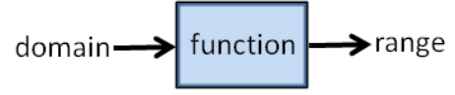
- As a table of values, a function has a unique value assigned to the second variable for each value of the first variable. In the “not a function” example below, the input value “1” has two different output values, 5 and –3, assigned to it, so the example is not a function.
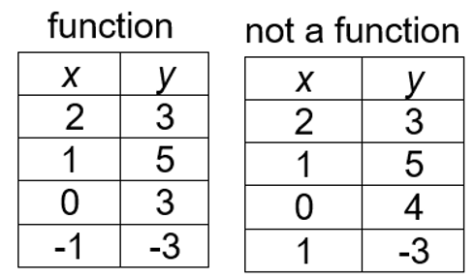
- As a set of ordered pairs, a function has a unique or different y-value assigned to each x-value. For example, the set of ordered pairs, {(1, 2), (2, 4), (3, 2), (4, 8)} is a function. However, this set of ordered pairs, {(1, 2), (2, 4), (3, 2), (2, 3)}, is not a function because the x-value of “2” has two different y-values.
- Some relations are functions; all functions are relations.
- Graphs of functions can be discrete or continuous.
- In a discrete function graph, there are separate, distinct points. A line would not be used to connect these points on a graph. The points between the plotted points have no meaning and cannot be interpreted. For example, the number of pets per household represents a discrete function because it is not possible to have a fraction of a pet.
- Functions may be represented as ordered pairs, tables, graphs, equations, physical models, or in words. Any given relationship can be represented using multiple representations.
- If a function is comprised of a discrete set of ordered pairs, then the domain is the set of all the x-coordinates, and the range is the set of all the y-coordinates. These sets of values can be determined given different representations of the function. For example, the domain of a function is {−1, 1, 2, 3} and the range is {−3, 3, 5}. The following examples are representations of this function.
  - The function represented as a table of values:
x | y
-1 | 5
1 | -3
2 | 3
3 | 5

  - The function represented as a set of ordered pairs: {(-1, 5), (1, -3), (2, 3), (3, 5)}.
  - The function represented as a graph on a coordinate plane:
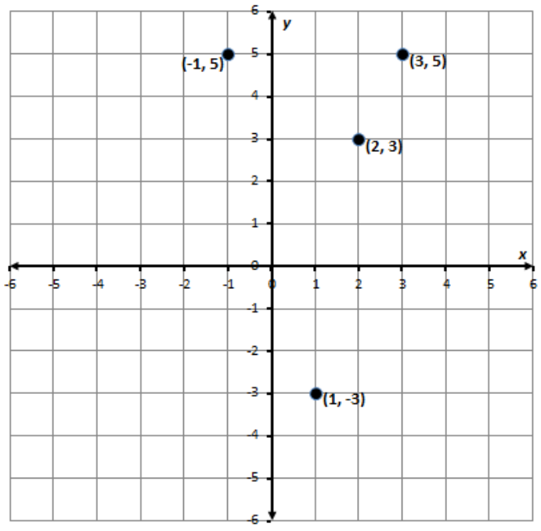
- As a graph of discrete points, a relation is a function when, for any value of x, a vertical line passes through no more than one point on the graph.
- A discussion about determining whether a continuous graph of a relation is a function using the vertical line test may occur in Grade 8, but will be explored further in Algebra 1.

8.PFA.3 The student will represent and solve problems, including those in context, by using linear functions and analyzing their key characteristics (the value of the y-intercept (b) and the coordinates of the ordered pairs in graphs will be limited to integers).
Students will demonstrate the following Knowledge and Skills:
- Determine how adding a constant (b) to the equation of a proportional relationship y = mx will translate the line on a graph.
- Describe key characteristics of linear functions including slope (m), y-intercept (b), and independent and dependent variables.
- Graph a linear function given a table, equation, or a situation in context.
- Create a table of values for a linear function given a graph, equation in the form of y = mx + b, or context.
- Write an equation of a linear function in the form y = mx + b, given a graph, table, or a situation in context.
- Create a context for a linear function given a graph, table, or equation in the form y = mx + b.
8.PFA.3 The student will represent and solve problems, including those in context, by using linear functions and analyzing their key characteristics (the value of the y-intercept (b) and the coordinates of the ordered pairs in graphs will be limited to integers).
Additional Content Background and Instructional Guidance:
- Functions may be a set of discrete points or a continuous set of points. A linear function is an equation in two variables whose graph is a straight line, a type of continuous function.
- A linear function represents a situation with a constant rate. For example, when driving at a steady rate of 35 mph, the distance increases as the time increases, but the rate of speed remains the same.
- Slope (m) represents the rate of change in a linear function or the “steepness” of the line. The slope of a line is a rate of change, a ratio describing the vertical change to the horizontal change.
slope = $\frac{change in y}{change in x}=\frac{vertical change}{horizontal change}$
- A line is increasing if it rises from left to right. The slope is positive (i.e., m > 0).
- A line is decreasing if it falls from left to right. The slope is negative (i.e., m < 0).
- A horizontal line has zero slope (i.e., m = 0).
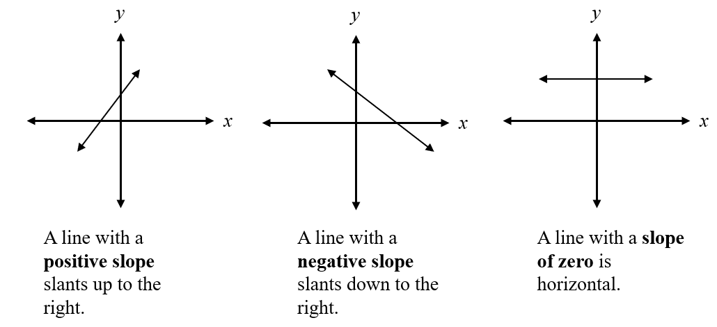
- A discussion about lines with undefined slope (vertical lines) would be beneficial for students in Grade 8 mathematics to compare undefined slope to lines with a defined slope. Further exploration of this concept will occur in Algebra 1.
- A linear function can be written in the form y = mx + b, where m represents the slope or rate of change in y compared to x, and b represents the y-intercept of the graph of the linear function. The y-intercept is the point at which the graph of the function intersects the y-axis and may be given as a single value, b, or as the location of a point (0, b).
- The impact of $b$ on $y=mx$ will determine if the line created will translate a parallel line up or down from the origin. The value of $b$ determines where the line will intersect the y-axis. If $b$ is a positive value, the line will translate up on the y-axis; if it is negative, it will translate down on the y-axis.
  - Example: Given the equation of the linear function$y=-3x+2$, the slope is −3 or $\frac{-3}{1}$ and the y-intercept is 2 or (0, 2).
  - Example: The table of values represents a linear function.
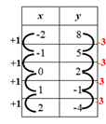
  - In the table, the point (0, 2) represents the y-intercept. The slope is determined by observing the change in each y-value compared to the corresponding change in the x-value.
slope = m = $\frac{change in y-value}{change in x-value}= \frac{-3}{+1}= -3$
- The slope, m, and y-intercept of a linear function can be determined given the graph of the function.
  - Example: Given the graph of the linear function, determine the slope and y-intercept.
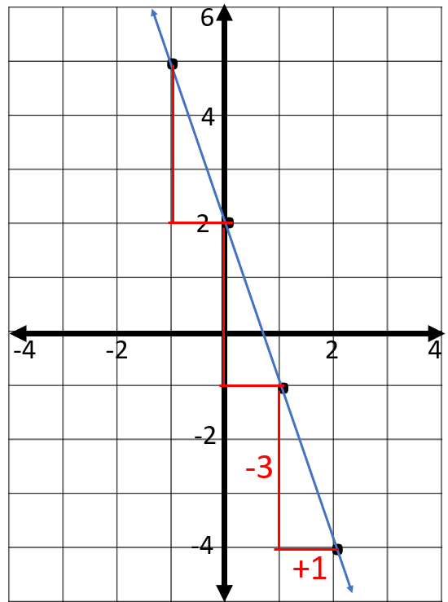
  - Given the graph of a linear function, the y-intercept is found by determining where the line intersects the y-axis. The y-intercept would be 2 or located at the point (0, 2). The slope can be found by determining the change in each y-value compared to the change in each x-value. Here, we could use slope triangles to help visualize this:
slope = m = $\frac{change in y-value}{change in x-value}= \frac{-3}{+1}= -3$
- Graphing a linear function given an equation can be addressed using different methods. One method involves determining a table of ordered pairs by substituting into the equation values for one variable and solving for the other variable, plotting the ordered pairs in the coordinate plane, and connecting the points to form a straight line. Another method involves using slope triangles to determine points on the line. For example, graph the linear function whose equation is $y=5x-1$.
- To graph the linear function, a table of values can be created by substituting arbitrary values for x to determine coordinating values for y:
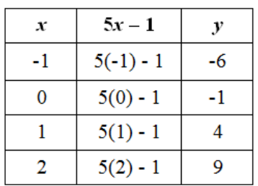
- The values can then be plotted as points on a graph.
- Knowing the equation of a linear function written in y = mx + b provides information about the slope and y-intercept of the function. If the equation is $y=5x-1$, then the slope, m, of the line is 5 or $\frac{5}{1},$and the y-intercept is −1 and can be located at the point (0, −1). The line can be graphed by first plotting the y-intercept.
- Other points can be plotted on the graph using the relationship between the y and x values.
- Slope triangles can be used to help locate the other points as shown in the graph below.
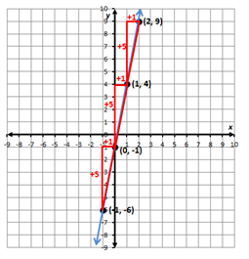
  - A table of values can be used in conjunction with slope triangles to verify the graph of a linear function. The y-intercept is located on the y-axis, which is where the x-coordinate is 0. The change in each y-value compared to the corresponding x-value can be verified by the patterns in the table of values.
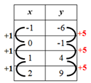
- The axes of a coordinate plane are generally labeled x and y; however, any letters may be used that are appropriate for the function.
- A function has values that represent the input (x) and values that represent the output (y). The independent variable is the input value. The dependent variable depends on the independent variable and is the output value.
- Below is a table of values for finding the approximate circumference of circles, $C=πd$, where the value of 𝜋 is approximated as 3.14.
Diameter | Circumference
1 in. | 3.14 in.
2 in. | 6.28 in.
3 in. | 9.42 in.
4 in. | 12.56 in.
  - The independent variable, or input, is the diameter of the circle. The values for the diameter make up the domain.
  - The dependent variable, or output, is the circumference of the circle. The set of values for the circumference makes up the range.
- In a graph of a continuous function, every point in the domain can be interpreted. Therefore, it is possible to connect the points on the graph with a continuous line because every point on the line answers the original question being asked.
- The context of a problem may determine whether it is appropriate for ordered pairs representing a linear relationship to be connected by a straight line. If the independent variable (x) represents a discrete quantity (e.g., number of people, number of tickets) then it is not appropriate to connect the ordered pairs with a straight line when graphing. If the independent variable (x) represents a continuous quantity (e.g., amount of time, temperature), then it is appropriate to connect the ordered pairs with a straight line when graphing.
  - Example: The function y = 7x represents the cost in dollars (y) for x tickets to an event. The domain of this function is discrete and is represented by discrete points on a graph. Not all values for x could be represented and connecting the points would not be appropriate.
  - Example: The function y = −2.5x + 20 represents the number of gallons of water (y) remaining in a 20-gallon tank being drained for x number of minutes. The domain in this function would be continuous. There would be an x-value representing any point in time until the tank is drained so connecting the points to form a straight line would be appropriate. Note: the context of the problem limits the values that x can represent to positive values, since time cannot be negative.
- Functions can be represented as ordered pairs, tables, graphs, equations, physical models, or in words. Any given relationship can be represented using multiple representations.
- The equation y = mx + b defines a linear function whose graph (solution) is a straight line. The equation of a linear function can be determined given the slope, m, and the y-intercept, b. Verbal descriptions of contextual situations that can be modeled by a linear function can also be represented using an equation.
  - Example: Write the equation of a linear function whose slope is $\frac{3}{4}$and y-intercept is −4, or located at the point (0, −4).
- The equation of this line can be found by substituting the values for the slope, m = $\frac{3}{4}$ , and the y-intercept, b = −4, into the general form of a linear function y = mx + b. Thus, the equation would be $y=\frac{3}{4}x-4$.
- Example: John charges a $30 flat fee to evaluate a personal watercraft that is not working properly and $50 per hour for any necessary repairs. Write a linear function that represents the total cost, y, of a personal watercraft repair, based on the number of hours, x, needed to repair it. Assume that there is no additional charge for parts.
- In this contextual situation, the y-intercept, b, would be $30 to represent the initial flat fee to evaluate the watercraft. The slope, m, would be $50 since that would represent the rate per hour. The equation to represent this situation would be y = 50x + 30.
- A proportional relationship between two variables can be represented by a linear function y = mx that passes through the point (0, 0) and thus has a y-intercept of 0. The variable y results from x being multiplied by m, the rate of change or slope.
- The linear function y = x + b represents a linear function that is a non-proportional additive relationship. The variable y results from the value b being added to x. In this linear relationship, there is a y-intercept of b, and the constant rate of change or slope would be 1. In a linear function with a slope other than 1, there is a coefficient in front of the x term, which represents the constant rate of change, or slope.

8.PFA.4 The student will write and solve multistep linear equations in one variable, including problems in context that require the solution of a multistep linear equation in one variable.
Students will demonstrate the following Knowledge and Skills:
- Represent and solve multistep linear equations in one variable with the variable on one or both sides of the equation (up to four steps) using a variety of concrete materials and pictorial representations.
- Apply properties of real numbers and properties of equality to solve multistep linear equations in one variable (up to four steps). Coefficients and numeric terms will be rational. Equations may contain expressions that need to be expanded (using the distributive property) or require combining like terms to solve.
- Write a multistep linear equation in one variable to represent a verbal situation, including those in context.
- Create a verbal situation in context given a multistep linear equation in one variable.
- Solve problems in context that require the solution of a multistep linear equation.
- Interpret algebraic solutions in context to linear equations in one variable.
- Confirm algebraic solutions to linear equations in one variable.
8.PFA.4 The student will write and solve multistep linear equations in one variable, including problems in context that require the solution of a multistep linear equation in one variable.
Additional Content Background and Instructional Guidance:
- A linear equation in one variable that does not exceed four steps could include, but are not limited to:
  - $2x+5=4x+6$
  - $3x+5-6x=8$
  - $3\left(x+5\right)=10$
  - $-2\left(x+4\right)+5x=6x-5$
- Equations that result in no solution or infinite solutions are beyond the scope of this standard.
- Modeling linear equations in one variable should reflect the Concrete-Representational-Abstract (CRA) model where the use of concrete materials is followed by pictorial representations, followed by abstract use of properties to solve.
- An algebraic equation is a mathematical statement that says that two expressions are equal (e.g., $2x+3=-4x+1$).
- In an equation, the equal sign (=) indicates that the value of the expression on the left is equivalent to the value of the expression on the right.
- Linear equations can be used to interpret, represent, model, and solve problems in context.
- Word choice and language are very important when representing verbal situations in context using mathematical operations, equality, and variables. When presented with an equation or context, student choice of language should reflect the situation being modeled. Identifying the mathematical operation(s) to represent the action(s) and the variable to represent the unknown quantity will help students write equations to represent contextual situations.
- At this level, when creating equations and verbal situations in context, the coefficient is limited to a positive value.
- Properties of real numbers and properties of equality can be used to solve equations, justify solutions, and express simplification. The following properties can be used, where appropriate, to further develop flexibility and fluency in problem solving (limitations may exist for the values of a, b, or c in this standard):
  - Commutative property of addition: $a+b=b+a$
  - Commutative property of multiplication: $a∙b=b∙a$
  - Associative property of addition: $\left(a+b\right)+c=a+(b+c)$
  - Associative property of multiplication: $\left(a∙b\right)∙c=a∙(b∙c)$
  - Subtraction and division are neither commutative nor associative.
  - Distributive property (over addition/subtraction): $a∙\left(b+c\right)=a∙b+a∙c and$
$$a∙\left(b-c\right)=a∙b-a∙c$$
  - The additive identity is zero (0) because any number added to zero is the number.
  - Identity property of addition (additive identity property): $a+0=a and 0+a=a$
  - The multiplicative identity is one (1) because any number multiplied by one is the number.
  - Identity property of multiplication (multiplicative identity property): $a∙1=a and 1∙a=a$
  - There are no identity elements for subtraction and division.
  - Inverses are numbers that combine with other numbers and result in identity elements (e.g., 5 + (–5) = 0; $\frac{1}{5}$ · 5 = 1).
    - Inverse property of addition (additive inverse property): $a+\left(-a\right)=0 and \left(-a\right)+a=0$
    - Inverse property of multiplication (multiplicative inverse property): $a∙\frac{1}{a}=1 and \frac{1}{a}∙a=1$
    - Zero has no multiplicative inverse.
  - Multiplicative property of zero: $a∙0=0 and 0∙a=0$
  - Substitution property: If $a=b$, then b can be substituted for a in any expression, equation, or inequality
  - Addition property of equality: If $a=b$, then $a+c=b+c$
  - Subtraction property of equality: If $a=b$, then $a-c=b-c$
  - Multiplication property of equality: If $a=b$, then $a∙c=b∙c$
  - Division property of equality: If $a=b$ and $c≠0$, then $\frac{a}{c}=\frac{b}{c}$
- Division by zero is not a possible mathematical operation. It is undefined. In the example below, there is no single defined number possibility for dividing by 0, since zero multiplied by any number is zero:
12 ÷ 0 = r → r · 0 = 12

8.PFA.5 The student will write and solve multistep linear inequalities in one variable, including problems in context that require the solution of a multistep linear inequality in one variable.
Students will demonstrate the following Knowledge and Skills:
- Apply properties of real numbers and properties of inequality to solve multistep linear inequalities (up to four steps) in one variable with the variable on one or both sides of the inequality. Coefficients and numeric terms will be rational. Inequalities may contain expressions that need to be expanded (using the distributive property) or require combining like terms to solve.
- Represent solutions to inequalities algebraically and graphically using a number line.
- Write multistep linear inequalities in one variable to represent a verbal situation, including those in context.
- Create a verbal situation in context given a multistep linear inequality in one variable.
- Solve problems in context that require the solution of a multistep linear inequality in one variable.
- Identify a numerical value(s) that is part of the solution set of a given inequality.
8.PFA.5 The student will write and solve multistep linear inequalities in one variable, including problems in context that require the solution of a multistep linear inequality in one variable.
Additional Content Background and Instructional Guidance:
- A linear inequality in one variable that does not exceed three steps could include:
  - $2x+5<4x+6$
  - $3x+5-6x>8$
  - $3\left(x+5\right)<10$
- When both expressions of an inequality are multiplied or divided by a negative number, the inequality sign reverses.
- A solution to an inequality is the value or set of values that can be substituted to make the inequality true.
- In an inequality, there can be more than one value for the variable that makes the inequality true. There can be many solutions (e.g., When given the inequality x + 4 > −3, the solutions are x > −7. This means that x can be any number greater than −7. A few solutions might be −6.5, −3, 0, 4, 25, etc.).
- Real-world problems can be modeled and solved using linear inequalities.
- Word choice and language are very important when representing verbal situations in context using mathematical operations, inequality symbols, and variables. When presented with an inequality or context, student choice of language should reflect the situation being modeled. Identifying the mathematical operation(s) to represent the action(s) and the variable to represent the unknown quantity will help students to write inequalities to represent contextual situations.
- At this level, when creating inequalities and verbal situations in context, the coefficient is limited to a positive value.
- The properties of real numbers and properties of inequality can be used to solve inequalities, justify solutions, and express simplification. Use the following properties, where appropriate, to further develop flexibility and fluency in problem solving (limitations may exist for the values of a, b, or c in this standard).
  - Commutative property of addition: $a+b=b+a$
  - Commutative property of multiplication: $a⋅b=b⋅a$
  - Associative property of addition: $\left(a+b\right)+c=a+\left(b+c\right)$
  - Associative property of multiplication: $\left(a⋅b\right)⋅c=a⋅\left(b⋅c\right)$
  - Subtraction and division are neither commutative nor associative.
  - Distributive property (over addition/subtraction): $a⋅\left(b+c\right)=a⋅b+a⋅c$ and $a⋅\left(b-c\right)=a⋅b-a⋅c$
  - The additive identity is zero (0) because any number added to zero is the number.
  - Identity property of addition (additive identity property):$a+0=a$ and $0+a=a$
  - The multiplicative identity is one (1) because any number multiplied by one is the number.
  - Identity property of multiplication (multiplicative identity property):$a⋅1=a$and $1⋅a=a$
  - There are no identity elements for subtraction and division.
  - Inverses are numbers that combine with other numbers and result in identity elements (e.g., $5+\left(-5\right)=0$ ; $\frac{1}{5}∙5=1$).
    - Inverse property of addition (additive inverse property): $a+\left(-a\right)=0 and \left(-a\right)+a=$
    - Inverse property of multiplication (multiplicative inverse property): $a⋅\frac{1}{a}=1$ and $\frac{1}{a}∙a=1$
    - Zero has no multiplicative inverse.
  - Multiplicative property of zero: $a∙0=0$and $0∙a=0.$
  - Substitution property: If $a=b$, then $b$can be substituted for a in any expression, equation, or inequality
  - Addition property of inequality: If $a<b$, then $a+c<b+c$; if $a>b$, then $a+c>b+c$
  - Subtraction property of inequality: If $a<b$, then $a-c<b-c;$ if $a>b$, then $a-c>b-c$
  - Multiplication property of inequality: If $a<b and c>0$, then $a∙c<b∙c$; if $a>b and c>0$, then $a∙c>b∙c$
  - Multiplication property of inequality (multiplication by a negative number): If $a<b and c<0$, then $a∙c>b∙c$; if $a>b and c<0$, then $a∙c<b∙c$
  - Division property of inequality: If $a<b and c>0$, then $\frac{a}{c}<\frac{b}{c}$; if $a>b and c>0$, then $\frac{a}{c}>\frac{b}{c}$
  - Division property of inequality (division by a negative number): If $a<b and c<0$, then $\frac{a}{c}>\frac{b}{c}$; if $a>b and c<0$, then $\frac{a}{c}<\frac{b}{c}$
- Division by zero is not a possible mathematical operation. It is undefined. In the example below, there is no single defined number possibility for dividing by 0, since zero multiplied by any number is zero:
12 ÷ 0 = r → r · 0 = 12

