2023 Mathematics Standards of Learning
Understanding the Standards – Grade 7
The Understanding the Standards document includes the mathematics understandings and key concepts that assist teachers in planning standards-focused instruction of the seventh grade 2023 Mathematics Standards of Learning. The Understanding the Standards includes definitions, explanations, and examples regarding each mathematics standard and describes what students should know (core knowledge) as a result of the instruction specific to the course/grade level.

Number and Number Sense
7.NS.1 The student will investigate and describe the concept of exponents for powers of ten and compare and order numbers greater than zero written in scientific notation.
Students will demonstrate the following Knowledge and Skills:
- Investigate and describe powers of 10 with negative exponents by examining patterns.
- Represent a power of 10 with a negative exponent in fraction and decimal form.
- Convert between numbers greater than 0 written in scientific notation and decimals.*
- Compare and order no more than four numbers greater than 0 written in scientific notation. Ordering may be in ascending or descending order.*
* On the state assessment, items measuring this knowledge and skill are assessed without the use of a calculator.
7.NS.1 The student will investigate and describe the concept of exponents for powers of ten and compare and order numbers greater than zero written in scientific notation.
Additional Content Background and Instructional Guidance:
- Negative exponents for powers of 10 are used to represent numbers between 0 and 1.
(e.g., ${10}^{-3}$ = $\frac{1}{1000}$ = 0.001).
- Exponents for powers of 10 can be investigated through patterns such as:
  - ${10}^{2}$ = 100
  - ${10}^{1}$ = 10
  - ${10}^{0}$ = 1
  - ${10}^{-1}$=$\frac{1}{{10}^{1}}=\frac{1}{10}$ = 0.1
  - ${10}^{-2}$ =$\frac{1}{{10}^{2}}=\frac{1}{100}$ = 0.01
- Scientific notation should be used whenever the situation calls for the use of very large or very small numbers.
- A number written in scientific notation is the product of two factors - a decimal greater than or equal to 1 but less than 10, and a power of 10 (e.g., 3.1 ⋅ 10⁵= 310,000 and 2.85 × ${10}^{-4}$ = 0.000285).
- Numbers written in scientific notation can be interpreted to determine magnitude. For example, a student notices that their calculations reveal two values, $5.67×{10}^{11}$ and $1.14×{10}^{20}$. The student interprets both numbers as large values with $1.14×{10}^{20}$ being much larger than $5.67×{10}^{11}.$

7.NS.2 The student will reason and use multiple strategies to compare and order rational numbers.
Students will demonstrate the following Knowledge and Skills:
- Use multiple strategies (e.g., benchmarks, number line, equivalency) to compare (using symbols <, >, =) and order (a set of no more than four) rational numbers expressed as integers, fractions (proper or improper), mixed numbers, decimals, and percents. Fractions and mixed numbers may be positive or negative. Decimals may be positive or negative and are limited to the thousandths place. Ordering may be in ascending or descending order. Justify solutions orally, in writing or with a model.*
* On the state assessment, items measuring this knowledge and skill are assessed without the use of a calculator.
7.NS.2 The student will reason and use multiple strategies to compare and order rational numbers.
Additional Content Background and Instructional Guidance:
- The set of rational numbers includes the set of all numbers that can be expressed as fractions in the form $\frac{a}{b}$where a and b are integers and b does not equal zero. The decimal form of a rational number can be expressed as a terminating or repeating decimal. A few examples of rational numbers are: √25, −14, 2.3, 82, 75%, $0.\overline{7}$.
- Rational numbers may be expressed as positive and negative fractions or mixed numbers, positive and negative decimals, integers, and percents.
- The set of integers includes the set of whole numbers and their opposites {…⁻2, ⁻1, 0, 1, 2, …}.
- Zero has no opposite and is neither positive nor negative.
- The opposite of a positive number is negative, and the opposite of a negative number is positive.
- Negative numbers lie to the left of zero and positive numbers lie to the right of zero on a number line.
- Smaller numbers always lie to the left of larger numbers on the number line.
- Proper fractions, improper fractions, and mixed numbers are terms often used to describe fractions. A proper fraction is a fraction whose numerator is less than the denominator. An improper fraction is a fraction whose numerator is equal to or greater than the denominator. An improper fraction may be expressed as a mixed number. A mixed number is written with two parts: a whole number and a proper fraction (e.g., $3\frac{3}{5}$).
- Percent means “per 100” or how many “out of 100”; percent is another name for hundredths.
- A percent is a ratio in which the denominator is 100. A number followed by a percent symbol (%) is equivalent to that number with a denominator of 100 (e.g., $\frac{3}{5}$ = $\frac{60}{100}$ = 0.60 = 60%).
- Equivalent relationships among fractions, decimals, and percents may be determined by using concrete materials and pictorial representations (e.g., fraction bars, base ten blocks, fraction circles, colored counters, cubes, decimal squares, shaded figures, shaded grids, number lines, calculators).
- Methods for comparing and ordering rational numbers include using benchmarks, models, or number lines, and converting to one representation.

7.NS.3 The student will recognize and describe the relationship between square roots and perfect squares.
Students will demonstrate the following Knowledge and Skills:
- Determine the positive square root of a perfect square from 0 to 400.*
- Describe the relationship between square roots and perfect squares.*
* On the state assessment, items measuring this knowledge and skill are assessed without the use of a calculator.
7.NS.3 The student will recognize and describe the relationship between square roots and perfect squares.
Additional Content Background and Instructional Guidance:
- A perfect square is a whole number whose square root is an integer. (e.g., 36 = 6 ∙ 6 = 6²).
- Zero (a whole number) is a perfect square.
- A square root of a number is a number which, when multiplied by itself, produces the given number (e.g., √$\overline{121}$ is 11 since 11 ∙ 11 = 121).
- The symbol √ may be used to represent a non-negative (principal) square root.
- The square root of a number can be represented geometrically as the length of a side of a square. The connection between square roots and perfect squares can be made by investigating side lengths and areas of geometric squares using arrays, grid paper, square tiles, etc.
- Squaring a number and taking a square root of a number are inverse operations.

Computation and Estimation
7.CE.1 The student will estimate, solve, and justify solutions to multistep contextual problems involving operations with rational numbers.
Students will demonstrate the following Knowledge and Skills:
- Estimate, solve, and justify solutions to contextual problems involving addition, subtraction, multiplication, and division with rational numbers expressed as integers, fractions (proper or improper), mixed numbers, and decimals. Fractions may be positive or negative. Decimals may be positive or negative and are limited to the thousandths place.
7.CE.1 The student will estimate, solve, and justify solutions to multistep contextual problems involving operations with rational numbers.
Additional Content Background and Instructional Guidance:
- The set of rational numbers includes the set of all numbers that can be expressed as fractions in the form $\frac{a}{b}$where a and b are integers and b does not equal zero. The decimal form of a rational number can be expressed as a terminating or repeating decimal. A few examples of rational numbers are: √25, −14, 2.3, 82, 75%, $0.\overline{7}$.
- The set of integers includes the set of whole numbers and their opposites {…⁻2, ⁻1, 0, 1, 2, …}.
- Zero has no opposite and is neither positive nor negative.
- The opposite of a positive number is negative, and the opposite of a negative number is positive.
- Negative numbers lie to the left of zero and positive numbers lie to the right of zero on a number line.
- Smaller numbers always lie to the left of larger numbers on the number line.
- Proper fractions, improper fractions, and mixed numbers are terms often used to describe fractions. A proper fraction is a fraction whose numerator is less than the denominator. An improper fraction is a fraction whose numerator is equal to or greater than the denominator. An improper fraction may be expressed as a mixed number. A mixed number is written with two parts: a whole number and a proper fraction (e.g., $3\frac{3}{5}$).
- Solving problems in contextual situations enhances proficiency with estimation strategies. Contextual problems involving rational numbers in Grade 7 provide students with opportunities to use problem solving to apply computation skills involving positive and negative rational numbers expressed as integers, fractions, and decimals.

7.CE.2 The student will solve problems, including those in context, involving proportional relationships.
Students will demonstrate the following Knowledge and Skills:
- Given a proportional relationship between two quantities, create and use a ratio table to determine missing values.
- Write and solve a proportion that represents a proportional relationship between two quantities to find a missing value, including problems in context.
- Apply proportional reasoning to solve problems in context, including converting units of measurement, when given the conversion factor.
- Estimate and determine the percentage of a given whole number, including but not limited to the use of benchmark percentages.
7.CE.2 The student will solve problems, including those in context, involving proportional relationships.
Additional Content Background and Instructional Guidance:
- A proportion is a statement of equality between two ratios. A proportion can be written as $\frac{a}{b}$ = $\frac{c}{d}$, a:b = c:d, or a is to b as c is to d.
- Equivalent ratios are created by multiplying each value in a ratio by the same constant value. For example, the ratio of 3:2 would be equivalent to the ratio 6:4 because each of the values in 3:2 can be multiplied by 2 to get 6:4.
- A ratio table is a table of values representing a proportional relationship that includes pairs of values that represent equivalent rates or ratios.
- In a proportional relationship, two quantities increase multiplicatively. One quantity is a constant multiple of the other.
- A proportion can be solved by determining the product of the means and the product of the extremes. For example, in the proportion a:b = c:d, a and d are the extremes and b and c are the means. If values are substituted for a, b, c, and d such as 5:12 = 10:24, then the product of extremes (5 ∙ 24) is equal to the product of the means (12 ∙ 10).
- A proportion can be solved by determining equivalent ratios. A proportion is an equation which states that two ratios are equal. When solving a proportion, the ratios may first be written as fractions.
  - Example: A recipe for oatmeal cookies calls for 2 cups of flour for every 3 cups of oatmeal. How much flour is needed for a larger batch of cookies that uses 9 cups of oatmeal? To solve this problem, the ratio of flour to oatmeal could be written as a fraction in the proportion used to determine the amount of flour needed when 9 cups of oatmeal is used. To use a proportion to solve for the unknown cups of flour needed, solve the proportion: $\frac{2}{3}= \frac{x}{9}$
To use a table of equivalent ratios to find the unknown amount, create the table. To complete the table, create an equivalent ratio to 2:3. Just as 4:6 is equivalent to 2:3, then 6 cups of flour to 9 cups of oatmeal would create an equivalent ratio.
flour (cups) | 2 | 4 | ?
oatmeal (cups) | 3 | 6 | 9
- Proportions are used in everyday contexts, such as speed, recipe conversions, scale drawings, map reading, reducing, and enlarging, comparison shopping, and monetary conversions.
- Proportions can be used to convert length, weight (mass), and volume (capacity) within and between measurement systems. For example, if 1 inch is equal to approximately 2.54 centimeters (cm), how many inches are in 16 cm?
$\frac{1 inch}{2.54 cm}$ = $\frac{x inch}{16 cm}$
$$2.54x=1∙16$$
$$2.54x=16$$
$$x=\frac{16}{2.54}$$
$x=6.299$or about 6.3 inches
- Examples of conversions may include, but are not limited to:
  - Length: between feet and miles; miles and kilometers;
  - Weight: between ounces and pounds; pounds and kilograms; and
  - Volume: between cups and fluid ounces; gallons and liters.
- When converting measurement units in contextual situations, the precision of the conversion factor used will be determined by the accuracy required within the context of the problem. For example, when converting from miles to kilometers, a conversion factor of 1 mile ≈ 1.6 km or 1 mile ≈ 1.609 km may be used, depending upon the accuracy needed.
- Estimation may be used prior to calculating conversions to evaluate the reasonableness of a solution.
- A percent is a ratio in which the denominator is 100.
- Benchmark percentages may include 5%, 10%, 20%, 25%, 50%, and any multiples of 5%.
- Benchmark percentages and their equivalent fractions can be used as a point of reference. Double number lines can be used to easily interchange benchmark percentages and fractions. Values of benchmark percentages can be added, subtracted, or multiplied to calculate the value of other percentages.
- Common benchmark percentages can be used to determine tips.
  - Example: A customer decides to leave a 15% tip for a server. The customer could calculate 10% of the bill, and then calculate half of that, which is equal to 5%. Then the customer could add the two resulting values to obtain 15% of the bill.
- Proportions can be used to represent percent problems as follows: $\frac{percent}{100}$= $\frac{part}{whole}$

Measurement and Geometry
7.MG.1 The student will investigate and determine the volume formula for right cylinders and the surface area formulas for rectangular prisms and right cylinders and apply the formulas in context.
Students will demonstrate the following Knowledge and Skills:
- Develop the formulas for determining the volume of right cylinders and solve problems, including those in contextual situations, using concrete objects, diagrams, and formulas.
- Develop the formulas for determining the surface area of rectangular prisms and right cylinders and solve problems, including those in contextual situations, using concrete objects, two-dimensional diagrams, nets, and formulas.
- Determine if a problem in context, involving a rectangular prism or right cylinder, represents the application of volume or surface area.
- Describe how the volume of a rectangular prism is affected when one measured attribute is multiplied by a factor of $\frac{1}{4}$, $\frac{1}{3}$, $\frac{1}{2}$, 2, 3, or 4, including those in contextual situations.
- Describe how the surface area of a rectangular prism is affected when one measured attribute is multiplied by a factor of $\frac{1}{2}$ or 2, including those in contextual situations.
7.MG.1 The student will investigate and determine the volume formula for right cylinders and the surface area formulas for rectangular prisms and right cylinders and apply the formulas in context.
Additional Content Background and Instructional Guidance:
- A polyhedron is a solid figure whose faces are all polygons.
- A rectangular prism is a polyhedron in which all six faces are rectangles. A rectangular prism has eight vertices and 12 edges.
- A cylinder is a solid figure formed by two congruent parallel faces called bases joined by a curved surface. In this grade level, cylinders are limited to right circular cylinders, where the axis joining the two centers of the bases is perpendicular to the bases.
- A face is any flat surface of a solid figure.
- The surface area of a prism is the sum of the areas of all six faces and is measured in square units.
- The volume of a three-dimensional figure is a measure of capacity and is measured in cubic units.
- Nets are two-dimensional representations of a three-dimensional figure that can be folded into a model of the three-dimensional figure.
- A rectangular prism can be represented on a flat surface as a net that contains six rectangles — two that have areas of the measures of the length and width of the base, two others that have areas of the measures of the length and height, and two others that have areas of the measures of the width and height. The surface area of a rectangular prism is the sum of the areas of all six faces (SA = 2lw + 2lh + 2wh).
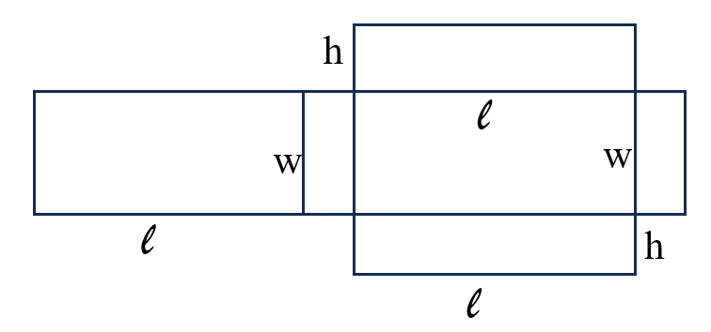
- It is helpful for students to use nets to explore the development of the formula for surface area. Students may find the sum of the faces of a rectangular prism and develop this expanded formula for surface area as:
SA = (lw)+(lw)+(lh)+(lh)+(wh)+(wh) = 2lw + 2lh + 2wh.
- A cylinder can be represented on a flat surface as a net that contains two circles (the bases of the cylinder) and one rectangular region (the curved surface of the cylinder) whose length is the circumference of the circular base and whose width is the height of the cylinder. The surface area of the cylinder is the sum of the area of the two circles and the rectangle representing the curved surface.
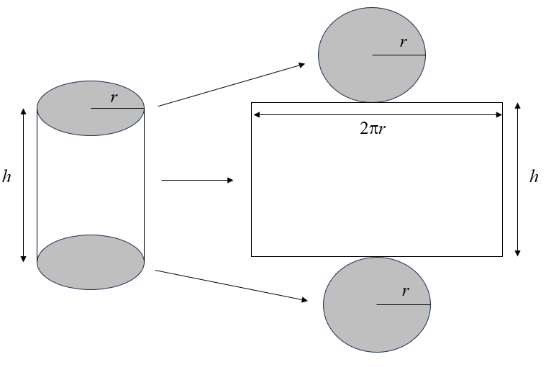
- When using the net of a cylinder and its labeled dimensions (radius and height) when developing a formula, students may find the sum of the two circular bases as ${πr}^{2}+ {πr}^{2}$. They may need to manipulate the net to form the 3-dimensional cylinder to discover that the width of the rectangular portion of the net is the circumference of the circle (2πr) and the length is the height of the cylinder. Their developed formula may look like this:
Surface Area (SA) = ${πr}^{2}+ {πr}^{2}$ + 2πrh.
- The volume of a rectangular prism is computed by multiplying the area of the base, B,
(length times width) by the height of the prism (V = Bh = lwh).
- The volume of a cylinder is computed by multiplying the area of the base, B, (${πr}^{2}$) by the height of the cylinder (V = ${πr}^{2}h$ = Bh).
- When developing the formula for volume of rectangular prisms, using centimeter cubes is helpful to facilitate the understanding that the volume can be found by finding the area of the base and multiplying it by its number of layers (height). This idea can then be applied to cylinders for students to discover that the volume is found by multiplying the area of the circular base by the height of the cylinder.
- The calculation of determining surface area and volume may vary depending upon the approximation for pi (π) that is used. Common approximations for π include 3.14 or $\frac{22}{7}$.
- When the measurement of one attribute of a rectangular prism is changed through multiplication or division the volume increases by the same factor by which the attribute increased.
  - Example: If a prism has a volume of 2 · 3 · 4, the volume is 24 cubic units. However, if one of the attributes is doubled, the volume doubles. That is, 2 · 3 · 8, the volume is 48 cubic units, or 24 cubic units doubled. This is an application of proportional reasoning.

7.MG.2 The student will solve problems and justify relationships of similarity using proportional reasoning.
Students will demonstrate the following Knowledge and Skills:
- Identify corresponding congruent angles of similar quadrilaterals and triangles, through the use of geometric markings.
- Identify corresponding sides of similar quadrilaterals and triangles.
- Given two similar quadrilaterals or triangles, write similarity statements using symbols.
- Write proportions to express the relationships between the lengths of corresponding sides of similar quadrilaterals and triangles.
- Recognize and justify if two quadrilaterals or triangles are similar using the ratios of corresponding side lengths.
- Solve a proportion to determine a missing side length of similar quadrilaterals or triangles.
- Given angle measures in a quadrilateral or triangle, determine unknown angle measures in a similar quadrilateral or triangle.
- Apply proportional reasoning to solve problems in context including scale drawings. Scale factors shall have denominators no greater than 12 and decimals no less than tenths.
7.MG.2 The student will solve problems and justify relationships of similarity using proportional reasoning.
Additional Content Background and Instructional Guidance:
- Congruent polygons have the same size and shape. In congruent polygons, corresponding angles and sides are congruent.
- Congruent polygons are similar polygons for which the ratio of the corresponding sides is 1:1. However, similar polygons are not necessarily congruent.
- The symbol ≅ is used to represent congruence. For example, ∠A ≅ ∠B is read as “Angle A is congruent to Angle B.”
- Similar polygons have corresponding sides that are proportional and corresponding interior angles that are congruent.
- Similarity has contextual applications in a variety of areas, including art, architecture, and the sciences.
- Similarity does not depend on the position or orientation of the figures.
- The symbol ~ is used to represent similarity. For example, ∆ABC ~ ∆DEF is read as “Triangle ABC is similar to triangle DEF.”
- Similarity statements can be used to determine corresponding parts of similar figures.
Example: Given: ∆ABC ~ ∆DEF
∠A corresponds to ∠D
$\overline{AB}$ corresponds to $\overline{DE}$
- A proportion representing corresponding sides of similar figures can be created.
  - Example: Given two similar quadrilaterals with corresponding angles labeled, write a proportion involving corresponding sides.
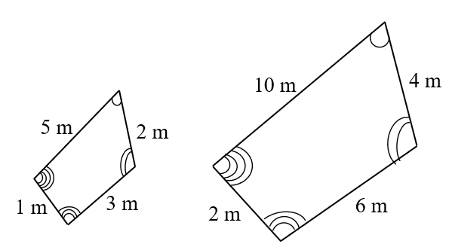
  - Some ways to express the proportional relationships between these two figures are $\frac{5}{10}=\frac{2}{4}$ or $\frac{5}{10}=\frac{3}{6}$ or $\frac{1}{2}=\frac{2}{4}$.
- The traditional notation for marking congruent angles is to use a curve on each angle. Congruent angles are denoted with the same number of curved lines. For example, if ∠A is congruent to ∠C, then both angles will be marked with the same number of curved lines.
- Congruent sides are denoted with the same number of hatch (or hash) marks on each congruent side. For example, a side on a polygon with two hatch marks is congruent to the side with two hatch marks on a congruent polygon or within the same polygon.
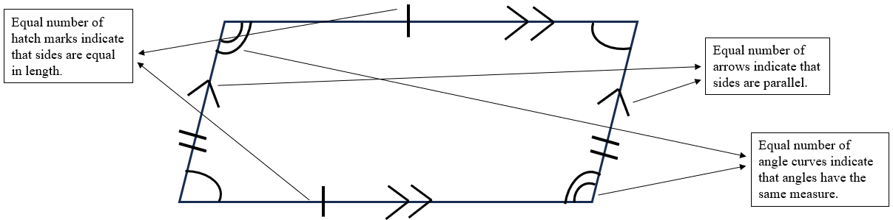

7.MG.3 The student will compare and contrast quadrilaterals based on their properties and determine unknown side lengths and angle measures of quadrilaterals.
Students will demonstrate the following Knowledge and Skills:
- Compare and contrast properties of the following quadrilaterals: parallelogram, rectangle, square, rhombus, and trapezoid:
  - parallel/perpendicular sides and diagonals;
  - congruence of angle measures, side, and diagonal lengths; and
  - lines of symmetry.
- Sort and classify quadrilaterals as parallelograms, rectangles, trapezoids, rhombi, and/or squares based on their properties:
  - parallel/perpendicular sides and diagonals;
  - congruence of angle measures, side, and diagonal lengths; and
  - lines of symmetry.
- Given a diagram, determine an unknown angle measure in a quadrilateral, using properties of quadrilaterals.
- Given a diagram, determine an unknown side length in a quadrilateral using properties of quadrilaterals.
7.MG.3 The student will compare and contrast quadrilaterals based on their properties and determine unknown side lengths and angle measures of quadrilaterals.
Additional Content Background and Instructional Guidance:
- A polygon is a closed plane figure composed of at least three line segments that do not cross.
- A quadrilateral is a polygon with four sides.
- Properties of quadrilaterals include the number of parallel sides, angle measures, number of congruent sides, lines of symmetry, and the relationship between the diagonals.
- A diagonal is a segment in a polygon that connects two vertices but is not a side.
- To bisect means to divide into two equal parts. A midpoint is the point where a line segment is divided into two congruent segments.
- A line of symmetry divides a figure into two congruent parts, each of which is the mirror image of the other. Lines of symmetry are not limited to horizontal and vertical lines.
- Parallel lines lie in the same plane and never intersect. Parallel lines are always the same distance apart and do not share any points. Therefore, parallel lines have the same slope.
- Perpendicular lines intersect at right angles.
- Adjacent sides are any two sides of a figure that share a common vertex.
- A parallelogram is a quadrilateral with both pairs of opposite sides parallel. Properties of a parallelogram include the following:
  - opposite sides are parallel and congruent;
  - opposite angles are congruent; and
  - diagonals bisect each other and one diagonal divides the figure into two congruent triangles.
- Parallelograms, with the exception of rectangles and rhombi, have no lines of symmetry. A rectangle and a rhombus have two lines of symmetry, with the exception of a square which has four lines of symmetry.
- A rectangle is a quadrilateral with four right angles. Properties of a rectangle include the following:
  - opposite sides are parallel and congruent;
  - all four angles are congruent and each angle measures 90°; and
  - diagonals are congruent and bisect each other.
- A rhombus is a quadrilateral with four congruent sides. Properties of a rhombus include the following:
  - all sides are congruent;
  - opposite sides are parallel;
  - opposite angles are congruent; and
  - diagonals bisect each other at right angles.
- A square is a quadrilateral that is a regular polygon with four congruent sides and four right angles. A square is a special type of a rectangle and a rhombus. Properties of a square include the following:
  - opposite sides are congruent and parallel;
  - all four angles are congruent and each angle measures 90°; and
  - diagonals are congruent and bisect each other at right angles.
- A square has four lines of symmetry. The diagonals of a square coincide with two of the lines of symmetry that can be drawn, as shown in the image below.
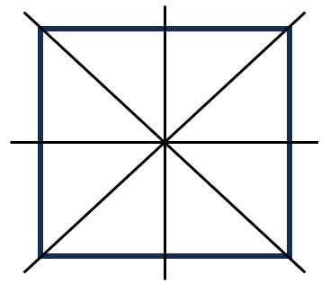
- A trapezoid is a quadrilateral with exactly one pair of parallel sides. The parallel sides of a trapezoid are called bases. The nonparallel sides of a trapezoid are called legs.
- An isosceles trapezoid has legs of equal length and congruent base angles. An isosceles trapezoid has one line of symmetry, as shown in the image below.
- A chart, graphic organizer, or Venn diagram can be used to organize quadrilaterals according to properties such as sides and/or angles.
- Quadrilaterals can be classified by the number of parallel sides: parallelograms, rectangles, rhombi, and squares each have two pairs of parallel sides; trapezoids have one pair of parallel sides; other quadrilaterals have no parallel sides.
- Quadrilaterals can be classified by the measures of the angles: rectangles and squares have four 90° angles; trapezoids may have zero or two 90° angles.
- Quadrilaterals can be classified by the number of congruent sides: rhombi and squares have four congruent sides; parallelograms and rectangles have two pairs of congruent sides; isosceles trapezoids have one pair of congruent sides.
- Any figure that has the properties of more than one subset of quadrilaterals can belong to more than one subset (e.g., a square can belong to the subset of squares, the subset of rhombi, the subset of rectangles, and the subset of parallelograms).
- The sum of the measures of the interior angles of a quadrilateral is 360°. Properties of quadrilaterals can be used to find unknown angle measures in a quadrilateral.

7.MG.4 The student will apply dilations of polygons in the coordinate plane.
Students will demonstrate the following Knowledge and Skills:
- Given a preimage in the coordinate plane, identify the coordinates of the image of a polygon that has been dilated. Scale factors are limited to $\frac{1}{4}$, $\frac{1}{2}$, 2, 3, or 4. The center of the dilation will be the origin.
- Sketch the image of a dilation of a polygon limited to a scale factor of $\frac{1}{4}$, $\frac{1}{2}$, 2, 3, or 4. The center of the dilation will be the origin.
- Identify and describe dilations in context including, but not limited to, scale drawings and graphic design.
7.MG.4 The student will apply dilations of polygons in the coordinate plane.
Additional Content Background and Instructional Guidance:
- A transformation of a figure, called the preimage, changes the size, shape, and/or position of the figure to a new figure, called the image.
- A transformation of preimage point A can be denoted as the image A’ (read as “A prime”).
- A dilation is a transformation in which an image is formed by enlarging or reducing the preimage proportionally by a scale factor from the center of dilation (limited to the origin in Grade 7).
- A dilation of a figure and the original figure are similar. The center of dilation may or may not be on the preimage. This concept can be connected to the study of similar figures and scale drawings.
- Contextual applications of dilations may include, but are not limited to, the following:
  - A model airplane is the production model of the airplane.
  - Photographs are resized by enlarging or reducing the image.
  - Blueprints of a building are a scale drawing of the actual building.

Probability and Statistics
7.PS.1 The student will use statistical investigation to determine the probability of an event and investigate and describe the difference between the experimental and theoretical probability.
Students will demonstrate the following Knowledge and Skills:
- Determine the theoretical probability of an event.
- Given the results of a statistical investigation, determine the experimental probability of an event.
- Describe changes in the experimental probability as the number of trials increases.
- Investigate and describe the difference between the probability of an event found through experiment or simulation versus the theoretical probability of that same event.
7.PS.1 The student will use statistical investigation to determine the probability of an event and investigate and describe the difference between the experimental and theoretical probability.
Additional Content Background and Instructional Guidance:
- In general, if all outcomes of an event are equally likely, the probability of an event occurring is equal to the ratio of desired outcomes to the total number of possible outcomes in the sample space.
- The probability of an event occurring can be represented as a ratio or equivalent fraction, decimal, or percent.
- The probability of an event occurring is a ratio between 0 and 1.
- A probability of 0 means the event will never occur (i.e., it is impossible).
- A probability of 1 means the event will always occur (i.e., it is certain).
- The theoretical probability of an event is the expected probability and can be determined with a ratio. If all outcomes of an event are equally likely, then:
theoretical probability of an event = $\frac{number of possible favorable outcomes}{total number of possible outcomes}$
- The experimental probability of an event is determined by carrying out a simulation or an experiment.
- The experimental probability of an event = $\frac{number of times desired outcomes occur}{number of trials in the experiment}$
- In experimental probability, as the number of trials increases, the experimental probability gets closer to the theoretical probability (Law of Large Numbers).
- Investigating the difference between the experimental probability and theoretical probability of the same event can be connected to comparing and ordering rational numbers.

7.PS.2 The student will apply the data cycle (formulate questions; collect or acquire data; organize and represent data; and analyze data and communicate results) with a focus on histograms.
Students will demonstrate the following Knowledge and Skills:
- Formulate questions that require the collection or acquisition of data with a focus on histograms.
- Determine the data needed to answer a formulated question and collect the data (or acquire existing data) using various methods (e.g., observations, measurement, surveys, experiments).
- Determine how sample size and randomness will ensure that the data collected is a sample that is representative of a larger population.
- Organize and represent numerical data using histograms with and without the use of technology.
- Investigate and explain how using different intervals could impact the representation of the data in a histogram.
- Compare data represented in histograms with the same data represented in other graphs, including but not limited to line plots (dot plots), circle graphs, and stem-and-leaf plots, and justify which graphical representation best represents the data.
- Analyze data represented in histograms by making observations and drawing conclusions. Determine how histograms reveal patterns in data that cannot be easily seen by looking at the corresponding given data set.
7.PS.2 The student will apply the data cycle (formulate questions; collect or acquire data; organize and represent data; and analyze data and communicate results) with a focus on histograms.
Additional Content Background and Instructional Guidance:
- Students should explore the entire data cycle with a question and set of data that has been collected or acquired. Student reflection should occur throughout the data cycle. The data cycle includes the following steps: formulating questions to be explored with data, collecting or acquiring data, organizing and representing data, and analyzing and communicating results.
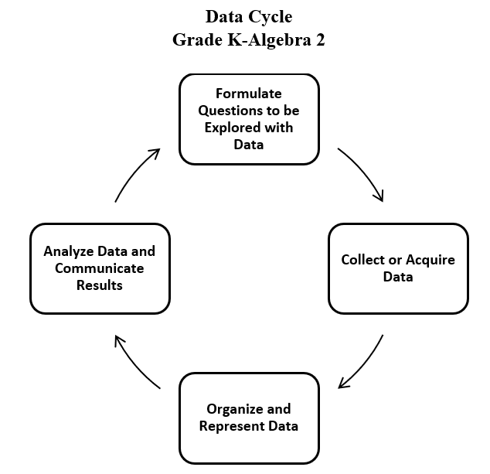
- To collect data for any problem situation, an experiment can be designed, a survey can be conducted, or other data-gathering strategies can be used. The data can be organized, displayed, analyzed, and interpreted to solve the problem.
- The teacher can provide data sets in addition to students engaging with their own data collection or acquisition.
- A population is the entire set of individuals or items from which data is drawn for a statistical study.
- A sample is a data set obtained from a subset that represents an entire population. This data set can be used to make reasonable assumptions about the whole population.
- Sampling is the process of selecting a suitable sample, or a representative part of a population, for the purpose of determining characteristics of the whole population.
- An example of a population would be the entire student body at a school, whereas a sample might be selecting a subset of students from each grade level. A sample may or may not be representative of the population as a whole. Questions to consider when determining whether an identified sample is representative of the population include:
  - What is the target population of the formulated question?
  - Who or what is the subject or context of the question?
- A random sample is one in which each member of the population has an equal chance of being selected. Random samples can be used to ensure that the sample is representative of the population and to avoid bias.
- Sample size refers to the number of participants or observations included in a study. Statistical data may be more accurate, and outliers may be more easily identified with larger sample sizes.
- Examples of questions to consider in building good samples:
  - What is the context of the data to be collected?
  - Who is the audience?
  - What amount of data should be collected?
- A histogram is a graph that provides a visual interpretation of numerical data by indicating the number of data points that lie within a range of values, called a class or a bin. The frequency of the data that falls in each class or bin is depicted by the use of a bar. Every element of the data set is not preserved when representing data in a histogram.
- A histogram is a form of bar graph in which the categories are consecutive and equal intervals. The length or height of each bar is determined by the number of data elements (frequency) falling into a particular interval. See the example below.
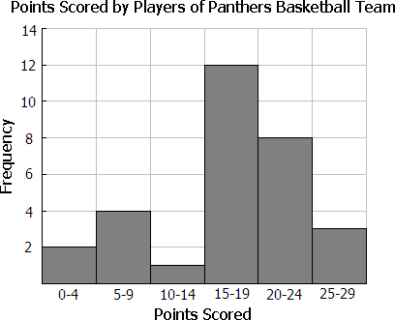
- Histograms do not directly display measures of center.
- Histograms do not display individual data points. Instead, histograms provide an easy-to-read summary for large data sets where displaying individual data points would become cumbersome.
- The data in a histogram is organized so that ranges of data values can be compared easily; that is, it can be determined which ranges occurred more or less often than others, the range that occurs most often, and where the data is concentrated. Histograms show where the ranges of data are centered or if there are gaps in data.
- Numerical data that can be characterized using consecutive intervals are best displayed in a histogram.
- Statistical questions or data sets that would not be well represented in a histogram include:
  - questions related to qualitative (categorical) data that would be better represented with circle graphs, bar graphs, etc.; and
  - questions related to quantitative (numerical) data that would be better represented with stem-and-leaf plots, line plots, etc. where visualizing individual data points would be important.
- A frequency distribution shows how often an item, a number, or range of numbers occurs. It can be used to construct a histogram.
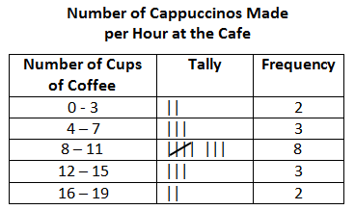
- To construct a histogram:
  - Organize collected data into a table. Create one column for data range categories (bins), divided into equal intervals that will include all of the data (for example, 0 - 10, 11 - 20, 21 - 30), and another column for frequency.
    - Bins should be all the same size.
    - Bins should include all of the data.
    - Boundaries for bins should reflect the data values being represented.
    - Determine the number of bins based upon the data.
    - If possible, the number of bins created should be a factor the number of data values (e.g., a histogram representing 20 data values might have 4 or 5 bins).
  - Create a graph. Mark the data range intervals on the x-axis (horizontal axis) with no space between the categories. Mark frequency on the y-axis (vertical axis), also in equal intervals. All histograms should include a title and labels that describe the data.
  - Plot the data. For each data range category (bin), draw a horizontal line at the appropriate frequency or marker. Then, create a vertical bar for that category reaching up to the marked frequency. Do this for each data range category (bin).
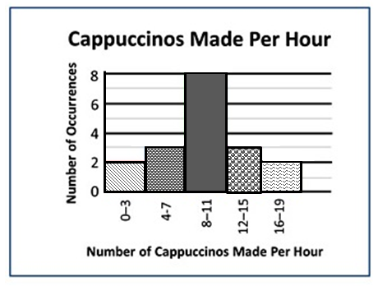
- Histograms may be drawn so that the bars are horizontal. To do this, interchange the x- and y-axis. Mark the data range intervals (bins) on the y-axis and the frequency on the x-axis. Draw the bars horizontally.
- Manipulating intervals in a histogram could result in misleading conclusions regarding the data set. For example, extremely large or small intervals (bins) can make it difficult to see the shape of the data.
- Comparisons, predictions, and inferences are made by examining characteristics of a data set displayed in a variety of graphical representations to draw conclusions. Data analysis helps describe data, recognize patterns or trends, and make predictions.
- There are two types of data: categorical and numerical. Categorical data can be sorted into groups or categories while numerical data are values or observations that can be measured. For example, types of fish caught would be categorical data while weights of fish caught would be numerical data. An awareness of the differences between categorical data and numerical data is important, however, students are not expected to know the terms for each type of data.
- In previous grades, students had experience with pictographs, bar graphs, line graphs, line plots, stem-and-leaf plots, and circle graphs. In Grade 7, students are not expected to construct these graphs.
  - A pictograph is used to show categorical data. Pictographs are used to show frequency and compare categories.
  - A bar graph is used for categorical data and is used to show comparisons between categories.
  - A line graph is used to show how numerical data changes over time.
  - A line plot provides an ordered display of all values in a data set and shows the frequency of data on a number line. Line plots are used to show the spread of the data, to include clusters (groups of data points) and gaps (large spaces between data points), and quickly identify the range, mode, and any extreme data values.
  - A stem-and-leaf plot is used for discrete numerical data and is used to show frequency of data distribution. A stem-and-leaf plot displays the entire data set and provides a picture of the distribution of data.
  - A circle graph is used for categorical and discrete numerical data. Circle graphs are used to show a relationship of the parts to a whole. Every element of the data set is not preserved when representing data in a circle graph.
- Different types of graphs can be used to display categorical and numerical data. The way data is displayed is often dependent on what someone is trying to communicate.
- Comparing different types of representations (charts and graphs) provides an opportunity to learn how different graphs can show different things about the same data. Discussions around what information different graphs representing the same data provides is beneficial for determining which graphical representation best represents the data.
- The information displayed in different graphs may be examined to determine how data are or are not related, differences between characteristics (comparisons), trends that suggest what new data might be like (predictions), and/or questions such as “What could happen if…” (inferences).

Patterns, Functions, and Algebra
7.PFA.1 The student will investigate and analyze proportional relationships between two quantities using verbal descriptions, tables, equations in y = mx form, and graphs, including problems in context.
Students will demonstrate the following Knowledge and Skills:
- Determine the slope, m, as the rate of change in a proportional relationship between two quantities given a table of values, graph, or contextual situation and write an equation in the form y = mx to represent the direct variation relationship. Slope may include positive or negative values (slope will be limited to positive values in a contextual situation).
- Identify and describe a line with a slope that is positive, negative, or zero (0), given a graph.
- Graph a line representing a proportional relationship, between two quantities given an ordered pair on the line and the slope, m, as rate of change. Slope may include positive or negative values.
- Graph a line representing a proportional relationship between two quantities given the equation of the line in the form y = mx, where m represents the slope as rate of change. Slope may include positive or negative values.
- Make connections between and among representations of a proportional relationship between two quantities using problems in context, tables, equations, and graphs. Slope may include positive or negative values (slope will be limited to positive values in a contextual situation).
7.PFA.1 The student will investigate and analyze proportional relationships between two quantities using verbal descriptions, tables, equations in y = mx form, and graphs, including problems in context.
Additional Content Background and Instructional Guidance:
- A rate is a ratio that compares two quantities measured in different units. A unit rate is a rate with a denominator of 1. Examples of rates include miles/hour and revolutions/minute.
- When two quantities, x and y, vary in such a way that one of them is a constant multiple of the other, the two quantities are “proportional.” A model for this situation is y = mx, where m is the slope or rate of change. Slope may also represent the unit rate of a proportional relationship between two quantities, also referred to as the constant of proportionality or the constant ratio of y to x. This can also be referred to as direct variation.
- A direct variation is a proportional relationship between two quantities. The statement “y is directly proportional to x” can be represented by the equation y = mx. The graph of a direct variation can be represented by a line passing through the origin (0, 0).
- The slope of a proportional relationship can be determined by finding the unit rate.
  - Example: The ordered pairs (4, 2) and (6, 3) make up points that could be included on the graph of a proportional relationship. Determine the slope, or rate of change, of a line passing through these points. Write an equation of the line representing this proportional relationship.
x | y
4 | 2
6 | 3

  - The slope, or rate of change, would be $\frac{1}{2}$ or 0.5 since the y-coordinate of each ordered pair is the result of multiplying $\frac{1}{2}$ times the x-coordinate. This would also be the unit rate of this proportional relationship. The ratio of y to x is the same for each ordered pair. That is, $\frac{y}{x }$ = $\frac{2}{4}$ = $\frac{3}{6}$ = $\frac{1}{2 }$ = 0.5.
  - The equation of a line representing this proportional relationship of y to x is y = $\frac{1}{2 }x$ or y = 0.5x.
- A linear function is an equation in two variables whose graph is a straight line, a type of continuous function.
- A linear function represents a situation with a constant rate. For example, when driving at a steady rate of 35 mph, the distance increases as the time increases, but the rate of speed remains the same.
- Slope (m) represents the rate of change in a linear function or the “steepness” of the line.
- The slope of a line is a rate of change, a ratio describing the vertical change to the horizontal change of the line.
slope = $\frac{change in y}{change in x}$= $\frac{vertical change}{horizontal change}$
- A line is increasing if it rises from left to right. The slope is positive (i.e., m > 0).
- A line is decreasing if it falls from left to right. The slope is negative (i.e., m < 0).
- A horizontal line has zero slope (i.e., m = 0).
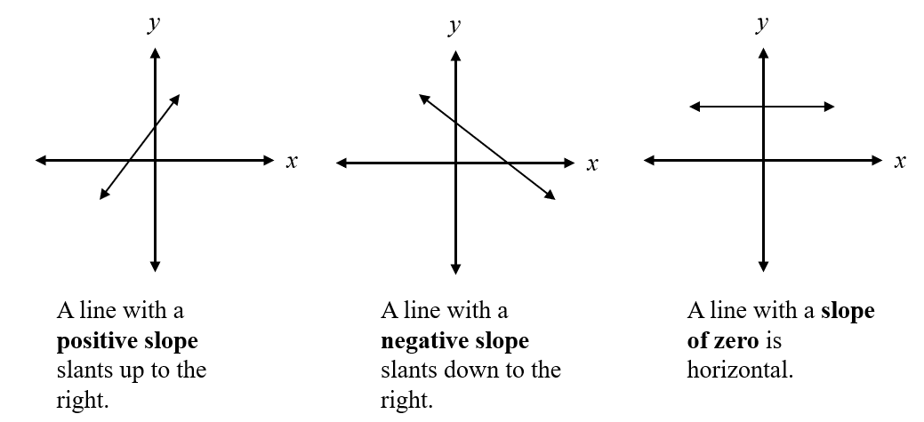
- The graph of the line representing a proportional relationship will include the origin (0, 0).
- A proportional relationship between two quantities can be modeled given a contextual situation. Representations may include verbal descriptions, tables, equations, or graphs. An informal discussion about independent and dependent variables when modeling contextual situations may be beneficial. (Formal instruction about dependent and independent variables occurs in Grade 8.)
  - Example (using a table of values): Cecil walks 2 meters every second (verbal description). If x represents the number of seconds and y represents the number of meters he walks, this proportional relationship can be represented using a table of values:
x (seconds) | 1 | 2 | 3 | 4
y (meters) | 2 | 4 | 6 | 8
    - This proportional relationship could be represented using the equation y = 2x, since he walks 2 meters for each second of time. That is, $\frac{y}{x }$ = $\frac{2}{1}$ = $\frac{4}{2}$ = $\frac{6}{3 }$ = $\frac{8}{4 }$ = $2$, the unit rate (constant of proportionality) is 2 or $\frac{2}{1}$. The same constant ratio of y to x exists for every ordered pair. This proportional relationship could be represented by the following graph:
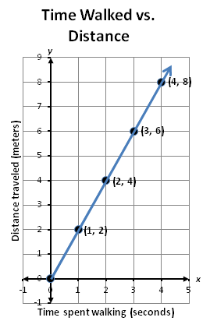
    - A graph of a proportional relationship can be created by graphing ordered pairs generated in a table of values (as shown above) or by observing the rate of change or slope of the relationship and using slope triangles to graph ordered pairs that satisfy the relationship given.
  - Example (using slope triangles): Cecil walks 2 meters every second. If x represents the number of seconds and y represents the number of meters he walks, this proportional relationship can be represented graphically using slope triangles.
    - The rate of change from (1, 2) to (2, 4) is 2 units up (the change in y) and 1 unit to the right (the change in x), $\frac{2}{1}$ or 2. Thus, the slope of this line is 2. Slope triangles can be used to generate points on a graph that satisfy this relationship.
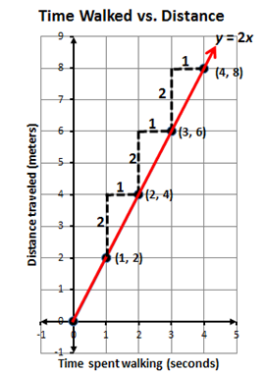
- In a proportional relationship, the relationship can be defined as y = mx, where m is known as the constant of proportionality and the ratio $\frac{y}{x}$ will always produce the same result. In a contextual situation, the terms x and y may take on meanings such as hours worked (x) and wages earned (y) or time passed (x) and distance traveled (y). Contextual situations may limit the slope or constant of proportionality to positive values.
- Graphing a line given an equation can be addressed using different methods. One method involves determining a table of ordered pairs by substituting into the equation values for one variable and solving for the other variable, plotting the ordered pairs in the coordinate plane, and connecting the points to form a straight line. Another method involves using slope triangles to determine points on the line.

7.PFA.2 The student will simplify numerical expressions, simplify and generate equivalent algebraic expressions in one variable, and evaluate algebraic expressions for given replacement values of the variables.
Students will demonstrate the following Knowledge and Skills:
- Use the order of operations and apply the properties of real numbers to simplify numerical expressions. Exponents are limited to 1, 2, 3, or 4 and bases are limited to positive integers. Expressions should not include braces { } but may include brackets [ ] and absolute value bars | |. Square roots are limited to perfect squares.*
- Represent equivalent algebraic expressions in one variable using concrete manipulatives and pictorial representations (e.g., colored chips, algebra tiles).
- Simplify and generate equivalent algebraic expressions in one variable by applying the order of operations and properties of real numbers. Expressions may require combining like terms to simplify. Expressions will include only linear and numeric terms. Coefficients and numeric terms may be positive or negative rational numbers.*
- Use the order of operations and apply the properties of real numbers to evaluate algebraic expressions for given replacement values of the variables. Exponents are limited to 1, 2, 3, or 4 and bases are limited to positive integers. Expressions should not include braces { } but may include brackets [ ] and absolute value bars | |. Square roots are limited to perfect squares. Limit the number of replacements to no more than three per expression. Replacement values may be positive or negative rational numbers.
* On the state assessment, items measuring this knowledge and skill are assessed without the use of a calculator.
7.PFA.2 The student will simplify numerical expressions, simplify and generate equivalent algebraic expressions in one variable, and evaluate algebraic expressions for given replacement values of the variables.
Additional Content Background and Instructional Guidance:
- An expression is a representation of a quantity. It may contain numbers, variables, and/or operation symbols. It does not have an “equal sign” (e.g. $\frac{3}{4}$, $5x$, 140 – 38.2, -18 ∙ 21, $(5+2x)∙4$). An expression cannot be solved.
- A numerical expression contains only numbers, the operations symbols, and grouping symbols.
- Expressions are simplified by using the order of operations.
- The order of operations is a convention that defines the computation order to follow in simplifying an expression. It ensures that there is only one correct value.
- The order of operations is as follows:
  - First, complete all operations within grouping symbols. If there are grouping symbols within other grouping symbols, do the innermost operations first. Note: Parentheses ( ), brackets [ ], absolute value bars | |, and the division bar should be treated as grouping symbols.
  - Second, evaluate all terms with exponents.
  - Third, multiply and/or divide in order from left to right.
  - Fourth, add and/or subtract in order from left to right.
- An algebraic expression is a variable expression that contains at least one variable (e.g., x – 3).
- Equivalent algebraic expressions can be modeled with concrete and pictorial representations. Modeling algebraic expressions should reflect the Concrete-Representational-Abstract (CRA) model.
- Simplifying an algebraic expression means to write the expression as a more compact and equivalent expression. This usually involves combining like terms.
- Like terms are terms that have the same variables and exponents. The coefficients do not need to be equivalent (e.g., 12x and -5x; 45 and -6 and $\frac{2}{3}$; 9y and -51y and $\frac{4}{9}y$). Like terms in Grade 7 are limited to variables with an exponent of 1.
- Like terms may be added or subtracted using properties of real numbers. For example,
4x + 2 – 2x
4x – 2x + 2
2x +2
4x + 2 – 2x and 2x +2 are equivalent expressions.
- To evaluate an algebraic expression, substitute a given replacement value for a variable and apply the order of operations.
  - For example, if a = 3 and b = -2 then 5a + b can be evaluated as 5(3) + (-2). When simplified using the order of operations, this equals 15 + (-2) = 13.
- Evaluating expressions occurs in many mathematical contexts including, but not limited to:
  - replacing the value of a variable to verify a solution to an equation;
  - replacing the value of a variable to confirm whether or not a value is part of the solution set to an inequality;
  - replacing values in formulas to determine surface area and volume.
- Expressions are simplified using the order of operations and applying the properties of real numbers. The following properties can be used, where appropriate, to further develop flexibility and fluency in problem solving (limitations may exist for the values of a, b, or c in this standard).
  - Commutative property of addition: $a+b=b+a$.
  - Commutative property of multiplication: $a∙b=b∙a$.
  - Associative property of addition: $\left(a+b\right)+c=a+(b+c)$.
  - Associative property of multiplication: $\left(a∙b\right)∙c=a∙(b∙c)$.
  - Subtraction and division are neither commutative nor associative.
  - Distributive property (over addition/subtraction): $a∙\left(b+c\right)=a∙b+a∙c and a∙\left(b-c\right)=a∙b-a∙c$.
  - The additive identity is zero (0) because any number added to zero is the number.
  - Identity property of addition (additive identity property): $a+0=a and 0+a=a$.
  - The multiplicative identity is one (1) because any number multiplied by one is the number.
  - Identity property of multiplication (multiplicative identity property): $a∙1=a and 1∙a=a$.
  - There are no identity elements for subtraction and division.
  - Inverses are numbers that combine with other numbers and result in identity elements (e.g., 5 + (–5) = 0; $\frac{1}{5}$ · 5 = 1).
    - Inverse property of addition (additive inverse property): $a+\left(-a\right)=$ 0 and $\left(-a\right)+a=0$.
    - Inverse property of multiplication (multiplicative inverse property): $a∙\frac{1}{a}=1 and \frac{1}{a}∙a=1$.
    - Zero has no multiplicative inverse.
  - Multiplicative property of zero: $a∙0=0 and 0∙a=0$.
  - Substitution property: If $a=b$, then b can be substituted for a in any expression, equation, or inequality.
- Division by zero is not a possible mathematical operation. It is undefined. In the example below, there is no single defined number possibility for dividing by 0, since zero multiplied by any number is zero:
12 ÷ 0 = r → r · 0 = 12

7.PFA.3 The student will write and solve two-step linear equations in one variable, including problems in context, that require the solution of a two-step linear equation in one variable.
Students will demonstrate the following Knowledge and Skills:
- Represent and solve two-step linear equations in one variable using a variety of concrete materials and pictorial representations.
- Apply properties of real numbers and properties of equality to solve two-step linear equations in one variable. Coefficients and numeric terms will be rational.
- Confirm algebraic solutions to linear equations in one variable.
- Write a two-step linear equation in one variable to represent a verbal situation, including those in context.
- Create a verbal situation in context given a two-step linear equation in one variable.
- Solve problems in context that require the solution of a two-step linear equation.
7.PFA.3 The student will write and solve two-step linear equations in one variable, including problems in context, that require the solution of a two-step linear equation in one variable.
Additional Content Background and Instructional Guidance:
- An equation is a mathematical sentence that states that two expressions are equal.
- The solution to an equation is the value(s) that makes it a true statement. Many equations have one solution and can be represented as a point on a number line. Not all linear equations have one solution; however, equations that have no solution or an infinite number of solutions are beyond the scope of Grade 7 and are addressed in Algebra 1.
- A variety of concrete materials such as colored chips, algebra tiles, or weights on a balance scale may be used to model solving equations in one variable.
- The inverse operation for addition is subtraction, and the inverse operation for multiplication is division.
- A two-step linear equation may include, but not be limited to, equations such as the following:
  - 2x + $\frac{1}{2}$ = -5
  - -25 = 7.2x + 1
  - $\frac{x-7}{-3}$ = 4
  - $\frac{3}{4}$x – 2 = 10
  - $3x+5x=4$
- An algebraic expression is a variable expression that contains at least one variable (e.g., 2x – 3).
- An algebraic equation is a mathematical statement that says that two expressions are equal (e.g., 2x – 8 = 7).
- Word choice and language are very important when representing verbal situations in context using mathematical operations, equality, and variables. When presented with an equation or context, choice of language should reflect the situation being modeled.
- Identifying the mathematical operation(s) to represent the action(s) and the variable to represent the unknown quantity will help to write equations to represent the contextual situation.
- When creating equations and verbal situations in context, the coefficient may be limited to a positive value.
- Properties of real numbers and properties of equality can be applied when solving equations and justifying solutions. The following properties should be used, where appropriate, to further develop flexibility and fluency in problem solving (limitations may exist for the values of a, b, or c in this standard):
  - Commutative property of addition: $a+b=b+a$
  - Commutative property of multiplication: $a∙b=b∙a$
  - Subtraction and division are not commutative.
  - The additive identity is zero (0) because any number added to zero is the number.
  - Identity property of addition (additive identity property): $a+0=a and 0+a=a$
  - The multiplicative identity is one (1) because any number multiplied by one is the number.
  - Identity property of multiplication (multiplicative identity property): $a∙1=a$ $and 1∙a=a$
  - There are no identity elements for subtraction and division.
  - Inverses are numbers that combine with other numbers and result in identity elements (e.g., 5 + (–5) = 0; $\frac{1}{5}$ · 5 = 1).
    - Inverse property of addition (additive inverse property): $a+\left(-a\right)=0 and \left(-a\right)+a=0$
    - Inverse property of multiplication (multiplicative inverse property): $a∙\frac{1}{a}=1 and \frac{1}{a}∙a=1$
    - Zero has no multiplicative inverse.
  - Multiplicative property of zero: $a∙0=0 and 0∙a=0$
  - Substitution property: If $a=b$, then b can be substituted for a in any expression, equation, or inequality.
  - Addition property of equality: If $a=b$, then $a+c=b+c$
  - Subtraction property of equality: If $a=b,$ then $a-c=b-c$
  - Multiplication property of equality: If $a=b,$ then $a∙c=b∙c$
  - Division property of equality: If $a=b and c≠0,$ then $\frac{a}{c}=\frac{b}{c}$
- Division by zero is not a possible mathematical operation. It is undefined. In the example below, there is no single defined number possibility for dividing by 0, since zero multiplied by any number is zero:
12 ÷ 0 = r → r · 0 = 12

7.PFA.4 The student will write and solve one- and two-step linear inequalities in one variable, including problems in context, that require the solution of a one- and two-step linear inequality in one variable.
Students will demonstrate the following Knowledge and Skills:
- Apply properties of real numbers and the addition, subtraction, multiplication, and division properties of inequality to solve one- and two-step inequalities in one variable. Coefficients and numeric terms will be rational.
- Investigate and explain how the solution set of a linear inequality is affected by multiplying or dividing both sides of the inequality statement by a rational number less than zero.
- Represent solutions to one- or two-step linear inequalities in one variable algebraically and graphically using a number line.
- Write one- or two-step linear inequalities in one variable to represent a verbal situation, including those in context.
- Create a verbal situation in context given a one or two-step linear inequality in one variable.
- Solve problems in context that require the solution of a one- or two-step inequality.
- Identify a numerical value(s) that is part of the solution set of as given one- or two-step linear inequality in one variable.
- Describe the differences and similarities between solving linear inequalities in one variable and linear equations in one variable.
7.PFA.4 The student will write and solve one- and two-step linear inequalities in one variable, including problems in context, that require the solution of a one- and two-step linear inequality in one variable.
Additional Content Background and Instructional Guidance:
- In an inequality, there can be more than one value for the variable that makes the inequality true. There can be many solutions. (e.g., Given the inequality x + 4 > −3, the solution is x > −7. This means that x can be any number greater than −7. A few solutions might be −6.5, −3, 0, 4, 25, etc.)
- Solutions to inequalities can be represented using a number line.
- When both expressions of an inequality are multiplied or divided by a negative number, the inequality symbol should be reversed (e.g., –3x < 15 is equivalent to x > –5).
- Word choice and language are very important when representing verbal situations in context using mathematical operations, inequality symbols, and variables. When presented with an inequality or context, choice of language should reflect the situation being modeled. Identifying the mathematical operation(s) to represent the action(s), and the variable to represent the unknown quantity will help to write inequalities that represent contextual situations.
- When creating inequalities and verbal situations in context, the coefficient may be limited to a positive value.
- Properties of real numbers and properties of inequality can be used to solve inequalities, justify solutions, and express simplification. The following properties can be used, where appropriate, to further develop flexibility and fluency in problem solving (limitations may exist for the values of a, b, or c in this standard).
  - Commutative property of addition: $a+b=b+a$
  - Commutative property of multiplication: $a∙b=b∙a$
  - Subtraction and division are not commutative.
  - The additive identity is zero (0) because any number added to zero is the number.
  - Identity property of addition (additive identity property): $a+0=a and 0+a=a$
  - The multiplicative identity is one (1) because any number multiplied by one is the number.
  - Identity property of multiplication (multiplicative identity property): $a∙1=a$ $and 1∙a=a$
  - There are no identity elements for subtraction and division.
  - Inverses are numbers that combine with other numbers and result in identity elements (e.g., 5 + (–5) = 0; $\frac{1}{5}$ · 5 = 1)
    - Inverse property of addition (additive inverse property): $a+\left(-a\right)=0$ $and \left(-a\right)+a=0$
    - Inverse property of multiplication (multiplicative inverse property): $a∙\frac{1}{a}=1 and \frac{1}{a}∙a=1$
    - Zero has no multiplicative inverse.
  - Multiplicative property of zero: $a∙0=0 and 0∙a=0$
  - Substitution property: If $a=b$, then b can be substituted for a in any expression, equation, or inequality.
  - Addition property of inequality: If $a<b,$ then$a+c<b+c$; if $a>b,$ then $a+c>b+c$
  - Subtraction property of inequality: If $a<b,$ then$a-c<b-c$; if $a>b,$ then $a-c>b-c$
  - Multiplication property of inequality: If $a<b and c>0,$ then $a∙c<b∙c$; if $a>b and c>0,$ then $a∙c>b∙c$
  - Multiplication property of inequality (multiplication by a negative number): If $a<b and c<0,$ then $a∙c>b∙c$; if $a>b and c<0,$ then $a∙c<b∙c$
  - Division property of inequality: If $a<b and c>0,$ then $\frac{a}{c}<\frac{b}{c}$; if $a>b and c>0,$ then $\frac{a}{c}>\frac{b}{c}$
  - Division property of inequality (division by a negative number): If $a<b$and $c<0,$ then $\frac{a}{c}>\frac{b}{c}$; if $a>b and c<0,$ then $\frac{a}{c}<\frac{b}{c}$
- Division by zero is not a possible mathematical operation. It is undefined. In the example below, there is no single defined number possibility for dividing by 0, since zero multiplied by any number is zero:
12 ÷ 0 = r → r · 0 = 12

