2023 Mathematics Standards of Learning
Understanding the Standards – Grade 6
The Understanding the Standards document includes the mathematics understandings and key concepts that assist teachers in planning standards-focused instruction of the sixth grade 2023 Mathematics Standards of Learning. The Understanding the Standards includes definitions, explanations, and examples regarding each mathematics standard and describes what students should know (core knowledge) as a result of the instruction specific to the course/grade level.

Number and Number Sense
6.NS.1 The student will reason and use multiple strategies to express equivalency, compare, and order numbers written as fractions, mixed numbers, decimals, and percents.
Students will demonstrate the following Knowledge and Skills:
- Estimate and determine the percent represented by a given model (e.g., number line, picture, verbal description), including percents greater than 100% and less than 1%.*
- Represent and determine equivalencies among decimals (through the thousandths place) and percents incorporating the use of number lines, and concrete and pictorial models.*
- Represent and determine equivalencies among fractions (proper or improper) and mixed numbers that have denominators that are 12 or less or factors of 100 and percents incorporating the use of number lines, and concrete and pictorial models.*
- Represent and determine equivalencies among decimals, percents, fractions (proper or improper), and mixed numbers that have denominators that are 12 or less or factors of 100 incorporating the use of number lines, and concrete and pictorial models.*
- Use multiple strategies (e.g., benchmarks, number line, equivalency) to compare and order no more than four positive rational numbers expressed as fractions (proper or improper), mixed numbers, decimals, and percents (decimals through thousandths, fractions with denominators of 12 or less or factors of 100) with and without models. Justify solutions orally, in writing or with a model. Ordering may be in ascending or descending order.*
* On the state assessment, items measuring this objective are assessed without the use of a calculator.
6.NS.1 The student will reason and use multiple strategies to express equivalency, compare, and order numbers written as fractions, mixed numbers, decimals, and percents.
Additional Content Background and Instructional Guidance:
- Fractions, decimals, and percents are three different ways to express the same number. Any number that can be written as a fraction can be expressed as a terminating or repeating decimal or a percent.
- Percent means “per 100” or how many “out of 100”; percent is another name for hundredths.
- A number followed by a percent symbol (%) is equivalent to a fraction with that number as the numerator and with 100 as the denominator (e.g., $30\%=\frac{30}{100}$; $139\%= \frac{139}{100}$).
- Percents can be expressed as fractions or decimals (e.g., $38\%=\frac{38}{100}=0.38$; $139\%= \frac{139}{100}=1.39$).
- Percents are used to solve contextual problems including sales, tax, and discounts.
- When estimating a percent, students should consider benchmarks of 0%, 25%, 50%, 75%, and 100%.
- For percents less than 1, focus on benchmarks that are less than 1% (like 0.5% or $\frac{3}{4}$%).
- Equivalent relationships among fractions, decimals, and percents may be determined by using concrete materials and pictorial representations (e.g., fraction bars, base 10 blocks, fraction circles, number lines, colored counters, cubes, decimal squares, shaded figures, shaded grids, or calculators).
- Some fractions can be rewritten as equivalent fractions with denominators of powers of 10 and can be represented as decimals or percents (e.g., $\frac{3}{5}$= $\frac{6}{10}$ = $\frac{60}{100}$= 0.60 = 60%). Fractions, decimals, and percents can be represented by using an area model, a set model, or a measurement model. For example, the fraction $\frac{1}{3}$ is shown below using each of the three models.
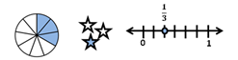
- The set of rational numbers includes the set of all numbers that can be expressed as fractions in the form $\frac{a}{b}$ where a and b are integers and b does not equal zero. The decimal form of a rational number can be expressed as a terminating or repeating decimal. A few examples of positive rational numbers are$:0.275, \frac{1}{4}$, 82, 75%, $\frac{22}{5}, \text{4.}\overline{\text{59}}.$
- Students are not expected to know the names of the subsets of the real numbers until Grade 8.
- Proper fractions, improper fractions, and mixed numbers are terms used to describe fractions. A proper fraction is a fraction whose numerator is less than the denominator. An improper fraction is a fraction whose numerator is equal to or greater than the denominator. An improper fraction may be expressed as a mixed number. A mixed number is written with two parts: a whole number and a proper fraction (e.g., 3$\frac{5}{8}$).
- Strategies using 0, $\frac{1}{2},$and 1 as benchmarks can be used to compare fractions and decimals. For example: Which is greater, $\frac{4}{7}$ or 0.4? $\frac{4}{7}$is greater than $\frac{1}{2}$because 4, the numerator, represents more than half of 7, the denominator. $0.4$ is less than $\frac{1}{2}$ because 0.4 is less than 0.5 which is equivalent to $\frac{1}{2}$. Therefore, $\frac{4}{7}$> $0.4$.
- When comparing two fractions close to 1, the distance from 1 can be used as the benchmark. For example: Which is greater, $\frac{6}{7}$ or $\frac{8}{9}$ ? $\frac{6}{7}$ is $\frac{1}{7}$ away from 1 whole. $\frac{8}{9}$ is $\frac{1}{9}$ away from 1 whole. Since, $\frac{1}{9}$ $<\frac{1}{7}$, then $\frac{6}{7}$ is a greater distance away from 1 whole than $\frac{8}{9 }$. Therefore, $\frac{6}{7}<\frac{8}{9}$.
- Some fractions have a decimal representation that is a terminating decimal, which means it has a finite number of digits (e.g., $\frac{1}{8} = 0.125$). Other fractions have a decimal representation that does not terminate but continues to repeat (e.g., $\frac{2}{9}$= 0.222…) The repeating decimal can be written with ellipses (three dots) as in 0.222… or denoted with a bar above the digits that repeat as in $0.\overline{2}.$
- Students may justify their reasoning by using benchmarks, number lines, equivalency, pictures, etc.

6.NS.2 The student will reason and use multiple strategies to represent, compare, and order integers.
Students will demonstrate the following Knowledge and Skills:
- Represent integers (e.g., number lines, concrete materials, pictorial models), including models derived from contextual situations, and identify an integer represented by a point on a number line.
- Compare and order integers using a number line.
- Compare integers, using mathematical symbols (<, >, =).
- Identify and describe the absolute value of an integer as the distance from zero on the number line.
6.NS.2 The student will reason and use multiple strategies to represent, compare, and order integers.
Additional Content Background and Instructional Guidance:
- The set of integers includes the set of whole numbers and their opposites {…⁻2, ⁻1, 0, 1, 2, …}. Zero has no opposite and is an integer that is neither positive nor negative.
- The opposite of a positive number is negative, and the opposite of a negative number is positive.
- Positive integers are greater than zero.
- Negative integers are less than zero.
- A negative integer is always less than a positive integer.
- On a conventional number line, a smaller number is always located to the left of a larger number (e.g., ⁻7 lies to the left of ⁻3, thus ⁻7 < ⁻3; 5 lies to the left of 8, thus 5 < 8).
- When comparing two negative integers using a number line, the negative integer that is closer to zero is greater.
- Integers are used in contextual situations, such as temperature (above/below zero degrees), deposits/withdrawals in a checking account, golf (above/below par), timelines, football yardage, positive and negative electrical charges, and altitude (above/below sea level).
- Integers should be explored by modeling on number lines, both horizontal and vertical, and using manipulatives, such as two-color counters, drawings, or algebra tiles.
- The absolute value of a number is the distance of a number from zero on the number line regardless of direction. Absolute value is represented using the symbol (e.g., $\left|-6\right| =6 and \left|6\right| =6$). Absolute value is always positive.
- The absolute value of zero is zero.
- An integer and its opposite are the same distance from zero on a number line. Thus, they have the same absolute value. For example: The opposite of 3 is ⁻3, and $\left|-3\right| =$ 3 and $\left|3\right| =3$.

6.NS.3 The student will recognize and represent patterns with whole number exponents and perfect squares.
Students will demonstrate the following Knowledge and Skills:
- Recognize and represent patterns with bases and exponents that are whole numbers.
- Recognize and represent patterns of perfect squares not to exceed${ 20}^{2}$, by using concrete and pictorial models.
- Justify if a number between 0 and 400 is a perfect square through modeling or mathematical reasoning.
- Recognize and represent powers of 10 with whole number exponents by examining patterns in place value.
6.NS.3 The student will recognize and represent patterns with whole number exponents and perfect squares.
Additional Content Background and Instructional Guidance:
- The symbol $⋅$can be used in Grade 6 in place of “×” to indicate multiplication.
- In exponential notation, the base is the number that is multiplied, and the exponent represents the number of times the base is used as a factor. For example, in $8^{3}$, 8 is the base and 3 is the exponent (e.g., $8^{3}= 8 ⋅ 8 ⋅ 8$).
- Any real number other than zero raised to the zero power is 1. Patterns can be used to foster this understanding for students. See the example below.
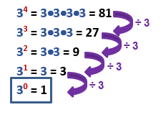
- Zero raised to the zero power ($0^{0}$) is undefined according to some calculators. Other calculators will return a value of 1 when 0 is raised to the 0 power. There is debate among mathematicians surrounding this value. Students should not be expected to provide a direct value for this quantity ($0^{0}$).
- An integer that can be expressed as the square of another integer is called a perfect square (e.g., $36 = 6 ⋅ 6 = 6^{2}$). Zero (a whole number) is a perfect square.
- Perfect squares may be represented geometrically as the areas of squares whose side lengths are whole numbers (e.g., $1 ⋅ 1, 2 ⋅ 2, 3 ⋅ 3$). This can be modeled with grid paper, tiles, geoboards, and virtual manipulatives.
- The examination of patterns in place value of the powers of 10 in Grade 6 leads to the development of scientific notation in Grade 7.

Computation and Estimation
6.CE.1 The student will estimate, demonstrate, solve, and justify solutions to problems using operations with fractions and mixed numbers, including those in context.
Students will demonstrate the following Knowledge and Skills:
- Demonstrate/model multiplication and division of fractions (proper or improper) and mixed numbers using multiple representations.*
- Multiply and divide fractions (proper or improper) and mixed numbers that include denominators of 12 or less. Answers are expressed in simplest form.*
- Investigate and explain the effect of multiplying or dividing a fraction, whole number, or mixed number by a number between zero and one.*
- Estimate, determine, and justify the solution to single-step and multistep problems in context that involve addition and subtraction with fractions (proper or improper) and mixed numbers, with and without regrouping, that include like and unlike denominators of 12 or less. Answers are expressed in simplest form.
- Estimate, determine, and justify the solution to single-step and multistep problems in context that involve multiplication and division with fractions (proper or improper) and mixed numbers that include denominators of 12 or less. Answers are expressed in simplest form.
* On the state assessment, items measuring this objective are assessed without the use of a calculator.
6.CE.1 The student will estimate, demonstrate, solve, and justify solutions to problems using operations with fractions and mixed numbers, including those in context.
Additional Content Background and Instructional Guidance:
- A fraction can be expressed in simplest form (simplest equivalent fraction) by dividing the numerator and denominator by their greatest common factor.
- When the numerator and denominator have no common factors other than 1, then the fraction is in simplest form.
- Addition and subtraction are inverse operations. Multiplication and division are inverse operations.
- Models for representing multiplication and division of fractions may include arrays, paper folding, repeated addition, repeated subtraction, fraction strips, fraction rods, pattern blocks, or area models.
- It is helpful to use estimation to develop computational strategies and determine the reasonableness of a solution. For example: $2\frac{7}{8} ⋅ \frac{3}{4}$ is about $\frac{3}{4}$ of 3, so the answer is between 2 and 3.
- When multiplying a whole number by a fraction such as $3 ⋅ \frac{1}{2}$, the meaning is the same as with multiplication of whole numbers: 3 groups the size of $\frac{1}{2}$ of the whole.
- When multiplying a fraction by a whole number such as $\frac{1}{3}⋅6$, we are trying to determine a part of the whole: $\frac{1}{3}$ of six wholes.
- When multiplying a fraction by a fraction such as $\frac{1}{2}⋅\frac{3}{4}$, the problem is asking for part of a part: one-half of $\frac{3}{4}$.
- It is helpful to use benchmark fractions or decimals to explore the effect of multiplying or dividing a fraction, whole number, or mixed number by a number between zero and one. Students should understand that multiplying by a number between zero and one will decrease the value of the original number and dividing by a number between zero and one will increase the value of the original number.
- Solving multistep problems in the context of contextual situations enhances proficiency with estimation strategies.
- Students may justify their reasoning by using estimation strategies, models, benchmarks, etc.

6.CE.2 The student will estimate, demonstrate, solve, and justify solutions to problems using operations with integers, including those in context.
Students will demonstrate the following Knowledge and Skills:
- Demonstrate/model addition, subtraction, multiplication, and division of integers using pictorial representations or concrete manipulatives.*
- Add, subtract, multiply, and divide two integers.*
- Simplify an expression that contains absolute value bars | | and an operation with two integers (e.g., –|5 – 8| or $\frac{\left|-12\right|}{8}$) and represent the result on a number line.
- Estimate, determine, and justify the solution to one and two-step contextual problems, involving addition, subtraction, multiplication, and division with integers.
* On the state assessment, items measuring this objective are assessed without the use of a calculator.
6.CE.2 The student will estimate, demonstrate, solve, and justify solutions to problems using operations with integers, including those in context.
Additional Content Background and Instructional Guidance:
- The set of integers is the set of whole numbers and their opposites {…⁻2, ⁻1, 0, 1, 2, …}. Zero has no opposite and is neither positive nor negative.
- Integers are used in contextual situations, such as temperature (above/below zero degrees), deposits/withdrawals in a checking account, golf (above/below par), timelines, football yardage, positive and negative electrical charges, and altitude (above/below sea level).
- Concrete experiences in formulating rules for adding, subtracting, multiplying, and dividing integers should be explored by examining patterns using calculators, a number line, and manipulatives, such as two-color counters, drawings, or algebra tiles.
- Sums, differences, products, and quotients of integers are either positive, negative, undefined or zero. This may be demonstrated using patterns and models.
- When determining the sum of:
  - a positive integer and a positive integer, the sum will be positive (e.g., 7 + 3 = 10).
  - a positive integer and a negative integer, the sum may be positive or negative (e.g., 7 + ⁻1 = 6; 3 + ⁻5 = ⁻2).
  - a negative integer and a negative integer, the sum will be negative (e.g., ⁻3 + (⁻4) = ⁻7).
- When determining the difference of:
  - a positive integer and a positive integer, the difference may be positive or negative (e.g., 7 – 3 = 4; 2 – 5 = ⁻3).
  - a positive integer and a negative integer, the difference will be positive (e.g., 7 – (⁻1) = 8).
  - a negative integer and a positive integer, the difference will be negative (e.g., ⁻3 – 1) = ⁻4).
  - a negative integer and a negative integer, the difference may be positive or negative (e.g., ⁻1 – (⁻2) = 1; ⁻6 – (⁻3) = ⁻3).
- When determining the product of:
  - a positive integer and a positive integer, the product will be positive (e.g., 7 $⋅$ 2 = 14).
  - a positive integer and a negative integer, the product will be negative (e.g., 6 $⋅$ (⁻3) = ⁻18).
  - a negative integer and a negative integer, the product will be positive (e.g., ⁻5 $⋅$ (⁻4) = 20).
- When determining the quotient of:
  - a positive integer and a positive integer, the quotient will be positive (e.g., 14 ÷ 2 = 7).
  - a positive integer and a negative integer, the quotient will be negative (e.g., 18 ÷ (⁻3) = ⁻6).
  - a negative integer and a positive integer, the quotient will be negative (e.g., ⁻15 ÷ 3 = ⁻5).
  - a negative integer and a negative integer, the quotient will be positive (e.g., ⁻20 ÷ (⁻2) = 10).
- Students may justify their reasoning by using estimation strategies, models, benchmarks, etc.

Measurement and Geometry
6.MG.1 The student will identify the characteristics of circles and solve problems, including those in context, involving circumference and area.
Students will demonstrate the following Knowledge and Skills:
- Identify and describe chord, diameter, radius, circumference, and area of a circle.
- Investigate and describe the relationship between:
  - diameter and radius;
  - radius and circumference; and
  - diameter and circumference.
- Develop an approximation for pi (3.14) by gathering data and comparing the circumference to the diameter of various circles, using concrete manipulatives or technological models.
- Develop the formula for circumference using the relationship between diameter, radius, and pi.
- Solve problems, including those in context, involving circumference and area of a circle when given the length of the diameter or radius.
6.MG.1 The student will identify the characteristics of circles and solve problems, including those in context, involving circumference and area.
Additional Content Background and Instructional Guidance:
- A chord is a line segment connecting any two points on a circle. A chord may or may not go through the center of a circle. The diameter is the longest chord of a circle.
- A diameter is a chord that goes through the center of a circle. The length of the diameter of a circle is twice the length of the radius.
- A radius is a line segment connecting the center of a circle to any point on the circle. Two radii end to end form a diameter of a circle.
- Perimeter is the path or distance around any plane figure. The perimeter of a circle is called the circumference.
- The circumference of a circle is about three times the measure of its diameter.
- The value of pi (π) is the ratio of the circumference of a circle to its diameter. Thus, the circumference of a circle is proportional to its diameter.
- The circumference of a circle is computed using C = πd or C = 2πr, where d is the diameter and r is the radius of the circle.
- The area of a closed curve is the number of nonoverlapping square units required to fill the region enclosed by the curve.
- The area of a circle is computed using the formula A = πr², where r is the radius of the circle.
- When determining area and circumference of a circle, the calculation may vary depending upon the approximation for pi that is used. Common approximations for π include 3.14, $\frac{22}{7},$or the pi (π) button on a calculator.

6.MG.2 The student will reason mathematically to solve problems, including those in context, that involve the area and perimeter of triangles and parallelograms.
Students will demonstrate the following Knowledge and Skills:
- Develop the formula for determining the area of parallelograms and triangles using pictorial representations and concrete manipulatives (e.g., two-dimensional diagrams, grid paper).
- Solve problems, including those in context, involving the perimeter and area of triangles and parallelograms.
6.MG.2 The student will reason mathematically to solve problems, including those in context, that involve the area and perimeter of triangles and parallelograms.
Additional Content Background and Instructional Guidance:
- Experiences in developing the formulas for area and perimeter using manipulatives such as tiles, one-inch cubes, graph paper, geoboards, or tracing paper, promote an understanding of the formulas and their use.
- If a parallelogram is subdivided into two congruent right triangles and one rectangle, one of the right triangles from the original parallelogram can be repositioned to form a rectangle. The original parallelogram is now in the shape of a rectangle in which the area can be determined using the formula A = bh.
- Any rectangle can be subdivided into two congruent right triangles by drawing a diagonal. Since the two resulting triangles are congruent, each triangle is exactly half of the area of the original rectangle. Hence, the area of a triangle can be determined using the formula $A = \frac{1}{2}bh.$
- Perimeter is the path or distance around any plane figure.
- The perimeter of a square whose side measures s can be determined by multiplying 4 by s (P = 4s), and its area can be determined by squaring the length of one side (A = s²).
- The perimeter of a rectangle can be determined by computing the sum of twice the length and twice the width (P = 2l + 2w, or P = 2(l + w)), and its area can be determined by computing the product of the length and the width (A = lw).
- The perimeter of a triangle can be determined by computing the sum of the side lengths ($P=a+b+c$), and its area can be determined by computing one-half of the product of the base and the height ($A=\frac{1}{2}bh$).

6.MG.3 The student will describe the characteristics of the coordinate plane and graph ordered pairs.
Students will demonstrate the following Knowledge and Skills:
- Identify and label the axes, origin, and quadrants of a coordinate plane.
- Identify and describe the location (quadrant or the axis) of a point given as an ordered pair. Ordered pairs will be limited to coordinates expressed as integers.
- Graph ordered pairs in the four quadrants and on the axes of a coordinate plane. Ordered pairs will be limited to coordinates expressed as integers.
- Identify ordered pairs represented by points in the four quadrants and on the axes of the coordinate plane. Ordered pairs will be limited to coordinates expressed as integers.
- Relate the coordinates of a point to the distance from each axis and relate the coordinates of a single point to another point on the same horizontal or vertical line. Ordered pairs will be limited to coordinates expressed as integers.
- Draw polygons in the coordinate plane given coordinates for the vertices; use coordinates to determine the length of a side joining points with the same first coordinate or the same second coordinate. Ordered pairs will be limited to coordinates expressed as integers. Apply these techniques in the context of solving contextual and mathematical problems.
6.MG.3 The student will describe the characteristics of the coordinate plane and graph ordered pairs.
Additional Content Background and Instructional Guidance:
- In a coordinate plane, the coordinates of a point are typically represented by the ordered pair (x, y), where x is the first coordinate and y is the second coordinate.
- Any given point is defined by only one ordered pair in the coordinate plane.
- The grid lines on a coordinate plane are perpendicular.
- The axes of the coordinate plane are the two intersecting perpendicular lines that divide the coordinate plane into four quadrants. The x-axis is the horizontal axis, and the y-axis is the vertical axis.
- The quadrants of a coordinate plane are the four regions created by the two intersecting perpendicular lines (x- and y-axes). Quadrants are named in counterclockwise order. The signs on the ordered pairs for quadrant I are (+,+); for quadrant II (–,+); for quadrant III (–, –); and for quadrant IV (+,–).
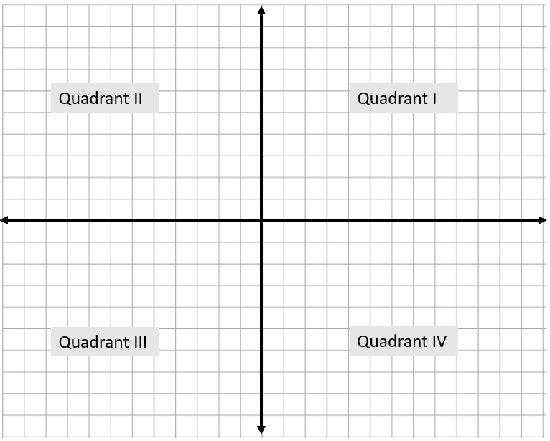
- In a coordinate plane, the origin is the point at the intersection of the x-axis and y-axis; the coordinates of this point are (0, 0).
- For all points on the x-axis, the y-coordinate is 0. For all points on the y-axis, the x-coordinate is 0.
- The coordinates may be used to name a point (e.g., the point (2, 7)). It is not necessary to say, “The point whose coordinates are (2, 7).” The first coordinate tells the location or distance of the point to the left or right of the y-axis and the second coordinate tells the location or distance of the point above or below the x-axis. For example, (2, 7) is two units to the right of the y-axis and seven units above the x-axis.
- Coordinates of points having the same x-coordinate are located on the same vertical line. For example, (2, 4) and (2, ⁻3) are both two units to the right of the y-axis and are vertically seven units from each other.
- Coordinates of points having the same y-coordinate are located on the same horizontal line. For example, (⁻4, ⁻2) and (2, ⁻2) are both two units below the x-axis and are horizontally six units from each other.

6.MG.4 The student will determine congruence of segments, angles, and polygons.
Students will demonstrate the following Knowledge and Skills:
- Identify regular polygons.
- Draw lines of symmetry to divide regular polygons into two congruent parts.
- Determine the congruence of segments, angles, and polygons given their properties.
- Determine whether polygons are congruent or noncongruent according to the measures of their sides and angles.
6.MG.4 The student will determine congruence of segments, angles, and polygons.
Additional Content Background and Instructional Guidance:
- The symbol for congruency is $≅$.
- Congruent figures have the same size and the same shape. Angles are congruent if they have the same measure. Line segments are congruent if they have the same length. Polygons are congruent if they have an equal number of sides, and all the corresponding sides and angles are congruent.
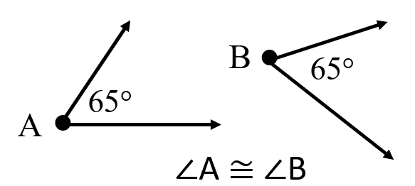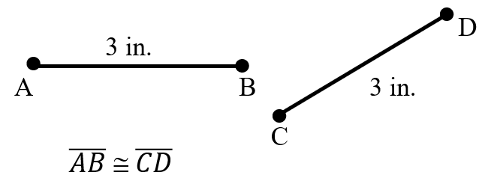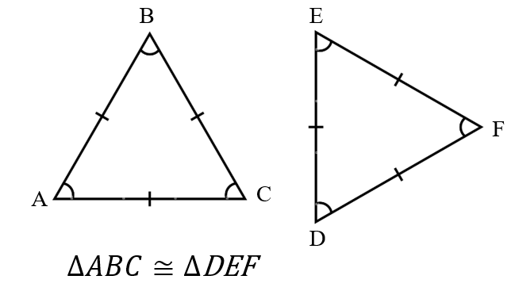
- A polygon is a closed plane figure composed of at least three line segments that do not cross.
- A regular polygon has congruent sides and congruent interior angles. The number of lines of symmetry of a regular polygon is equal to the number of sides of the polygon.
- A line of symmetry divides a figure into two congruent parts, each of which is the mirror image of the other. Lines of symmetry are not limited to horizontal and vertical lines.
- Noncongruent figures may have the same shape but not the same size.
- Students should be familiar with geometric markings in figures to indicate congruence of sides and angles and to indicate parallel sides. An equal number of hatch (hash) marks indicate that those sides are equal in length. An equal number of arrows indicate that those sides are parallel. An equal number of angle curves indicate that those angles have the same measure. See the diagram below. 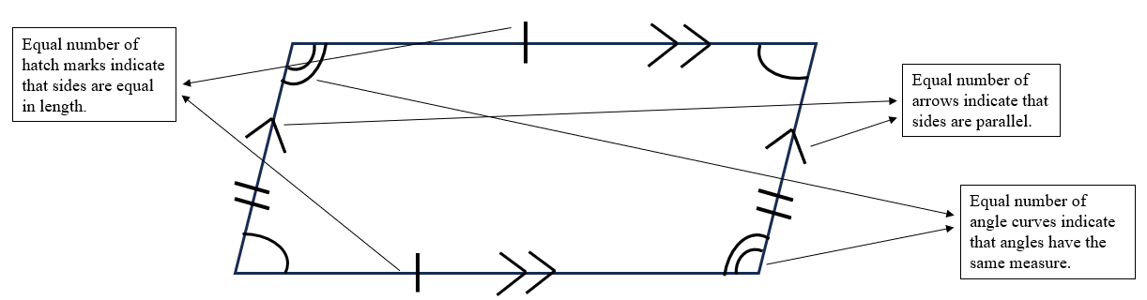
- The determination of the congruence or noncongruence of two figures can be accomplished by placing one figure on top of the other or by comparing the measurements of all corresponding sides and angles.
- Construction of congruent angles, line segments, and polygons helps students understand congruency.

Probability and Statistics
6.PS.1 The student will apply the data cycle (formulate questions; collect or acquire data; organize and represent data; and analyze data and communicate results) with a focus on circle graphs.
Students will demonstrate the following Knowledge and Skills:
- Formulate questions that require the collection or acquisition of data with a focus on circle graphs.
- Determine the data needed to answer a formulated question and collect the data (or acquire existing data) using various methods (e.g., observations, measurement, surveys, experiments).
- Determine the factors that will ensure that the data collected is a sample that is representative of a larger population.
- Organize and represent data using circle graphs, with and without the use of technology tools. The number of data values should be limited to allow for comparisons that have denominators of 12 or less or those that are factors of 100 (e.g., in a class of 20 students, 7 choose apples as a favorite fruit, so the comparison is 7 out of 20, $\frac{7}{20}$, or 35%).
- Analyze data represented in a circle graph by making observations and drawing conclusions.
- Compare data represented in a circle graph with the same data represented in other graphs, including but not limited to bar graphs, pictographs, and line plots (dot plots), and justify which graphical representation best represents the data.
6.PS.1 The student will apply the data cycle (formulate questions; collect or acquire data; organize and represent data; and analyze data and communicate results) with a focus on circle graphs.
Additional Content Background and Instructional Guidance:
- Students should explore the entire data cycle with a question and set of data that has been collected or acquired. Student reflection should occur throughout the data cycle. The data cycle includes the following steps: formulating questions to be explored with data, collecting or acquiring data, organizing and representing data, and analyzing and communicating results.
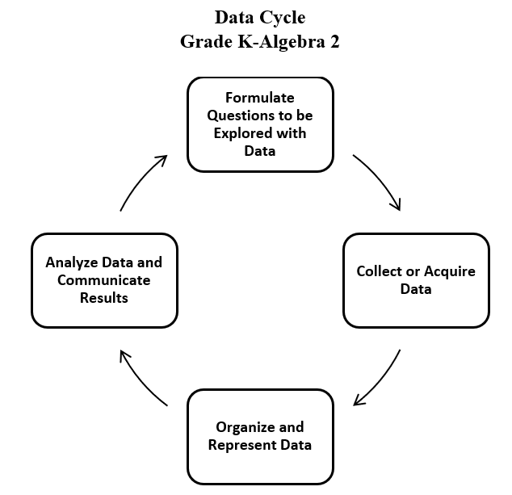

- There are many methods to collect data for any problem situation. These may include experiments, surveys, observations, or other data-gathering strategies. The data can be organized, displayed, analyzed, and interpreted to solve the problem.
- The teacher can provide data sets to students in addition to students engaging in their own data collection or acquisition.
- A population is the entire set of individuals or items from which data is drawn for a statistical study.
- A sample is a data set obtained from a subset that represents an entire population. This data set can be used to make reasonable assumptions about the whole population.
- Sampling is the process of selecting a suitable sample, or representative part of a population, for the purpose of determining characteristics of the whole population. A cursory overview of sampling is intended for Grade 6.
- An example of a population would be the entire student body at a school, whereas a sample might be selecting a subset of students from each grade level. A sample may or may not be representative of the population as a whole. Questions to consider when determining whether an identified sample is representative of the population include:
  - What is the target population of the formulated question?
  - Who or what is the subject or context of the formulated question?
- Examples of questions to consider in building good samples:
  - What is the context of the data to be collected?
  - Who is the audience?
  - What amount of data should be collected?
- A circle graph is used for categorical and discrete numerical data. Circle graphs are used for data showing a relationship of the parts to the whole.
  - Example: The favorite fruit of 20 students in Mrs. Jones’ class was recorded in a table. Compare the same data displayed in both a circle graph and a bar graph.
Fruit Preference | # of students
banana | 6
apple | 7
pear | 3
strawberry | 4

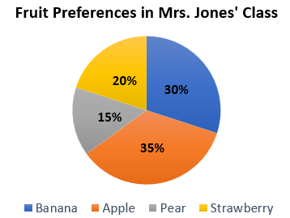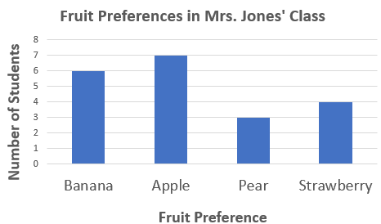

- Circle graphs can represent percent or frequency.
- Circle graphs are not effective for representing data with large numbers of categories.
- Teachers should be reasonable about the selection of data values. The number of data values can affect how a circle graph is constructed (e.g., 10 out of 25 would be 40%, but 7 out of 9 would be $77.\overline{7}$%, making the construction of a circle graph more complex). Students should have experience constructing circle graphs, but a focus should be placed on the analysis of circle graphs.
- Students are not expected to construct circle graphs by multiplying the percentage of data in a category by 360° in order to determine the central angle measure. Limiting comparisons to fraction parameters noted in the standard will assist students in constructing circle graphs.
- Categorical data can be sorted into groups or categories while numerical data are values or observations that can be measured. For example, types of fish caught would be categorical data while weights of fish caught would be numerical data.
- Circle graphs must include a title, percent or number labels for data categories, and a key. A key is essential to explain how to read the graph. A title is essential to explain what the graph represents.
- Circle graphs can be created in programs such as Excel or Google spreadsheets. Some programs refer to circle graphs as pie charts.
- In previous grades, students had experience with pictographs, bar graphs, line graphs, line plots and stem-and-leaf plots. In Grade 6, students are not expected to construct these graphs.
  - A pictograph is used to show categorical data. Pictographs are used to show frequency and compare categories.
  - A bar graph is used for categorical data and is used to show comparisons between categories.
  - A line graph is used to show how numerical data changes over time.
  - A line plot provides an ordered display of all values in a data set and shows the frequency of data on a number line. Line plots are used to show the spread of the data, to include clusters (groups of data points) and gaps (large spaces between data points), and quickly identify the range, mode, and any extreme data values.
  - A stem-and-leaf plot uses columns to display a summary of discrete numerical data while maintaining the individual data points. A stem-and-leaf plot displays data to show its shape and distribution.
- Different situations call for different types of graphs (e.g., visual representations). The way data are displayed is often dependent upon what question is being investigated and what someone is trying to communicate.
- Comparing different types of representations (e.g., charts, graphs, line plots) provides students with opportunities to learn how different graphs can show different aspects of the same data. Following the construction of representations, discussions around what information each representation provides or does not provide should occur.
- The information displayed in different graphs may be examined to determine how data are or are not related, differences between characteristics (comparisons), trends that suggest what new data might be like (predictions), and/or questions such as “What could happen if…” (inferences).
- Connections can be made with probability and drawing conclusions from a circle graph.
- In general, if all outcomes of an event are equally likely, the probability of an event occurring is equal to the ratio of desired outcomes to the total number of possible outcomes in the sample space.
- The probability of an event occurring can be represented as a ratio or equivalent fraction, decimal, or percent.
- Based on the data in the circle graph, the likelihood of an event can be determined as impossible, unlikely, equally likely, likely, and certain.
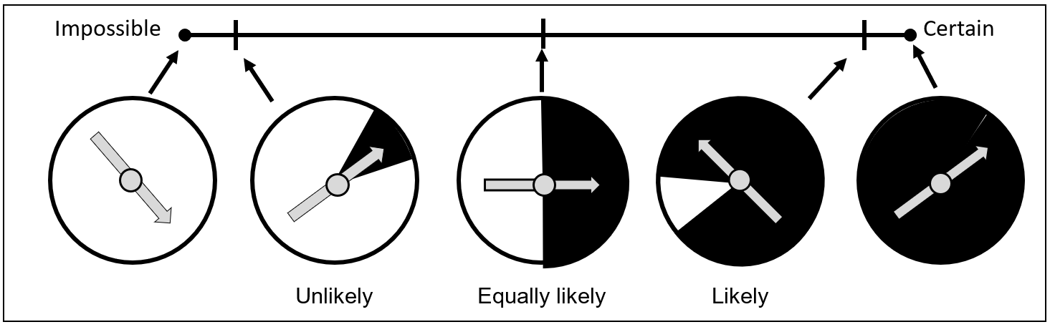

6.PS.2 The student will represent the mean as a balance point and determine the effect on statistical measures when a data point is added, removed, or changed.
Students will demonstrate the following Knowledge and Skills:
- Represent the mean of a set of data graphically as the balance point represented in a line plot (dot plot).
- Determine the effect on measures of center when a single value of a data set is added, removed, or changed.
- Observe patterns in data to identify outliers and determine their effect on mean, median, mode, or range.
6.PS.2 The student will represent the mean as a balance point and determine the effect on statistical measures when a data point is added, removed, or changed.
Additional Content Background and Instructional Guidance:
- Categorical data can be sorted into groups or categories while numerical data are values or observations that can be measured. For example, types of fish caught would be categorical data while weights of fish caught would be numerical data.
- Measures of center are types of averages for a data set. They represent numbers that describe a data set. Mean, median, and mode are measures of center that are useful for describing different situations.
- Mean may be appropriate for sets of data where there are no values much higher or lower than those in the rest of the data set.
- Median may be appropriate when data sets have some values that are much higher or lower than most of the other values in the data set. The median is the middle value of a data set in ranked order. If there are an odd number of pieces of data, the median is the middle value. If there are an even number of pieces of data, the median is the numerical average of the two middle values.
- Mode may be appropriate when the set of data has some identical values, when data is categorical, or when the data reflect the most popular option. The mode is the piece of data that occurs most frequently. If no value occurs more often than any other, there is no mode. If there are multiple values that occur most often, each of these values is a mode. When there are exactly two modes, the data set is bimodal.
- Mean can be defined as the point on a number line where the data distribution is balanced. This requires that the sum of the distances from the mean of all the points above the mean is equal to the sum of the distances from the mean of all the data points below the mean. This is the concept of mean as the balance point.
  - Example: Given the data set: 2, 3, 7, the mean value of 4 can be represented on a number line as the balance point:
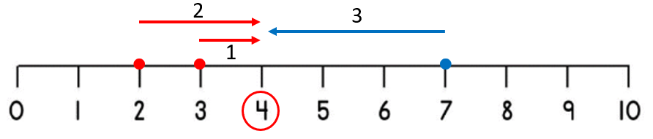
- The mean can also be found by calculating the numerical average of the data set.
- In Grade 5 mathematics, students had experiences defining the mean as fair share.
- Defining mean as the balance point is a prerequisite for understanding standard deviation, which is addressed in high school level mathematics.
- An outlier can be identified by sorting the data in ascending order. A data value that is an abnormal distance relative to the other values in the data set is an outlier. It represents a value that "lies outside" (is much smaller or larger than) most of the other values in a set of data. Outliers have a greater effect on the mean and range of a data set but have less of an effect on the median or mode.
- In Grade 6, students are not expected to mathematically determine outliers. Instead, at this level, they are expected to visually determine outliers when provided a representation of a data set.

Patterns, Functions, and Algebra
6.PFA.1 The student will use ratios to represent relationships between quantities, including those in context.
Students will demonstrate the following Knowledge and Skills:
- Represent a relationship between two quantities using ratios.
- Represent a relationship in context that makes a comparison by using the notations $\frac{a}{b}$, a:b, and a to b.
- Represent different comparisons within the same quantity or between different quantities (e.g., part to part, part to whole, whole to whole).
- Create a relationship in words for a given ratio expressed symbolically.
- Create a table of equivalent ratios to represent a proportional relationship between two quantities, when given a ratio.
- Create a table of equivalent ratios to represent a proportional relationship between two quantities, when given a contextual situation.
6.PFA.1 The student will use ratios to represent relationships between quantities, including those in context.
Additional Content Background and Instructional Guidance:
- A ratio is a comparison of any two quantities. A ratio is used to represent relationships within a quantity and between quantities. Ratios are used in contextual situations when there is a need to compare quantities.
- In the elementary grades, students are taught that fractions represent a part-to-whole relationship. However, fractions may also express a measurement, an operator (multiplication), a quotient, or a ratio. Examples of fraction interpretations include:
  - fractions as parts of wholes: $\frac{3}{4}$ represents three parts of a whole, where the whole is separated into four equal parts;
  - fractions as measurement: the notation $\frac{3}{4}$ can be interpreted as three one-fourths of a unit;
  - fractions as an operator: $\frac{3}{4}$ represents a multiplier of three-fourths of the original magnitude;
  - fractions as a quotient:$\frac{3}{4}$ represents the result obtained when three is divided by four; and
  - fractions as a ratio: $\frac{3}{4}$ is a comparison of 3 of a quantity to the whole quantity of 4.
- A ratio may be written using a colon (a:b), the word “to” (a to b), or fraction notation $\frac{a}{b}$.
- The order of the values in a ratio is directly related to the order in which the quantities are compared. For example, in a certain class, there is a ratio of 3 girls to 4 boys (3:4).
- Another comparison that could represent the relationship between these quantities is the ratio of 4 boys to 3 girls (4:3). Both ratios give the same information about the number of girls and boys in the class, but they are distinct ratios. When you switch the order of comparison (girls to boys vs. boys to girls), there are two different ratios expressed.
- Fractions may be used when determining equivalent ratios.
  - Example: The ratio of girls to boys in a class is 3:4, this can be interpreted as:
    - number of girls = $\frac{3}{4}$ ∙ number of boys;
    - in a class with 16 boys, number of girls = $\frac{3}{4}$ ∙ (16) = 12 girls.
  - Example: A similar comparison could compare the ratio of boys to girls in the class as being 4:3, which can be interpreted as:
    - number of boys = $\frac{4}{3}$ ∙ number of girls;
    - in a class with 12 girls, number of boys = $\frac{4}{3}$ ∙ (12) = 16 boys.
- A ratio can compare two real-world quantities (e.g., miles per gallon, unit rate, and circumference to diameter of a circle).
- Ratios may or may not be written in simplest form.
- A ratio can represent different comparisons within the same quantity or between different quantities.
Ratio | Comparison
part-to-whole  (within the same quantity) | compare part of a whole to the entire whole
part-to-part  (within the same quantity) | compare part of a whole to another part of the same whole
whole-to-whole  (different quantities) | compare all of one whole to all of another whole
part-to-part  (different quantities) | compare part of one whole to part of another whole

- Examples: Given Quantity A and Quantity B, the following comparisons could be expressed.
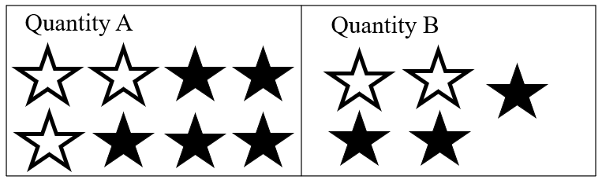

Ratio | Example | Ratio Notation(s)
part-to-whole  (within the same quantity) | compare the number of unfilled stars to the total number of stars in Quantity A | 3:8; 3 to 8; or $\frac{3}{8}$
part-to-part  (within the same quantity) | compare the number of unfilled stars to the number of filled stars in Quantity A | 3:5 or 3 to 5
whole-to-whole (different quantities) | compare the number of stars in Quantity A to the number of stars in Quantity B | 8:5 or 8 to 5
part-to-part (different quantities) | compare the number of unfilled stars in Quantity A to the number of unfilled stars in Quantity B | 3:2 or 3 to 2
- Part-to-part comparisons and whole-to-whole comparisons are ratios that are not typically represented in fraction notation except in certain contexts, such as determining whether two different ratios are equivalent.
- Equivalent ratios are created by multiplying each value in a ratio by the same constant value. For example, the ratio of 4:2 would be equivalent to the ratio 8:4, since each value in the first ratio could be multiplied by 2 to obtain the second ratio.
- Students will begin to make the connection between equivalent ratios and proportionality. A proportional relationship consists of two quantities where there exists a constant number such that each measure in the first quantity multiplied by this constant gives the corresponding measure in the second quantity.
- Proportional thinking requires students to think multiplicatively, rather than additively. The relationship between two quantities could be additive (i.e., one quantity is a result of adding a value to the other quantity) or multiplicative (i.e., one quantity is the result of multiplying the other quantity by a value). See the examples below.
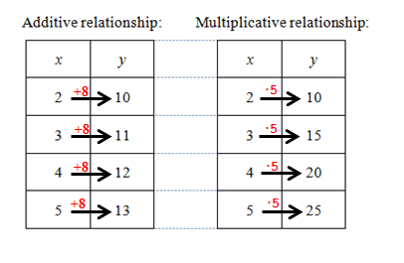
  - In the additive relationship, y is the result of adding 8 to x.
  - In the multiplicative relationship, y is the result of multiplying x times 5.
  - The ordered pair (2, 10) is a quantity in both relationships; however, the relationship evident between the other quantities in the table, discerns between additive or multiplicative.
- It is important to use contextual situations to model proportional relationships. Context can help students to see the relationship between two quantities.
- In the elementary grades, students had experiences with tables of values (input/output tables that are additive and multiplicative). The concept of a ratio table should be connected to students’ prior knowledge of representing number patterns in tables.
- A ratio table is a table of values representing a proportional relationship that includes pairs of values that represent equivalent rates or ratios. A constant exists that can be multiplied by the measure of one quantity to get the measure of the other quantity for every ratio pair. The same proportional relationship exists between each pair of quantities in a ratio table.
- Example: Given that the ratio of y to x in a proportional relationship is 8:4, create a ratio table that includes three additional equivalent ratios.
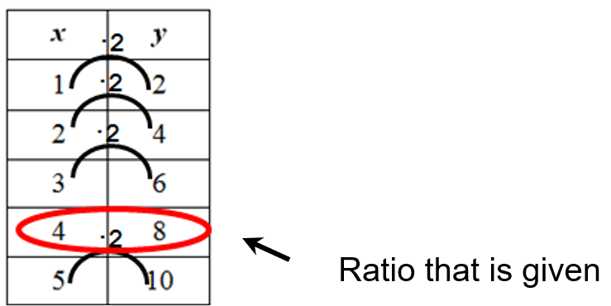

6.PFA.2 The student will identify and represent proportional relationships between two quantities, including those in context (unit rates are limited to positive values).
Students will demonstrate the following Knowledge and Skills:
- Identify the unit rate of a proportional relationship represented by a table of values, a contextual situation, or a graph.
- Determine a missing value in a ratio table that represents a proportional relationship between two quantities using a unit rate.
- Determine whether a proportional relationship exists between two quantities, when given a table of values, context, or graph.
- When given a contextual situation representing a proportional relationship, find the unit rate and create a table of values or a graph.
- Make connections between and among multiple representations of the same proportional relationship using verbal descriptions, ratio tables, and graphs.
6.PFA.2 The student will identify and represent proportional relationships between two quantities, including those in context (unit rates are limited to positive values).
Additional Content Background and Instructional Guidance:
- A rate is a ratio that involves two different units and how they relate to each other. Relationships between two units of measure are also rates (e.g., inches per foot).
- A unit rate describes how many units of the first quantity of a ratio correspond to one unit of the second quantity.
  - Example: If it costs $10 for 5 items at a store (a ratio of 10:5 comparing cost to the number of items), then the unit rate would be $2.00/per item (a ratio of 2:1 comparing cost to number of items).
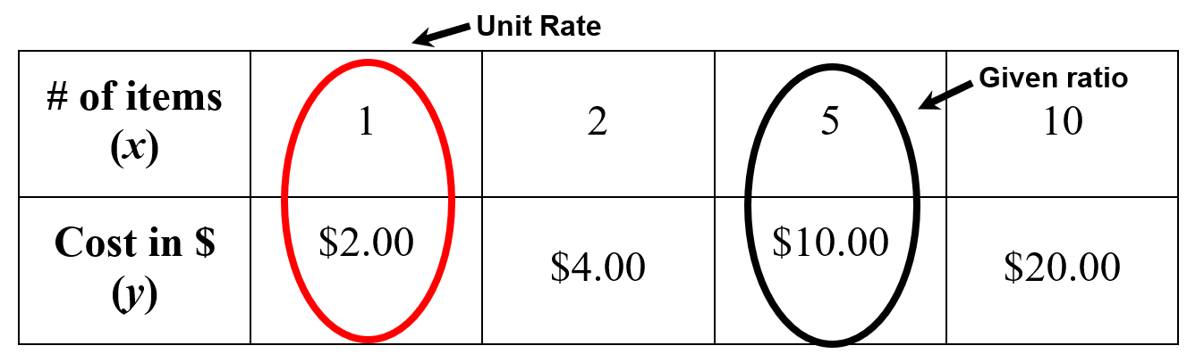
- Any ratio can be converted into a unit rate by writing the ratio as a fraction and then dividing the numerator and denominator each by the value of the denominator.
  - Example: It costs $8 for 16 gourmet cookies at a bake sale. What is the price per cookie (unit rate) represented by this situation?
  - $\frac{8}{16}=\frac{8÷16}{16÷16}=\frac{0.5}{1}$
  - It would cost $0.50 per cookie, which would be the unit rate.
- Examples such as $\frac{8}{16}$ and 40 to 10 are ratios but are not unit rates. However, $\frac{0.5}{1}$ and 4 to 1 are examples of unit rates.
- Example of a proportional relationship:
  - Ms. Cochran is planning a year-end pizza party for her students. Ace Pizza offers free delivery and charges $8 for each medium pizza. This ratio table represents the cost (y) per number of pizzas ordered (x).
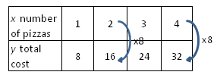
  - In this relationship, the ratio of y (cost in $) to x (number of pizzas) in each ordered pair is the same:
$$\frac{8}{1}=\frac{16}{2}=\frac{24}{3}=\frac{32}{4}$$
- Example of a non-proportional relationship:
  - Uptown Pizza sells medium pizzas for $7 each but charges a $3 delivery fee per order. This table represents the cost per number of pizzas ordered.
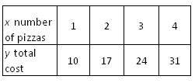
  - The ratios represented in the table above are not equivalent.
  - In this relationship, the ratio of y to x in each ordered pair is not the same:
$$\frac{10}{1}≠\frac{17}{2}≠\frac{24}{3}≠\frac{31}{4}$$
- Other non-proportional relationships will be studied in later mathematics courses.
- Proportional relationships involve collections of pairs of equivalent ratios that may be graphed in the coordinate plane. The graph of a proportional relationship includes ordered pairs (x, y) that represent pairs of values that may be represented in a ratio table.
- Proportional relationships can be expressed using verbal descriptions, tables, and graphs. When describing proportional relationships verbally, the phrases “for each,” “for every,” and “per” are used.
- Example: (verbal description) To make a drink, mix 1 liter of syrup with 3 liters of water. If x represents how many liters of syrup are in the mixture and y represents how many liters of water are in the mixture, this proportional relationship can be represented using a ratio table:
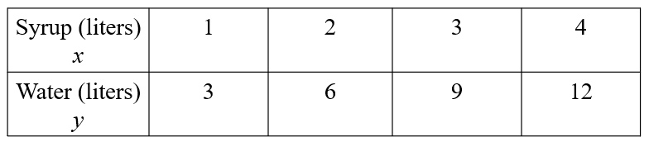
  - The ratio of the amount of water (y) to the amount of syrup (x) is 3:1. Additionally, the proportional relationship may be graphed using the ordered pairs in the table.
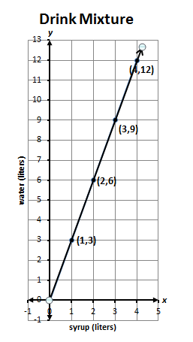
- The representation of the ratio between two quantities may depend upon the order in which the quantities are being compared. For example: In the mixture example above, we could also compare the ratio of the liters of syrup per liters of water, as shown:
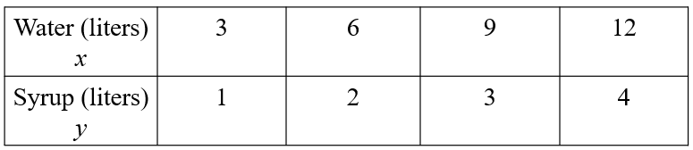
  - In this comparison, the ratio of the amount of syrup (y) to the amount of water (x) would be 1:3.
  - The graph of this relationship could be represented by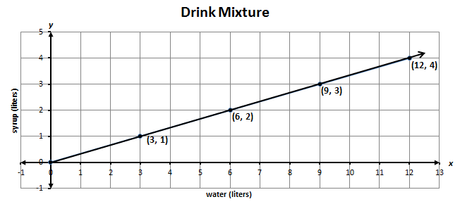
- Students should be aware of how the order in which quantities are compared affects the way in which the relationship is represented as a table of equivalent ratios or as a graph.
- Double number line diagrams can also be used to represent proportional relationships and determine pairs of equivalent ratios. See the example below. 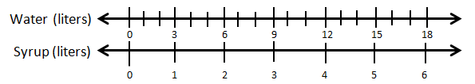

  - In this proportional relationship, there are three liters of water for each liter of syrup represented on the number lines.
- A graph representing a proportional relationship includes ordered pairs that lie in a straight line that, if extended, would pass through (0, 0). The context of the problem and the type of data represented by the graph must be considered when determining whether the points are to be connected by a straight line on the graph.
- Example of the graph of a non-proportional relationship:
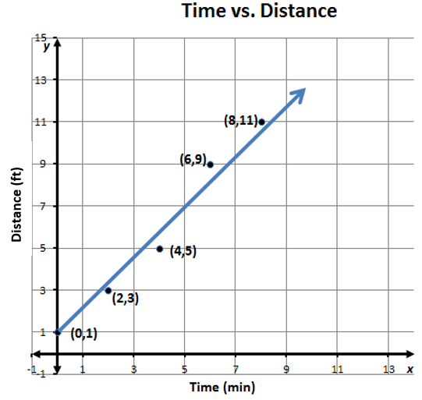
  - The relationship of distance (y) to time (x) is non-proportional. The ratio of y to x for each ordered pair is not equivalent. That is,
$$\frac{11}{8}≠\frac{9}{6}≠\frac{5}{4}≠\frac{3}{2}≠\frac{1}{0}$$
  - The points of the graph do not lie in a straight line. Additionally, the line does not pass through the point (0, 0), thus the relationship of y to x cannot be considered proportional.
- Contextual situations that model proportional relationships can typically be represented by graphs in the first quadrant, since in most contextual situations, the values for x and y are positive. Additionally, unit rates are typically positive in contextual situations involving proportional relationships.
- A unit rate could be used to find missing values in a ratio table.
  - Example: A store advertises a price of $25 for 5 DVDs. What would be the cost to purchase 2 DVDs? 3 DVDs? 4 DVDs?
# DVDs | 1 | 2 | 3 | 4 | 5
Cost | $5 | ? | ? | ? | $25
- The ratio of $25 per 5 DVDs is also equivalent to a ratio of $5 per 1 DVD, which would be the unit rate for this relationship. This unit rate could be used to find the missing value of the ratio table above. If we multiply the number of DVDs by a constant multiplier of 5 (the unit rate) we obtain the total cost. Thus, 2 DVDs would cost $10, 3 DVDs would cost $15, and 4 DVDs would cost $20.
- At this level, students should build a conceptual understanding of proportional relationships and unit rates before moving to more abstract representations and complex computations in higher grade levels. Students are not expected to use formal calculations for slope and unit rates (e.g., slope formula) in Grade 6.

6.PFA.3 The student will write and solve one-step linear equations in one variable, including contextual problems that require the solution of a one-step linear equation in one variable.
Students will demonstrate the following Knowledge and Skills:
- Identify and develop examples of the following algebraic vocabulary: equation, variable, expression, term, and coefficient.
- Represent and solve one-step linear equations in one variable, using a variety of concrete manipulatives and pictorial representations (e.g., colored chips, algebra tiles, weights on a balance scale).
- Apply properties of real numbers and properties of equality to solve a one-step equation in one variable. Coefficients are limited to integers and unit fractions. Numeric terms are limited to integers.
- Confirm solutions to one-step linear equations in one variable using a variety of concrete manipulatives and pictorial representations (e.g., colored chips, algebra tiles, weights on a balance scale).
- Write a one-step linear equation in one variable to represent a verbal situation, including those in context.
- Create a verbal situation in context given a one-step linear equation in one variable.
6.PFA.3 The student will write and solve one-step linear equations in one variable, including contextual problems that require the solution of a one-step linear equation in one variable.
Additional Content Background and Instructional Guidance:
- An algebraic equation is a mathematical statement that says two expressions are equal (e.g., 2x + 7 = 15).
- An expression is a representation of quantity. It may contain numbers, variables, and/or operation symbols. It does not have an “equal sign (=)” (e.g.,$\frac{3}{4}$, 5x, 140 − 38.2, 18 ∙ 21, 5 + x). An algebraic expression is an expression that contains at least one variable (e.g., x – 3). An expression cannot be solved.
- A variable is a symbol used to represent an unknown quantity.
- A term is a number, variable, product, or quotient in an expression of sums and/or differences. In the expression 7x² + 5x – 3, there are three terms, 7x², 5x, and 3.
- A coefficient is the numerical factor in a term. In the term 3xy², 3 is the coefficient; in the term z, 1 is the coefficient.
- A one-step linear equation may include, but not be limited to, equations such as the following:
  - 2x = 5
  - y − 3 = ⁻6
  - $\frac{1}{5}$x = ⁻3
  - a − (−4) = 11
- A variety of concrete materials such as colored chips, algebra tiles, or weights on a balance scale may be used to model solving equations in one variable.
- A verbal expression can be represented by a variable expression. Numbers are used when they are known; variables are used when the numbers are unknown. Example, the verbal expression “a number multiplied by 5” could be represented by the variable expression “n ∙ 5” or “5n.”
- A verbal sentence is a complete word statement (e.g., “The sum of a number and two is five” could be represented by “n + 2 = 5”).
- The solution to an equation is a value that makes it a true statement. Many equations have one solution and are represented as a point on a number line. Solving an equation or inequality involves a process of determining which value(s) from a specified set, if any, make the equation or inequality a true statement. Substitution can be used to determine whether a given value(s) makes an equation or inequality true.
- Word choice and language are very important when representing verbal situations in context using mathematical operations, equality, and variables. When presented with an equation or context, student choice of language should reflect the situation being modeled. Identifying the mathematical operation(s) to represent the action(s) and the variable to represent the unknown quantity will help students to write equations that represent the contextual situation.
- Properties of real numbers and properties of equality can be used to solve equations, justify equation solutions, and express simplification. Students should use the following properties, where appropriate, to further develop flexibility and fluency in problem solving (limitations may exist for the values of a, b, or c in this standard).
  - Commutative property of addition: $a+b=b+a$
  - Commutative property of multiplication: $a∙b=b∙a$
  - Subtraction and division are neither commutative nor associative.
  - Identity property of addition (additive identity property): $a+0=a and 0+a=a$
  - Identity property of multiplication (multiplicative identity property): $a∙1=a and 1∙a=a$
  - The additive identity is zero (0) because any number added to zero is equal to the number. The multiplicative identity is one (1) because any number multiplied by one is equal to the number. There are no identity elements for subtraction and division.
  - Inverses are numbers that combine with other numbers and result in identity elements.
  - Inverse property of addition (additive inverse property):$a+\left(-a\right)=0 and \left(-a\right)+a=0$ (e.g., 5 + (⁻5) = 0)
  - Inverse property of multiplication (multiplicative inverse property): $a∙\frac{1}{a}=1 and \frac{1}{a}∙a=1$ (e.g., 5$∙ \frac{1}{5}$ = 1)
  - Zero has no multiplicative inverse.
  - Multiplicative property of zero: $a∙0=0 and 0∙a=0$
  - Division by zero is not a possible mathematical operation. It is undefined.
  - Addition property of equality: If $a=b$, then $a+c=b+c$
  - Subtraction property of equality: If $a=b,$ then $a-c=b-c$
  - Multiplication property of equality: If $a=b,$ then $a∙c=b∙c$
  - Division property of equality: If $a=b and c≠0,$ then $\frac{a}{c}=\frac{b}{c}$
  - Substitution property: If $a=b,$ then b can be substituted for a in any expression, equation, or inequality

6.PFA.4 The student will represent a contextual situation using a linear inequality in one variable with symbols and graphs on a number line.
Students will demonstrate the following Knowledge and Skills:
- Given the graph of a linear inequality in one variable on a number line, represent the inequality in two equivalent ways (e.g., x < -5 or -5 > x) using symbols. Symbols include <, >, ≤, ≥.
- Write a linear inequality in one variable to represent a given constraint or condition in context or given a graph on a number line.
- Given a linear inequality in one variable, create a corresponding contextual situation or create a number line graph.
- Use substitution or a number line graph to justify whether a given number in a specified set makes a linear inequality in one variable true.
- Identify a numerical value(s) that is part of the solution set of a given inequality in one variable.
6.PFA.4 The student will represent a contextual situation using a linear inequality in one variable with symbols and graphs on a number line.
Additional Content Background and Instructional Guidance:
- The solution set to an inequality is the set of all numbers that make the inequality true.
- Inequalities can represent contextual situations.
  - Example: Jaxon works at least 4 hours per week mowing lawns. Write an inequality representing this situation and graph the solution.
x ≥ 4 or 4 ≤ x
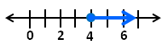

  - Students might then be asked: “Would Jaxon ever work 3 hours in a week? 6 hours?
- The variable in an inequality may represent values that are limited by the context of the problem or situation. For example, if the variable represents all children in a classroom who are taller than 36 inches, the variable will be limited to have a minimum and maximum value based on the heights of the children. Students are not expected to represent these situations with a compound inequality (e.g., 36 < x < 70) but only recognize that the values satisfying the single inequality, x > 36, will be limited by the context of the situation.
- Inequalities using the < or > symbols are represented on a number line with an open circle on the number and a shaded line in the direction of the solution set.
  - Example: When graphing x < 4, use an open circle on the 4 to indicate that the 4 is not included in the solution set.
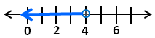
- Inequalities using the ≤ or ≥ symbols are represented on a number line with a closed circle on the number and a shaded line in the direction of the solution set.
  - Example: When graphing x $≥$ 4, fill in the circle on the 4 to indicate that the 4 is included in the solution set.
- It is important for students to see inequalities written with the variable before the inequality symbol and after. Example: x > 5 is not the same relationship as 5 > x. However, x > 5 is the same relationship as 5 < x.

