2023 Mathematics Standards of Learning
Understanding the Standards - Geometry
The Understanding the Standards document includes the mathematics understandings and key concepts that assist teachers in planning standards-focused instruction of the Geometry 2023 Mathematics Standards of Learning. The Understanding the Standards includes definitions, explanations, and examples regarding each mathematics standard and describes what students should know (core knowledge) as a result of the instruction specific to the course/grade level.

Reasoning, Lines and Transformations
G.RLT.1 The student will translate logic statements, identify conditional statements, and use and interpret Venn diagrams.
Students will demonstrate the following Knowledge and Skills:
- Translate propositional statements and compound statements into symbolic form, including negations ($\sim p,$ read “not p”), conjunctions (p $∧q$, read “p and q”), disjunctions (p$∨q$, read “p or q”), conditionals (p $→$ q, read “if p then q”), and biconditionals (p$↔$ q, read “p if and only if q”), including statements representing geometric relationships.
- Identify and determine the validity of the converse, inverse, and contrapositive of a conditional statement, and recognize the connection between a biconditional statement and a true conditional statement with a true converse, including statements representing geometric relationships.
- Use Venn diagrams to represent set relationships, including union, intersection, subset, and negation.
- Interpret Venn diagrams, including those representing contextual situations.
G.RLT.1 The student will translate logic statements, identify conditional statements, and use and interpret Venn diagrams.
Additional Content Background and Instructional Guidance:
- Symbolic notation is used to represent logical arguments, including the use of →, ↔, ~, ∴, $∧$, and $∨$.
- The symbol ∴ is read as “therefore.”
- When a conditional (p→q) and its converse (q→p) are true, the statements can be written as a biconditional:
  - p iff q
  - p if and only if q
  - p↔q
- The Pythagorean Theorem and its converse can be used as an example. If a triangle is a right triangle, then the sum of the squares of the legs is equal to the square of the hypotenuse
($a^{2}+b^{2}=c^{2})$. If the sum of the squares of the legs is equal to the square of the hypotenuse ($a^{2}+b^{2}=c^{2}$), then the triangle is a right triangle. Therefore, a triangle is a right triangle if and only if the sum of the squares of the legs is equal to the square of the hypotenuse
($a^{2}+b^{2}=c^{2}$).
- Logical arguments consist of a set of premises or hypotheses and a conclusion.
- Truth and validity are not synonymous. Valid logical arguments may be false. Validity requires only logical consistency between the statements, but it does not imply true statements.
- For example, the following argument is valid, but not true. If you are a happy person, then you like animals. If you like animals, then you like dogs. Therefore, if you are a happy person, then you like dogs.
- Formal proofs utilize symbols of formal logic to determine the validity of a logical argument.
- Inductive reasoning, deductive reasoning, and proofs are critical in establishing general claims.
- Inductive reasoning is the method of drawing conclusions from a limited set of observations.
- Deductive reasoning is the method that uses logic to draw conclusions based on definitions, postulates, and theorems. Valid forms of deductive reasoning include the law of syllogism, the law of contrapositive, the law of detachment, and the identification of a counterexample.
- Proof is a justification that is logically valid and based on initial assumptions, definitions, postulates, theorems, and/or properties.
- The law of detachment states that if p→q is true and p is true, then q is true. For example, if two angles are vertical, then they are congruent. ∠A and ∠B are vertical, therefore ∠A ≅ ∠B.
- The law of syllogism states that if p→q is true and q→r is true, then p→r is true. For example, if two angles are vertical, then they are congruent. If two angles are congruent, then they have the same measure. Thus, if two angles are vertical, then they have the same measure.
- The law of contrapositive states that if p→q is true and ~q is true, then ~p is true. For example, if two angles are vertical, then they are congruent. ∠A ≇ ∠B, therefore ∠A and ∠B are not vertical.
- A counterexample is used to show an argument is false. For example, the argument “All rectangles are squares,” is proven false with the following counterexample since quadrilateral ABDC is a rectangle but not a square.
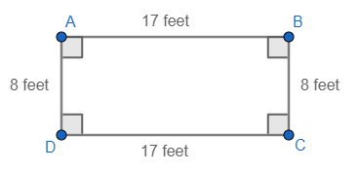
- A counterexample of a statement confirms the hypothesis but negates the conclusion.
- Exploration of the representation of conditional statements using Venn diagrams may assist in deepening student understanding.
- Venn diagrams can be interpreted within contextual situations.
- Venn diagrams can be used to support the understanding of special quadrilateral relationships or problems involving probability. For example –
  - Surveys can provide opportunities for discussion of experimental probability. For example, the Venn diagram below shows the results of a survey of students to determine who likes comedy movies (C) and/or horror movies (H). Eight students like comedy movies, but not horror movies; five students like horror movies, but not comedy movies; and two students like both comedy movies and horror movies.
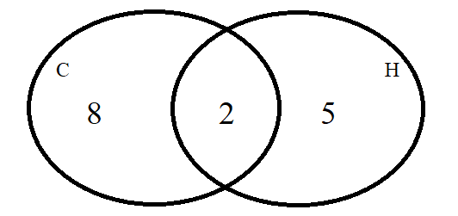

G.RLT.2 The student will analyze, prove, and justify the relationships of parallel lines cut by a transversal.
Students will demonstrate the following Knowledge and Skills:
- Prove and justify angle pair relationships formed by two parallel lines and a transversal, including:
  - corresponding angles;
  - alternate interior angles;
  - alternate exterior angles;
  - same-side (consecutive) interior angles; and,
  - same-side (consecutive) exterior angles.
- Prove two or more lines are parallel given angle measurements expressed numerically or algebraically.
- Solve problems by using the relationships between pairs of angles formed by the intersection of two parallel lines and a transversal.
G.RLT.2 The student will analyze, prove, and justify the relationships of parallel lines cut by a transversal.
Additional Content Background and Instructional Guidance:
- Parallel lines intersected by a transversal form angle with specific relationships.
- If two parallel lines are intersected by a transversal, then:
  - corresponding angles are congruent;
  - alternate interior angles are congruent;
  - alternate exterior angles are congruent;
  - same-side (consecutive) interior angles are supplementary; and,
  - same-side (consecutive) exterior angles are supplementary.
- Transformations of vertical and linear angle pairs can be used to explore relationships of alternate interior, alternate exterior, corresponding, and same-side interior angles.
- To prove two or more lines parallel, one of the angle pairs listed above must be shown to be true. The angles must be on the same transversal that intersects both or all of the lines.
- The parallel line construction uses the Converse of the Corresponding Angles Theorem which states, “If two lines ($\overset{⃡}{EF}$ and $\overset{⃡}{GJ}$) and a transversal ($\overset{⃡}{EG}$) form corresponding angles ($∠HEI$ and $∠KGL$) that are congruent, then the lines ($\overset{⃡}{EF}$ and $\overset{⃡}{GJ}$) are parallel.
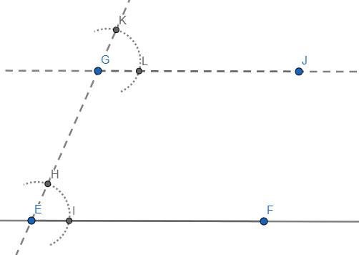

G.RLT.3 The student will solve problems, including contextual problems, involving symmetry and transformation.
Students will demonstrate the following Knowledge and Skills:
- Locate, count, and draw lines of symmetry given a figure, including figures in context.
- Determine whether a figure has point symmetry, line symmetry, both, or neither, including figures in context.
- Given an image or preimage, identify the transformation or combination of transformations that has/have occurred. Transformations include:
  - translations;
  - reflections over any horizontal or vertical line or the lines y = x or y = -x;
  - clockwise or counterclockwise rotations of 90°, 180°, 270°, or 360° on a coordinate grid where the center of rotation is limited to the origin; and
  - dilations, from a fixed point on a coordinate grid.
G.RLT.3 The student will solve problems, including contextual problems, involving symmetry and transformation.
Additional Content Background and Instructional Guidance:
- Symmetry and transformations can be explored with coordinate methods.
- Transformations and combinations of transformations can be used to define and describe the movement of objects in a plane or coordinate system.
- A transformation of a figure, called a preimage, changes the size, shape, and/or position of the figure to a new figure called the image.
- A rigid transformation (or isometry) is a transformation that does not change the size or shape of a geometric figure. is a special kind of transformation that does not change the size or shape of a figure.
- The image of an object or function graph after a rigid transformation is congruent to the preimage of the object.
- Congruent figures can be shown through a series of rigid transformations.
- A translation is a rigid transformation in which an image is formed by moving every point on the preimage the same distance in the same direction.
- The rules for translation can be described using coordinates and/or verbal descriptions.
- Coordinate rules for translation:
Translation | (x,y)→(x+a, y+b)
Reflection across the x-axis | (x,y)→(x, −y)
Reflection across the y-axis | (x,y)→(−x, y)
Reflection across the line y=x | (x,y)→(y, x)
Reflection across the line y=-x | (x,y)→(−y, −x)
Rotation 90° (counterclockwise) about the origin | (x,y)→(−y, x)
Rotation 180° about the origin | (x,y)→(−x, −y)
Rotation 270° (counterclockwise) about the origin | (x,y)→(y, −x)
Dilation with respect to the origin and scale factor of k | (x,y)→(kx, ky)
- A reflection is a rigid transformation in which an image is formed by reflecting the preimage over a line called the line of reflection. All corresponding points in the image are equidistant from the line of reflection.
- The midpoint between any set of reflected points lies on the line of reflection.
- The line of reflection can be determined by finding the midpoint (or balance point) between any set of two reflected points.
- A rotation is a rigid transformation in which an image is formed by rotating the preimage about a point called the center of rotation. The center of rotation may or may not be on the preimage.
- A dilation is a transformation in which an image is formed by enlarging or reducing the preimage proportionally by a scale factor from the center of dilation. The center of dilation may or may not be on the preimage. The image is similar to the preimage.
- A set of points has line symmetry if and only if there is a line, l, such that the reflection through l of each point in the set is also a point in the set.
- Point symmetry exists when a figure is built around a single point called the center of the figure. For every point in the figure, there is another point found directly opposite it on the other side of the center, at the same distance from the center. A figure with point symmetry will appear the same after a 180° rotation. In point symmetry, the center point is the midpoint of every segment formed by joining a point to its image.
- The perpendicular bisector construction creates the perpendicular bisector as the line of reflection of the provided line segment.

Triangles
G.TR.1 The student will determine the relationships between the measures of angles and lengths of sides in triangles, including problems in context.
Students will demonstrate the following Knowledge and Skills:
- Given the lengths of three segments, determine whether a triangle could be formed.
- Given the lengths of two sides of a triangle, determine the range in which the length of the third side must lie.
- Order the sides of a triangle by their lengths when given information about the measures of the angles.
- Order the angles of a triangle by their measures when given information about the lengths of the sides.
- Solve for interior and exterior angles of a triangle, when given two angles.
G.TR.1 The student will determine the relationships between the measures of angles and lengths of sides in triangles, including problems in context.
Additional Content Background and Instructional Guidance:
- For a triangle to exist, the length of each side must be within a range that is determined by the lengths of the other two sides.
- The longest side of a triangle is opposite the largest angle of the triangle and the shortest side is opposite the smallest angle.
- In a triangle, the lengths of two sides and the included angle determine the length of the side opposite the angle.
- Because isosceles triangles have two congruent sides, they also have two congruent angles.
- Triangle Angles Sum Theorem: the sum of the measures of the interior angles of a triangle is 180°.
- Exterior Angle Theorem: an exterior angle of a triangle is equal to the sum of the two opposite interior angles.

G.TR.2 The student will, given information in the form of a figure or statement, prove and justify two triangles are congruent using direct and indirect proofs, and solve problems involving measured attributes of congruent triangles.
Students will demonstrate the following Knowledge and Skills:
- Use definitions, postulates, and theorems (including Side-Side-Side (SSS); Side-Angle-Side (SAS); Angle-Side-Angle (ASA); Angle-Angle-Side (AAS); and Hypotenuse-Leg (HL)) to prove and justify two triangles are congruent.
- Use algebraic methods to prove that two triangles are congruent.
- Use coordinate methods, such as the slope formula and the distance formula, to prove two triangles are congruent.
- Given a triangle, use congruent segment, congruent angle, and/or perpendicular line constructions to create a congruent triangle (SSS, SAS, ASA, AAS, and HL).
G.TR.2 The student will, given information in the form of a figure or statement, prove and justify two triangles are congruent using direct and indirect proofs, and solve problems involving measured attributes of congruent triangles.
Additional Content Background and Instructional Guidance:
- Tools for understanding the standard: physical protractor, ruler, compass, straight edge, paper folding as well as digital tools in mathematical and drafting platforms (dynamic software).
- Deductive or inductive reasoning is used in mathematical proofs.
- Congruence does not depend on the position of the triangles.
- Congruent figures are also similar, but similar figures are not necessarily congruent. This relationship can be depicted through a Venn diagram.
- The phrase, “Corresponding parts of congruent triangles are congruent,” is abbreviated CPCTC.
- Two triangles can be proven congruent using the following criterion:
- Side-Angle-Side (SAS);
- Side-Side-Side (SSS);
- Angle-Angle-Side (AAS);
- Angle-Side-Angle (ASA); and,
- Hypotenuse-Leg (HL).
- Triangle congruency can be explored using geometric constructions such as an angle congruent to a given angle or a line segment congruent to a given line segment.
- The construction for an angle congruent to a given angle can be justified using congruent triangles. In the example below, using the congruent segment construction, $\overline{BF}≅\overline{DH}$ and $\overline{FG}≅\overline{HI}$. Because of the intersecting arcs, $∠BFG≅∠DHI$. Thus, $∆BFG≅∆DHI$ by SAS.
- The construction for the bisector of a given angle can be justified using congruent triangles. In the example construction below, the construction of a perpendicular bisector creates a set of congruent triangles, $∆ACD≅BCD$ by SSS. Using CPCTC, $∠ACE≅∠BCE$. Also, because $∆ACB$ is isosceles with $\overline{AC}≅\overline{BC}$, $∆CAE≅∆CBE$. Thus, $∆ACE≅∆BCE$ by ASA. Because $∠CEA≅∠CEB$, by CPCTC, and they form a linear pair, they must be right angles. This, combined with $\overline{AE}≅\overline{BE}$ by CPCTC, proves that $\overline{CD}$ is the perpendicular bisector of $\overline{AB}$.

- The construction of the perpendicular to a given line from a point not on the line can be justified by proving $∆CDG≅∆CEG$. The proof is very similar to the proof for the construction of the perpendicular bisector.
- The construction of the perpendicular to a given line from a point on the line can be justified using isosceles and congruent triangles by SSS.

G.TR.3 The student will, given information in the form of a figure or statement, prove and justify two triangles are similar using direct and indirect proofs, and solve problems, including those in context, involving measured attributes of similar triangles.
Students will demonstrate the following Knowledge and Skills:
- Use definitions, postulates, and theorems (including Side-Angle-Side (SAS); Side-Side-Side (SSS); and Angle-Angle (AA)) to prove and justify that triangles are similar.
- Use algebraic methods to prove that triangles are similar.
- Use coordinate methods, such as the slope formula and the distance formula, to prove two triangles are similar.
- Describe a sequence of transformations that can be used to verify similarity of triangles located in the same plane.
- Solve problems, including those in context involving attributes of similar triangles.
G.TR.3 The student will, given information in the form of a figure or statement, prove and justify two triangles are similar using direct and indirect proofs, and solve problems, including those in context, involving measured attributes of similar triangles.
Additional Content Background and Instructional Guidance:
- Tools for understanding the standard: physical protractor, ruler, compass, straight edge, paper folding as well as digital tools in mathematical and drafting platforms (dynamic software).
- Deductive or inductive reasoning is used in mathematical proofs.
- Similarity does not depend on the position of the triangles.
- Similar triangles are created using dilations.
- A dilation is a transformation in which an image is formed by enlarging or reducing the preimage proportionally by a scale factor from the center of dilation. The center of dilation may or may not be on the preimage. The image of a dilation is similar to the preimage.
- Congruent figures are also similar, but similar figures are not necessarily congruent. Thus, congruence is a special case of similarity.
- Corresponding sides of similar triangles are proportional.
- Corresponding angles of similar triangles are congruent.
- Proportional reasoning is important when comparing attribute measures in similar figures.
- The altitude in a right triangle creates three similar right triangles.
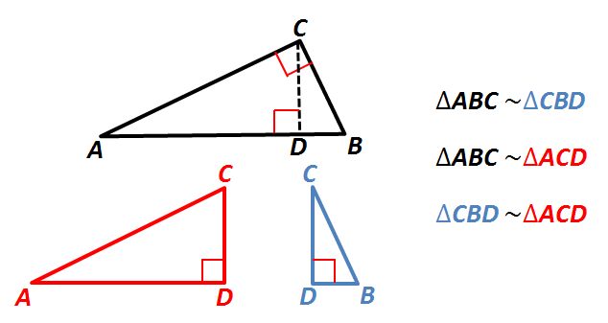
- Similar triangles are connected to trig triangles. The similarity between triangles with the same angles is why the trig functions are consistent across all right triangles with the same angle.

G.TR.4 The student will model and solve problems, including those in context, involving trigonometry in right triangles and applications of the Pythagorean Theorem.
Students will demonstrate the following Knowledge and Skills:
- Determine whether a triangle formed with three given lengths is a right triangle.
- Find and verify trigonometric ratios using right triangles.
- Model and solve problems, including those in context, involving right triangle trigonometry (sine, cosine, and tangent ratios).
- Solve problems using the properties of special right triangles.
- Solve for missing lengths in geometric figures, using properties of 45°-45°-90° triangles, where rationalizing denominators may be necessary.
- Solve for missing lengths in geometric figures, using properties of 30°-60°-90° triangles, where rationalizing denominators may be necessary.
- Solve problems, including those in context, involving right triangles using the Pythagorean Theorem and its converse, including recognizing Pythagorean Triples.
G.TR.4 The student will model and solve problems, including those in context, involving trigonometry in right triangles and applications of the Pythagorean Theorem.
Additional Content Background and Instructional Guidance:
- Tools for understanding the standard: physical protractor, ruler, compass, straight edge, paper folding as well as digital tools in mathematical and drafting platforms (dynamic software).
- The converse of the Pythagorean Theorem can be used to determine if a triangle is a right triangle. If $c^{2}=a^{2}+b^{2}$, then the triangle is right.
- If a triangle is not a right triangle, the Pythagorean Inequality Theorem can be used to determine the type of triangle based on angles.
    - If $c^{2}<a^{2}+b^{2}$, then the triangle is acute.
    - If $c^{2}>a^{2}+b^{2}$, then the triangle is obtuse.
- Similar triangles can be used to develop the concept of Pythagorean triples and trigonometric ratios.
- The sine of an acute angle in a right triangle is equal to the cosine of its complement.
- Missing side lengths or angle measurements in a right triangle can be solved by using sine, cosine, and tangent ratios.
- 45°-45°-90° and 30°-60°-90° triangles are special right triangles because their side lengths can be specified as exact values using radicals rather than decimal approximations.
- Pythagorean triples are whole number side length measures of right triangles. Examples include (3, 4, 5) and (5, 12, 13).
- Additional sets of Pythagorean triples can be found by applying properties for similar triangles and proportional sides. For example, doubling the sides of a triangle with sides of (3, 4, 5) creates another Pythagorean triple of (6, 8, 10).
- Pythagorean theorem can be used to develop the distance formula. When the two endpoints are graphed, a right triangle can be drawn with the hypotenuse being the diagonal distance between the points. The distance horizontally and vertically can be substituted for 𝑎 and 𝑏 in the Pythagorean theorem.
- The distance formula can be used to determine the length of a line segment when given the coordinates of the endpoints.
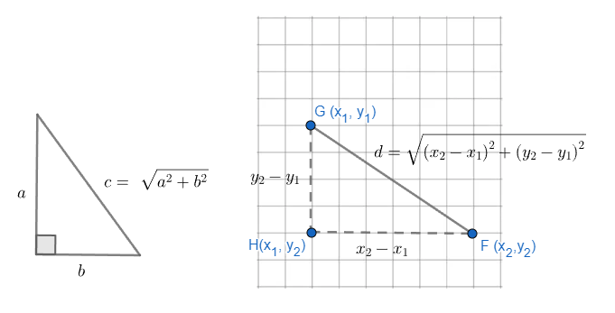

Polygons and Circles
G.PC.1 The student will prove and justify theorems and properties of quadrilaterals, and verify and use properties of quadrilaterals to solve problems, including the relationships between the sides, angles, and diagonals.
Students will demonstrate the following Knowledge and Skills:
- Solve problems, using the properties specific to parallelograms, rectangles, rhombi, squares, isosceles trapezoids, and trapezoids.
- Prove and justify that quadrilaterals have specific properties, using coordinate and algebraic methods, such as the slope formula, the distance formula, and the midpoint formula.
- Prove and justify theorems and properties of quadrilaterals using deductive reasoning.
- Use congruent segment, congruent angle, angle bisector, perpendicular line, and/or parallel line constructions to verify properties of quadrilaterals.
G.PC.1 The student will prove and justify theorems and properties of quadrilaterals, and verify and use properties of quadrilaterals to solve problems, including the relationships between the sides, angles, and diagonals.
Additional Content Background and Instructional Guidance:
- The properties of quadrilaterals can be verified experimentally using rulers, protractors, coordinate methods, and other measurement tools.
- A parallelogram is a quadrilateral with both pairs of opposite sides parallel. Additional properties of a parallelogram include:
- opposite sides are congruent;
- opposite angles are congruent;
- consecutive angles are supplementary; and,
- diagonals bisect each other.
- A rectangle is a quadrilateral with four right angles. In addition to all the parallelogram properties, the properties of rectangles also include:
- diagonals are congruent.
- A rhombus is a quadrilateral with four congruent sides. In addition to all the parallelogram properties, the properties of rhombi also include:
- all sides are congruent;
- diagonals are perpendicular;
- diagonals bisect opposite angles; and,
- diagonals divide the rhombus into four congruent right triangles.
- A square is a quadrilateral that is a regular polygon with four congruent sides and four right angles. In addition to all of the parallelogram, rhombus, and rectangle properties, the properties of squares also include:
- diagonals divide the square into four congruent 45°-45°-90° triangles.
- In order to prove that a quadrilateral is a square, it must be shown that the quadrilateral has at least one rhombus property as well as at least one rectangle property.
- A trapezoid is a quadrilateral with exactly one pair of parallel sides. The parallel sides of a trapezoid are called bases. The nonparallel sides of a trapezoid are called legs.
- An isosceles trapezoid is a quadrilateral with one set of opposite sides parallel and the other set of opposite sides congruent. In addition to all of the trapezoid properties, the properties of an isosceles trapezoid also include:
- base angles are congruent; and,
- diagonals are congruent.
- Properties of quadrilaterals can be used to identify the quadrilateral and to determine the measures of sides and angles.
- Given coordinate representations of quadrilaterals, the distance, slope, and midpoint formulas may be used to prove and justify that quadrilaterals have specific properties.
- The angle relationships formed when parallel lines are intersected by a transversal can be used to prove the properties of quadrilaterals.
- Deductive reasoning can be used to prove and justify theorems of quadrilaterals. Examples include:
  - All rectangles have congruent diagonals. Quadrilateral ABCD is a rectangle. Quadrilateral ABCD has diagonals that are congruent.
  - If a quadrilateral is a rhombus, then its opposite sides are parallel. If a quadrilateral has opposite sides parallel, then it is a parallelogram. Conclusion: If a quadrilateral is a rhombus, then it is a parallelogram.
- Congruent triangles can be used to prove properties of quadrilaterals.
- The construction of the perpendicular bisector of a line segment can be justified using the perpendicular diagonals of a rhombus.
- The construction of the perpendicular to a given line from a point on, or not on, the line can be justified using the perpendicular diagonals of a rhombus.
- The construction of a bisector of a given angle can be justified using that the diagonals of a rhombus bisect the angles.
- Verify properties of quadrilaterals with compass constructions:
Property | Construction
Both pairs of opposite sides are parallel | Parallel line
Both pairs of opposite sides are congruent | Congruent segments
Both pairs of opposite angles are congruent | Congruent angles
Diagonals bisect each other | Congruent segments
One pair of opposite sides are congruent and parallel | Congruent segments and parallel lines
Diagonals are congruent | Congruent segments
All sides are congruent | Congruent segments
Diagonals are perpendicular bisectors of each other | Perpendicular line and congruent segments
Diagonals bisect opposite angles | Angle bisector
Nonparallel sides are congruent | Congruent segments
Base angles are congruent | Congruent angles

G.PC.2 The student will verify relationships and solve problems involving the number of sides and measures of angles of convex polygons.
Students will demonstrate the following Knowledge and Skills:
- Solve problems involving the number of sides of a regular polygon given the measures of the interior and exterior angles of the polygon.
- Justify the relationship between the sum of the measures of the interior and exterior angles of a convex polygon and solve problems involving the sum of the measures of the angles.
- Justify the relationship between the measure of each interior and exterior angle of a regular polygon and solve problems involving the measures of the angles.
G.PC.2 The student will verify relationships and solve problems involving the number of sides and measures of angles of convex polygons.
Additional Content Background and Instructional Guidance:
- In convex polygons, each interior angle has a measure less than 180°.
- In concave polygons, one or more interior angles have a measure greater than 180°.
- A regular polygon is a convex polygon that is both equiangular (all angles congruent) and equilateral (all sides congruent).
- The sum of the measures of the interior angles of a convex polygon may be found by dividing the interior of the polygon into nonoverlapping triangles and multiplying the number of triangles created by 180$°$.
- An exterior angle is formed by extending a side of a polygon.
- The exterior angle and the corresponding interior angle form a linear pair.
- The sum of exterior angles in any convex polygon is 360$°$.
- As the number of sides increases in a regular polygon, the measure of each interior angle increases and the measure of each exterior angle decreases.
- Given a number of sides, the following chart can be used to organize the polygon formulas.
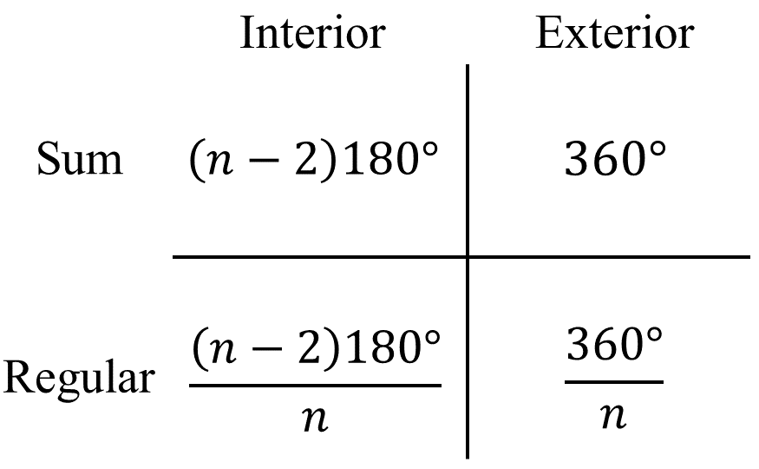

G.PC.3 The student will solve problems, including those in context, by applying properties of circles.
Students will demonstrate the following Knowledge and Skills:
- Determine the proportional relationship between the arc length or area of a sector and other parts of a circle.
- Solve for arc measures and angles in a circle formed by central angles.
- Solve for arc measures and angles in a circle involving inscribed angles.
- Calculate the length of an arc of a circle.
- Calculate the area of a sector of a circle.
- Apply arc length or sector area to solve for an unknown measurement of the circle including the radius, diameter, arc measure, central angle, arc length, or sector area.
G.PC.3 The student will solve problems, including those in context, by applying properties of circles.
Additional Content Background and Instructional Guidance:
- A central angle is an angle whose vertex is the center of the circle.
- An inscribed angle is an angle whose vertex is a point on the circle and whose sides contain chords of the circle.
- The measure of a central angle is equal to the measure of its intercepted arc.
- The measure of an inscribed angle is half the measure of its intercepted arc.
- Portions of circles can be thought of in three ways:
  - Arc Measure: Measured in degrees or radians and expresses the portion of the circle out of the whole. It is not affected by the size of the circle.
  - Arc Length: Measured in linear units (e.g., inches, meters) and expresses the length of a particular arch. It is affected by the size of the circle.
  - Sector Area: Measured in square units (e.g., $in.^{2}$, $m^{2}$) and expresses how much area is contained within the sector. It is affected by the size of the circle.
- The ratio of the central angle to 360° is proportional to the ratio of the arc length to the circumference of the circle.
- The ratio of the central angle to 360° is proportional to the ratio of the area of the sector to the area of the circle.

G.PC.4 The student will solve problems in the coordinate plane involving equations of circles.
Students will demonstrate the following Knowledge and Skills:
- Derive the equation of a circle given the center and radius using the Pythagorean Theorem.
- Solve problems in the coordinate plane involving equations of circles:
  - given a graph or the equation of a circle in standard form, identify the coordinates of the center of the circle;
  - given the coordinates of the endpoints of a diameter of a circle, determine the coordinates of the center of the circle.
  - given a graph or the equation of a circle in standard form, identify the length of the radius or diameter of the circle.
  - given the coordinates of the endpoints of the diameter of a circle, determine the length of the radius or diameter of the circle.
  - given the coordinates of the center and the coordinates of a point on the circle, determine the length of the radius or diameter of the circle; and
  - given the coordinates of the center and length of the radius of a circle, identify the coordinates of a point(s) on the circle.
- Determine the equation of a circle given:
  - a graph of a circle with a center with coordinates that are integers;
  - coordinates of the center and a point on the circle;
  - coordinates of the center and the length of the radius or diameter; and,
  - coordinates of the endpoints of a diameter.
G.PC.4 The student will solve problems in the coordinate plane involving equations of circles.
Additional Content Background and Instructional Guidance:
- A circle is a locus of points equidistant from a given point, the center.
- The distance between any point on the circle and the center is the length of the radius.
- The equation of a circle with a given center and radius can be derived using the Pythagorean Theorem as follows: Every point (x, y) on a circle is the same distance from the center of the circle (h, k). This distance is defined as the radius (r). To determine the distance (radius) between (x, y) and (h, k), a right triangle is created with the hypotenuse as the radius (r) and the legs defined as (x – h) and (y – k). Substituting these variables into the Pythagorean Theorem results in the following equation: (x – h)² + (y – k)² = r².
- Standard form for the equation of a circle is (x – h)² + (y – k)² = r², where the coordinates of the center of the circle are (h, k) and r is the length of the radius.
- Given the graph of a circle in the coordinate plane, identify the circle’s center and radius/diameter required to determine the equation for the circle. The midpoint of the diameter is the center of the circle.
- The midpoint formula can be used to find the center of the circle when given two endpoints.
- The distance formula can be used to determine the length of a radius given an endpoint and a midpoint.
- The equation of a circle gives the coordinates of every point, (x, y), on the circle.

Two- and Three-Dimensional Figures
G.DF.1 The student will create models and solve problems, including those in context, involving surface area and volume of rectangular and triangular prisms, cylinders, cones, pyramids, and spheres.
Students will demonstrate the following Knowledge and Skills:
- Identify the shape of a two-dimensional cross-section of a three-dimensional figure.
- Create models and solve problems, including those in context, involving surface area of three-dimensional figures, as well as composite three-dimensional figures.
- Solve multistep problems, including those in context, involving volume of three-dimensional figures, as well as composite three-dimensional figures.
- Determine unknown measurements of three-dimensional figures using information such as length of a side, area of a face, or volume.
G.DF.1 The student will create models and solve problems, including those in context, involving surface area and volume of rectangular and triangular prisms, cylinders, cones, pyramids, and spheres.
Additional Content Background and Instructional Guidance:
- A cylinder is a solid figure formed by two congruent parallel faces called bases joined by a curved surface. In this course, cylinders are limited to right circular cylinders.
- A prism is a polyhedron that has a congruent pair of parallel bases and faces that are parallelograms. In this course, prisms are limited to right prisms.
- A pyramid is a polyhedron with a base that is a polygon and three or more faces that are triangles with a common vertex.
- A cone is a solid figure formed by a face called a base that is joined to a vertex (apex) by a curved surface. In this course, cones are limited to right circular cones.
- Slicing a three-dimensional figure using a geometric plane results in an intersection that is a two-dimensional figure. Slicing vertically, horizontally, or diagonally can result in cross-sections that include circles, triangles, rectangles, squares, ellipses, and trapezoids.
- Subdivision of polygons may assist in determining the area of regular polygons.
- The formula for the area of regular polygon is $A=\frac{1}{2}ap$, where:
- $a$ represents apothem which is the perpendicular distance from any side to the center of the regular polygon; and,
- $p$represents the length of the polygon’s perimeter.
- Generalize the surface area formula of prisms and cylinders to $SA=LA+2B$.
- Generalize the surface area formula of cones and pyramids to $SA=LA+B$.
- The surface area of a prism or pyramid is the sum of the areas of all its faces.
- The surface area of a cylinder, cone, or hemisphere is the sum of the areas of the curved surface and base(s).
- The surface area of a sphere is the area of the curved surface.
- Surface area of spheres, cones, and cylinders should be considered in terms of π or as a decimal approximation.
- Calculators may be used to determine decimal approximations for results.
- The lateral area (LA) of a cylinder or a cone is the area of the curved surface of the cylinder or cone, not including the base(s).
- The lateral area (LA) of a prism or a pyramid is the sum of the areas of all faces, not including the base(s).
- Generalize the volume formula of prisms and cylinders to $V=Bh$.
- Generalize the volume formula of cones and pyramids to $V=\frac{1}{3}Bh$.
- Volume and surface area of spheres, cones and cylinders should be considered in terms of π or as a decimal approximation.
- Composite figures consist of two or more three-dimensional figures. The surface area of a composite figure may not be equal to the sum of the surface areas of the individual figures.
- Composite figures consist of two or more three-dimensional figures. The volume of a composite figure equals the sum or difference of the volumes of the individual figures.

G.DF.2 The student will determine the effect of changing one or more dimensions of a three-dimensional geometric figure and describe the relationship between the original and changed figure.
Students will demonstrate the following Knowledge and Skills:
- Describe how changes in one or more dimensions of a figure affect other derived measures (perimeter, area, total surface area, and volume) of the figure.
- Describe how changes in surface area and/or volume of a figure affect the measures of one or more dimensions of the figure.
- Solve problems, including those in context, involving changing the dimensions or derived measures of a three-dimensional figure.
- Compare ratios between side lengths, perimeters, areas, and volumes of similar figures.
- Recognize when two- and three-dimensional figures are similar and solve problems, including those in context, involving attributes of similar geometric figures.
G.DF.2 The student will determine the effect of changing one or more dimensions of a three-dimensional geometric figure and describe the relationship between the original and changed figure.
Additional Content Background and Instructional Guidance:
- A change in one dimension of a figure results in a predictable change in area. The resulting figure may or may not be similar to the original figure.
- A change in one dimension of a figure results in a predictable change in volume. The resulting figure may or may not be similar to the original figure.
- A change in one dimension of a figure results in a predictable change in perimeter. The resulting figure may or may not be similar to the original figure.
- A change in surface area and/or volume results in a predictable change in one or more dimensions of the figure. The resulting figure may or may not be similar to the original figure.
- A constant ratio, the scale factor, exists between corresponding dimensions of similar figures.
- If the ratio between dimensions of similar figures is a:b then:
- the ratio of their areas is $a^{2}: b^{2}.$
- the ratio of their volumes is $a^{3}: b^{3}$.
- Proportional reasoning is important when comparing attribute measures in similar figures.

