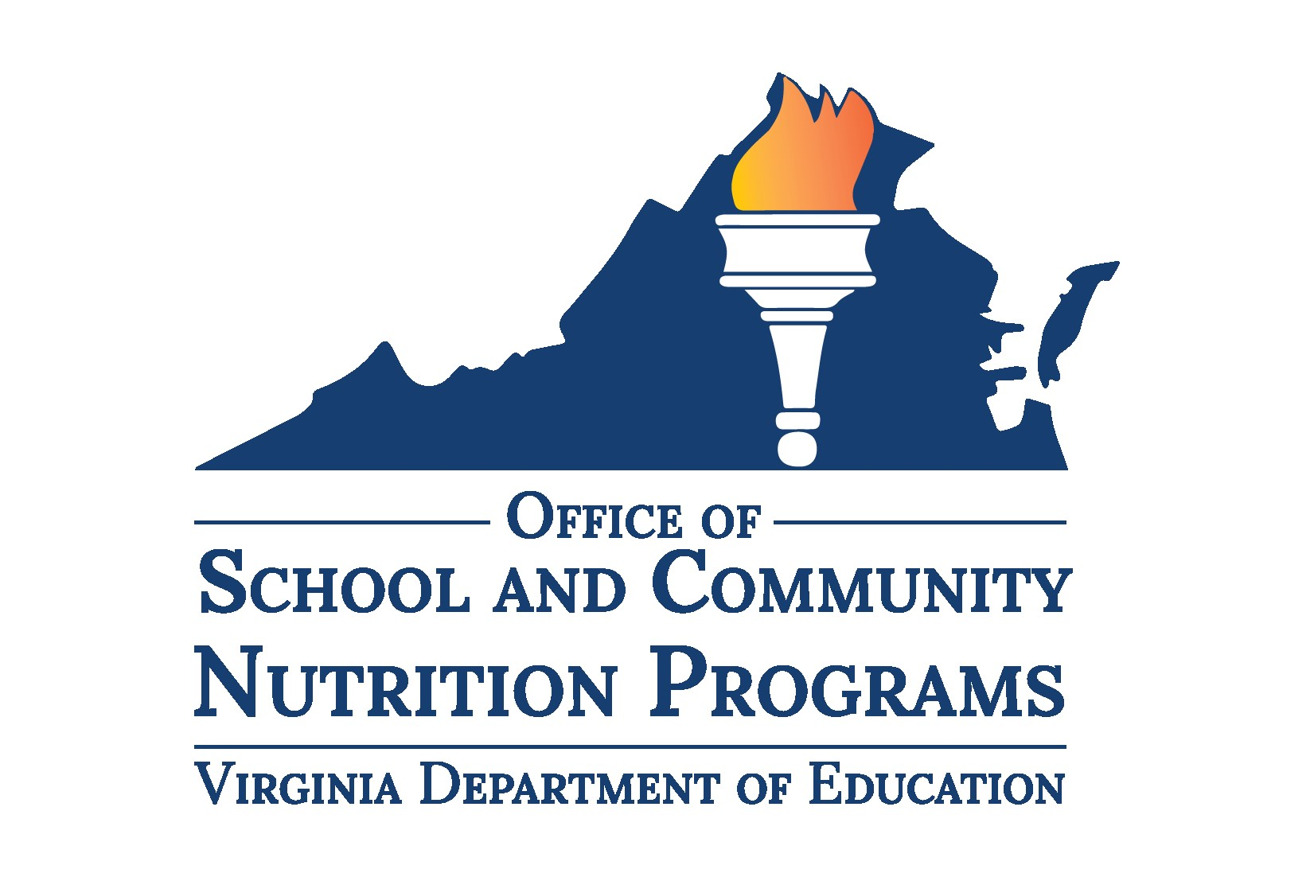

School Level Report Card

Tool for the Triennial Assessment
This tool is intended to help schools track their degree of compliance to regulations and progress towards attaining the goals of their school division’s Local School Wellness Policy. Complete this tool at the school level by entering the requested information and selecting “Yes” or “No” in sections I-VI to indicate whether goals were obtained and/or guidelines were met. Return the completed tool to the individual responsible for completing the division Triennial Assessment.
Division Name:
School Name:
Date of Evaluation:
Select all grade levels in your school or select N/A if ungraded:

N/A
Pre-K
K
1
5
6
7
8
9
10
11
12

2
3
4

Nutrition Promotion and Education
Our school meets the specific goals for nutrition promotion and education as outlined in our Wellness Policy:
- [Insert goal for nutrition promotion and education as described in your Wellness Policy.]
Yes No
- [Optional: Insert additional goal(s) for nutrition promotion and education as described in your Wellness Policy.]
Yes No

Physical Activity
Our school meets the specific goals for physical activity as outlined in our Wellness Policy:
- [Insert goal for physical activity as described in your Wellness Policy.]
Yes No
- [Optional: Insert additional goal(s) for physical activity as described in your Wellness Policy.]
Yes No

Other School-Based Wellness Activities
Our school meets specific goals for other school-based activities that promote student wellness as outlined in our Wellness Policy:
- [Insert goal for other school-based wellness activity as described in your Wellness Policy.]
Yes No
- [Optional: Insert additional goal(s) for other school-based wellness activities as described in your Wellness Policy.]
Yes No

Standards and Nutrition Guidelines for All Foods and Beverages Sold
Our school meets the standards and nutrition guidelines for all foods and beverages sold to students on the school campus during the school day that are consistent with federal and state regulations:
- We follow federal school meal nutrition standards for all foods and beverages available for sale on campus during the school day.
Yes No
- We have adopted and implemented Smart Snacks nutrition standards for ALL items sold during school hours, including a la carte offerings and food sold in school stores and vending machines.
Yes No
- We follow [School Division]’s policy on exempt fundraisers as outlined in our Division’s Wellness Policy pursuant to current regulations § 22.1-207.4 of the Code of Virginia.
This language may be replaced with the requirements stated in your Wellness Policy, not to exceed 30 exempt school-sponsored fundraisers per school year.
Yes No
- [Optional: Insert additional standards and nutrition guidelines for all foods and beverages sold as described in your Wellness Policy.]
Yes No

Standards for All Foods and Beverages Provided, But Not Sold
Our school meets the requirements for nutrition standards for all foods and beverages provided, but not sold, to students during the school day (e.g. in classroom parties, classroom snacks brought by parents, or other foods given as incentives):
- We follow [School Division]’s policy on standards for all foods and beverages provided, but not sold, as outlined in our Division’s Wellness Policy.
This language may be replaced with the requirements stated in your Wellness Policy.
Yes No
- [Optional: Insert additional standards for all foods and beverages provided, but not sold, as described in your Wellness Policy]
Yes No

Policy for Food and Beverage Marketing
Our school meets the standards that allow marketing and advertising of only those foods and/or beverages that meet the Smart Snacks nutrition standards.
- All food and beverage marketing meets Smart Snacks nutrition standards.
Yes No
- [Optional: Insert additional policies for food and beverage marketing as described in your Wellness Policy.]
Yes No

Progress
Include any additional wellness practices taking place and describe progress made in attaining the goals of your Wellness Policy:

Contact
The Wellness Policy leadership includes one or more school officials who have the authority to ensure each school complies with the policy. This individual may be contacted for more information about the Wellness Policy practices at [School Name].
Name:
Position/Title:
Email:
Phone:
Return this completed report card to your Wellness Policy designee or other individual responsible for completing the Triennial Assessment.

