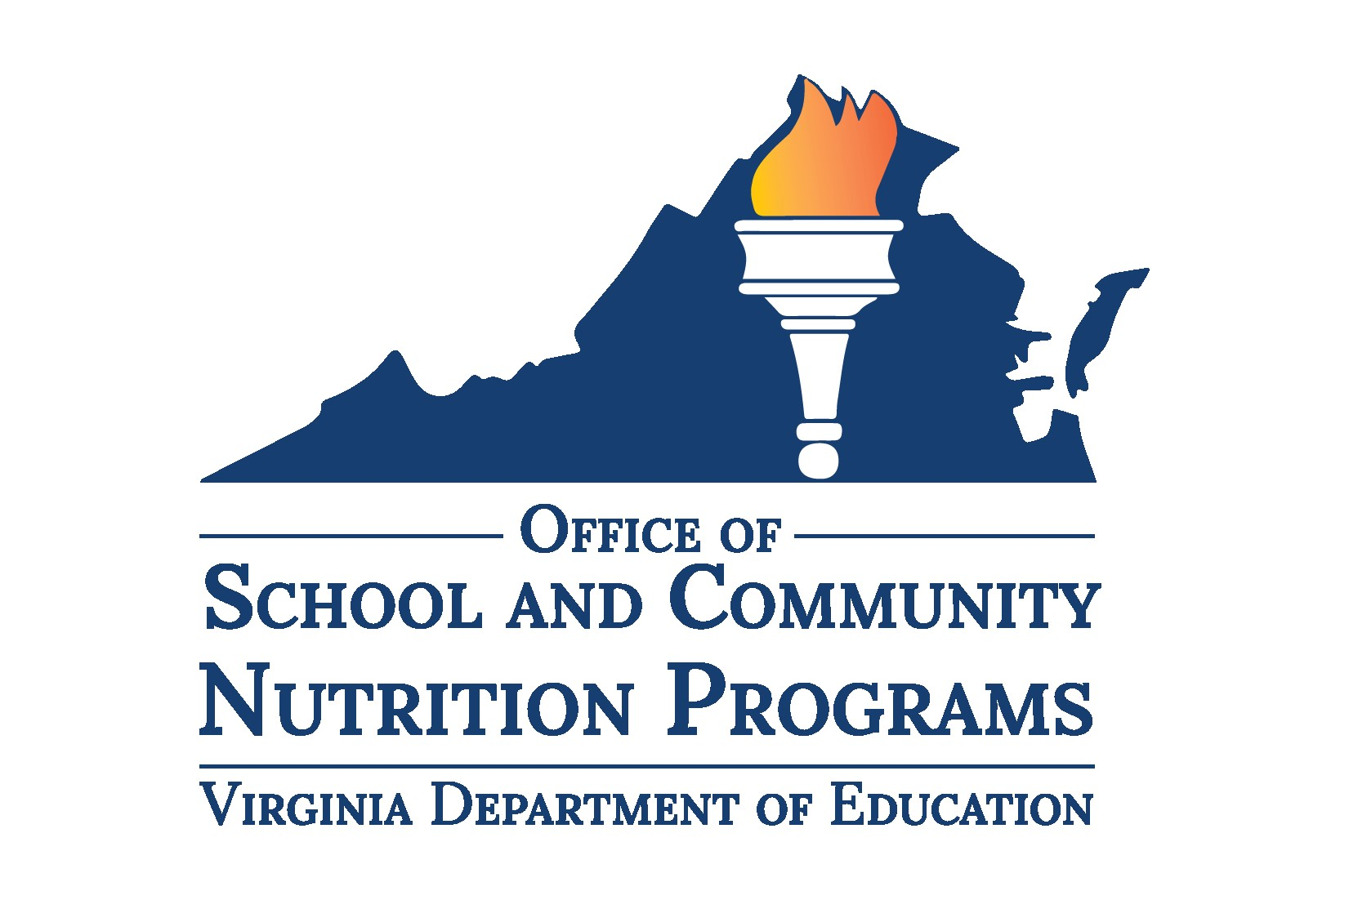

Local School Wellness Policy

Policy Template
OBJECTIVE: To provide Virginia school divisions with a compliant template for updating the Local School Wellness Policy (Wellness Policy). This template meets the minimum federal and Virginia regulations.
INSTRUCTIONS: The content formatted in bold and italics throughout this document is instructional and should not be included in the LEA’s final Wellness Policy. All content within [brackets] should be modified according to each LEA’s unique needs. Please delete all instructions (in italics) before finalizing your document and update all modifiable fields (red brackets).
This document is a template version of the Virginia Department of Education, Office of School and Community Nutrition Programs (VDOE-SCNP) Model Wellness Policy. This template scores 49 for total strength and 56 for total comprehensiveness from the Wellness School Assessment Tool (WellSAT3.0) scorecard. Additional division-specific language may be added to this template. If information is removed, the policy should be checked against the VDOE-SCNP Wellness Policy Checklist on the VDOE website and the WellSAT3.0 to ensure compliance, comprehensiveness, and strength of policy language.
Additional resources, including a Guidance Document for Updating the Wellness Policy, can be found on our website under Local School Wellness Policy and Triennial Assessment.
The LEA is ultimately responsible for ensuring the division’s Wellness Policy complies with all federal and state regulations.

[Insert Division/School Logo]

Local School Wellness Policy

[Division or school name]

[Implementation Year, i.e., 2024]

Leadership
The [wellness policy leader, i.e., wellness coordinator], with support from the [health and wellness committee, i.e., school health advisory board (SHAB)], shall implement and ensure compliance with the Local School Wellness Policy (Wellness Policy) by leading the review, update, and evaluation of the policy.

Public Involvement¹
The division will invite a diverse group of stakeholders and the public to participate in the development, implementation, and periodic review and update of the Wellness Policy. The public will be notified through [social media posts, the division website, or other mode of public notification] for opportunities to participate.

School Meals¹
All schools within [division/school name] participate in the National School Lunch Program (NSLP) and School Breakfast Program (SBP) [and Summer Food Service Program (SFSP) and/or any additional federal meal program(s) the division or school participates in]. All meals served to students meet or exceed current nutrition requirements established under the Healthy Hunger-free Kids Act of 2010, as specified in the Code of Federal Regulations at 7CFR210.10 and 7CFR220.8.
[Every school within division name/school name] will provide breakfast through at least one alternative breakfast service model in addition to the traditional breakfast service in the cafeteria to encourage breakfast consumption and ensure access for every student. Alternative breakfast models include Breakfast in the Classroom, Grab-and-Go Breakfast, and Second Chance Breakfast.

Foods Sold Outside of School Meal Programs (Smart Snacks)¹
Any foods and beverages sold to students at school during the school day other than those foods provided as part of the school meal programs shall meet the standards established in USDA-FNS Nutrition Standards for All Foods Sold in Schools (Smart Snacks) rule. The school day is defined by USDA as the period from midnight the night before to 30 minutes after the end of the instructional day. This includes foods and beverages sold in vending machines and a la carte.

Foods Provided, Not Sold¹
The division requires foods offered on the school campus meet or exceed the USDA-FNS Smart Snacks rule including those provided at celebrations or classroom snacks brought by staff or family members. Foods and beverages will not be used as a reward or withheld as punishment.

Food and Beverage Marketing¹
Marketing of any foods and beverages on the school campus during the school day must meet the USDA-FNS Smart Snacks rule.

School-Sponsored Fundraisers
Fundraising during and outside school hours will sell only non-food items or foods and beverages that meet or exceed the USDA-FNS Smart Snacks rule. LEAs may choose to allow up to 30 school-sponsored fundraisers per site per school day to be exempt from the Smart Snacks rule. Schools are encouraged to promote physical activity fundraisers such as walk-a-thons, jump rope for heart, and fun runs.
Any fundraiser that sells food or beverages may not be conducted during meal service times. This includes from 6:00 a.m. to the end of the breakfast period and from the beginning of the first lunch period to the end of the last lunch period.
The fundraiser designee approves, tracks, and monitors fundraisers to ensure compliance with the nutrition standards for school-sponsored fundraisers. The fundraiser designee for [division/school name] is the [fundraiser designee; i.e., school principal, wellness policy designee, etc.; NOT a school nutrition personnel] and a fundraiser-tracking document is kept on file in the [main office or on the school website].

Nutrition Education¹
[Division/school name] will provide at least 140 minutes of nutrition education to every student and exceed the expectations of the Virginia Department of Education (VDOE) Health Standards of Learning (SOLs) by integrating nutrition concepts and skills into mathematics, language arts, social science, and elective courses throughout the school year. The cafeteria environment will reinforce nutrition education provided in the classroom.

Nutrition Promotion¹
[Division/school name] will promote positive nutrition habits in the cafeteria, classrooms, and throughout the school environment. Schools may participate in nutrition promotion through farm to school activities, such as:
- Local foods served in school are promoted with signage and/or social media posts;
- Special events revolve around agriculture or farming;
- Career exploration, internships, and mentoring opportunities are available;
- An active school garden is operated and garden produce is offered in the cafeteria;
- A local agricultural farmer visits our school each school year;
- Students take field trips to local agricultural farms.²

Physical Education/Physical Activity¹
[Division/school name] will provide every student with physical education that exceeds the expectations of the VDOE Physical Education SOLs and teaches the skills needed to achieve and maintain a health-enhancing level of personal fitness and develop the knowledge, attitudes, behaviors, and confidence needed to be physically active for life. A program of physical activity is provided for all students in grades kindergarten through five consisting of at least 20 minutes per day or an average of 100 minutes per week during the school year. A program of physical activity is available to all students in grades six through 12 with a goal of at least 150 minutes per week on average during the school year.

Other Activities that Promote Student Wellness¹
[Division/school name] will seek to provide school climates that support social and emotional wellbeing and promote positive relationships among students, staff, parents, and community members. Using the Collaborative for Academic, Social, and Emotional Learning (CASEL), schools will provide students with instruction to increase self-awareness, self-management, social awareness, relationship skills, and responsible decision-making.

Triennial Assessment¹
The division will evaluate compliance with the Wellness Policy no less than once every three years and make the results available to the public on the school website. The assessment will include the extent to which each school follows the policy regulations, the extent to which the policy compares to a model policy, and a description of the progress made in attaining the goals of the policy. The assessment results will be used to update the Wellness Policy.

Public Update and Information¹
Annually, the division will inform families and the public about the content, implementation, and/or any updates to the Wellness Policy through the school website and Board of Education meetings.

Requirement by Code of Federal Regulations: Local School Wellness Policy (7CFR210.31)
Recommended best practice by the Virginia Department of Education, Office of School and Community Nutrition Programs.
Requirement by Virginia Code: Regulations Governing Nutritional Standards for Competitive Foods Available for Sale in Public Schools (8VAC20-740)

