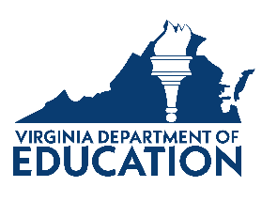
Virginia Department of Education

Equitable Services Timeline for Coordinators

October 2023 - March 2024
Inform private schools of services and send out Intent to Participate forms
March – April 2024
Engage in meaningful consultation
July 1, 2024
Submit Intent to Participate and Affirmation of Consultation documentation to VDOE via SharePoint
September 2024
Finalize enrollment data; complete application amendments and proportionate share calculations; finalize Agreement of Services Plans
December 1, 2024
Submit Agreement of Service plans to state via SharePoint

Samples of all the required forms can be downloaded for the Equitable Services website.

Sample 2024-25 Intent to Participate Form:
This form should be sent by the school division to all non-public schools physically located within the school division attendance area (An optional form is available for Title I attendance zone outside of the division).
  - Completed and returned by April 1, 2024 - even if private schools do not wish to participate.

Sample 2024-25 Affirmation of Consultation Form:
This form should be completed by all participating non-public schools to certify that:
- timely and meaningful consultation occurred before the LEA made any decision that affected the participation of eligible private school students.
- timely and meaningful consultation did not occur before the LEA made any decision that affected the participation of eligible private school students.

Sample 2024-25 Agreement of Services Form:
This form should be completed by all participating non-public schools to certify that:
- timely and meaningful consultation occurred for the program design and is equitable with respect to eligible private school children.
- timely and meaningful consultation did not occur and/or the program design is not equitable with respect to eligible private school children.

