What Time Is It?
Grade Level: Grade 8
Subject(s):
Primary: Math
Integrated Activity: Reading and Science
Reporting Category:
Measurement and Geometry
Lesson Summary and Connections:
Students will use interactive clocks, sorting cards and scenarios to learn about time and how to read an analog clock to the minute.
Lesson Components Links
VESOL(s)  Complexity Continuum | Functional Skills | Assistive Technology | Materials
Vocabulary | Common Misconceptions | Student-Friendly Outcome(s) | Introductory Activity
Plan for Instruction | Differentiation | Reflection | Formative Assessment
Word Wall Cards | Supplemental Materials | Practice Items | Integrated Activity

VESOL(s):
M-8.3: The student will tell time and measure elapsed time in minutes using analog and digital clocks including with context.
Complexity Continuum:
Times could be in one-minute increments in a.m. or p.m. and could include up to +/- 24 hours of elapsed time. Contexts will relate the time to an appropriate activity.
R-8.6 The student will identify an individual, event, or idea in a fiction passage that is read to the student or that the student reads.
Complexity Continuum:
The passage including an individual, event, or idea could range from three medium sentences with five to seven words to a paragraph with five to seven sentences.
S-8.3 Recognize that the sun provides Earth with light and energy.
Complexity Continuum:
Using simple pictures, diagrams, or representations, concepts could range from:
- recognizing the difference between day and night to
- recognizing that the sun gives the vast majority of light and heat energy to Earth and its organisms to
- recognizing the connection between Earth’s rotation and daytime and nighttime and Earth’s tilt on its axis and the four major seasons.

Functional Skill(s):
- Learning how to calculate how long it will take to accomplish a task.
- Determine if they have enough time to finish an assignment or task.
- Identify people and events happening around them.

Assistive Technology/AAC (Augmentative and Alternative Communication):
- Communication devices appropriate for the student programmed with numbers for counting and responding
- Enlarge materials for students with vision impairments
- Alternative methods of responses

Materials:
- Word Wall Cards
- Blank Analog Clock.
- Interactive Clock
- Telling Time to the Minute Analog Cards
- Telling Time to the Minute Digital Cards
- Optional Materials
  - Page protector
  - Chart paper
  - Sticky notes
  - Online Interactive Clock
  - Paper plates and Brads to make interactive clock
  - Judy Clock

Vocabulary:
Prior Knowledge
- time | - digital clock | - analog clock | - digital/analog clock
- daytime | - nighttime | - am | - pm
- noon | - midnight
Current Vocabulary
- time on clock | - event | - sequencing

Common Misconceptions:
- Since time does not use the base ten system, students may struggle understanding that one day is 24 hours, one hour is 60 minutes. They will try to use base ten strategies to determine hours and minutes.
- Students may count the hour/minute they are starting from instead of the next hour/minute.
- Students may struggle understanding each number on the clock represents a multiple of 5.
- Students may struggle understanding the difference between a.m. and p.m. and how it relates to noon and midnight.

Student-Friendly Outcome(s):
- I will be able to tell time to the minute.
- I will be able to tell the difference between a.m. and p.m.
- I will be able to tell the difference between noon and midnight.

Introductory Activity:
- Display a digital clock:
  - Show 4:00 p.m. on a digital clock. Have students brainstorm activities they would be doing at that time of day. (Getting off the bus, eating a snack, watching TV, playing outside…). Ask questions like, “Is it daytime or nighttime? “Is it afternoon or morning?”, “Will it be light or dark outside?” “Is the time closer to midnight or noon?”
  - Show the same time on an analog clock and ask students if it shows the same time as the digital clock. Have the students explain how they know it is the same time as the digital clock.
  - Next, show the digital clock at 9:00 p.m. and repeat the same process as before.
  - Continue changing the time (stick to times on the hour or half hour) until you feel students are ready to move on to the lesson.

Plan for Instruction:
- The majority of the vocabulary for this lesson has been taught in previous years. Use the Word Wall Cards as a starting point for your lesson. Ask students what they remember about each one and quickly jot down any additional ideas on a sticky-note on the card. Display the cards throughout the lesson so students can refer back to them while learning the concept.
Reading an Analog clock:
  - Activity 1: Modeling - Create an interactive clock using the Interactive Clock template or use an online clock or “Judy Clock” to model how to tell time to the minute.
  - Remind students that the numbers 1 - 12 represent multiples of 5 and each tick mark represents a minute.
  - Start with the clock at 12:00 and have students tell you what time it is. Move the minute hand to the one and ask students, “What time is it now?” Encourage students to explain their thinking. Next, move the minute hand to one tick mark after the 1 and ask the same question. Continue to move the minute hand around the clock, stopping and having students tell the time and justify their responses.
  - Suggested strategies student can use to tell time:
    - Count each tick mark (starting at 12) until they get to the minute hand.
    - Count by 5’s (using the numbers) until they get to the number before the minute hand and count up by one.
    - Recognize the benchmarks for each quarter-hour (15 minutes is at 3, 6 is 30 minutes, and 9 is 45 minutes) and count up from the closest benchmark by 5 (using the numbers) or ones (using the tick marks).
    - Encourage students to be creative and use a strategy, a mix of strategies, or create their own.
- Activity 2: Practice the Skill - When you feel students have had enough group practice, hand each student an interactive clock (or online interactive clock).
  - If possible, have students work with a partner. One partner calls out a time, and the other partner displays it on the interactive clock. If students cannot work with partners, have one student call out a time and the rest of the class models the time on their clock.
  - The teacher should be walking around and asking questions like, “How do you know that is the correct time?” or “Can you explain your thinking?”
  - After about 15 minutes or when you feel students need a transition, have a whole group discussion about what they learned and how they can use it in the future. Highlight when strategies are mentioned.
- Activity 3: Practice/Formative Assessment - Hand a set of Telling Time by the Minute Analog Cards to each student. This activity could be done as a whole class or during small group instruction.
  - Start this part by having students lay out the cards so they can see each one. The teacher will then ask a basic-level question and the students will either hold up the card or point to the correct card.
    - Suggested basic questions/statements: “Find the card that shows a time in the 3 o’clock hour.”, “Which card shows a time after 10 o’clock”, “It is time to get on the bus. Which card shows a time that could be correct? Explain why you chose your card.” Continue with basic-level questions until students are ready to move on.
    - Suggested formative questions (write them on the board so students can see the digital time): “Which card shows a time of 2:47? Tell your partner why you think the card you chose is correct.”, “Find the card that shows a time of 3:55. What activity could you do at this time? Would your activity be in the a.m. or p.m.? Explain.” Vary your questions according to the levels of students in your class.
  - Once students are ready to move on, hand out the Telling Time by the Minute Digital Cards. Have students match the analog card to the digital card.

Differentiation:
For students who may be struggling:
- Decrease the amount of cards being used in Activity 3.
- Substitute the digital clock cards for the analog cards for Activity 3.
- Enlarge the Analog clock so students have more room to write.
- Throughout the lesson, use the basic-level suggested questions.
For students who need enrichment:
- Students can create their own strategy for reading time on a clock.
- Have student write or say the time on the analog cards instead of matching them to the digital cards in Activity 3.
- Throughout the lesson, use the higher-level suggested questions.

Reflection:
In a small group or individually:
- Show a digital clock with the time of 8:37 a.m. Ask the following questions:
  - What time does the clock read?
  - What is an activity you would do during this time?
  - Is the time in the daytime or nighttime?
  - Is the time before or after noon?
  - Is the time closer to noon or midnight?
- Show an analog clock with the time of 10:48. Ask the following questions:
  - What time does the clock read? How do you know?
  - Would I use a.m. or p.m. if it was nighttime?
  - Would I use a.m. or p.m. if it was morning?

Formative Assessment:
- Use the matching activity as a formative assessment.
- During the lesson, record student responses or progress on a chart.

Integrated Activity:
Reading: R-8.6 Identify an individual, event, or idea in a fiction passage that is read to the student or that the student reads.
- It Happens Every Day (Tarheelreader.org)
- Before reading the story to the class, have students brainstorm what they think happens every day. Create a chart of their responses.
- As a class or individually, read the story It Happens Every Day.
  - While reading:
    - Stop to ask questions about the story and/or pictures.
    - Ask students to make predictions. If students struggle to make predictions, model how you would make a prediction.
    - Point out key ideas or descriptive words in the story that help the reader understand.
    - Model good reading strategies such as: Pausing and asking yourself questions, highlighting words or phrases, writing notes in the margin, etc.
  - After the story has been read:
    - Ask students to tell what parts of the story helped them predict and determine the answer to the question: What happens every day?
    - Explain that all of the parts they used to predict and determine are called events and all stories contain events to help the reader understand. (There is an event Word Wall card provided to use as a support.)
    - Ask questions to tie the story to the math content such as: What time do you think the sun comes up? Is it daytime or nighttime when the sun sets? Would you use a.m. or p.m. when talking about a sunrise?
Science: S-8.3 Recognize that the sun provides Earth with light and energy.
While teaching the different times:
  - Incorporate the terms day and night. Have students brainstorm how the sun in the solar system plays a part in daytime and nighttime. Continue the conversation about other properties of the sun.
  - Discuss the connection between the Earth’s rotation and the terms daytime/nighttime, midnight/noon, and a.m./p.m.

Word Wall Cards:

Clock
time

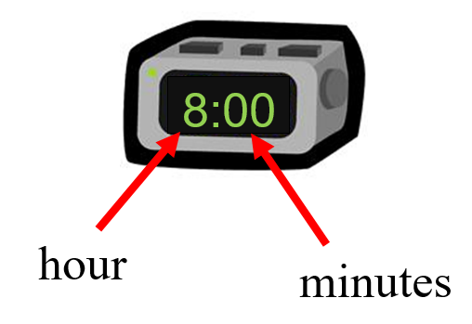

digital

Midnight

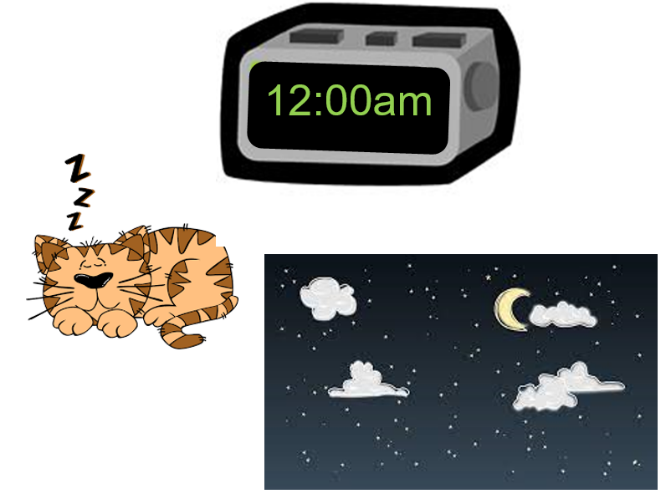

Noon

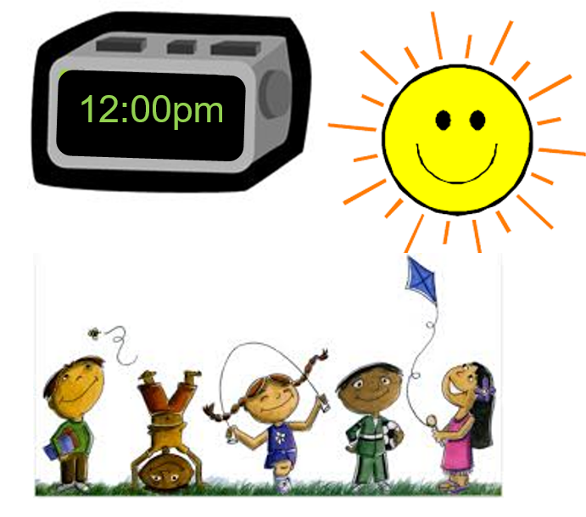
AM

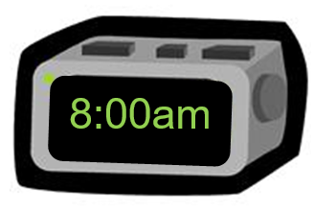

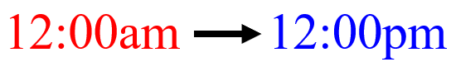midnight to noon
PM

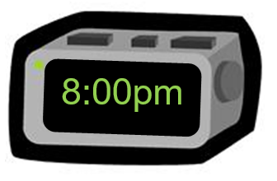

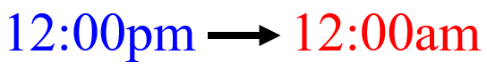noon to midnight

Daytime

Nighttime

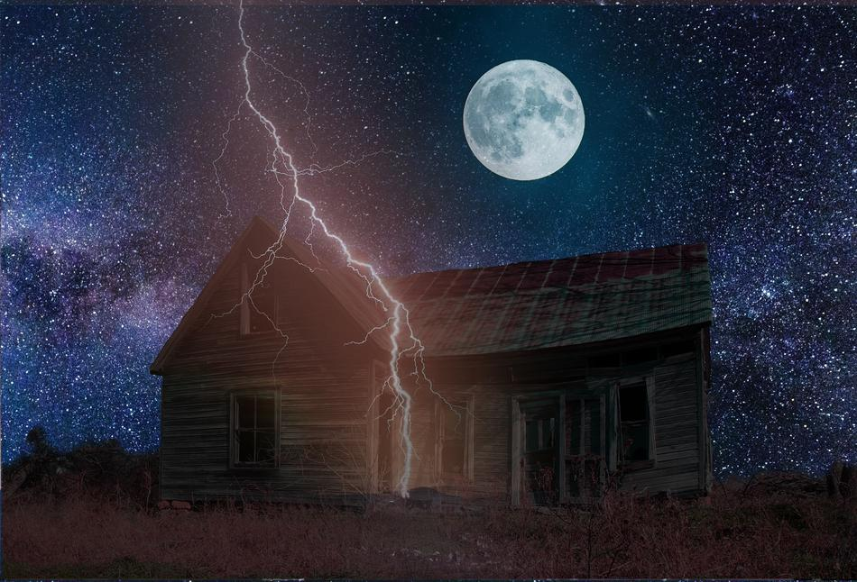

Clock
time

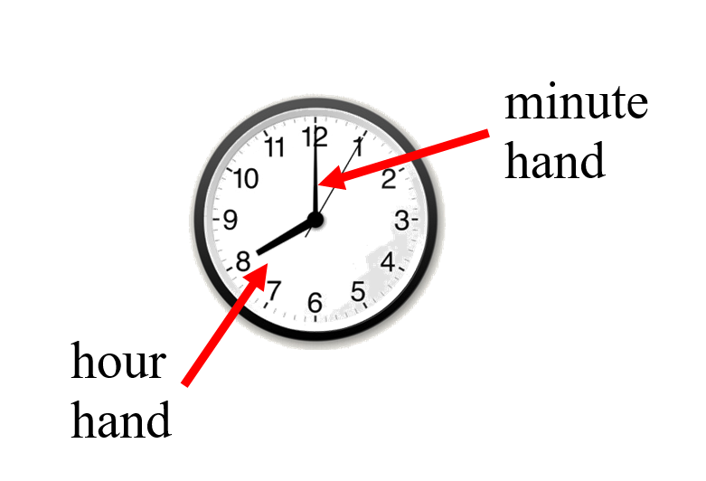

analog
Clock
time

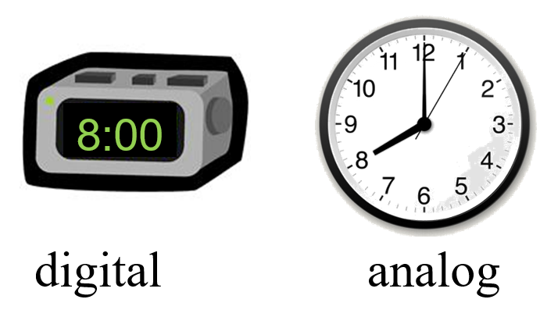

Clock
minutes, one-half hour,
one hour

30 minutes = one-half hour
60 minutes = 1 hour
24 hours = 1 day
Event
Something that happens in a story

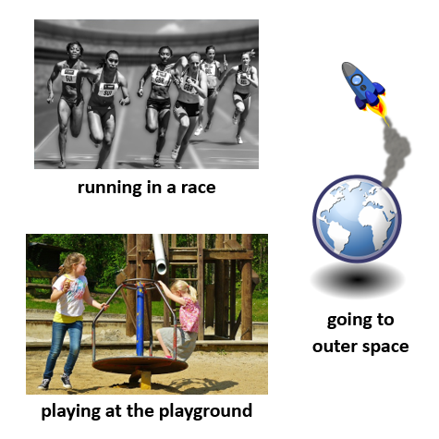

Supplemental Materials:
Analog Clock
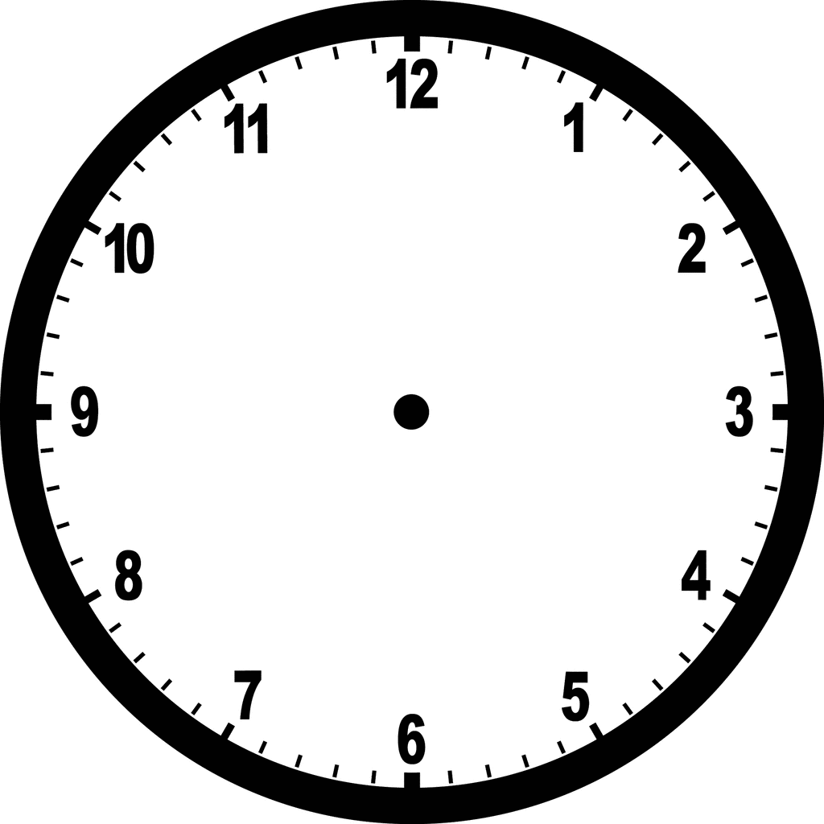
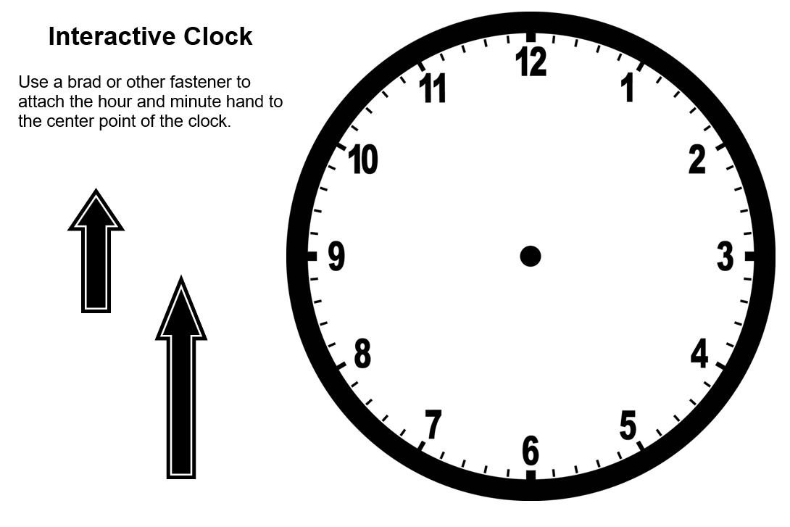
Telling Time to the Minute Digital Cards
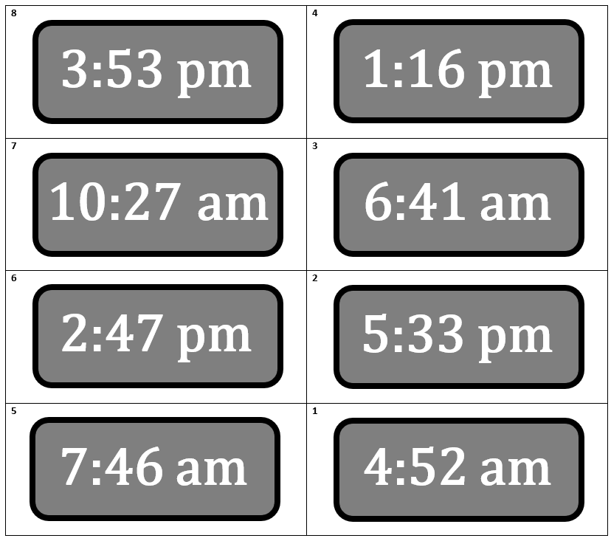
Telling Time to the Minute
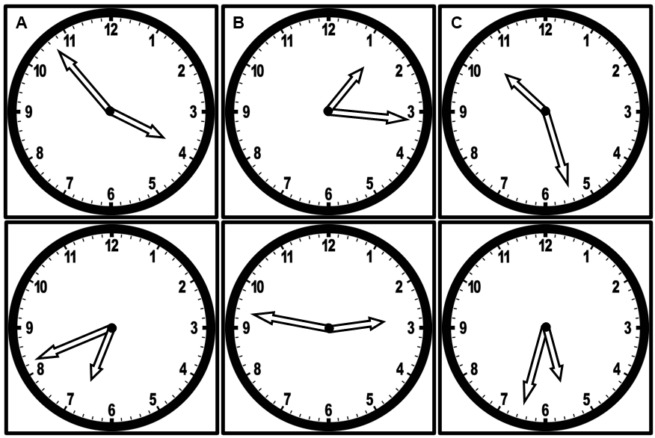

Practice Items

Grade 6 Item:
Examiners Text:

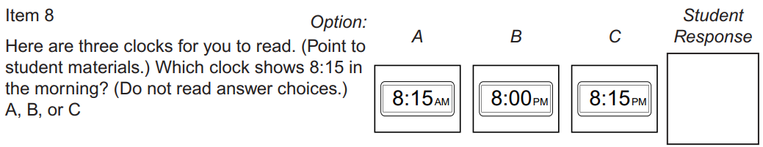

Student Question:

