**One Steppin’ Word Problems**

### Using Manipulatives

### Candies Adding/Pretzel Subtracting

**Subject(s):**

Primary: Math

Integrated Activity: Reading

**Reporting Category:** Number, Number Sense, Computation, and Estimation

**Lesson Summary and Connections:**

In this lesson the students will learn how to solve one-step word problems involving addition or subtraction using a variety of manipulatives.

**Lesson Components Links**

|  |  |  |  |
| --- | --- | --- | --- |
| **[VESOL(s)](#_VESOL(s):__)**  **[Complexity Continuum](#_VESOL(s):__)** | **[Functional Skills](#_Functional_Skill(s):)** | [**Assistive Technology**](#_Assistive_Technology/ACC_(Augmentat) | **Materials** |
| **Vocabulary** | **Common Misconceptions** | [**Student-Friendly Outcome(s)**](#_Student-Friendly_Outcome(s):) | **Introductory Activity** |
| **Plan for Instruction** | **Differentiation** | **Reflection** | **Formative Assessment** |
| **Word Wall Cards** | **Supplemental Materials** | **Practice Items** | **Integrated Activity** |

## VESOL(s)

## M-3.6: The student will solve one-step word problems using addition and subtraction.

**Complexity Continuum:**

Given a context, numbers from 0 to 20 could be added, with their sum not to exceed 20. Whole numbers from 0 through 10 could be subtracted.

**R-3.2:** The student will answer questions about a passage that is read to the student or that the student reads.

**Complexity Continuum:**

The passage could range from a sentence with five or fewer words through a sentence with seven or more words.

## Functional Skill(s):

* Addition is important, as it helps students to understand the concept of how many, how much, total, altogether, etc., in the context of real-world contextual situations (for example, how many apples, total books, crayons, flowers, shoes, money, or how much candy altogether).
* Subtraction is important, as it helps students to understand the concept of take away, give away, how much left, etc., in the context of real-world contextual situations (for example, how many items or how much money is left when some have/has been taken or given away).
* Students can use different strategies to find an answer to a real-world problem which can transfer to real-life activities (e.g., when they are at the store, playing games, etc.).

## Assistive Technology/AAC (Augmentative and Alternative Communication):

* AAC Device with number words preprogramed
* Low Tech Number board or number cards
* Larger items to use when counting

## Materials:

* Ziploc snack bags
* Manipulatives: candies, pretzels, blocks, counters, etc.
* Grade 2 Common Addition and Subtraction Problem Types
* Addition/Subtraction word problem cards
* Number and Symbol (addition, subtraction, equal) cards
* Math Mats
* Optional Materials:
  + Number line or Number path
  + Rekenrek or beaded number line
  + Virtual Manipulatives - [Didax Virtual Manipulatives](https://www.didax.com/math/virtual-manipulatives.html)
  + Virtual Manipulatives - [Toy Theater](https://toytheater.com/category/teacher-tools/virtual-manipulatives/counter-manipulatives/)

## Vocabulary:

**Prior Knowledge** What words will students need to know prior to starting the lesson?

|  |  |  |  |  |  |  |  |  |
| --- | --- | --- | --- | --- | --- | --- | --- | --- |
| |  |  |  |  | | --- | --- | --- | --- | | * Number 2 | * Number 9 | * Number 14 | * Join | | * Number path | * Separate | * Counting by ones | * All | |

**Current Vocabulary** What words will students learn during the lesson?

|  |  |  |  |
| --- | --- | --- | --- |
| * Addition 1 | * Sum | * Take away | * Minus |
| * Addition 2 | * More | * Subtraction 1 | * Total |
| * Equal | * Altogether | * Subtraction 2 |  |

## Common Misconceptions:

* Students might confuse the + and - signs.
* Students might have trouble setting up the problem.
* Students might think certain words (e.g., total, together) mean addition when they could mean addition or subtraction.

## Student-Friendly Outcome(s):

* I can add two numbers to get a sum.
* I can subtract numbers to get a difference.
* I can solve an addition word problem.
* I can solve a subtraction word problem.

**Part One: Addition Plan for Instruction**

## Introductory Activity

* Show a bag of candies (or other manipulatives). Use questions like the following to engage students in the lesson.
* What do you notice or wonder about the bag of candies?
* How many candies are in this bag?
* What are the colors of candies in the bag?
* What other questions do you have about the bag of candies?
* **Teacher says:** Today we will learn how to use addition in the real world. Addition is important as it can help us find how many apples are in a bag, number of crayons are in two boxes, total amount of books, how much money we have, how many flowers in a vase, or how much candy we have. We will also be using our reading skills to help solve the problems. In solving word problems, it is important to understand what the questions are asking us to find.
* **Teacher says**: We will use (candies) to help with this lesson.I will model a word problem first. Then we will work on a few problems together.
  + *Teacher will not give out the manipulatives/snack bags until after the lesson has been modeled.*

Note to teacher: This lesson may be broken up over multiple days providing the students with multiple opportunities to practice the skills.

## Pre-plan for Instruction:

* Use the following list to prepare materials for the lesson.
  + Prepare the Number and Symbol cards (supplemental materials).
  + Prepare the Addition Word Problem cards (supplemental materials).
* Use the following list to prepare students for the lesson.
  + Review numbers and one to one correspondence.
  + Review that the last number counted tells how many.
  + Review adding and subtracting (M-3.5).
  + Review prior vocabulary and pre-teach current vocabulary.

**Teacher Led Activity:** Use the example dialogue to guide you through the lesson.

* **Teacher says**: Let’s read the word problem. I have 4 candies and Mr. Jones (you can fill in a name from your class or use this name) gave me 3 more candies. How many candies do I have altogether?
  + *Project the word problem for students to see.*
* **Teacher says**:  I am going to put 4 candies on my table. Let’s count them together.
  + W*ait on responses before moving on.*
* **Teacher says:** Yes, it is 4 candies. (repeat if needed)
  + *Re-read the word problem aloud. When modeling, have the co-teacher ready to assist students.*
* **Teacher says**: I have 4 candies (*have co teacher hand you three more*) and Mr. Jones gave me 3 more candies. How many candies did Mr. Jones give me?
  + *Wait for student response.*
* **Teacher says**: I am going to put the 3 candies on my table near the first 4 candies.
  + *Count the 3 candies as a class.*
* **Teacher says**: How many candies do I have altogether? Count all the candy.
  + W*ait on responses before moving on.* *Encourage students to explain their thinking.*
* **Teacher says**: Yes, I have 7 candies altogether. Now we are going to use the number and symbol cards to represent how many candies we have altogether.
  + *Count the first group of 4 candies.*
* **Teacher says**: What number card do we need to find?
  + *Place the number 4 card under the 4 candies.* *Next, count the second group of 3 candies.*
* **Teacher says**: What number card do we need now?
  + *Place the number 3 card under the 3 candies.* *Hold up the +/*– *symbol cards.*
* **Teacher says**: Which symbol do we use to show adding? How do you know?
  + *Wait for student responses and encourage students to explain their answers.*
  + *Put the addition symbol card in the middle between the addends.*
* **Teacher says**: Lastly, we will show how many candies we have altogether by placing the equal symbol card after the number 3 card. What is the total number of candies? Let’s place the number 7 card next to the equal sign to represent the total number of candies we have.
  + Encourage students to use different strategies to add the two numbers together. Some students will need to count each candy, some may be able to start at 4 and count on, and others may already know this fact.
* **Teacher says:**  The addition/plus sign tells us to **add**. The equal sign separates the numbers being added and their **sum** and shows the two sides of the number sentence are equal.
* Give the students a Math Mat and a snack bag of candy (if you do not have candy, you can use other manipulatives like cubes, colored tiles, or virtual manipulatives). Instruct them not to eat the candy. The students can eat the candies after the activity. Encourage the students to use their number and symbol cards to represent the problem.

**Guided Practice Activity:** Word problems using manipulatives

* Use the following word problems as a guide to create your own task cards.
  + **Teacher says**: (*Student name*), you have 3 candies, and I give you 5 more candies. How many candies do you have altogether?
  + **Teacher says**: (*Student name*), you have 2 candies, and I have 3 candies. How many candies do we have in total?
* In addition to these example problems, there are word problems task cards, including blank cards in the supplemental materials. Use these Addition/Subtraction Word Problem Task Cards with students or use the Grade 2 Common Addition and Subtraction Problem Types to create different word problems based on each student’s ability.
* As students work, the teacher will ask guiding questions like, “Why did you use the number ___?”, “What if we added one more? How would that change the problem?”, “Which number represents the amount of candy in this pile? How do you know?”, “Can you organize the candies in a way to help you count them or recognize the total number of candies more quickly?”

**Modeling addition word problems using drawings.**

Here are some examples of how students can represent the problem using a simple drawing. This can be done while using the manipulatives or could be used to transition from the manipulatives to symbolic representations.

* Sue has one box of candies in her drawer. Her mother gave her two more boxes. How many boxes does she have now?

1 + 2 = 3



* John has 6 bags of candy in his bookbag. His friend has 3 bags of candy in his bookbag. How many total bags of candy do John and his friend have altogether?

6 + 3 = 9



**Part Two: Subtraction Plan for Instruction**

## Pre-plan for Instruction:

* Use the following list to prepare materials for the lesson.
  + Prepare the Number and Symbol cards (supplemental materials)
  + Prepare the Addition Word Problem Task cards (supplemental materials)
* Use the following list to prepare students for the lesson.
  + Review numbers and one to one correspondence.
  + Review that the last number word counted tells how many.
  + Review adding and subtracting (M-3.5).
  + Review prior vocabulary and pre-teach current vocabulary.

**Teacher Led Activity:** Use the example dialogue to help guide you through the lesson.

* **Teacher says:** Today will be solving word problems that involve subtraction. Subtraction is important as it helps us understand the concept of take away, give away, how much left, etc. We will use (pretzels) to help with this lesson.
  + *Teacher will not give out the snack bags until after the lesson has been modeled.*
  + Teacher reads the following problem:

***I have 5 pretzels. I will give Mrs. Jones two pretzels. How many pretzels will I have left?***

* **Teacher says:** How many pretzels should I start with?
  + *Wait for student responses.*
* **Teacher says:** Correct, I will start with 5 pretzels. How would I show the next part, “…give Mrs. Jones two pretzels?”
  + *Encourage students to come up with different ways to model taking away two pretzels.*
* **Teacher says:** How many pretzels will we have left after we give Mrs. Jones two pretzels?
  + *Give students time to think about the amount remaining. Some students may need to recount the pretzels left and others will know how many.*
* **Teacher says:** Now, let’s use our Number and Symbol cards to make a math sentence.
  + *If this is a different day, hand out the number and symbol cards.*
  + *Encourage students to try to create the subtraction sentence on their own.*
  + *If students are struggling to create the number sentence, guide them in a similar manner as with part 1 of this lesson.*
  + *Remind students the* “–“ *symbol means to subtract, and we can use the words subtract, minus, or take away to describe subtraction.*

**Guided Practice Activity:** Word problems with manipulatives

* Give the students a Math Mat a bag of pretzels (if you do not have pretzels, you can use other manipulatives like cubes, colored tiles, or even virtual manipulatives). Instruct them not to eat the pretzels. The students can eat them after the activity.
* Use the following word problems as a guide to create your own task cards.
  + **Teacher says:** (*Student name*), you have four pretzels. You put two of these pretzels in the bowl. How many pretzels do you have left?
  + **Teacher says:** (*Student name*), I have 6 pretzels. I will give you one pretzel. How many pretzels do I have leftover?
* In addition to these example problems, there are word problem task cards, including blank cards in the supplemental materials. Use these Addition/Subtraction Word Problem Task Cards with students or use the Grade 2 Common Addition and Subtraction Problem Types to create different word problems based on each student’s ability.
* As students work, the teacher will ask guiding questions like, “Why did you use the number ___?”, “What if we take away one more? How would that change the problem?”, “Which number represents the amount of pretzels in this pile? How do you know?”, “Can you organize the pretzels in a way to help you count them or recognize the number of pretzels more quickly?”

**Model- subtracting word problems using drawings.**

Here are some examples of how students can represent the problem using a simple drawing. This can be done while using the manipulatives or a way to transition from the manipulatives to symbolic representations.

* John bought 4 pretzels for lunch, and he gave two to Jackie. How many pretzels does John have left?

4 – 2 = 2

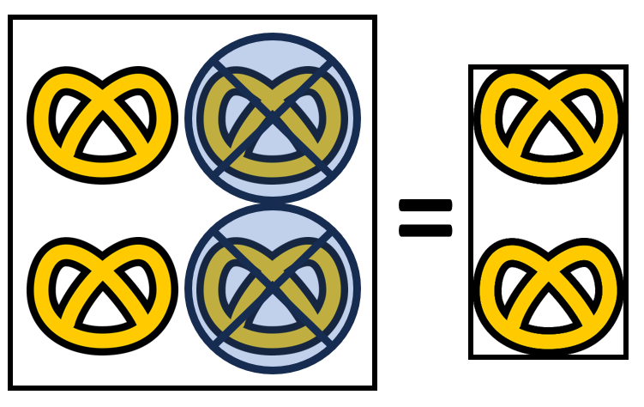

* Mindy had 5 pretzels. Mindy ate one. How many pretzels does she have left?

5 – 1 = 4

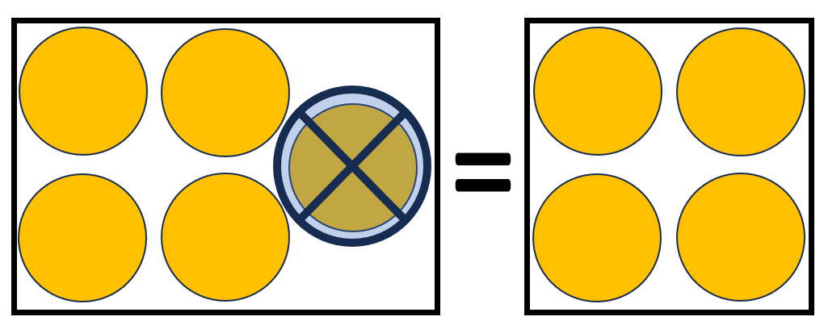

## Differentiation:

**Part One and Two**

* Some students may be able to use the number and symbol cards and other may be able to write the number sentence without the cards.
* Use technology to make word problem task cards interactive. (Click and drag)
* Use smaller (0-10) or larger numbers (0-20) to match the ability level of your students.
* Enlarge number and symbol cards for students with visual impairments.
* Use other manipulatives to represent items in contextual word problems (e.g., counters for cookies).
* Mix addition and subtraction word problems for capable students. Ask questions such as, which operation would be used? Why would you use that operation? Is there more than one way to answer this problem?
* Have students create their own word problems.
* Have students bring in 20 or less small items from home to be able to relate and connect to each student’s real life (toys, food, etc.).

## Reflection:

**Part One**

* Present this problem and give students time to use manipulatives, draw simple pictures, or use the traditional algorithm.

*There were two boxes of cupcakes on the table. One box had 3 cupcakes and the other had 2 cupcakes. Gillian and Brook added the cupcakes to find out how many total cupcakes were in the two boxes together. Gillian said there were 6 cupcakes and Brook said there were 5 cupcakes.*

Who was correct? How do you know/why were they correct?

**Part Two**

* Present this problem and give students time to use manipulatives, draw simple pictures, or use the traditional algorithm.

*Two dogs, Tucker and Piper, were playing in the backyard. Tucker had 7 bones and Piper stole ____ of her bones. Tucker was sad because she only had ____ bones left.*

Finish the story by telling how many bones you think Piper stole and how many Tucker would have left. Be able to explain your answers.

## Formative Assessment:

## Part One

In addition to monitoring student responses to teacher questions and work during class time, use the following questions for formative assessment.

1. John has three lollipops. Brenda also has three lollipops. How many lollipops do John and Brenda have in total?
2. Julia has two cartons of milk. Mr. Jones gave her one more carton of milk. How many total cartons of milks does Julia have?
3. Mary has three blocks. She gets 4 more blocks. How many blocks does Mary have altogether?

**Part Two**

In addition to monitoring student responses to teacher questions and work during class time, use the following questions for formative assessment.

1. John has five lollipops. He gave Thomas 2 of these lollipops. How many lollipops does John have left?
2. Mary came to school with nine sticks of gum. At lunch she gave two sticks away to her friends. How many sticks of gum does Mary have left?
3. Jami and I have 7 cookies altogether. If Jami has 4 cookies, how many cookies do I have?

## Integrated Reading Activity:

**Part One**

Use the question examples below to model for students good reading strategies (sound out words, use other words in the sentence to figure out the meaning of the word, pausing while reading to think about what you read, underline important information etc.).

Mom put three cookies on my plate. Dad put one cookie on my plate. Now I have ____cookies altogether. *(The student will use manipulatives or draw the number sentence, then write the number sentence: 3 + 1 = 4.)*

**Comprehension Questions**

* What did mom and dad do?
* Where did mom put the cookies?
* Who put three cookies on the plate?

Mrs. Smith has three sharpened pencils on her desk. She sharpens five more pencils and places them on her desk. Now Mrs. Smith has __________ sharpened pencils altogether*. (The student will use manipulatives or draw the number sentence then write the number sentence 3 + 5 = 8.)*

**Comprehension Questions**

* Who sharpens five pencils?
* Where were all the pencils placed?
* How many pencils did Mrs. Smith have at the beginning?

**Part Two**

Use the question examples below to model for students good reading strategies (sound out words, use other words in the sentence to figure out the meaning of the word, pausing while reading to think about what you read, underline important information etc.).

Mom put three cookies on my plate. Dad ate one cookie from my plate. Now I have ____cookies. *(The student will use manipulatives or draw the number sentence then write the number sentence: 3 - 1 = 2.)*

**Comprehension Questions**

* What did dad eat?
* Where were the cookies?

My teacher has three pencils on her desk. She gave Sue two pencils. My teacher has ____ pencils on her desk now*. (The student will use manipulatives or draw the number sentence then write the number sentence 3 - 2 = 1.)*

**Comprehension Questions**

* Where does the teacher have her pencils?
* To whom did the teacher give the pencils?

## Notes:

**Extensions and Connections (for all students)**

Connections can be made by using familiar items from the home environment. Using images of known items will help students create word problems independently to deepen their understanding.

Students can draw circles, shapes, animals or use images to make their number sentences. Then create an addition and subtraction word problem using the vocabulary.  (2 red apples plus sign 1 red apple equal sign 3 red apples)

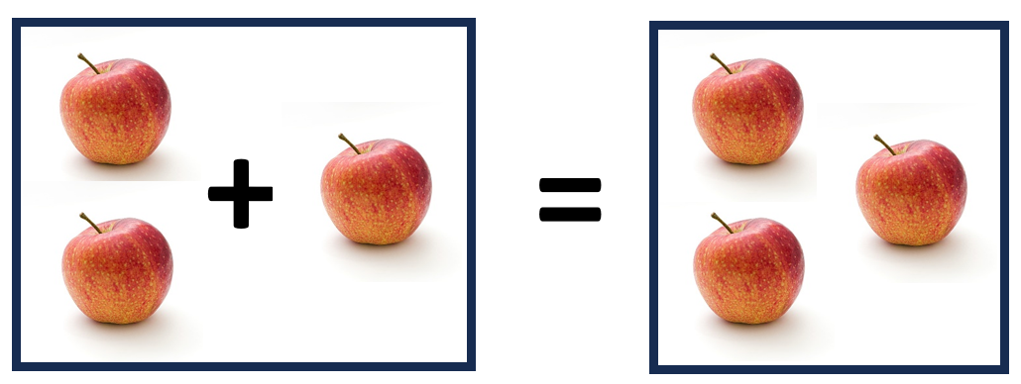

* I had two apples, then Ben gave me one apple. Now I have three apples.

    2 + 1 = 3

* Students can make connections between addition and subtraction. (3 red apples minus sign 1 red apple equal sign 2 red apples)

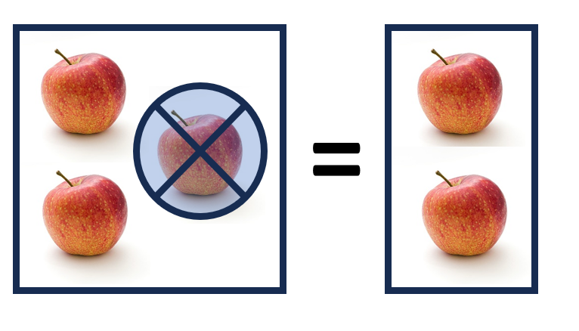

* We had three apples. I ate one. Now we have two apples.

3 – 1 = 2

## Word Wall Cards:

Number

Two gingerbread cookies. The number 2 and the word numeral with an arrow pointing to the number.

Number

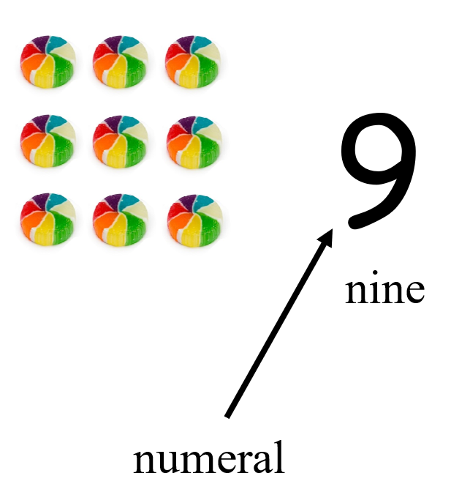

Number

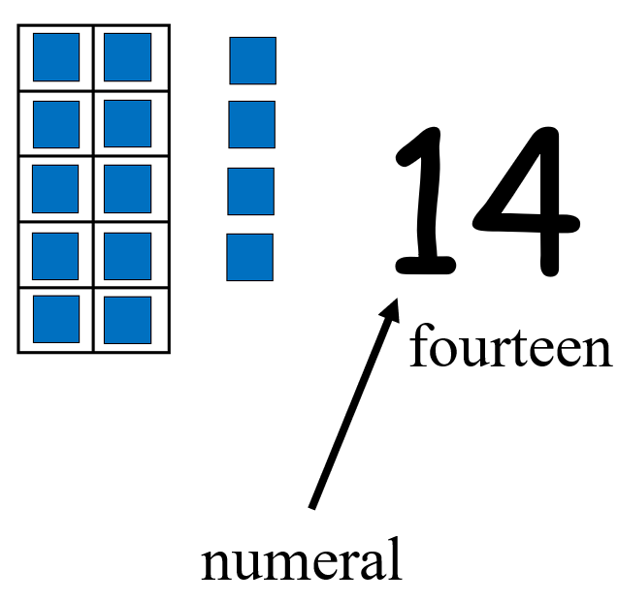

Counting by Ones

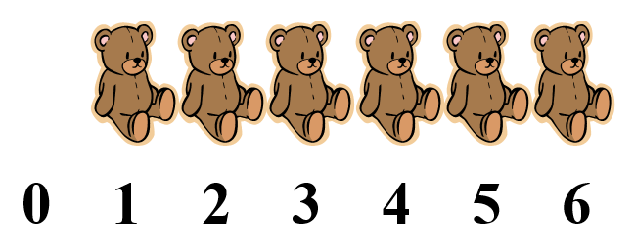

Number Path

ten connected squares in a row with the numbers 1 through 10 on them.

Addition

(add)

3 dogs and 1 dog is

4 dogs

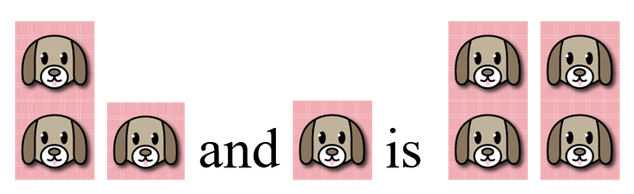

Addition

9 + 3 = 12

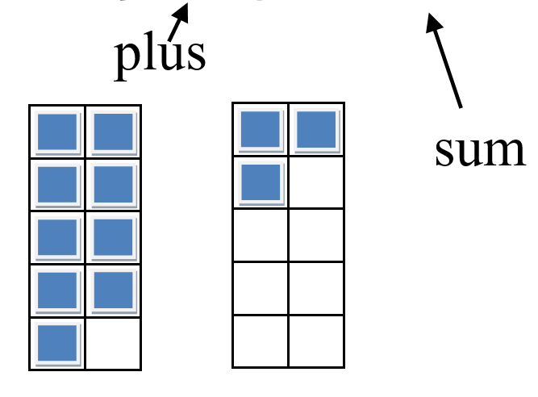

Join



How many girls and boys are there?

Subtraction

(subtract)

6 cupcakes take away 2 cupcakes is 4 cupcakes

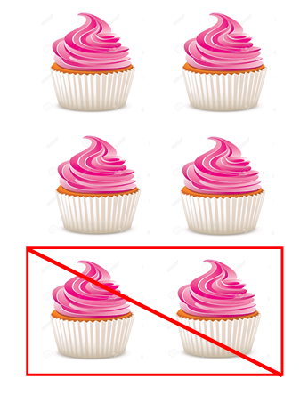

Subtraction

(subtract)

8 – 2 = 6

minus difference

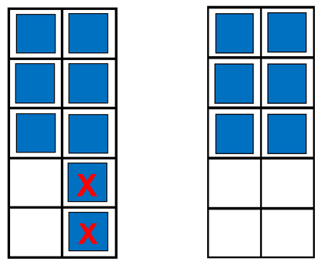

Separate

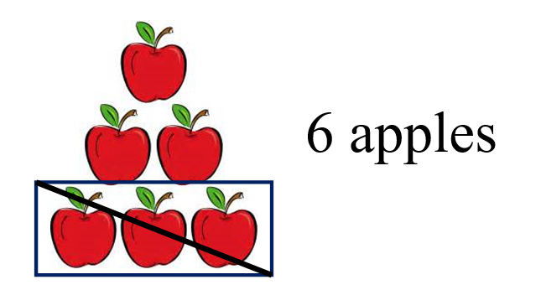

3 apples were eaten

How many apples are there now?

Equal

has the same value

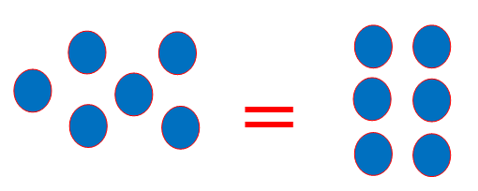

6 = 6

1 + 5 = 2 + 4

6 = 3 + 3

## Supplemental Materials:

* Teachers can use the Grade 2 Common Addition and Subtraction Problem Types from the Understanding the Standard section in the curriculum framework to create additional word problems.

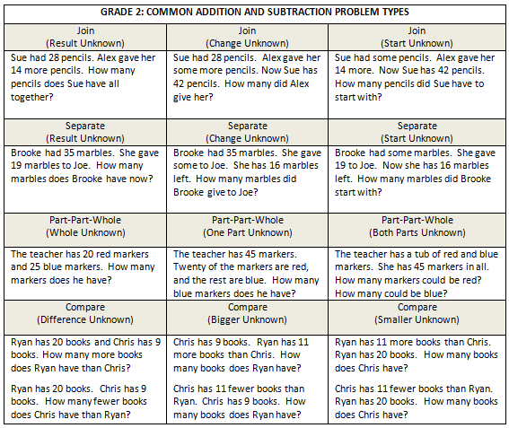

Example Addition and Subtraction Word Problem Task Cards:   
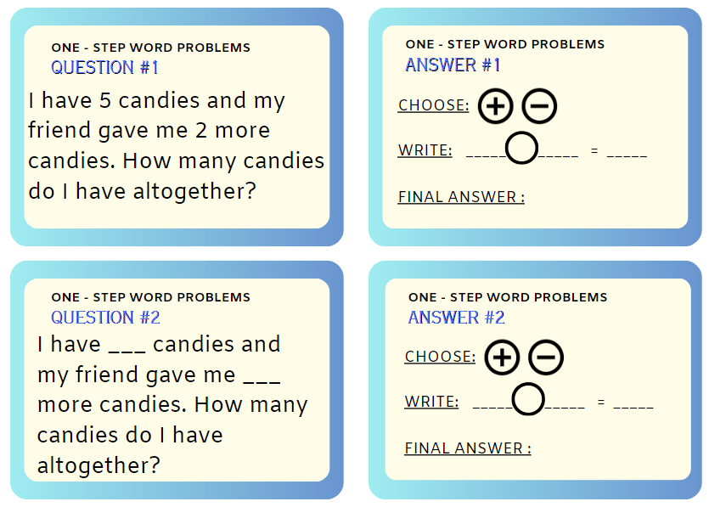

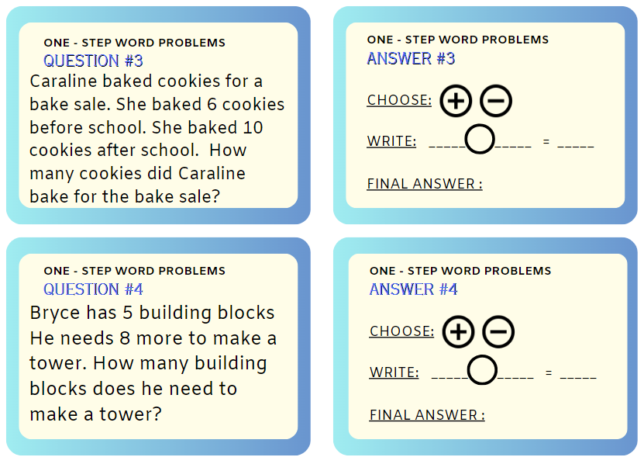

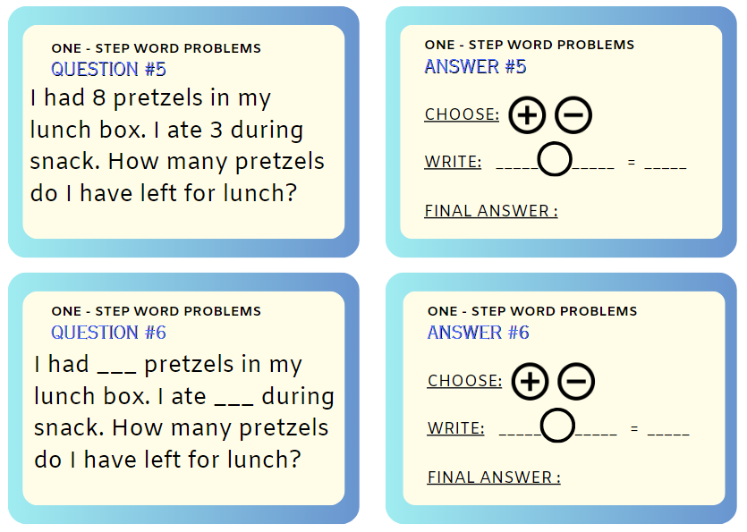

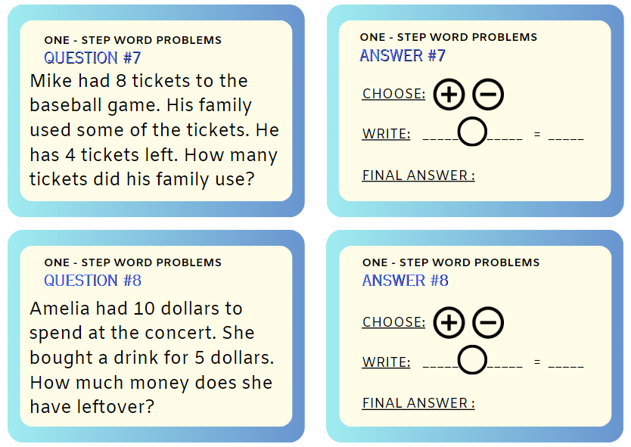

Number and Symbol Cards: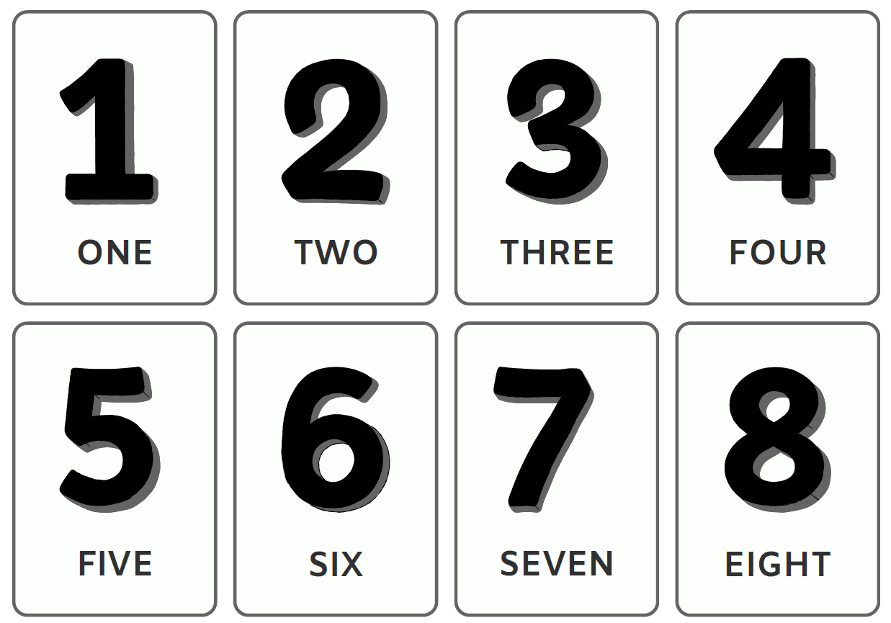

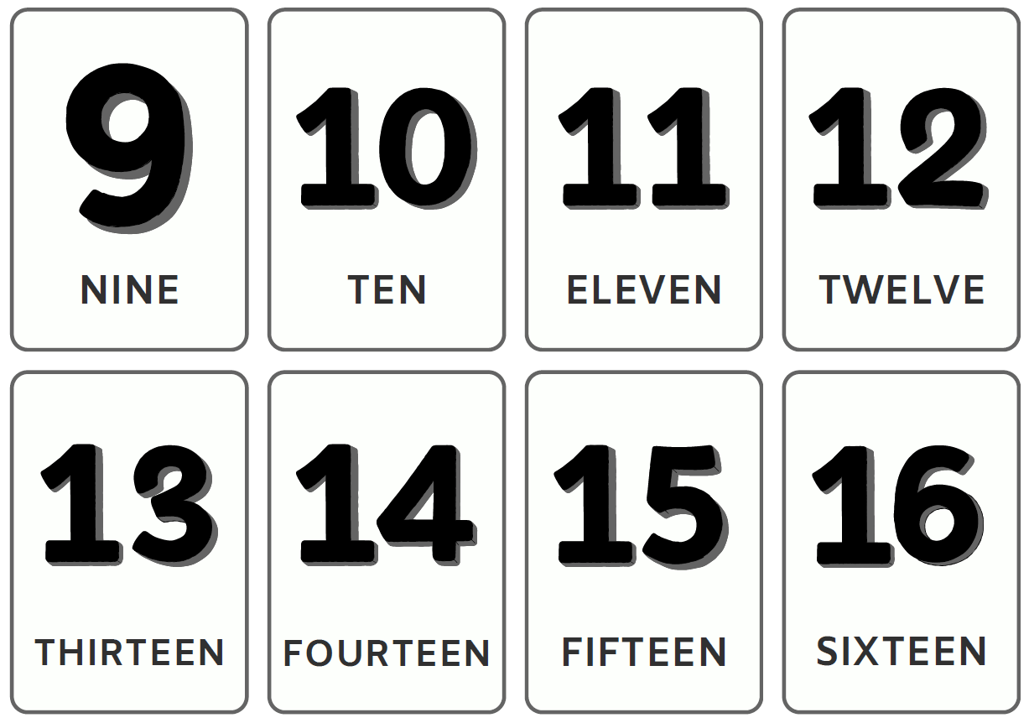

Student number and symbol cards 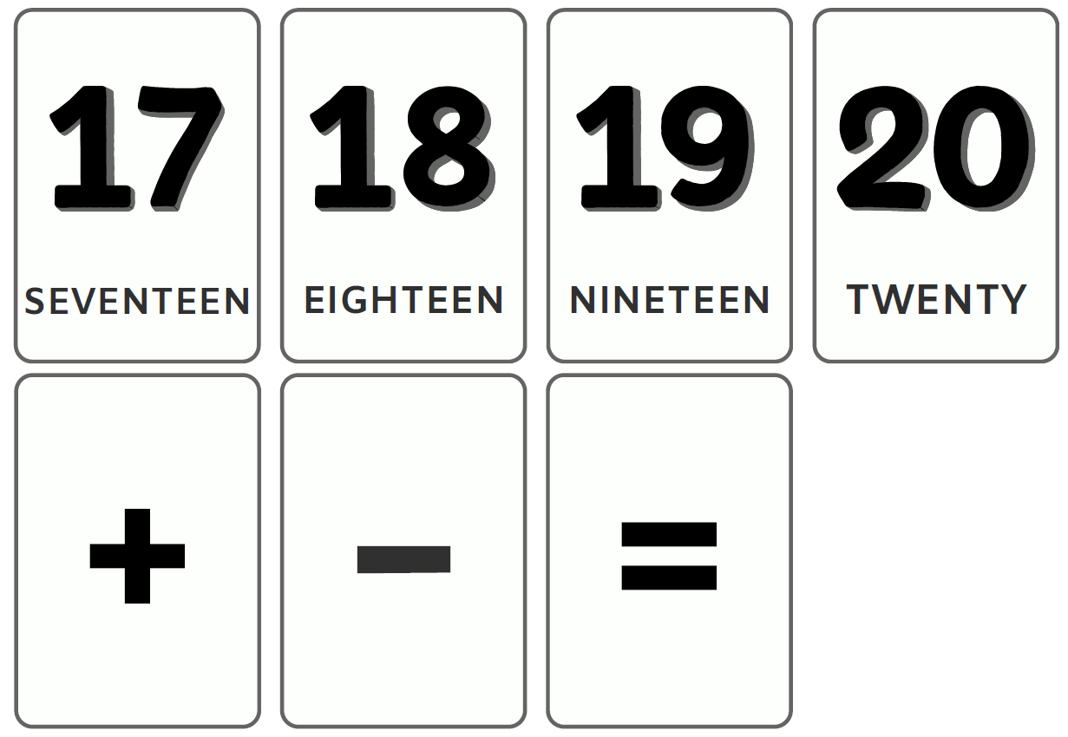

Math Mats:

## 

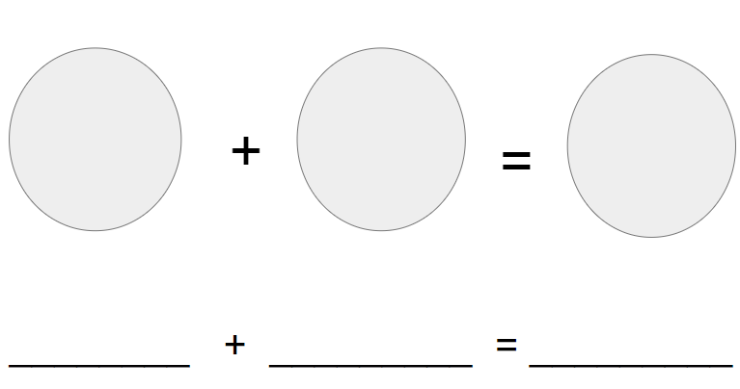

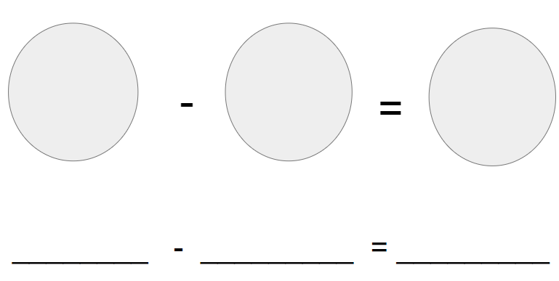

## Practice Items:

an image of five pencils
5 minus 1 equals blank
Sam has 5 pencils, but gives one to Hannah. How many pencils does Sam have left?
A, 1, B, 4, C, 5