2023 Mathematics Standards of Learning
Understanding the Standards – Grade 5
The Understanding the Standards document includes the mathematics understandings and key concepts that assist teachers in planning standards-focused instruction of the fifth grade 2023 Mathematics Standards of Learning. The Understanding the Standards includes definitions, explanations, and examples regarding each mathematics standard and describes what students should know (core knowledge) as a result of the instruction specific to the course/grade level.

Number and Number Sense
5.NS.1 The student will use reasoning and justification to identify and represent equivalency between fractions (with denominators that are thirds, eighths, and factors of 100) and decimals; and compare and order sets of fractions (proper, improper, and/or mixed numbers having denominators of 12 or less) and decimals (through thousandths).
Students will demonstrate the following Knowledge and Skills:
- Use concrete and pictorial models to represent fractions with denominators that are thirds, eighths, and factors of 100 in their equivalent decimal form.*
- Use concrete and pictorial models to represent decimals in their equivalent fraction form (thirds, eighths, and factors of 100).*
- Identify equivalent relationships between decimals and fractions with denominators that are thirds, eighths, and factors of 100 in their equivalent decimal form, with and without models.*
- Compare (using symbols <, >, =) and order (least to greatest and greatest to least) a set of no more than four decimals and fractions (proper, improper) and/or mixed numbers using multiple strategies (e.g., benchmarks, place value, number lines). Justify solutions orally, in writing, or with a model.*
* On the state assessment, items measuring this objective are assessed without the use of a calculator.

5.NS.1 The student will use reasoning and justification to identify and represent equivalency between fractions (with denominators that are thirds, eighths, and factors of 100) and decimals; and compare and order sets of fractions (proper, improper, and/or mixed numbers having denominators of 12 or less) and decimals (through thousandths).
Additional Content Background and Instructional Guidance:
- Conceptual understanding of decimal and fraction equivalencies should be built using manipulatives and models (e.g., fraction bars, base 10 blocks, 10-by-10 grids, decimal squares, number lines, and hundredths discs). These models can also be valuable tools when students are comparing and ordering decimals and/or fractions.
- The focus should be on determining equivalent decimals of fractions with denominators that are factors of 100, allowing students to make connections to tenths and hundredths (e.g., $\frac{2}{5}$ = $\frac{4}{10}=$ 0.4 and $\frac{7}{20}$ = $\frac{35}{100}$ = 0.35).
- There are repeating decimals and terminating decimals.
- Fractions such as $\frac{1}{3}$, whose decimal representation does not end (e. g., $\frac{1}{3}$ = 0.333…) are referred to as repeating decimals. A repeating decimal can be written with an ellipsis (three dots) as in 0.333… or denoted with a bar above the digits that repeat as in 0.$\overline{3}$.
- Decimals that have a finite number of digits (e.g., 0.25, 0.4) are referred to as terminating decimals.
- Proper fractions, improper fractions, and mixed numbers are terms often used to describe fractions. A proper fraction is a fraction whose numerator is less than the denominator. An improper fraction is a fraction whose numerator is equal to or greater than the denominator. An improper fraction may be expressed as a mixed number. A mixed number is written with two parts: a whole number and a proper fraction (e.g., 3$\frac{5}{8}$).
- Strategies used for comparing and ordering fractions (proper and improper) and mixed numbers may include:
  - more than 1 whole;
  - less than 1 whole;
  - comparing fractions to familiar benchmarks (e.g., 0, $\frac{1}{2}$, 1);
  - distance from or to 0, $\frac{1}{2}$, 1;
  - determining equivalent fractions;
  - using like denominators; or
  - using like numerators.

5.NS.2 The student will demonstrate an understanding of prime and composite numbers, and determine the prime factorization of a whole number up to 100.
Students will demonstrate the following Knowledge and Skills:
- Given a whole number up to 100, create a concrete or pictorial representation to demonstrate whether the number is prime or composite, and justify reasoning.
- Classify, compare, and contrast whole numbers up to 100 using the characteristics prime and composite.
- Determine the prime factorization for a whole number up to 100.

5.NS.2 The student will demonstrate an understanding of prime and composite numbers, and determine the prime factorization of a whole number up to 100.
Additional Content Background and Instructional Guidance:
- Natural numbers are the counting numbers starting at one.
- A prime number is a natural number, other than one, that has exactly two different factors, one and the number itself.
- A composite number is a natural number that has factors other than one and itself.
- The number one is neither prime nor composite because it has only one set of factors and both factors are one.
- Multiplication can be represented using a dot (⋅) or symbol (×) (e.g., 56 ⋅ 32 or 56 × 32).
- The prime factorization of a number is a representation of the number as the product of its prime factors. For example, the prime factorization of 18 is 2 ⋅ 3 ⋅ 3. Prime factorization concepts can be developed by using factor trees. Students at this level are not expected to represent prime factorization using exponents.
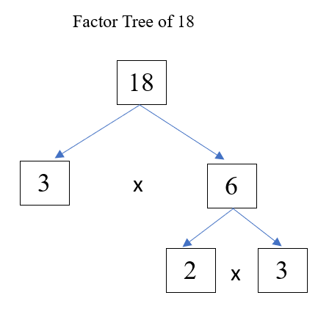
- Prime or composite numbers can be represented by rectangular models or rectangular arrays on grid paper.
- A prime number can be represented by only one rectangular array (e.g., seven can be represented by a 7 ⋅ 1 and a 1 × 7 array).
- A composite number can always be represented by two or more rectangular arrays of different size (e.g., nine can be represented by a 9 ⋅ 1 or a 3 ⋅ 3 array; six can be represented by a 6 ⋅ 1 or a 2 ⋅ 3 array).
- To prove a number is prime or composite, use the characteristics of prime and composite numbers.
  - For a number greater than 2, if the number is even, it is a composite number.
  - If the number has a factor other than 1 and itself, it is a composite number.

Computation and Estimation
5.CE.1 The student will estimate, represent, solve, and justify solutions to single-step and multistep contextual problems using addition, subtraction, multiplication, and division with whole numbers.
Students will demonstrate the following Knowledge and Skills:
- Estimate the sum, difference, product, and quotient of whole numbers in contextual problems.
- Represent, solve, and justify solutions to single-step and multistep contextual problems by applying strategies (e.g., estimation, properties of addition and multiplication) and algorithms, including the standard algorithm, involving addition, subtraction, multiplication, and division of whole numbers, with and without remainders, in which:
  - sums, differences, and products do not exceed five digits;
  - factors do not exceed two digits by three digits;
  - divisors do not exceed two digits; or
  - dividends do not exceed four digits.
- Interpret the quotient and remainder when solving a contextual problem.

5.CE.1 The student will estimate, represent, solve, and justify solutions to single-step and multistep contextual problems using addition, subtraction, multiplication, and division with whole numbers.
Additional Content Background and Instructional Guidance:
- In problem solving, emphasis should be placed on thinking and reasoning rather than on key words. Focusing on key words such as in all, altogether, difference, etc., encourages a particular operation rather than make sense of the context of the problem. A keyword focus leads to solving a limited set of problems and often leads to incorrect solutions as well as challenges in upcoming grades and courses.
- The problem-solving process is enhanced by modeling contextual problems using acting out, charts, number lines, manipulatives, drawings, and bar diagrams.
- Bar diagrams serve as a model that can provide ways to visualize, represent, and understand the relationship between known and unknown quantities and can be used to solve problems. Four examples of bar diagrams are shown below:
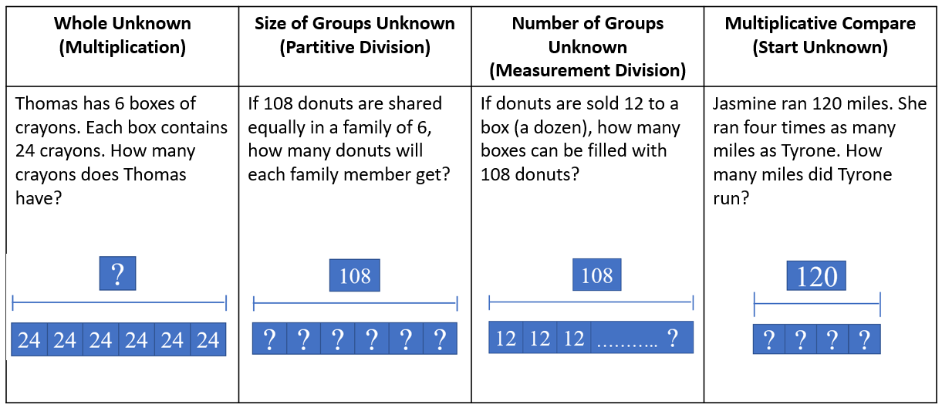
- Estimation skills are valuable, time-saving tools particularly in practical situations when exact answers are not required, and can be used in determining the reasonableness of the sum or difference when solving for the exact answer.
- An estimate is a number that lies within a range of the exact solution, and the estimation strategy used in a particular problem determines how close the estimate is to the exact solution. Estimates involve using friendlier numbers to mentally compute a reasonable answer before any exact computation is calculated.
- Students should explore reasons for estimation, using practical experiences, and using various estimation strategies to solve contextual problems. Estimation strategies include rounding, using compatible numbers, and front-end estimation.
- When estimating, students should consider whether it is important that the estimate is greater than or less than the exact answer. In the following examples using the same addends, each estimation strategy results in a different sum, so opportunities should be given to examine the context and the demand for precision in deciding which estimation strategy to use.
  - Rounding numbers is one estimation strategy and may be introduced through the use of a number line. When given a number to round, use multiples of ten, hundred, thousand, ten thousand, or hundred thousand as benchmarks and use the nearest benchmark value to represent the number. For example, using rounding to the nearest hundred to estimate the sum of 255 + 481 would result in 300 + 500 = 800.
  - Using compatible numbers is another estimation strategy. Compatible numbers are pairs of numbers that are easy to add and subtract mentally. For example, using compatible numbers to estimate the sum of 255 + 481 could result in 250 + 450 = 700.
  - Using front-end estimation is another estimation strategy. Front-end estimation involves truncating numbers to the highest place value to compute. For example, using front-end estimation to estimate the sum of 255 + 481 would result in 200 + 400 = 600.
- When an exact answer is required, opportunities to explore whether the answer can be determined mentally or must involve paper and pencil, or calculators help students select the most efficient approach.
- Give opportunities to explore and apply the properties of addition and multiplication as strategies for solving addition, subtraction, multiplication, and division problems using a variety of representations (e.g., manipulatives, diagrams, symbols).
- The properties of the operations are “rules” about how numbers work and how they relate to one another. Formal terms for these properties are not expected at this grade level, but utilization of these properties develops further flexibility and fluency in solving problems. The following properties are most appropriate for exploration at this level:
  - The commutative property of addition states that changing the order of the addends does not affect the sum (e.g., 4 + 3 = 3 + 4). Similarly, the commutative property of multiplication states that changing the order of the factors does not affect the product (e.g., 2 ⋅ 3 = 3 ⋅ 2).
  - The identity property of addition states that if zero is added to a given number, the sum is the same as the given number (e.g., 4 + 0 = 4). The identity property of multiplication states that if a given number is multiplied by one, the product is the same as the given number (e.g., 7 × 1 = 7).
  - The associative property of addition states that the sum stays the same when the grouping of addends is changed (e.g., 15 + (35 + 16) = (15 + 35) + 16).
  - The distributive property states that multiplying a sum by a number gives the same result as multiplying each addend by the number and then adding the products. Several examples of the distributive property are shown below:
  - 3(9) = 3(5 + 4) = (3 × 5) + (3 × 4) = 15 + 12 = 27
  - 3(54 + 4) = (3 × 54) + (3 × 4) = 162 + 12 = 174
  - 5 × (3 + 7) = (5 × 3) + (5 × 7) = 15 + 35 = 50
  - (2 × 3) + (2 × 5) = 2 × (3 + 5) = 2 × 8 = 16
9 × 23 = 9(20 + 3) = 180 + 27 = 207
- The distributive property can be used to illustrate the multiplication algorithm, as shown in the two examples below.
8 × 34 = 8 (30 + 4)
= (8 × 30) + (8 × 4)
= 240 + 32
= 272
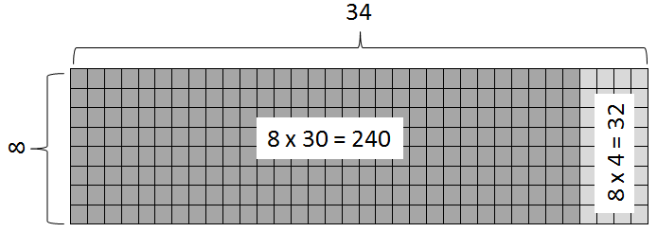

12 × 23 = (10 + 2) × (20 + 3)
= 10 (20 + 3) + 2 (20 + 3)
= (10 × 20 + 10 × 3) + (2 × 20 + 2 × 3)
= 200 + 30 + 40 + 6
= 276
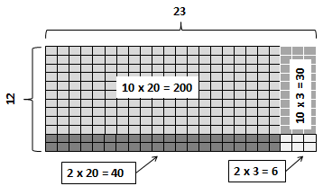
- Dividing by zero is undefined because it always leads to a contradiction. As demonstrated below, there is no single defined number possibility for dividing by 0, since zero multiplied by any number is zero:
12 ÷ 0 = r → r · 0 = 12
- Extensive research has been undertaken over the last several decades regarding different problem types. Many of these studies have been published in professional mathematics education publications using different labels and terminology to describe the varied problem types.
- Opportunities to experience a variety of problem types related to multiplication and division should be given. Some examples are included in the following chart:
Grade 5: Common Multiplication and Division Problem Types
Equal Group Problems
Whole Unknown  (Multiplication) | Size of Groups Unknown  (Partitive Division) |  | Number of Groups Unknown  (Measurement Division)
There are 25 boxes of crayons. Each box contains 96 crayons. How many crayons are there in all? | If 2,400 crayons are divided equally among 25 tubs, how many crayons will go into each tub? |  | If 2,400 crayons are placed into tubs with each tub containing 96 crayons, how many tubs can be filled?
Multiplicative Comparison Problems
Result Unknown | Start Unknown |  | Comparison Factor Unknown
Tyrone traveled 125 miles last month. Jasmine traveled 15 times as many miles as Tyrone did during the same month. How many miles did Jasmine travel? | Jasmine traveled 1,956 miles last summer. She traveled 12 times as many miles as Tyrone during the same summer. How many miles did Tyrone travel? |  | Jasmine traveled 1,275 miles in December. Tyrone traveled 85 miles in December. Jasmine traveled how many times more miles than Tyrone?
Array or Area Problems
Whole Unknown |  | One Dimension Unknown
There are 28 sections of parking at the stadium. There are 115 cars parked in each section of the parking lot at the stadium. How many cars are parked at the stadium all together?  Mr. Myers’s barn measures 35 feet by 110 feet. How many square feet are in the barn? |  | There are 3,220 cars parked at the stadium. The cars are divided evenly among each of the 28 sections of parking lot. How many cars are parked in each section?  There are 3,220 cars parked at the stadium. There are exactly 115 cars parked in each section. How many sections are filled with cars?  Mr. Myers’ rectangular barn covers 3,850 square feet. The width of the barn is 35 feet. What is the length of the barn?
Combination Problems
Outcomes Unknown |  | Factors Unknown
An experiment involves tossing a coin and rolling a die. How many different outcomes are possible?  Kelly has 2 pairs of pants and 3 shirts that can all be worn together. How many different outfits consisting of a pair of pants and a shirt does she have? |  | Mike bought some new shorts and shirts that can all be worn together. He has a total of 12 different outfits. If he bought 3 pairs of shorts, how many shirts did he buy?
- Students need exposure to various types of contextual division problems in which they must interpret the quotient and remainder based on the context. The chart below includes an example of each type of problem.
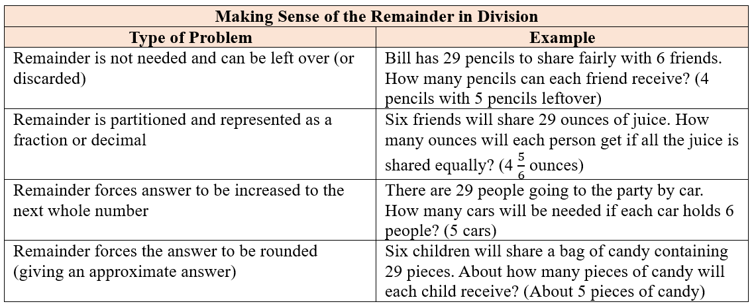

5.CE.2 The student will estimate, represent, solve, and justify solutions to single-step and multistep problems, including those in context, using addition and subtraction of fractions with like and unlike denominators (with and without models), and solve single-step contextual problems involving multiplication of a whole number and a proper fraction, with models.
Students will demonstrate the following Knowledge and Skills:
- Determine the least common multiple of two numbers to find the least common denominator for two fractions.
- Estimate and determine the sum or difference of two fractions (proper or improper) and/or mixed numbers, having like and unlike denominators limited to 2, 3, 4, 5, 6, 8, 10, and 12 (e.g., $\frac{5}{8}$ + $\frac{1}{4}$ , $\frac{4}{5}$ − $\frac{2}{3}$ , 3$\frac{3}{4}$ + 2$\frac{5}{12}$), and simplify the resulting fraction.*
- Estimate and solve single-step and multistep contextual problems involving addition and subtraction with fractions (proper or improper) and/or mixed numbers having like and unlike denominators, with and without models. Denominators should be limited to 2, 3, 4, 5, 6, 8, 10, and 12. Answers should be expressed in simplest form.
- Solve single-step contextual problems involving multiplication of a whole number, limited to 12 or less, and a proper fraction (e.g., 9 × $\frac{2}{3}$, 8 × $\frac{3}{4}$), with models. The denominator will be a factor of the whole number and answers should be expressed in simplest form.*
* On the state assessment, items measuring this objective are assessed without the use of a calculator.

5.CE.2 The student will estimate, represent, solve, and justify solutions to single-step and multistep problems, including those in context, using addition and subtraction of fractions with like and unlike denominators (with and without models), and solve single-step contextual problems involving multiplication of a whole number and a proper fraction, with models.
Additional Content Background and Instructional Guidance:
- Students should have exposure to a variety of representations of fractions, both concrete and pictorial (e.g., fraction bars, fraction circles, length models, area models, set models).
- Fractions can have five different meanings or interpretations: part-whole, division, measurement, ratio, and operator. In prior grades, students engaged with fractions as a numerical way of representing part of a whole region (area model), part of a group (set model), or part of a length (measurement model). In Grade 6, the ratio and operator interpretations will be introduced.
- When working with fractions, the whole must be defined.
- In a region/area model (e.g., fraction circles, pattern blocks, geoboards, grid paper, color tiles), the whole is divided or partitioned into parts with area of equivalent value. The fractional parts may or may not be congruent and could have a different shape as shown in the middle example below:
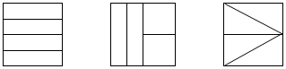
- In a set model (e.g., chips, counters, cubes), each member of the set is an equivalent part of the set. In set models, the whole needs to be defined, but members of the set may have different sizes and shapes. For instance, if a whole is defined as a set of 10 shapes, the shapes within the set may be different. In the example below, students should identify hearts as representing $\frac{5}{10}$ (or one-half) of the shapes in the set.
- In a length/measurement model (e.g., fraction strips, rods, number lines, rulers), each length represents an equal part of the whole. For example, given a strip of paper, students could fold the narrow strip into four equal parts, with each part representing one-fourth. Students will notice that there are four one-fourths in the entire length of the strip of paper. A concrete model connects to a representation of a number line to make sense of the spaces that show the value of the fraction.
- On the number line below, the red dot is located on the fraction for the number of hearts shown in the set above.
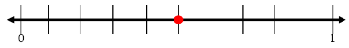
- A ruler is an important representation of the length model of fractions. When using rulers to measure length, opportunities should be provided to students to identify the points of the ruler that represent the lengths of halves, fourths and eighths and connections should be made to fractions and mixed numbers.
- Estimation skills are valuable, time-saving tools that help students focus on the meaning of the numbers and operations, encourage reflective thinking, and help build informal number sense with fractions. Reasoning with benchmarks provides students with an opportunity to estimate without using an algorithm. Estimation can be used to check the reasonableness of an answer.
- Proper fractions, improper fractions, and mixed numbers are terms often used to describe fractions. A proper fraction is a fraction whose numerator is less than the denominator. An improper fraction is a fraction that is greater than or equal to one whole (i.e., whose numerator is greater than or equal to the denominator (e.g., $\frac{7}{4}$)). An improper fraction may also be expressed as a mixed number. A mixed number is written with two parts: a whole number and a proper fraction (e.g., 3$\frac{5}{8}$). The value of a mixed number is the sum of its two parts.
- A unit fraction is a fraction in which the numerator is one (e.g., $\frac{1}{4}$).
- Fractions having like denominators have the same meaning as fractions having common denominators. To add and subtract fractions and mixed numbers, it often helps to find the least common denominator. The least common denominator (LCD) of two or more fractions is the least common multiple (LCM) of the denominators.
- The least common multiple of two or more numbers is the lowest number that is a multiple of all the given numbers. For example, the least common multiple of 3 and 4 is 12.
Multiples of 3: 3, 6, 9, 12, 15, 18…
Multiples of 4: 4, 8, 12, 16, 20, 24…
- To add or subtract with fractions that do not have the same denominator, first find equivalent fractions with the least common denominator. Then add or subtract and write the answer in simplest form.
- A fraction can be expressed in simplest form (simplest equivalent fraction). One way to simplify a fraction is by modeling an equivalent fraction. Another way is to divide the numerator and denominator by their greatest common factor. This is the same as dividing by one whole.
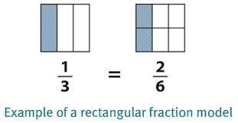
- When the numerator and denominator have no common factors other than one, then the fraction is in simplest form.

5.CE.3 The student will estimate, represent, solve, and justify solutions to single-step and multistep problems, including those in context, using addition, subtraction, multiplication, and division with decimal numbers.
Students will demonstrate the following Knowledge and Skills:
- Apply estimation strategies (e.g., rounding to the nearest whole number, tenth or hundredth; compatible numbers, place value) to determine a reasonable solution for single-step and multistep contextual problems involving addition, subtraction, and multiplication of decimals, and single-step contextual problems involving division of decimals.
- Estimate and determine the product of two numbers using strategies and algorithms, including the standard algorithm, when given:
  - a two-digit factor and a one-digit factor (e.g., 2.3 × 4; 0.08 × 0.9; .16 × 5);*
  - a three-digit factor and a one-digit factor (e.g., 0.156 × 4, 3.28 × 7, 8.09 × 0.2);* and
  - a two-digit factor and a two-digit factor (e.g., 0.85 × 3.7, 14 × 1.6, 9.2 × 3.5).*
(Products will not exceed the thousandths place, and leading zeroes will not be considered when counting digits.)
- Estimate and determine the quotient of two numbers using strategies and algorithms, including the standard algorithm, in which:*
  - quotients do not exceed four digits with or without a decimal point;
  - quotients may include whole numbers, tenths, hundredths, or thousandths;
  - divisors are limited to a single digit whole number or a decimal expressed as tenths; and
  - no more than one additional zero will need to be annexed.
- Solve single-step and multistep contextual problems involving addition, subtraction, and multiplication of decimals by applying strategies (e.g., estimation, modeling) and algorithms, including the standard algorithm.
- Solve single-step contextual problems involving division with decimals by applying strategies (e.g., estimation, modeling) and algorithms, including the standard algorithm.
* On the state assessment, items measuring this objective are assessed without the use of a calculator.

5.CE.3 The student will estimate, represent, solve, and justify solutions to single-step and multistep problems, including those in context, using addition, subtraction, multiplication, and division with decimal numbers.
Additional Content Background and Instructional Guidance:
- In Grade 4, students had experience with identifying, representing, comparing, and ordering decimals through the thousandths. Students in Grade 4 also solved problems involving addition and subtraction of decimals through the thousandths.
- Addition and subtraction of decimals may be investigated using a variety of models (e.g., 10-by-10 grids, number lines, money). The examples below show a model of decimal addition using base 10 blocks and a number line.
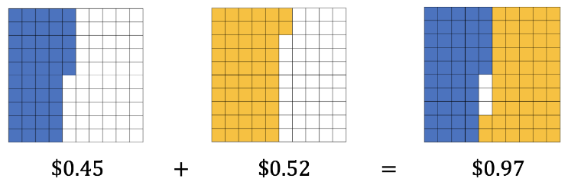
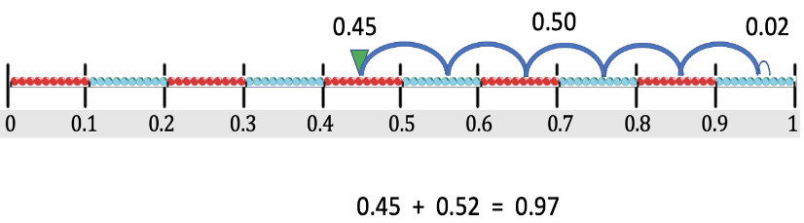
- The base 10 relationships that support the procedures developed for whole number computation apply to decimal computation, providing guidance for careful attention to the placement of the decimal point in the solution.
- Number lines are useful tools when developing a conceptual understanding of rounding with decimal numbers. A number line with benchmark numbers can be useful in rounding to the nearest hundredth, tenth, or whole number by determining which number is closer.
  - 5.824 rounded to the nearest whole number is 6.
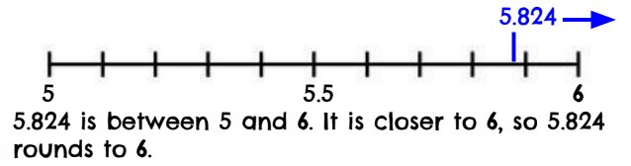

- 5.824 rounded to the nearest tenth is 5.8.
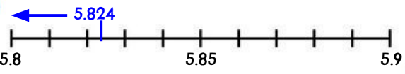
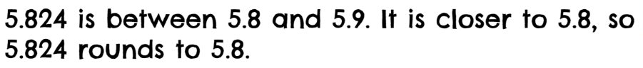
- Meter sticks are an important representation of decimals. When measuring length, students can identify the points of the meter stick that represent millimeters (thousandths), centimeters (hundredths), decimeters (tenths), and meters (whole).
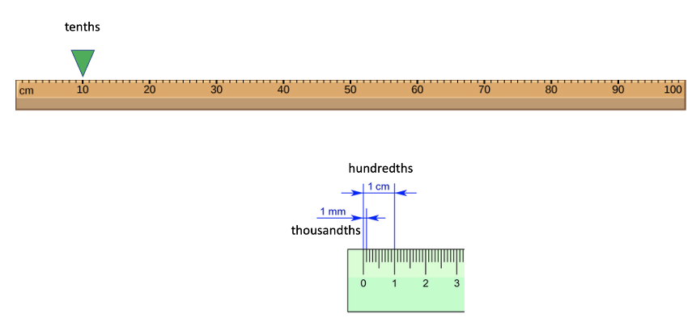
- Estimation skills are valuable, time-saving tools that help students focus on the meaning of the numbers and operations, encourage reflective thinking, and help build informal number sense with decimals. Reasoning with benchmarks provides students with an opportunity to estimate without using an algorithm (e.g., 2.75 + 3.2 is about 3 + 3, so the sum is about 6).
- In cases where an exact product is not required, the product of decimals can be estimated using strategies for multiplying whole numbers, such as front-end and compatible numbers, or rounding (e.g., 1.8 × 5 is about 2 × 5, so the product will be about 10; 0.85 × 2.3 is about 1 × 2, so the product will be about 2). In each case, determination of where to place the decimal point is necessary to ensure that the product is reasonable.
- Estimation can be used to determine a reasonable range for the answer to computation problems and to verify the reasonableness of sums, differences, products, and quotients of decimals (e.g., the quotient of 14.7 $÷$ 2 will fall between 14 $÷2$ and 16 $÷$ 2, thus the quotient will be between 7 and 8).
- The terms associated with multiplication are listed below:
factor 7.6
factor × 2.3
product 17.48
- Multiplication with decimals is performed the same way as multiplication of whole numbers. The only difference is the placement of the decimal point in the product.
- The terms associated with division are listed below:
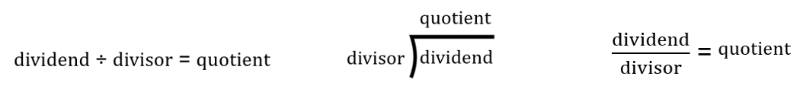
- Division with decimals is performed the same way as division of whole numbers. The only difference is the placement of the decimal point in the quotient.
- Multiplication and division of decimals can be represented with arrays, paper folding, repeated addition, repeated subtraction, base 10 models, and area models.
- The two examples below show models of decimal multiplication using base 10 blocks. In the second example, the purple shaded squares represent the overlap (i.e., the product of 0.4 $×$ 0.6).
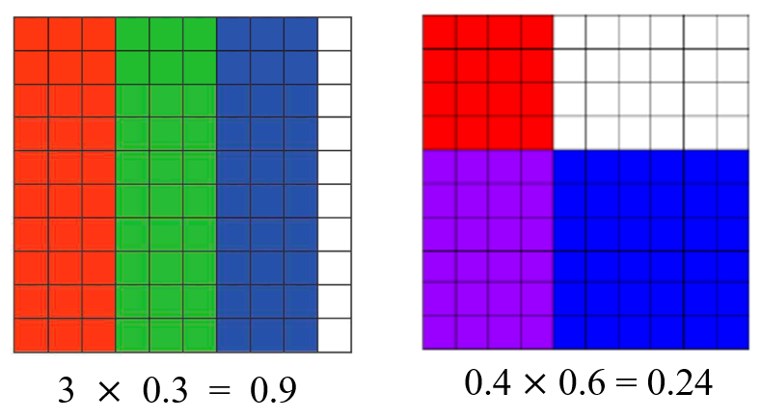

- The fair-share concept of decimal division can be modeled using manipulatives (e.g., base 10 blocks), as demonstrated in the example below.
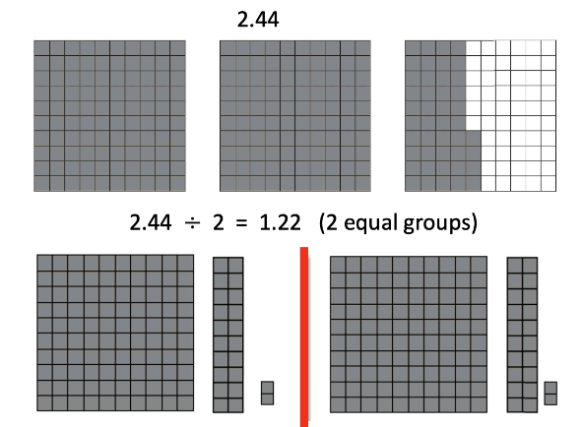
- Examples of appropriate decimal division problems for Grade 5 include, but are not limited to: 2.386 ÷ 2; 0.6 ÷ 2; 1.78 ÷ 5; etc.
- The following scenarios provide examples of contextual decimal division problems that would be appropriate for Grade students to solve:
  - A scientist collected three water samples from local streams. Each sample was the same size, and she collected 1.35 liters of water in all. What was the volume of each water sample?
  - There are exactly 12.5 liters of sports drink available to the tennis team. If each tennis player will be served 2 liters, how many tennis players can be served?
  - The 4-person relay team race is exactly 10.76 miles long. Each person on the team will run the same distance. How many miles will each person run?
- When solving division problems, numbers may need to be expressed as equivalent decimals by annexing zeros. This occurs when a zero must be added in the dividend as a placeholder.

5.CE.4 The student will simplify numerical expressions with whole numbers using the order of operations.
Students will demonstrate the following Knowledge and Skills:
- Use order of operations to simplify numerical expressions with whole numbers, limited to addition, subtraction, multiplication, and division in which:*
  - expressions may contain no more than one set of parentheses;
  - simplification will be limited to five whole numbers and four operations in any combination of addition, subtraction, multiplication, or division;
  - whole numbers will be limited to two digits or less; and
  - expressions should not include braces, brackets, or fraction bars.
- Given a whole number numerical expression involving more than one operation, describe which operation is completed first, which is second, and which is third.*
* On the state assessment, items measuring this objective are assessed without the use of a calculator.

5.CE.4 The student will simplify numerical expressions with whole numbers using the order of operations.
Additional Content Background and Instructional Guidance:
- An equation represents the relationship between two expressions of equal value (e.g., 12 ⋅ 4 = 60 − 12).
- The equal symbol (=) means that the values on either side are equivalent (balanced).
- The not equal symbol (≠) means that the values on either side are not equivalent (not balanced).
- An expression is a representation of a quantity. It is made up of numbers, variables, computational symbols, and grouping symbols. It does not have an equal symbol (e.g., 15 × 12).
- Expressions containing more than one operation can be simplified by using the order of operations.
- The order of operations is a convention that defines the computation order to follow when simplifying an expression that contains more than one operation. It ensures that there is only one correct value.
- The order of operations is as follows:
  - First, complete all operations within grouping symbols. If there are grouping symbols within other grouping symbols, do the innermost operation first. (Note that students in Grade 5 are not expected to simplify expressions having parentheses within other grouping symbols.)
Note: If there are multiple operations within the parentheses, apply the order of operations.
  - Second, evaluate all terms with exponents. (Note that students in Grade 5 are not expected to simplify expressions with exponents.)
  - Third, multiply and/or divide in order from left to right.
  - Fourth, add and/or subtract in order from left to right.
- Investigating arithmetic operations with whole numbers helps students learn about different properties of arithmetic relationships. These relationships remain true regardless of the set of numbers.

Measurement and Geometry
5.MG.1 The student will reason mathematically to solve problems, including those in context, that involve length, mass, and liquid volume using metric units.
Students will demonstrate the following Knowledge and Skills:
- Determine the most appropriate unit of measure to use in a contextual problem that involves metric units:
  - length (millimeters, centimeters, meters, and kilometers);
  - mass (grams and kilograms); and
  - liquid volume (milliliters and liters).
- Estimate and measure to solve contextual problems that involve metric units:
  - length (millimeters, centimeters, and meters);
  - mass (grams and kilograms); and
  - liquid volume (milliliters and liters).
- Given the equivalent metric measure of one unit, in a contextual problem, determine the equivalent measurement within the metric system:
  - length (millimeters, centimeters, meters, and kilometers);
  - mass (grams and kilograms); and
  - liquid volume (milliliters and liters).

5.MG.1 The student will reason mathematically to solve problems, including those in context, that involve length, mass, and liquid volume using metric units.
Additional Content Background and Instructional Guidance:
- Length is the distance between two points along a line. Metric units for measurement of length include millimeters, centimeters, meters, and kilometers. Appropriate measuring devices include centimeter rulers, meter sticks, and tape measures.
- Weight and mass are different. Mass is the amount of matter in an object. Weight is determined by the pull of gravity on the mass of an object. The mass of an object remains the same regardless of its location. The weight of an object changes depending on the gravitational pull at its location. In everyday life, most people are interested in determining an object’s mass, although they use the term weight (e.g., “How much does it weigh?” versus “What is its mass?”).
- Volume is the amount of space that an object or substance occupies and is measured in cubic units. Metric units to measure liquid volume (capacity) include milliliters and liters.
- Experiences measuring familiar objects help establish benchmarks and facilitate the use of the appropriate units of measure to make estimates.
- Students at this level will be given the equivalent measure of one unit when asked to determine equivalencies between units in the metric system. For example, students will be told one kilometer is equivalent to 1,000 meters. Then they will apply that relationship to determine:
  - the number of meters in 3.5 kilometers;
  - the number of kilometers equal to 2,100 meters; or
  - Seth ran 2.78 kilometers on Saturday. How many meters are equivalent to 2.78 kilometers?
5.MG.2 The student will use multiple representations to solve problems, including those in context, involving perimeter, area, and volume.
Students will demonstrate the following Knowledge and Skills:
- Investigate and develop a formula for determining the area of a right triangle.
- Estimate and determine the area of a right triangle, with diagrams, when the base and the height are given in whole number units, in metric or U.S. Customary units, and record the solution with the appropriate unit of measure (e.g., 16 square inches).
- Describe volume as a measure of capacity and give examples of volume as a measurement in contextual situations.
- Investigate and develop a formula for determining the volume of rectangular prisms using concrete objects.
- Solve problems, including those in context, to estimate and determine the volume of a rectangular prism using concrete objects, diagrams, and formulas when the length, width, and height are given in whole number units. Record the solution with the appropriate unit of measure (e.g., 12 cubic inches).
- Identify whether the application of the concept of perimeter, area, or volume is appropriate for a given situation.
- Solve contextual problems that involve perimeter, area, and volume in standard units of measure.

5.MG.2 The student will use multiple representations to solve problems, including those in context, involving perimeter, area, and volume.
Additional Content Background and Instructional Guidance:
- Perimeter is the path or distance around any plane figure. It is a measure of length (e.g., the perimeter of the book cover is 38 inches).
- Area is the surface included within a plane figure. Area is measured by the number of square units needed to cover a surface or plane figure (e.g., the area of the book cover is 90 square inches or 90 in.²).
- Volume of a three-dimensional figure is a measure of capacity and is measured in cubic units (e.g., the volume of the box is 150 cubic inches or 150 in.³).
- Students should have opportunities to label the perimeter, area, and volume with the appropriate units of measure.
- A right triangle has one right angle. The distance from the top of the right triangle to its base is called the height of the triangle. Two congruent right triangles can always be arranged to form a square or a rectangle.
- The diagonal of the rectangle shown below divides the rectangle in half creating two right triangles. The legs of the right triangles are congruent to the side lengths of the rectangle. The representation illustrates that the area of each right triangle is half the area of the rectangle.
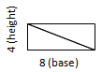
- Students should have opportunities to use manipulatives (e.g., tangrams, attribute blocks, grid paper, geoboards) to discover and use the formulas for the area of a right triangle and the volume of a rectangular prism.
- Exploring the decomposition of shapes helps students discover algorithms for determining area of various shapes (e.g., area of a triangle = $\frac{1}{2}$ × base × height).
- To develop the formula for determining the volume of a rectangular prism (i.e., volume = length × width × height), students should have opportunities to fill rectangular prisms (e.g., shoe boxes, cereal boxes) with cubes by first covering the bottom of the box and then building up the layers to fill the entire box.

5.MG.3 The student will classify and measure angles and triangles, and solve problems, including those in context.
Students will demonstrate the following Knowledge and Skills:
- Classify angles as right, acute, obtuse, or straight and justify reasoning.
- Classify triangles as right, acute, or obtuse and equilateral, scalene, or isosceles and justify reasoning.
- Identify congruent sides and right angles using geometric markings to denote properties of triangles.
- Compare and contrast the properties of triangles.
- Identify the appropriate tools (e.g., protractor, straightedge, angle ruler, available technology) to measure and draw angles.
- Measure right, acute, obtuse, and straight angles, using appropriate tools, and identify measures in degrees.
- Use models to prove that the sum of the interior angles of a triangle is 180 degrees and use the relationship to determine an unknown angle measure in a triangle.
- Solve addition and subtraction contextual problems to determine unknown angle measures on a diagram.

5.MG.3 The student will classify and measure angles and triangles, and solve problems, including those in context.
Additional Content Background and Instructional Guidance:
- Angles can be classified according to their measures as right, acute, obtuse, or straight. Angles are measured in degrees. A degree is $\frac{1}{360}$ of a complete rotation of a full circle. There are 360 degrees in a circle.
- An acute angle measures greater than zero degrees but less than 90 degrees.
- A right angle measures exactly 90 degrees.
- An obtuse angle measures greater than 90 degrees but less than 180 degrees.
- A straight angle measures exactly 180 degrees.
- Protractors, straight edges, or angle rulers are tools that could be used to measure the number of degrees in an angle. Students should have experiences using protractors or angle rulers, as well as available technology, to draw and measure angles.
- Right angles can be used as an important benchmark. Before measuring an angle, first compare the angle to a right angle to determine whether the measure of the angle is less than or greater than 90 degrees.
- Angle measures are additive. When an angle is decomposed into non-overlapping parts, the angle measure of the whole is the sum of the angle measures of the parts.
- Students should have opportunities to measure the three angles of various triangles to find that the sum of the three angles in a triangle is 180 degrees.
- Given the measures of two angles in a triangle, the third angle measure can be determined through the use of problem solving.
- Triangles can be classified by the measure of their largest angle and by the measure of their sides.
- A triangle can be classified according to the measure of its largest angle:
  - A right triangle has one right angle.
  - An obtuse triangle has one obtuse angle.
  - An acute triangle has three acute angles.
- A triangle can be classified according to the length of its sides:
  - An equilateral triangle has three congruent sides. All angles of an equilateral triangle are congruent and measure 60 degrees.
  - An isosceles triangle has at least two congruent sides. An equilateral triangle is a special case of an isosceles triangle (which has at least two congruent sides).
  - A scalene triangle has no congruent sides.
- Congruent sides are denoted with the same number of hatch (or hash) marks on each congruent side, as shown below.

Probability and Statistics
5.PS.1 The student will apply the data cycle (formulate questions; collect or acquire data; organize and represent data; and analyze data and communicate results) with a focus on line plots (dot plots) and stem-and-leaf plots.
Students will demonstrate the following Knowledge and Skills:
- Formulate questions that require the collection or acquisition of data.
- Determine the data needed to answer a formulated question and collect or acquire existing data (limited to 30 or fewer data points) using various methods (e.g., polls, observations, measurements, experiments).
- Organize and represent a data set using a line plot (dot plot) with a title, labeled axes, and a key, with and without the use of technology tools. Line plots (dot plots) may contain whole numbers, fractions, or decimals.
- Organize and represent numerical data using a stem-and-leaf plot with a title and key, where the stems are listed in ascending order and the leaves are in ascending order, with or without commas between the leaves.
- Analyze data represented in line plots (dot plots) and stem-and-leaf plots and communicate results orally and in writing:
  - describe the characteristics of the data represented in a line plot (dot plot) and stem-and-leaf plot as a whole (e.g., the shape and spread of the data);
  - make inferences about data represented in line plots (dot plots) and stem-and-leaf plots (e.g., based on a line plot (dot plot) of the number of books students in a bus line have in their backpack, every student will have from two to four books in their backpack);
  - identify parts of the data that have special characteristics and explain the meaning of the greatest, the least, or the same (e.g., the stem-and-leaf plot shows that the same number of students scored in the 90s as scored in the 70s);
  - draw conclusions about the data and make predictions based on the data to answer questions; and
  - solve single-step and multistep addition and subtraction problems using data from line plots (dot plots) and stem-and-leaf plots.

5.PS.1 The student will apply the data cycle (formulate questions; collect or acquire data; organize and represent data; and analyze data and communicate results) with a focus on line plots (dot plots) and stem-and-leaf plots.
Additional Content Background and Instructional Guidance:
- Students should explore the entire data cycle with a question and set of data that has been collected or acquired. Student reflection should occur throughout the data cycle. The data cycle includes the following steps: formulating questions to be explored with data, collecting or acquiring data, organizing and representing data, and analyzing and communicating results.

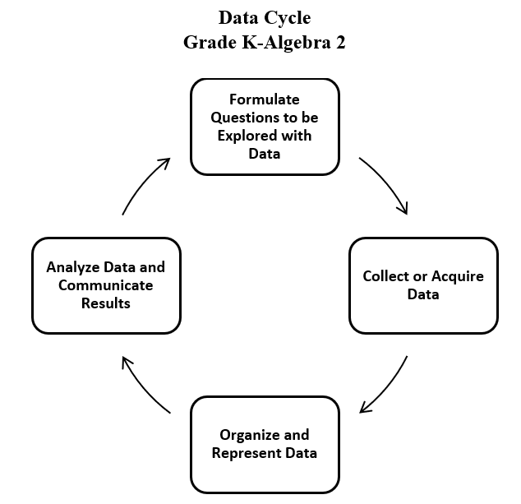
- Statistics is the science of conducting studies to collect, organize, summarize, analyze, and draw conclusions from data.
- The emphasis in all work with statistics should be on the analysis of the data and the communication of the analysis. Data analysis should include opportunities to describe the data, recognize patterns or trends, and make predictions.
- Statistical investigations should be active, with students formulating questions about something in their environment and determining ways to answer the questions.
- Investigations that support collecting data can be brief class surveys or more extended projects occurring over multiple days.
- There are two types of data: categorical and numerical. Categorical data can be sorted into groups or categories while numerical data are values or observations that can be measured. For example, types of fish caught would be categorical data while weights of fish caught would be numerical data. While students need to be aware of the differences, at this level, they do not have to know the terms for each type of data.
- Students should have experiences displaying data in a variety of graphical representations, and determining which representation is most appropriate (e.g., a representation that is more helpful in analyzing and interpreting the data to answer questions and make predictions).
- Prior to Grade 5, students engaged with object graphs, picture graphs, pictographs, tables, bar graphs, and line graphs. In Grade 5, students focus on data represented in line plots (also referred to as dot plots) and stem-and-leaf plots.
- A line plot shows the frequency of data on a number line.
- To create a line plot, ​first create a part of a number line that includes all the values in the data set and the value one less than the smallest value in the data set and one more than the largest value in the data set as shown in the line plot below.
- Provide a title for the line plot that communicates the context from which the data was collected.
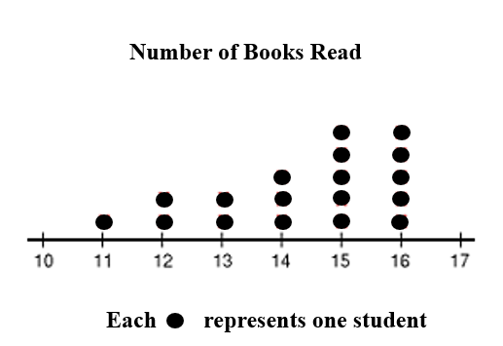
- Next, place an X (or dot) on the number line above each value in the data set. If a value occurs more than once in a data set, place ​an X​ over that number for each time it occurs. Provide a key for the line plot.
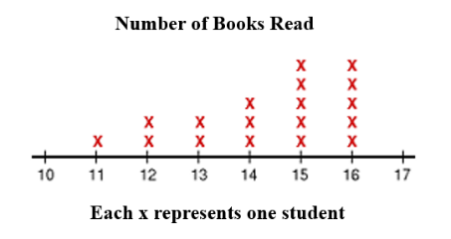

- A line plot provides an ordered display of all values in a data set and shows the frequency of data on a number line. Line plots are used to show the spread of the data, to include clusters (groups of data points) and gaps (large spaces between data points), and quickly identify the range, mode, and any extreme data values.
- In the line plot above, the number of Xs shows that 18 students provided data.
- The range (e.g., the spread) of a data set is the difference between the largest value and the smallest value in the data set. In the line plot above, the range can be found by subtracting 11 from 16 which is 5.
- The mode of a data set is the value that occurs the most often. The line plot above has two modes, 15 and 16.
- By observing the line plot above, one can see that every student read more than ten books, and most of the students read more than 13 books.
- A stem-and-leaf plot, like the one shown below, has the following characteristics:
  - a stem-and-leaf plot uses columns and rows to display a summary of discrete numerical data while maintaining the individual data points;
  - the data are organized from least to greatest;
  - each value is separated into a stem and a leaf (e.g., two-digit numbers are separated into stems (tens) and leaves (ones));
  - the stems are listed vertically from least to greatest with a line to their right. No stem can be skipped. For example, in the stem-and-leaf plot below, there are no data for the stem 5, thus 5 is listed but shows no leaves;
  - the leaves are listed horizontally, also from least to greatest, and can be separated by spaces or commas. Every value in the data set is recorded, regardless of the number of repeats (e.g., in the line plot below, the number 62 is represented three times); and
  - a title is displayed to provide context for the data and a key is included to explain how to read the stem-and-leaf plot.

Minutes Walked Per Student During the Weekend
Stem | Leaf
0 | 6
1 | 5,7,8
2 | 1,4,5,6
3 | 1,3,7,7,7
4 | 0,0,4,8
5
6 | 2,2,2,3,8
Key 2|5 = 25
- A stem-and-leaf plot displays each piece of data to show the shape and distribution of the data as a whole. The stem-and-leaf plot above displays data for the number of minutes each student in class walked last weekend. Using the shape and distribution of the stem-and-leaf plot the following interpretations can be made:
  - The number of leaves shows that 22 students submitted data.
  - The least number of minutes walked was 6 and the greatest number of minutes walked was 68.
  - The difference between 6 and 68 is the range of the data or 62 minutes.
  - The same number of students walked 37 as walked 62 minutes.
  - A prediction could be made that based on the shape of the data and the clustering in the 20s, 30s, and 40s, it is likely that a new student entering the class would walk more than 20 minutes but less than 50 minutes.
- Different situations call for different types of graphs (e.g., visual representations). The way data are displayed is often dependent upon what question is being investigated and what someone is trying to communicate.
- Comparing different types of representations (e.g., charts, graphs, line plots) provides students with opportunities to learn how different graphs can show different aspects of the same data. Following the construction of representations, discussions around what information each representation provides or does not provide should occur.
- Tables or charts organize the exact pieces of data collected and display numerical information. They do not show visual comparisons, which generally means it takes longer to notice and identify trends.
- Interpretations of the data that include comparisons, inferences, and recognizing trends that may exist are made by examining characteristics of a data set displayed in a variety of graphical representations.
- Grade 5 introduces some ways to describe data sets using measures of center (e.g., mode, mean, and median) and measures of spread of the data (e.g., range). Standard 5.PS.2 explains the knowledge and skills for the standard and provides information about using measures of center and spread.
- At this level, students may start to notice characteristics about the data, such as clusters or outliers. While students are not expected to mathematically determine outliers in a data set, they may visually notice when one data point is by itself. For example, in the line plot below, students may notice that the data is clustered around the values 36 to 38 or they may observe that the X over 31 is an outlier in the data set.
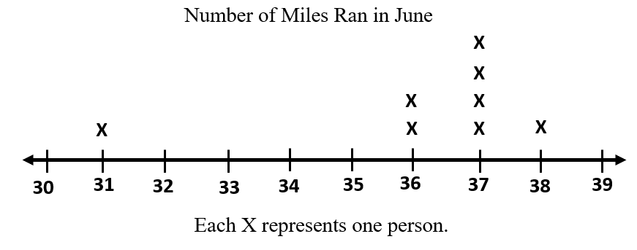
- When comparing different data representations, it is important to ask questions such as:
  - What inferences can you make?
  - What do you notice about the data?
  - In which representations can you identify individual data points?
  - In which representations can you quickly identify the mode or median? The range?

5.PS.2 The student will solve contextual problems using measures of center and the range.
Students will demonstrate the following Knowledge and Skills:
- Describe mean as fair share.
- Describe and determine the mean of a set of data values representing data from a given context as a measure of center.
- Describe and determine the median of a set of data values representing data from a given context as a measure of center.
- Describe and determine the mode of a set of data values representing data from a given context as a measure of center.
- Describe and determine the range of a set of data values representing data from a given context as a measure of spread.

5.PS.2 The student will solve contextual problems using measures of center and the range.
Additional Content Background and Instructional Guidance:
- Students should have opportunities to build a conceptual understanding of the measures of center (e.g., mean, median, and mode) and the spread (e.g., range) of various data sets.
- The mean, median, mode, and range are four ways that data can be analyzed.
- The mean, or average, represents a fair share of the data. Equally dividing the sum of all values in the data set by the number of values in the data set constitutes a fair share. That is, a mean can be thought of as a number that each member of a group would have if all the data values were combined and distributed equally among the members.
- In Grade 6, students will learn about the mean as the balancing point.
- The idea of dividing as sharing equally should be demonstrated visually and with manipulatives to develop the conceptual foundation for the arithmetic process.
- Using connecting cubes, as in the following problem, is one way of visually representing mean as fair share.
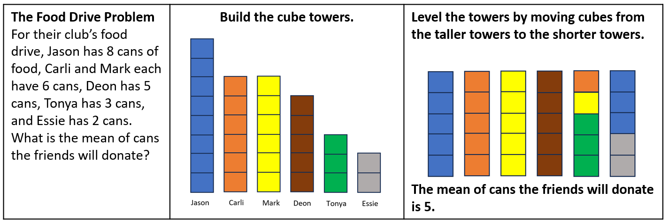
- The median is the middle number of a data set that has been ordered from least to greatest. If there are an odd number of data values, the median is the middle value in ranked order. If there are an even number of data values, the median is the average of the two middle values.
- The mode is the data value that occurs most frequently in the data set. There may be one, more than one, or no mode in a data set. Organizing the data from least to greatest supports an efficient observation of the data and makes it easier to identify the mode(s) of a data set.
- The range is the spread of a set of data. The range of a set of data is the difference between the greatest and least values in the data set. It is determined by subtracting the least number in the data set from the greatest number in the data set.
- Given the following data set of students’ test scores 73, 77, 84, 87, 89, 91, 94:
  - the mean can be determined by adding the test scores then dividing by the number of values in the data set. 73 + 77 + 84 + 87 + 89 + 91 + 94 = 595. Then 595 $÷$ 7 = 85. The mean, or average score, is 85.
  - the median can be determined by the value of the middle number when ordered from least to greatest. Because this data set has seven values, the mode is the fourth value, which is 87.
  - the mode can be determined by seeing if any individual value appears more than the other values. In this data set of test scores, there is no mode because each score appears one time.
  - the range can be determined by subtracting the least value from the greatest value in the data set. Thus, the range is 94 – 73 = 21.
- Opportunities to build a conceptual understanding of what the range tells about the data, and seeing the values in context of other characteristics of the data should be given.
- Line plots and stem-and-leaf plots (see “Understanding the Standard” for SOL 5.PS.1) are visual representations that allow students to quickly determine the range and mode(s) of a data set. They can also be used to determine the median and mean of a data set.

5.PS.3 The student will determine the probability of an outcome by constructing a model of a sample space and using the Fundamental (Basic) Counting Principle.
Students will demonstrate the following Knowledge and Skills:
- Determine the probability of an outcome by constructing a sample space (with a total of 24 or fewer equally likely possible outcomes), using a tree diagram, list, or chart to represent and determine all possible outcomes.
- Determine the number of possible outcomes by using the Fundamental (Basic) Counting Principle.

5.PS.3 The student will determine the probability of an outcome by constructing a model of a sample space and using the Fundamental (Basic) Counting Principle.
Additional Content Background and Instructional Guidance:
- A spirit of investigation and experimentation should permeate probability instruction. Opportunities should be given that allow for explorations and the use of manipulatives, tables, tree diagrams, and lists.
- Probability is the measure of likelihood that an event will occur. An event is a collection of outcomes from an investigation or experiment. Likelihood is expressed in informal terms (e.g., impossible, likely, certain). Probability is expressed as a fraction from 0 to 1.
- The probability of an event can be expressed as a fraction, where the numerator represents the number of favorable outcomes, and the denominator represents the total number of possible outcomes. If all the outcomes of an event are equally likely to occur, the probability of the event is equal to:
Probability of event = $\frac{number of favorable outcomes}{total number of possible outcomes}$
- Probability is quantified as a number between zero and one. An event is “impossible” if it has a probability of zero (e.g., the probability that the month of April will have 31 days). An event is “certain” if it has a probability of one (e.g., the probability that if today is Thursday, then tomorrow will be Friday).
- When a probability experiment has very few trials, the results can be misleading. The more times an experiment is done, the closer the experimental probability comes to the theoretical probability (e.g., a coin lands heads up half of the time).
- Opportunities to describe the degree of likelihood of an event occurring in informal terms (e.g., impossible, unlikely, equally likely, likely, and certain) should be given. Activities should include contextual examples.
- A sample space represents all possible outcomes of an experiment. The sample space may be organized in a list, chart, or tree diagram.
- Determining the sample space for combinations problems is important for Grade 5 students. For example, how many different outfit combinations be made from two shirts (red and blue) and three pairs of pants (black, white, khaki)? The sample space displayed in a tree diagram would show the outfit combinations: red-black; red-white; red-khaki; blue-black; blue-white; blue-khaki. There are six possible combinations, or outcomes.
- Patterns may be generalized when determining the sample space. The Fundamental (Basic) Counting Principle is a computational procedure to determine the total number of possible outcomes when there are multiple choices or events. It is the product of the number of outcomes for each choice or event that can be chosen individually. For example, the possible final outcomes or outfits of four shirts (green, yellow, blue, red), two pairs of shorts (tan or black), and three types of shoes (sneakers, sandals, flip flops) is 4 × 2 × 3 = 24 outfits.
- Exploring the use of tree diagrams for modeling combinations helps students develop the Fundamental Counting Principle. For the ice cream combinations problem below, applying the Fundamental Counting Principle shows there are 3 × 3 × 2 = 18 outcomes.
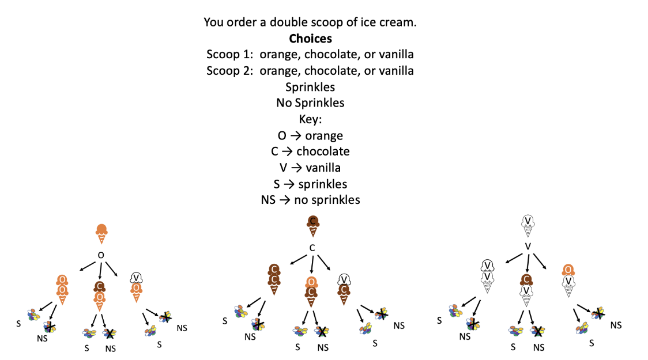

Patterns, Functions, and Algebra
5.PFA.1 The student will identify, describe, extend, and create increasing and decreasing patterns with whole numbers, fractions, and decimals, including those in context, using various representations.
Students will demonstrate the following Knowledge and Skills:
- Identify, describe, extend, and create increasing and decreasing patterns using various representations (e.g., objects, pictures, numbers, number lines, input/output tables, function machines).
- Analyze an increasing or decreasing single-operation numerical pattern found in lists, input/output tables, and function machines, and generalize the change to identify the rule, extend the pattern, or identify missing terms. (Patterns will be limited to addition, subtraction, multiplication, and division of whole numbers; addition and subtraction of fractions with like denominators of 12 or less; and addition and subtraction of decimals expressed in tenths or hundredths).
- Solve contextual problems that involve identifying, describing, and extending increasing and decreasing patterns using single-operation input and output rules (limited to addition, subtraction, multiplication, and division of whole numbers; addition and subtraction of fractions with like denominators of 12 or less; and addition and subtraction of decimals expressed in tenths or hundredths).

5.PFA.1 The student will identify, describe, extend, and create increasing and decreasing patterns with whole numbers, fractions, and decimals, including those in context, using various representations.
Additional Content Background and Instructional Guidance:
- The ability to recognize, interpret, and generalize patterns supports understanding of many mathematical concepts. Primary grades develop the knowledge and skills to recognize regularity in a sequence of numbers or shapes found in repeating patterns. In Grade 3, students engaged with sequences of numbers or shapes to recognize and describe growing patterns. In Grade 4, students applied generalizations to extend patterns and find missing terms. In Grade 5, students are expected to describe “rules” for patterns and use this to find missing terms.
- Students should have opportunities to explore increasing and decreasing growing patterns using concrete materials and calculators. Calculators are valuable tools for generating and analyzing patterns. The emphasis is not on computation but on identifying and describing patterns.
- Patterns at this level may include addition, subtraction, multiplication, and division of whole numbers; addition or subtraction of fractions (with like denominators 12 or less); or addition and subtraction of decimals expressed in tenths or hundredths. Several sample numerical patterns are included below:
  - 1, 2, 4, 7, 11, 16, …
  - 2, 4, 8, 16, 32, …
  - 32, 30, 28, 26, 24, …
  - $\frac{1}{4 }$, $\frac{3}{4}$, 1$\frac{1}{4}$, 1$\frac{3}{4}$…
  - 0.25, 0.50, 0.75, 1.00, …
- Generalizing patterns to identify rules and apply rules to solve problems builds the foundation for functional thinking. Sample input/output tables that require determination of the rule and missing terms can be found below.
Rule: ? |  |  | Rule: ?
Input | Output |  | Input | Output
4 | 8 |  | 20 | 4
5 | ? |  | 15 | 3
6 | 12 |  | ? | 1
? | 20 |  | 25 | 5
- Teachers may make a connection to SOL 5.PFA.2 and have students state the rule of an input/output table as a verbal expression.
- A verbal expression involving one operation can be represented by a variable expression that describes the relationship. Numbers are used when they are known; variables are used when the numbers are unknown. The example in the table below defines the relationship between the input number (x) and output number (y) as x + 3. Students may orally describe the pattern below as “plus three” or “given any number, x, add three.”
x | y
6 | 9
7 | 10
11 | 14
15 | 18

5.PFA.2 The student will investigate and use variables in contextual problems.
Students will demonstrate the following Knowledge and Skills:
- Describe the concept of a variable (presented as a box, letter, or other symbol) as a representation of an unknown quantity.
- Write an equation (with a single variable that represents an unknown quantity and one operation) from a contextual situation, using addition, subtraction, multiplication, or division.
- Use an expression with a variable to represent a given verbal expression involving one operation (e.g., “5 more than a number” can be represented by y + 5).
- Create and write a word problem to match a given equation with a single variable and one operation.

5.PFA.2 The student will investigate and use variables in contextual problems.
Additional Content Background and Instructional Guidance:
- An equation is a statement that represents the relationship between two expressions of equal value using variables, numbers, and operation symbols, and an equal sign symbol.
- An expression is a representation of a quantity. It is made up of numbers, variables, and/or computational symbols. It does not have an equal symbol (e.g., 8, 15 × 12).
- A variable is a symbol that can stand for an unknown number (e.g., a + 4 = 6) or for a quantity that changes (e.g., the rule or generalization for the pattern for an input/output table such as x + 2 = y).
- A relationship with two unknown values will have more than one variable used for the unknown values that make a true statement (e.g., the rule or generalization for the pattern for an input/output table such as x + 3 = y). In this situation there will be more than one replacement for x and y to make the statement true. For example, if x is replaced with 8, then y must be replaced with 11. If x is replaced with 24, then y must be replaced with 27.
- An equation may contain a variable and an equal symbol (=). For example, the sentence, “A full box of cookies and four extra equal 24 cookies,” can be written as b + 4 = 24, where b stands for the number of cookies in one full box. The sentence, “Three full boxes of cookies contain a total of 60 cookies,” can be written as 3b = 60.
- Another example of an equation is b + 3 = 23. This equation could be used to represent the contextual situation, “How many cookies are in a box if the box plus three more equals 23 cookies?” where b stands for the number of cookies in the box.
- By using story problems and numerical sentences, students begin to explore forming equations and representing quantities using variables.
- An equation containing a variable is neither true nor false until the variable is replaced with a number and the value of the expressions on both sides are compared and are equal.
- Teachers should consider varying the letters used (in addition to x) to represent variables.
- The symbol • is sometimes used to represent multiplication and can be confused with the variable x. In addition to varying the use of letters as variables, this confusion can be minimized by using other mathematics conventions for showing multiplication (e.g., 4(x) = 20 or 4x = 20 in addition to 4 • x = 20).

