2023 Mathematics Standards of Learning
Understanding the Standards – Grade 4
The Understanding the Standards document includes the mathematics understandings and key concepts that assist teachers in planning standards-focused instruction of the fourth grade 2023 Mathematics Standards of Learning. The Understanding the Standards includes definitions, explanations, and examples regarding each mathematics standard and describes what students should know (core knowledge) as a result of the instruction specific to the course/grade level.

Number and Number Sense
4.NS.1 The student will use place value understanding to read, write, and identify the place and value of each digit in a nine-digit whole number.
Students will demonstrate the following Knowledge and Skills:
- Read nine-digit whole numbers, presented in standard form, and represent the same number in written form.
- Write nine-digit whole numbers in standard form when the numbers are presented orally or in written form.
- Apply patterns within the base 10 system to determine and communicate, orally and in written form, the place and value of each digit in a nine-digit whole number (e.g., in 568,165,724, the 8 represents 8 millions and its value is 8,000,000).

4.NS.1 The student will use place value understanding to read, write, and identify the place and value of each digit in a nine-digit whole number.
Additional Content Background and Instructional Guidance:
- Reading and writing large numbers should be meaningful for students. Experiences can be provided that relate practical situations in students’ environments (e.g., the population of the school versus a school division, seats in an auditorium versus a stadium, number of letters in a word versus on a page).
- The structure of the base 10 number system is based upon a simple pattern of tens, where each place is ten times the value of the place to its right. This structure, known as a ten-to-one place value relationship, is helpful in comparing and ordering numbers.
- Place value refers to the value of each digit and depends upon the position of the digit in the number. For example, in the number 7,864,352, the 8 is in the hundred thousands place, and the value of the 8 is eight hundred thousand or 800,000.
- Numbers are arranged into groups of three places called periods (ones, thousands, millions, etc.). The value of the places within the periods repeat (hundreds, tens, ones). Commas are used to separate the periods. Knowing the value of the place and period of a number helps students determine values of digits in any number as well as read and write numbers.
- Whole numbers may be written in a variety of forms:
  - standard: 1,234,567;
  - written: one million, two hundred thirty-four thousand, five hundred sixty-seven;
  - expanded: (1,000,000 + 200,000 + 30,000 + 4,000 + 500 + 60 + 7); or
  - expanded (1×1,000,000) + (2 × 100,000) + (3 × 10,000) + (4 × 1,000) + (5 × 100) + (6 × 10) + (7 × 1)
- Concrete materials such as base 10 blocks or bundles of sticks may be used to represent whole numbers through thousands. Larger numbers may be represented by digit cards, place value charts, or on number lines.

4.NS.2 The student will demonstrate an understanding of the base 10 system to compare and order whole numbers up to seven digits.
Students will demonstrate the following Knowledge and Skills:
- Compare two whole numbers up to seven digits each, using words (greater than, less than, equal to, not equal to) and/or using symbols (>, <, =, ≠).
- Order up to four whole numbers up to seven digits each, from least to greatest or greatest to least.

4.NS.2 The student will demonstrate an understanding of the base 10 system to compare and order whole numbers up to seven digits.
Additional Content Background and Instructional Guidance:
- Numbers written in standard form are often more easily compared. Students are then able to use the number of digits in a whole number, and the place and value of those digits, to compare and order numbers.
- Numbers written in expanded form are also easy to compare, as the value of each digit in each place value is written out, making them easier to compare.
- A number line is one model that can be utilized when comparing and ordering numbers.
- Mathematical symbols (>, <) used to compare two unequal numbers are called inequality symbols.

4.NS.3 The student will use mathematical reasoning and justification to represent, compare, and order fractions (proper, improper, and mixed numbers with denominators 12 or less), with and without models.
Students will demonstrate the following Knowledge and Skills:
- Compare and order no more than four fractions (proper or improper), and/or mixed numbers, with like denominators by comparing the number of parts (numerators) using fractions with denominators of 12 or less (e.g., $\frac{1}{5}$ < $\frac{3}{5}$). Justify comparisons orally, in writing, or with a model.*
- Compare and order no more than four fractions (proper or improper), and/or mixed numbers, with like numerators and unlike denominators by comparing the size of the parts using fractions with denominators of 12 or less (e.g., $\frac{3}{8}$ < $\frac{3}{5}$). Justify comparisons orally, in writing, or with a model.*
- Use benchmarks (e.g., 0, $\frac{1}{2}$, or 1) to compare and order no more than four fractions (proper or improper), and/or mixed numbers, with like and unlike denominators of 12 or less. Justify comparisons orally, in writing, or with a model.*
- Compare two fractions (proper or improper) and/or mixed numbers using fractions with denominators of 12 or less, using the symbols >, <, and = (e.g., $\frac{2}{3}$ > $\frac{1}{7}$). Justify comparisons orally, in writing, or with a model.*
- Represent equivalent fractions with denominators of 12 or less, with and without models.*
- Compose and decompose fractions (proper and improper) and/or mixed numbers with denominators of 12 or less, in multiple ways, with and without models.*
- Represent the division of two whole numbers as a fraction given a contextual situation and a model (e.g., $\frac{3}{5}$ means the same as 3 divided by 5 or $\frac{3}{5}$ represents the amount of muffin each of five children will receive when sharing three muffins equally).
* On the state assessment, items measuring this objective are assessed without the use of a calculator.

4.NS.3 The student will use mathematical reasoning and justification to represent, compare, and order fractions (proper, improper, and mixed numbers with denominators 12 or less), with and without models.
Additional Content Background and Instructional Guidance:
- A fraction is a numerical way of representing part of a whole. Fractions can have different meanings: part-whole, measurement, division, ratio, and operator. When working with fractions, the whole must be defined. In Grade 4, fractions most commonly represent part-whole, measurement, or division situations.
- At this grade level, models can provide considerable support for developing student understanding of the different fraction concepts and for justifying solutions when problem solving.
- Representations that students use in fraction explorations, activities, and during problem solving should be based on the concept being developed. At this grade level, the three representations most commonly used are region/area models, set models, or length/measurement models.
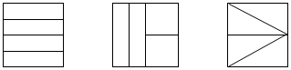
- In a region/area model (e.g., fraction circles, pattern blocks, geoboards, grid paper, color tiles), the whole is continuous and divided or partitioned into parts with areas of equivalent value. The fractional parts may or may not be congruent and could have a different shape as shown in the middle example below. This model is helpful when developing the part-whole concept.

- In a set model (e.g., chips, counters, cubes), the whole is made up of discrete members of the set, where each member is an equivalent part of the set. In set models, the whole needs to be defined, but members of the set may have different sizes and shapes. For example, if a whole is defined as a set of 10 shapes, the shapes within the set may be different. In the example below, students should identify hearts as representing $\frac{5}{10}$ (or one-half) of the shapes in the set shown:

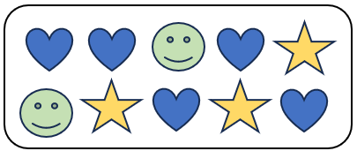
- In a length/measurement model (e.g., fraction strips, rods, number lines, rulers), each length represents an equal part of the whole. For example, given a strip of paper, students could fold the narrow strip into four equal parts, with each part representing one-fourth. Students will notice that there are four one-fourths in the entire length of the strip of paper. A concrete model connects to a representation of a number line to make sense of the spaces that show the value of the fraction.
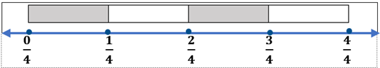
- A ruler is an important representation of the length model of fractions. When using rulers to measure length, opportunities should be provided for students to identify the points of the ruler that represent the lengths of halves, fourths, and eighths, and students should be encouraged to make connections to fractions and mixed numbers.
- The value of a fraction $\frac{a}{b}$is dependent on both b, the number of equivalent parts in a whole (denominator), and a, the number of those parts being considered (numerator).
- Proper fractions, improper fractions, and mixed numbers are terms often used to describe fractions. A proper fraction is a fraction whose numerator is less than the denominator. An improper fraction is a fraction that is greater than or equal to one whole (i.e., whose numerator is greater than or equal to the denominator (e.g., $\frac{7}{4}$)). An improper fraction may also be expressed as a mixed number. A mixed number is written with two parts: a whole number and a proper fraction (e.g., 3$\frac{5}{8}$). The value of a mixed number is the sum of its two parts.
- A fraction can represent the result obtained when two numbers are divided.
  - The number of gumdrops each child receives when 40 gumdrops are shared equally among 5 children can be expressed as $\frac{40}{5}$ or 8.
- When presented with a fraction $\frac{3}{5}$ representing division, the division expression representing the fraction is written as 3 ÷ 5.
  - When 3 cakes are divided equally among 4 people, the fraction $\frac{3}{4}$ may be interpreted as the amount of cake each person will receive.
- Equivalent fractions name the same amount. Students should have multiple opportunities to explore and use a variety of representations including visual fraction models and folding paper to represent, explore, and explain why two fractions are equivalent. For example, $\frac{1}{2}$ is equivalent to $\frac{4}{8}$ because the fractions themselves represent the same value, even though the number and size of the parts differ.
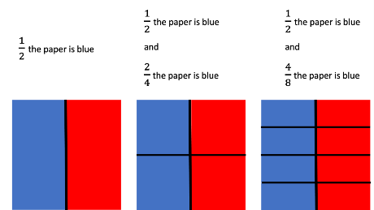
- Concrete and pictorial models, benchmarks (e.g., 0, $\frac{1}{2}$, 1), and equivalent forms are helpful in judging the size of fractions.
- Composing and decomposing fractions develops a deeper understanding of fractional concepts. For example, the use of benchmarks can aid in comparing and ordering fractions, and solving problems involving addition and subtraction of fractions. The example below compares the fractions $\frac{3}{4}$ and $\frac{7}{12}$ using the benchmark fraction $\frac{1}{2}$.
- The more parts the whole is divided into, the smaller each individual part will be (e.g., $\frac{1}{5}$ < $\frac{1}{3}$). 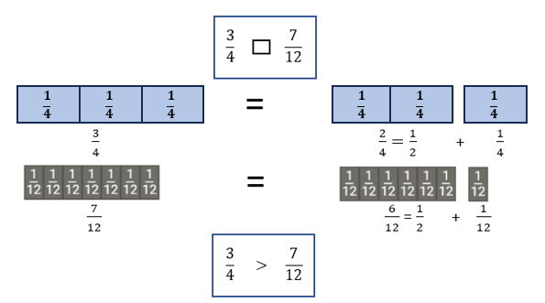
- Fractions with a numerator of one are called unit fractions (e.g., $\frac{1}{4}$).
- When fractions have the same denominator, they are said to have “common denominators” or “like denominators.” Comparing fractions with like denominators involves comparing only the numerators.
- Strategies for comparing fractions with unlike denominators may include:
  - comparing fractions to familiar benchmarks (e.g., 0, $\frac{1}{2}$, 1); and
  - determining equivalent fractions using models such as fraction strips, number lines, fraction circles, rods, pattern blocks, cubes, base 10 blocks, tangrams, graph paper, or patterns in a multiplication chart.

4.NS.4 The student will use mathematical reasoning and justification to represent, compare, and order decimals through thousandths, with and without models.
Students will demonstrate the following Knowledge and Skills:
- Investigate and describe the ten-to-one place value relationship for decimals through thousandths, using concrete models (e.g., place value mats/charts, decimal squares, base 10 blocks).
- Represent and identify decimals expressed through thousandths, using concrete, pictorial, and numerical representations.
- Read and write decimals expressed through thousandths, using concrete, pictorial, and numerical representations.
- Identify and communicate, both orally and in written form, the place and value of each digit in a decimal through thousandths (e.g., given 0.385, the 8 is in the hundredths place and has a value of 0.08).
- Compare using symbols (<, >, =) and/or words (greater than, less than, equal to) and order (least to greatest and greatest to least), a set of no more than four decimals expressed through thousandths, using multiple strategies (e.g., benchmarks, place value, number lines). Justify comparisons with a model, orally, and in writing.

4.NS.4 The student will use mathematical reasoning and justification to represent, compare, and order decimals through thousandths, with and without models.
Additional Content Background and Instructional Guidance:
- Decimal numbers expand the set of whole numbers and, like fractions, are a way of representing part of a whole.
- A decimal point (.) separates the whole number from the part of the decimal number that is less than one. A number containing a decimal point is called a decimal number or simply a decimal.
- The structure of the base 10 number system is based upon a simple pattern of tens, where each place is ten times the value of the place to its right. This is known as a ten-to-one place value relationship (e.g., in 2.35, 3 is in the tenths place since it takes ten one-tenths to make one whole). Concrete materials that clearly illustrate the relationships among ones, tenths, hundredths, and thousandths, and are physically proportional (e.g., the ones piece is ten times larger than the tenths piece) may be used to represent decimal numbers. Examples of proportional manipulatives include decimal squares, base 10 blocks, or meter sticks. In moving beyond the concrete, non-proportional manipulatives where the relationship is not visible in the material such as money or number disks (e.g., 1, 10, 100, 1000) can be helpful in developing place value understanding of decimal numbers.
- To read decimals,
  - read the whole number to the left of the decimal point;
  - read the decimal point as “and;”
  - read the digits to the right of the decimal point just as you would read a whole number; and say the name of the place value of the digit in the smallest place.
- Any decimal less than 1 will include a leading zero. For example, 0.125 can be read as “zero and one hundred twenty-five thousandths” or as “one hundred twenty-five thousandths.”
- Decimals may be written in a variety of forms:
  - standard: 26.537;
  - written: twenty-six and five hundred thirty-seven thousandths;
  - expanded: 20 + 6 + 0.5 + 0.03 + 0.007; or
  - expanded: (2 × 10) + (6 × 1) + (5 × 0.1) + (3 × 0.01) + (7 × 0.001)
- Number lines and beaded number lines serve as useful tools when using benchmarks (e.g., 0, 0.5, 1) to compare and order decimals. The terms closer to, between, and a little more than are often used when comparing and ordering decimals (e.g., 0.48 is a little less than 0.5; 0.98 is close to 1; 0.75 is between 0.5 and 1).

4.NS.5 The student will reason about the relationship between fractions and decimals (limited to halves, fourths, fifths, tenths, and hundredths) to identify and represent equivalencies.
Students will demonstrate the following Knowledge and Skills:
- Represent fractions (proper or improper) and/or mixed numbers as decimals through hundredths, using multiple representations, limited to halves, fourths, fifths, tenths, and hundredths.*
- Identify and model equivalent relationships between fractions (proper or improper) and/or mixed numbers and decimals, using halves, fourths, fifths, tenths, and hundredths.*
- Write the decimal and fraction equivalent for a given model (e.g., $\frac{1}{4}$ = 0.25 or 0.25 = $\frac{1}{4}$; 1.25 = $\frac{5}{4}$ or 1$\frac{1}{4}$; 1.02 = $\frac{102}{100}$ or 1$\frac{2}{100}$).*
* On the state assessment, items measuring this objective are assessed without the use of a calculator.

4.NS.5 The student will reason about the relationship between fractions and decimals (limited to halves, fourths, fifths, tenths, and hundredths) to identify and represent equivalencies.
Additional Content Background and Instructional Guidance:
- Decimals and fractions represent the same relationship. They are both used when representing a number less than a whole (e.g., 0.5 is written as $\frac{5}{10}$ or $\frac{1}{2}$ ) and when representing wholes plus some part of a whole (e.g., 2.31 is written as 2 $\frac{31}{100}$).
- Decimal notation is used when writing a number with a decimal. Wholes are recorded to the left of the decimal point and the part of the whole is recorded to the right. Decimals are another way of writing fractions whose denominators are powers of ten (e.g., 10, 100, 1000). Just as the counting numbers are based on powers of ten, decimals are based on powers of ten. The table below shows the relationship between decimals and fractions.
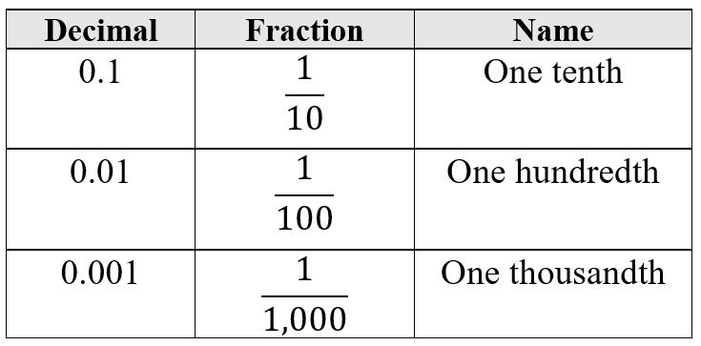
- Base 10 models can concretely model the relationship between fractions and decimals (e.g., 10-by-10 grids, meter sticks, number lines, decimal squares, decimal circles, money).

Computation and Estimation
4.CE.1 The student will estimate, represent, solve, and justify solutions to single-step and multistep problems, including those in context, using addition and subtraction with whole numbers.
Students will demonstrate the following Knowledge and Skills:
- Determine and justify whether an estimate or an exact answer is appropriate when solving contextual problems involving addition and subtraction with whole numbers. Refine estimates by adjusting the final amount, using terms such as closer to, between, and a little more than.
- Apply strategies (e.g., rounding to the nearest 100 or 1,000, using compatible numbers, other number relationships) to estimate a solution for single-step or multistep addition or subtraction problems with whole numbers, where addends or minuends do not exceed 10,000.*
- Apply strategies (e.g., place value, properties of addition, other number relationships) and algorithms, including the standard algorithm, to determine the sum or difference of two whole numbers, where addends and minuends do not exceed 10,000.*
- Estimate, represent, solve, and justify solutions to single-step and multistep contextual problems involving addition and subtraction with whole numbers where addends and minuends do not exceed 1,000,000.
* On the state assessment, items measuring this objective are assessed without the use of a calculator.

4.CE.1 The student will estimate, represent, solve, and justify solutions to single-step and multistep problems, including those in context, using addition and subtraction with whole numbers.
Additional Content Background and Instructional Guidance:
- Estimation skills are valuable, time-saving tools particularly in practical situations when exact answers are not required, and can be used in determining the reasonableness of the sum or difference when solving for the exact answer.
- An estimate is a number that lies within a range of the exact solution, and the estimation strategy used in a particular problem determines how close the estimate is to the exact solution. Estimates involve using friendlier numbers to mentally compute a reasonable answer before any exact computation is calculated.
- Students should explore reasons for estimation, using practical experiences, and use various estimation strategies to solve contextual problems. Estimation strategies include rounding, using compatible numbers, and front-end estimation.
- When estimating, students should consider whether it is important that the estimate is greater than or less than the exact answer. In the following examples using the same addends, each estimation strategy results in a different sum, so students should be encouraged to examine the context and the demand for precision in deciding which estimation strategy to use.
  - Rounding numbers is one estimation strategy and may be introduced through the use of a number line. When given a number to round, use multiples of ten, hundred, thousand, ten thousand, or hundred thousand as benchmarks and use the nearest benchmark value to represent the number. For example, using rounding to the nearest hundred to estimate the sum of 255 + 481 would result in 300 + 500 = 800.
  - Using compatible numbers is another estimation strategy. Compatible numbers are pairs of numbers that are easy to add and subtract mentally. For example, using compatible numbers to estimate the sum of 255 + 481 could result in 250 + 500 = 750.
  - Using front-end estimation is another estimation strategy. Front-end estimation involves truncating numbers to the highest place value to compute. For example, using front-end estimation to estimate the sum of 255 + 481 would result in 200 + 400 = 600.
- When an exact answer is required, opportunities to explore whether the answer can be determined mentally or must involve paper and pencil, or calculators help students select the most efficient approach.
- Number lines are useful tools when developing a conceptual understanding of rounding with whole numbers. When given a number to round, locate it on the number line. Next, determine the closest multiples of thousand, ten thousand, or hundred thousand it is between. Then, identify to which it is closer.
- Grade 4 students should explore and apply the properties of addition as strategies for solving addition and subtraction problems using a variety of representations (e.g., manipulatives, diagrams, and symbols).
- The properties of the operations are “rules” about how numbers work and how they relate to one another. Students at this level do not need to use the formal terms for these properties but should utilize these properties to further develop flexibility and fluency in solving problems. The following properties are most appropriate for exploration at this level:
  - The identity property of addition states that if zero is added to a given number, the sum is the same as the given number (e.g., 24 + 0 = 24);
  - The commutative property of addition states that changing the order of the addends does not affect the sum (e.g., 24 + 136 = 136 + 24);
  - The associative property of addition states that the sum stays the same when the grouping of addends is changed (e.g., 15 + (35 + 16) = (15 + 35) + 16).
- Computational fluency is the ability to think flexibly in order to choose appropriate strategies to solve problems accurately and efficiently. A certain amount of practice is necessary to develop fluency with computational strategies. The practice must be motivating and systematic if students are to develop fluency in computation.
- An expression is a representation of a quantity. It is made up of numbers, variables, and/or computational symbols. It does not have an equal symbol (e.g., 8, 15 × 12).
- Mathematical relationships can be expressed using equations. An equation represents the relationship between two expressions of equal value (e.g., 12 × 4 = 60 − 12).
- The equal symbol (=) means that the values on either side are equivalent (balanced).
- The not equal symbol (≠) means that the values on either side are not equivalent (not balanced).
- In problem solving, emphasis should be placed on thinking and reasoning rather than on key words. Focusing on key words such as in all, altogether, difference, etc., encourages students to perform a particular operation rather than make sense of the context of the problem. A key-word focus prepares students to solve a limited set of problems and often leads to incorrect solutions as well as challenges in upcoming grades and courses.
- Bar diagrams serve as a model that can provide students ways to visualize, represent, and understand the relationship between known and unknown quantities and to solve problems.
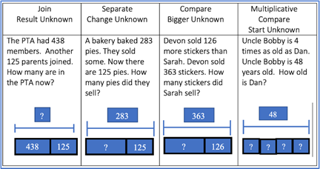

4.CE.2 The student will estimate, represent, solve, and justify solutions to single-step and multistep problems, including those in context, using multiplication with whole numbers, and single-step problems, including those in context, using division with whole numbers; and recall with automaticity the multiplication facts through 12 × 12 and the corresponding division facts.
Students will demonstrate the following Knowledge and Skills:
- Determine and justify whether an estimate or an exact answer is appropriate when solving contextual problems involving multiplication and division of whole numbers. Refine estimates by adjusting the final amount, using terms such as closer to, between, and a little more than.
- Recall with automaticity the multiplication facts through 12 × 12 and the corresponding division facts.*
- Create an equation using addition, subtraction, multiplication, and division to represent the relationship between equivalent mathematical expressions (e.g., 4 × 3 = 2 × 6; 10 + 8 = 36 ÷ 2; 12 × 4 = 60 $-$ 12).
- Identify and use the appropriate symbol to distinguish between expressions that are equal and expressions that are not equal, using addition, subtraction, multiplication, and division (e.g., 4 × 12 = 8 × 6 and 64 ÷ 8 ≠ 8 × 8).
- Determine all factor pairs for a whole number 1 to 100, using concrete, pictorial, and numerical representations.
- Determine common factors and the greatest common factor of no more than three numbers.
- Apply strategies (e.g., rounding, place value, properties of multiplication and/or addition) and algorithms, including the standard algorithm, to estimate and determine the product of two whole numbers when given:
  - a two-digit factor and a one-digit factor;*
  - a three-digit factor and a one-digit factor;* or
  - a two-digit factor and a two-digit factor.*
- Estimate, represent, solve, and justify solutions to single-step and multistep contextual problems that involve multiplication with whole numbers.
- Apply strategies (e.g., rounding, compatible numbers, place value) and algorithms, including the standard algorithm, to estimate and determine the quotient of two whole numbers, given a one-digit divisor and a two- or three-digit dividend, with and without remainders.*
- Estimate, represent, solve, and justify solutions to single-step contextual problems involving division with whole numbers.
- Interpret the quotient and remainder when solving a contextual problem.
* On the state assessment, items measuring this objective are assessed without the use of a calculator.
4.CE.2 The student will estimate, represent, solve, and justify solutions to single-step and multistep problems, including those in context, using multiplication with whole numbers, and single-step problems, including those in context, using division with whole numbers; and recall with automaticity the multiplication facts through 12 × 12 and the corresponding division facts.
Additional Content Background and Instructional Guidance:
- Estimation skills are valuable, time-saving tools particularly in practical situations when exact answers are not required and can be used in determining the reasonableness of the product or quotient when solving for the exact answer.
- An estimate is a number that lies within a range of the exact solution, and the estimation strategy used in a particular problem determines how close the estimate is to the exact solution. Estimates involve using friendlier numbers to mentally compute a reasonable answer before any exact computation is calculated.
- Students should explore reasons for estimation, using practical experiences, and use various estimation strategies to solve contextual problems. Estimation strategies include rounding, using compatible numbers, and front-end estimation.
- When estimating, students should consider whether it is important that the estimate is greater than or less than the exact answer. Students should be encouraged to examine the context and the demand for precision in deciding which estimation strategy to use.
- Rounding numbers is one estimation strategy and may be introduced with a number line. When given a number to round, use multiples of ten, hundred, or thousand as benchmarks and use the nearest benchmark value to represent the number.
- Using compatible numbers is another estimation strategy. Compatible numbers are pairs of numbers that are easy to multiply and divide mentally.
- Using front-end estimation is another estimation strategy. Front-end estimation involves truncating numbers to the highest place value to compute.
- When an exact answer is required, opportunities to explore whether the answer can be determined mentally or must involve paper and pencil, or calculators help students select the most efficient approach.
- Grade 4 students should explore and apply the properties of multiplication as strategies for solving multiplication and division problems using a variety of representations (e.g., manipulatives, diagrams, and symbols).
- The properties of the operations are “rules” about how numbers work and how they relate to one another. Students at this level do not need to use the formal terms for these properties but should utilize these properties to further develop flexibility and fluency in solving problems. The following properties are most appropriate for exploration at this level:
  - the identity property of multiplication states that if a given number is multiplied by one, the product is the same as the given number (e.g., 8 × 1 = 8);
  - the commutative property of multiplication states that changing the order of the factors does not affect the product (e.g., 12 × 43 = 43 × 12);
  - the associative property of multiplication states that the product stays the same when the grouping of factors is changed (e.g., 16 × (40 × 5) = (16 × 40) × 5);
  - The distributive property states that multiplying a sum by a number gives the same result as multiplying each addend by the number and then adding the products. Several examples are shown below:
    - 3(9) = 3(5 + 4) = (3 × 5) + (3 × 4) = 15 + 12 = 27
    - 5 × (3 + 7) = (5 × 3) + (5 × 7) = 15 + 35 = 50
    - (2 × 3) + (2 × 5) = 2 × (3 + 5) = 2 × 8 = 16
    - 9 × 23 = 9(20 + 3) = 180 + 27 = 207
  - The distributive property can also be demonstrated using an area model, as shown below:
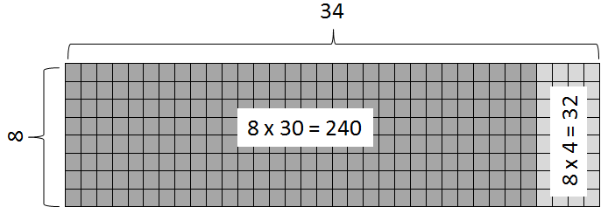
- In Grade 3, students developed an understanding of the meanings of multiplication and division of whole numbers through activities and contextual problems involving equal-sized groups, arrays, and length models. In addition, students worked to develop recall with automaticity of multiplication facts through 10 × 10 along with the corresponding division facts.
- Students develop an understanding of the meaning of multiplication and division of whole numbers through activities and contextual problems that involve equal-sets or equal-groups, arrays, and length models.
- The equal-sets or equal-groups model lends itself to sorting a variety of concrete objects into equal groups and reinforces the concept of multiplication as a way to find the total number of items in a collection of groups, with the same amount in each group, and the total number of items can be found by repeated addition or skip counting.
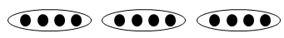
- The array model, consisting of rows and columns (e.g., three rows of four columns for a 3-by-4 array), helps build an understanding of the commutative property.
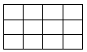
- The length model (e.g., a number line) also reinforces repeated addition or skip counting.
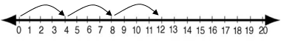
- Multiplication and division are inverse operations.
- Dividing by zero is undefined because it always leads to a contradiction. In the example below, there is no single defined number possibility for dividing by 0, since zero multiplied by any number is zero: If 12 ÷ 0 = r, then r · 0 = 12.
- Computational fluency is the ability to think flexibly in order to choose appropriate strategies to solve problems accurately and efficiently. The development of computational fluency relies on quick access to number facts. The patterns and relationships that exist in the facts can be used to learn and retain the facts. By studying patterns and relationships, students build a foundation for fluency with multiplication and division facts.
- In developing and using strategies to learn the multiplication facts through the twelves table, students should use concrete materials, hundreds charts, and mental mathematics. Strategies to learn the multiplication facts include an understanding of:
  - multiples;
  - doubles;
  - properties of zero and one as factors;
  - building off foundational facts (distributive property);
  - commutative property; and
  - related facts.
- Meaningful practice of computation strategies can be attained through hands-on activities, manipulatives, and graphic organizers.
- A certain amount of practice is necessary to develop fluency with computational strategies. The practice must be motivating and systematic if students are to develop fluency in computation.
- Automaticity of facts can be achieved through timed exercises such as flashcards and/or supplemental handouts to generate many correct responses in a short amount of time.
- An expression is a representation of a quantity. It is made up of numbers, variables, and/or computational symbols. It does not have an equal symbol (e.g., 8, 15 × 12).
- Mathematical relationships can be expressed using equations. An equation represents the relationship between two expressions of equal value (e.g., 12 × 4 = 60 − 12).
- The equal symbol (=) means that the values on either side are equivalent (balanced).
- The not equal symbol (≠) means that the values on either side are not equivalent (not balanced).
- The terms associated with multiplication are listed below:
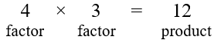
- A factor is a number that divides another number, leaving no remainder. In other words, if multiplying two whole numbers gives us a product, then the numbers we are multiplying are factors of the product because the product is divisible by the factors.
- The formats and terms associated with division are listed below:
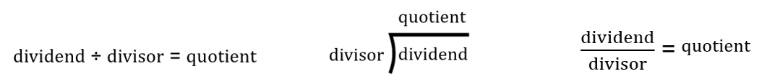
- Division is the operation of making equal groups. When the original amount and the number of groups are known, divide to determine the size of each group. When the original amount and the size of each group are known, divide to determine the number of groups. Both situations may be modeled with base 10 blocks, place value chips, or other manipulatives.
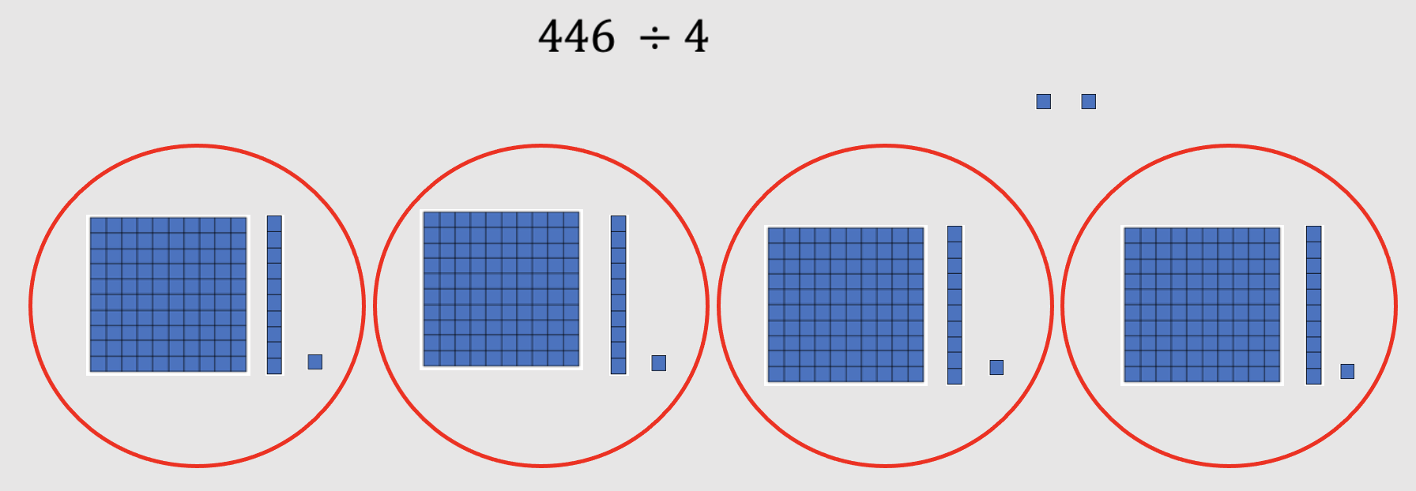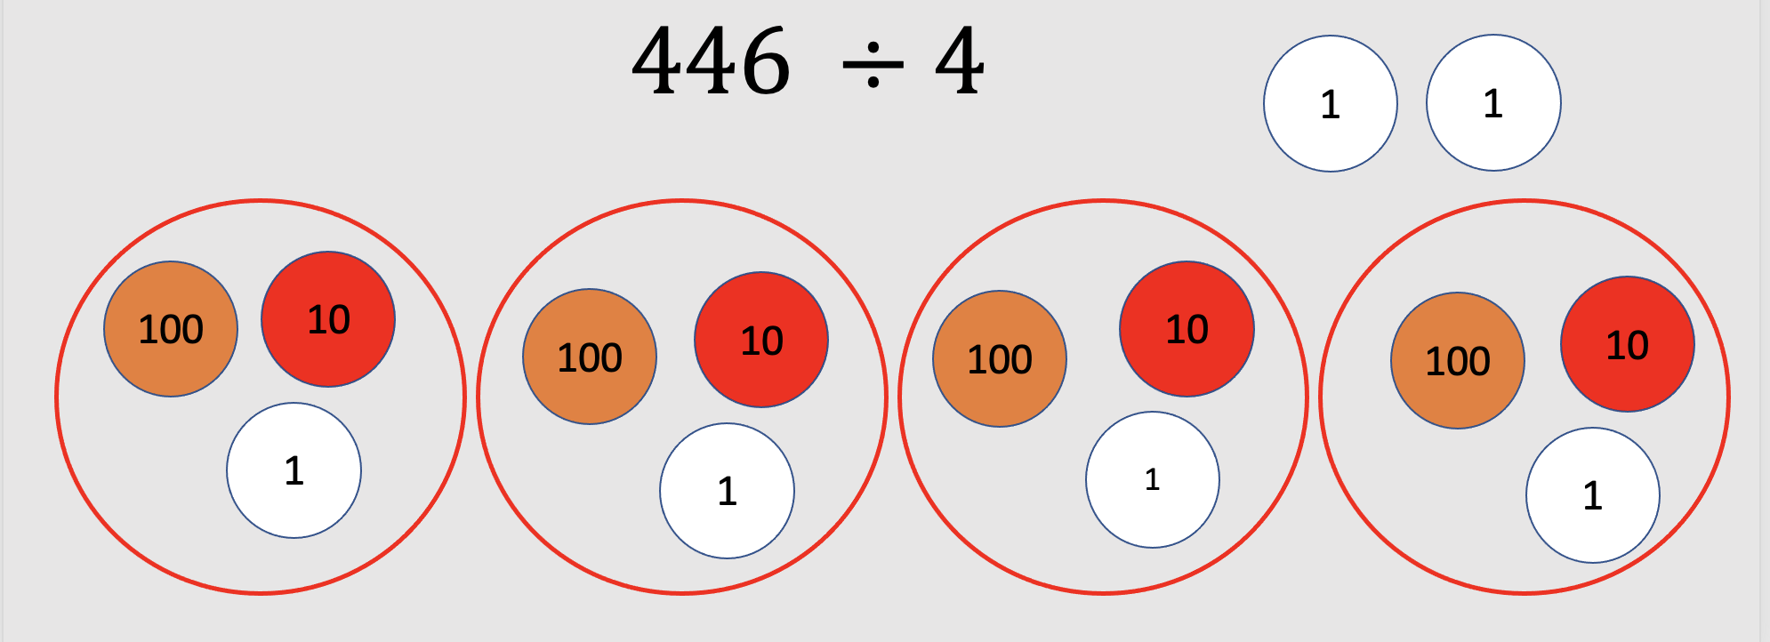
- Students benefit from experiences with various methods of division, such as repeated subtraction, partial quotients, and the standard algorithm.
- In problem solving, emphasis should be placed on thinking and reasoning rather than on key words. Focusing on key words such as in all, altogether, difference, etc., encourages students to perform a particular operation rather than make sense of the context of the problem. A key-word focus prepares students to solve a limited set of problems and often leads to incorrect solutions as well as challenges in upcoming grades and courses.
- Extensive research has been undertaken over the last several decades regarding different problem types. Many of these studies have been published in professional mathematics education publications using different labels and terminology to describe the varied problem types. Some examples are included in the following chart:
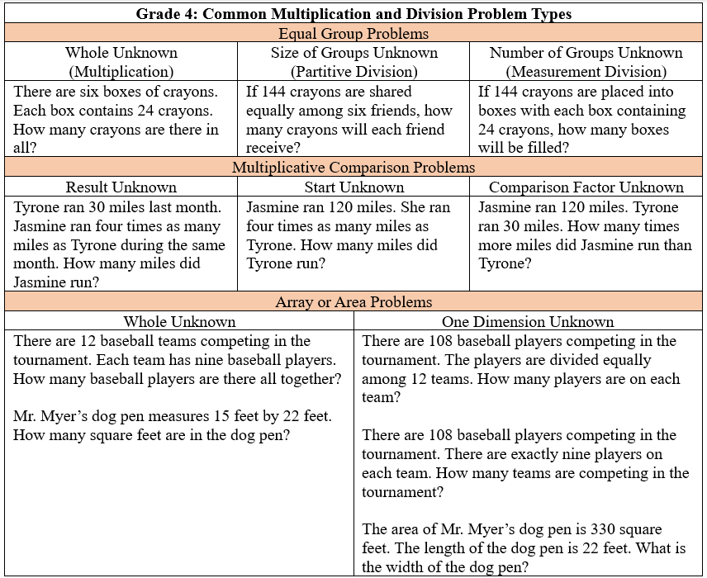
- Students need exposure to various types of contextual division problems in which they must interpret the quotient and remainder based on the context. The chart below includes an example of each type of problem.
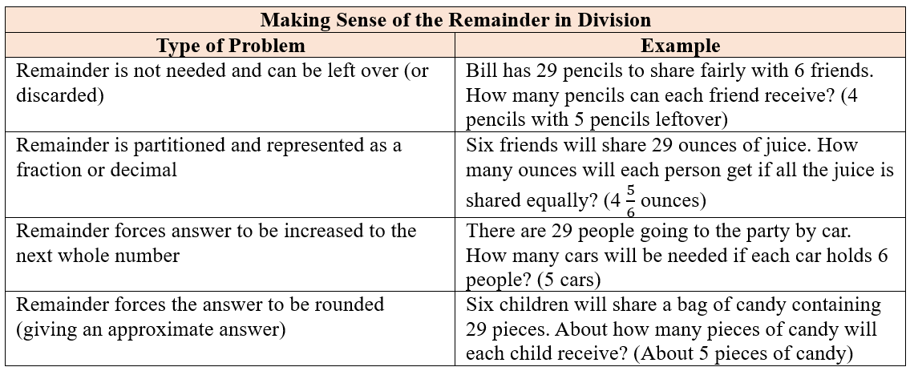
- Bar diagrams serve as a model that can provide students ways to visualize, represent, and understand the relationship between known and unknown quantities and to solve problems.
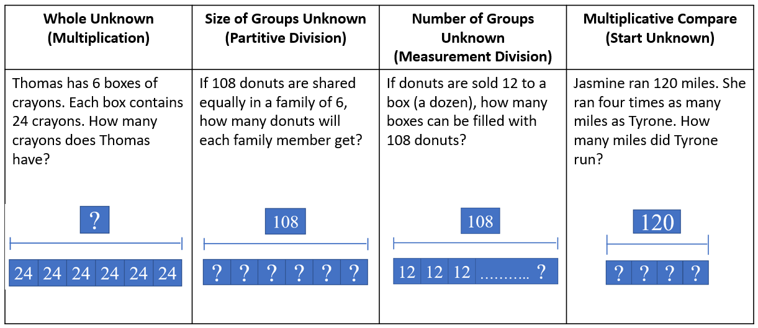
- Students will solve problems involving the division of decimals in Grade 5.

4.CE.3 The student will estimate, represent, solve, and justify solutions to single-step problems, including those in context, using addition and subtraction of fractions (proper, improper, and mixed numbers with like denominators of 2, 3, 4, 5, 6, 8, 10, and 12), with and without models; and solve single-step contextual problems involving multiplication of a whole number (12 or less) and a unit fraction, with models.
Students will demonstrate the following Knowledge and Skills:
- Estimate and determine the sum or difference of two fractions (proper or improper) and/or mixed numbers, having like denominators limited to 2, 3, 4, 5, 6, 8, 10, and 12 (e.g., $\frac{3}{8}$ + $\frac{3}{8}$, 2$\frac{1}{5}$ + $\frac{4}{5}$, $\frac{7}{4}$ - $\frac{5}{4}$) and simplify the resulting fraction. Addition and subtraction with fractions may include regrouping.*
- Estimate, represent, solve, and justify solutions to single-step contextual problems using addition and subtraction with fractions (proper or improper) and/or mixed numbers, having like denominators limited to 2, 3, 4, 5, 6, 8, 10, and 12, and simplify the resulting fraction. Addition and subtraction with fractions may include regrouping.
- Solve single-step contextual problems involving multiplication of a whole number, limited to 12 or less, and a unit fraction (e.g., 6 × $\frac{1}{3}$, $\frac{1}{5}$ × 8, 2 × $\frac{1}{10}$), with models.*
- Apply the inverse property of multiplication in models (e.g., use a visual fraction model to represent $\frac{4}{4}$ or 1 as the product of 4 × $\frac{1}{4}$).
* On the state assessment, items measuring this objective are assessed without the use of a calculator.

4.CE.3 The student will estimate, represent, solve, and justify solutions to single-step problems, including those in context, using addition and subtraction of fractions (proper, improper, and mixed numbers with like denominators of 2, 3, 4, 5, 6, 8, 10, and 12), with and without models; and solve single-step contextual problems involving multiplication of a whole number (12 or less) and a unit fraction, with models.
Additional Content Background and Instructional Guidance:
- Students should have exposure to a variety of representations of fractions, both concrete and pictorial (e.g., fraction bars, fraction circles, length models, area models, set models).
- Reasonable estimates to problems involving addition and subtraction of fractions can be established by using benchmarks such as 0, $\frac{1}{2}$, and 1. For example, $\frac{3}{5}$ and $\frac{4}{5}$ are both greater than $\frac{1}{2}$, so their sum is greater than 1.
- Students should investigate addition and subtraction with fractions using a variety of models (e.g., fraction circles, fraction strips, pattern blocks, number lines, rulers).
- Students should explore composing and decomposing fractions as a strategy for the addition and subtraction of fractions, as demonstrated in the example below.
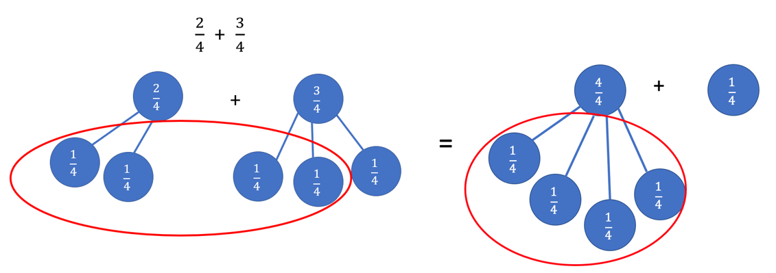
- Proper fractions, improper fractions, and mixed numbers are terms often used to describe fractions. A proper fraction is a fraction whose numerator is less than the denominator. An improper fraction is a fraction whose numerator is equal to or greater than the denominator. An improper fraction may be expressed as a mixed number. A mixed number is written with two parts: a whole number and a proper fraction (e.g., 3$\frac{5}{8}$).
- Instruction involving addition and subtraction of fractions should include experiences with proper fractions, improper fractions, and mixed numbers as addends, minuends, subtrahends, sums, and differences.
- In Grade 4, students are expected to solve fraction addition and subtraction problems that require regrouping. Some examples of regrouping using models are shown below.
  - Addition of Proper Fractions with Regrouping and Simplifying
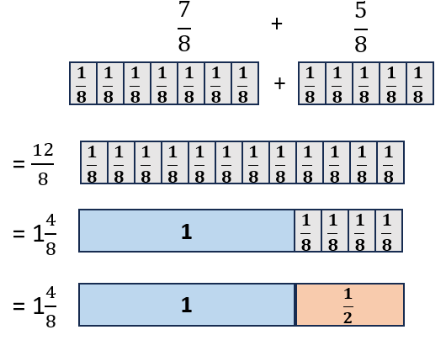

  - Addition of Mixed Numbers with Regrouping
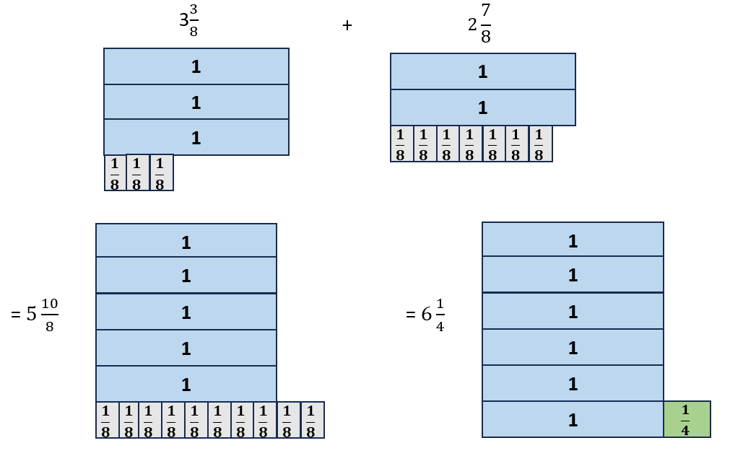
  - Subtraction of Mixed Numbers with Regrouping
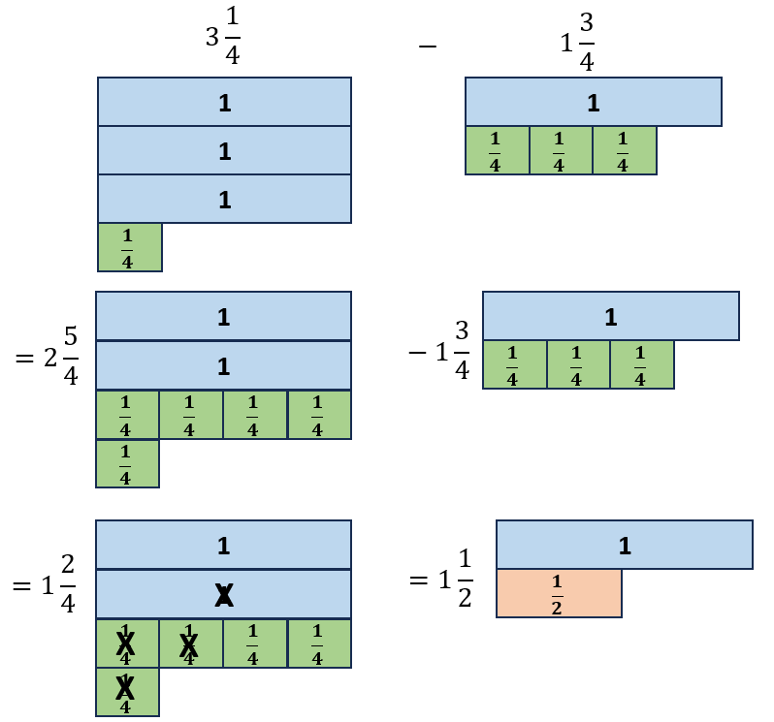
- Equivalent fractions are ways of describing the same quantity, the difference being in how the same size whole is partitioned. Simplifying fractions is finding the equivalent fraction with the fewest partitions represented in the denominator (e.g., $\frac{14}{12}$ can be simplified to $\frac{7}{6}$ because they are equivalent fractions and there are fewer partitions represented in the denominator. Each sixth is composed of two twelfths).
- A fraction is in simplest form when its numerator and denominator have no common factors other than one. The numerator can be greater than the denominator.
- In Grade 4, students should begin exploring multiplication with fractions by solving problems that involve a whole number and a unit fraction.
- Models for representing multiplication of fractions may include arrays, repeated addition, fraction strips or rods, and pattern blocks, paper folding, or other area models. The examples below show two ways to model 2 × $\frac{1}{3}$ using pattern blocks and a number bond.
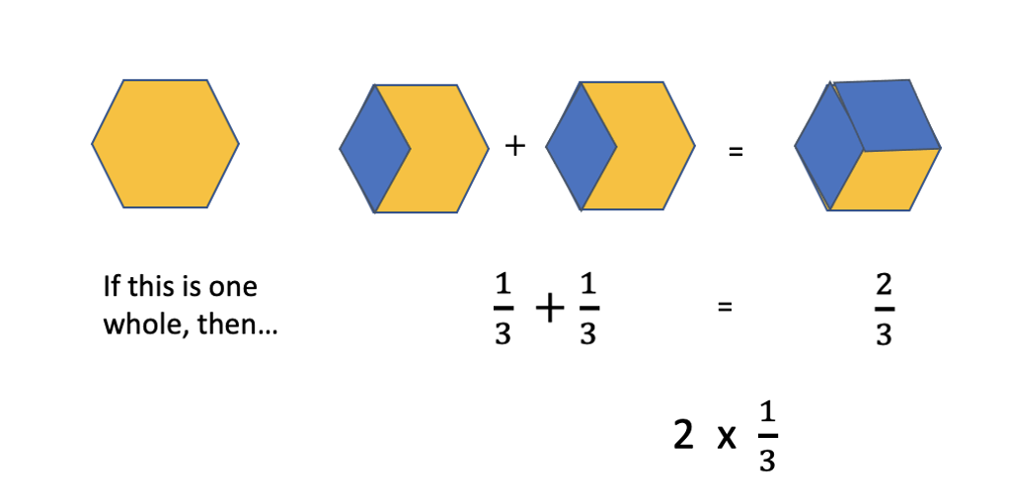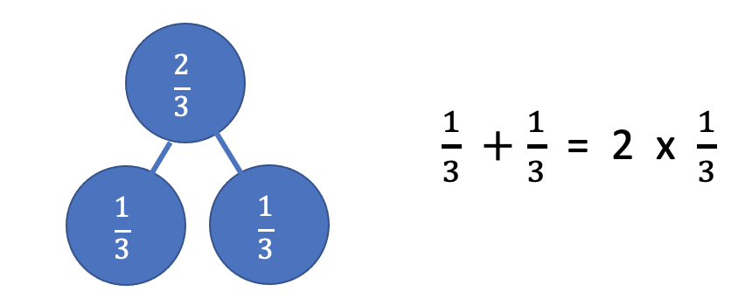
- When multiplying a whole number by a fraction such as 6 × $\frac{1}{2}$ , the meaning is the same as with multiplication of whole numbers: six groups the size of $\frac{1}{2}$ of the whole.
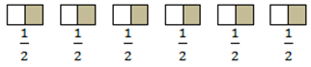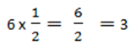
- When multiplying a fraction by a whole number such as $\frac{1}{2}$ × 6, we are trying to determine a part of the whole (e.g., one-half of six).
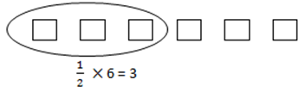
- The inverse property of multiplication states that every number has a multiplicative inverse, and the product of multiplicative inverses is 1 (e.g., 5 and $\frac{1}{5}$ are multiplicative inverses because 5 × $\frac{1}{5}$ = 1). The multiplicative inverse of a given number can be called the reciprocal of the number. Students at this level do not need to use the term for the properties of the operations.
- Examples of problems Grade 4 students should be able to solve include, but are not limited to, the following:
  - If nine children each bring $\frac{1}{3}$ cup of candy for the party, how many thirds will there be? What will be the total number of cups of candy?
  - If it takes $\frac{1}{4}$ cup of ice cream to fill an ice cream cone, how much ice cream will be needed to fill eight cones?

4.CE.4 The student will estimate, represent, solve, and justify solutions to single-step and multistep problems, including those in context, using addition and subtraction of decimals through the thousandths, with and without models.
Students will demonstrate the following Knowledge and Skills:
- Apply strategies (e.g., rounding to the nearest whole number, using compatible numbers) and algorithms, including the standard algorithm, to estimate and determine the sum or difference of two decimals through the thousandths, with and without models, in which:*
  - decimals do not exceed the thousandths; and
  - addends, subtrahends, and minuends are limited to four digits.
- Estimate, represent, solve, and justify solutions to single-step and multistep contextual problems using addition and subtraction of decimals through the thousandths.
* On the state assessment, items measuring this objective are assessed without the use of a calculator.

4.CE.4 The student will estimate, represent, solve, and justify solutions to single-step and multistep problems, including those in context, using addition and subtraction of decimals through the thousandths, with and without models.
Additional Content Background and Instructional Guidance:
- Addition and subtraction of decimals may be explored, using a variety of models (e.g., 10-by-10 grids, number lines, money).
- Students need a strong understanding of decimal place value to add and subtract decimal numbers accurately. They should be expected to solve a variety of problems such as 0.35 + 0.9; 1.7 – 0.55; or 0.3 + 0.637.
- The use of equivalent decimals may be necessary when solving addition and subtraction facts with decimals (e.g., 0.5 = 0.50 = 0.500).
- In problem solving, emphasis should be placed on thinking and reasoning rather than on key words. Focusing on key words such as in all, altogether, difference, etc. encourages students to perform a particular operation rather than make sense of the context of the problem. It prepares students to solve a very limited set of problems and often leads to incorrect solutions.

Measurement and Geometry
4.MG.1 The student will reason mathematically to solve problems, including those in context, that involve length, weight/mass, and liquid volume using U.S. Customary and metric units.
Students will demonstrate the following Knowledge and Skills:
- Determine an appropriate unit of measure to use when measuring:
  - length in both U.S. Customary (inch, foot, yard, mile) and metric units (millimeter, centimeter, meter);
  - weight/mass in both U.S. Customary (ounce, pound) and metric units (gram, kilogram); and
  - liquid volume in both U.S. Customary (cup, pint, quart, gallon) and metric units (milliliter, liter).
- Estimate and measure:
  - length of an object to the nearest U.S. Customary unit ($\frac{1}{2}$ inch, $\frac{1}{4}$ inch, $\frac{1}{8}$ inch, foot, yard) and nearest metric unit (millimeter, centimeter, or meter);
  - weight/mass of an object to the nearest U.S. Customary unit (ounce, pound) and nearest metric unit (gram, kilogram); and
  - liquid volume to the nearest U.S. Customary unit (cup, pint, quart, gallon) and nearest metric unit (milliliter, liter).
- Compare estimates of length, weight/mass, or liquid volume with the actual measurements.
- Given the equivalent measure of one unit, solve problems, including those in context, by determining the equivalent measures within the U.S. Customary system for:
  - length (inches and feet, feet and yards, inches and yards);
  - weight/mass (ounces and pounds); and
  - liquid volume (cups, pints, quarts, and gallons).

4.MG.1 The student will reason mathematically to solve problems, including those in context, that involve length, weight/mass, and liquid volume using U.S. Customary and metric units.
Additional Content Background and Instructional Guidance:
- The concept of a standard measurement unit is one of the major ideas in understanding measurement. Familiarity with standard units is developed through hands-on experiences of comparing, estimating, and measuring. Students benefit from opportunities to evaluate their estimates for reasonableness and refine their estimates in order to increase accuracy of future measurements.
- One unit of measure may be more appropriate than another to use when measuring an object, depending on the size of the object and the degree of accuracy desired. Real life experiences comparing the size of different units in order to select the most appropriate unit (e.g., measuring their desk in both inches and feet; measuring the length of the classroom in inches, feet, yards, millimeters, centimeters, and meters) help establish benchmarks and support a student’s ability to estimate length.
- The measurement of an object must include the unit of measure along with the number of iterations.
- Length is the distance between two points along a line.
- U.S. Customary units for measurement of length include inches, feet, yards, and miles. Appropriate measuring devices include rulers, yardsticks, and tape measures. Metric units for measurement of length include millimeters, centimeters, and meters. Appropriate measuring devices include centimeter rulers, meter sticks, and tape measures.
- The relationship between halves, fourths, and eighths as illustrated in length models forms a foundation for measuring fractional parts with measurement tools (Reference Understanding the Standard for 4.NS.3).
- Weight and mass are different. Mass is the amount of matter in an object. Weight is determined by the pull of gravity on the mass of an object. The mass of an object remains the same regardless of its location. The weight of an object changes depending on the gravitational pull at its location. In everyday life, most people are interested in determining an object’s mass, although they use the term weight (e.g., “How much does it weigh?” versus “What is its mass?”).
- Experiences measuring the weight/mass of familiar objects (e.g., foods, pencils, book bags, shoes) help to establish benchmarks and support a student’s ability to estimate weight/mass.
- There are a variety of measuring devices (e.g., balances, bathroom scales, food scales) to measure weight in U.S. Customary units (ounces, pounds) and metric units (grams, kilograms).
- Liquid volume is the amount of liquid a container can hold.
- U.S. Customary units for measurement of liquid volume include cups, pints, quarts, and gallons. Metric units for measurement of liquid volume include milliliters and liters.
- Students should measure the liquid volume of everyday objects in U.S. Customary units and metric units, and record the volume including the appropriate unit of measure (e.g., 24 gallons).
- Benchmarks of common objects need to be established for each of the specified units of measure (e.g., the liquid volume of a school lunch milk carton is about one cup, the length of a piece of blank paper is about one foot, a basketball is about one pound, etc.). Practical experiences measuring familiar objects help to establish benchmarks and support a student’s ability to estimate measures.
- Students at this level will be given the equivalent measure of one unit when asked to determine equivalencies between units in the U.S. Customary system. Some examples may include, but are not limited to:
  - 12 inches = 1 foot
  - 1 yard = 3 feet
  - 16 ounces = 1 pound
  - 1 pint = 2 cups
- For example, students will be given the information that one gallon is equivalent to four quarts. Then they will apply that relationship to determine:
  - the number of quarts in five gallons;
  - the number of gallons equal to 20 quarts;
  - When empty, Tim’s 10-gallon container can hold how many quarts?; or
  - Maria has 20 quarts of lemonade. How many empty one-gallon containers will she be able to fill?

4.MG.2 The student will solve single-step and multistep contextual problems involving elapsed time (limited to hours and minutes within a 12-hour period).
Students will demonstrate the following Knowledge and Skills:
- Solve single-step and multistep contextual problems involving elapsed time in hours and minutes, within a 12-hour period (within a.m., within p.m., and across a.m. and p.m.) when given:
  - the starting time and the ending time, determine the amount of time that has elapsed in hours and minutes;
  - the starting time and amount of elapsed time in hours and minutes, determine the ending time; or
  - the ending time and the amount of elapsed time in hours and minutes, determine the starting time.

4.MG.2 The student will solve single-step and multistep contextual problems involving elapsed time (limited to hours and minutes within a 12-hour period).
Additional Content Background and Instructional Guidance:
- Elapsed time is the amount of time that has passed between two given times.
- Elapsed time can be found by counting on from the starting time or counting back from the ending time.
- Elapsed time should be modeled and demonstrated using analog clocks, timelines, or t-charts.
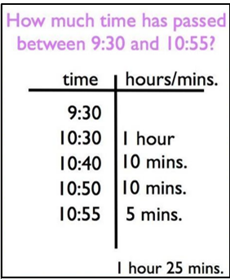
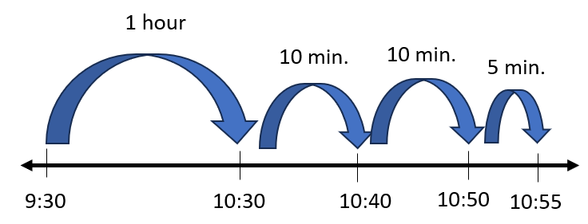

4.MG.3 The student will use multiple representations to develop and use formulas to solve problems, including those in context, involving area and perimeter limited to rectangles and squares (in both U.S. Customary and metric units).
Students will demonstrate the following Knowledge and Skills:
- Use concrete materials and pictorial models to develop a formula for the area and perimeter of a rectangle (including a square).
- Determine the area and perimeter of a rectangle when given the measure of two adjacent sides (in whole number units), with and without models.
- Determine the area and perimeter of a square when given the measure of one side (in whole number units), with and without models.
- Use concrete materials and pictorial models to explore the relationship between area and perimeter of rectangles.
- Identify and represent rectangles with the same perimeter and different areas or with the same area and different perimeters.
- Solve contextual problems involving area and perimeter of rectangles and squares.

4.MG.3 The student will use multiple representations to develop and use formulas to solve problems, including those in context, involving area and perimeter limited to rectangles and squares (in both U.S. Customary and metric units).
Additional Content Background and Instructional Guidance:
- In Grade 3, students determined the area of a given polygon by counting the number of square units needed to cover the polygon and explained the usefulness of area as a measurement in a contextual situation. Students also used U.S. Customary and metric units to measure the distance around a polygon with no more than six sides to determine the perimeter, and explained the usefulness of perimeter as a measurement in a contextual situation.
- Area is the surface included within a plane figure. Area is measured by the number of square units needed to cover a surface or plane figure (e.g., the area of the book cover is 90 square inches or 90 in.²).
- Transparent grids or geoboards are useful tools for exploring the area of a figure. Connections can be made to arrays and the area model of multiplication, and can support the investigation, development, and use of the area formula.
- Perimeter is the path or distance around any plane figure. To determine the perimeter of any polygon, determine the sum of the lengths of the sides (e.g., the perimeter of the book cover is 38 inches).
- Students should use concrete materials to investigate, develop, and use the formulas for the area of a rectangle (including a square):
  - Area of a square = side length × side length
  - Area of rectangle = length × width
- Students should use concrete materials to investigate, develop, and use the formulas for the perimeter of a rectangle (including a square):
  - Perimeter of a square = side length + side length + side length + side length
  - Perimeter of a square = 4 × side length
  - Perimeter of rectangle = side length + side length + side length + side length
  - Perimeter of rectangle = (2 × length) + (2 × width)
- As rectangles and squares are explored, the idea of congruent sides should be emphasized (e.g., the perimeter of a square is 4 × side length because all four sides are congruent). The perimeter or area of a rectangle can also be determined when provided the measures of two adjacent sides. Adjacent sides are any two sides of a figure that share a common vertex.
- Students should use a variety of concrete materials (e.g., color tiles, inch squares, grid paper) when creating rectangles with the same area but different perimeters and creating rectangles with the same perimeter but different areas. This is important for helping to understand the relationship between area and perimeter. See examples below.
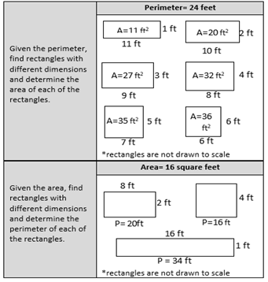
- Perimeter and area should always be labeled with the appropriate unit of measure.
- The exploration of area and perimeter lends itself to contextual problems that have multiple solutions. For example, if Joan has 16 feet of fencing to put around a rectangular garden, what could be the dimensions of her garden? Similarly, if Jack wanted to create a dog pen with an area of 24 square feet, how many feet of fencing would he need?

4.MG.4 The student will identify, describe, and draw points, rays, line segments, angles, and lines, including intersecting, parallel, and perpendicular lines.
Students will demonstrate the following Knowledge and Skills:
- Identify and describe points, lines, line segments, rays, and angles, including endpoints and vertices.
- Describe endpoints and vertices in relation to lines, line segments, rays, and angles.
- Draw representations of points, line segments, rays, angles, and lines, using a ruler or straightedge.
- Identify parallel, perpendicular, and intersecting lines and line segments in plane and solid figures, including those in context.
- Use symbolic notation to name points, lines, line segments, rays, angles, and to describe parallel and perpendicular lines.

4.MG.4 The student will identify, describe, and draw points, rays, line segments, angles, and lines, including intersecting, parallel, and perpendicular lines.
Additional Content Background and Instructional Guidance:
- Points, lines, line segments, rays, and angles, including endpoints and vertices, are fundamental components of noncircular geometric figures.
- A point is an exact location in a plane and in space. It has no length, width, or height. A point is usually named with a capital letter.
- A line is a collection of points extending infinitely in both directions. It has no endpoints. When a line is drawn, at least two points on it can be marked and given capital letter names. Arrows must be drawn to show that the line goes on infinitely in both directions (e.g., $\overset{⃡}{AB}$ is read as “line AB”).
- A line segment is a part of a line. It has two endpoints and includes all the points between and including the endpoints. To name a line segment, name the endpoints (e.g., $\overline{AB}$ is read as “line segment AB”).
- A ray is a part of a line. It has one endpoint and extends infinitely in one direction. To name a ray, say the name of its endpoint first and then say the name of one other point on the ray (e.g., $\vec{AB}$ is read as “ray AB”).
- An angle is formed by two rays that share a common endpoint called the vertex. Angles are found wherever lines or line segments intersect.
- An angle can be named in three different ways by using:
  - three letters in order: a point on one ray, the vertex, and a point on the other ray;
  - one letter at the vertex; or
  - a number written inside the rays of the angle.
- A vertex is the point at which two lines, line segments, or rays meet to form an angle. In solid figures, a vertex is the point at which three or more edges meet.
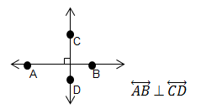
- Lines in a plane either intersect or are parallel. Perpendicularity is a special case of intersection.
- Intersecting lines have one point in common.
- Perpendicular lines intersect at right angles. The symbol ⊥ is used to indicate that two lines are perpendicular. For example, the notation $\overset{⃡}{AB}⊥\overset{⃡}{CD}$ is read as “line AB is perpendicular to line CD.”
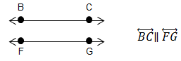
- Parallel lines lie in the same plane and never intersect. Parallel lines are always the same distance apart and do not share any points. The symbol ∥ indicates that two or more lines are parallel. For example, the notation $\overset{⃡}{BC}$∥$\overset{⃡}{FG}$ is read as “line BC is parallel to line FG.”

4.MG.5 The student will classify and describe quadrilaterals (parallelograms, rectangles, squares, rhombi, and/or trapezoids) using specific properties and attributes.
Students will demonstrate the following Knowledge and Skills:
- Develop definitions for parallelograms, rectangles, squares, rhombi, and trapezoids through the exploration of properties and attributes.
- Identify and describe points, line segments, angles, and vertices in quadrilaterals.
- Identify and describe parallel, intersecting, perpendicular, and congruent sides in quadrilaterals.
- Compare, contrast, and classify quadrilaterals (parallelograms, rectangles, squares, rhombi, and/or trapezoids) based on the following properties and attributes:
  - parallel sides;
  - perpendicular sides;
  - congruence of sides; and
  - number of right angles.
- Denote properties of quadrilaterals and identify parallel sides, congruent sides, and right angles by using geometric markings.
- Use symbolic notation to name line segments and angles in quadrilaterals.

4.MG.5 The student will classify and describe quadrilaterals (parallelograms, rectangles, squares, rhombi, and/or trapezoids) using specific properties and attributes.
Additional Content Background and Instructional Guidance:
- The study of geometric figures must be active, using visual images and concrete materials (e.g., graph paper, pattern blocks, geoboards, geometric solids, computer software tools).
- The study of polygons is rich with geometry vocabulary. At this level, students are expected to accurately use the following vocabulary:
  - A polygon is a closed plane figure composed of at least three line segments that do not cross.
    - A quadrilateral is a polygon with four sides.
    - A parallelogram is a quadrilateral with both pairs of opposite sides parallel and congruent.
    - A rectangle is a quadrilateral with four right angles, and opposite sides that are parallel and congruent.
    - A rhombus is a quadrilateral with four congruent sides. Opposite sides are congruent and parallel, and opposite angles are congruent.
    - A square is a special type of rectangle that has four congruent sides in addition to four right angles. A square is also a special type of rhombus that has four right angles in addition to four congruent sides.
    - A trapezoid is a quadrilateral with exactly one pair of parallel sides.
- The shortest distance between two points in a plane, a flat surface, is a line segment.
- Lines either intersect or are parallel. Intersecting lines have exactly one point in common.
- Perpendicularity is a special case of intersection. Perpendicular lines and line segments intersect at right angles. The symbol ⊥ is used to indicate that two lines or line segments are perpendicular. For example, in the image below, the notation $\overline{AB}$ ⊥ $\overline{AC}$ is read as “line segment AB is perpendicular to line segment AC.”
- Parallel lines lie in the same plane and never intersect. Parallel lines are always the same distance apart and do not share any points. The symbol ∥ indicates that two or more lines or line segments are parallel. For example, in the image below, the notation $\overline{BC}$ ∥ $\overline{FG}$ is read as “line segment BC is parallel to line segment FG.”
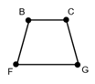
- Congruent figures have the same size and shape. Congruent sides have the same length. Congruent angles have the same measure.
- The geometric markings shown on the rectangle below indicate parallel sides with an equal number of arrows, congruent sides indicated with an equal number of hatch (hash) marks, and right angle with a square symbol.
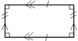
- Students should have opportunities to use geometric markings in figures to indicate congruence of sides and angles and to indicate parallel sides.

4.MG.6 The student will identify, describe, compare, and contrast plane and solid figures according to their characteristics (number of angles, vertices, edges, and the number and shape of faces), with and without models.
Students will demonstrate the following Knowledge and Skills:
- Identify concrete models and pictorial representations of solid figures (cube, rectangular prism, square pyramid, sphere, cone, and cylinder).
- Identify and describe solid figures (cube, rectangular prism, square pyramid, and sphere) according to their characteristics (number of angles, vertices, edges, and by the number and shape of faces).
- Compare and contrast plane and solid figures (limited to circles, squares, triangles, rectangles, spheres, cubes, square pyramids, and rectangular prisms) according to their characteristics (number of sides, angles, vertices, edges, and the number and shape of faces).

4.MG.6 The student will identify, describe, compare, and contrast plane and solid figures according to their characteristics (number of angles, vertices, edges, and the number and shape of faces), with and without models.
Additional Content Background and Instructional Guidance:
- Students’ experiences with plane and solid figures should be hands-on and relevant to their environment.
- The study of plane and solid figures is rich with geometry vocabulary. At this level, students are expected to accurately use the following vocabulary:
- A plane figure is any closed, two-dimensional shape.
- A solid figure is three-dimensional, having length, width, and height.
- A vertex is the point at which three or more edges meet in a solid figure.
- A face is any flat surface of a solid figure.
- An edge is the line segment where two faces of a solid figure intersect.
- An angle is formed by two rays with a common endpoint called the vertex. Angles are found wherever lines and/or line segments intersect.
- A cube is a solid figure with six congruent, square faces. All edges are the same length. A cube has eight vertices and 12 edges.
- A rectangular prism is a solid figure in which all six faces are rectangles. A rectangular prism has eight vertices and 12 edges. A cube is a special case of a rectangular prism.
- A sphere is a solid figure with all its points the same distance from its center.
- A square pyramid is a solid figure with a square base and four faces that are triangles with a common vertex. A square pyramid has five vertices and eight edges.
- Characteristics of solid figures included at this grade level are defined in the chart below:
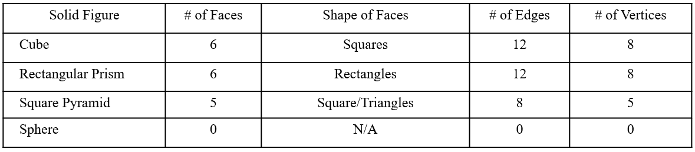

Probability and Statistics
4.PS.1 The student will apply the data cycle (formulate questions; collect or acquire data; organize and represent data; and analyze data and communicate results) with a focus on line graphs.
Students will demonstrate the following Knowledge and Skills:
- Formulate questions that require the collection or acquisition of data.
- Determine the data needed to answer a formulated question and collect or acquire existing data (limited to 10 or fewer data points) using various methods (e.g., observations, measurements, experiments).
- Organize and represent a data set using line graphs with a title and labeled axes with whole number increments, with and without the use of technology tools.
- Analyze data represented in line graphs and communicate results orally and in writing:
  - describe the characteristics of the data represented in a line graph and the data as a whole (e.g., the time period when the temperature increased the most);
  - identify parts of the data that have special characteristics and explain the meaning of the greatest, the least, or the same (e.g., the highest temperature shows the warmest day);
  - make inferences about data represented in line graphs;
  - draw conclusions about the data and make predictions based on the data to answer questions; and
  - solve single-step and multistep addition and subtraction problems using data from line graphs.

4.PS.1 The student will apply the data cycle (formulate questions; collect or acquire data; organize and represent data; and analyze data and communicate results) with a focus on line graphs.
Additional Content Background and Instructional Guidance:
- Students should explore the entire data cycle with a question and set of data that has been collected or acquired. Student reflection should occur throughout the data cycle. The data cycle includes the following steps: formulating questions to be explored with data, collecting or acquiring data, organizing and representing data, and analyzing and communicating results.
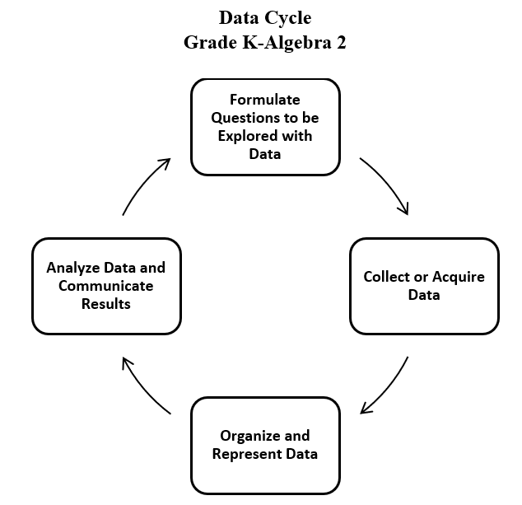
- Statistics is the science of conducting studies to collect, organize, summarize, analyze, and draw conclusions from data.
- The emphasis in all work with statistics should be on the analysis of the data and the communication of the analysis. Data analysis should include opportunities to describe the data, recognize patterns or trends, and make predictions.
- Statistical investigations should be active, with students formulating questions about something in their environment and determining ways to answer the questions.
- The following activities should be student generated at this level:
  - formulating questions about something in the student’s environment that yields data that changes over time;
  - predicting answers to questions under investigation;
  - collecting and representing initial data;
  - determining whether the data answer the questions asked.
- Data are pieces of information collected about people or things. The primary purpose of collecting data is to answer questions. The primary purpose of interpreting data is to inform decisions (e.g., which type of clothing to pack for a trip based on a weather graph or which type of lunch to serve based upon class favorites).
- Investigations involving practical data should occur frequently; data can be collected through brief class polls or through more extended experiments/projects occurring over multiple days.
- The teacher can provide data sets to students in addition to students engaging in their own data collection or acquisition.
- Technology tools can be used to collect, organize, and visualize data. These tools support progression to analysis of data in a more efficient manner.
- There are two types of data: categorical (e.g., qualitative) and numerical (e.g., quantitative). Categorical data are observations about characteristics that can be sorted into groups or categories, while numerical data are values or observations that can be measured. For example, types of fish caught would be categorical data while weights of fish caught would be numerical data. While students need to be aware of the differences, at this level, they do not have to know the terms for each type of data.
- In Grade 3, students had experiences with categorical data represented in bar graphs and pictographs.
- In Grade 4, students are expected to engage with numerical data that changes over time and is represented in line graphs.
- Line graphs are used to represent quantitative data collected about a specific subject and over a specific time interval. All the data points are plotted on a coordinate grid and the points are connected by a line. A line graph of a data set shows when change is increasing, decreasing, or staying the same over short intervals of time and over the entire period of time.
- The values along the horizontal axis of a line graph represent continuous data, usually some measure of time (e.g., time in years, months, or days). The data presented on a line graph is referred to as “continuous data,” as it represents data collected over a continuous period of time.
- The values represented on the vertical axis represent the data collected for what is being measured at each increment of time. The scale values on the vertical axis should represent equal increments of multiples of whole numbers depending upon the data being collected. Plot a point to represent the data collected for each time increment. Use line segments to connect the points in order moving left to right.
- Scales shown on the horizontal and vertical axes label increments of the graph. Students should have experience with various increments when creating line graphs limited to multiples of 1, 2, 5, 10, or 100. The scale should extend one increment above the greatest recorded piece of data.
- Each axis should be labeled, and the graph should be given a title.
- Comparing different types of representations (tables and line graphs) provide students an opportunity to learn how different representations can show different aspects of the same data.
- Tables are one way to organize the exact data collected and display numerical information. They do not show visual comparisons, which generally means it takes longer to understand or to observe trends.
- A trend is the general direction in which something is developing or changing over time. A projection is a prediction of future change. Trends and projections are usually illustrated using line graphs in which the horizontal axis represents time.
- Examining a line graph from left to right shows how one variable changes over time and reveals trends or progress of change in the data collected over time.
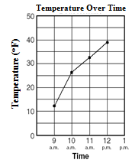
- Examples of some questions that could be explored in comparing the table to a line graph below include: In which representation do you readily see the increase or decrease of temperature over time? In which representation is it easiest to determine when the greatest rise in temperature occurred? In which representation can you draw some conclusions about what the temperature will be at the next measurement time?

Time | Temperature
9 a.m. | 12
10 a.m. | 26
11 a.m. | 33
12 p.m. | 39

- Students are interested in and notice individual data points and are able to describe parts of the data — where their own data falls on the graph, which value occurs most frequently, and which values are the largest and smallest. It is important to develop student understanding as they begin to think about the set of data as a whole.
- Data analysis helps describe data, recognize patterns or trends, and make predictions.
- Statements representing an analysis and interpretation of the characteristics of the data in the line graph should be included (e.g., patterns or trends of increase and/or decrease, and least and greatest data value).
- Students should interpret data by making observations from line graphs by describing the characteristics of the data and the data as a whole (e.g., the time period when the temperature increased the most, similarities and differences, the total number over a period of time, the time period during which no change occurred).

4.PS.2 The student will model and determine the probability of an outcome of a simple event.
Students will demonstrate the following Knowledge and Skills:
- Describe probability as the degree of likelihood of an outcome occurring using terms such as impossible, unlikely, equally likely, likely, and certain.
- Model and determine all possible outcomes of a given simple event where there are no more than 24 possible outcomes, using a variety of manipulatives (e.g., coins, two-sided counters, number cubes, spinners).
- Write the probability of a given simple event as a fraction between 0 and 1, where there are no more than 24 possible outcomes.
- Determine the likelihood of an event occurring and relate it to its whole number or fractional representation (e.g., impossible or zero; equally likely; certain or one).
- Create a model or contextual problem to represent a given probability.

4.PS.2 The student will model and determine the probability of an outcome of a simple event.
Additional Content Background and Instructional Guidance:
- Probability is the measure of likelihood that an event will occur. An event is a collection of outcomes from an investigation or experiment.
- A spirit of investigation and experimentation should permeate probability instruction, where students are actively engaged in explorations and have opportunities to use manipulatives.
- For an event such as flipping a coin, the things that can happen are called outcomes. For example, there are two possible outcomes when flipping a coin: the coin can land heads up, or the coin can land tails up. The two possible outcomes, heads up or tails up, are equally likely which can be expressed as $\frac{1}{2}$.
- If all outcomes of an event are equally likely, the probability of an event can be expressed as a fraction, where the numerator represents the number of favorable outcomes, and the denominator represents the total number of possible outcomes. If all the outcomes of an event are equally likely to occur, the probability of the event is equal to:
$$\frac{number of favorable outcomes}{total number of possible outccomes}$$
- Probability is quantified as a number between 0 and 1 and may be represented on a number line.
- An event is “impossible” if it has a probability of zero (e.g., if eight balls are in a bag, four yellow and four blue, it is impossible that a red ball could be selected).
- An event is “certain” if it has a probability of one (e.g., if ten pennies are in a bag, the probability of selecting a penny is certain).
- For another event such as spinning a spinner that is one-third red and two-thirds blue, the two outcomes, red and blue, are not equally likely.
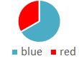
- Equally likely events can be represented with fractions of equivalent value. For example, on a spinner with eight sections of equal size, where three of the eight sections are labeled G (green) and three of the eight sections are labeled B (blue), the chances of landing on green or on blue are equally likely; the probability of each of these events is the same, or $\frac{3}{8}$.
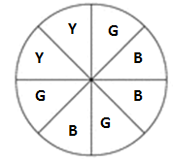
- In Grade 4, students are not expected to simplify the fraction that represents the probability of a contextual situation.
- Models or contextual problem may be created to represent a given probability. For example, if asked to create a box of marbles where the probability of selecting a black marble is $\frac{4}{8}$, sample responses might include:

- When a probability experiment has very few trials, the results can be misleading. The more times an experiment is done, the closer the experimental probability comes to the theoretical probability (e.g., a coin lands heads up half of the time). Students should have experiences using the results of a statistical investigation to predict what might occur in the future and justify the reasoning behind the prediction. For example, when given a table showing the results of randomly pulling marbles from a bag, students predict the next color that might be pulled and justify their prediction.
- Experiences with probability that involve combinations will occur in Grade 5 (e.g., How many different outfits can be made given three shirts and two pairs of pants?).

Patterns, Functions, and Algebra
4.PFA.1 The student will identify, describe, extend, and create increasing and decreasing patterns (limited to addition, subtraction, and multiplication of whole numbers), including those in context, using various representations.
Students will demonstrate the following Knowledge and Skills:
- Identify, describe, extend, and create increasing and decreasing patterns using various representations (e.g., objects, pictures, numbers, number lines, input/output tables, and function machines).
- Analyze an increasing or decreasing single-operation numerical pattern found in lists, input/output tables, or function machines and generalize the change to identify the rule, extend the pattern, or identify missing terms.
- Given a rule, create increasing and decreasing patterns using numbers and input/output tables (including function machines).
- Solve contextual problems that involve identifying, describing, and extending increasing and decreasing patterns using single-operation input and output rules.

4.PFA.1 The student will identify, describe, extend, and create increasing and decreasing patterns (limited to addition, subtraction, and multiplication of whole numbers), including those in context, using various representations.
Additional Content Background and Instructional Guidance:
- The ability to recognize, interpret, and generalize patterns supports understanding of many mathematical concepts. In the primary grades, students develop the knowledge and skills to recognize regularity in a sequence of numbers or shapes found in repeating patterns. In Grade 3, students worked with sequences of numbers or shapes to recognize and describe increasing growing patterns. In Grade 4, students are expected to apply generalizations to extend patterns and find missing terms. The foundation of observing relationships leads to identifying rules for the relationships, which is foundational knowledge for algebra and the study of functions.
- Patterns and functions can be represented in many ways and described using words, tables, graphs, and symbols.
- Patterning activities should be introduced by making connections between concrete materials and numerical representations (e.g., number sequences, tables, description).
- In Grade 4, numerical patterns will focus on growing patterns (both increasing and decreasing) involving addition, subtraction, multiplication, and division of whole numbers.
- Opportunities to explore increasing and decreasing growing patterns using concrete materials and calculators are important. Calculators are valuable tools for generating and analyzing patterns. The emphasis is not on computation but on identifying and describing patterns.
- Sample growing patterns that can be represented as numerical (arithmetic) growing patterns include:
  - 2, 4, 8, 16, …;
  - 8, 10, 13, 17, …;
  - 325, 300, 275, 250…; and
  - 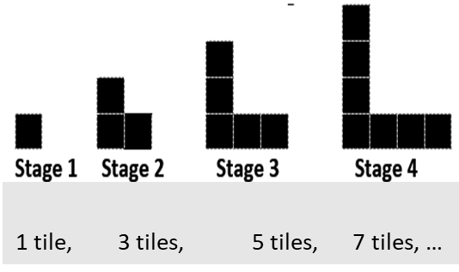
- At this level, input/output tables should be analyzed for a pattern to determine an unknown value or to describe the rule that explains how to find the output when given the input. Determining and applying rules builds the foundation for functional thinking. Sample input/output tables that require determination of the rule or missing terms can be found below:
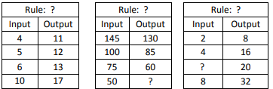
- Students will use various representations (e.g., number sequences, tables, concrete or pictorial models, verbal descriptions) for numerical patterns with whole numbers to solve contextual problems such as:
  - A group of players are coming to the end-of-season soccer celebration. One square table can seat 4 people, two square tables can seat 8 people, etc. How many people would be seated at five square tables? 13 square tables?
  - A community started a softball league for students in Grades 4 and 5. The first year there were 19 players. The second year there were 23 players. The third year there were 27 players, and the fourth year there were 31 players.
    - If this pattern continues, how many players will be in the league in the sixth year?
    - If this pattern continues, in which year will there be 55 players?

