2023 Mathematics Standards of Learning
Understanding the Standards – Grade 3

The Understanding the Standards document includes the mathematics understandings and key concepts that assist teachers in planning standards-focused instruction of the third grade 2023 Mathematics Standards of Learning. The Understanding the Standards includes definitions, explanations, and examples regarding each mathematics standard and describes what students should know (core knowledge) as a result of the instruction specific to the course/grade level.

Number and Number Sense
3.NS.1 The student will use place value understanding to read, write, and determine the place and value of each digit in a whole number, up to six digits, with and without models.
Students will demonstrate the following Knowledge and Skills:
- Read and write six-digit whole numbers in standard form, expanded form, and word form.
- Apply patterns within the base 10 system to determine and communicate, orally and in written form, the place and value of each digit in a six-digit whole number (e.g., in 165,724, the 5 represents 5 thousands and its value is 5,000).
- Compose, decompose, and represent numbers up to 9,999 in multiple ways, according to place value (e.g., 256 can be 1 hundred, 14 tens, 16 ones, but also 25 tens, 6 ones), with and without models.

3.NS.1 The student will use place value understanding to read, write, and determine the place and value of each digit in a whole number, up to six digits, with and without models.
Additional Content Background and Instructional Guidance:
- Experiences that relate to practical situations in students’ environments should be provided so that the reading and writing of large numbers becomes meaningful (e.g., the population of the school versus the school division, the number of seats in an auditorium versus a stadium, the number of letters in a word versus on a page).
- Numbers are arranged into groups of three places called periods (ones, thousands, millions, etc.). Places within the periods repeat (hundreds, tens, ones). Commas are used to separate the periods. Knowing the place value and period of a number helps students read and write numbers, and determine the value of a digit in any number.
- The structure of the base 10 number system is based upon a pattern of tens, where each place is ten times the value of the place to its right.
- Place value refers to the value of each digit and depends upon the position (place) of the digit in the number. In the number 7,864, the 8 is in the hundreds place, and the value of the 8 is eight hundred.
- Whole numbers may be written in a variety of formats, including:
  - standard: 123,456;
  - word or written: one hundred twenty-three thousand, four hundred fifty-six;
  - expanded: 100,000 + 20,000 + 3,000 + 400 + 50 + 6; or (1 x 100,000) + (2 x 10,000) + (3 x 1,000) + (4 x 100) + (5 x 10) + (6 x 1).
- Concrete materials that clearly illustrate the relationships among hundreds, tens, and ones, and are physically proportional (e.g., the tens piece is ten times larger than the ones piece) may be used to represent whole numbers. When moving beyond the concrete, non-proportional manipulatives such as number disks (e.g., 1, 10, 100, 1000) can be helpful in developing place value understanding of larger numbers.
- The ability to rename and think flexibly about numbers enhances a student's ability to make sense of algorithms. Decomposition of numbers in a variety of ways (e.g., 2,345 is 23 hundreds, 4 tens, and 5 ones; or 2 thousands, 34 tens, and 5 ones; or 22 hundreds, 13 tens, and 15 ones) supports understandings essential to the operations of addition/subtraction and multiplication/division. This flexibility builds background understanding for the ideas that students use when regrouping (e.g., when subtracting 18 from 174, a student may choose to regroup and think of 174 as 1 hundred, 6 tens, and 14 ones, while another student might regroup 174 as 1 hundred, 5 tens, and 24 ones, then subtract 18 from 24).

3.NS.2 The student will demonstrate an understanding of the base 10 system to compare and order whole numbers up to 9,999.
Students will demonstrate the following Knowledge and Skills:
- Compare two whole numbers, each 9,999 or less, using symbols (>, <, =, ≠) and/or words (greater than, less than, equal to, not equal to), with and without models.
- Order up to three whole numbers, each 9,999 or less, represented with and without models, from least to greatest and greatest to least.

3.NS.2 The student will demonstrate an understanding of the base 10 system to compare and order whole numbers up to 9,999.
Additional Content Background and Instructional Guidance:
- The ten-to-one place value relationship of numbers is helpful when comparing and ordering numbers.
- Numbers written in standard form are often more easily compared. Students are then able to use the number of digits in a whole number, and the place and value of those digits, to compare and order numbers.
- Numbers written in expanded form are also easy to compare, as the value of each digit in each place value is written out, making them easier to compare.
- A number line is one model that can be used when comparing and ordering numbers.
- Mathematical symbols (>, <) used to compare two unequal numbers are called inequality symbols. The equal symbol (=) means that the values on either side are equivalent (balanced). The not equal (≠) symbol means that the values on either side are not equivalent (not balanced).

3.NS.3 The student will use mathematical reasoning and justification to represent and compare fractions (proper and improper) and mixed numbers with denominators of 2, 3, 4, 5, 6, 8, and 10), including those in context.
Students will demonstrate the following Knowledge and Skills:
- Represent, name, and write a given fraction (proper or improper) or mixed number with denominators of 2, 3, 4, 5, 6, 8, and 10 using:
  - region/area models (e.g., pie pieces, pattern blocks, geoboards);
  - length models (e.g., paper fraction strips, fraction bars, rods, number lines); and
  - set models (e.g., chips, counters, cubes).
- Identify a fraction represented by a model as the sum of unit fractions.
- Use a model of a fraction greater than one to count the fractional parts to name and write it as an improper fraction and as a mixed number (e.g., $\frac{1}{4}$, $\frac{2}{4}$, $\frac{3}{4}$, $\frac{4}{4}$, $\frac{5}{4}$ = 1 $\frac{1}{4}$).
- Compose and decompose fractions (proper and improper) with denominators of 2, 3, 4, 5, 6, 8, and 10 in multiple ways (e.g., $\frac{7}{4}$ = $\frac{4}{4}$ + $\frac{3}{4}$ or $\frac{4}{6}$ = $\frac{3}{6}$ + $\frac{1}{6}$ = $\frac{2}{6}$ + $\frac{2}{6}$) with models.
- Compare a fraction, less than or equal to one, to the benchmarks of 0, $\frac{1}{2}$, and 1 using area/region models, length models, and without models.
- Compare two fractions (proper or improper) and/or mixed numbers with like numerators of 2, 3, 4, 5, 6, 8, and 10 (e.g., $\frac{2}{3}$ > $\frac{2}{8}$) using words (greater than, less than, equal to) and/or symbols (>, <, =), using area/region models, length models, and without models.
- Compare two fractions (proper or improper) and/or mixed numbers with like denominators of 2, 3, 4, 5, 6, 8, and 10 (e.g., $\frac{3}{6}$ <$\frac{4}{6}$) using words (greater than, less than, equal to) and/or symbols (>, <, =), using area/region models, length models, and without models.
- Represent equivalent fractions with denominators of 2, 3, 4, 5, 6, 8, or 10, using region/area models and length models.

3.NS.3 The student will use mathematical reasoning and justification to represent and compare fractions (proper and improper) and mixed numbers with denominators of 2, 3, 4, 5, 6, 8, and 10), including those in context.
Additional Content Background and Instructional Guidance:
- A fraction is a numerical way of representing part of a whole. Fractions can have different meanings: part-whole, measurement, division, ratio, and operator. When working with fractions, the whole must be defined. In Grade 3, fractions most commonly represent part-whole or measurement situations.
- The value of a fraction $\frac{a}{b}$ is dependent on both b, the number of equivalent parts in a whole (denominator), and a, the number of those parts being considered (numerator).
- A unit fraction is a fraction with a numerator of one (e.g., $\frac{1}{3}, \frac{1}{8}$).
- Proper fractions, improper fractions, and mixed numbers are terms often used to describe fractions. A proper fraction is a fraction that is less than one whole (i.e., a fraction whose numerator is less than the denominator). An improper fraction is a fraction that is greater than or equal to one whole (i.e., whose numerator is greater than or equal to the denominator). An improper fraction may also be expressed as a mixed number. A mixed number is written with two parts: a whole number and a proper fraction. The value of a mixed number is the sum of its two parts.
- Students should have opportunities to use models to count fractional parts that go beyond one whole. As a result of building the whole while they are counting, students will begin to generalize that when the numerator and the denominator are the same, there is one whole and when the numerator is larger than the denominator, there is more than one whole. They also will begin to see a fraction as the sum of unit fractions (e.g., three-fourths is the same as three one-fourths or six-sixths is the same as six one-sixths, which is equal to one whole). This provides students with a visual, as in the example below, for when one whole is reached and helps students develop a greater understanding of the relationship between the numerator and denominator.

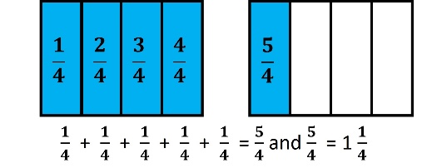
- Representations that students use in fraction explorations, activities, and during problem-solving help to develop specific fraction concepts. At this grade level, the three representations most used are region/area models, set models, or length/measurement models.
- In a region/area model (e.g., pie pieces, pattern blocks, geoboards, drawings), the whole is divided or partitioned into parts with areas of equivalent value. The region/area model is helpful with visualizing and understanding the part-whole relationship. The fractional parts are not always congruent and could have a different shape as shown in the middle example below:
- In a set model (e.g., chips, counters, cubes, drawings), the model is made up of discrete members of the set, where each member is an equivalent part of the set. The set model may be challenging for students who demonstrate limited understanding of the part-whole relationship. In set models, the whole needs to be defined, but members of the set may have different sizes and shapes. For example, if a whole is defined as a set of 10 shapes, the shapes within the set may be different. In the example below, stars represent $\frac{3}{10}$ of the set:
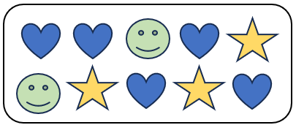
- In a length/measurement model (e.g., rods, connecting cubes, number lines, rulers, and drawings), each length represents an equal part of the whole. For example, given a narrow strip of paper, students could fold the strip into four equal parts, with each part representing one-fourth. Students will notice that there are four one-fourths in the entire length of the strip of paper that has been divided into fourths. Connecting a concrete or pictorial model to a representation of a number line helps students to make sense of the spaces that show the value of the fraction as shown below.
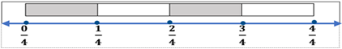
- A ruler is an important representation of the length model of fractions. When using rulers to measure length, students can make a connection to fractions and mixed numbers when they identify the points of the ruler that represent the lengths of halves, fourths, and eighths.
- Composing and decomposing fractions develops a deeper understanding of fractional concepts including the use of models, benchmarks, and equivalent forms to compare and order fractions as well as estimating size.
- Experiences at this level should include exploring and reasoning about comparing fractions in context (e.g., If a recipe requires one-half cup of sugar, and if there is one-third cup of sugar in the kitchen, will that be enough to make the recipe?)
- A variety of experiences focusing on comparing includes:
  - fractions with like denominators;
  - fractions with like numerators;
  - fractions that are more than one whole and less than one whole; and
  - fractions close to zero, close to one-half, and close to one whole.

3.NS.4 The student will solve problems, including those in context, that involve counting, comparing, representing, and making change for money amounts up to $5.00.
Students will demonstrate the following Knowledge and Skills:
- Determine the value of a collection of bills and coins whose total is $5.00 or less.
- Construct a set of bills and coins to total a given amount of money whose value is $5.00 or less.
- Compare the values of two sets of coins or two sets of bills and coins, up to $5.00, with words (greater than, less than, equal to) and/or symbols (>, <, =) using concrete or pictorial models.
- Solve contextual problems to make change from $5.00 or less by using counting on or counting back strategies with concrete or pictorial models.

3.NS.4 The student will solve problems, including those in context, that involve counting, comparing, representing, and making change for money amounts up to $5.00.
Additional Content Background and Instructional Guidance:
- Students benefit from engaging in everyday opportunities to count a collection of coins and one-dollar bills and compare two collections of coins and one-dollar bills whose total values are $5.00 or less.
- Representing the value of coins can be demonstrated using a variety of organizers such as 5- and 10-frames, hundreds charts, or proportional money pieces.
- The value of a collection of coins and bills can be determined by:
  - counting on;
  - beginning with the highest value; and/or
  - grouping the coins and bills into groups that are easier to count.
- Skip counting strategies can be beneficial when determining the value of groups of like coins.
- One strategy that can be used to make change during a purchase includes counting on by using coins and then bills (e.g., starting with the amount to be paid, the purchase price, and counting on until the amount given is reached). See the following example.
Haley is helping her mom in the Little League concession stand. A customer’s bill is $2.68, and he gives Haley a five-dollar bill to pay for his purchase. How could Haley use counting on to give the correct amount of change to the customer?
- An efficient way to return change is to count on as you lay down each coin or bill. If the customer’s purchase cost is $2.68, the change could be counted out in the following ways:
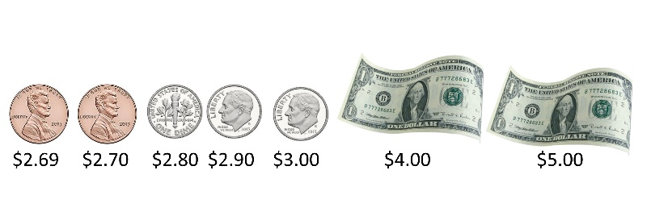
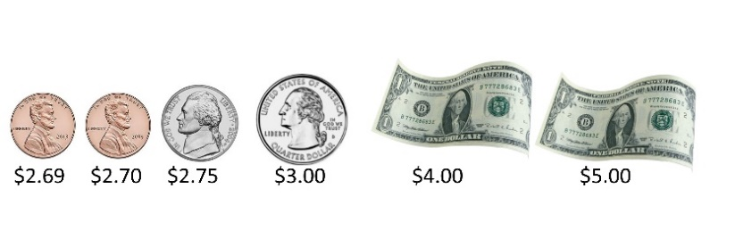

Computation and Estimation
3.CE.1 The student will estimate, represent, solve, and justify solutions to single-step and multistep problems, including those in context, using addition and subtraction with whole numbers where addends and minuends do not exceed 1,000.
Students will demonstrate the following Knowledge and Skills:
- Determine and justify whether an estimate or an exact answer is appropriate when solving single-step and multistep contextual problems involving addition and subtraction, where addends and minuends do not exceed 1,000.
- Apply strategies (e.g., rounding to the nearest 10 or 100, using compatible numbers, using other number relationships) to estimate a solution for single-step or multistep addition or subtraction problems, including those in context, where addends or minuends do not exceed 1,000.
- Apply strategies (e.g., place value, properties of addition, other number relationships) and algorithms, including the standard algorithm, to determine the sum or difference of two whole numbers where addends and minuends do not exceed 1,000.
- Identify and use the appropriate symbol to distinguish between expressions that are equal and expressions that are not equal (e.g., 256 - 13 = 220 + 23; 457 + 100 ≠ 557 + 100).
- Represent, solve, and justify solutions to single-step and multistep contextual problems involving addition and subtraction with whole numbers where addends and minuends do not exceed 1,000.

3.CE.1 The student will estimate, represent, solve, and justify solutions to single-step and multistep problems, including those in context, using addition and subtraction with whole numbers where addends and minuends do not exceed 1,000.
Additional Content Background and Instructional Guidance:
- Estimation skills are valuable, time-saving tools particularly in practical situations when exact answers are not required. Estimates can also be used in determining the reasonableness of the sum or difference when solving for the exact answer.
- An estimate is a number that lies within a range of the exact solution, and the estimation strategy used in a particular problem determines how close the estimate is to the exact solution.
- Estimates involve using friendlier numbers to mentally compute a reasonable answer before any exact computation is calculated.
- Reasons for estimation can be explored using practical experiences and various estimation strategies to solve contextual problems. When estimating, students should consider whether it is important that the estimate is greater than or less than the exact answer. This may inform the choice of estimation strategy. In the following examples using the same addends, each estimation strategy results in a different sum, so students should be encouraged to examine the context and the demand for precision when deciding which estimation strategy to use. Estimation strategies include rounding, using compatible numbers, and front-end estimation:
- Rounding numbers is one estimation strategy and may be introduced through the use of a number line. When given a number to round, use multiples of ten, hundred, or thousand as benchmarks and use the nearest benchmark value to represent the number. For example, using rounding to the nearest hundred to estimate the sum of 255 + 481 would result in 300 + 500 = 800.
- Using compatible numbers is another estimation strategy. Compatible numbers are two or more numbers that are easy to add and subtract mentally. For example, using compatible numbers to estimate the sum of 255 + 481 could result in 250 + 450 = 700.
- Using front-end estimation is another estimation strategy. Front-end estimation involves truncating numbers to the highest place value to compute. For example, using front-end estimation to estimate the sum of 255 + 481 would result in 200 + 400 = 600. Front end estimation may be more useful when working with larger numbers. While it is an efficient strategy, it may not be as accurate as other estimation strategies.
- Conceptual understanding and computational fluency are built by using various strategies and representations. Regrouping is used in addition and subtraction algorithms and can be challenging for many students to understand. Using concrete materials (e.g., base 10 blocks, connecting cubes, beans and cups, etc.) to explore, model, and stimulate discussion about a variety of problem situations helps students understand the concept of regrouping, and enables them to move from the concrete to the representational to the abstract (symbolic). Student-created representations, such as drawings, diagrams, tally marks, graphs, or written comments are strategies that help students make these connections that lead to developing computational fluency.
- ​​​Addition is the combining of quantities. Addition problems use the following terms:
  - addend → 423
  - addend → + 246
  - sum → 669
- Subtraction is the inverse of addition. Subtraction yields the difference between two numbers. Subtraction problems use the following terms:
  - minuend → 798
  - subtrahend → – 541
  - difference → 257
- Flexible methods of adding whole numbers by combining numbers in a variety of ways, most depending on place values, are useful. Grade 3 students continue to explore and apply the properties of addition as strategies for solving addition and subtraction problems using a variety of representations (e.g., manipulatives, diagrams, symbols).
- Place value strategies include:
  - Using base 10 blocks to model the operation;
  - Decomposing both numbers into expanded form and operating on individual place values (e.g., partial sums, partial differences);
  - Decomposing one number to count on or count back, with or without a number line;
  - Using the standard algorithm. ​
- The properties of the operations are “rules” about how numbers work and how they relate to one another. Students at this level do not need to use the formal terms for these properties but should utilize these properties to further develop flexibility and fluency in solving problems. The following properties of addition are most appropriate for exploration at this level:
  - the commutative property of addition, which states that changing the order of the addends does not affect the sum (e.g., 4 + 3 = 3 + 4); and
  - the associative property of addition, which states that the sum stays the same when the grouping of addends is changed (e.g., 15 + (35 + 16) = (15 + 35) + 16).
- Equivalent relationship strategies include:
  - decomposing values to reach compatible numbers; and
  - compensation strategies (e.g., subtracting the same value from both numbers in a subtraction problem or adding a value to one addend and subtracting the same value from the other addend in an addition problem).
- In problem solving, emphasis is placed on thinking and reasoning rather than on key words. Focusing on key words such as in all, altogether, difference, etc., encourages students to perform a particular operation rather than make sense of the context of the problem. A focus on key words prepares students to solve a limited set of problems and often leads to incorrect solutions as well as challenges or misconceptions in subsequent grades and courses.
- Reasoning about problem solving can be developed using comprehension strategies such as visualizing, retelling, or acting out problem situations.
- Students should experience a variety of problem types related to addition and subtraction. Examples are included in the following chart:
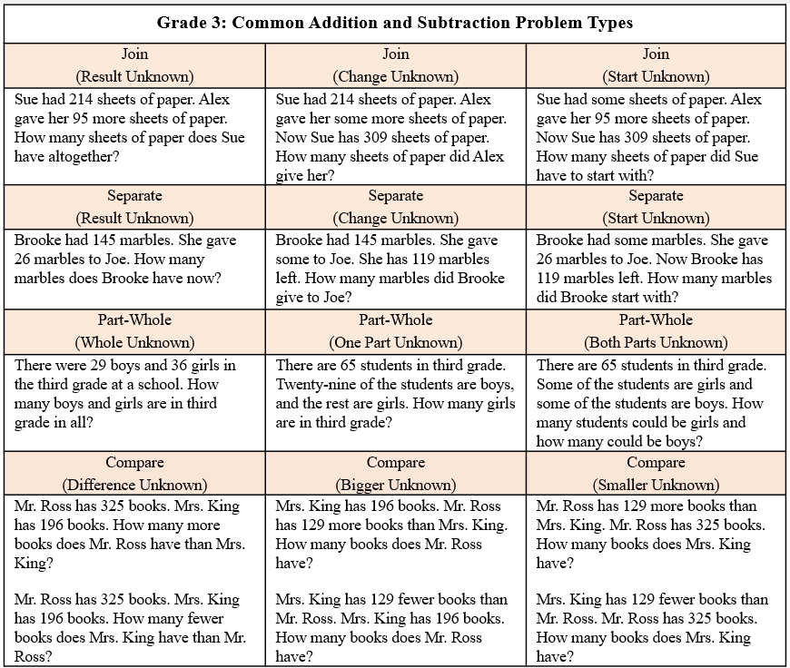
- Bar diagrams serve as a model that can provide students a way to visualize, represent, and understand the relationship between known and unknown quantities and to solve problems.
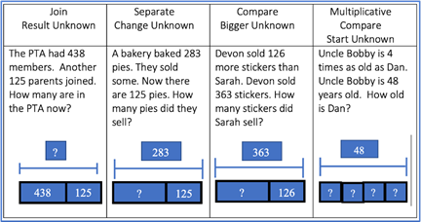
- Mathematical relationships can be expressed using equations (number sentences). A number sentence is an equation with numbers (e.g., 6 + 3 = 9; or 6 + 3 = 4 + 5).
- The equal symbol (=) means that the values on either side are equivalent (balanced). An equation can be represented using balance scales, with equal amounts on each side (e.g., 3 + 5 = 6 + 2).
- The not equal (≠) symbol means that the values on either side are not equivalent (not balanced).

3.CE.2 The student will recall with automaticity multiplication and division facts through 10 × 10; and represent, solve, and justify solutions to single-step contextual problems using multiplication and division with whole numbers.
Students will demonstrate the following Knowledge and Skills:
- Represent multiplication and division of whole numbers through 10 × 10, including in a contextual situation, using a variety of approaches and models (e.g., repeated addition/subtraction, equal-sized groups/sharing, arrays, equal jumps on a number line, using multiples to skip count).
- Use inverse relationships to write the related facts connected to a given model for multiplication and division of whole numbers through 10 × 10.
- Apply strategies (e.g., place value, the properties of multiplication and/or addition) when multiplying and dividing whole numbers.
- Demonstrate fluency with multiplication facts through 10 × 10 by applying reasoning strategies (e.g., doubling, add-a-group, subtract-a-group, near squares, and inverse relationships).
- Represent, solve, and justify solutions to single-step contextual problems that involve multiplication and division of whole numbers through 10 × 10.
- Recall with automaticity the multiplication facts through 10 × 10 and the corresponding division facts.
- Create an equation to represent the mathematical relationship between equivalent expressions using multiplication and/or division facts through 10 × 10 (e.g., 4 × 3 = 14 - 2, 35 ÷ 5 = 1 × 7).

3.CE.2 The student will recall with automaticity multiplication and division facts through 10 × 10; and represent, solve, and justify solutions to single-step contextual problems using multiplication and division with whole numbers.
Additional Content Background and Instructional Guidance:
- In Grade 2, students had experiences exploring skip counting patterns for 2s, 5s, and 10s, and building equal groups to represent those patterns. This content provides background knowledge to support initial understandings of multiplication.
- The terms associated with multiplication are listed below:
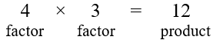
- The formats and terms associated with division are listed below:
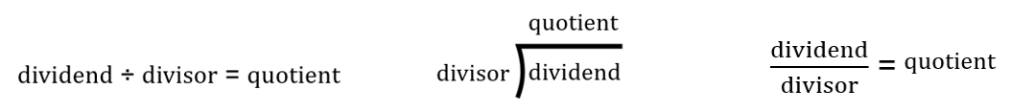
- Students develop an understanding of the meaning of multiplication and division of whole numbers through activities and contextual problems that involve equal-sets or equal-groups, arrays, and length models.
- The equal-sets or equal-groups model lends itself to sorting a variety of concrete objects into equal groups. It reinforces the concept of multiplication as a way to find the total number of items in a collection of groups, with the same amount in each group, using repeated addition or skip counting. The equal groups model represents division as fair shares by defining the number of groups and sharing items one by one until all items are equally distributed or by determining the number of equal groups of a given size required to exhaust all the items. The image below shows three groups of four circles, which can be represented as 4 + 4 + 4 = 12 or as 3 × 4 = 12. It could also be represented as 12 – 4 – 4 – 4 = 0 or as 12 ÷ 3 = 4 or as 12 ÷ 4 = 3.
- The array model consists of rows and columns (e.g., three rows of four columns for a 3-by-4 array). In a multiplication problem, the numbers of rows and columns represent the two factors, and the total number of squares represents the product. In a division problem, the total number of squares represents the dividend, and the number of the rows and columns represent the divisor and quotient.
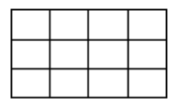
- The length model (e.g., a number line) reinforces the relationship between repeated addition (skip counting) and multiplication. For example, the model below shows 3 jumps of 4 or skip counting 4, 8, 12 to solve 3 × 4.
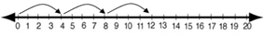
- The number line model can also be used to solve a division problem such as 6 ÷ 3 represented on the number line below by noting how many jumps of three are needed to go from six to zero (i.e., 6 ÷ 3 = 2).
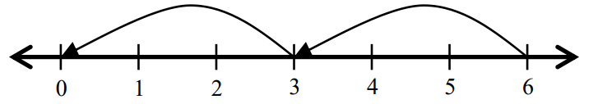
- Multiplication and division are inverse operations.
- Dividing by zero is undefined because it always leads to a contradiction. As demonstrated below, there is no single defined number possibility for r when dividing by 0, since zero multiplied by any number is zero:
  - If 12 ÷ 0 = r, then r × 0 = 12
- Computational fluency is the ability to think flexibly in order to choose appropriate strategies to solve problems accurately and efficiently. Students should develop fluency and recall with automaticity facts to 20.
- Flexibility requires knowledge of more than one approach to solving a particular kind of problem. Being flexible allows students to choose an appropriate strategy for the numbers involved.
- Accuracy is the ability to determine a correct answer using knowledge of number facts and other important number relationships.
- Efficiency is the ability to carry out a strategy easily when solving a problem without getting bogged down in too many steps or losing track of the logic of the strategy being used.
- The development of computational fluency relies on quick access to number facts. The patterns and relationships that exist in the facts can be used to learn and retain the facts. By studying patterns and relationships, students build a foundation for fluency with multiplication and division facts.
- By the end of Grade 3, students are expected to be able to recall with automaticity all multiplication and division facts through 10 × 10.
- Beginning with learning the foundational multiplication facts for 0, 1, 2, 5, and 10 allows students to utilize prior skip counting skills and the use of doubles to solve problems. Understanding and using the foundational facts can be helpful in ​​deriving and learning all multiplication facts. For example, decomposing one of the factors in 7 × 6 allows for the use of the foundational facts of 5s and 2s. This knowledge can be combined to learn the facts for 7 (e.g., 7 × 6 can be thought of as (5 × 6) + (2 × 6)).
- The properties of the operations are “rules” about how numbers work and how they relate to one another. Students at this level do not need to use the formal terms for these properties but should utilize these properties to further develop flexibility and fluency in solving problems. The following properties are most appropriate for exploration at this level:
  - The commutative property of multiplication states that changing the order of the factors does not affect the product (e.g., 2 × 3 = 3 × 2).
  - The identity property of multiplication states that multiplying a number by one results in a product that is the same as the given number (e.g., 7 × 1 = 7).
  - The associative property of multiplication states that the product stays the same when the grouping of factors is changed (e.g., 6 × (3 × 5) = (6 × 3) × 5).
  - The distributive property states that multiplying a sum by a number gives the same result as multiplying each addend by the number and then adding the products:
8 × 7 = 8 × (5 + 2)
8 × 7 = (8 × 5) + (8 × 2)
8 × 7 = 40 + 16
8 × 7 = 56
- Strategies that allow students to derive unknown multiplication facts include:
  - doubles (2s facts; double 9 is 18 so 9 × 2 = 18);
  - doubling twice (4s facts; double 6 is 12 and double 12 is 24 so 6 × 4 = 24);
  - doubling three times (8s facts; double 7 is 14 and double 14 is 28 and double 28 is 56 so 7 × 8 = 56);
  - halving (5s facts are half of ten; half of 80 is 40 so 8 × 5 = 40);
  - decomposing into known facts using the distributive property (e.g., 7 × 3 can be thought of as (5 × 3) + (2 × 3));
  - building up and building down from known facts (9 × 3 can be thought of as (10 × 3) – (1 × 3)).
- Strategies that allow students to derive unknown division facts include:
  - the inverse relationship between division and multiplication (5 × 3 = 15 so 15 ÷ 3 = 5);
  - halving (2s facts; half of 16 is 8 so 16 ÷ 2 = 8);
  - halving twice (4s facts; half of 28 is 14 and half of 14 is 7 so 28 ÷ 4 = 7); and
  - halving three times (8s facts; half of 48 is 24, half of 24 is 12, and half of 12 is 6 so 48 ÷ 8 = 6).
- Students should experience a variety of problem types related to multiplication and division. Some examples are included in the following chart:
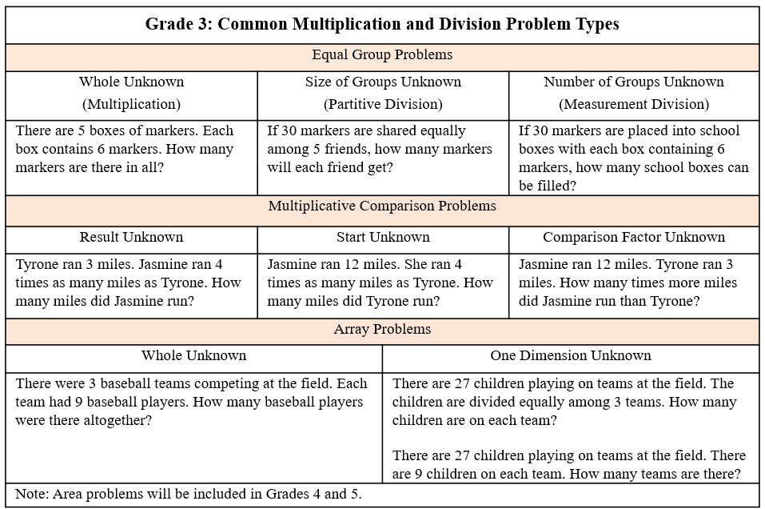
- An equation is a mathematical sentence in which two expressions are equivalent. It consists of two expressions, one on each side of an equal symbol (e.g., 6 × 3 = 18, 10 = 5 × 2, 4 × 3 = 2 × 6).
- An equation can be represented using balance scales, with equal amounts on each side (e.g., 4 × 1 = 2 + 2).

Measurement and Geometry
3.MG.1 The student will reason mathematically using standard units (U.S. Customary and metric) with appropriate tools to estimate and measure objects by length, weight/mass, and liquid volume to the nearest half or whole unit.
Students will demonstrate the following Knowledge and Skills:
- Justify whether an estimate or an exact measurement is needed for a contextual situation and choose an appropriate unit.
- Estimate and measure:
  - length of an object to the nearest U.S. Customary unit ($\frac{1}{2}$ inch, inch, foot, yard) and metric unit (centimeter, meter);
  - weight/mass of an object to the nearest U.S. Customary unit (pound) and metric unit (kilogram); and
  - liquid volume to the nearest U.S. Customary unit (cup, pint, quart, gallon) and metric unit (liter).
- Compare estimates of length, weight/mass, or liquid volume with the actual measurements.

3.MG.1 The student will reason mathematically using standard units (U.S. Customary and metric) with appropriate tools to estimate and measure objects by length, weight/mass, and liquid volume to the nearest half or whole unit.
Additional Content Background and Instructional Guidance:
- The concept of a standard measurement unit is one of the major ideas in understanding measurement. Familiarity with standard units is developed through hands-on experiences of comparing, estimating, and measuring.
- Students benefit from opportunities to evaluate their estimates for reasonableness and refine their estimates to increase the accuracy of future measurements.
- One unit of measure may be more appropriate than another to use when measuring an object, depending on the size of the object and the degree of accuracy desired. Authentic experiences comparing the size of different units help students to select the most appropriate unit to use when measuring various objects (e.g., measuring their desk in both inches and feet, measuring the length of the classroom in inches, feet, yards, and meters).
- Benchmarks of common objects need to be established for one inch, one foot, one yard, one centimeter, and one meter. Practical experiences measuring the length of familiar objects help to establish benchmarks. Students’ experiences should include the use of a variety of tools, including rulers, measuring tapes, yardsticks, and meter sticks.
- When using rulers to measure length, students should identify the points of the ruler that represent halves and make a connection to fractions and mixed numbers.
- Benchmarks of common objects need to be established for one pound and one kilogram. Practical experiences measuring the weight of familiar objects help to establish benchmarks. Students’ experiences should include the use of a variety of scales (e.g., bathroom scales, kitchen scales, balance scales, and spring scales).
- Benchmarks of common objects need to be established for one cup, one pint, one quart, one gallon, and one liter. Practical experiences measuring the volume (capacity) of familiar objects help to establish benchmarks. Students’ experiences should include the use of a variety of measuring cups and containers.

3.MG.2 The student will use multiple representations to estimate and solve problems, including those in context, involving area and perimeter (in both U.S. Customary and metric units).
Students will demonstrate the following Knowledge and Skills:
- Solve problems, including those in context, involving area:
  - describe and give examples of area as a measurement in contextual situations; and
  - estimate and determine the area of a given surface by counting the number of square units, describe the measurement (using the number and unit) and justify the measurement.
- Solve problems, including those in context, involving perimeter:
  - describe and give examples of perimeter as a measurement in contextual situations;
  - estimate and measure the distance around a polygon (with no more than six sides) to determine the perimeter and justify the measurement; and
  - given the lengths of all sides of a polygon (with no more than six sides), determine its perimeter and justify the measurement.

3.MG.2 The student will use multiple representations to estimate and solve problems, including those in context, involving area and perimeter (in both U.S. Customary and metric units).
Additional Content Background and Instructional Guidance:
- A polygon is a closed plane figure composed of at least three line segments that do not cross. A plane figure is any closed, two-dimensional shape.
- Area is the surface included within a plane figure. Area is measured by the number of square units needed to cover a surface or plane figure (e.g., the area of the book cover is 90 square inches).
- Students should have opportunities to explore the concepts of area using hands-on experiences (e.g., filling or covering a polygon with tiles (square units) and counting the tiles to determine its area). Students should also have opportunities to explore area in contextual situations (e.g., painting a wall, mowing the lawn).
- The unit of measure used to find the area is stated along with the numerical value (e.g., the area of the book cover is 90 square inches).
- Transparent grids or geoboards are useful tools for exploring the area of a figure.
- Students are not required to multiply to find the area of squares or rectangles in Grade 3. However, connections can be made to arrays and the area model of multiplication when using grids to measure the area of a square or rectangle to support future understanding of the area formula, which is addressed in Grade 4.
- Perimeter is the path or distance around any plane figure.
- Perimeter can be conceptualized as a linear measurement. This can be demonstrated by using a string to stretch around the edge of a figure and then measuring the length of the string.
- Opportunities to explore the concept of perimeter should involve hands-on experiences (e.g., placing toothpicks (units) around a polygon and counting the number of toothpicks to determine its perimeter). Students should also explore the use of perimeter in contextual situations (e.g., putting ribbon around a picture, a fence around a yard).
- The unit of measure used to find the perimeter is stated along with the numerical value (e.g., the perimeter of the book cover is 38 inches).
- Provide experiences that include both measuring the length of sides as well as being given the side lengths to determine the perimeter of a polygon.

3.MG.3 The student will demonstrate an understanding of the concept of time to the nearest minute and solve single-step contextual problems involving elapsed time in one-hour increments within a 12-hour period.
Students will demonstrate the following Knowledge and Skills:
- Tell and write time to the nearest minute, using analog and digital clocks.
- Match a written time (e.g., 4:38, 7:09, 12:51) to the time shown on analog and digital clocks to the nearest minute.
- Solve single-step contextual problems involving elapsed time in one-hour increments, within a 12-hour period (within a.m. or within p.m.) when given:
  - the starting time and the ending time, determine the amount of time that has elapsed;
  - the starting time and amount of elapsed time in one-hour increments, determine the ending time; or
  - the ending time and the amount of elapsed time in one-hour increments, determine the starting time.

3.MG.3 The student will demonstrate an understanding of the concept of time to the nearest minute and solve single-step contextual problems involving elapsed time in one-hour increments within a 12-hour period.
Additional Content Background and Instructional Guidance:
- Time passes in equal increments (e.g., seconds, minutes, or hours).
- The use of an analog clock facilitates the understanding of time relationships between minutes and hours, and hours and days.
- There are 60 minutes in one hour, and 24 hours in one day.
- The use of a demonstration clock with gears ensures that the positions of the hour hand and the minute hand are precise at all times.
- Time is usually described using a 12-hour clock, so two times in the day have the same numeric name. The use of a.m. (before noon) and p.m. (after noon) allows distinction between the two times.
- Elapsed time is the amount of time that has passed between two given times.
- Elapsed time should be modeled and demonstrated using geared analog clocks and timelines. The images below could be used to represent the following situation: practice started at 3:35 and lasted for 2 hours.
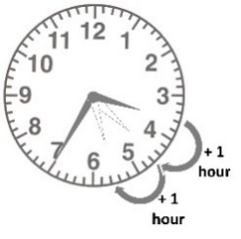 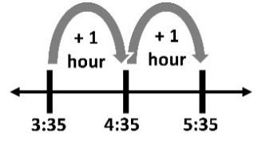
- Elapsed time can be found by counting on from the starting time or counting back from the ending time.
- In Grade 4, students will experience elapsed time problems that require crossing from a.m. to p.m. (e.g., the length of the school day) or from p.m. to a.m. (e.g., number of hours of sleep).

3.MG.4 The student will identify, describe, classify, compare, combine, and subdivide polygons.
Students will demonstrate the following Knowledge and Skills:
- Describe a polygon as a closed plane figure composed of at least three line segments that do not cross.
- Classify figures as polygons or not polygons and justify reasoning.
- Identify and describe triangles, quadrilaterals, pentagons, hexagons, and octagons in various orientations, with and without contexts.
- Identify and name examples of polygons (triangles, quadrilaterals, pentagons, hexagons, octagons) in the environment.
- Classify and compare polygons (triangles, quadrilaterals, pentagons, hexagons, octagons).
- Combine no more than three polygons, where each has three or four sides, and name the resulting polygon (triangles, quadrilaterals, pentagons, hexagons, octagons).
- Subdivide a three-sided or four-sided polygon into no more than three parts and name the resulting polygons.

3.MG.4 The student will identify, describe, classify, compare, combine, and subdivide polygons.
Additional Content Background and Instructional Guidance:
- The study of polygons is rich with geometry vocabulary. At this level, students should be introduced to the following vocabulary and should be encouraged to use it accurately during instruction:
- A polygon is a closed plane figure composed of at least three line segments that do not cross.
- A line is a collection of points extending indefinitely in both directions. It has no endpoints.
- A line segment is part of a line. It has two endpoints and includes all the points between and including those endpoints.
- A ray is a part of a line. It has one endpoint and extends indefinitely in one direction.
- A vertex is a point at which two or more lines, line segments, or rays meet to form an angle.
- An angle is formed by two rays that share a common endpoint called the vertex. Angles are found wherever lines or line segments intersect.
- The sides of a polygon are formed by line segments.
- Polygons are named according to the number of sides:
- triangle is a three-sided polygon;
- quadrilateral is a four-sided polygon;
- pentagon is a five-sided polygon;
- hexagon is a six-sided polygon; and
- octagon is an eight-sided polygon.
- Students in Grade 3 identify four-sided polygons as quadrilaterals but may also recognize rectangles and squares as names for specific quadrilaterals. In Grade 4, students will learn to name and classify other quadrilaterals.
- Polygons may be described by their attributes. Attributes of a polygon include:
- having congruent or noncongruent sides;
- angle measures (e.g., right angles);
- number of sides and angles;
- area; and
- perimeter.
- A regular polygon has congruent sides and angles. An irregular polygon has sides and angles of different lengths and measures.
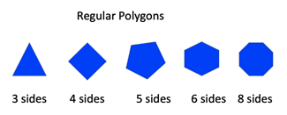
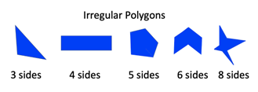
- Students should have experiences with both regular and irregular polygons, and have opportunities to notice patterns with regular polygons. For example, as the number of sides increases, the closer to a circle the figure becomes. Similarly, as the number of sides increases, the measure of each angle increases. While students in Grade 3 are not expected to measure the angles of polygons, they may notice that the angles become “wider” or “more open” as the number of sides increases.
- Polygons retain their shape despite changes in orientation or transformations. It is important to present polygons in a variety of spatial orientations so that students do not develop the common misconception that polygons must have one side parallel to the bottom of the page on which they are printed.
- A composite or compound figure is any figure that is made up of two or more geometric shapes.
- When subdividing, or decomposing, polygons, students develop an understanding of the conservation of area (i.e., the area of a figure does not change when it is subdivided, as long as no parts are removed). Concrete materials can be used to divide a polygon into familiar figures. (e.g., pattern blocks, tangrams, geoboards, grid paper, paper folding).
- When combining and subdividing polygons, both regular and irregular polygons can be used or created.
- When combining and subdividing polygons, discuss changes in the number of sides, perimeter, area, etc. between the original and resulting polygons.

Probability and Statistics
3.PS.1 The student will apply the data cycle (formulate questions; collect or acquire data; organize and represent data; and analyze data and communicate results) with a focus on pictographs and bar graphs.
Students will demonstrate the following Knowledge and Skills:
- Formulate questions that require the collection or acquisition of data.
- Determine the data needed to answer a formulated question and collect or acquire existing data (limited to 30 or fewer data points for no more than eight categories) using various methods (e.g., polls, observations, tallies).
- Organize and represent a data set using pictographs that include an appropriate title, labeled axes, and key. Each pictograph symbol should represent 1, 2, 5 or 10 data points.
- Organize and represent a data set using bar graphs with a title and labeled axes, with and without the use of technology tools. Determine and use an appropriate scale (increments limited to multiples of 1, 2, 5 or 10).
- Analyze data represented in pictographs and bar graphs, and communicate results orally and in writing:
  - describe the categories of data and the data as a whole (e.g., data were collected on preferred ways to cook or prepare eggs - scrambled, fried, hard boiled, and egg salad);
  - identify parts of the data that have special characteristics, including categories with the greatest, the least, or the same (e.g., most students prefer scrambled eggs);
  - make inferences about data represented in pictographs and bar graphs;
  - use characteristics of the data to draw conclusions about the data and make predictions based on the data (e.g., it is unlikely that a third grader would like hard boiled eggs); and
  - solve one- and two-step addition and subtraction problems using data from pictographs and bar graphs.

3.PS.1 The student will apply the data cycle (formulate questions; collect or acquire data; organize and represent data; and analyze data and communicate results) with a focus on pictographs and bar graphs.
Additional Content Background and Instructional Guidance:
- Students should explore the entire data cycle with a question and set of data that has been collected or acquired. Student reflection should occur throughout the data cycle. The data cycle includes the following steps: formulating questions to be explored with data, collecting or acquiring data, organizing and representing data, and analyzing and communicating results.
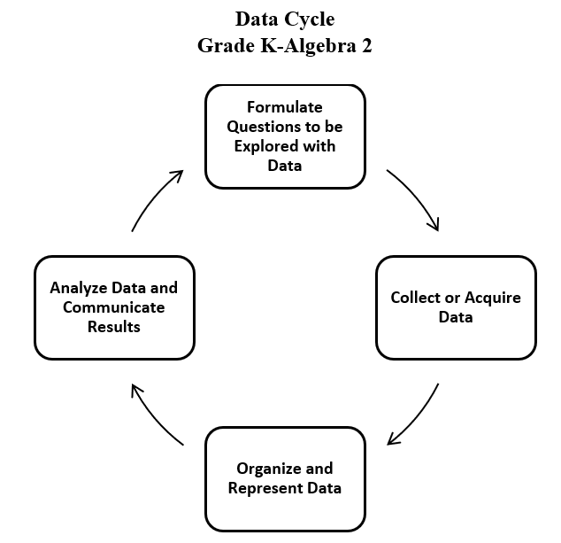
- Formulating questions for investigations is student-generated at this level. For example: What is the cafeteria lunch preferred by students in the class when four lunch options are offered?
- Data are pieces of information collected about people or things. The primary purpose of collecting data is to answer questions. The primary purpose of interpreting data is to inform decisions (e.g., which type of clothing to pack for a trip based on a weather graph or which type of lunch to serve based on class favorites).
- Investigations involving data should occur frequently and relate to students’ experiences, interests, and environment. Contexts should ensure that students can collect or have access to all necessary data. In Grade 3, students are encouraged to explore data sets larger than their classroom (e.g., grade level, school) and evaluate whether a given data set is representative of larger or smaller populations.
- Data can be generated from probability experiments using materials such as two-color counters, spinners, and number cubes. The possible outcomes from these experiments are the data categories.
- Technology tools can be used to collect, organize, and visualize data. These tools support progression to analysis of data in a more efficient manner.
- The purpose of a graph is to represent data gathered to answer a question. Different types of graphs can be used to display categorical data. The way data are displayed often depends on what someone is trying to communicate.
- A pictograph is used to show frequencies and compare categories. Pictographs can be misleading or challenging to read because a symbol can represent more than one data point.
- A key is provided for the symbol in a pictograph when the symbol represents more than one piece of data (e.g., represents five people in a graph). The key is used in a graph to assist in the analysis of the displayed data. One-half of a symbol represents one-half of the value of the symbol being used, as indicated in the key.
- Students’ prior knowledge and work with skip counting helps them to interpret the data in a pictograph.
- Pictographs are most often defined as a pictorial representation of numerical data. The focus of instruction should be placed on reading and using the key when analyzing the graph.
- A bar graph is used to show comparisons and to organize the data for larger data sets. The scale of a bar graph allows for easy representation of all data counts.
- Bar graphs are used to compare counts of different categories (categorical data). Using grid paper helps to increase accuracy in graphs. Technology can also be used to create bar graphs (e.g., spreadsheets, graphing programs, websites).
- At this level, a bar graph uses horizontal or vertical parallel bars to represent counts for up to 8 categories. One bar is used for each category with the length of the bar representing the count for that category. There is space before, between, and after the bars.
- The axis displaying the scale, representing the count for the categories, should begin at zero and extend one increment above the greatest recorded piece of data. Grade 3 students collect data that is recorded in increments of whole numbers, limited to multiples of 1, 2, 5, or 10.
- Each axis should be labeled, and the graph should be given a title.
- Statements about a graph should express predictions based on the analysis and interpretation of the characteristics of data in graphs (e.g., the lunchroom may run out of pizza since that is the lunch students have liked the most).
- The information displayed in different graphs may be examined to determine how data are or are not related, differences between characteristics (comparisons), trends that suggest what new data might be like (predictions), and/or “what could happen if” (inferences).
- Exposure to the analysis of traditional and nontraditional data representations supports the development of data literacy. Examples of nontraditional data representations may include word clouds, frequency graphs, quadrant graphs, etc.

Patterns, Functions, and Algebra
3.PFA.1 The student will identify, describe, extend, and create increasing and decreasing patterns (limited to addition and subtraction of whole numbers), including those in context, using various representations.
Students will demonstrate the following Knowledge and Skills:
- Identify and describe increasing and decreasing patterns using various representations (e.g., objects, pictures, numbers, number lines).
- Analyze an increasing or decreasing pattern and generalize the change to extend the pattern or identify missing terms using various representations.
- Solve contextual problems that involve identifying, describing, and extending patterns.
- Create increasing and decreasing patterns using objects, pictures, numbers, and number lines.
- Investigate and explain the connection between two different representations of the same increasing or decreasing pattern.

3.PFA.1 The student will identify, describe, extend, and create increasing and decreasing patterns (limited to addition and subtraction of whole numbers), including those in context, using various representations.
Additional Content Background and Instructional Guidance:
- Developing fluency and flexibility in identifying, describing, and extending patterns is fundamental to mathematics, particularly algebraic reasoning.
- The use of materials to extend patterns permits an analysis and generalization of change that supports experimentation or problem-solving approaches.
- Growing patterns involve a progression from term to term, which make them more challenging for students than repeating patterns. Growing patterns can increase or decrease. Students in Grade 2 worked with repeating patterns and were introduced to increasing growing patterns. At this level, students will work with increasing and decreasing patterns.
- Increasing and decreasing patterns may be represented in various ways, including dot patterns, staircases, geometric shapes, pictures, number lines, hundreds charts, numeric sequences, etc.
- When students analyze an increasing or decreasing pattern, they identify what changes and what stays the same from term to term. This begins the process of generalization to determine what comes next in a pattern which leads to the foundation of algebraic reasoning. The process of looking for a generalization or relationship (e.g., rule) will provide students with information about how the pattern changes and allows them to identify apparent features of the pattern that are not explicit in the identified relationship. In many growing patterns, the change can be described as an increase or decrease by a constant value.
- In certain numeric growing patterns (arithmetic sequences), students will be able to determine the difference, called the common difference, between each succeeding number (e.g., term) in order to determine what is added to or subtracted from each previous number to obtain the next number. Students do not need to use the phrases arithmetic sequence or common difference at this level.
- In Grade 3, numeric growing patterns will be limited to addition and subtraction of whole numbers.

- Sample growing numeric patterns include:
  - 6, 9, 12, 15, 18, … (increasing pattern);
  - 1, 2, 4, 7, 11, 16, … (increasing pattern); and
  - 20, 18, 16, 14, … (decreasing pattern).
- Sample geometric figure patterns include:

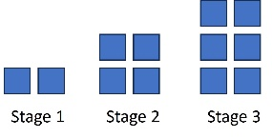
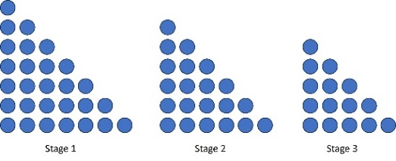
- Tools such as hundreds charts, pattern blocks, color tiles, number lines, calculators, toothpicks, etc. facilitate experimentation and problem-solving, allowing students to create patterns and make connections between different representations of the same pattern (transfer).
- Sample increasing and decreasing pattern transfers include:
  - 2, 5, 8, 11, 14... which has the same structure as 4, 7, 10, 13, 16...
  - 50, 45, 40, 35... which has the same structure as 63, 58, 53, 48...
  - blue, red, blue, blue, red, blue, blue, blue, red,… which has the same structure as …
- During student exploration of patterns, there are many opportunities to make explicit connections to other mathematics content, including:
  - even and/or odd numbers (e.g., counting a collection by 2 vs. counting by 3);
  - geometric figures with increasing numbers of sides (e.g., triangle, quadrilateral, pentagon...);
  - multiplication, skip counting, and repeated addition or subtraction (e.g., 0, 3, 6, 9…); and
  - place value (e.g., adding or subtracting 10 or 100).

