2023 Mathematics Standards of Learning
Understanding the Standards – Grade 2

The Understanding the Standards document includes the mathematics understandings and key concepts that assist teachers in planning standards-focused instruction of the second grade 2023 Mathematics Standards of Learning. The Understanding the Standards includes definitions, explanations, and examples regarding each mathematics standard and describes what students should know (core knowledge) as a result of the instruction specific to the course/grade level.

Number and Number Sense
2.NS.1 The student will utilize flexible counting strategies to determine and describe quantities up to 200.
Students will demonstrate the following Knowledge and Skills:
- Represent forward counting patterns when counting by groups of 2 up to at least 50, starting at various multiples of 2 and using a variety of tools (e.g., objects, number lines, hundreds charts).
- Represent forward counting patterns created when counting by groups of 5s, 10s, and 25s starting at various multiples up to at least 200 using a variety of tools (e.g., objects, number lines, hundreds charts).
- Describe and use patterns in skip counting by multiples of 2 (to at least 50), and multiples of 5, 10, and 25 (to at least 200) to justify the next number in the counting sequence.
- Represent forward counting patterns when counting by groups of 100 up to at least 1,000 starting at 0 using a variety of tools (e.g., objects, number lines, calculators, one thousand charts).
- Represent backward counting patterns when counting by groups of 10 from 200 or less using a variety of tools including objects, number lines, calculators, and hundreds charts.
- Describe and use patterns in skip counting backwards by 10s (from at least 200) to justify the next number in the counting sequence.
- Choose a reasonable estimate up to 1,000 when given a contextual problem (e.g., What would be the best estimate for the number of students in our school – 5, 50, or 500?).
- Represent even numbers (up to 50) with concrete objects, using two equal groups or two equal addends.
- Represent odd numbers (up to 50) with concrete objects, using two equal groups with one leftover or two equal addends plus 1.
- Determine whether a number (up to 50) is even or odd using concrete objects and justify reasoning (e.g., dividing collections of objects into two equal groups, pairing objects).

2.NS.1 The student will utilize flexible counting strategies to determine and describe quantities up to 200.
Additional Content Background and Instructional Guidance:
- The patterns developed because of grouping and/or skip counting are precursors for recognizing numeric patterns and number relationships and connect to money and telling time. Powerful tools for developing these concepts include counters, number charts (e.g., hundreds charts, 120 charts, 200 charts) and calculators.
- Skip counting is based on adding on the same-sized group each time. Opportunities to highlight numbers used in skip counting on a hundreds chart, for example, serve as a visual of the multiples of 2s, 5s, 10s, etc. Background knowledge is created for students as they explore growing patterns (increasing) in Grade 2 and develop an understanding of multiplication in Grade 3.
- As students explore concrete and visual patterns of skip counting, they begin to move from conceptual to procedural understanding by generalizing and deepening their understanding of number concepts. A generalization allows students to recognize a new situation in which it can be applied and adapted appropriately. A generalization students might make when exploring the pattern of skip counting by 10s on a hundred chart is shown below:
  - When counting by 10s, the next number will always add a group of 10 to the tens place.
  - When counting by 10s from a multiple of 10, the next number will be a multiple of 10 and will have a 0 in the ones place.
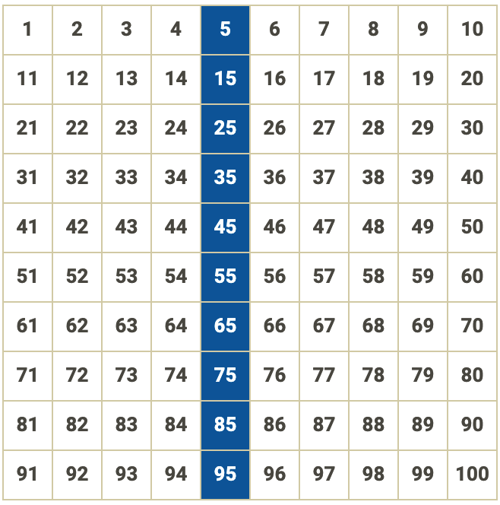
- Skip counting lays the foundation for mathematical content that students will learn in subsequent grades, such as:
  - skip counting forward by 2s, 5s, 10s, 25s, and 100s and skip counting backwards by 10s to compute numbers flexibly;
  - starting at 0 and skip counting by twos to determine even numbers;
  - starting at 0 and skip counting by fives to read time on a clock to the nearest five minutes and count the value of a collection of nickels;
  - starting at 0 and skip counting by tens to count the value of a collection of dimes and using base 10 blocks to determine place value;
  - starting at 0 and skip counting by twenty-fives to count the value of a collection of quarters; and
  - skip counting by hundreds and using base 10 blocks to determine place value.
- Calculators can be used to display the numerical growing (increasing) patterns resulting from skip counting. The constant feature of the four-function calculator can be used to display the numbers in the sequence when skip counting by that constant.
- Exploring ways to estimate the number of objects in a set, based on appearance (e.g., clustering, grouping, comparing), enhances the development of number sense.
- To estimate means to determine a number that is close to the exact amount. When asking for an estimate, teachers might ask, “About how much?” or “About how many?” or “Is this about 5, 50, or 500?”
- Opportunities to estimate a quantity, given a benchmark of 10 and/or 100 objects, enhance a student’s ability to estimate with greater accuracy.
- Odd and even numbers can be explored in different ways (e.g., dividing collections of objects into two equal groups or pairing objects in a group). When pairing objects, the number of objects is even when each object has a pair or partner. When an object is left over, or does not have a pair, then the number is odd.
- Examples of ways to use manipulatives to show even and odd numbers may include (but are not limited to):
  - for an even number, such as 12, six pairs of counters can be formed with no remainder, or two groups of six counters (two addends of 6) can be formed with no remainder. This can connect to fluency strategies for doubling; and
  - for an odd number, such as 13, six pairs of counters can be formed with one counter remaining, or two groups of six counters can be formed with one counter remaining (two addends of 6 plus 1 more). This can connect to fluency strategies for doubling +1.

2.NS.2 The student will demonstrate an understanding of the ten-to-one relationships of the base 10 number system to represent, compare, and order whole numbers up to 999.
Students will demonstrate the following Knowledge and Skills:
- Write the three-digit whole number represented by a given model (e.g., concrete objects, pictures of base 10 blocks).
- Read, write, and represent three-digit numbers in standard form, expanded form, and word form, using concrete or pictorial representations.
- Apply patterns within the base 10 system to determine and communicate, orally and in written form, the place (ones, tens, hundreds) and value of each digit in a three-digit whole number (e.g., in 352, the 5 represents 5 tens and its value is 50).
- Investigate and explain the ten-to-one relationships among ones, tens, and hundreds, using models.
- Compose and decompose whole numbers up to 200 by making connections between a variety of models (e.g., base 10 blocks, place value cards, presented orally, in expanded or standard form) and counting strategies (e.g., 156 can be 1 hundred, 5 tens, 6 ones; 1 hundred, 4 tens, 16 ones; 15 tens, 6 ones).
- Plot and justify the position of a given number up to 100 on a number line with pre-marked benchmarks of 1s, 2s, 5s, 10s, or 25s.
- Compare two whole numbers, each 999 or less, represented concretely, pictorially, or symbolically, using words (greater than, less than, or equal to) and symbols (>, <, or =). Justify reasoning orally, in writing, or with a model.
- Order up to three whole numbers, each 999 or less, represented concretely, pictorially, or symbolically from least to greatest and greatest to least.

2.NS.2 The student will demonstrate an understanding of the ten-to-one relationships of the base 10 number system to represent, compare, and order whole numbers up to 999.
Additional Content Background and Instructional Guidance:
- A strong place value foundation is important when representing, comparing, and ordering numbers. Hands-on experiences are essential to developing the ten-to-one place value understanding for the base 10 number system and in determining the value of each digit in a 3-digit number.
- Models that accurately illustrate the relationships among ones, tens, and hundreds, are physically proportional (e.g., the tens piece is ten times larger than the ones piece).
- Manipulatives that can be physically connected and separated into groups of hundreds, tens, and leftover ones (e.g., snap cubes, beans on craft sticks, pennies in cups, bundles of sticks, beads on pipe cleaners) should be used prior to transitioning to base 10 blocks, which cannot be broken apart.
- Ten-to-one trading activities with manipulatives on place value mats provide experiences for developing the understanding of the places in the base 10 system. Place value cards show numbers in expanded form and can help conceptualize the value of each place as students use models to build and represent numbers.
- Flexibility in thinking about numbers is critical (e.g., 84 is equivalent to 8 tens and 4 ones, or 7 tens and 14 ones, or 84 ones). This flexibility builds background knowledge for the concepts used when regrouping. For example, when subtracting 18 from 184, a student may choose to regroup and think of 184 as 1 hundred, 7 tens, and 14 ones. Students would benefit from experiences building multiple representations of two-digit numbers before progressing to three-digit numbers.
- Number lines with pre-marked benchmarks of 1s, 2s, 5s, 10s, or 25s are useful tools for developing an understanding of place value and can be used to plot and justify the position of a given number up to 100. Connections can be made to rounding when estimating.

2.NS.3 The student will use mathematical reasoning and justification to solve contextual problems that involve partitioning models into equal-sized parts (halves, fourths, eighths, thirds, and sixths).
Students will demonstrate the following Knowledge and Skills:
- Model and describe fractions as representing equal-size parts of a whole.
- Describe the relationship between the number of fractional parts needed to make a whole and the size of the parts (i.e., as the whole is divided into more parts, each part becomes smaller).
- Compose the whole for a given fractional part and its value (in context) for halves, fourths, eighths, thirds, and sixths (e.g., when given $\frac{1}{4}$, determine how many pieces would be needed to make $\frac{4}{4}$).
- Using same-size fraction pieces, from a region/area model, count by unit fractions up to two wholes (e.g., zero one-fourths, one one-fourth, two one-fourths, three one-fourths, four one-fourths, five one-fourths; or zero-fourths, one-fourth, two-fourths, three-fourths, four-fourths, five-fourths).
- Given a context, represent, name, and write fractional parts of a whole for halves, fourths, eighths, thirds, and sixths using:
  - region/area models (e.g., pie pieces, pattern blocks, geoboards);
  - length models (e.g., paper fraction strips, fraction bars, rods, number lines); and
  - set models (e.g., chips, counters, cubes).
- Compare unit fractions for halves, fourths, eighths, thirds, and sixths using words (greater than, less than or equal to) and symbols (>, <, =), with region/area and length models.

2.NS.3 The student will use mathematical reasoning and justification to solve contextual problems that involve partitioning models into equal-sized parts (halves, fourths, eighths, thirds, and sixths).
Additional Content Background and Instructional Guidance:
- Understanding fractions means understanding all the possible concepts that fractions can represent. Students must experience fractions across many constructs, including part of a whole, ratios, and division. At this grade level, students will use a fraction as a numerical way of representing part of a whole region (e.g., an area model), part of a group (e.g., a set model), or part of a length (e.g., a measurement model). At this level, models should be used extensively to support student understanding of the different fraction concepts.
- Fractional parts are equal shares or equal-sized portions of a whole or unit. A unit can be an object or a collection of things. Fair sharing problems (i.e., equal shares) is an idea that young children understand intuitively because of experiences sharing objects with siblings, friends, etc.
- When working with fractions, the whole must be defined. A whole can be divided in multiple ways so that the parts are equivalent. At this level, students may have difficulty drawing figures or partitioning figures accurately.
- Fractional parts have special names that tell how many parts of that size are needed to make the whole. For example, thirds require three equal parts to make a whole.
- A unit fraction is a fraction whose numerator is 1 (e.g., $\frac{1}{4}$, $\frac{1}{8}, \frac{1}{6}$).
- The more fractional parts needed to make a whole, the smaller the parts will be. For example, eighths are smaller than fourths. Students should have experiences dividing a whole into additional parts. As the whole is divided into more parts, students should begin to make conjectures that each part becomes smaller (e.g., folding a paper in half one time, creates two halves; folding it in half again, creates four fourths, which are smaller pieces; folding it in half again, creates eight eighths, which are even smaller pieces).
- Fraction notation is introduced in Grade 2. As students use models to investigate fractions, teachers should introduce the convention for writing a fraction using the symbolic notation such as $\frac{3}{4}$. In this notation 4, the denominator, represents the number of equal-sized parts needed to make a whole and 3, the numerator, represents the number of parts under consideration in the whole. The part of the whole under consideration may be the shaded or the unshaded part of a picture.
- Language such as “out of” (e.g., $\frac{3}{4}$ is the same as 3 out of 4) can lead to misconceptions and partial understandings in naming the numerator and denominator as whole numbers. Instead, the use of fraction language (e.g., three one-fourths or three-fourths) builds understanding of magnitude of fractional size and value.
- Students at this level may try to inaccurately apply whole number reasoning in their work with fractions before they gain a deep understanding of fractions as numbers. Solving contextual problems working with models and explaining how the model represents the fraction will strengthen students’ understanding.
- Opportunities to compose fractions and make connections among fraction representations by connecting concrete or pictorial representations with spoken or symbolic representations will deepen fraction sense.
- When given a fractional part of a whole and its value (e.g., one-third), students should explore with models how many one-thirds it will take to build one whole, to build two wholes, etc.
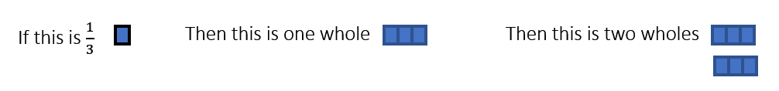
- Counting unit fractional parts to build the whole will support student understanding of how many parts are needed to make a whole (e.g., that four-fourths make one whole). It is important that students count fractional parts both by naming the unit fraction with each count (e.g., ONE one-fourth, TWO one-fourths) and counting consecutive parts (e.g., one-fourth, two-fourths) to build their sense of fraction magnitude.
- Students should be provided opportunities to use models to count fractional parts that go beyond one whole. As a result of building the whole while they are counting, students will begin to generalize that when the numerator and the denominator are the same, there is one whole and when the numerator is larger than the denominator, there is more than one whole. They also will begin to see a fraction as the sum of unit fractions (e.g., three-fourths is the same as three one-fourths or six-sixths is the same as six one-sixths, which is equal to one whole). This provides students with a visual for when one whole is reached and helps students develop a greater understanding of the relationship between the numerator and denominator.
- In a region/area model, the whole is a continuous region and can be partitioned/divided into parts having the same area. Region/area models (e.g., circular and rectangular pie pieces, pattern blocks, geoboards, folding paper, etc.) are helpful tools for students. As they touch and move the concrete objects students begin to understand the part to whole relationship and other concepts about fractions.
- In a length model, the whole is continuous, and each partitioned length represents an equal part of the whole length. For example, given a strip of paper, students could fold the strip into four equal parts, with each part representing one-fourth. Students will notice the length of the first section has length $\frac{1}{4}$, the next section is two $\frac{1}{4}$s, etc. Students should connect a concrete model to a representation of a number line to make sense of the spaces that show the value of the fraction.
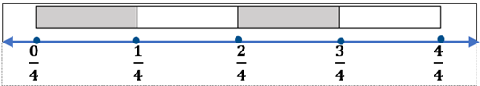
- In a set model, the whole is discontinuous, and the set of discrete items represents the whole. Each item in the set represents an equivalent part of the set. For example, in a set of six counters, one counter represents one-sixth of the set. In the set model, the set can be subdivided into subsets with the same number of items in each subset. For example, a set of six counters can be subdivided into two subsets of three counters each and each subset represents three-sixths or one-half of the whole set.
- Using models when comparing unit fractions supports the understanding that as the number of pieces needed to make a whole increases, the size of each individual piece decreases (i.e., the larger the denominator the smaller the piece when the pieces are from the same size whole; therefore, $\frac{1}{3}$ > $\frac{1}{4}$). Students in Grade 2 will only compare unit fractions using area/region and length models.
- Students in Grade 2 are not expected to convert a fraction greater than one into a mixed number or vice versa. Students will formally learn to represent fractions greater than one as well as mixed numbers symbolically in Grade 3.

2.NS.4 The student will solve problems that involve counting and representing money amounts up to $2.00.
Students will demonstrate the following Knowledge and Skills:
- Identify a quarter and its value and determine multiple ways to represent the value of a quarter using pennies, nickels, and/or dimes.
- Count by ones, fives, tens, and twenty-fives to determine the value of a collection of mixed coins and one-dollar bills whose total value is $2.00 or less.
- Construct a set of coins and/or bills to total a given amount of money whose value is $2.00 or less.
- Represent the value of a collection of coins and one-dollar bills (limited to $2.00 or less) using the cent (¢) and dollar ($) symbols and decimal point (.).

2.NS.4 The student will solve problems that involve counting and representing money amounts up to $2.00.
Additional Content Background and Instructional Guidance:
- The money system used in the United States consists of coins and bills based on relationships involving ones, fives, and tens. The dollar is the basic unit. Experiences with real currency will allow for exposure to various representations of each coin (e.g., state quarters, newer currency compared to older currency).
- The value of a collection of coins and bills can be determined by beginning with the highest value, and/or by grouping the coins and bills into groups and skip counting or counting on to determine the value.
- Students need opportunities to construct and count collections of coins and one-dollar bills whose total value is $2.00 or less, including trading and grouping a variety of coin combinations.
- Emphasis is placed on the representation of the symbols for dollars and cents (e.g., $0.35 and 35¢ are both read as “thirty-five cents”; $2.00 is read as “two dollars”).
- Students at this level have not formally been introduced to the meaning of the decimal point; however, when reading money amounts, they should represent the amount orally by stating “and” when they reach the decimal point. For example, $1.15 should be read as “one dollar and 15 cents.” Decimals are formally introduced in Grade 4.

Computation and Estimation
2.CE.1 The student will recall with automaticity addition and subtraction facts within 20 and estimate, represent, solve, and justify solutions to single-step and multistep problems, including those in context, using addition and subtraction with whole numbers where addends or minuends do not exceed 100.
Students will demonstrate the following Knowledge and Skills:
- Apply strategies (e.g., rounding to the nearest 10, compatible numbers, other number relationships) to estimate a solution for single-step addition or subtraction problems, including those in context, where addends and minuends do not exceed 100.
- Apply strategies (e.g., the use of concrete and pictorial models, place value, properties of addition, the relationship between addition and subtraction) to determine the sum or difference of two whole numbers where addends or minuends do not exceed 100.
- Represent, solve, and justify solutions to single-step and multistep contextual problems (e.g., join, separate, part-part-whole, comparison) involving addition or subtraction of whole numbers where addends or minuends do not exceed 100.
- Demonstrate fluency with addition and subtraction within 20 by applying reasoning strategies (e.g., doubles, near doubles, make-a-ten, compensations, inverse relationships).
- Recall with automaticity addition and subtraction facts within 20.
- Use patterns, models, and strategies to make generalizations about the algebraic properties for fluency (e.g., 4 + 3 is equal to 3 + 4; 0 + 8 = 8).
- Determine the missing number in an equation (number sentence) through modeling and justification with addition and subtraction within 20 (e.g., 3 + = 5 or + 2 = 5; 5 – = 3 or 5 – 2 = ).
- Use inverse relationships to write all related facts connected to a given addition or subtraction fact model within 20 (e.g., given a model for 3 + 4 = 7, write 4 + 3 = 7, 7 – 4 = 3, and 7 – 3 = 4).
- Describe the not equal symbol (≠) as representing a relationship where expressions on either side of the not equal symbol represent different values and justify reasoning.
- Represent and justify the relationship between values and expressions as equal or not equal using appropriate models and/or symbols (e.g., 9 + 24 = 10 + 23; 45 - 9 = 46 - 10; 15 +16 ≠ 31 +15).

2.CE.1 The student will recall with automaticity addition and subtraction facts within 20 and estimate, represent, solve, and justify solutions to single-step and multistep problems, including those in context, using addition and subtraction with whole numbers where addends or minuends do not exceed 100.
Additional Content Background and Instructional Guidance:
- Estimation is a valuable, time-saving skill used when exact answers are not required or needed, especially in practical situations.
- Estimation can be used to check the reasonableness of the sum or difference when an exact answer is required.
- Rounding is one strategy used to estimate. It is often used to assess the reasonableness of a solution or to give an estimate of an amount. Rounding a number to the nearest ten means determining which two tens the number lies between and then determining which ten the number is closest to (e.g., 48 is between 40 and 50 and rounded to the nearest ten is 50, because 48 is closer to 50 than it is to 40).
- Using compatible numbers is another estimation strategy. Compatible numbers are two or more numbers that are easy to add and subtract mentally. For example, using compatible numbers to estimate the sum of 57 + 45 could result in 60 + 40 = 100.
- Addition and subtraction should be taught concurrently to develop an understanding of inverse relationships.
- Addition and subtraction problems should be presented in both horizontal and vertical written format.
- Mental computation helps build students’ number sense. Mentally adding or subtracting two-digit numbers may include strategies such as those shown below:
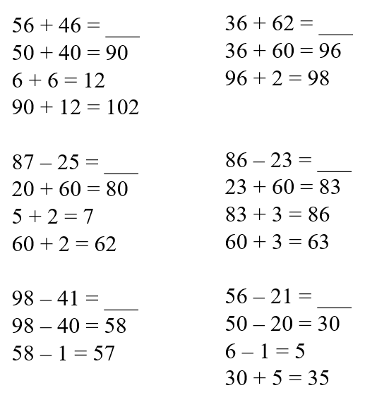
- The terms utilized in addition and subtraction include:
- At this level, students do not need to use the terms addend, minuend, or subtrahend for addition and subtraction.
- Problem-solving means engaging in a task for which a solution or a method of solution is not known in advance. Solving problems using data and graphs offers one way to connect mathematics to practical situations.
- Conceptual understanding and computational fluency are built by using various strategies and representations. Regrouping is used in addition and subtraction algorithms and can be challenging for many students to understand. The use of concrete materials (e.g., base 10 blocks, connecting cubes, beans and cups) to explore, model, and stimulate discussion about a variety of problem situations helps students understand the concept of regrouping, and enables them to move forward from the concrete to the representational to the abstract (symbolic). Student-created representations, such as drawings, diagrams, tally marks, graphs, or written comments are strategies that students use as they make these connections that lead to developing computational fluency.
- In problem-solving, emphasis should be placed on thinking and reasoning rather than on key words. Focusing on key words such as in all, altogether, difference, etc., encourages students to perform a particular operation rather than make sense of the context of the problem. A key word focus prepares students to solve a limited set of problems and often leads to incorrect solutions as well as challenges in upcoming grades and courses.
- Extensive research has been undertaken over the last several decades regarding different problem types. Many of these studies have been published in professional mathematics education publications using different labels and terminology to describe the varied problem types.
- Students should experience a variety of problem types related to addition and subtraction. Problem type examples are included in the following chart:
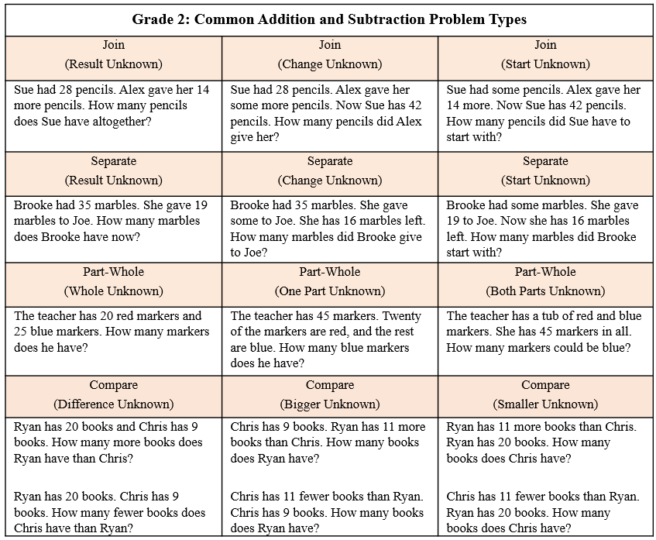
- The problem-solving process is enhanced when students:
  - visualize the action in the story problem and draw a picture to show their thinking;
  - model the problem using manipulatives, representations, and/or number sentences/equations; and
  - justify their reasoning and varied approaches through collaborative discussions.
- Computational fluency is the ability to think flexibly in order to choose appropriate strategies to solve problems accurately and efficiently. Recall with automaticity is developed through the understanding of strategies and the relationship of numbers and facts.
- Flexibility requires knowledge of more than one approach to solving a particular kind of problem. Being flexible allows students to choose an appropriate strategy for the numbers involved.
- Accuracy is the ability to determine a correct answer using knowledge of number facts and other important number relationships.
- Efficiency is the ability to carry out a strategy easily when solving a problem without getting bogged down in too many steps or losing track of the logic of the strategy being used.
- Concrete models should be used initially to develop an understanding of addition and subtraction facts.
- Automaticity of facts can be achieved through meaningful practice using strategies which may include number talks, games, hands-on activities, dot cards, and ten frames.
Examples of Addition and Subtraction Strategies
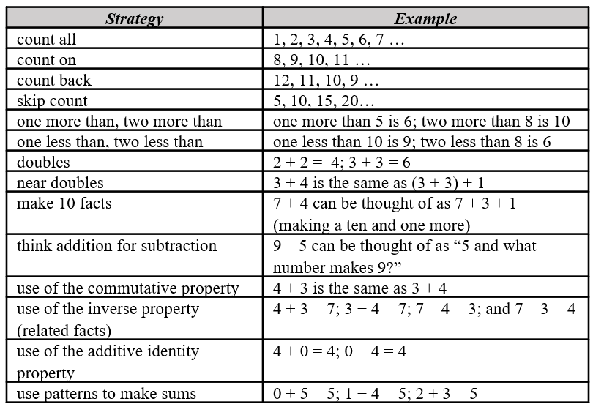
- The understanding of related facts can be applied when finding the solution to problems involving a missing addend in addition sentences or missing parts in subtraction sentences. This understanding is developed through experiences with inverse relationships and is used as a strategy to develop fluency.
- Grade 2 students should begin to explore and generalize the properties of addition as strategies for solving addition and subtraction problems using a variety of representations.
- The properties of the operations are “rules” about how numbers work and how they relate to one another. Students at this level do not need to use the formal terms for these properties but should utilize these properties to further develop flexibility and fluency in solving problems. The following properties are most appropriate for exploration at this level:
  - the commutative property of addition states that changing the order of the addends does not affect the sum (e.g., 4 + 3 = 3 + 4);
  - the identity property of addition states that if zero is added to a given number, the sum is the same as the given number (e.g., 0 + 2 = 2); and
  - the associative property of addition states that the sum stays the same when the grouping of addends is changed (e.g., 4 + (6 + 7) = (4 + 6) + 7).
- Models such as 10 or 20 frames and part-part-whole diagrams help develop an understanding of relationships between equations and operations.
- Manipulatives such as connecting cubes, counters, and number scales can be used to model equations.
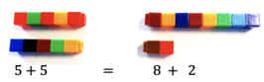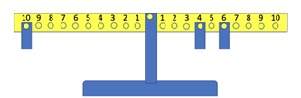
- The equal sign (=) is a symbol used to indicate equivalence or balance. It represents a relationship where expressions on each side of the equal symbol represent the same value(s).
- The not equal sign (≠) is a symbol used to indicate nonequivalence or balance. It represents a relationship where expressions on each side of the equal symbol represent different value(s).
- An equation (number sentence) is a mathematical statement representing two expressions that are equivalent. It consists of two expressions, one on each side of an equal sign (e.g., 5 + 3 = 8, 8 = 5 + 3, 4 + 3 = 9 - 2). An equation can be represented using a number balance scale, with equal amounts on each side (e.g., 3 + 5 = 6 + 2). A balance scale should be used to develop the idea of equivalence and nonequivalence concretely.
- An expression represents a quantity. An expression may contain numbers, variables, and/or computational operation symbols. It does not have an equal symbol (e.g., 5, 4 + 3, 8 - 2). Students at this level are not expected to use the terms expression or variable.
- Exploring equations in less familiar forms can help students build a deeper understanding of the concept of equality (e.g., 8 = 10 - 2, 5 = 5, or 7 ≠ 10 - 5). For students to develop the concept of equality, students need to see the = symbol used in various appropriate locations (e.g., 3 + 4 = 7, 5 = 2 + 3).

Measurement and Geometry
2.MG.1 The student will reason mathematically using standard units (U.S. Customary) with appropriate tools to estimate, measure, and compare objects by length, weight, and liquid volume to the nearest whole unit.
Students will demonstrate the following Knowledge and Skills:
- Explain the purpose of various measurement tools and how to use them appropriately by:
  - identifying a ruler as an instrument to measure length;
  - identifying different types of scales as instruments to measure weight; and
  - identifying different types of measuring cups as instruments to measure liquid volume.
- Use U.S. Customary units to estimate, measure, and compare the two for reasonableness:
  - the length of an object to the nearest inch, using a ruler;
  - the weight of an object to the nearest pound, using a scale; and
  - the liquid volume of a container to the nearest cup, using a measuring cup.

2.MG.1 The student will reason mathematically using standard units (U.S. Customary) with appropriate tools to estimate, measure, and compare objects by length, weight, and liquid volume to the nearest whole unit.
Additional Content Background and Instructional Guidance:
- The process of measurement involves determining the appropriate tool, selecting a unit of measure, counting the number of times the unit is used to measure the object, and arriving at an approximate total number of units.
- A clear concept of the size of one unit is necessary before one can measure to the nearest whole unit.
- Students benefit from opportunities to evaluate their estimates for reasonableness and refine their estimates in order to increase the accuracy of future measurements.
- Students benefit from experiences that allow them to explore the relationship between the size of the unit of measurement and the number of units needed to measure the length, weight, and volume of an object. Measuring the same object twice using different units (e.g., once with paper clips and once with markers) will help students to develop an understanding about the relationship between the size of the unit used to measure and the number of units necessary to measure.
- Linear measurement is identifying and counting the number of units that represent the length of an object. A “broken ruler” can serve as a useful tool in emphasizing the need to focus on counting the number of units that make up the length of an object.
- Benchmarks of common objects should be established for one inch and should be used when estimating lengths. Practical experiences measuring the length of familiar objects help to establish benchmarks. Students’ experiences should include the use of a variety of rulers, including rulers that have zero labeled and those that do not, and instruction should include an explanation of how to use each type of ruler.
- The measurement of weight is determined by identifying and counting the number of units that represent the weight of an object.
- Benchmarks of common objects should be established for one pound and should be used when estimating weights. Practical experiences measuring the weight of familiar objects help to establish benchmarks. Students’ experiences should include the use of a variety of scales (e.g., bathroom scales, kitchen scales, balance scales, and spring scales), and instruction should include an explanation of how to use each type of scale.
- The measurement of liquid volume (capacity) is determined by identifying and counting the number of units that represent the volume of an object.
- Benchmarks of common objects should be established for one whole cup and should be used when estimating volume. Practical experiences measuring the volume (capacity) of familiar objects help to establish benchmarks. Student experiences should include the use of a variety of measuring cups, and instruction should include an explanation of how to use them.

2.MG.2 The student will demonstrate an understanding of the concept of time to the nearest five minutes, using analog and digital clocks.
Students will demonstrate the following Knowledge and Skills:
- Identify the number of minutes in an hour (60 minutes) and the number of hours in a day (24 hours).
- Determine the unit of time (minutes, hours, days, or weeks) that is most appropriate when measuring a given activity or context and explain reasoning (e.g., Would you measure the time it takes to brush your teeth in minutes or hours?).
- Show, tell, and write time to the nearest five minutes, using analog and digital clocks.
- Match a written time (e.g., 1:35, 6:20, 9:05) to the time shown on an analog clock to the nearest five minutes.

2.MG.2 The student will demonstrate an understanding of the concept of time to the nearest five minutes, using analog and digital clocks.
Additional Content Background and Instructional Guidance:
- Many experiences using clocks help students develop an understanding of the telling of time to the hour, half-hour, and nearest five minutes, including:
  - the numbers in conjunction with the tick marks on a clock measure both hours and minutes, depending on the hand of the clock. The positions of the two hands on an analog clock are read to tell the time.
  - a digital clock shows the time by displaying the time in numbers which are read as the hour and minutes.
  - relating time on the hour and half-hour to daily routines and school schedules (e.g., bedtime, lunchtime, recess time).
  - connecting the hour and half-hour to fraction concepts.
- The use of a demonstration clock with gears can be beneficial as it ensures that the positions of the hour hand and the minute hand are always precise and shows the relationship between the hour and minute hands.
- Time passes in equal increments (e.g., seconds, minutes, hours). There are 60 minutes in one hour and 24 hours in one day.
- Classroom experiences that help students determine the most appropriate unit of time for an activity or context will further their understanding of the passage of time. Examples might include:
  - Walking to the lunchroom from the classroom can be measured in minutes.
  - It would be best to measure the time it takes to complete one day of school in hours.
  - It takes only minutes for me to brush my teeth.
- The concepts of a.m. and p.m. are developed through relevant, contextual events (e.g., students eat breakfast in the a.m. or go to bed during the p.m.). This will help with the understanding of elapsed time in future grades.

2.MG.3 The student will identify, describe, and create plane figures (including circles, triangles, squares, and rectangles) that have at least one line of symmetry and explain its relationship with congruency.
Students will demonstrate the following Knowledge and Skills:
- Explore a figure using a variety of tools (e.g., paper folding, geoboards, drawings) to show and justify a line of symmetry, if one exists.
- Create figures with at least one line of symmetry using various concrete and pictorial representations.
- Describe the two resulting figures formed by a line of symmetry as being congruent (having the same shape and size).

2.MG.3 The student will identify, describe, and create plane figures (including circles, triangles, squares, and rectangles) that have at least one line of symmetry and explain its relationship with congruency.
Additional Content Background and Instructional Guidance:
- A line of symmetry divides a figure into two congruent parts, each of which is the mirror image of the other. (The figures could be folded on the line of symmetry and both parts would match exactly. The two parts are congruent – the same size and shape.) These lines can be horizontal, vertical, or diagonal. An example is shown below:
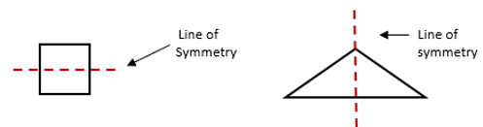
- Children learn about symmetry through hands-on experiences with geometric figures and the creation of geometric pictures and patterns.
- Guided explorations of the study of symmetry using mirrors, paper folding, geoboards, and pattern blocks will enhance students’ understanding of the attributes of symmetrical figures.
- Congruent figures have exactly the same size and shape. Figures that are not congruent do not have exactly the same size and shape. Congruent figures remain congruent even if they are in different spatial orientations.
- Symmetry is justified by describing the resulting shapes of a divided figure as congruent.
- While investigating symmetry, children move figures, such as pattern blocks, intuitively, thereby exploring transformations of those figures. A transformation is the movement of a figure — either a translation, rotation, or reflection. A translation is the result of sliding a figure in any direction; rotation is the result of turning a figure around a point or a vertex; and reflection is the result of flipping a figure over a line. Children at this level do not need to know the terms related to transformations of figures.

2.MG.4 The student will describe, name, compare, and contrast plane and solid figures (circles/spheres, squares/cubes, and rectangles/rectangular prisms).
Students will demonstrate the following Knowledge and Skills:
- Trace faces of solid figures (cubes and rectangular prisms) to create the set of plane figures related to the solid figure.
- Compare and contrast models and nets (cutouts) of cubes and rectangular prisms (e.g., number and shapes of faces, edges, vertices).
- Given a concrete or pictorial model, name and describe the solid figure (sphere, cube, and rectangular prism) by its characteristics (e.g., number of edges, number of vertices, shapes of faces).
- Compare and contrast plane and solid figures (circles/spheres, squares/cubes, and rectangles/rectangular prisms) according to their characteristics (e.g., number and shapes of their faces, edges, vertices).

2.MG.4 The student will describe, name, compare, and contrast plane and solid figures (circles/spheres, squares/cubes, and rectangles/rectangular prisms).
Additional Content Background and Instructional Guidance:
- An important part of the geometry strand in kindergarten through Grade 2 is the naming and describing of figures. Children move from their own vocabulary and begin to incorporate conventional terminology as the teacher uses geometric terms.
  - A plane figure is any closed, two-dimensional shape.
  - A vertex is a point at which two or more lines, line segments, or rays meet to form an angle. In solid figures, a vertex is the point at which three or more edges meet.
  - A line is a collection of points extending indefinitely in both directions. It has no endpoints.
  - A line segment is part of a line. It has two endpoints and includes all the points between and including those endpoints.
  - A ray is part of a line. It has one endpoint and extends indefinitely in one direction.
  - An angle is formed by two rays that share a common endpoint called the vertex. Angles are found wherever lines or line segments intersect.
  - A solid figure is a three-dimensional figure, having length, width, and height.
  - A circle is a set of points in a plane (e.g., two-dimensional) that are the same distance from a point called the center. A circle has no edges or vertices.
  - A sphere is a solid figure with all its points in space (e.g., three-dimensional) the same distance from its center. A sphere has no edges or vertices.
  - A rectangle is a quadrilateral with four right angles.
  - A square is a special type of rectangle with four congruent (equal length) sides and four right angles.
  - A right angle measures exactly 90 degrees.
  - A rectangular prism is a solid figure in which all six faces are rectangles. A rectangular prism has eight vertices and 12 edges.
  - A cube is a solid figure with six congruent, square faces. All edges are the same length. A cube has eight vertices and 12 edges. It is a special type of rectangular prism.
  - An edge is the line segment where two faces of a solid figure intersect.
  - A face is any flat side of a solid figure (e.g., a square is a face of a cube).
- Hands-on, contextual experiences with plane and solid figures develop an understanding of the characteristics of each when making comparisons.
- Tracing the faces of cubes and rectangular prisms, decomposing cubes and rectangular prisms along their edges, and using nets to compose cubes and rectangular prisms help students understand the set of plane figures related to the solid figure.
- The net of a solid figure is what the figure would look like if it was unfolded. The image below shows an example of the net of a rectangular prism. Nets can be used to fold and compose three-dimensional shapes to develop an understanding of the relationship between the net and the solid figure they represent.

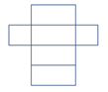
Net of a rectangular prism

Probability and Statistics
2.PS.1 The student will apply the data cycle (pose questions; collect or acquire data; organize and represent data; and analyze data and communicate results) with a focus on pictographs and bar graphs.
Students will demonstrate the following Knowledge and Skills:
- Pose questions, given a predetermined context, that require the collection of data (limited to 25 or fewer data points for no more than six categories).
- Determine the data needed to answer a posed question and collect the data using various methods (e.g., voting; creating lists, tables, or charts; tallying).
- Organize and represent a data set using a pictograph where each symbol represents up to 2 data points. Determine and use a key to assist in the analysis of the data.
- Organize and represent a data set using a bar graph with a title and labeled axes (limited to 25 or fewer data points for up to six categories, and limit increments of scale to multiples of 1 or 2).
- Analyze data represented in pictographs and bar graphs and communicate results:
  - ask and answer questions about the data represented in pictographs and bar graphs (e.g., total number of data points represented, how many in each category, how many more or less are in one category than another). Pictograph keys will be limited to symbols representing 1, 2, 5, or 10 pieces of data and bar graphs will be limited to scales with increments in multiples of 1, 2, 5, or 10; and
  - draw conclusions about the data and make predictions based on the data.

2.PS.1 The student will apply the data cycle (pose questions; collect or acquire data; organize and represent data; and analyze data and communicate results) with a focus on pictographs and bar graphs.
Additional Content Background and Instructional Guidance:
- Students should explore the entire data cycle with a question and set of data that has been collected or acquired. Student reflection should occur throughout the data cycle. The data cycle includes the following steps: formulating questions to be explored with data, collecting or acquiring data, organizing and representing data, and analyzing and communicating results.
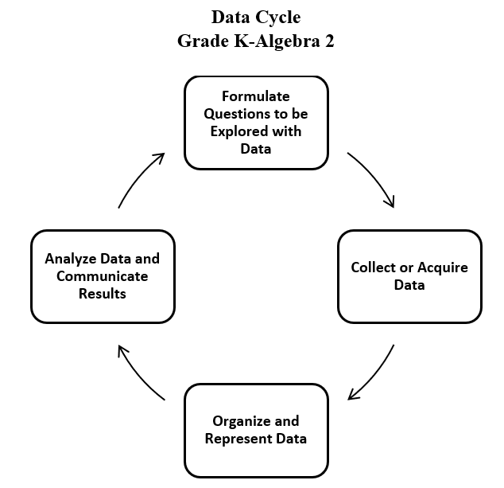
- Data are pieces of information collected about people or things. The primary purpose of collecting data is to answer questions. The primary purpose of interpreting data is to inform decisions (e.g., which type of clothing to pack for a vacation based on a weather graph or which type of lunch to serve based upon class favorites).
- The teacher can provide data sets to students in addition to students engaging in their own data collection. The data cycle can be used to make connections between mathematics and other disciplines including science, social studies, or language arts.
- After generating questions, students decide what information is needed and how it can be collected.
- The collection of the data often leads to new questions to be investigated.
- The purpose of a graph is to represent data gathered to answer a question. In Grade 2, students are to collect and organize data in bar graphs and pictographs.
- A bar graph is used to show comparisons and to organize the data for larger data sets. The scale of a bar graph allows for easy representation of all data frequencies.
- A pictograph is used to show frequencies and compare categories. Pictographs can be challenging to read because a symbol can represent more than one data point.
- Pictographs can be horizontal or vertical. An example of a vertical pictograph is shown:
The Types of Pets We Have
Cat | Dog | Horse | Fish
= 2 students
- A key should be provided when the symbol represents more than one piece of data to assist in the analysis of the displayed data. At this level, each symbol should represent 1, 2, 5, or 10 pieces of data (e.g., represents two people in the pictograph above).
- Students’ prior knowledge and work with skip counting helps them to identify the number of pictures or symbols to be used in a pictograph.
- Definitions for the terms picture graph and pictographs vary. Pictographs are most often defined as a pictorial representation of numerical data. The focus of instruction should be placed on reading and using the key in analyzing the graph. There is no need for students to distinguish between a picture graph and a pictograph.
- Bar graphs are used to compare frequencies of different categories (categorical data). Using grid paper may ensure more accurate graphs.
- A bar graph uses horizontal or vertical parallel bars to represent counts for several categories. One bar is used for each category, with the length of the bar representing the count for that category. There is space before, between, and after each of the bars.
- The axis displaying the scale that represents the count for the categories should begin at zero and extend one increment above the greatest recorded piece of data. In Grade 2, students should collect data that are recorded in increments of whole numbers limited to multiples of 1, 2, 5, or 10.
- At this level, the number of categories on a bar graph should be limited to six. A key should be included where appropriate.
- Each axis should be labeled, and the graph should be given a title.
- Statements that represent an analysis and interpretation of the data in the graph should be discussed with students and written (e.g., similarities and differences, least and greatest, the categories, total number of responses, how many more or less are in one category than another).

Patterns, Functions, and Algebra
2.PFA.1 The student will describe, extend, create, and transfer repeating and increasing patterns (limited to addition of whole numbers) using various representations.
Students will demonstrate the following Knowledge and Skills:
- Identify and describe repeating and increasing patterns.
- Analyze a repeating or increasing pattern and generalize the change to extend the pattern using objects, pictures, and numbers.
- Create a repeating or increasing pattern using various representations (e.g., objects, pictures, numbers).
- Transfer a given repeating or increasing pattern from one form to another (e.g., objects, pictures, numbers) and explain the connection between the two patterns.

2.PFA.1 The student will describe, extend, create, and transfer repeating and increasing patterns (limited to addition of whole numbers) using various representations.
Additional Content Background and Instructional Guidance:
- Patterning is a fundamental cornerstone of mathematics, particularly algebra. The process of generalization leads to the foundation of algebraic reasoning. A generalization allows students to recognize a new situation in which it can be applied and adapted appropriately.
- Opportunities to create, identify, describe, extend, and transfer patterns are essential to the primary school experience and lay the foundation for understanding place value and thinking algebraically.
- In a repeating pattern, the part of the pattern that repeats is called the core.
- Growing patterns, which can be increasing, and decreasing, involve a progression from term to term. This makes them more challenging for students than repeating patterns. At this level, students will work with increasing growing patterns. Students must determine what comes next, and begin the process of generalization, which leads to the foundation of algebraic reasoning. Students need experiences identifying what changes and what stays the same in a growing pattern. Increasing patterns may be represented in various ways, including with numbers, dot patterns, pictures, number lines, hundreds charts, etc.
- In numeric increasing patterns, students must determine the difference, called the common difference, between each succeeding number to determine what is added to each previous number to obtain the next number. Students do not need to use the term common difference at this level.
- In Grade 2, growing numeric patterns will be limited to increasing values.
- Sample numeric patterns include:
  - 6, 9, 12, 15, 18, … (increasing pattern);
  - 2, 4, 6, 8, 10, … (increasing pattern); and
  - 1, 3, 5, 1, 3, 5, 1, 3, 5… (repeating pattern).
- A sample contextual increasing pattern is shown below:

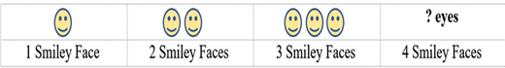
How Many Eyes?
- Additional contextual examples could include the number of wheels on bikes, the number of legs on chairs, etc.
- In patterns using objects or figures, students must often recognize transformations of a figure, particularly rotation or reflection. Rotation is the result of turning a figure, and reflection is the result of flipping a figure over a line. Children at this level do not need to know the terms related to transformations of figures.
- Examples of patterns using objects or figures include:
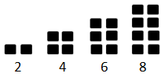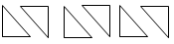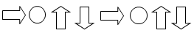
- Transferring a pattern is creating the pattern in a different form or representation.
- Examples of pattern transfers include:
  - 10, 20, 30, 40… has the same structure as 14, 24, 34, 44… because both patterns increase by 10;
  - has the same structure as
because the core (first 4 shapes) repeats; and
  - 1, 3, 5, 1, 3, 5, 1, 3, 5 has the same structure as ABCABC.

