2023 Mathematics Standards of Learning
Understanding the Standards - Kindergarten

The Understanding the Standards document includes the mathematics understandings and key concepts that assist teachers in planning standards-focused instruction of the kindergarten 2023 Mathematics Standards of Learning. The Understanding the Standards includes definitions, explanations, and examples regarding each mathematics standard and describes what students should know (core knowledge) as a result of the instruction specific to the course/grade level.

Number and Number Sense
K.NS.1 The student will utilize flexible counting strategies to determine and describe quantities up to 100.
Students will demonstrate the following Knowledge and Skills:
- Use one-to-one correspondence to determine how many are in a given set containing 30 or fewer concrete objects (e.g., cubes, pennies, balls), and describe the last number named as the total number of objects counted.
- Recognize and explain that the number of objects remains the same regardless of the arrangement or the order in which the objects are counted.
- Represent forward counting by ones using a variety of tools, including five-frames, ten-frames, and number paths (a prelude to number lines).
- Count forward orally by ones from 0 to 100.
- Count forward orally by ones, within 100, starting at any given number.
- Count backward orally by ones when given any number between 1 and 20.
- State the number after, without counting, when given any number between 0 and 30.
- State the number before, without counting, when given any number between 1 and 20.
- Use objects, drawings, words, or numbers to compose and decompose numbers 11-19 into a ten and some ones.
- Group a collection of up to 100 objects (e.g., counters, pennies, cubes) into sets of ten and count by tens to determine the total (e.g., there are 3 groups of ten and 6 leftovers, 36 total objects).

K.NS.1 The student will utilize flexible counting strategies to determine and describe quantities up to 100.
Additional Content Background and Instructional Guidance:
- Counting is a complex skill that involves three developmental levels:
  - rote sequence;
  - one-to-one correspondence; and
  - the cardinality of numbers.
- Counting involves two separate skills: verbalizing the list (rote sequence counting) of standard number words in order (e.g., “zero, one, two, three, …”) and connecting this sequence with the objects in the set being counted, using one-to-one correspondence.
- Connecting rote counting to the counting of collections is necessary for students to understand the meaning of a number. Association of number words with collections of objects is achieved by moving, touching, or pointing to objects as the number words are spoken. Objects may be presented in random order or arranged for easy counting.
- When counting objects:
  - number names are said in standard order;
  - one item is counted for each number word (one-to-one correspondence);
  - the number of objects is the same regardless of their arrangement or the order in which they were counted (conservation of number);
  - the last number verbalized names the total amount of objects counted (cardinality);
  - each successive number name refers to a quantity that is one larger (hierarchical inclusion).
- When a set is empty, it has zero objects or elements. Zero is both a number and a digit.
- Counting forward and backward leads to the development of counting on and counting back. Counting forward by rote lays the foundation for addition. Counting backward by rote lays the foundation for subtraction. Identifying the number after and/or the number before any given number demonstrates an understanding of number relationships as opposed to a memorized sequence of numbers.
- Counting forward by rote, supported by visuals such as the hundred chart or number path, advances children’s development of sequencing.
- A number path is a counting model where each number is represented within a rectangle and can be counted. This is an example of a number path:
1 | 2 | 3 | 4 | 5 | 6 | 7 | 8 | 9 | 10
- A number line is a length model where each number represents its length (distance) from zero. When young children use a number line as a counting tool, they often confuse what should be counted (the numbers or the spaces between the numbers). A number path is more appropriate for students at this age.
- Counting skills are essential components of the development of number sense; however, they are only one of the indicators of the understanding of numbers.
- Describing numbers 11 to 19 as a ten and some ones will help students think of ten ones as a unit of ten. This also lays a foundation for place value. 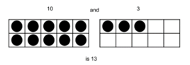 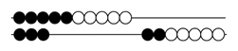
- Manipulatives that can be grouped into sets of tens and ones such as counters on ten-frames, beans in cups, buttons on paper plates, connecting cubes, etc., help students organize, understand, and count groups of tens and ones.

K.NS.2 The student will identify, represent, and compare quantities up to 30.
Students will demonstrate the following Knowledge and Skills:
- Read, write, and identify the numerals 0 through 30.
- Construct a set of objects that corresponds to a given numeral within 30, including an empty set.
- Determine and write the numeral that corresponds to the total number of objects in a given set of 30 or fewer concrete objects or pictorial models.
- Given a set of up to 30 objects, construct another set which has more, fewer, or the same number of objects using concrete or pictorial models.
- Given a numeral up to 30, construct a set which has more, fewer, or the same number of objects using concrete or pictorial models.
- Compare two sets containing up to 30 concrete objects or pictorial models, using the terms more, fewer, or the same as (equal to).
- Compare numbers up to 30, to the benchmarks of 5 and to the benchmark of 10 using various models (e.g., five frames, ten frames, number paths [a prelude to number lines], beaded racks, hands) using the terms greater than, less than, or the same as (equal to).

K.NS.2 The student will identify, represent, and compare quantities up to 30.
Additional Content Background and Instructional Guidance:
- Kinesthetic involvement (e.g., tracing the numerals or using tactile materials such as sand, sandpaper, carpeting, or finger paint) facilitates the writing of numerals.
- Symbolic reversals in numeral writing are common at this level and should not be mistaken for lack of understanding.
- Comparing sets is an extension of conservation of number (e.g., 5 is 5 whether it is 5 marbles or 5 basketballs even though 5 basketballs take up more space). When comparing objects, the set can be arranged differently while still containing the same number (e.g., 5 marbles in a cup is the same as 5 marbles on the floor).
- Quickly recognizing and naming the number of objects in a small group without counting is called subitizing. The size of the group a student can subitize is dependent upon the arrangement. At this age, students should subitize irregular or unfamiliar arrangements up to 5. When there is a familiar or structured pattern (e.g., dots on number cubes, counters on a ten frame) students may be able to subitize larger numbers.
- Sets of objects can be compared by matching, lining up the objects, visually estimating magnitude, recognizing quantities without counting (subitizing), or counting the number of objects in each set.
- Using the terms more and fewer together build an understanding of their relationship. For example, when asking which group has more, follow with asking which group has fewer.
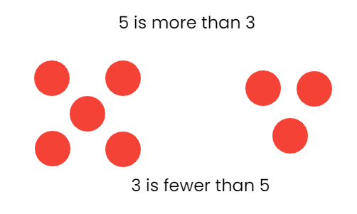
- Benchmarks of 5 and 10 are useful when comparing numbers. Various models (e.g., five frames, ten frames, and number paths) can be helpful when students are comparing numbers using the benchmarks of 5 and 10.

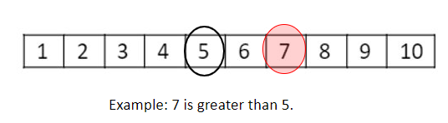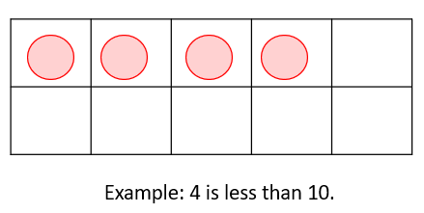

Computation and Estimation
K.CE.1 The student will model and solve single-step contextual problems using addition and subtraction with whole numbers within 10.
Students will demonstrate the following Knowledge and Skills:
- Use objects, drawings, words, or numbers to compose and decompose numbers less than or equal to 5 in multiple ways.
- Recognize and describe with fluency part-part-whole relationships for numbers up to 5 in a variety of configurations.
- Model and identify the number that makes 5 when added to a given number less than or equal to 5.
- Use objects, drawings, words, or numbers to compose and decompose numbers less than or equal to 10 in multiple ways.
- Model and identify the number that makes 10 when added to a given number less than or equal to 10.
- Model and solve single-step contextual problems (join, separate, and part-part-whole) using 10 or fewer concrete objects.

K.CE.1 The student will model and solve single-step contextual problems using addition and subtraction with whole numbers within 10.
Additional Content Background and Instructional Guidance:
- Problem-solving is enhanced by:
  - visualizing the action in the problem;
  - modeling the problem using manipulatives, representations, and/or number sentences; and
  - justifying reasoning and varied approaches through collaborative discussions.
- Extensive research has been undertaken over the last several decades regarding different problem types. Many of these studies have been published in professional mathematics education publications using different labels and terminology to describe the varied problem types.
- The problem types most appropriate in kindergarten are included in the chart below:
Kindergarten: Common Addition and Subtraction Problem Types
Join  (Result Unknown) | Sue had 4 pennies. Josh gave her 2 more. How many pennies does Sue have altogether?
Separate  (Result Unknown) | Sue had 8 pennies. She gave 5 pennies to Josh. How many pennies does Sue have now?
Part-Part-Whole  (Whole Unknown) | Josh has 4 red balloons and 3 blue balloons. How many balloons does he have?
Part-Part-Whole  (Both Parts Unknown) | Josh has 5 balloons. Some of them are red and some of them are blue. How many balloons can be blue and how many can be red?
- The language “equals,” “is” or “is the same as” are appropriate when describing the results of contextual problems.
- Operation symbols (+, -, =) are formally introduced in Grade 1.
- Computational fluency is the ability to think flexibly to choose appropriate strategies to solve problems accurately and efficiently. Flexibility requires knowledge of more than one approach to solving a particular kind of problem.
- Accuracy is the ability to determine a correct answer using knowledge of number facts and other important number relationships.
- Efficiency is the ability to carry out a strategy easily when solving a problem without getting bogged down in too many steps or losing track of the logic of the strategy being used.
- Composing and decomposing numbers flexibly forms a basis for understanding properties of the operations and later formal algebraic concepts and procedures.
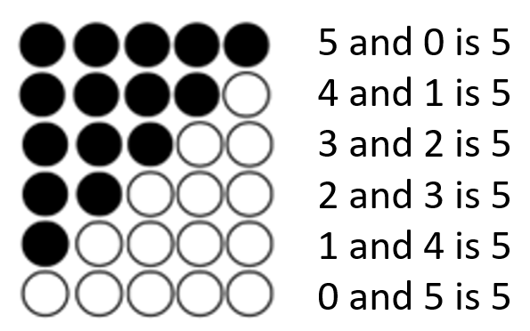
- Quickly recognizing and naming the number of objects in a small group without counting is called subitizing. The size of the group a student can subitize is dependent upon the arrangement. At this age, students should subitize irregular or unfamiliar arrangements up to 5. When there is a familiar or structured pattern (e.g., dots on number cubes, counters on a ten frame) students may be able to subitize larger numbers.
- Numbers can be composed and decomposed using part-whole relationships (e.g., 4 can be decomposed as 3 and 1, 2 and 2, or 4 and 0).
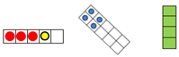
- Dot patterns should be presented in both regular and irregular arrangements. This will help students to understand that numbers are made up of parts and will later assist them in combining parts as well as counting on.
- Benchmarks of 5 and 10 are essential in building place value knowledge through the understanding of decomposition of the numbers of 5 and 10.
- Parts of 5 and 10 should be represented in a variety of ways, such as five frames, ten frames, strings of beads, arrangements of tiles or toothpicks, dot cards, or beaded number frames.

Measurement and Geometry
K.MG.1 The student will reason mathematically by making direct comparisons between two objects or events using the attributes of length, height, weight, volume, and time.
Students will demonstrate the following Knowledge and Skills:
- Use direct comparisons to compare, describe, and justify the:
  - lengths of two objects using the terms longer or shorter;
  - heights of two objects using the terms taller or shorter;
  - weights of two objects using the terms heavier or lighter;
  - volumes of two containers using the terms more or less; and
  - amount of time spent on two events using the terms longer or shorter.

K.MG.1 The student will reason mathematically by making direct comparisons between two objects or events using the attributes of length, height, weight, volume, and time.
Additional Content Background and Instructional Guidance:
- Hands-on experiences are needed to gain the ability to compare the attributes of objects.
- The attribute being measured (e.g., length, height, weight, volume) must be identified before the items are compared.
- Length is the distance between two points.
- Height is the distance from the bottom or base of something to the top.
- Weight is a measure of the heaviness of an object.
- Volume is the measure of the capacity of a container and how much it holds.
- Time is the measure of an event from its beginning to its end.
- Conservation of measurement is the understanding that the attributes of an object do not change when the object is manipulated (e.g., a piece of string that is coiled maintains its length as it is straightened; the volume of water does not change when poured from a pitcher into a fish tank).

K.MG.2 The student will identify, describe, name, compare, and construct plane figures (circles, triangles, squares, and rectangles).
Students will demonstrate the following Knowledge and Skills:
- Identify and name concrete and pictorial representations of circles, triangles, squares, and rectangles regardless of their orientation in space.
- Describe triangles, squares, and rectangles to include the number of sides and number of vertices.
- Describe a circle using terms such as round and curved.
- Distinguish between examples and nonexamples of identified plane figures (circles, triangles, squares, and rectangles).
- Compare and contrast two plane figures using characteristics to describe similarities and differences.
- Construct plane figures (circles, triangles, squares, and rectangles) using a variety of materials (e.g., straws, sticks, pipe cleaners).

K.MG.2 The student will identify, describe, name, compare, and construct plane figures (circles, triangles, squares, and rectangles).
Additional Content Background and Instructional Guidance:
- A plane figure is any closed, two-dimensional shape.
- A vertex is the point at which two or more lines, line segments, or rays meet to form an angle. The term vertices is the plural form of vertex.
- A polygon is a closed plane figure composed of at least three line segments that do not cross. Students at this level do not need to use the term polygon.
- A triangle is a polygon with three sides and three vertices. Experiences with different types of triangles allow students to analyze the characteristics of triangles (e.g., equilateral, isosceles, scalene, right, acute, obtuse); however, at this level, they are not expected to name the various types.
- A quadrilateral is a polygon with four sides and four vertices. Students at this level do not need to use the term quadrilateral.
- A rectangle is a quadrilateral with four right angles.
- A square is a quadrilateral with four congruent (equal length) sides and four right angles. At this level, students might describe a square as a special rectangle with four sides of equal length. Students at this level do not need to use the term congruent.
- A circle is not a polygon because it does not have straight sides.
- An important part of the geometry strand in kindergarten through Grade 2 is the naming and describing of figures. Students move from using their own vocabulary to incorporating conventional terminology as the teacher uses geometric terms.
- Triangles, rectangles, and squares should be presented in a variety of spatial orientations so that students are less likely to develop the common misconception that triangles, rectangles, and squares must have one side parallel to the bottom of the page on which they are printed.
- A common misconception that students develop is referring to a rotated square as a diamond. Ongoing clarification should be provided (i.e., a square is a square regardless of its location in space; there is no plane figure called a diamond).

- Early experiences with comparing, sorting, composing, and subdividing figures or manipulatives (e.g., pattern blocks, attribute blocks) assist students in analyzing the characteristics of plane geometric figures.

K.MG.3 The student will describe the units of time represented in a calendar.
Students will demonstrate the following Knowledge and Skills:
- Identify a calendar as a tool used to measure time.
- Name the days of the week and state that there are seven days in one week.
- Determine the day before and after a given day (e.g., yesterday, today, tomorrow).
- Name the twelve months of the year and state that there are twelve months in one year.
- Distinguish between days of the week and months of the year.

K.MG.3 The student will describe the units of time represented in a calendar.
Additional Content Background and Instructional Guidance:
- The calendar is a tool used to represent units of time (e.g., days, weeks, months, years). Using a calendar develops the concept of a day as a 24-hour period rather than a period of time from sunrise to sunset.
- Practical situations are appropriate to develop a sense of the interval of time between events (e.g., club or team meetings occur every week on Monday; there is one week between meetings).

Probability and Statistics
K.PS.1 The student will apply the data cycle (pose questions; collect or acquire data; organize and represent data; and analyze data and communicate results) with a focus on object graphs and picture graphs.
Students will demonstrate the following Knowledge and Skills:
- Sort and classify concrete objects into appropriate subsets (categories) based on one attribute (e.g., size, shape, color, thickness).
- Describe and label attributes (e.g., size, color, shape) of a set of objects (e.g., coins, counters, buttons) that has been sorted.
- Pose questions, given a predetermined context, that require the collection of data (limited to 25 or fewer data points for no more than four categories).
- Determine the data needed to answer a posed question, and collect the data using various methods (e.g., counting objects, drawing pictures).
- Organize and represent a data set (vertically or horizontally) by sorting concrete objects into organized groups to form a simple object graph.
- Organize and represent a data set (vertically or horizontally) using pictures to form a simple picture graph.
- Analyze data represented in object graphs and picture graphs and communicate results:
  - ask and answer questions about the data represented in object graphs and picture graphs (e.g., how many in each category, which categories have the greatest, least, or the same amount of data); and
  - draw conclusions about the data and make predictions based on the data.

K.PS.1 The student will apply the data cycle (pose questions; collect or acquire data; organize and represent data; and analyze data and communicate results) with a focus on object graphs and picture graphs.
Additional Content Background and Instructional Guidance:
- Students should explore the entire data cycle with a question and set of data that has been collected or acquired. Student reflection should occur throughout the data cycle. The data cycle includes the following steps: formulating questions to be explored with data, collecting or acquiring data, organizing and representing data, and analyzing and communicating results.
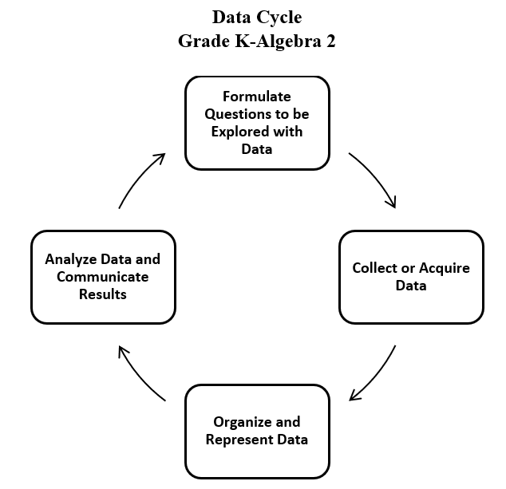
- Exploration of the entire data cycle with a question and set of data that has been collected or acquired should occur throughout the school year. Reflection should occur throughout the data cycle.
- To sort is to compare a set of objects in order to find similarities and differences, so that they may be arranged into organized groups.
- To classify is to arrange or organize a set of objects according to a category or attribute (a quality or characteristic).
- At the kindergarten level, using one attribute such as color, size, shape, or thickness is used to sort and classify.
- Items to be sorted may include:
  - Coins (pennies, nickels, dimes, quarters) - Although formal instruction on coin values and equivalencies will begin in Grade 1, kindergarten students are expected to sort and name coins.
  - Shapes - Attribute blocks and pattern blocks are among the manipulatives that are particularly appropriate for sorting and comparing size and shape; and
  - Real-world objects
- General similarities and differences among objects are easily observed by children entering kindergarten, who can focus on any single attribute. The teacher’s task is to move students toward a more sophisticated understanding of classification in which two or more attributes connect or differentiate sets, such as those found in nature (e.g., leaves having both different colors and different figures). The teacher can provide data sets to students in addition to students engaging in their own data collection.
- Data are pieces of information collected about people or things. The primary purpose of collecting data is to answer questions. The primary purpose of interpreting data is to inform decisions (e.g., which type of clothing to pack for a vacation based on a weather graph or which type of lunch to serve based upon class favorites).
- Methods for organizing data could include five frames or ten frames, tally charts, or various methods of grouping concrete materials. Tallying is a method for gathering information. Tally marks are used to show how often something happens or occurs. Each tally mark represents one occurrence. Tally marks are clustered into groups of five, with four vertical marks representing the first four occurrences and the fifth mark crossing the first four on a diagonal to represent the fifth occurrence.
- At this level, data gathered and displayed by students should be limited to 25 or fewer data points for no more than four categories.
- In the process of collecting data, students make decisions about what is relevant to their investigation (e.g., when collecting data on their classmates’ favorite pets, making the decision to limit the categories to common pets).
- When students begin to collect data, they recognize the need to categorize, which helps develop the understanding of “things that go together.” Categorical data are used when constructing object graphs, picture graphs, pictographs, and bar graphs.
- Different types of representations emphasize different things about the same data. Object graphs and picture graphs are the focus in kindergarten.
- Object graphs are graphs that use concrete materials to represent the categorical data that are collected (e.g., cubes stacked by the month, with one cube representing the birthday month of each student).
- Picture graphs are graphs that use pictures to represent and compare information. At this level, each picture should represent one data point.
- Students represent data to convey results of their investigations, using concrete objects, pictures, and numbers to provide a “picture” of the organized data.
- Opportunities to interpret graphs, created with the assistance of the teacher, that contain data points where the entire class is represented (e.g., tables that show who brought their lunch and who will buy their lunch for any given day; a picture graph showing how students traveled to school – bus, car, walk) are needed and should continue throughout the school year.
- When drawing conclusions about the data teachers should pose questions such as, “What might happen? What will happen? What will not happen?”
- When data are presented in an organized manner, students can interpret and discuss the results and implications of their investigation (e.g., identifying parts of the data that have special characteristics, including categories with the greatest, the least, or the same number of responses).
- Graphs can be used to make connections between mathematics and science or social studies (e.g., types of plants found in the school yard, how students get to school).

Patterns, Functions, and Algebra
K.PFA.1 The student will identify, describe, extend, and create simple repeating patterns using various representations.
Students will demonstrate the following Knowledge and Skills:
- Identify and describe the core found in repeating patterns.
- Extend a repeating pattern by adding at least two complete repetitions of the core to the pattern.
- Create and describe a repeating pattern using objects, colors, sounds, movements, or pictures.

K.PFA.1 The student will identify, describe, extend, and create simple repeating patterns using various representations.
Additional Content Background and Instructional Guidance:
- Patterning is a fundamental cornerstone of mathematics, particularly algebra. The process of generalization leads to the foundation of algebraic reasoning.
- Opportunities to describe, extend, and create repeating patterns are essential to the primary school experience and lay the foundation for algebraic thinking.
- Concrete objects for patterning can include connecting cubes, color tiles, pattern blocks, counters, buttons, etc.
- Concrete materials and pictorial representations (e.g., picture cards) allow students to explore the idea of patterning and make revisions when needed. Extending a pattern on paper limits a student’s ability to repeat the pattern beyond the length of the paper.
- Patterning includes:
  - creating a given pattern, using objects, sounds, movements, and pictures;
  - describing a pattern includes identifying the core of the pattern and labeling the pattern;
  - recording a pattern with pictures or symbols;
  - analyzing patterns in practical situations (e.g., calendar, seasons, days of the week).
- The part of the pattern that repeats is called the core.
- At this level, extending patterns when given a complete repetition of a core (e.g., ABCABCABC) as well as when the final repetition of the core is incomplete (e.g., ABCABCAB... or Red, Blue, Green, Red, Blue, Green, Red, Blue…) is appropriate.
- Examples of repeating patterns include:
  - ABABABAB;
  - ABCABC;
  - ABBAABBA;
  - AABBAABBAABB; and
  - AABAAB.
- Students may begin to discover patterns and relationships within numbers (e.g., part-whole combinations, on the hundreds chart, number path, etc.).

