Procedures for Using Web Extensions in TestNav as a
Virginia Standards of Learning (SOL) Online Test Accommodation
(updated March 18, 2024)
These procedures will assist divisions in determining how specific web extensions may be used by students with disabilities for online SOL testing. These web extensions allow students who are eligible for speech-to-text and/or word prediction accommodations to access speech-to-text and word prediction applications while in TestNav. Accommodations must be listed in the student’s IEP or 504 plan before they may be provided to the student for SOL testing. The web extensions are embedded in TestNav for an SOL test, but they must be selected in advance on the Student Registration/Personal Needs Profile (SR/PNP) screens in PearsonAccess^{next}.
In addition to the selection of the PNP Web Extension, accommodation code 21, Response Devices, must be selected on the students Special Test Accommodations section on the Student Test Details screen in PearsonAccess^{next}.
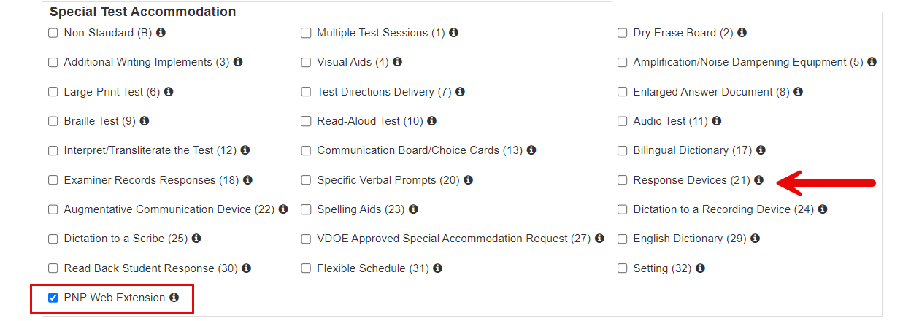
It is not necessary for the web extensions or applications, Co:Writer Universal and/or Read&Write, to be installed on a student’s browser or computer. Web extensions are supported on Windows, MacOS, and ChromeOS only. Android and iOS (iPad) devices do NOT currently support the use of the TestNav web extensions. Note that web extensions on non-secure tests, like practice items, are supported only on the Chrome web browser.
Students should utilize the Virginia Practice Items to become familiar with the speech-to-text accommodation and web extensions prior to testing. Note that web extensions on non-secure tests, like practice items, are supported only on the Chrome browser. An alternative is to use the Virginia Practice Items within the TestNav application. The specific practice items and tests where the speech-to-text accommodation is available include Grade 5 Integrated Reading and Writing (IRW), Grade 8 IRW, End-of-Course IRW, and End-of-Course Writing. When accessing practice items, the user will not need to select PNP Web Extension or Response Device accommodation 21. The user will select the appropriate grade 5, 8, or End-of-Course Integrated Reading and Writing with Speech to Text Accommodation practice set or End-of-Course Writing Practice Tool with Speech to Text Accommodation.

To access Co:Writer Universal or Read&Write web extensions in TestNav, follow these steps:
Step 1: For an SOL test, the SR/PNP for the student must designate that the student will have access to web extensions for the specific test (e.g., Grade 5 IRW) in PearsonAccess^{next}. In the Virginia Practice Items, select the appropriate test and scroll to find the practice items with the speech-to-text accommodation included.
Step 2: After the student logs in to the test or opens the practice item, the following screen will appear where the test administrator (or student) must select the appropriate web extension to be used during the assessment. Select the “Enable” button next to the correct web extension and then select “Continue To Test.”
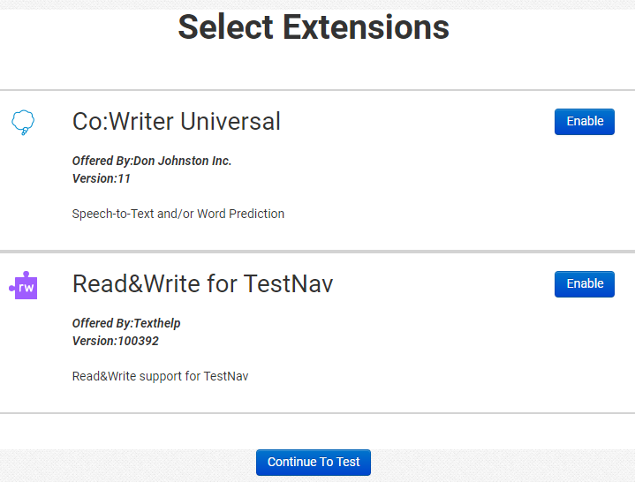
- Note: If when taking an SOL test, the screen above does not appear, then a web extension was not properly designated as an accommodation in PearsonAccess^{next}.
- Only one web extension is to be selected.
  - Both extensions have similar features, but the student should select the web extension they are most familiar with.
  - Do not assign a web extension to a student on the day of the test if the student has not used this web extension before.

Step 3: Follow the directions for the specific web extension that is selected.

If selecting Read&Write:
- After selecting Read&Write, select “Continue To Test” when the following screen appears. Do not select “Add More Extensions.”

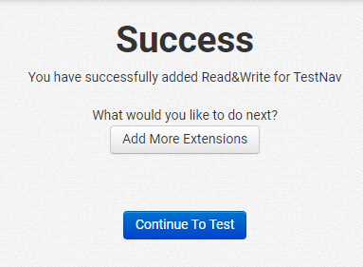

  - A small toolbar appears at the top menu bar upon login and can be moved around the page by clicking on the arrow icon and dragging the bar to the preferred location. The student will use the toolbar shown below to enable Talk&Type (speech-to-text) and word prediction when responding to the prompt. If the icons in the tool bar are gray rather than purple, the toolbar is disabled.

If selecting Co:Writer Universal:
- The examiner (or student) must toggle off either feature (Word Prediction or Speech-to-Text) the student is not approved to use. Continue with both features if approved.
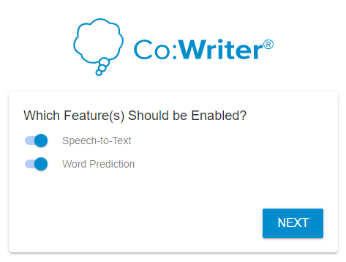
- Select the “Next” button.
- The student does not need a license to use Co:Writer Universal on the assessment.
  - If the student has an existing license for Co:Writer, they can log into their account and load their previously selected user settings for the assessment.
  - If the student does not have a license, or chooses not to load their settings, the test examiner (or student) can “SKIP” this step.
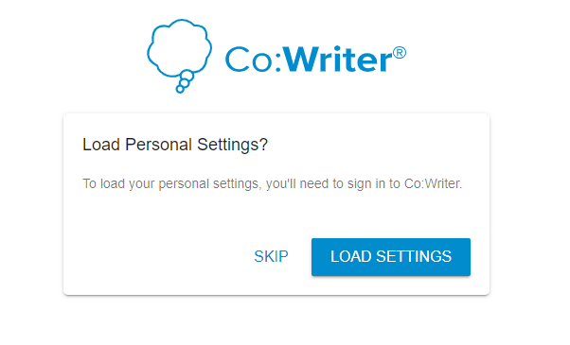

- Select “Continue To Test” when the following screen appears. Do not select “Add More Extensions.”
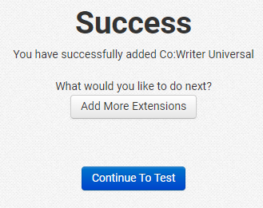

- The student may now continue to the test using the Co:Writer toolbar.
  - The Co:Writer menu will only appear for open response items. Click in the response box for the word prediction box to appear. A Co:Writer icon will also appear in the lower right corner of the screen. Clicking on that icon enables or disables the tool.

Enabled Disabled

  - The student will use the toolbar shown below to enable speech-to-text and word prediction.
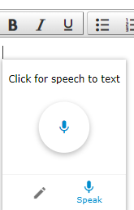

Notes:
- If it is determined that the incorrect web extension was selected, the student must exit out of the test and log in to the test again. Upon doing so, the correct web extension can be selected, and the student will be able to resume testing.
- Co:Writer Universal along with the Read&Write web extension will automatically capitalize the first word in a sentence when Speech-to-Text is enabled.
- When accessing the Word Prediction feature in Co:Writer Universal, the auto-generated word list will read back the words within the list to the student when the student’s cursor hovers over a particular word and as the student completes typing a word or sentence. If a student is using Read&Write, the auto-generated list will read back the words within the list to the student when the student’s cursor hovers over a particular word only.
- Students who take an audio version of the test are permitted to have this read-back functionality.
- When students do not qualify for an audio test, the read-back functionality will need to be addressed:
  - For a student not using personal settings in Co:Writer Universal or the Read&Write extension, have the student mute the computer by setting the speaker icon in TestNav to “0” or by muting the speakers on the student’s testing device.
  - For a student using personal settings in Co:Writer Universal, disable the read-back function before the student loads personal settings.

- If a student experiences the read-back functionality while testing in a group, the examiner or proctor should assist the student with muting the computer and permit the student to continue testing. Fora student who uses and loads personal settings in Co:Writer Universal,, direct the student to exit the test, change the settings, and then resume the test.

