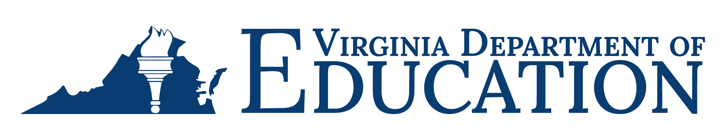
Virginia Adult Education
Narrative Report 2022-2023

Submitted to the U.S. Department of Education, December 2023

Virginia Adult Education Narrative Report 2022-2023
This report is prepared and submitted to the U.S. Department of Education, Office of Career, Technical, and Adult Education (OCTAE) pursuant to annual reporting requirements. This report and those from previous years are made available on the Virginia Department of Education’s (VDOE) Data, Monitoring, and Evaluation webpage.

State Leadership Funds (AEFLA Section 223)
The VDOE uses state leadership funds to provide, directly and through cooperative agreement with the Virginia Adult Learning Resource Center (VALRC) at Virginia Commonwealth University, opportunities for professional development (PD) and technical assistance to adult education and literacy practitioners throughout the Commonwealth.
In support of the requirement in Sec. 223(1)(a), alignment of adult education and literacy activities with other core programs and one-stop partners, the vision of the 2020-2024 Virginia WIOA Combined State Plan is to “improve economic opportunity for all Virginians by serving those who are not yet earning a sustainable wage and, as important, by focusing the resources and mechanisms of our workforce system to recruit people into the workforce and connecting them to businesses in high demand industries.” To carry out this vision, the VDOE uses state leadership funds to provide technical assistance, training, advising, and resources to eligible providers for offering career pathways and integrated education and training (IET) programming to ensure that adult learners have equitable opportunities to acquire digital literacy, employability, and academic skills, and are prepared for further postsecondary education, training, or employment.
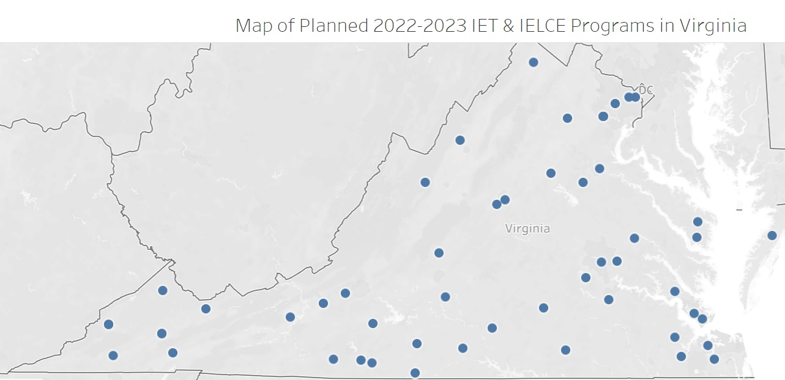
In program year (PY) 2022-2023, the VALRC facilitated a year-long Professional Learning Community (PLC) focused on Virginia’s implementation of IET and Integrated English Literacy and Civics Education (IELCE) programming. For the eight PLC sessions, a mean of 14 IET practitioners, including instructors, program managers, occupational trainers, and workforce partners participated from all of Virginia’s 22 adult education regions, providing a virtual space for collaboration across the state to share resources, networks, and expert guidance to strengthen learning outcomes, credential attainment, employability, and collaborations with workforce partners and employers. To further support the growth of IETs and career pathways, the VALRC continuously updated and maintained their IET Blueprint website (https://ietblueprint.com/) to align with the state’s IET planning tool, updated maps showcasing the state’s planned IET cohorts for PY2022-2023, as well as the implementation guidance.
In November 2022, the VDOE, VALRC and the WIOA Title IV agency, the Department for Aging and Rehabilitative Services (DARS) co-hosted a two-day hybrid Career Pathways Summit: Research, Practice, and Partners with 159 participating adult education practitioners and workforce partners. The event included a keynote research presentation followed by a partner-led discussion panel on the findings from the U.S. Department of Labor’s Career Pathways Descriptive and Analytical Project and how those findings impact career pathways programming. The first day of the Summit also included afternoon sessions on quality career pathways and IET cohorts, partnerships with Career and Technical Education programs, and registered apprenticeship. As part of the second day of the Summit, 38 adult educators attended a three-hour career coaching session that featured the Virginia Community College System’s (VCCS) master trainer and the GED® Testing Service, which presented remotely about their partnership with Credly by Pearson and how students can utilize digital badges in their job search.
To support effective IETs and transitions to further education, training, and employment, a cohort of 23 adult education practitioners was sponsored to participate in a career coach certification course, offered by the VCCS. This is the second cohort to be sponsored. Ten completed their certification in the PY2022-2023 timeframe; others continued to receive support toward earning their full certification.
The VDOE Adult Career Pathways Specialist continued to serve on the Sector Strategy and Career Pathway Academy (SSCPA) statewide effort to promote increased awareness of and interagency collaboration around sector strategies and career pathways among all workforce partners across agencies and locations. Just over 170 workforce professionals participated in PY2022-2023.
In support of the requirement in Sec. 223(1)(b), the establishment or operation of high-quality professional development (PD) programs, the vision of the VDOE is for the continuous improvement of instruction in adult education and literacy and support for practitioners in all roles to provide high-quality programming and instruction. The VDOE, through its cooperative agreement with the VALRC, supports both required and permissible state leadership activities as part of a high-quality PD program.
Building on effective virtual training models developed during the pandemic, the VALRC continued to offer primarily virtual PD options to programs, including webinar series, open conversation series, facilitated online courses, self-paced tutorials, PLCs, on-request workshops for regional programs, and conference presentations at state and national conferences. Additionally, as programs returned to in-person instruction, the VALRC developed and delivered seven on-demand PD events for local programs, focusing on standards-aligned instruction, reading instruction, workforce preparation, serving refugees, and working with adults with disabilities. The VALRC developed and delivered several three-part webinar series on writing strategies, math instruction, cultural competence, and standards-aligned instruction. The VALRC Literacy Specialist also developed and delivered PD on using interactive data maps, including data from the Program for the International Assessment of Adult Competencies (PIAAC) Skills Map and the Barbara Bush Foundation Literacy Map, for data-informed programmatic and instructional planning. The VALRC facilitated four-month PLC groups focusing on Spanish high school equivalency instructional practices, family literacy programming, IETs, serving refugees and new immigrants, and digital literacy through the Teaching Skills that Matter (TSTM) resources. During PY2022-2023, the VALRC provided more than 338 hours of PD to 1,822 attendees over 79 training events. The overall average hours of PD per participant was 6.4 hours, an increase from the pre-pandemic level of 1.7 hours per participant in PY2018-2019.

The VALRC offered webinars, online resources, and facilitated online courses on quality online instruction. Quality Teaching Online (QTO) webinars were developed and refined through participation in the Innovating Digital Education in Adult Learning (IDEAL) Consortium’s Digital Equity and Inclusion study circle. Additionally, the VALRC maintained a page on its main website (valrc.org) that provides rubrics, tips, strategies, and quality indicators for virtual instruction.

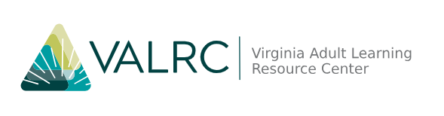
In spring 2023, eleven participants completed the VALRC-facilitated ten-hour TSTM PLC, focused on the TSTM digital literacy resources. Participating educators were introduced to TSTM’s nine “skills that matter” (workforce readiness or “soft” skills) and reviewed engaging instructional approaches along with exemplar, classroom-ready lessons. The PLC format gave participants a chance to choose materials to explore in more depth, make an action plan for their own learning environment, share their plans, and report back on their implementation successes and challenges. The VALRC also delivered facilitated, four-week online courses, including Beyond Basics: ESOL Beginning Literacy, Disabilities and the Adult Learner; ESOL Basics; and Beyond Basics: Multilevel ESOL Classes.
As a way to support programs serving newcomer immigrant and refugee groups, the VALRC facilitated five Serving Refugees PLC sessions in the winter and spring of 2023 to provide a space for programs to share how they were working with partner agencies, preparing for an increase in beginning literacy learners, providing culturally responsive education, as well as how they were serving Internationally Trained Professionals (ITPs). Throughout the four-month PLC, guest speakers presented on connecting with refugee resettlement agencies and community liaisons for recruitment and engagement of participants; provided information and resources for using an asset-based and culturally responsive approach when working with emerging English language learners; and provided training for ESOL and adult basic education (ABE) teachers. In addition, the VALRC developed materials for programs to use with community partners to articulate the role of adult education in refugee resettlement and connect refugees to educational services until they are able to start attending adult education classes. The VALRC also developed two toolkits to support instructors’ work with adult immigrant and refugee groups: ESOL Literacy Toolkit and the Social Emotional Learning Toolkit for New Americans.
In PY2022-2023, the VALRC maintained and updated the Inclusive Virginia (inclusive.valrc.org) website devoted to providing adult education program leadership, staff, and instructors with information, instructional strategies, resources, and accommodations for providing access to effective adult education for all learners. To further support digital accessibility, the VALRC’s Senior Instructional Technology Specialist developed a self-paced virtual tutorial, Five Components of Accessibility, on the VALRC’s Canvas platform for just-in-time PD on inclusive digital practices.
In support of the requirement in Sec. 223(1)(c), the provision of technical assistance, the VDOE provided technical assistance and guidance to eligible providers by sharing promising practices on high-quality, research-based instruction and programming; program accountability; and serving effectively as a one-stop partner. Technical assistance needs are solicited from program managers throughout the year and are informed by the results of the VDOE’s monitoring and evaluation efforts, described below.

The VALRC supports the VDOE in providing technical assistance by facilitating monthly data office hours with the VDOE staff and bimonthly program managers’ webinars and curating archived recordings. In November 2022, as part of the Career Pathways Summit, the VALRC and VDOE hosted a second day for program managers. The VDOE presented an in-depth and county-by-county look at trends in state demographics revealed by the most recent American Community Survey data. This data drives the funding formula for grantees and reflected what many program managers had expressed over the past few years about demographic shifts. The external analysis was funded through the VALRC’s cooperative agreement.
The VDOE, VALRC and DARS co-hosted a two-day hybrid Career Pathways Summit: Research, Practice, and Partners with 159 participating adult education practitioners and workforce partners.
The VALRC disseminated resources through its publications, websites, and listservs. Primary areas of focus include standards-based instruction (SBI) and implementation guidance, distance education, data management and use, digital skills, career pathways, program management, high school equivalency instruction, English language acquisition, numeracy, and accommodating learning disabilities.
Throughout PY2022-2023, the VDOE engaged in a procurement action to select a new state management information system. This action was informed by a task force of practitioners who participated in all aspects of procurement development, bid reviews, demonstrations, and review of references. LACES by LiteracyPro was selected, and by the end of the program year, the contract was finalized.
In PY2022-2023, the VALRC assigned three adult education program manager peer mentors to support three new regional program managers. Throughout the year, the VALRC provided coaching protocols, facilitated virtual meetings, and offered stipends for the mentors. The VALRC documented the process and solicited feedback from the mentor/mentee pairs in order to improve upon and continue the process for mentor-mentee pairs in the future.
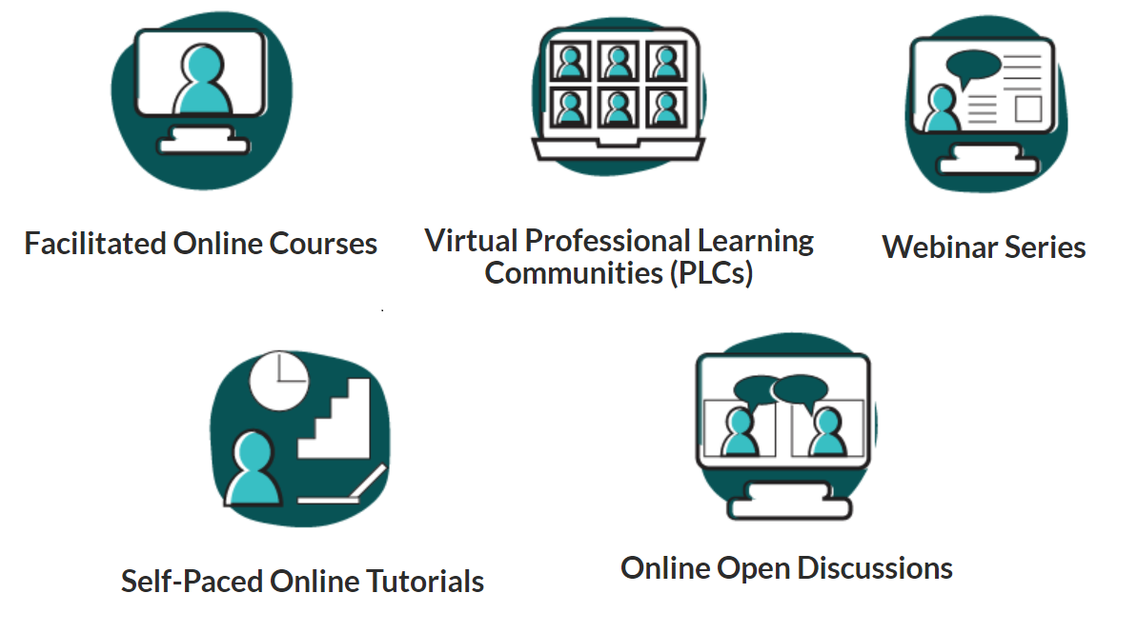
In PY2022-2023, the VALRC updated its website to promote greater interactivity and to better connect communications to new content, events, and PD opportunities. The site includes an events calendar where participants can learn about and register for PD, searchable resource collections, digital versions of VALRC publications, VALRC’s two podcast series, news updates, an interactive provider directory that is searchable by both location and service type, and a contact form to receive updates from the VALRC-supported listservs. The VALRC also updated and maintained three additional resource websites focusing on GED® preparation, inclusive practices for individuals with disabilities, and the IET Blueprint; four listservs; and the GED® Helpline. Publications and communications produced by the VALRC include a quarterly newsletter called Progress; two podcast series that highlight promising practices around the state; a YouTube channel; social media updates on Facebook and LinkedIn; and a monthly PD opportunities email announcement to its statewide listservs to share upcoming events, PD opportunities from LINCS.ed.gov and other providers, as well as the VALRC offerings.
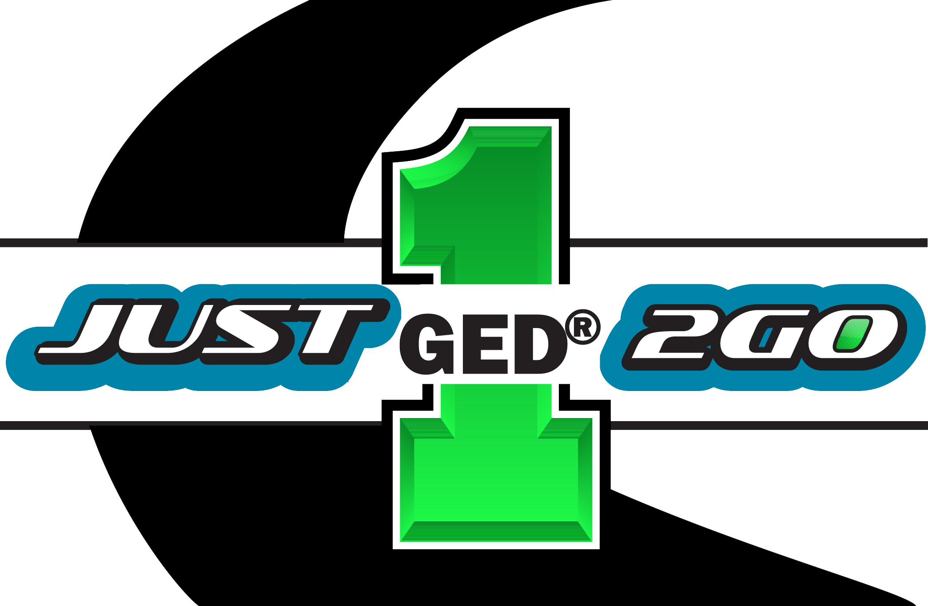
In January 2022, in response to a need identified by the VDOE to reach and recruit adult learners who have one remaining GED® test left to pass, the VALRC designed and launched the “Just 1 to Go” promotional campaign and marketing toolkit that includes an original logo and customizable templates for social media posts, emails, webpages, video scripts, and flyers for use by adult education programs around the state. The VALRC’s Communications Specialist continues to provide technical assistance to programs around accessing and optimizing use of the toolkit and incorporate it into programs’ communication strategies. This campaign was also promoted by all One-Stop partners in a coordinated effort to emphasize the critical importance of a secondary credential to job seekers. The starting list for this ongoing campaign included 3,396 individuals from the community, corrections, and adult education programs who were identified as missing only one subtest from earning their secondary credential. As of the end of PY2022-2023, 413 individuals (12 percent) had completed their last subtest and earned their secondary credential. Of the 413 graduates, 164 (40 percent) were connected with an adult education program and 64 (15 percent) were connected with a correctional education program.
In collaboration with teachers and program managers across the state, the VALRC solicited written work from learners and published its second annual adult learner publication, Spotlight. Spotlight features learners’ stories of refugee resettlement, immigration, challenges in education, successes in education, and original art and literature from across the state. Both the inaugural and second annual publications were printed and distributed to programs to use as an instructional tool. VALRC specialists also incorporated Spotlight into PD on using student writing for language arts instruction, including English learning. The VALRC’s podcast series, Voices from the Field, continues to highlight promising practices and innovations around the state. This year, the podcast episodes focused on connecting with refugees and refugee-serving groups, highlights in workforce development and career pathways, and learner reflections on writing for the Spotlight publication. The VALRC also curates Stories from the Field, its second podcast series, which focuses on learner achievements and credential attainments, practitioner and program innovations, and challenges the field faces.
The VALRC continued to support six programs in implementation family literacy programs. The VALRC provided PD through the National Center for Families Learning (NCFL) and hosted a monthly PLC where programs continued to learn about implementing the four components of family literacy and explored best practices for recruiting and retaining families. The VALRC and NCFL also provided individualized coaching and support to each program, which included on-site observations of programs, targeted resource development, and monthly calls. Recruitment was challenging, especially in the fall of 2022 as not all schools were operating in-person regularly. By the spring semester, five of the six programs were working with families.
At the 2022 Virginia Association for Adult and Continuing Education (VAACE) conference, the VDOE and VALRC delivered sessions focused on distance education, contextualizing adult education for workforce preparation, and demonstrating Standards in Action instructional techniques for English learners. The VDOE staff provided a master class in how to use the GED® Manager interface and a keynote presentation to look at the statewide data and discuss the service trends that had been disrupted and re-imagined due to pandemic-related restrictions.
In support of the requirement in Sec. 223(1)(d), monitoring and evaluation of quality, VDOE uses state leadership and administrative funds to support monitoring and evaluation activities, which include not only evaluating the quality of and improvement in local adult education activities but also the effectiveness of efforts by the VALRC. The requirement to disseminate information about models and proven and/or promising adult education practices within the state is discussed as an integral component of the work that the VALRC delivers as PD and technical support under 223(a)(1)(b).
The VALRC collects and analyzes evaluation data from participants in their PD offerings, using the information to inform future topics, modes of delivery, degrees of intensity, clarify delivery, and evaluate the distribution of their efforts across the providers.
The VALRC collects and analyzes evaluation data from participants in their PD offerings, using the information to inform future topics, modes of delivery, degrees of intensity, clarify delivery, and evaluate the distribution of their efforts across the providers.
The VDOE’s system for assessing the quality of providers of adult education and literacy activities is based on five major activities, which can occur both consecutively and concurrently throughout the program year: (1) a program self-assessment survey completed by each provider, (2) the distribution and review of an annual risk rubric for each program, (3) ongoing data monitoring of information entered by each program in the state Management Information System (MIS) and the Online Management of Education Grant Awards (OMEGA) fiscal system throughout the program year, (4) technical assistance calls, the content of which is based on 1-3 above, between the VDOE and each funded program, and (5) the identification of programs for site-visit reviews, based on information collected in activities 1-3 above.
In PY2022-2023, activities 1-3 listed above were successfully completed, starting with the distribution of the Program Self-Assessment Survey, which is designed as a means for programs to document their leadership and management processes and assist the VALRC and state office staff in the development of program-specific technical assistance plans. Risk rubrics were created from various data related to program operations and performance and distributed to all funded programs. Technical assistance calls were conducted with programs throughout the year as needed but were not scheduled with each program (4) due to the January announcement of the 2023-2025 adult education grant competition.
Responses to the 2023-2025 competitive adult education grant application led to the VDOE team adding a targeted monitoring visit to the types of site visits in PY2022-2023. A targeted monitoring visit, both in-person or virtual, will be conducted on an as-needed basis and may occur at any time throughout the year. Depending on the issue(s), a peer reviewer may be recruited to participate. A targeted monitoring visit does not mean the program is exempt from a full in-person site visit. One program was identified in June for a targeted monitoring visit, which will occur next program year.
The VDOE team also issued terms and conditions to the 2023-2025 grant recipients. All recipients are required to document that, through the 2023-2025 grant cycle, staff members will receive training on serving individuals with disabilities and on the science of reading. Progress toward meeting these requirements will be monitored throughout the 2023-2025 grant cycle.
Monitoring activities from PY2021-2022 carried over into PY2022-2023. An on-site review on June 15 and 28-30, 2022, and a virtual review on September 15, 2022, were conducted with both Region 13, serving the counties of Brunswick, Halifax, and Mecklenburg and Region 14, serving the counties of Amelia, Buckingham, Charlotte, Cumberland, Lunenburg, Nottoway, and Prince Edward in Southside Virginia. Southside Virginia Community College serves as the fiscal agent for regions 13 and 14; therefore, the on-site monitoring reviews occurred concurrently as many of the administrative processes and staff members are shared between programs. A Report of Findings was issued to each region, and the corrective action plans (CAP) were approved. Region 10, serving the counties of Albemarle, Fluvanna, Greene, Louisa, and Nelson and the city of Charlottesville, received an on-site monitoring visit in PY2021-2022 and continued to work on their CAP throughout PY2022-2023.
Many of the activities described above as responsive to state leadership requirements 223(1)(a) through (d) include elements of permissible state leadership activities as well. For example, the work to support practitioners to offer high-quality online distance instruction and disseminate standards-based curricula through the commissioned online courses draws on permissible activities 223(2)(b), (c) and (i). Providing technical assistance on implementing IET programming for career pathways and ensuring comprehension of the new reporting requirements also draws on the permissible activities of 223(2)(d) through (g). The work by the VALRC to develop and disseminate the “Just 1 to Go” GED® campaign and a video to be used in the statewide referral portal is an example of permissible activity 223(2)(l).

Performance Data Analysis
Virginia is proud to have exceeded all negotiated performance targets in PY2022-2023. Enrollment rebounded significantly in PY2022-2023, passing pre-pandemic levels.
Virginia is proud to have exceeded all negotiated performance targets in PY2022-2023. Enrollment rebounded significantly in PY2022-2023, passing pre-pandemic levels. In PY2022-2023, Virginia served 18,118 participants, up from 14,152 the previous year. Approximately 60 percent of our students were served in English language learning programs, and, in PY2022-2023; 33 percent of our foreign-educated students were internationally trained professionals. Of note is the percentage of students who report that they are employed while enrolled. In the past five years, only in PY2020-2021 did this percentage dip below 50 percent and even then, by less than a percentage point.
Taken together, adult education in Virginia is a majority-minority program. Over 75 percent of our students identify themselves as a race or ethnicity other than White. Hispanic students are our largest minority group. Over 65 percent of our students were women and 40 percent of our total enrollment was Hispanic women.
Multiple aspects of adult education services have been transformed through and since the pandemic as programs adapted remote intake, assessment, and instruction as a regular part of their service model and continued the intensive outreach and flexibility established during the pandemic. The overall average number of hours of instruction was 74.85 hours per student, up slightly from the year before, and 32.51 percent of students had some hours recorded as distance education. Retention remained high at 66.19 percent. The state office frequently discussed the retention rate with providers and the factors that contribute to it such as flexibility of scheduling and individual tutoring to help students continue to make progress.
On several performance measures, IET students outperformed the state aggregate measures in PY2022-2023. The new MSGs were the topic of ongoing and intensive professional development and technical assistance as programs strategically designed their IETs, communicated with their partners, and learned how to report and track progress. Reporting MSG Types 3, 4, and 5 yielded 628 additional MSGs reported by the state on NRS Table 4. Programs offered many IET courses and 1,868 participants, 10.31 percent of the total enrollment, were enrolled in an IET. Follow up measures for IET students indicated that 49.29 percent were employed in the second quarter after exit and 49.53 percent in the fourth quarter compared to the state’s overall rates of 26.61 percent and 29.79 percent, respectively. Median quarterly earnings in the second quarter after exit for IET students was $7,549.94, compared to the state overall earnings rate of $7,110.02. The rate of attaining a recognized postsecondary credential within one year of exit for IET students was 70.64 percent, compared to the state’s overall rate of 44.00 percent.
In PY2022-2023, 43 percent of the state’s 2,244 adult GED® graduates were connected with an adult education program. This is an increase from the previous year’s 34 percent. Ongoing initiatives such as Virginia’s “Test for Free” and “Just 1 to Go” campaigns continued to promote enrollment and re-engagement in adult education and provide an opportunity for students to earn free testing vouchers. Virginia’s adults had a 76 percent GED® pass rate, as compared to the 75 percent national pass rate during the same period.

Integration with One-Stop Partners
Virginia has over 50 comprehensive and affiliate Center locations in the 14 workforce regions.
In PY2016-2017, the state delegated the roles and responsibilities for addressing One-Stop requirements under 34 CFR part 463, subpart J, to the regional program managers and their fiscal agents. The regional programs work closely with their local workforce development boards (LWDB) and One-Stop operators to coordinate services, identify regional workforce needs, and facilitate access to adult education services through the One-Stops, called Virginia Career Works Centers. Virginia has over 50 comprehensive and affiliate Center locations in the 14 workforce regions. In PY2022-2023, the 22 regional programs contributed a total of $55,300.53 to Centers either in direct funds or in-kind contributions toward infrastructure in accordance with the MOU established by each LWDB; this represents 0.36 percent of the federal award. All regional programs participated in the services offered at their Centers, and regional program managers served on boards and committees of the LWDBs. Most Centers continued to offer online, virtual services even as they increased their provision of in-person service. Of note, some career services are now offered as a regular practice to adult education students through remote synchronous appointments. These appointments, either individual or with a class of students, were coordinated by both the adult education staff and the Center staff and have been described as more approachable and productive for students than a referral to another physical location.
During PY2022-2023, the VDOE collaborated with our Title IV partners to offer cross-agency professional development on adult career pathways. We hosted a lead author of the U.S. Department of Labor efforts on career trajectories to keynote a one-day hybrid event which drew over 100 participants. As a follow-up learning opportunity, a webinar was hosted by the same partners to feature the National Skills Coalition’s analysis of the need for digital skills in job openings advertised in Virginia. Again, this cross-agency offering drew over 100 participants to focus on the critical need for digital upskilling and broadband infrastructure. This event was timed to bring attention to the work in Virginia on the Digital Opportunity Act which was beginning stakeholder engagement efforts.
As PY2022-2023 was a competition year for adult education, LWDB colleagues and state colleagues from other agencies were recruited as grant application reviewers during the competition period. Over 40 reviewers were oriented to the competition and purposes of the WIOA title II program and provided critical feedback and reviews for the applications.

Integrated English Literacy and Civics Education Program (AEFLA Section 243)
The VDOE held a multi-year competition in 2020 for PY2020-2023 awards; PY2022-2023 was the third of the three years. Seventeen IELCE applicants were awarded, including fiscal agents at community colleges, school divisions, and community-based literacy organizations. The IELCE programs are clustered in the high-immigrant population areas of Northern Virginia, Richmond City, Charlottesville, and the Hampton Roads area. Four additional programs are in the rural agricultural areas of the New River Valley, Shenandoah Valley, and Eastern Shore. IELCE applicants were required to offer or partner to offer an IET in an industry aligned to their LWDB’s strategic plan or regional economic analysis. Applicants mapped their plans and partners’ contributions onto the IET Planning Tool, a graphic organizer required for all IETs.
In PY2022-2023, there were 4,320 IELCE participants statewide, 343 of whom participated in IET programs. The IET enrollment represents 8 percent of the total IELCE enrollment and 18 percent of the state’s total IET enrollment of 1,868. Aligning occupational training to the language capabilities of English language learners remains a challenge for programs; some programs continue to create opportunities that scaffold the foundational skills necessary to be successful in occupational training.
IET programs in PY2022-2023 were offered for students in sectors including healthcare, educational services, technology, transportation, administrative support services, construction, manufacturing, accommodation/food services, other services (entrepreneurship), personal services, and retail/customer service. 162 participants earned credentials during the program year including Certified Guest Service Gold Professional, Childhood Development Associate Level 1, Microsoft Office Specialist, Customer Service and Sales, Personal Care Aide, Entrepreneurship, Certified Nurse Aide, Certified Medical Aide, Certified Dental Assisting, AWS Welding, Certified Veterinary Assistant, Forklift Operator, CompTIA ITF+/A+, Paraprofessional, EPA Section 608, NOCTI Electrical Occupations.
In PY2022-2023, there were 4,320 IELCE participants statewide, 343 of whom participated in IET programs.
At the outset of PY2022-2023, the VDOE launched a year-long focus on technical assistance for programs to offer rigorous IET programs and to incorporate the new MSGs (types 3, 4, and 5) for IET and workplace literacy programs. Through various presentation opportunities, this guidance was contextualized and re-presented to help develop practitioners’ understanding of how to adjust their program design to take full advantage of demonstrating gains.
Other technical assistance efforts included a two-day Career Pathways Summit, offered in collaboration with WIOA Title IV partners, during which various career pathways topics were explored. This included a session with the VDOE colleagues in Career and Technical Education in which specialists offered practitioners ideas for working with local secondary and adult CTE programs; a host of resources for career pathways curriculum and credentialling were shared during the session and in follow-up technical assistance. The VALRC also hosted PLCs to support providers in their efforts to design and deliver IETs. Supporting language learners continues to be a focus of Virginia’s IET technical assistance.
Programs consult with their LWDBs’ plans to prepare and place students for in-demand occupations and provide career services to students either by a program-based career navigator or by hosting regular access to a career coach from the local community college or Career Works Center. These services continued to be offered remotely through teleconferencing and individual appointments. Programs also serve businesses in their communities by announcing and promoting job openings to students and hosting recruitment activities such as career fairs, many of which were held virtually. These activities are reported to the VDOE quarterly and contribute to the statewide report of business services.
Post-exit indicators reported in PY2022-2023 for IELCE students in the follow-up cohort indicate that 15.31 percent were employed in the second quarter after exit, 17.89 percent were employed in the fourth quarter after exit, and 42.55 percent attained a recognized postsecondary credential within one year of exit. All IET providers are expected to work with their workforce development partners to identify in-demand occupations in their region.

Adult Education Standards
Since the adoption of the College and Career Readiness Standards (CCRS) in 2016, the VDOE and the VALRC have been implementing training and technical assistance and institutionalizing the use of standards-based instruction (SBI) through practices and grant requirements. Virginia is now in what Susan Pimentel, in the Handbook for Sustaining Standards-based Instruction in Adult Education (2014), describes as Stage Four implementation, “Initiating a Scale-Up Plan: Sustaining Momentum, Progress, and Creative Renewal.” The VDOE competitive grants require that programs demonstrate full implementation of standards-based instruction; program monitoring ensures that programs self-assess and document this implementation. The SBI webpage (valrc.org/standards-based-instruction) of the VALRC website provides key links, resources, and technical assistance.
The VALRC provided a variety of training options to support new and experienced educators in effective SBI, from foundational training introducing the CCRS and English Language Proficiency Standards (ELPS) to subject-area-specific training that fully integrates standards.
The VALRC provided a variety of training options to support new and experienced educators in effective SBI, from foundational training introducing the CCRS and English Language Proficiency Standards (ELPS) to subject-area-specific training that fully integrates standards. The three-part, interactive Teaching the Key Shifts webinar series, focused on integrating the CCRS English language arts/literacy key shifts into instruction, was offered in spring 2023. Other standards-aligned PD offerings included a three-part fall webinar series on evidence-based writing instruction; a three-part spring webinar series on math instruction; and two webinars on teaching reading and writing using published writing by adult learners as models. Customized PD support based on local program requests included technical assistance provided to a regional specialist leading a CCRS-focused in-service and development and delivery of a half-day training: Contextualizing Standards-based Instruction for Transferable Skill-building. Virginia also continued to support dissemination and use of the standards-aligned TSTM skills, lessons, and approaches, offering a spring PLC that focused on lesson planning and implementation using the TSTM digital literacy materials.

As many programs around the state worked to serve an influx of refugee learners, VALRC offered many ELPS-aligned PD opportunities designed to support educators in serving this demographic as well as other English language learners (ELLs). These included a four-session Serving Refugees, New Americans, and Immigrants in Adult Education PLC; two webinars on contextualized phonics instruction; a webinar on preparing ELLs for purposeful reading; two, six-week online courses on serving learners at the beginning literacy level and teaching multilevel classes; and, an eight-week ESOL Basics online course.

The VDOE supported the rollout of nine (three mathematics, three English language arts, and three English for speakers of other languages) CCRS-aligned online courses intended to support the expansion of remote synchronous and asynchronous instruction for adult learners. Initial development work on these courses was completed by Virtual Virginia in 2022, and the courses were introduced to educators through a one-day, on-site training in August 2022. Virtual Virginia provided ongoing technical assistance in hosting and utilizing the courses to local and regional programs. VALRC facilitated a post-training listening session in fall 2022 and, in spring 2023, brought together a group of teachers to review and pilot the suite of courses, making recommendations for revisions (carried out by Virtual Virginia) and for implementation. By managing a master suite of exportable Canvas courses, Virginia aims to minimize the duplication of effort by regional adult education programs and instructors and create a high-quality set of courses for adult education and literacy instruction that is aligned to rigorous standards and best practices and designed to be customizable by instructors.

Programs for Corrections Education and Education of Other Institutionalized Individuals
During PY2022-2023, there was no methodology in place for matching the recidivism rate for criminal offenders or released individuals served in programs supported with Section 225 funds. However, the Virginia Department of Corrections (VADOC) has published state definitions and formulas for setting the state rate of recidivism of re-arrest, re-conviction, and re-incarceration at intervals of 6, 12, 18, 24, and 36 months. Virginia continues to have one of the lowest recidivism rates in the country at 20.6 percent.
Although correctional education services remained limited in PY2022-2023 again due to pandemic restrictions and severe staffing shortages in the facilities, some regional programs were able to offer educational services in local and regional jails, community institutions, a halfway house, and community re-entry programs, including through distance education materials. IET programming that awarded credentials toward solar installation, was also offered in a state facility through a special arrangement. Enrollment was up from 416 in the previous year to 615 correctional education participants.
Virginia continues to have one of the lowest recidivism rates in the country at 20.6 percent.
Of those 615 participants, 143 (23 percent) participated in an IET program in correctional facilities and 84 participants (59 percent) earned an industry recognized credential. This included credentials in Solar Installation, Horticulture, ServSafe Manager, and Certified Logistics Associate.
In PY2022-2023, these facilities experienced a 79 percent increase in the number of GED® passers over the prior year as academic preparation and testing volume continued to increase from the pandemic limitations. In total, 120 individuals earned a secondary credential. In addition, the state GED® pass rate for the correctional population increased from 70 percent to 76 percent, which is higher than the national pass rate.

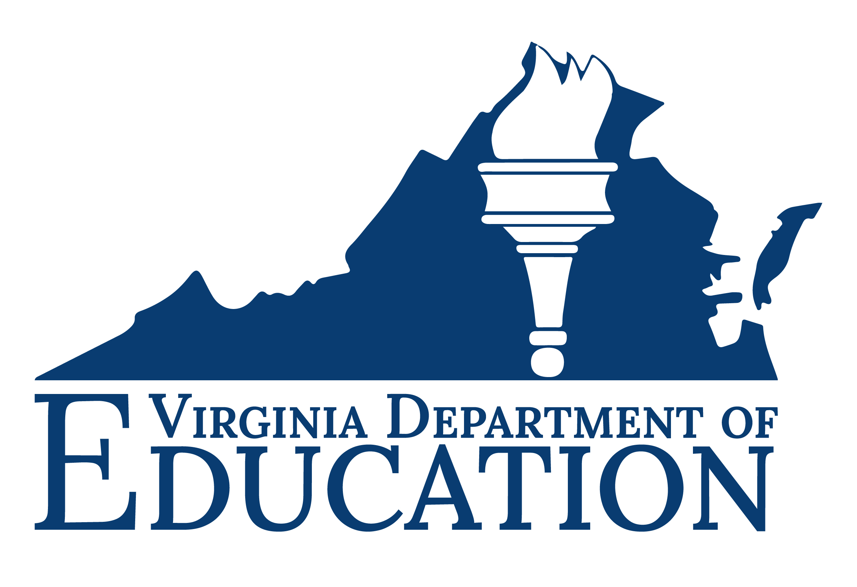

Cover Photo Credits: CCDA Hogar, Waynesboro City Public Schools, Brooks Crossing Innovation and Opportunity Center

