2024 Summer Residential Governor’s School (SRGS)

Medicine and Health Sciences Application
Information Page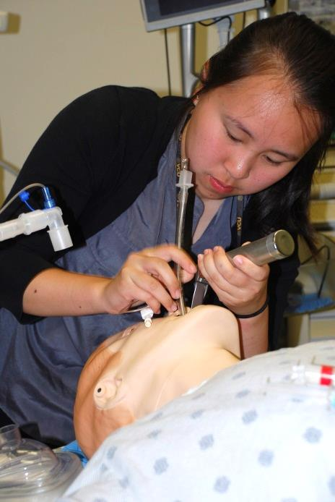
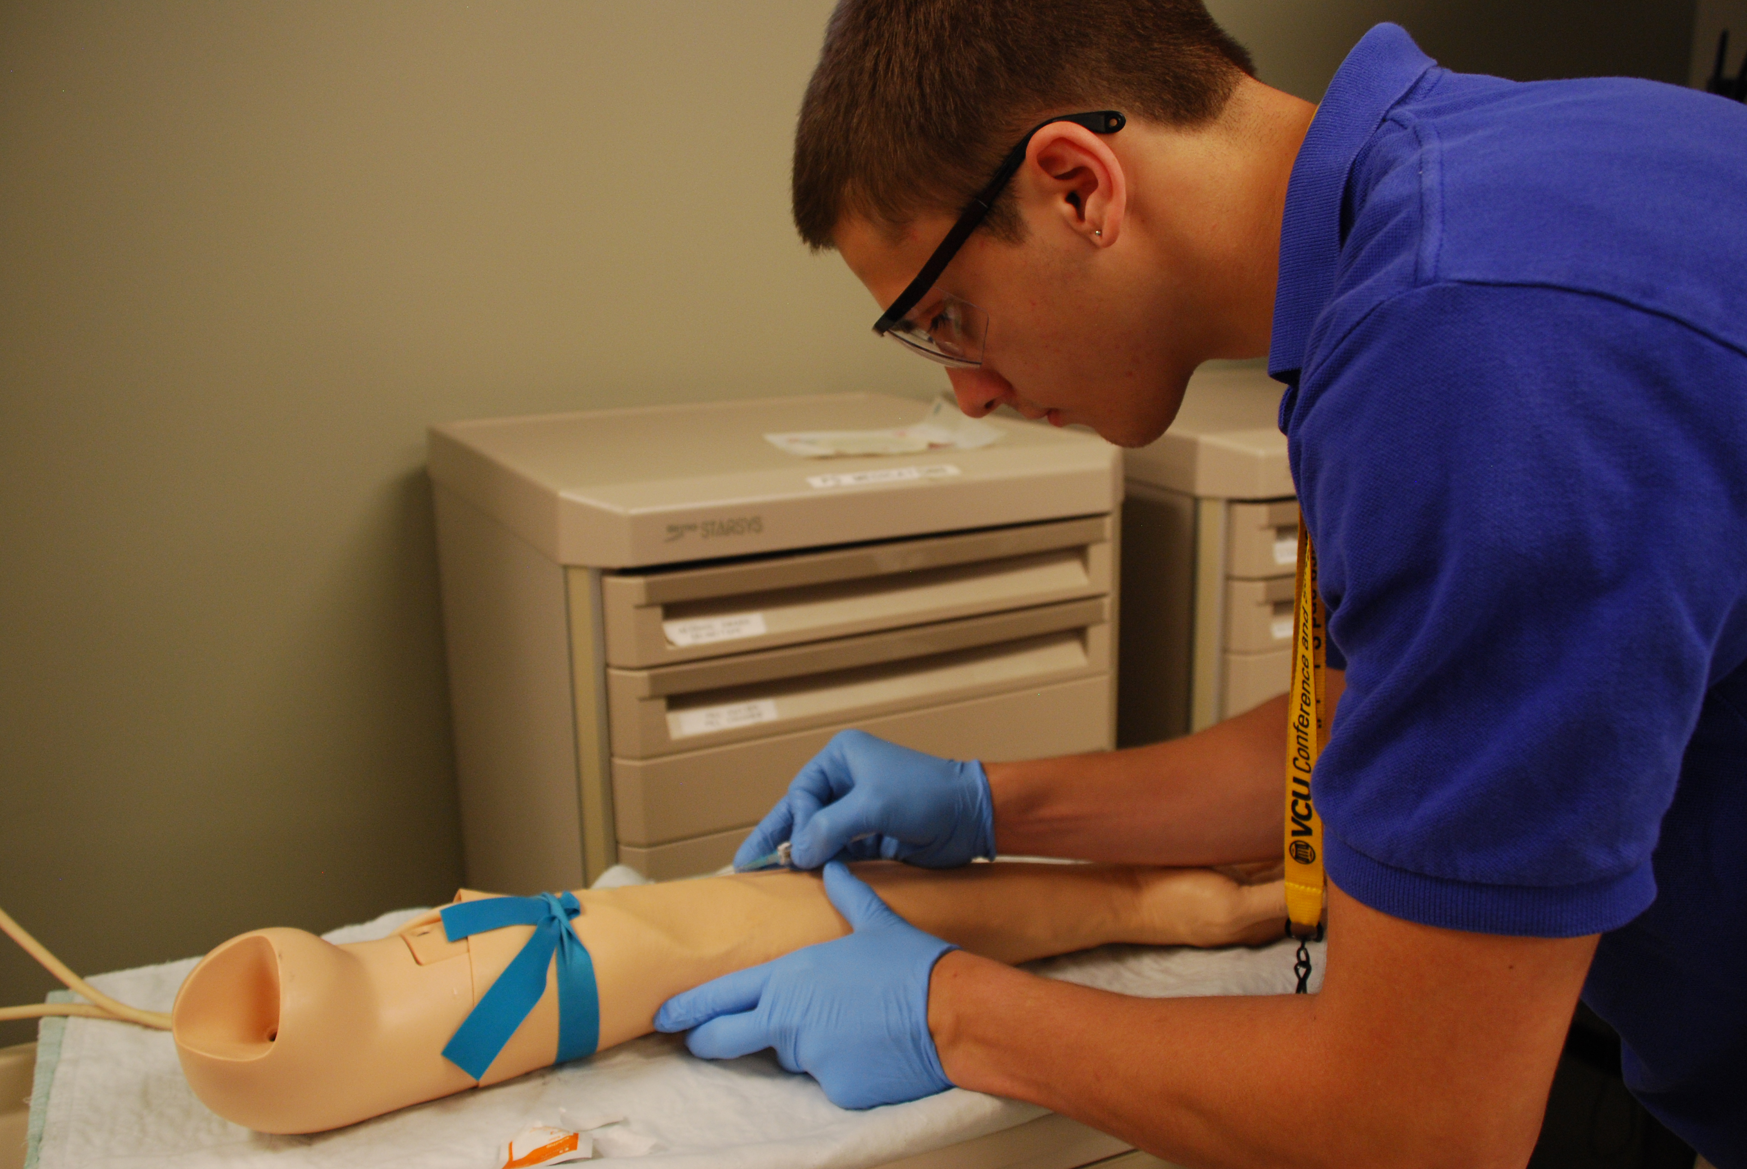
For Summer 2024 only, students may apply to the MHS program even if they have applied to another academic program. Students may only attend one program.

The Summer Residential Governor’s School (SRGS) for Medicine and Health Sciences provides an enhanced curriculum that explores medicine and the health sciences as a foundation for integrated study.

- The Medicine and Health Sciences SRGS program is designed to enhance the connection between research in health sciences and the practice of medicine for students.

- Students explore various aspects of medicine and health sciences through diverse and synergistic thinking and questioning. Students are engaged in hands-on classroom activities, laboratory exercises and field experiences.

- Students are immersed in complex analysis and critical thinking exercises which involve real-world scenarios to deepen their understanding of concepts and practices within the medical field.

- The Medical and Health Sciences SRGS program is suited for students with a serious interest in science, curiosity about the effects science in the fields of medicine and health care, and motivation to spend a month in a rigorous, academically accelerated setting during the summer.

Students must key in the data on the first page of this application for clarity and accuracy.

For division information, please contact the gifted education coordinator whose contact information is available at the following Web site: http://www.doe.virginia.gov/instruction/gifted_ed/ed_services_plans/local_div_coordinators.pdf

The Virginia Department of Education does not discriminate on the basis of race, sex, color, national origin, religion, sexual orientation, gender identity, age, political affiliation, veteran status, or against otherwise qualified persons with disabilities in its programs and activities and provides equal access to the Boy Scouts and other designated youth groups. The following position has been designated to handle inquiries regarding the Department’s nondiscrimination policies: Deputy Superintendent – Finance and Operations, Virginia Department of Education, P.O. Box 2120, Richmond, Virginia 23218-2120, (804) 225-2025.

For further information on Federal nondiscrimination regulations, contact the Office of Civil Rights at OCR.DC@ed.gov or call 1 (800) 421-3481.You may also view Executive Order 1 (2014), which specifically prohibits discrimination on the basis of race, sex, color, national origin, religion, sexual orientation, gender identity, age, political affiliation, or against otherwise qualified persons with disabilities. The policy permits appropriate employment preferences for veterans and specifically prohibits discrimination against veterans. You may obtain additional information at the Commonwealth of Virginia’s official website concerning this equal opportunity policy.

2024 SUMMER RESIDENTIAL Governor's SCHOOL (SRGS)

Medicine and Health Sciences Application

APPLICANTS MUST KEY THIS PAGE FOR CLARITY AND ACCURACY.

I attend Public School Private School Home School

Applicant Information: Complete all requested information.

Personal Information
First Name |  |  |  |  |  | Date of Birth
Middle Name |  |  |  |  |  | Nickname
Last Name |  |  |  |  |  | Graduation Year
Mailing Address
City |  |  | Virginia ZIP
Home Telephone |  | Student’s Email
Parent’s/Guardian’s Work Phone |  | Parent’s/Guardian’s Email
Parent’s/Guardian’s Work Phone |  | Parent’s/Guardian’s Email

High School Information: Complete all requested information.
High School |  | HS Contact Name and Email
School Address
City/State/ZIP
Telephone |  | Fax Number
Public School Students Only
Division Name |  | School Division LEA Number

Student Statement:
The decision to apply for Governor's School is my own. I want to participate fully in the program. If selected, I will abide by the rules and expectations explained in the program descriptions and all other expectations provided by the program director. The responses contained in this application are my own work and are truthfully offered. I acknowledge that if accepted to two programs, I may only attend one Summer Residential Governor’s School.

SIGNATURE OF APPLICANT DATE

For Official Use Only by Gifted Education Coordinator: Indicate student's score and rank.

Score from page 8 ______________ Rank ______________
(round to the nearest hundredth)

Applicant's Full Name

ALL APPLICANTS MUST COMPLETE INFORMATION ON THIS PAGE

Career Highlights: Activities, Research and Honors
In the three sections that follow, list accomplishments that highlight your positions of leadership or intellectual activities. Higher scores will be awarded to activities/programs in which you hold a position of leadership, and to research, study, presentations, and competitions associated with extracurricular clubs, community groups, national organizations, etc.

Activities/Programs
List the three most significant activities/programs in which you have participated during the past three years that relate to your area of interest. Include the complete name of the organization, sponsoring agency, or group. Also, describe the time involved and any leadership position you have held. Under “Year” indicate the calendar year of the training or activity. If you need more space, attach a second sheet. Please explain any acronyms that you use.
Activity and Organization | Position Held | Time Involved | Year
Example:  Mu Alpha Theta | Vice President | 6 hours/week | 2015
- 1.
- 2.
- 3.
Research/Study Experiences
List the three most significant research/study experiences you have had in the past three years that relate to your area of interest. Make sure you include the name of any group, organization, or individual with whom you studied. If you need more space, attach a second sheet.
Study/Brief Description | Teacher | Organization | Time
Example: VJAS research project exploring the consequences of fertilizer run-off on the York River | Danny Peters, Biology | York High School | 2 semesters,  2014-15
- 1.
- 2.
- 3.
Honors/Recognitions
In this section, please list the three most significant honors/recognitions you have received during the last three years in your area of interest.
Honor/Recognition |  | Level of Competition – Regional, State, National, International |  | Year
Example:  Selected participant/Virginia Rotary Youth Leadership Seminar/ Virginia Tech |  | State |  | 2015-2016
- 1.
- 2.
- 3.
 | Applicant's Full Name

Medicine AND HEALTH SCIENCES APPLICANTS

Final selection of participants is made by the program and/or site directors and is based on the strength of the application, program needs, and the availability of mentors.
Have you worked with a mentor during your high school experience? Yes No

With whom do/did you work?
Where do/did you work?
For how long have you worked with this mentor?

Medicine And Health Sciences Essay
Students must respond to the prompt below as the essay component for the application. The essay should be 300-500 words (approximately two pages of double-spaced 12-point type, with a 1” margin on each side). Include your name in the upper right-hand corner of each page of the essay. Number the pages 5a and 5b and place them in the final academic application after this page. You should review the rubric below and consider each of the areas carefully as you proofread and edit your essay. You may seek advice from appropriate teachers as you draft and revise your essay. This is a graded element worth 24 points.

Composition | 0 – 1 | 2 | 3 | 4
Central Idea/Position | Missing | Unclear | Weak | Strong
Evidence/Details | Unclear | Minimal | Adequate | Precise/Relevant
Organization/Unity | Lacking | Random/Many digressions | Lapses/ Some digressions | Logical/Unified
Counter Claims | Absent | Weak | Attempted | Effective
Word Choice | Lacking | Limited | Some Specificity | Highly Specific
MECHANICS | 0 | 1 | 2
Sentence Structure | Weak | Some variety | Varied
Usage | Incorrect | Some incorrect | Consistently correct
Mechanics | Incorrect | Some incorrect | Consistently correct

Medicine And Health Sciences Essay Topic
Imagine that you are a medical student on your rounds in the hospital. Discuss some important interactions that you might observe between a health care provider and patients and among staff members themselves. Discuss the communication, teamwork, and leadership skills that you would consider important for a medical student to possess in order to work effectively in a modern integrative health care system with culturally diverse patients.

Applicant's Full Name

ALL APPLICANTS AND PARENT/GUARDIAN MUST COMPLETE INFORMATION ON THIS PAGE

Applicant and Parent/Guardian Assurances

I, the parent/guardian of , permit my son/daughter, if selected, to participate in the 2024 Summer Residential Governor's School. I realize that transportation to and from the Governor's School and spending money for personal expenses must be provided by the participants. I understand that if selected for the program, he/she must abide by the rules and expectations set forth for the school. I further agree that I have been duly informed that LEAVES OF ABSENCE from these programs are allowed only for SEVERE CASES OF MEDICAL AND/OR FAMILY EMERGENCIES. Medical and family emergencies include major illness, hospitalization, or death of an immediate family member or guardian. I also understand that failure to participate in the programs, or unwillingness to abide by the rules and expectations, may be just cause for immediate dismissal. I acknowledge that if accepted to another program, my son/daughter may only attend one Summer Residential Governor’s School.

SIGNATURE OF PARENT/GUARDIAN DATE

Both student and parent/guardian must initial after having read the following assurances. These constitute the expectations for students who apply or accept invitations to the summer residential governor's school program.
Student  Initials | Parent or  Guardian  Initials | Assurances
 |  | I understand that leaves of absence are granted ONLY in the case of medical or family emergencies as described above. Participants are expected to arrive at the site by the opening ceremony, indicated in the 2024 Student and Parent Guide for Governor's Schools, and remain at the site through the closing ceremony.
 |  | I understand that the programs require concerted academic focus, preparation, and motivation from all participants and that participants are expected to demonstrate the emotional maturity and self-discipline to participate in the activities and to demonstrate respect for self, others, program, and school.
 |  | I understand that participants will be expected to follow the rules and expectations outlined in the 2024 Student and Parent Guide for Governor's Schools, and any handbook or other instructions provided by the program director. These rules and expectations have been thoroughly read and are understood.
 |  | I understand that each nominee and division gifted education coordinator/private school regional coordinator will be mailed acceptance and alternate information by April 18, 2024, and that no information will be available before that date.
 |  | I understand that possession of tobacco or alcohol, weapons, or nonprescription drugs will result in the participant's immediate dismissal from the program and that participants are also subject to any disciplinary action that the sponsoring school division or private school chooses to invoke. Certain infractions may also result in legal consequences as outlined in the Code of Virginia.
 |  | I understand that previous participants of any Summer Residential Governor's School program (including Governor's Foreign Language Academies) shall not apply for or participate in the Summer Residential Governor's School program; and I am not applying for a 2024 Governor's Foreign Language Academy.
 |  | I certify that I am a resident of the Commonwealth of Virginia and eligible for a free, public education in the Commonwealth.
 |  | I understand failure to provide complete and accurate medical and prescription information may result in immediate dismissal from the program.
 |  | I understand that I waive my rights to review and inspect my child’s application and score sheet for the Summer Residential Governor’s School program.
 |  | I certify that these are my truthful responses to these assurances.

Applicant's Full Name

INFORMATION ON THIS PAGE MUST BE COMPLETED BY THE APPROPRIATE CONTENT AREA TEACHER

Teacher Recommendation A
This recommendation must be completed by any current teacher/instructor from a content area closely related to the student's SRGS program of interest who is familiar with this student’s current work. There are two required parts to the recommendation: a rating scale and a narrative.

Rating Scale Teacher A
1. What course or program of studies has the student taken under your supervision? In what year(s)?

2. Please estimate the extent to which the student has demonstrated in your class(es) the qualities listed below. Use the scale from 0-2 as indicated. Be sure to respond to all qualities; items omitted are included as a zero when computing a score. Please use only whole number values.
0=Good (Above Average) 1=Excellent (Top 10 Percent) 2=Outstanding (Top 2-3 Percent) SCORE
1. | Motivation and initiative
2. | Self-direction
3. | Intellectual curiosity
4. | Independence of thought
5. | Originality of ideas
6. | Use of higher-level thinking skills
7. | Attitude toward learning
8. | Ability to contribute to a group process
9. | Willingness to accept ideas of others
10. | Emotional stability, maturity, and self-discipline
11. | Openness to new experiences
12. | Cooperative behavior
13. | Respect and tolerance for the views of others
 |  | Subtotal A (out of 26 points)

Narrative Teacher A
Teachers, please complete the narrative portion of the recommendation using specific examples from your work with this student to indicate how the student demonstrates these qualities: ability to work cooperatively and meaningfully in groups; openness to new and diverse situations; goals for academic growth; creativity; and intellectual and social maturity. Please print your narrative on school, personal, or professional letterhead. Sign and date both the printed rating scale and narrative and return them to the guidance office or as otherwise directed.

Signature of Teacher |  | Printed Name |  | Date
Email Address |  | Phone #

Applicant's Full Name

INFORMATION ON THIS PAGE MUST BE COMPLETED BY THE APPROPRIATE ADULT

Adult Recommendation B
This recommendation must be completed by any teacher/instructor/advisor/adult (outside of the student's family) who is familiar with this student’s work. There are two required parts to the recommendation: a rating scale and a narrative.

Rating Scale Recommender B
1. What course, program of study or activities has the student taken under your supervision? In what year(s)?

2. Please estimate the extent to which the student has demonstrated the qualities listed below. Use the scale from 0-2 as indicated. Be sure to respond to all qualities; items omitted are included as a zero when computing a score. Please use only whole number values.
0=Good (Above Average) 1=Excellent (Top 10 Percent) 2=Outstanding (Top 2-3 Percent) SCORE
1. | Motivation and initiative
2. | Self-direction
3. | Intellectual curiosity
4. | Independence of thought
5. | Originality of ideas
6. | Use of higher-level thinking skills
7. | Attitude toward learning
8. | Ability to contribute to a group process
9. | Willingness to accept ideas of others
10. | Emotional stability, maturity, and self-discipline
11. | Openness to new experiences
12. | Cooperative behavior
13. | Respect and tolerance for the views of others
 |  | Subtotal A (out of 26 points)

Narrative Recommender B
Recommender: Please complete the narrative portion of the recommendation using specific examples from your work with this student to indicate how the student demonstrates these qualities: ability to work cooperatively and meaningfully in groups; openness to new and diverse situations; goals for academic growth; creativity; and intellectual and social maturity. Please print your narrative on school, personal, or professional letterhead. Sign and date both the printed rating scale and narrative and return them to the guidance office or as otherwise directed.

Signature of Recommender |  | Printed Name |  | Date
Email Address |  | Phone #

Applicant's Full Name

INFORMATION ON THIS PAGE MUST BE COMPLETED BY APPROPRIATE SCHOOL AND DIVISION PERSONNEL

Principal/Head of School Recommendation
I hereby certify that this student is qualified and genuinely interested in attending the Summer Residential Governor's School. I recommend this applicant.
Signature of Principal/Head of School |  | Printed Name |  | Date
School Name |  | Public School LEA Number

Gifted Education Coordinator/Regional Coordinator Recommendation
I hereby certify that this student is qualified and genuinely interested in attending the Summer Residential Governor's School. I further certify that the nominee’s attendance and discipline records have been reviewed and that information has been taken into appropriate consideration. I thereby recommend this student for consideration.
Signature of Gifted Education or Regional Coordinator |  | Printed Name |  | Date
Name of School Division |  | Private School Region
Email Address |  | Telephone

Division/Regional Selection Committee Date of Meeting:
Name Position
1.
2.
3.
4.
5.
6.
7.
8.
9.
10.
11.
12.
13.
14.

Applicant's Full Name

INFORMATION ON THIS PAGE MUST BE COMPLETED BY THE GIFTED EDUCATION OR REGIONAL COORDINATOR

2024 SUMMER RESIDENTIAL GOVERNOR’S SCHOOL MEDICINE AND HEALTH SCIENCES SCORES PAGE
I. Career Highlights: Activities, Research, & Honors
1 or 2 points possible per activity/program; no more than three may be counted. (6 max)
1 or 2 points possible per research/study experience; no more than three may be counted. (6 max)
1 or 2 points possible per honor/recognition; no more than three may be counted (6 max)

TOTAL I: ( Activities) + ( Research) + ( Honors) = (18 max)

II. Essay Evaluation
Reader One: Rate as 6 5 4 3 2 1
Reader Two: Rate as 6 5 4 3 2 1

TOTAL II: [( Reader One) + ( Reader Two)] x 2 = (24 max)

III. Teacher/Adult Recommendations
Rating Scale:
[Teacher A (26 max) + Adult B (26 max)] divided by 2 = (26 max)

Narrative Evaluation:
[Teacher A (06 max) + Adult B (6 max.)] multiplied by 2 = (24 max)

TOTAL III: [( Rating Scale) + ( Narrative)] multiplied by .52 = (26 max)

Round to the nearest hundredth
IV. Applicant Aptitude and Achievement
Mark the correct response in each category. Include test information below. Use scale (8, 7, 6, 5, 4 or 3) to assign points to each category. Private schools should consider the courses their students take that are comparable to AP/IB/Cambridge/AYGS courses when determining course difficulty.
Norm-referenced Test 1 |  | Norm-referenced  Test 2 |  | Grade Point Average |  | Course Difficulty
(99-98%) | 8 | (99-98%) | 8 | 4.0-3.8 | 8 | Early college scholar… | 8
(97-95%) | 7 | (97-95%) | 7 | 3.7-3.5 | 7 | Challenging… | 7
(94-90%) | 6 | (94-90%) | 6 | 3.4-3.0 | 6 | Moderate degree… | 6
(89-85%) | 5 | (89-85%) | 5 | 2.9-2.5 | 5 | General program… | 5
(84-80%) | 4 | (84-80%) | 4 | 2.5-2.0 | 4
(<80%) | 3 | (<80%) | 3 | <2.0 | 3
TOTAL IV: |  | + |  | + |  | + |  | (32 max)

Test 1: ____________________________________ | ___________________________________ | Date Taken:
Test 2: ____________________ | ___________________________________ | Date Taken:

GRAND TOTAL: (Add Totals of Parts I + II + III + IV) = (100 max)
Round to the nearest hundredth; e.g., 92.36

