For information regarding accessibility of this document, please contact Sarah Gallagher at Sarah.Gallagher@doe.virginia.gov

VIRGINIA

MIGRANT EDUCATION PROGRAM

COMPREHENSIVE NEEDS ASSESSMENT

SUMMARY REPORT

November 2019


Prepared by Applied Learning Technology Associates

TABLE OF CONTENTS

1. Introduction & Purpose ……………………………………… 2

2. Implementation of the Process…………………………………… 4

3. CNA Analysis & Results ………………………………………… 6

Concern 1: Language Arts Proficiency …………………………… 6

Concern 2: Mathematics Proficiency …………………………….. 18

Concern 3: Barriers to Retention & Graduation ………………….. 27

Need For Pre-School Services ……………………………………. 29

4. Summary …………………………………………………………. 30

6. Conclusion ………………………………………….……………. 31

Appendix A – CNA Data Collection Forms and Surveys

Appendix B - Statistics

VIRGINIA MIGRANT EDUCATION PROGRAM

COMPREHENSIVE NEEDS ASSESSMENT 2019

Summary Report

Applied Learning Technology Associates

Introduction & Purpose
The United States Office of Migrant Education requires that all states complete a comprehensive needs assessment (CNA) in migrant education and use the results of that needs assessment to guide service delivery in the state. In addition, it is required that states use a continuous improvement model and evaluate the impact of the service delivery plan on student needs. The draft guidance from OME is clear in regard to the goal of the needs assessment and the service delivery plan as follows:
The primary purpose of the comprehensive needs assessment is to guide the overall design of the MEP on a statewide basis. It is not sufficient to simply document the need for the program (e.g., 50 percent of migrant students are not proficient in reading, or 30 percent of migrant students do not graduate from high school). Rather, SEAs and local operating agencies must identify the special educational needs of migrant children and determine the specific services that will help migrant children achieve the state’s measurable outcomes and performance targets. . . .
SEAs are also required to develop a comprehensive state plan for service delivery that describes the strategies the SEA will pursue on a statewide basis to help migrant children achieve the performance targets that the state has adopted for all children in reading and math, high school graduation, reducing school dropouts, school readiness (where applicable), and any other performance target that the state has identified for migrant children.
The SEA's comprehensive state plan for service delivery is the basis for the use of all MEP funds in the state. . . .

Each state is required by the U. S. Office of Migrant Education to implement a current comprehensive needs assessment of migrant education programs. The purpose of the needs assessment is to target service delivery as well as funding on areas of greatest need for priority migrant students, particularly in areas related to academic achievement.

Applied Learning Technology Associates (ALTA) from Colorado was engaged as the external contractor to facilitate the design and implementation of the comprehensive needs assessment process. ALTA also analyzed data collected from both the quantitative and qualitative assessments and provided consultation to the CNA Committee regarding interpretation of the data and the results. The Virginia CNA Committee was convened online in spring on April 10th, 2019 in Richmond, Virginia to identify current concern statements regarding needs, review data, and to make recommendations to guide the process. The committee consisted of state MEP staff and representatives from each of the six Migrant programs in Virginia.

The CNA Committee first identified general needs from baseline data and then developed concerns to be investigated which targeted areas of high priority needs for migrant students within the state. The concern statements identified by the CNA Committee based on baseline needs for 2019 are as follows:

Concern 1: We are concerned that significant numbers of migrant students in Virginia are not proficient in reading/language arts and the migrant program needs to effectively target the foundational skills necessary to ensure that students are acquiring the basic building blocks necessary to master reading and writing.

Concern 2: We are concerned that significant numbers of migrant students in Virginia are not proficient in mathematics and the migrant program needs to effectively target the foundational skills necessary to ensure that students are acquiring the basic building blocks necessary to master essential mathematic skills.

Concern 3: We are concerned that there is a low graduation rate and retention rate for migrant students in Virginia, and there is a need to identify the critical barriers to success and to target the most effective instructional and other strategies to increase graduation rates for migrant students, particularly for those that are priority for service students.

The results and the conclusions included in this report are provided to the Virginia Migrant Education Program and the CNA Committee to facilitate the development of recommendations for service delivery in the state of Virginia to best meet the needs of migrant students.

The Virginia Migrant Education Program consist of six MEP programs, four regional and two district based. The following map is used courtesy of the Virginia State Migrant Program.

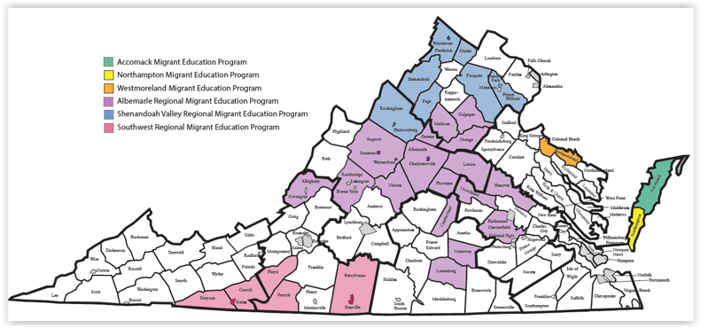
Implementation of the Process

Following the review of the concern statements, local migrant program directors were asked to assist in the identification of key data sources and processes to investigate each of the concerns. ALTA was charged with developing strategies to collect data that would result in a valid needs assessment. However, it was critical due to the time constraints of local programs and staff limitations that the process be as efficient to implement as possible. ALTA created the following strategies to facilitate the investigation of needs related to the concern statements:

- In order to investigate the concern statement regarding migrant student needs to enhance proficiency in language arts state assessment scores were used. However, since many migrant students do not take the state assessment or are not present for the state assessment, additional performance measures needed to be created. To provide a more comprehensive understanding of migrant student needs ALTA developed a data collection format in which teachers could rate individual student proficiency Pre-K through 12th grade in relation to skills identified in Virginia State Standards (see Appendix A for sample data collection forms). The data collection format also includes demographic data on students and Priority For Service (PFS) Status. Data was also collected to identify student needs in reading through the use of surveys of migrant program administrators and teachers as well as parent surveys. On-site interviews of staff and parents to assess language arts needs were completed at two randomly selected programs (Northhampton and Accomack). Finally, data was collected from the Migrant Literacy NET reading screener results which identify the specific reading needs of migrant students. This data was also included as part of the CNA analysis to help identify reading needs for Virginia migrant students.

- In order to investigate the second concern statement to assess student needs in mathematics scores from the Virginia State Assessment in mathematics were used. Similar to language arts, many migrant students do not take the state assessment in math or are not present for the state assessment, therefore additional performance measures needed to be created. In order to get a comprehensive understanding of migrant student needs in math ALTA developed data collection formats which allowed teachers to rate student proficiency in math in relation to the Virginia standards. The data collection formats include teacher ratings of proficiency in relation to Virginia state content. This data collection format was designed to be completed for each individual migrant student by teachers. These data collection forms also provide basic demographic information on students such as grade level, school and teacher information, and priority for service status (see Appendix A for sample data collection forms). Additionally, data was collected to identify student needs in math through the use of surveys of migrant program administrators and teachers as well as parent surveys. On-site interviews of staff and parents to assess mathematics needs were completed at two randomly selected programs (Northhampton and Accomack). This data was also included as part of the CNA analysis to help identify math needs for Virginia migrant students.

- In order to investigate the third concern statement regarding low graduation rates, state assessment scores in both language arts and math were used as well as the data collection formats developed by ALTA to target a body of evidence to include teacher ratings of proficiency in relation to Virginia state content standards. This data collection format was designed to be completed for each individual migrant student by teachers. The student data collection forms also provide basic demographic information on students such as grade level, school and teacher information, and priority for service status (see Appendix A for sample data collection forms). Additionally, data was collected to identify student needs related to retention and graduation through the use of surveys of migrant program administrators and teachers as well as parent surveys. Finally, on-site interviews of staff and parents to assess graduation and retention needs were completed at two randomly selected programs (Northhampton and Accomack). This data was also included as part of the CNA analysis to help identify math needs for Virginia migrant students.

- Finally, in order to assess the specific need for services for pre-school migrant students in terms of readiness for school in the content areas of reading and math, questions were added to the surveys of needs for administrators and teachers of migrant students as well as parents to complete. An example of these surveys is included in Appendix A.

The data collection formats were reviewed and discussed with the state program administrator and the local migrant program coordinators to insure that data was collected using consistent, reliable, and valid methodology. All local migrant programs were provided electronic copies of all survey forms. Each migrant program was required to distribute the survey instruments to all migrant summer program teachers in spring and summer of 2019 and teachers were required to collect data on all students possible. The data was forwarded to the local program to the state department and then on to ALTA for analysis.
CNA Analysis and Results

Concern 1: We are concerned that significant numbers of migrant students in Virginia are not proficient in reading/language arts and the migrant program needs to effectively target the foundational skills necessary to ensure that students are acquiring the basic building blocks necessary to master reading and writing.

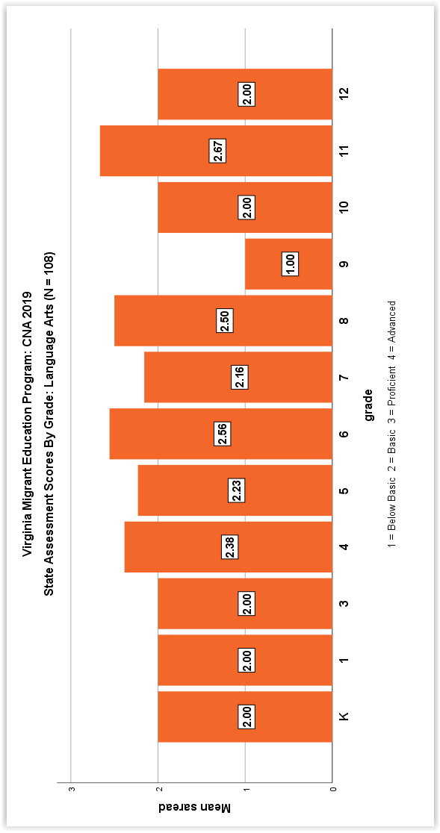
Analysis: State assessment scores in language arts were available for 108 of migrant the 308 students statewide participating in the needs assessment (35%). The following charts includes mean scores for the language arts state assessment across grade levels and by MEP Program for 2018-2019
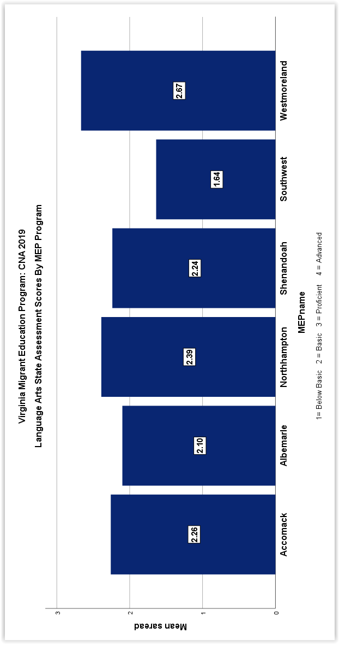

Since many migrant students in Virginia do not take the state assessment in language arts and there are no other standardized state assessments used across all districts teacher ratings were used to assess student proficiency needs. Teachers were asked to rate student proficiency for all students across language arts standards. Data forms to assess language arts needs were collected for 304 students. Based on the 4-point rubric (4 = Advanced, 3 = Proficient, 2 = Basic, 1 = Below Basic), The Virginia Language Arts standards are divided into two levels K-5 and Grades 6-12. The following charts indicate student proficiency by grade for each of these levels.

Number of K-5 Students Rated by Teachers in Language Arts 2019 (N = 175)

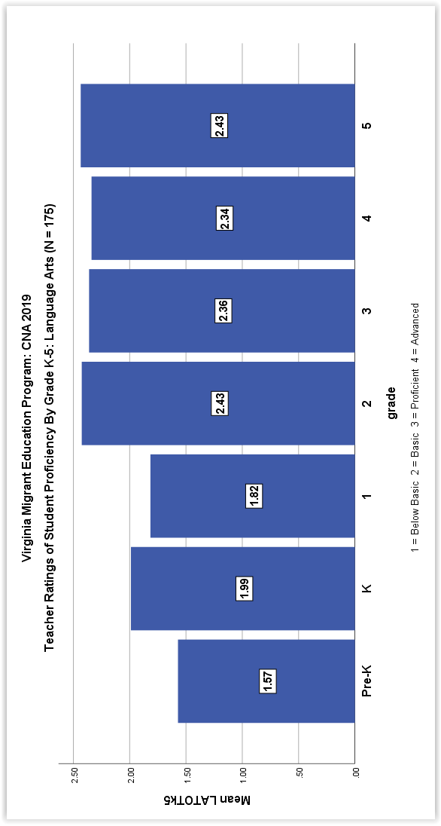

Number of 6-12 Students Rated by Teachers in Language Arts 2019 (N = 129)

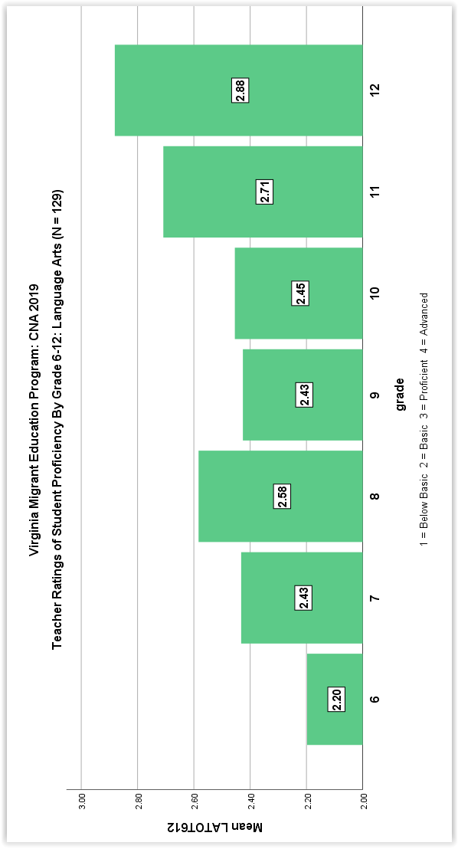

A critical piece of the CNA is to identify the needs of Priority For Service (PFS) students. Priority for service students are those who have had their education interrupted in the past year and who are at risk academically. Based on these criteria, there were 265 priority for service (PFS) students identified for 2019 out of the 308 total CNA participants in reading (86% of total). The average proficiency rating across all language arts standards for all grade levels for PFS students was 2.28 (Basic). The following graphs illustrate the proficiency levels of PFS students at the K-5 and 6-12 grade levels.

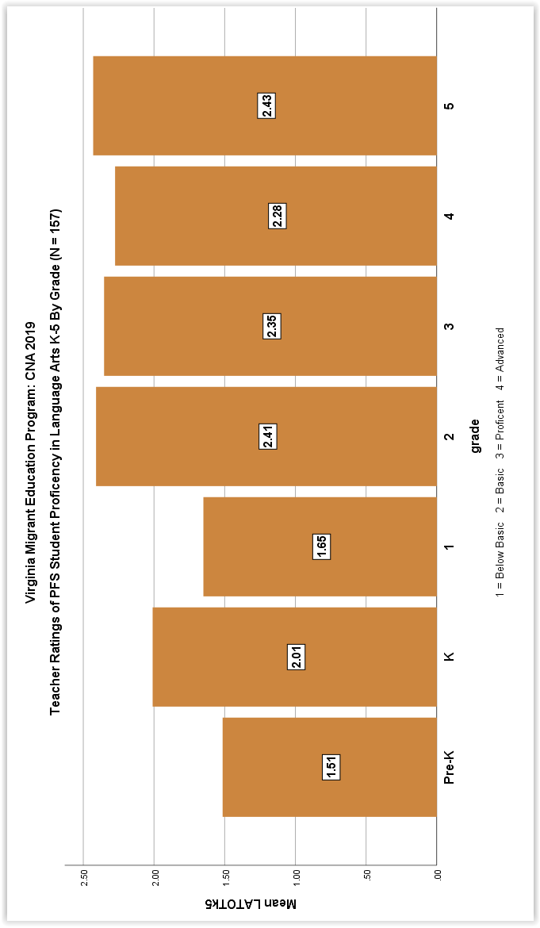

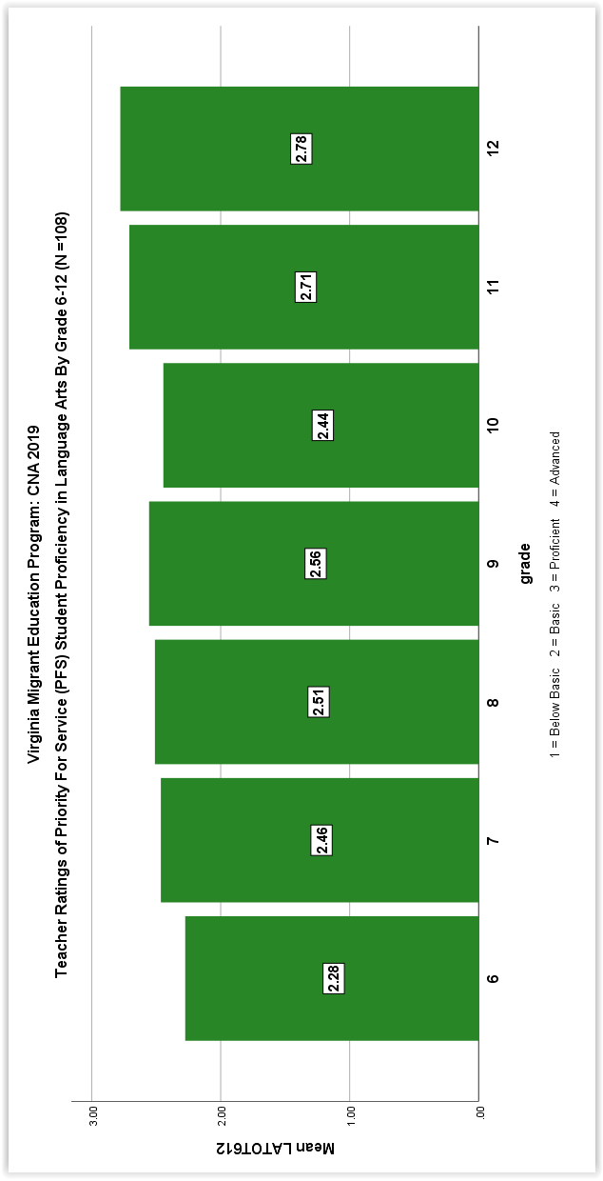

The following graphs illustrate the differences in student language arts proficiency by MEP Program both K-5 and Grades 6-12.
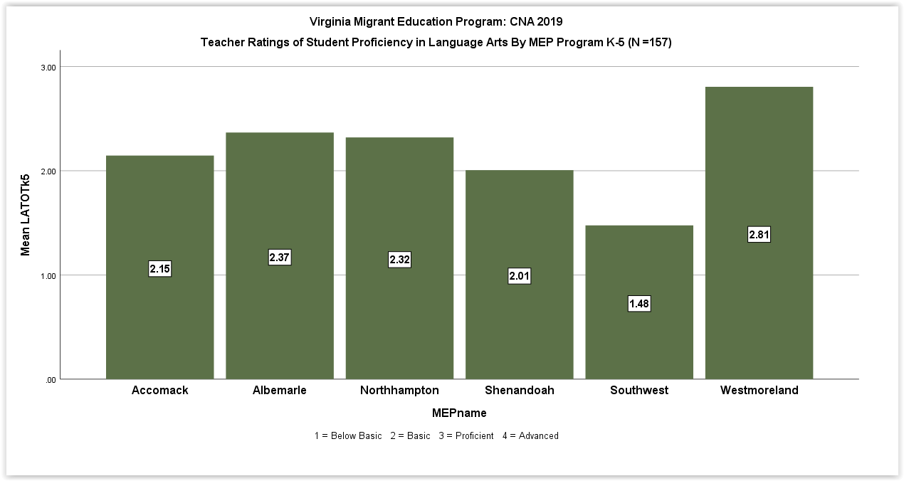

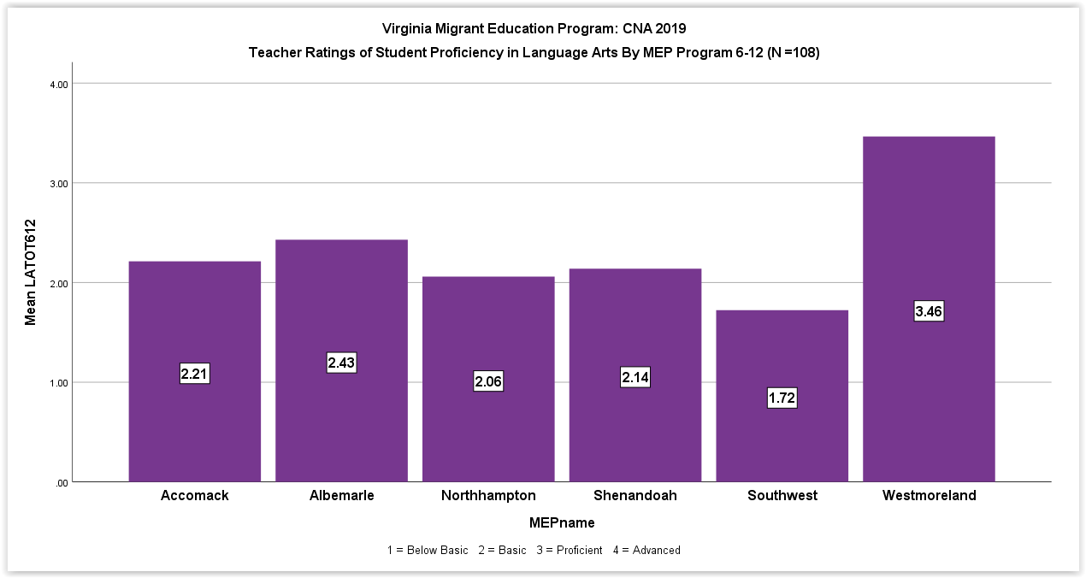
Teachers we also asked to rate PFS student proficiency in each of the language arts standards. The following graphs illustrates the results for both the K-5 and 6-12 grade levels:

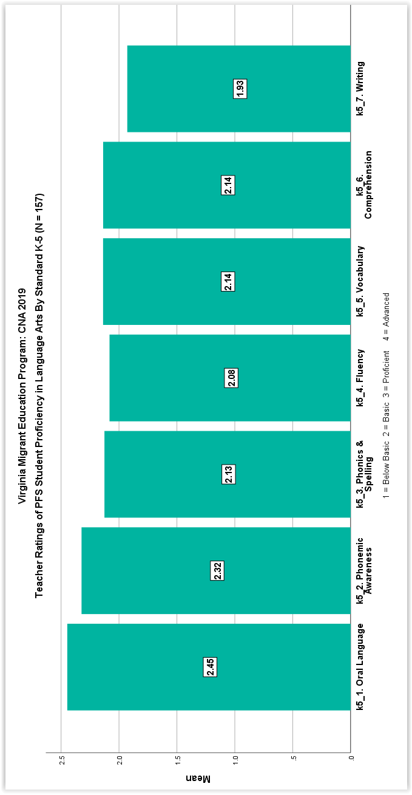

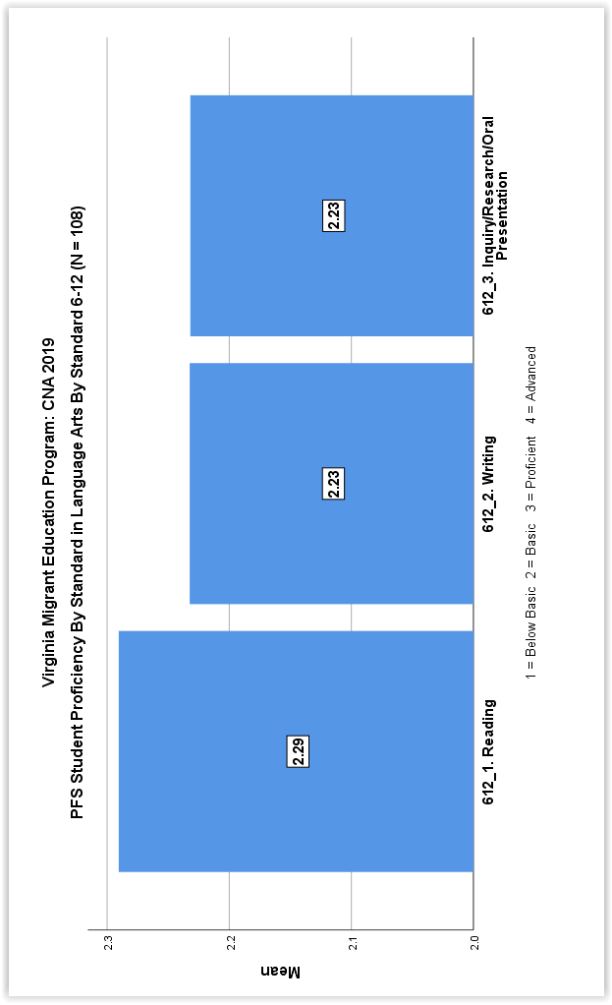

The following graphs illustrate student proficiency by standard in language arts broken down by MEP Program for both K-5 and 6-12

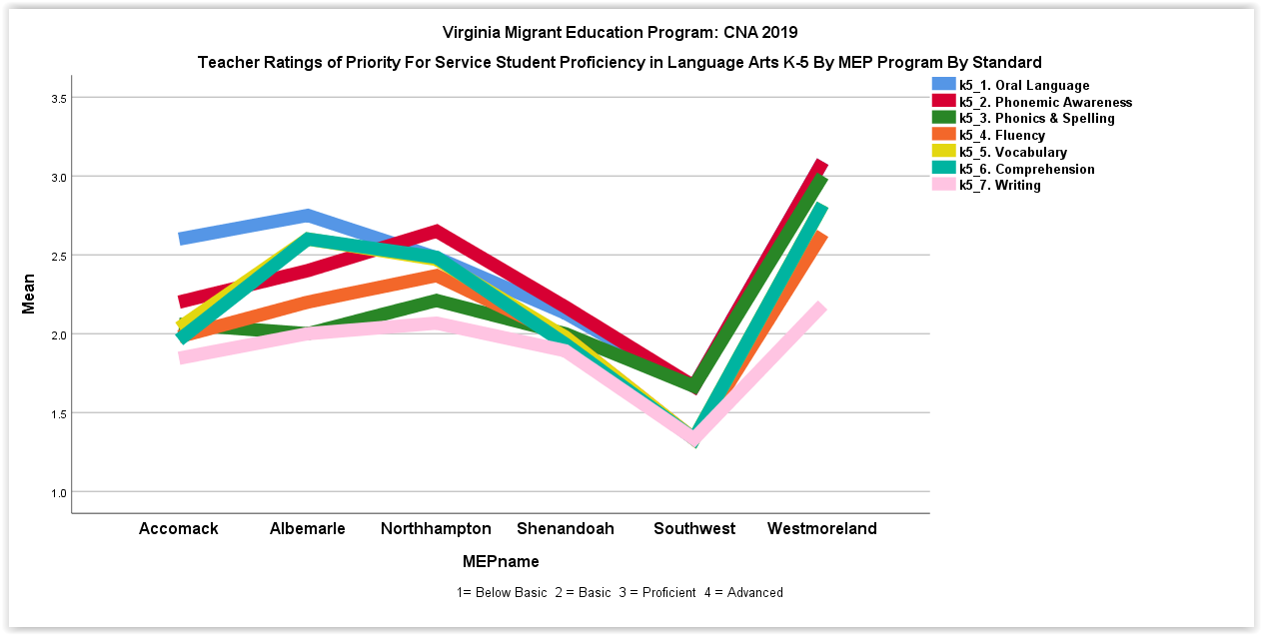

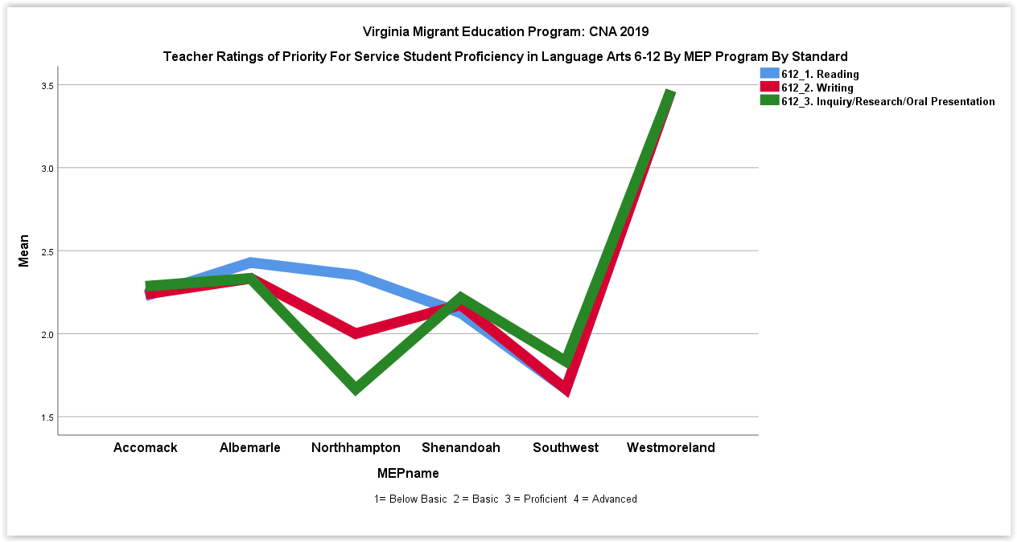
In terms of skills, teachers rated the highest academic reading needs for PFS eligible migrant students K-12 to be as follows (1 = Below Basic, 2 = Basic, 3 = Proficient, 4 = Advanced)

Top Ranked Migrant Student Needs in Language Arts

Grade Level Highest Areas of Need Average Rating

K-5 Writing 1.93
Reading Fluency 2.08
Phonics & Spelling 2.13

6-12 Writing 2.13
Inquiry, Research & Oral Presentation 2.13

The data collected from the administrator and teacher survey indicated that the top three needs for all migrant students related to language arts: reading comprehension, reading vocabulary and writing. The parent survey indicated that writing was the top priority followed by reading in terms of needs.
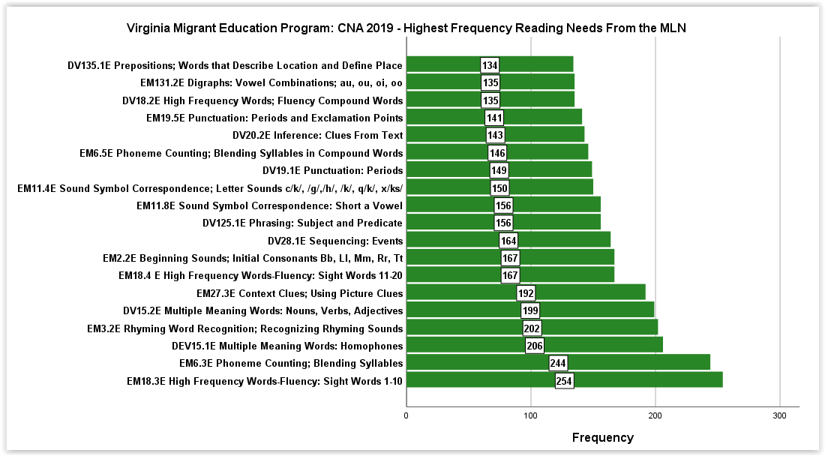
Additionally, significant numbers of Virginia migrant students completed online reading screeners on the Migrant Literacy NET. The screeners identify students reading needs. The top needs in reading identified by the Migrant Literacy screeners were primarily in the areas of beginning reading vocabulary and phonics. The following chart illustrates the reading needs with the highest frequency:
The onsite interviews with staff from both the Northhampton and the Accomack staff and parents indicated that in language arts vocabulary and decoding were the top needs identified in reading. Writing was also cited as a critical need. English language acquisition issues were also targeted as high need in relation to language arts for migrant students in these programs. Languages include Spanish and Haitian Creole.

Finally, MEP program staff and teachers were asked to identify strategies that have been effective in facilitating student proficiency in language arts. For language arts the strategies identified with the most frequency on the survey and in the data include:

1. Small group instruction targeting vocabulary and comprehension

2. Tutoring targeting vocabulary and comprehension

3. Using the screeners and tutorials on the Migrant Literacy NET targeting phonics and vocabulary.

Concern 2: We are concerned that significant numbers of migrant students in Virginia are not proficient in mathematics and the migrant program needs to effectively target the foundational skills necessary to ensure that students are acquiring the basic building blocks necessary to master essential mathematic skills.

Analysis: Data forms to assess math needs were collected for 286 of the 308 participants in the needs assessment over the spring and summer of 2019. State assessment scores in mathematics were available for 117 students who participated in the needs assessment (38% of the total 308 participants). The following chart illustrates the mean scores of the 117 students who completed the math state assessment by grade level in math.
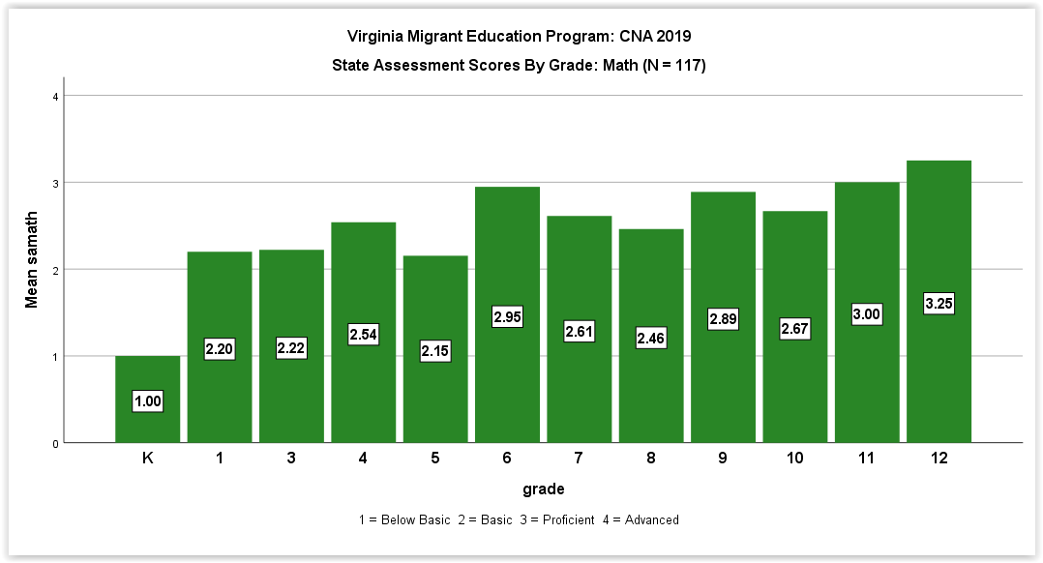

The following graph illustrates the differences in student proficiency in mathematics by MEP Program on the state assessment.

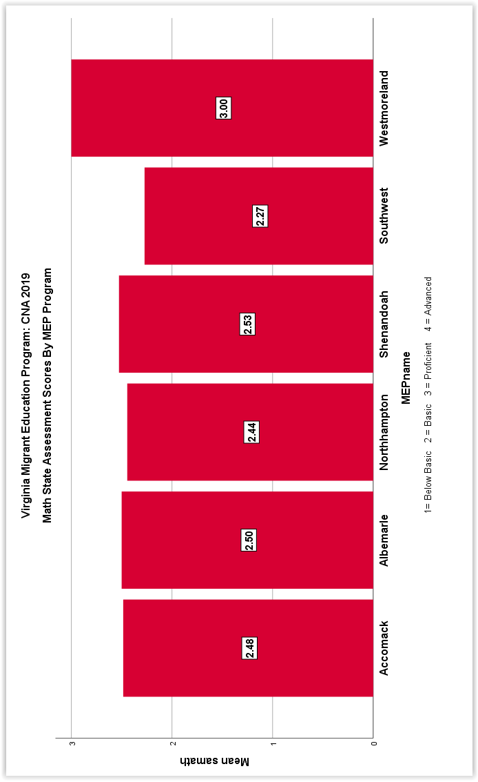

Since many migrant students in Virginia do not take the state assessment in math and there are no other standardized state assessments used across all districts, teacher ratings were used to assess student proficiency needs. Teachers were asked to rate student proficiency for all eligible migrant students across all math standards. Based on the 4-point rubric (4 = Advanced, 3 = Proficient, 2 = Basic, 1 = Below Basic). The following graph indicates student proficiency by grade in math

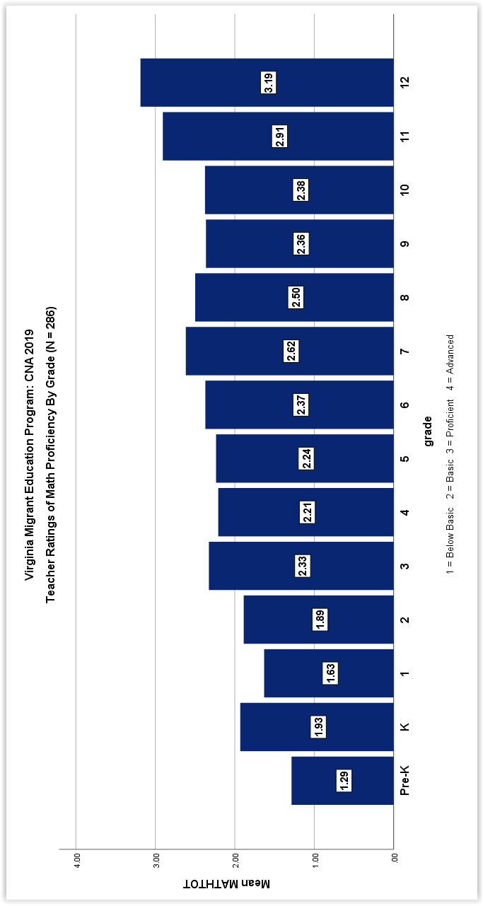

The following graph illustrates student proficiency in math by MEP Program in 2019.
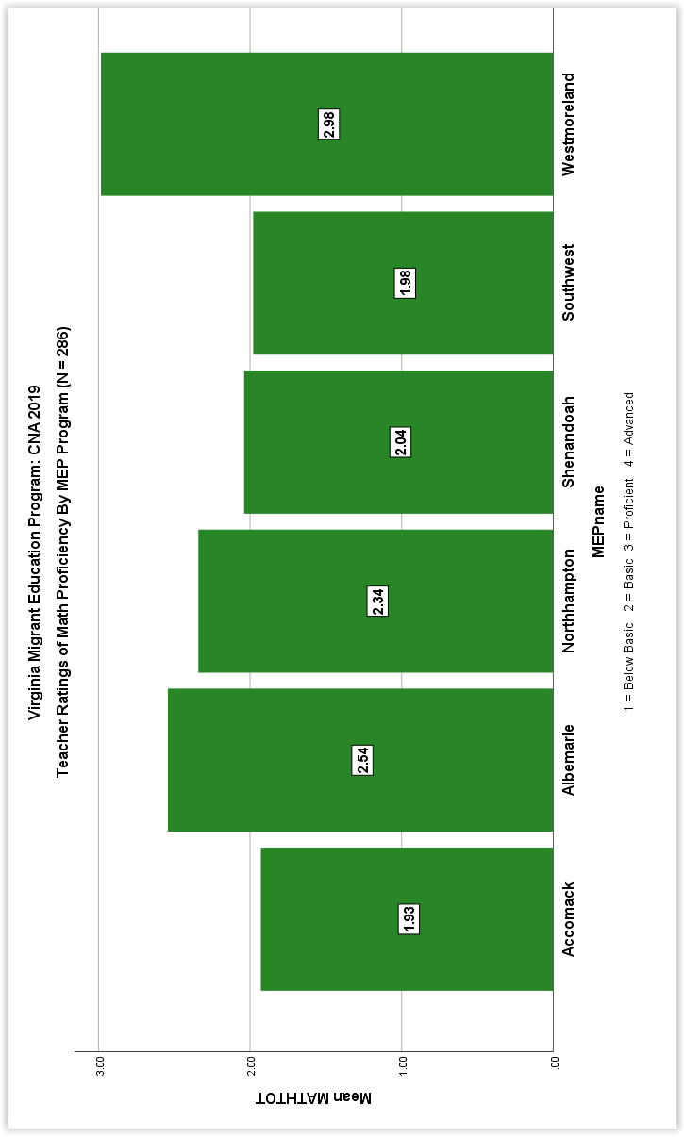

A critical piece of the CNA is to identify the needs of priority for service students. Priority for service students are those who have had their education interrupted in the past year and who are at risk academically. Based on these criteria, there were 265 priority for service (PFS) students identified for 2019 out of the 308 total needs assessment participants in math (86% of total students). The average proficiency rating across all math standards for potential PFS students was 2.24 (Basic). The following graph illustrates the mean teacher ratings of Priority For Service (PFS) migrant students in math by grade level.

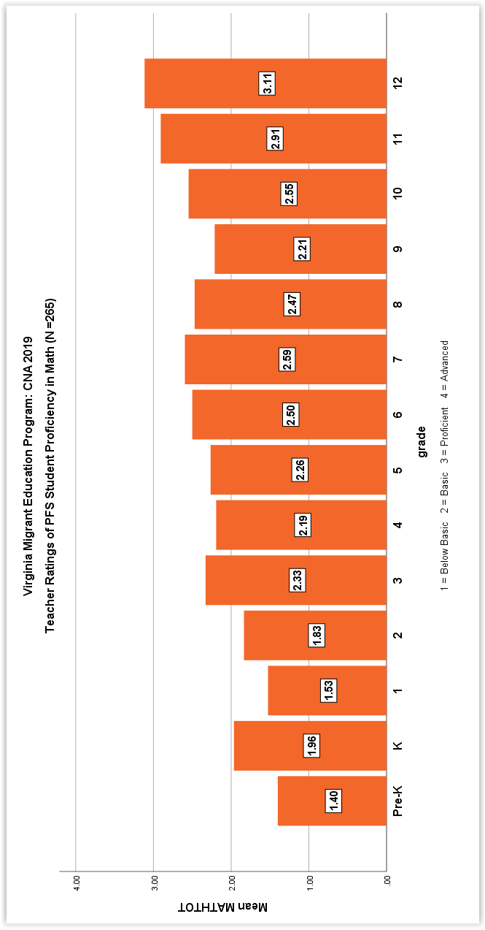

The following graph provides data regarding PFS student proficiency in math by MEP Program.

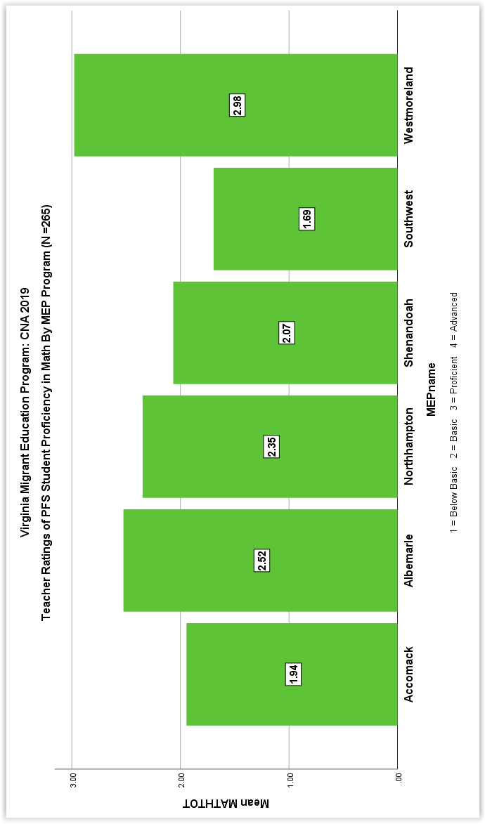

Teachers we also asked to rate PFS student proficiency in each of the math standards. The following graph illustrates the results:

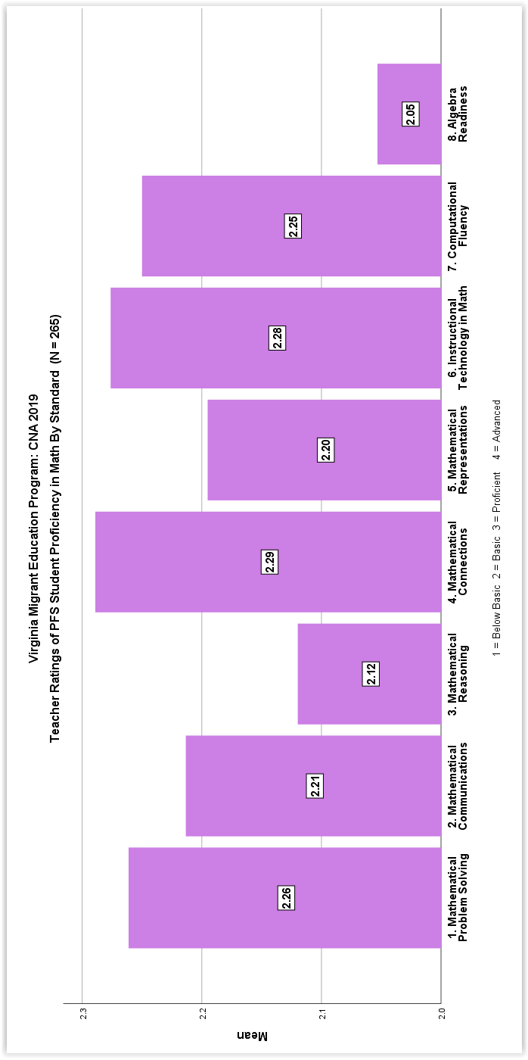

The following graphs illustrate student proficiency by standard in language arts broken down by MEP Program for both K-5 and 6-12

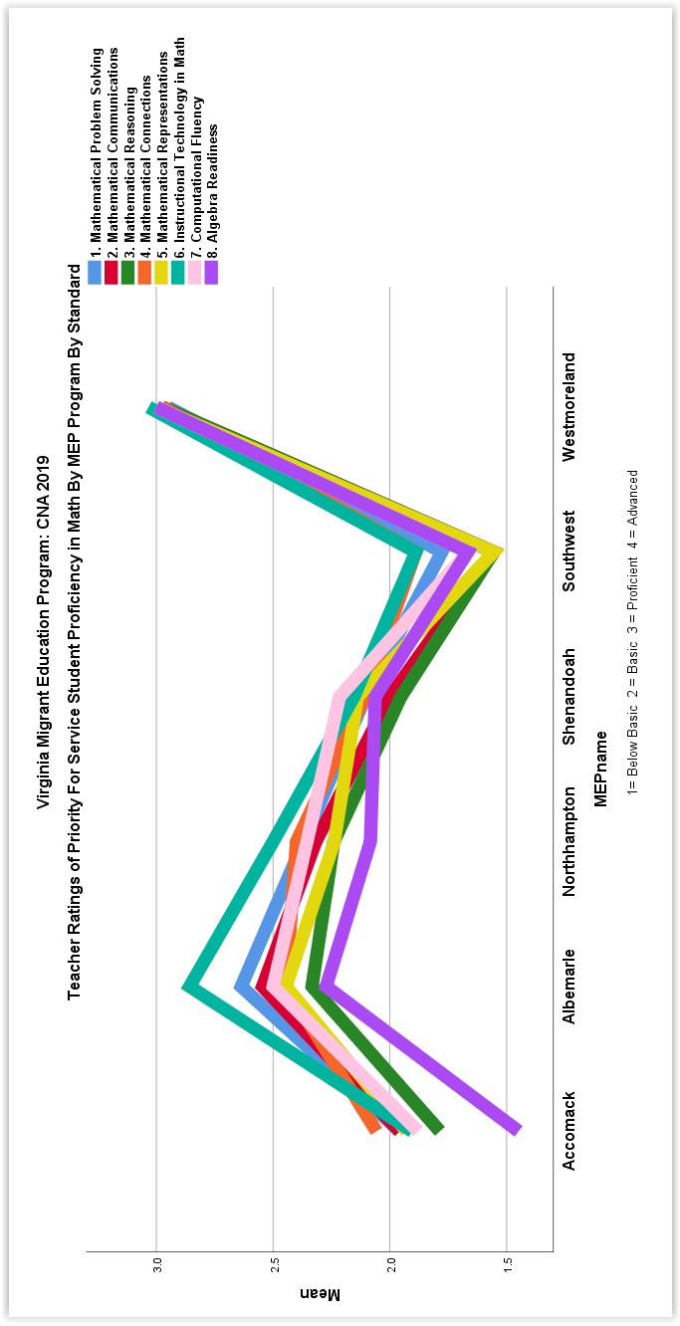

In terms of skills, teachers rated the highest academic math needs for at-risk eligible migrant students K-12 to be as follows:

Top Ranked Migrant Student Needs in Math

Grade Level Highest Areas of Need Average Rating

K-12 Algebra Readiness 2.05
Mathematical Reasoning 2.12
Mathematical Representations 2.20

The data collected from the administrator and teacher survey indicated that missing foundational skills in math were considered the second highest need for all for migrant students. The skills rated as high need in math were: basic number sense and operations, measurement and the use of measurement tools in math and algebra, patterns and functions. The parent survey indicated that improvement of math skills was ranked 5th highest in terms of student needs.

The onsite interviews with staff from both the Northhampton and the Accomack staff and parents indicated that in basic operations, math vocabulary and word problems were the top needs identified in math. English language acquisition issues were also targeted as high need in relation to mathematics for migrant students in these programs. Languages include Spanish and Haitian Creole.

Finally, MEP program staff and teachers were asked to identify strategies that have been effective in facilitating student proficiency in mathematics. For mathematics the strategies identified with the most frequency on the survey and in the data include:

1. Hands on math activities

2. Small group instruction in math

3. ESL support in math

4. Tutoring in math

Concern 3: We are concerned that there is a low graduation rate and retention rate for migrant students in Virginia, and there is a need to identify the critical barriers to success and to target the most effective instructional and other strategies to increase graduation rates for migrant students, particularly for those that are priority for service students.

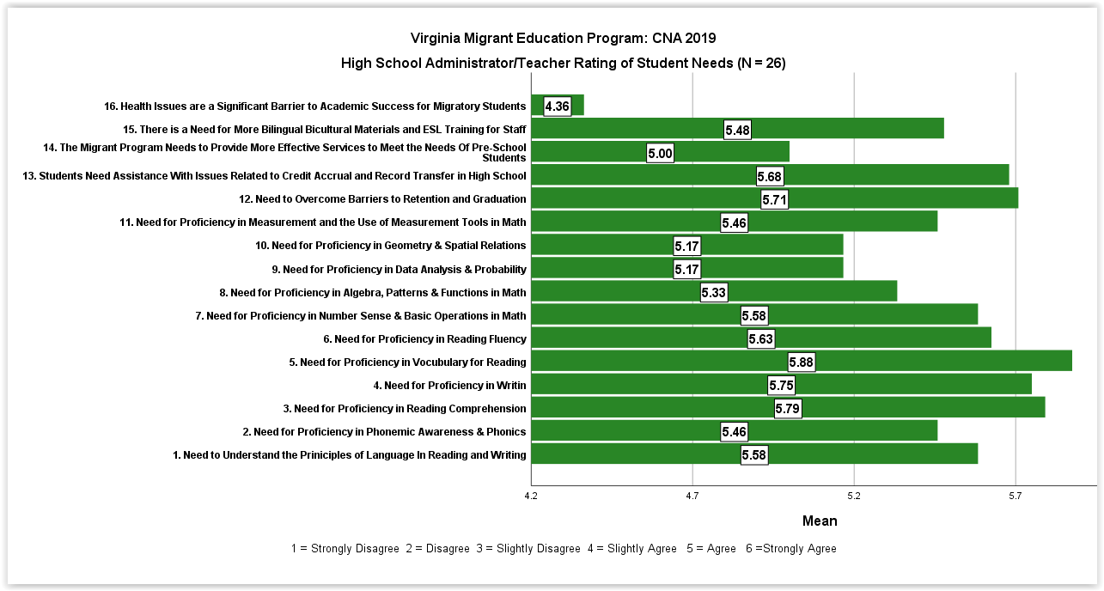
Analysis: Data collected was from both the state assessment in language arts and math as well as teacher ratings of student performance as well as the administrator teacher surveys regarding barriers to graduation and retention. Specifically, proficiency in reading and math for grades K-12 are key factors impacting the retention and graduation rate for all eligible migrant students. The survey of migrant program administrators and teachers at the high school level of secondary level student needs which target the top barriers to graduation and retention results are indicated below:

The administrator/teacher survey results indicated that the most significant barriers to retention and graduation for secondary students based on the following rubric (1 =Strongly Disagree, 2 = Disagree, 3 = Slightly Disagree, 4 = Slightly Agree, 5 = Agree, 6 = Strongly Agree) are:

Top Ranked Secondary Migrant Student Needs (Barriers To Graduation)

Highest Areas of Need Average Rating

Vocabulary in Reading 5.88

Reading Comprehension 5.79

Writing 5.75

Assistance With Issues Related to Credit Accrual
& Record Transfer 5.68

The onsite interviews with staff from both the Northhampton and the Accomack staff and parents identified the following targets to facilitate student graduation from high school:

1. ESL support for EL students at the secondary level. Languages include Spanish and Haitian Creole.

2. Option to acquire a GED

3. Counseling and family involvement activities to emphasize the importance of graduation

4. Target reading and writing proficiency through tutoring and the Migrant Literacy NET

Finally, MEP program staff and teachers were asked to identify strategies that have been effective in facilitating student proficiency in mathematics. To overcome barriers to retention and graduation the strategies identified with the most frequency on the survey and in the data include:

1. Parental involvement and family literacy activities

2. Teacher investment in migrants (mentoring program, cultural awareness training, etc.)

3. Tutoring in missing foundational academic skills
Need for additional pre-school and readiness programs and interventions

The U.S. Office of Migrant Education requires that all state migrant programs assess the needs of pre-school migrant students. Both the administrator/teacher survey and the parent survey asked stakeholders to rate pre-school students’ needs in Virginia. The administrators and teachers ranked the need for additional readiness for school services 15th among sixteen possible needs. Parents rated the need for additional pre-school services to be 6th among six possible needs.

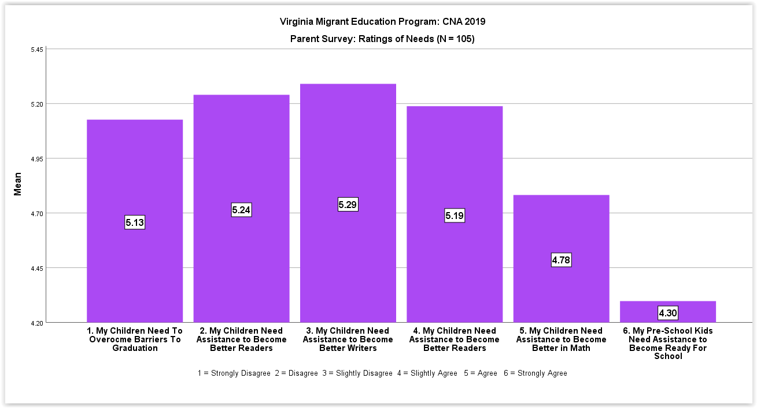

As a result of the success of existing support and preschool programs the Virginia CNA committee has not chosen to focus concern statements for the needs assessment or service delivery on pre-school age migrant students.

Summary

Based on the data analysis and CNA results, the following needs were identified as significant and having an impact on service delivery:

- The overall assessment of needs in relation to concern statement 1 (migrant students are not achieving proficiency in language arts) indicated:

1. The average migrant student had a mean score on 2.28 (Basic) on the state assessment (i.e. significantly less than proficient)
2. The mean teacher rating for Priority For Service (PFS) student in language art was 2.28 (Basic) level.
3. Language Arts proficiency is significantly lower for migrant students who are Pre-K through 1st grade.
4. The Westmoreland MEP Program has significantly higher language arts proficiency on both the state assessment and the teacher ratings
5. The critical areas of need in language arts are writing, reading fluency and reading vocabulary.
6. Writing is the highest need across every MEP program
7. The highest areas of reading needs identified thorough the assignment of tutorials on the Migrant Literacy NET are phonics and vocabulary.
8. The most effective strategies identified by program staff to impact language arts proficiency are small group instruction, tutoring and the Migrant Literacy NET tutorials.
9. English language acquisition is a significant barrier to language arts proficiency for many migrant students

B The overall assessment of needs in relation to concern statement 2 (migrant students are not achieving proficiency in math) indicated that the following needs were identified as significant and having an impact on service delivery:

1. The average migrant student had a mean score on 2.57 (Basic Plus) on the state math assessment (i.e. moving toward proficient)
2. The mean teacher rating for Priority For Service (PFS) student in math was 2.24 (Basic) level.
3. Math proficiency is significantly lower for migrant students who are Pre-K through 2nd grade.
4. The Westmoreland MEP Program has significantly higher mathematics proficiency on both the state assessment and the teacher ratings
5. The critical areas of need in mathematics are algebra readiness, number sense and basic operations, mathematical representations and reasoning.
6. English language acquisition is a significant barrier to mathematics proficiency for many migrant students

- The overall assessment of needs in relation to concern statement 3 (barriers to school retention and graduation for migrant students) indicated that the following needs were identified as significant and having an impact on service delivery:

1. Need to provide services to enhance proficiency in vocabulary in reading.
2. Need to provide services to enhance proficiency in reading comprehension.
3. Need to provide services to enhance proficiency in writing.
4. Need to provide assistance with issues related to credit accrual & record transfer.
5. ESL support for EL students at the secondary level.
6. Option to acquire a GED.
7. Counseling and parent involvement activities to emphasize the importance of graduation.

Conclusion

This report is submitted to the State Migrant Director and the Virginia CNA Committee for review. The purpose of this report is to provide the state and the CNA Committee with the data and analysis necessary to form recommendations regarding the service delivery plan for migrant education in the State of Virginia. These recommendations should be used to formulate measurable program outcomes to meet the needs of priority for service migrant students (as required by the U.S. Office of Migrant Education). The measurable outcomes (based on the comprehensive needs assessment and the recommendations) are to be used to evaluate the impact and effectiveness of the Virginia Migrant Education Program to meet the needs of migrant students. The recommendations and measurable outcomes should be included in the Virginia Service Delivery Plan. All migrant programs, nationally, will be evaluated using this continuous improvement system.

Appendix A

Data Collection Forms

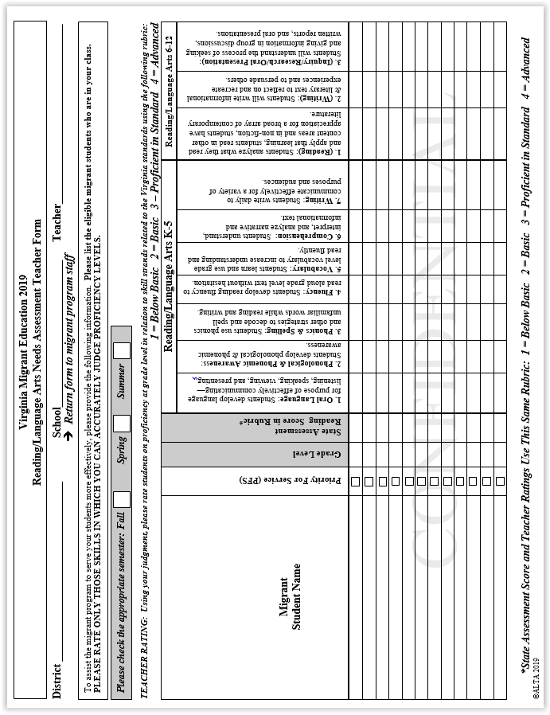
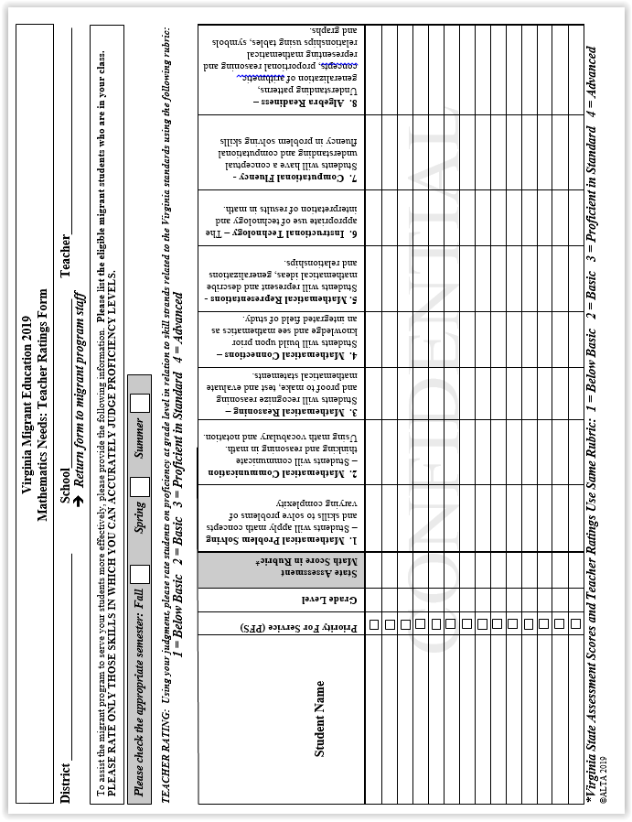
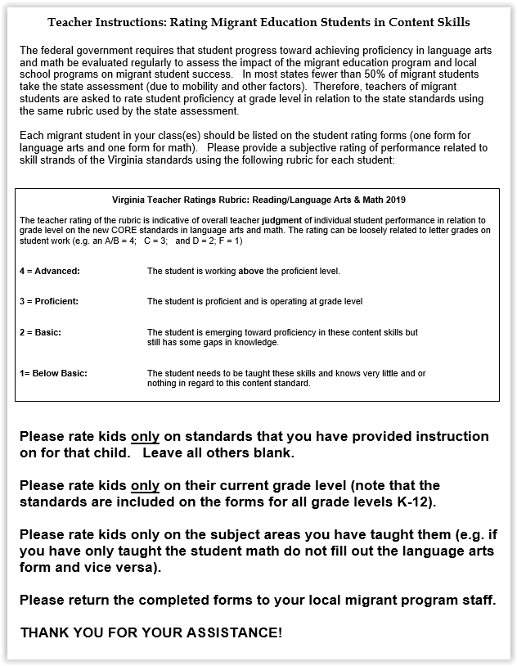
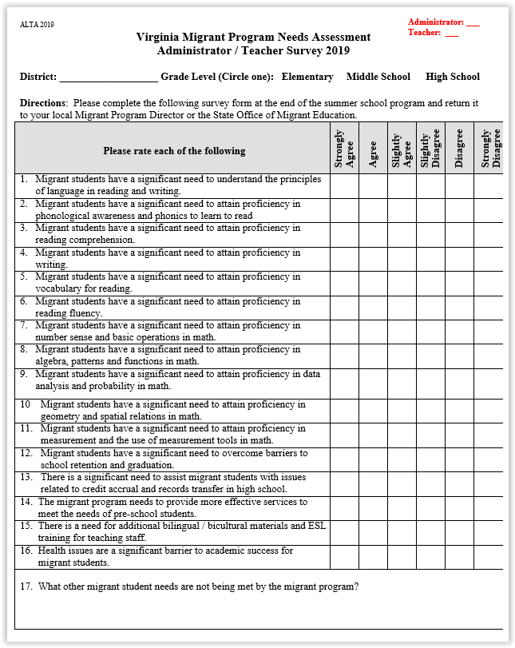
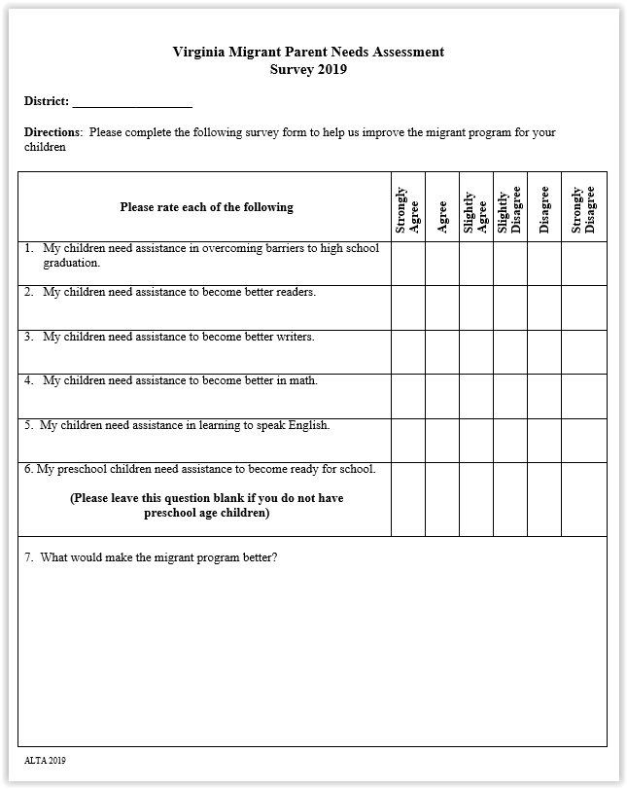
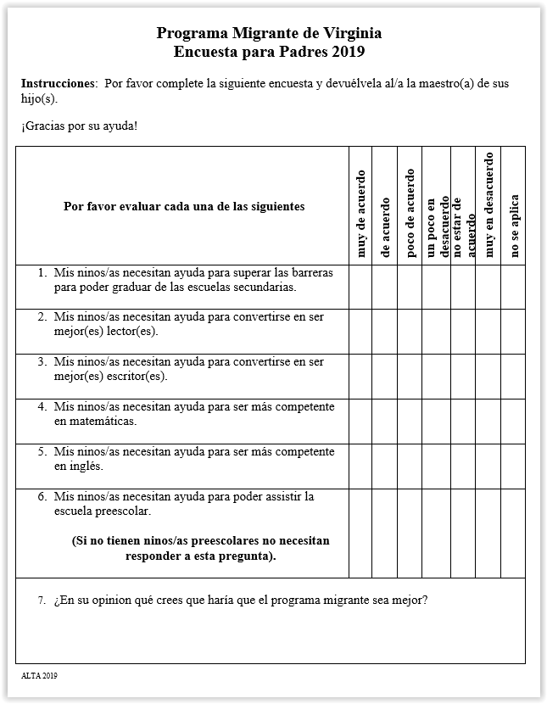


Appendix B

Statistics



