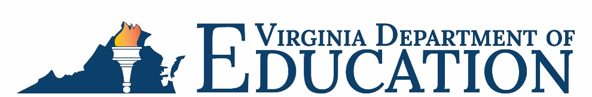

Office of School Nutrition Programs

Federal Program Administrative Review School Nutrition Program Summary
Section 207 of the Healthy Hunger Free Kids Act 2010, amended section 22 of the National School Lunch Act (42 U.S.C. 1769c) requires the Virginia Department of Education, Office of School Nutrition Programs (VDOE-SNP), to report the final results of the administrative review to the public in an accessible, easily understood manner in accordance with guidelines promulgated by the Secretary.
School Food Authority (SFA): Cristo Rey Richmond High School
Date of Administrative Review: November 14, 2023
Review Month and Year: September 2023
Date review results were provided to the SFA: November 27, 2023
Date review summary was publicly posted: January 5, 2024
SFA participates in the following Child Nutrition Programs:
☒ School Breakfast Program
☒ National School Lunch Program
☐ Fresh Fruit & Vegetable Program
☐ Afterschool Snack
☐ Seamless Summer Option
SFA operates under the following Special Provisions:
☐ Community Eligibility Provision
☐ Provision 2

Review Findings
Review Area | Details
Program Access and Reimbursement  ☒ Certification and Benefit Issuance  ☒ Verification  ☒ Meal Counting and Claiming | One meal application and direct certification error was identified.  A confirmation review not conducted.
Meal Patterns and Nutritional Quality  ☒ Meal Components and Quantities  ☒ Offer versus Serve  ☐ Dietary Specifications and Nutrient Analysis | Issue identified onsite with breakfast offerings meeting OVS criteria.  The SFA did not have a process for recording a la carte items.  Grain items at lunch did not meet whole grain-rich criteria.
School Nutrition Environment and Civil Rights  ☒ Food Safety  ☒ Local Wellness Policy  ☐ Smart Snacks and Competitive Foods  ☒ Civil Rights | The SFA did not have a procedure for recording refrigerator temperatures.  Violations of the Buy American provision were observed onsite.  The Local School Wellness Policy did not meet all federal requirements.  Annual civil rights training was not conducted for all staff.
USDA is an equal opportunity provider, employer, and lender.

