Mathematics Instructional Plan – Algebra 2

Inverse Functions
Strand: Functions
Topic: Exploring Inverse Functions
Primary SOL: A2.F.2 The student will investigate and analyze characteristics of square root, cube root, rational, polynomial, exponential, logarithmic, and piecewise-defined functions algebraically and graphically.
- Determine the inverse of a function algebraically and graphically, given the equation of a linear or quadratic function (linear, quadratic, and square root). Justify and explain why two functions are inverses of each other.
Related SOL: A2.F.2 a,b,j

Materials
- Exploring Inverse Functions activity sheet (attached)
- Three different colors of pens, markers, or highlighters
- Examples of Functions and Their Inverse Functions activity sheet (attached)
- Finding the Inverse of a Function activity sheet (attached)
- Graphing utility

Vocabulary
dependent variable, domain, independent variable, input, one-to-one function, output, range, reflection, vertical line test, line of reflection

Student/Teacher Actions: What should students be doing? What should teachers be doing?
Suggested Time: 90 minutes
- Have students work in groups and complete the Exploring Inverse Functions activity sheet as a warm-up activity. Choose a completed paper from each group and post it around the room. Have students do a quick gallery walk to see the output from each group. Debrief the activity by discussing students’ responses to these guiding questions for the activity.
- How do you find the area of the square, given the length of sides?
- How do you find the length of sides of the square, given the area?
- How are the graphs of the two functions related with respect to the line $y=x$ ?
- Next have students start working on the Examples of Functions and their Inverses activity sheet independently, and then in groups to share what they noticed. As groups are working on these, listen to discussions so you know which groups to select to share what they noticed. Pull the class back together to go over what the different groups noticed. Consolidate the groups’ findings on the board. With questioning or instruction, fill in any missing details that are important for students to notice. Sample ways to drive the discussion are listed below:
  - When discussing how the x-values and y-values flip columns on the tables, then define the inverse of a function as a set of ordered pairs in which $(a,b)∈f$, then $(b,a)∈$ $f^{-1}$ (inverse of $f$).
  - When discussing the last example on the Examples of Functions activity sheet, have students discuss why they think the quadratic has a restriction given on the domain. Let them hypothesize what would happen if it did not restrict the domain. Ask students how they can tell by looking at a function if its inverse will also be a function. Lead them to see that functions in which the unique inputs (values of x from the domain) correspond or “map” to unique outputs (values of f(x) from the range) have an inverse that is a function. Tell them that this is referred to a one-to-one function.
  - Discuss the vertical line test—what it is and why it works. Ask whether a horizontal line test would tell us anything useful. If needed, have students graph y = −0.5(x + 2)² + 3 and then graph the horizontal line y = 2. Ask, “Where does the line intersect the parabola?” “Why does the horizontal line test work?” Connect this back to one-to-one functions.
  - If it isn’t directly brought up, ask students what they notice about the function’s equation and the inverse’s equation. Discuss that a function y = f(x) is a rule that tells us to do something with the input, x. Hence, f(x) = 2x tells us to multiply the input by 2. Emphasize that the inverse of f “undoes” whatever f does; therefore, f ⁻¹(x) = $\frac{1}{2}$x, because $\frac{1}{2}$ is the multiplicative inverse of 2. Show students that to find the inverse of $f(x)=3x-1$, you perform the inverse operations in reverse order. That is, begin with your input, x, add 1, and then divide by 3: $f^{-1}=\frac{x+1}{3}$. Ask students how they can use this knowledge to come up with steps to find the inverse if they are given just the function’s equation.
  - Demonstrate that for a function y = f(x) to have an inverse function, f must be one-to-one: that is, for every x in the domain, there is exactly one y in its range, and likewise, each y in the range corresponds to exactly one x in the domain. The correspondence from the range of f onto the domain of f is, therefore, also a function. This function is the inverse of f.

Apply f(x) Apply f ⁻¹(x)
Input x
f(x)
x
Input x
f ^{–1}(x)
x

f ⁻¹[f(x)] = x

Apply f ⁻¹(x) Apply f(x)

f[f ⁻¹(x)] = x

- Ask students to determine whether each pair of functions below are inverses. They should be able to justify their reasoning for their answer.
h(x) = 3x + 4 and g(x) = $\frac{x-4}{3}$
$f\left(x\right)=4x-3$ and $j\left(x\right)=\frac{1}{4}x-3$
$p\left(x\right)=x^{2}-4$ and $q\left(x\right)= \sqrt{x+4}$
Note: The last example provides another chance to discuss the need to restrict the domain so that it will be a one-to-one function.
- Finding the inverse: Inform students that the graph of a one-to-one function, f, and its inverse are symmetric with respect to y = x. Therefore, we can identify f ⁻¹ by interchanging the roles of x and y: if f is defined by the equation y = f(x), then f ⁻¹ is defined by the equation x = f(y). The equation x = f(y) defines f ⁻¹ implicitly. Solving for y will produce the explicit form of f ⁻¹ as y = f ⁻¹(x).
- Give students the function f(x) = 2x + 3, and ask whether f is one-to-one. (Yes, it is linear and increasing.) Have them find the inverse, written in inverse function notation (allow students to decide whether to find the inverse graphically or algebraically).
f(x) = 2x + 3
f ⁻¹(x) = $\frac{1}{2}$(x − 3) This is the explicit form.
What is the domain of f ? What is the domain of f ⁻¹?
What is the range of f ? What is the range of f ⁻¹?
Note: One way students can justify their work is by graphing f(x) = 2x + 3 and its inverse, f ⁻¹(x) = $\frac{1}{2}$(x − 3), with y = x. Point out the symmetry of the graphs with respect to y = x.
- If needed, show several examples of finding the inverse both algebraically and graphically using other functions and discuss how to find the domain and range of the function and its inverse. Then determine whether the inverse is a function or not.
- Have students complete the Finding the Inverse of a Function activity sheet. The activity focuses on finding the inverse both algebraically and graphically.

Assessment

Questions
    - On graph paper, graph the functions $f\left(x\right)=\frac{3}{4}x+2 and g\left(x\right)=\frac{4}{3}x-2$. Are these functions inverses of one another? Why or why not?
    - Graph $f\left(x\right)= -3x+5$. Now, graph y = x. Without manipulating the original function algebraically, graph $f^{-1}(x)$. Use the line of reflection to determine points on the inverse function.

Journal/writing prompts
    - Describe, in detail, three methods for finding the inverse of $f\left(x\right)=\frac{2}{3}x-4$.
    - Explain what it means for a function to be “one-to-one,” and describe two methods for determining whether or not a function is one-to-one.
    - Justify the identity function, y = x, being the line of reflection for a function and its inverse.

Other Assessments
  - Have students complete the following Khan Academy practice exercises on Inverse Functions:
  - Evaluate Inverse Functions
  - Find Inverse Functions
  - Verifying Inverse Functions

Extensions and Connections (for all students)
- Have students find the inverse of y = f(x) = x². Because f(x) is not one-to-one on its domain, restrict the domain to x ≥ 0.
- Have students graph y = 10^{x} and y = log x. Ask, “Are both functions one-to-one? Are they mirror images of one another? If so, with respect to which line? What can we conclude about the two functions?”
- Pose the following problem: “We have studied many functions, including absolute value, quadratic, square root, and cube root. Of those functions, identify which have inverses and which do not. Explain your reasoning.”

Strategies for Differentiation
- Have students play a matching game to match inverse functions, both as graphs and as algebraic expressions. Use cards or an interactive whiteboard.
- Use vocabulary cards for related vocabulary listed above.

Note: The following pages are intended for classroom use for students as a visual aid to learning.

Virginia Department of Education ©2018 (Revised December 2023)
Exploring Inverse Functions
- Complete the table below showing the relationship between the length of the sides of a square and the area of the square.
Length of Sides | Area |  | Area | Length of Sides
1 |  |  | 1
2 |  |  | 4
3 |  |  | 9
Graph the data in the table on the same set of axes using a different color to draw each graph.
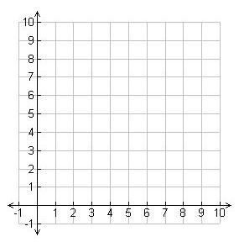
Answer the following questions:
- How do you find the area of the square given the length of sides?

- How do you find the length of sides given the area?

- Draw the line, $y=x$, using a third color, on the same graph to the left. How are the graphs of the two functions related with respect to the line$y=x$?

- The table below shows the cents made per view for Tik Tok.
Cents | Views
10 | 2,000
20 | 4,000
50 | 10,000
100 | 20,000

- Draw a graph using the data from the table above.
- Create a formula to convert cents into views.
- How do you convert views back to cents?
- Using the same axis, draw a graph with cents as the domain and views as the range.
- Graph $y=x.$
Examples of Functions and Their Inverse Functions
Look at the three sets of functions and their inverse functions for any patterns that occur in these examples.
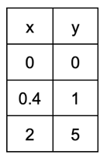
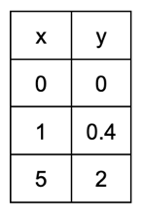
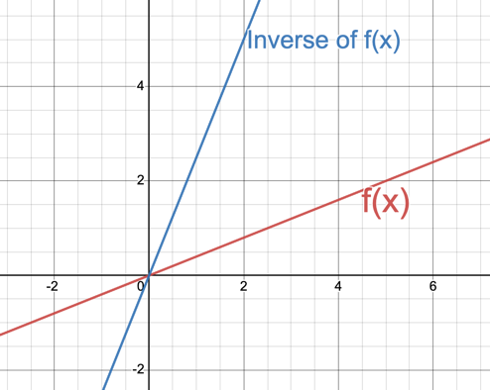
Example 1:
Function: $f\left(x\right)=\frac{2}{5}x$ Inverse Function: $f^{-1}\left(x\right)=\frac{5}{2}x$

Domain: (-∞, ∞) Domain: (-∞, ∞)
Range: (-∞, ∞) Range: (-∞, ∞)

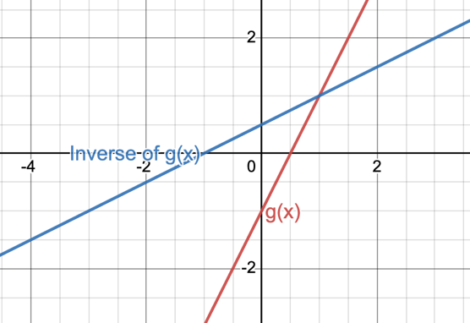
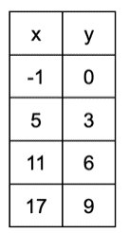
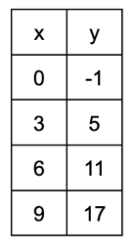
Example 2:
Function: $g\left(x\right)=2x-1$ Inverse Function: $g^{-1}\left(x\right)=\frac{x+1}{2}$

Domain: (-∞, ∞) Domain: (-∞, ∞)
Range: (-∞, ∞) Range: (-∞, ∞)
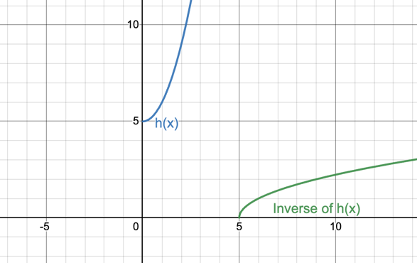
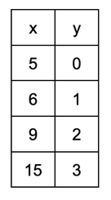
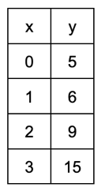
Example 3:
Function: $h\left(x\right)=x^{2}+5$, where $x≥0$ Inverse Function: $h^{-1}\left(x\right)=\sqrt{x-5}$

Domain: [0, ∞) Domain: [5, ∞)
Range: [5, ∞) Range: [0, ∞)
Summarize all that you noticed in all three examples:
Finding the Inverse of a Function
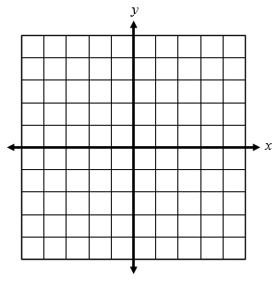
Find the inverse of each function algebraically. Graph the function and its inverse. Determine whether the inverse is a function. Determine the domain and range of the function and its inverse.
- $f\left(x\right)= \frac{1}{2}x+6$

- $f\left(x\right)=(x+{2)}^{2}-3, x≥ -2$

- $f\left(x\right)=\sqrt{x-3}+1$

Make a claim about whether the following functions are inverses of each other. Be sure to explain your claim and provide evidence to support your claim.

- $f\left(x\right)=2x-5$ and $g\left(x\right)=\frac{1}{2}x+5$

- $h\left(x\right)={(x-2)}^{2}+3$, where x ≥ 2 and $j\left(x\right)=\sqrt{x-3}+2$

Given the graphs below, graph the inverse of the function. Explain whether the inverse is a function or not. Write the domain and range of the given graph and its inverse.
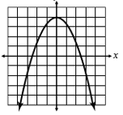
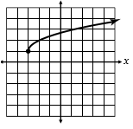
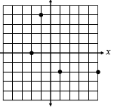
y y y

