Parallel Lines and Angle Relationships
Strand: Reasoning, Lines, and Transformations
Topic: Investigate the angles formed when parallel lines are intersected by a
transversal.
Primary 2023 SOL: G.RLT.2 The student will analyze, prove, and justify the relationships of parallel lines cut by a transversal.
- Prove and justify angle pair relationships formed by two parallel lines and a transversal, including:
  - corresponding angles;
  - alternate interior angles;
  - alternate exterior angles;
  - same-side (consecutive) interior angles; and
  - same-side (consecutive) exterior angles.
- Prove two or more lines are parallel given angle measurements expressed numerically or algebraically.
- Solve problems by using the relationships between pairs of angles formed by the intersection of two parallel lines and a transversal.
Related SOL: G.RLT.1

Materials
- Lines and Angles: Part 1 activity sheet (attached)
- Lines and Angles: Part 2 activity sheet (attached)
- Lines and Angles: Part 3 activity sheet (attached)
- Dynamic geometry software package (computer-based or handheld) or protractors and patty paper
Vocabulary
adjacent angles, alternate exterior angles, alternate interior angles, angle, complementary angles, conjecture, corresponding angles, linear pair, parallel lines, transversal, same-side (consecutive) interior angles, same side (consecutive) exterior angles, supplementary angles, transversal, vertical angles

Student/Teacher Actions: What should students be doing? What should teachers be doing?
            - Remind students about the vocabulary terms they have seen before and introduce new vocabulary. Students should have a clear understanding that:
              - a transversal is any line that intersects at least two lines (the lines are not required to be parallel);
              - angle pair types (alternate interior, alternate exterior, corresponding, same-side or consecutive interior, and same-side or consecutive exterior) are created when two lines are intersected by a transversal (again, the lines are not required to be parallel).
            - Distribute the Lines and Angles activity sheets (Parts 1 and 2), and have students use a dynamic geometry software package to complete them. If software is not available, have students use protractors or patty paper to measure the angles on the worksheet. (If neither measuring tools nor software is available, activities could be modified by giving students the angle measures.)
            - Distribute the Lines and Angles: Part 3 activity sheet, and have students complete it.
            - Discuss students’ findings and conjectures with the class.
            - Discuss relevant postulates and theorems.

Assessment

Questions
- Use Figure 1 to answer the following questions:
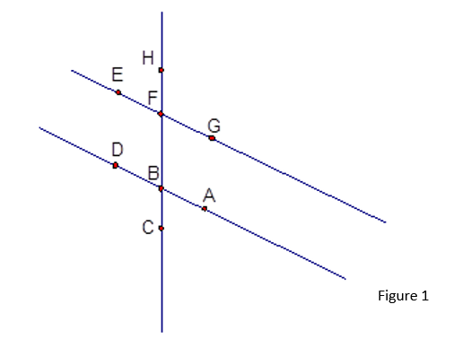
  - If you are told that ∠EFH ≅ ∠DBF, what conclusion can you make? Why?
  - If you are told that ∠EFB ≅ ∠HFG, what conclusion can you make? Why?
  - If you are told that ∠CBD + m∠DBF = 180, what conclusion can you make? Why?
  - If you are told that m∠GFB + m∠ABF = 180, what conclusion can you make? Why?
  - If you are told that m∠DBF = m∠GFB = 70, what conclusion can you make? Why?
  - If you are told m∠DBC + m∠EFH = 180, what conclusion can you make? Why?

- Using Figure 2: Determine whether any pairs of opposite sides are parallel. Explain your thinking.
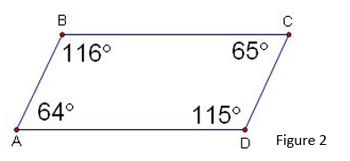

- Using Figure 3: Given ∠1 ≅ ∠3, can you determine that any segments are parallel? If so, which ones, and why? What if ∠6 ≅ ∠3?

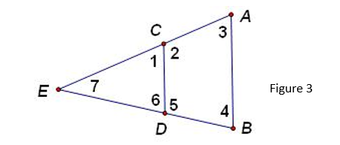

- Using Figure 4: One way to build stairs is to attach triangular blocks to an angled support, as shown on the right. If the support makes a 32-degree angle with the floor (m∠2), what must m∠1 be so the step will be parallel to the floor? The sides of the angled support are parallel.

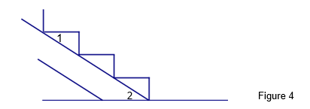

- Using Figure 5: Find the measure of ∠x.

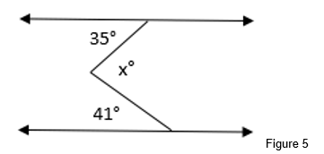

Journal/writing prompts
- Summarize the conclusions you have made about parallel lines and special pairs of angles.
- Name four conditions that involve angles and are sufficient to prove that two lines are parallel.
- The white lines along the long edges of a football field are called sidelines. Yard lines are perpendicular to the sidelines and cross the field every five yards. Explain why you can conclude that the yard lines are parallel.
- Diagonal or angle parking is seen as one of the safer types of parking (see image below). This type of parking is typically created with spaces using 45° to 60° angles. Describe how the knowledge gained from this lesson will help to ensure that the parking lines are parallel.
                - 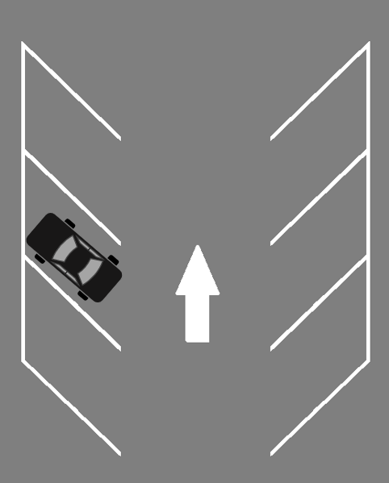

Other Assessments
- Have groups of four students construct a short quiz covering the information presented in the class on a given day and administer it to another group in the class.

Extensions and Connections (for all students)
- Have students create diagrams, using parallel lines and special angles. For example, the students could design a city with parallel streets that are intersected by a transversal street. Give directions such as, “Place a restaurant and bank at corresponding angles.”
- Arrange for students to visit a construction site to see how plumb lines are used to make vertical lines from which parallel lines can be drawn and to see how angles are used in construction.
- Invite an architect, carpenter, or builder to visit the classroom to discuss the importance of geometry (specifically lines and angles in this case) in the construction industry.
- Have students research the importance of lines and angles in the fields of architecture and construction. They can create a presentation for the class.
- A periscope (see image below) is a tubular optical instrument containing lenses and mirrors by which an observer obtains an otherwise obstructed field of view. Have students draw a diagram showing the path of light in a periscope. (Definition and image from Merriam-Webster Online Dictionary)
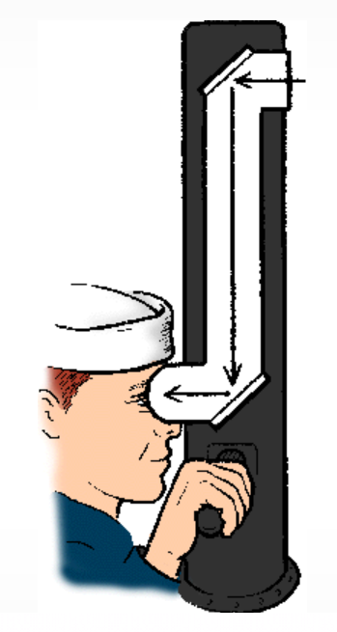

- Discuss practical applications of parallel lines. Examples might include: the construction of stairs, use of a plumb line, how a periscope works, agriculture and planning for crops, orchards, orange groves, city planning for housing developments and roads, etc.

Strategies for Differentiation
- Allow students to use a calculator (e.g., talking calculator, large number calculator).
- Vocabulary words can be illustrated, and audio added into presentation software. This can then be converted to video and played on an mp3 player.
- Provide students with index cards and have them write the definition of each word in a specific color of ink or pencil. Have them draw an illustration of the word in another color of ink or pencil. Trace the pair of angles in a color. They can use these cards to study at home or with another student.
- Use a dynamic geometry software package to have students color-code lines and angles to differentiate between them. If software is not available, have students highlight the parallel lines.
- Have students use two colors of yarn or string to lay out parallel lines and transversals. On activity sheets, they can highlight the parallel lines in one color and the transversal in another.
- Have students use straws or long pieces of licorice to visualize parallel lines and transversals before using the software.
- Use patty paper to verify congruent angles.
- In a think-pair-share activity, have students pair up: One student draws lines with transversals, and the other tries to determine whether the lines are parallel.
- In a think-pair-share activity, have students pair up and find examples of parallel lines, different angles, etc., in the classroom. Then have them share their findings with the rest of the class.
- Ask students to go out into the community and find examples of parallel lines and angles (both complementary and supplementary). They can either draw them or take photographs of them to share with the class.
- Have students paste vocabulary words with illustrations onto 8.5” x 11” sheets of paper in their notebooks.
- Use painters’ or masking tape on the floor to create a set of parallel lines and a transversal. Call out an angle relationship (corresponding, alternate interior, etc.) and have the students place their feet in the correct positions. Once they catch on, add music to help with fluency. Put them in partners and have the partner verify the position of the feet. Then they switch places.

Note: The following pages are intended for classroom use for students as a visual aid to learning.

Virginia Department of Education ©2018 (Revised December 2023)

Lines and Angles: Part 1
Name _______________________________ Date _______________________________
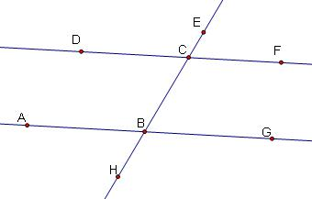
We are going to explore pairs of angles. Start a new sketch in a dynamic geometry software package, following these steps:
- Draw a line containing two points. Name the points A and B.
- Draw $\overset{⃡}{CD}$ so that $\overset{⃡}{AB}$ and $\overset{⃡}{CD}$ are not parallel.
- Draw $\overset{⃡}{BC}$.
- Draw and label points D, E, F, G, and H, as shown on the diagram at the right.
- Measure the angles listed below:

m∠DCE = _________ m∠ECF =_________
m∠BCD = _________ m∠BCF = _________
m∠ABC = _________ m∠GBC = _________
m∠ABH = _________ m∠GBH = _________

- List the pairs of alternate interior angles. How do the angle measurements within each pair relate?

- List the pairs of alternate exterior angles. How do the angle measurements within each pair relate?

- List the pairs of corresponding angles. How do the angle measurements within each pair relate?

- List the pairs of same-side (consecutive) interior angles. How do the angle measurements within each pair relate?

- List the pairs of same-side (consecutive) exterior angles. How do the angle measurements within each pair relate?

Lines and Angles: Part 2
Name _______________________________ Date _______________________________
Start a new sketch in a dynamic geometry software package, following the steps below.
- Draw a line containing two points. Name the points A and B.
- Draw a point not on $\overset{⃡}{AB}$. Label it C.
- Construct a line through C parallel to $\overset{⃡}{AB}$.
- Draw $\overset{⃡}{BC}$.
- Draw and label points D, E, F, G, and H, as shown on the diagram at the right.
- Measure the angles listed below:

m∠DCE = _________ m∠ECF =_________
m∠BCD = _________ m∠BCF = _________
m∠ABC = _________ m∠GBC = _________
m∠ABH = _________ m∠GBH = _________

- List the pairs of alternate interior angles. How do the angle measurements within each pair relate?

- List the pairs of alternate exterior angles. How do the angle measurements within each pair relate?

- List the pairs of corresponding angles. How do the angle measurements within each pair relate?

- List the pairs of same-side (consecutive) interior angles. How do the angle measurements within each pair relate?

- List the pairs of same-side (consecutive) exterior angles. How do the angle measurements within each pair relate?

Lines and Angles: Part 3
Name _______________________________ Date _______________________________
Use the diagrams you formed in Lines and Angles Parts 1 and 2 to complete the following:
- How do the angle pair relationships (questions 6 – 10 on Part 1 and questions 7 – 11 on Part 2) differ between Lines and Angles: Part 1 and Lines and Angles: Part 2? What causes this difference? Check with your classmates. Did they find similar results?

- Make conjectures about when angle pairs will be congruent or supplementary. Rewrite each conjecture in “If …, then” form. For example, “If two parallel lines are cut by a transversal, then corresponding angles are congruent.” “If the measures of two angles add up to 90 degrees, then those angles are complementary.” “If two angles are vertical, then they are …”

If two parallel lines are cut by a transversal, then
- alternate interior angles are _____________________.
- alternate exterior angles are _____________________.
- corresponding angles are ______________________.
- same-side (consecutive) interior angles are ____________________.
- same-side (consecutive) exterior angles are ______________________.

- Write the converse of the conjectures and determine whether they are true.

- Write biconditionals for any true conjecture and converse.

