Function Transformation: Exploring Linear, Quadratic, & Exponential Functions
Strand: Functions
Topic: Transforming Linear, Quadratic, & Exponential Functions
Primary SOL: A.F.1 The student will investigate, analyze, and compare linear functions algebraically and graphically, and model linear relationships.
- Investigate and explain how transformations to the parent function y = x affects the rate of change (slope) and the y-intercept of a linear function.
A.F.2 The student will investigate, analyze, and compare characteristics of functions, including quadratic, and exponential functions, and model quadratic and exponential relationships.
- Graph a quadratic function, f(x), in two variables using a variety of strategies, including transformations f(x) + k and kf(x), where k is limited to rational values.
- Graph an exponential function, f(x), in two variables using a variety of strategies, including transformations f(x) + k and kf(x), where k is limited to rational values.
Related SOL: A.F.1.h; A.F.2.h

Materials
- Desmos Calculator bit.ly/transf-a1 (see page 3 for QR code)
- Function Transformation worksheet (included)

Vocabulary
transformation, slope, x-intercept, y-intercept, constant, variable, vertex

Note about the activity:

This lesson is intended to be an introduction to functions. The goal is to understand transformations from a parent function—it is not necessary for the student to have previous experience graphing functions.

It could be used as an initial introduction for ALL functions, or used at three different points, prior to introducing each function-type.

This activity intentionally used the Desmos graphing utility (rather than Desmos classroom) in order to encourage students to write about their discoveries. These summaries and sketches can be used as notes for future reference.
Student/Teacher Actions: What should students be doing? What should teachers be doing?
- ALL students should have a copy of the included paper response sheet. It is encouraged to use one (1) device with the Desmos link per two (2) students to encourage conversation.
- The writing and prediction steps are essential as students are developing conceptual understanding. Encourage students to compare their thinking with other groups. The written summaries can serve as notes to reference in the future.
- As students are asked to sketch their prediction of the graphs (steps 3, 6, and 10), encourage students to explain their sketches to their partner before they use the Desmos tool to check their answer.
- If students are incorrect, encourage them to explain their thinking as they correct their images. Students could use a colored pencil to show the correct sketch and explain their error in writing next to the sketch.

Assessment

Questions
    - Linear: Compare and contrast the equations $y=-2x$ and $y=x-2$. Both equations have a ‘-2.’ How is each transformation different?
    - Quadratic: Compare and contrast the equations $y=-3x^{2}$ and $y=x^{2}-3$. Both equations have a ‘-3.’ How is each transformation different?
    - Exponential: Compare and contrast the equations $y=3∙{(2)}^{x}$ and
$y=\frac{1}{3}∙{(2)}^{x}$. How are the $3$ and the $\frac{1}{3}$ similar and different?

Journal/writing prompts
    - Comparing linear to exponential: Given the two functions $y=3x+4$ and
$y=3∙2^{x}+4$, what would be similarities and differences between these functions? How do the 3 and the 4 affect each transformation from its parent function [$y=x$ or $y=2^{x}$]?

Other Assessments
    - Students create questions for each other on whiteboards. [Given a sketch, can your partner write the equation? Given an equation, can your partner make a sketch?] Use Desmos to check the work and keep score.

Extensions and Connections (for all students)
- Questions 12-14 explore the base of the exponential function. This is an extension, and not required for the introduction to transformations.
- The optional extension of several forms for quadratic functions (vertex and factored forms) allows students to discuss advantages of each form. Additionally, students could look to compare the various forms when a quadratic graph overlaps. (What is the same? What is different?)
- The final problem provides an opportunity to explore exponential functions with negative, rational bases.

Strategies for Differentiation
- In the prediction/sketch stage (problems 3, 6, and 10), ask students to explain to a partner the choices they make for their sketch. Teacher could project the Desmos (rather than students checking with Desmos).

Note: The following pages are intended for classroom use for students as a visual aid to learning.

Virginia Department of Education ©2023

Access to Desmos Calculator
http://bit.ly/transf-a1

Function Transformation
Name Date

Materials for each group
- Desmos Calculator: http://bit.ly/transf-a1

We are going to explore how various functions can transform on the graph. Before we begin, talk with your group about the meaning of the word ‘transform.’
Write:
Our group thinks that the word transform means…

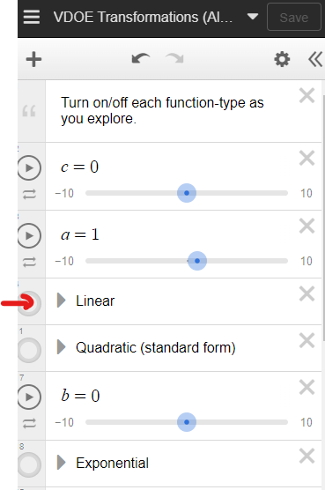
Some examples of ways that the word transform is used are…

Now we will begin our exploration of LINEAR functions. Use the QR code or the link above to open the Desmos graph.

Linear Functions:
Turn on the Linear Function. (See picture on the right à)
Directions
1. Use the ‘a’ and ‘c’ sliders to transform the function. Draw a sketch of the newly transformed function at various settings. Write the equation for each situation.
a = 3; c = 0 | a = 0; c = 2 | a = 4; c = 5
Equation: | Equation: | Equation:

Write:
2. Describe how each of the sliders causes a transformation of the line. [Include information about both positive and negative values.]
When I move the ‘a’ slider, the function…

When ‘a’ is negative…

When ‘a’ is between -1 and 1…

When I move the ‘c’ slider, the function…

When ‘c’ is negative…

Something that does not change about the function is…

Predict:
3. For each situation, predict how the function will appear on the graph. After you have sketched your graph, check your prediction using the Desmos tool.
$$y=3x-2$$ | $$y= -2x+4$$ | $$y=\frac{1}{2}x+1$$

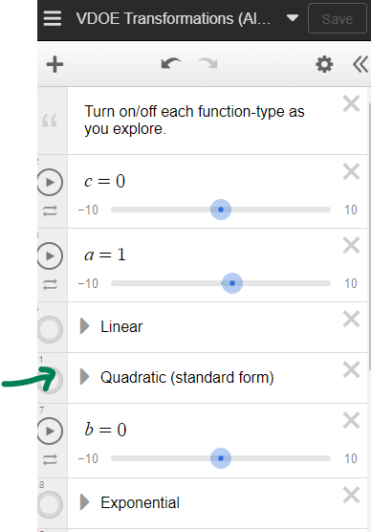
Now we will begin our exploration of QUADRATIC functions. If it is not already open, use the QR code or the link to open the Desmos graph: http://bit.ly/transf-a1
Quadratic Functions:
Turn on the Quadratic Function. (See picture on the right à)
[Note: Make sure the other functions are off!]

Directions
4. Use the ‘a’ and ‘c’ sliders to transform the function. Draw a sketch of the newly transformed function at various settings. Write the equation for each situation.
a = 3; c = 0 | a = -1; c = 0 | a = 1; c = -2
Equation: | Equation: | Equation:

Write:
5. Describe how each of the sliders causes a transformation of the line. [Include information about both positive and negative values.]
When I move the ‘a’ slider, the function…

When ‘a’ is negative…

When ‘a’ is between -1 and 1…

When I move the ‘c’ slider, the function…

When ‘c’ is negative…

When ‘a’ is zero… I think this is true because…

Predict:
6. For each situation, predict how the function will appear on the graph. After you have sketched your graph, check your prediction using the Desmos tool.
$$y=3x^{2}-2$$ | $$y=-2x^{2}-2$$ | $$y=\frac{1}{2}x^{2}+1$$

Write:
7. Compare and contrast how transformations of linear and quadratic functions are the same and different.

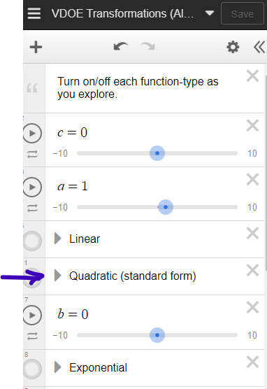
Now we will explore EXPONENTIAL functions. If it is not already open, use the QR code or the link above to open the Desmos graph: http://bit.ly/transf-a1

Exponential Functions:
Turn on the Exponential Function. (See picture to the right à)
[Note: Make sure the other functions are off!]

Directions
8. DO NOT MOVE THE ‘p’ SLIDER YET.
Use the ‘a’ and ‘c’ sliders to transform the function. Draw a sketch of the newly transformed function at various settings. Write the equation for each situation.
a = 3; c = 0 | a = -1; c = 0 | a = 1; c = -2
Equation: | Equation: | Equation:

Write:
9. Describe how each of the sliders causes a transformation of the line. [Include information about both positive and negative values.]
When I move the ‘a’ slider, the function…

When ‘a’ is negative…

When ‘a’ is between -1 and 1…

When I move the ‘c’ slider, the function…

When ‘c’ is negative…

When ‘a’ is zero… I think this is true because…
Predict:
10. For each situation, predict how the function will appear on the graph. After you have sketched your graph, check your prediction using the Desmos tool.
$$y=\frac{1}{2}∙{\left(2\right)}^{x}+0$$ | $$y=1∙{\left(2\right)}^{x}+3$$ | $$y=\frac{1}{2}∙{\left(2\right)}^{x}+3$$

Write:
11. Compare and contrast how transformations of linear and exponential functions are the same and different from the transformation of quadratic or linear functions.

Explore:
12. Now we get to explore the ‘p’ slider. Sketch a graph of each function.
$$y=4∙{\left(2\right)}^{x}+0$$ | $$y=2∙{\left(4\right)}^{x}+0$$

Write:
13. Describe the similarities and differences you see with these two graphs.

14. Explore what happens to the function when entering various values for ‘p.’ Include sketches with your description. [Include when ‘p’ is large, when 0<p<1, and when p<0.]

