Transformations
Strand: Measurement & Geometry
Topic: Applying Transformations
Primary 2023 SOL: 8.MG.3 The student will apply translations and reflections to polygons in the coordinate plane.
- Given a preimage in the coordinate plane, identify the coordinates of the image of a polygon that has been translated vertically, horizontally, or a combination of both.
- Given a preimage in the coordinate plane, identify the coordinates of the image of a polygon that has been reflected over the x- or y-axis
- Given a preimage in the coordinate plane, identify the coordinates of the image of a polygon that has been translated and reflected over the x- or y-axis or reflected over the x- or y-axis and then translated.
- Sketch the image of a polygon that has been translated vertically, horizontally, or a combination of both.
- Sketch the image of a polygon that has been reflected over the x- or y-axis.
- Sketch the image of a polygon that has been translated and reflected over the x- or y-axis, or reflected over the x- or y-axis and then translated.
- Identify and describe transformations in context (e.g., tiling, fabric, wallpaper designs, art).

Materials
- Alike and Different activity sheet (attached)
- Investigating Translations and Reflections activity sheet (attached)
- Transformation Tango Recording Sheet (attached)

Vocabulary
horizontal translation, image, preimage, reflection, transformation, translation, vertical translation

Student/Teacher Actions: What should students be doing? What should teachers be doing?
- Start the class with the reasoning routine Alike and Different. Display the image and ask students to think about and suggest the similarities and differences between the objects. The teacher should record the ideas in a T-chart.
  - Sample Responses/Teacher Talking Points:
    - Alike - both are squares, both are labeled ABCD, the y-values are the same for each letter
    - Different - one is labeled with A’B’C’D’, the x-values are different, they are in different quadrants
- Have students complete the Investigating Translations and Reflections activity sheet with a partner. Debrief as a whole class.
  - Teacher Talking Points:
    - A transformation of a figure, called the preimage, changes the size, shape, and/or position of the figure to a new figure, called the image.
    - A transformation of preimage point A can be denoted as the image A’ (read as “A prime”).
    - A translation is a transformation in which an image is formed by moving every point on the preimage the same distance in the same direction.
    - A reflection is a transformation in which an image is formed by reflecting the preimage over a line called the line of reflection. Each point on the image is the same distance from the line of reflection as the corresponding point in the preimage.
    - Translations and reflections maintain congruence between the preimage and image but change location. Reflections change the orientation of the image.
    - The result of first translating and then reflecting over the x- or y-axis may not result in the same transformation of reflecting over the x- or y-axis and then translating.
- Have students complete Transformation Tango Recording Sheet. Students should list the preimage coordinates, complete the transformation indicated, sketch it on the coordinate grid, and list the image coordinates. After transforming the three polygons, students will create a polygon of their own in quadrant IV, list the preimage coordinates, perform two transformations on it, sketch it, and list the image coordinates. Have them exchange their sketches of the preimage and image with a partner to see if they can determine what transformation was performed.

Assessment

Questions
  - What is different about describing locations and transformations on a two-dimensional surface and in space?

What does it mean to transform a polygon?

What are ways that performing a transformation could change a polygon?

How do you determine the coordinates of an image after a transformation?
  - What stayed the same and what changed from your preimage to your image?
  - Was the order in which the transformations were applied important? Why?
  - How did the sketch help in determining the type of transformation(s)?

Journal/Writing Prompts
  - Describe examples of transformations encountered in real life.
  - In animation and graphic design, describe about how transformations might be used to make production easier and faster.

Extensions and Connections (for all students)
- Have each student draw a figure on graph paper and complete five different transformations of the figure. Then, have students write out the directions for these five transformations and exchange them with other students, who will follow the directions in order to create the same transformations.
- Have students create tessellations.
- Label each corner of the room with a different type of transformation. Give students sample transformation cards and have them go to the transformation corners that their samples represent.
- Create a dance routine in which students perform movements based on reflections and translations, and label the movements as such.
- Use online resources to model transformations.

Strategies for Differentiation
- Start with all figures in quadrant I for the first few examples.
- Have students complete one transformation of a figure, then progress to completing more than one transformation of the same figure.
- Have students use patty paper or tracing paper to complete transformations.
- Have students find examples of transformations within the classroom or on their clothing.
- Provide original figures already drawn so that students only have to draw the transformed figure.
- Use color-coding.
- Provide a numbered coordinate plane.

Note: The following pages are intended for classroom use for students as a visual aid to learning.

Virginia Department of Education ©2018 (Revised December 2023)
Alike and Different
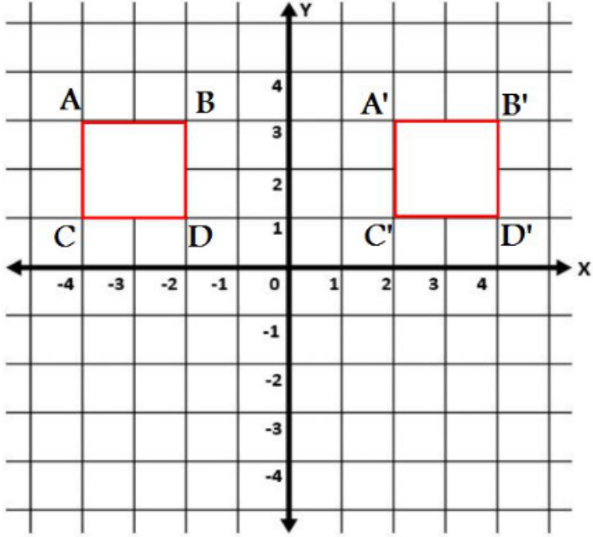

What do you notice and wonder about these polygons? How are they alike and different?

Investigating Transformations and Reflections
 | Preimage  Coordinates | How would you describe what is happening from the preimage to the image?  What happened to the x-coordinates?  What happened to the y-coordinates? |  | Image  Coordinates
A |  |  | A’
B |  |  | B’
C |  |  | C’
D |  |  | D’

Summarize your observations. How did the translation of this preimage affect the coordinates of the resulting image?

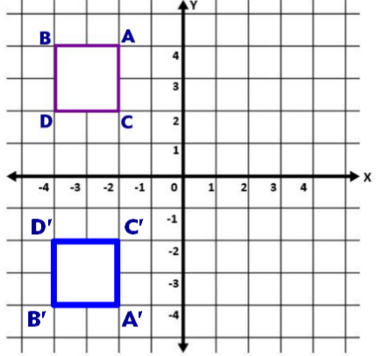

 | Preimage  Coordinates | How would you describe what is happening from the preimage to the image?  What happened to the x-coordinates?  What happened to the y-coordinates? |  | Image  Coordinates
A |  |  | A’
B |  |  | B’
C |  |  | C’
D |  |  | D’

Summarize your observations. How does the reflection of this preimage affect the coordinates of the resulting image?

How is this the same as a translation? How is it different?
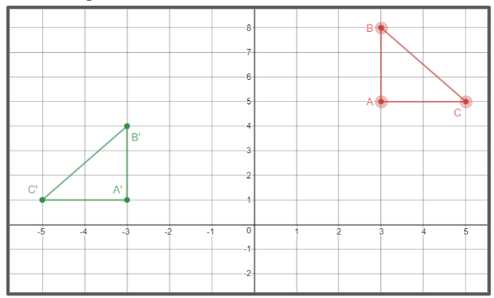
 | Preimage  Coordinates | How would you describe what is happening from the preimage to the image?  What happened to the x-coordinates?  What happened to the y-coordinates? |  | Image  Coordinates
A |  |  | A’
B |  |  | B’
C |  |  | C’

Summarize your observations. How does the reflection then translation of this preimage affect the coordinates of the resulting image?

Does order matter when doing more than one transformation?

Transformation Tango Recording Sheet
Name Date
You are creating images for a video game for children called Transformation Tango. Your job is to transform the shapes according to the directions. You will need to record the preimage coordinates, transform the figure by sketching it on the coordinate plane, then record the new image coordinates. Once you have transformed the shapes already drawn, create a polygon of your own in quadrant IV, and then apply two transformations to your polygon. Be sure to record your preimage coordinates, the two transformations performed, and new image coordinates. Exchange your preimage and image sketches with a partner and see if they can determine what two transformations you performed.
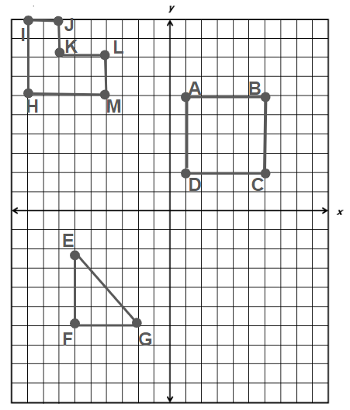
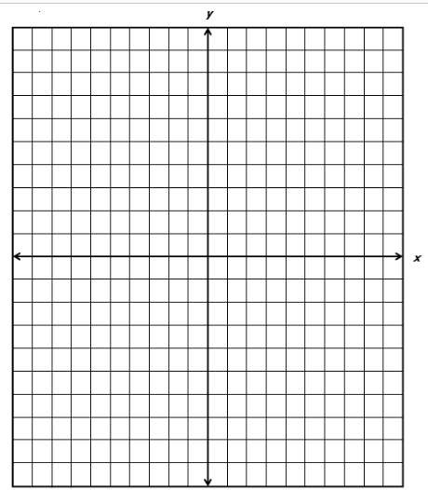

Shape | Preimage | Transformation | Image
Rectangle | A ( )  B ( )  C ( )  D ( ) | Translate 5 units to the left and 3 units up. | A’ ( )  B’ ( )  C’ ( )  D’ ( )
Hexagon | H ( )  I ( )  J ( )  K ( )  L ( )  M ( ) | Reflect across the x-axis. | H’ ( )  I’ ( )  J’ ( )  K’ ( )  L’ ( )  M’ ( )
Right Triangle | E ( )  F ( )  G ( ) | Reflect across the y-axis and translate 2 units down. | E’ ( )  F’ ( )  G’ ( )
Your Choice (Draw a polygon in quadrant IV) | ( )  ( )  ( )  ( ) | Apply two transformations to your polygon in quadrant IV. | ( )  ( )  ( )  ( )

How do you determine the coordinates of an image after a transformation?

What stayed the same and what changed from your preimage to your image?

Was the order in which the transformations were applied important? Why?

How did the sketch help in determining the type of transformation(s)?

How could you determine which transformation has been performed on the preimage?

